SN-GCJA5 sensor on Raspberry PI

Table of Contents
1. Background 2
2. Hardware connection 3
2.1 SN-GCJA5 3
2.1.1 I2C communication 3
2.1.2 Serial communication 3
2.2 SDS011 4
3. Software 4
3.1 Installing the software 4
3.1.1 Install BCM2835 library 4
3.1.2 Install smbus.h 4
3.1.3 Install program 4
3.1.4 compile 5
3.1.5 Parameter setting 6
3.2 Program options 7
3.3 Program usage examples 8
3.3.1 SN-GCJA5 output with I2C 8
3.3.2 SN-GCJA5 with serial 9
3.3.3 SN-GCJA5 and SDS011 output 9
3.4 Stability 10
4.0 Overview of SN-GCJA5 library calls 11
4.1 void setDebug(uint8_t val) 11
4.2 bool begin(char *device) 11
4.3 void close() 11
4.4 void SetClock(uint16_t clock) 11
4.5 float getPM1_0() 11
4.6 float getPM2_5() 11
4.7 float getPM10() 11
4.8 uint16_t getPC0_5() 11
4.9 uint16_t getPC1_0() 11
4.10 uint16_t getPC2_5() 11
4.11 uint16_t getPC5() 11
4.12 uint16_t getPC7_5() 11
4.13 uint16_t getPC10() 12
4.14 uint8_t getState() 12
4.15 uint8_t getStatusSensors() 12
4.16 uint8_t getStatusPD() 12
4.17 uint8_t getStatusLD() 12
4.18 uint8_t getStatusFan() 12
4.19 bool SetI2cDevice(uint8_t adapter) 12
4.20 bool SetI2cExit(uint16_t speed) 12
5. Difference PM10 and PM2.5 13
6. Compare against SDS-011 14
6.1 SDS-011 definition 14
6.2 SN-CGJA5 definition 14
6.3 compare SN-GCJA5-I2C SDS-011 15
6.4 compare SN-GCJA5-Serial SDS-011 16
7. Personal observation (November 2020) 17
7.1 Plus 17
7.2 Minus 17
Appendix A: Inside SN-GCJA5 19

1. Background

In 2019 a new particle sensor SN-GCJA5 was announced from Panasonic.

It uses a laser and photo-diode to detect the particles with light scattering. It has an inside fan, which is very silent, to force air-movement.

Having worked on many other particle sensors in the past (like the SPS30) I wanted to check out this device and understand how it compares to the others.

Please see my personal conclusion in chapter 7 after 2 weeks of working with the sensor.

Paul van Haastrecht
paulvha@hotmail.com

Version 2.0 / March 2021

When BOTH the BCM2835 and I2C devices are enabled in the kernel, the I2C channel may become un-useable after close down. Normally on exit the program will reset GPIO5 and GPIO3 back to input.

An option ‘-k speed’ has been added. If set GPIO5 and GPIO3 will continue to be SDA/SCL and the speed will be set to requested.

Option ‘-A #’ has been added to use the I2C kernel devices (/dev/i2c-x) instead of BCM2835. However the I2C speed has to be set manually see chapter 3.2

Version 1.0 / November 2020
- initial version

2. Hardware connection

2.1 SN-GCJA5

2.1.1 I2C communication

As documented in the datasheet, there is NO need for SN-GCJA5 for external pull-up. It has internal 10K pull-up to 3V3 so we can connect directly to a Raspberry PI on the GPIO2 / SDA / Pin 3 and GPIO3 / SCL / Pin 5. They also have already 1.8K resistors.

SN-GCJA5 pin Raspberry Pi
1 VCC -------------- 5V
2 GND -------------- GND
3 SCL -------------- SCL (pin 5)
4 SDA -------------- SDA (pin 3)
5 Serial Not used

2.1.2 Serial communication
The sensor can also communicate over serial. Depending on your Raspberry Pi you have to take different steps. You can NOT use the mini-uart as that has the following limitations:
- No break detection No framing errors detection
- No parity bit No receive timeout interrupt
- No DCD, DSR, DTR or RI signals
Not able to do a parity bit is the killer as the sensor is using 1 start, 8 data, 1 even parity, 1 stop at 9600 baud. So you have to make the UART0 available which is actually used on many boards for Bluetooth. (See https://www.raspberrypi.org/documentation/configuration/uart.md)

If you have a Raspberry Pi4 you can enable one of the other 4 UART’s (see https://www.raspberrypi.org/forums/viewtopic.php?t=244827)

I have tested on a Raspberry Pi4, running PI-OS / Buster.
- In /boot/config.txt added a line at the bottom dtoverlay = uart3
- reboot
- You now find the device /dev/ttyAMA1
- This is using TX = GPIO 4, RX = GPIO 5, CTS = GPIO6 and RTS = GPIO7
- Connected to serial from the sensor to GPIO5

SN-GCJA5 pin Raspberry Pi
1 VCC -------------- 5V
2 GND -------------- GND
3 SCL
4 SDA
5 Serial -------------- GPIO5

2.2 SDS011
In case you want to add an SDS011 to the program, mine is connected with a Serial / USB converter. Hence is was inserted on a USB port.

3. Software

3.1 Installing the software

3.1.1 Install BCM2835 library
Note : In case you have defined INCLUDE_BCM2835_I2C the BCM2835 library is needed. See 3.1.5 for setting the parameter.

Install latest from BCM2835 from : http://www.airspayce.com/mikem/bcm2835/

1. wget http://www.airspayce.com/mikem/bcm2835/bcm2835-1.68.tar.gz
2. tar -zxf bcm2835-1.68.tar.gz // 1.68 was version number at the time of writing
3. cd bcm2835-1.68
4. ./configure
5. sudo make check
6. sudo make install

3.1.2 Install smbus.h
If you want to use the kernel device (/dev/i2c-x) for I2C communication (defining INCLUDE_KERNEL_I2C in 3.1.5) you need to install the development package :
sudo apt-get install libi2c-dev

3.1.3 Install program
The library software has been written based on the Sparkfun library for Arduino.
The following files (part of the basic package) in a directory gcja5

gcja5.cpp
This is the user level / interface program

gcja5_lib.h and gcja5_lib.cpp
These contain the connection between the user level program and the gcja5. The library calls are described in chapter 4.

makefile
The makefile for the program

The following program is included as well but is optional

sds011 folder:
sds011_lib.cpp sds011_lib.h : SDS-011 driver
sdsmon.cpp sdsmon.h : SDS-011 monitor
serial.c serial.h : serial setting

3.1.4 compile

To compile the program, go in the directory (gcja5) and type
make

To create a build the gcja5 with SDS011 monitor (in case you want to include)
make BUILD=SDS011

3.1.5 Parameter setting

In gcja5_lib.h a number of program compile parameters can be set:

INCLUDE_SERIAL
In case you do NOT want to include serial communication you can comment out the define. Enabled by default.

INCLUDE_BCM2835_I2C
In case you do NOT want to include I2C communication using BCM2835 library you can comment out the define. In case you want to include, you must install the BCM2835 library. Enabled by default.

INCLUDE_KERNEL_I2C
In case you do NOT want to include I2C communication using kernel devi2c-x device you can comment out the define. In case you want to include, you must install the smbus. Enabled by default.

Note: compile will fail is INCLUDE_SERIAL, INCLUDE_BCM2835_I2C and INCLUDE_KERNEL_I2C are not selected.

GCJAS5_SPEED
This is set to 50Khz given the instability

RASPBERRY_PI_BOARD
The different Raspberry PI boards have different core speeds. The earlier versions use 250Mhz, where the Pi3 was around 300Mhz and the Pi4 around 400Mhz. Actually the core speeds increases with the workload on the processor. This has a BIG impact on setting the I2C speed. Setting the right Pi-level board is important.

MAXBUF
Is used for the a number of different buffers.

In gcja5.cpp / init_variables() :

loop_count
Number of times a sensor reading is performed. This is set to 10 in case you do not overrule with the ‘-l’ command line option.

loop_delay
The seconds between a sensor reading. This set to 5 in case you do not overrule with the ‘-w’ command line option.

Timestamp
By default a timestamp is NOT included. This can be overruled with the ‘-t’ command line option.

include_particle
By default the particle count numbers are not included, this can be overruled with ‘-p’

3.2 Program options
When you type : ./gcja5 -h the following information is displayed:

sudo ./gcja5 [options] (version 2.0)

program options
-A# index number for /dev/i2c-# (no default) note 1
-B do not display output in color
-l # number of measurements (0 = endless) (default 10)
-w # wait-time (seconds) between measurements(default 5)
-v # verbose / debug level (0 – 2) (default 0)
-t add timestamp to output (default No stamp)
-p include particle count (default excluded)
-c add condition/status of the sensor (default excluded)
-s # enable serial communication port (No default) note 2
-i # set I2C speed (default is 50Khz) note 3
-k # On exit keep GPIO SDA/ SCL at speed # (default reset to input) note 3, 4

If compiled with SDS011 the following is added:

SDS011 options:
-S port Enable SDS011 input from port (No default)
-C add correlation calculation (default removed)

Note 1:
This option is only shown if INCLUDE_KERNEL_I2C set during the compile. When the -A option is applied on the command line ( e.g. -A 1) the program will use the enabled I2C driver (/dev/i2c-1) in the kernel. By default it will use the BCM2835.
When using kernel drive one can not change the I2C speed on the fly. This needs to be done manually by adding a dtparam= i2c_baudrate =50000 (for 50Khz) in /boot/config.txt and reboot
Note 2:
This option is only shown if INCLUDE_SERIAL was set during compile.
Note 3:
This option is only with INCLUDE_BCM2835_I2C set during the compile.
Note 4:
With the -k option you can keep GPIO 5 and 3 defined as SDA and SCL on exit. The I2C-speed will be set to the speed ( between 1 and 400Khz) on exit.

3.3 Program usage examples

3.3.1 SN-GCJA5 output with I2C
sudo ./gcja5 : will show the mass density
== SN-GCJA5 MASS ===
PM1.0 PM2.5 PM10
0.13 0.00 0.00
0.78 0.90 1.00
4.46 5.09 5.58
7.62 8.61 9.69
12.78 14.14 15.91
14.17 15.32 17.11
16.41 17.56 19.89
16.48 18.42 20.17
17.01 18.62 20.93
17.37 19.18 54.20
Reached the loopcount of 10.
closing down

sudo ./gcja5 -t , will add a timestamp
== SN-GCJA5 MASS ===
PM1.0 PM2.5 PM10
Nov 10 2020 18:59:18 13.25 14.40 16.33
Nov 10 2020 18:59:24 14.01 14.83 16.87
Nov 10 2020 18:59:29 14.01 15.49 17.56
Nov 10 2020 18:59:35 15.45 16.77 19.61
Nov 10 2020 18:59:40 14.99 17.10 19.09
Nov 10 2020 18:59:46 14.42 16.52 18.57
Nov 10 2020 18:59:52 13.85 15.79 17.62
Nov 10 2020 18:59:57 15.34 16.58 51.41
Nov 10 2020 19:00:03 17.01 18.66 20.99
Nov 10 2020 19:00:08 17.09 18.57 20.88
Reached the loopcount of 10.
closing down

sudo ./gcja5 -p : will add the particle count to the output
== SN-GCJA5 MASS === == PARTICLE COUNT ==
PM1.0 PM2.5 PM10 PM1.0 PM2.5 PM10
14.56 16.20 18.23 327 343 346
13.66 15.31 17.35 311 328 329
15.77 17.56 19.88 337 370 370
18.93 21.20 24.31 248 402 398
18.45 20.92 23.53 364 393 395
14.83 17.10 19.09 321 345 347
14.12 16.31 18.33 312 338 341
13.09 15.56 17.35 298 337 463
13.69 16.62 18.68 317 347 350
15.55 17.57 19.89 335 360 366
Reached the loopcount of 10.
closing down

sudo ./gcja5 -c : will add the status information
== SN-GCJA5 MASS === ===== Status =====
PM1.0 PM2.5 PM10 LD PD Fan
53.90 62.47 70.28 0 0 0
56.65 65.88 74.11 0 0 0
59.28 67.98 74.38 0 0 0
60.96 69.03 80.88 0 0 0
63.61 73.41 82.59 0 0 0
71.00 81.88 92.11 0 0 0
74.37 86.53 97.20 0 0 0
70.34 81.88 92.11 0 0 0
74.80 86.96 97.69 0 0 0
70.39 81.06 91.89 0 0 0
Reached the loopcount of 10.
closing down

NOTE : did you notice the increase in PM mass density?? My wife is cooking the evening meal ..

3.3.2 SN-GCJA5 with serial
sudo ./gcja5 -p -s /dev/ttyAMA1
== SN-GCJA5 MASS === == PARTICLE COUNT ==
PM1.0 PM2.5 PM10 PM1.0 PM2.5 PM10
5.00 5.00 6.00 74 76 76
5.00 5.00 5.00 66 71 71
4.00 5.00 5.00 77 86 86
5.00 6.00 7.00 69 84 84
5.00 6.00 7.00 78 91 92
5.00 6.00 7.00 98 113 115
7.00 8.00 15.00 109 119 122
8.00 8.00 9.00 127 134 136
9.00 10.00 17.00 113 122 123
8.00 9.00 10.00 108 119 119
Reached the loopcount of 10.
closing down
Note: on serial communication the SN-GCJA5 is only providing the mass density digit numbers before the decimal point. On I2C it will provide also the mass density numbers behind the decimal point.

3.3.3 SN-GCJA5 and SDS011 output
So I compiled to include the SDS011 and connected that device over USB
sudo ./gcja5 -S /dev/ttyUSB0 will add the SDS011 PM info
== SN-GCJA5 MASS === === SDS011 ===
PM1.0 PM2.5 PM10 PM2.5 PM10
85.65 97.02 109.15 112.50 191.40
90.05 101.55 114.57 113.50 191.90
94.37 107.39 120.82 113.20 187.90
90.50 103.55 116.62 117.60 194.50
93.96 106.94 120.23 117.30 188.20
94.99 109.99 123.86 119.80 190.20
93.71 108.99 122.59 122.90 193.40
129.32 113.85 133.31 126.70 198.10
97.19 113.83 133.29 126.80 198.00
100.99 116.22 135.55 131.20 205.50
Reached the loopcount of 10.
closing down

Note : My wife is still cooking the evening meal :-)

sudo ./gcja5 -S /dev/ttyUSB0 -C will add correlation calculation (% different to SDS011)
== SN-GCJA5 MASS === === SDS011 === =Correlation=
PM1.0 PM2.5 PM10 PM2.5 PM10 PM2.5% PM10%
109.14 126.28 142.06 147.80 234.30 17.04% 64.93%
114.24 130.20 146.60 145.60 229.90 11.83% 56.82%
117.61 135.90 153.01 144.70 226.90 6.48% 48.29%
112.89 128.68 144.62 144.30 230.60 12.14% 59.46%
116.21 125.93 141.80 144.90 226.20 15.06% 59.52%
108.38 121.57 136.89 143.70 223.50 18.21% 63.27%
101.32 113.39 127.69 142.60 219.80 25.76% 72.13%
102.73 114.33 128.75 142.70 221.90 24.81% 72.35%
101.81 114.67 129.00 138.90 211.80 21.13% 64.18%
106.89 119.75 134.85 137.20 214.60 14.57% 59.15%
Reached the loopcount of 10.
closing down

Note : look at the huge difference PM10

3.4 Stability
The SN-GCJA5 does not seem to like many I2C calls to follow quickly after each other. It happened often that it backed-out and there is NO response anymore from the sensor and you need remove power and reapply power. Not only on the Raspberry Pi, but also on Arduino Mega2560.
Although I have already 300mS sleep after each read (in cgaj5_lib.cpp / I2C_read()) it still happens to “hang” on a regular base. Looking with an oscilloscope it proved that SCL is continued been pulled low by the SN-CGJA5, making any communication impossible. It is not clock-stretching, which is normally in the ms, but this is a constant pull low of SCL. Removing SCL from the Raspberry Pi will report an I2C-error but the SCL output of the SN-CGJA5 is still low. The only way to restart communication is to remove and re-apply the 5V.
Also readings of the different numbers can suddenly be HUGE. Hence I have included in main_loop() a check and it can try to obtain new values that makes more sense before display. Best is to keep also a low I2C speed, hence I used 50Khz in the program. But this also happens when connected serial, so it looks to be a sensor issue.
To reduce the back-out instead of different I2C calls all the data all time, it reads all the data in ONE I2C call into a buffer. The different data is read from that buffer, unless that data was already reported. In that case again the single read-all-the data call is performed again.
I have also included the option to connect over serial. The sensor will sent each second 32 bytes of data. While that works stable, the disadvantage is that the mass density numbers from the sensor are only those BEFORE the decimal point (e.g. 1 and not 1.28). Not sure why that has been done as 4 bytes are reserved within the block of 32 for each density number, but only 2 bytes are used.

4.0 Overview of SN-GCJA5 library calls

4.1 void setDebug(uint8_t val)
Will enable or disable driver debug messages. Valid options for level of debug
0 : no debug message (default)
1 : sending and receiving data
2 : 1 + protocol progress

4.2 bool begin(char *device)
This will initialize the communication. When a device is provided (like /dev/ttyAMA1) the library will work with serial communication on that device. When no device is provided it will use I2C by default. Will return true successful else false

4.3 void close()
This will reset the hardware and release the memory

4.4 void SetClock(uint16_t clock)
Will set the I2C clock speed

4.5 float getPM1_0()
Will return the PM1.0 mass density or zero if error.

4.6 float getPM2_5()
Will return the PM2.5 mass density or zero if error.

4.7 float getPM10()
Will return the PM10 mass density or zero if error.

4.8 uint16_t getPC0_5()
Will return the Particle count for PM 0.5. ( 03. - 0.5 um)

4.9 uint16_t getPC1_0()
Will return the Particle count for PM 1.0. ( 03. - 1.0 um)

4.10 uint16_t getPC2_5()
Will return the Particle count for PM 2.5 ( 03. - 2.5 um)

4.11 uint16_t getPC5()
Will return the Particle count for PM 5 ( 03. - 5 um)

4.12 uint16_t getPC7_5()
Will return the Particle count for PM 7.5 ( 03. - 7.5 um)

4.13 uint16_t getPC10()
Will return the Particle count for PM 10 ( 03. - 10 um)

4.14 uint8_t getState()
Will return the SN-GCJA5 status byte. 0 (zero) is good !

4.15 uint8_t getStatusSensors()
Will return the number of SN-GCJA5 sensors operating with s/w correction or error.
0 (zero) is good !

4.16 uint8_t getStatusPD()
Will return the SN-GCJA5 Photo-Diode status operating with s/w correction or error.
0 (zero) is good !

4.17 uint8_t getStatusLD()
Will return the SN-GCJA5 Laser-Diode status operating with s/w correction or error.
0 (zero) is good !

4.18 uint8_t getStatusFan()
Will return the SN-GCJA5 fan status operating with s/w correction or error.
0 (zero) is good !

4.19 bool SetI2cDevice(uint8_t adapter)
Will select to use the I2C kernel device instead of BCM2835. The adapter number will be added to the name /dev/i2c-#

4.20 bool SetI2cExit(uint16_t speed)
By default GPIO 5 and GPIO 3 will be reset to input on exit. By defining a speed GPIO5 and GPIO3 will continue to be set for SDA and SCL and with I2C speed set to speed.

5. Difference PM10 and PM2.5


https://www.arb.ca.gov/research/aaqs/pm/pm.htm
An PM10 surface is 16 x PM2.5, while the PM10 volume is 64 x PM2.5. This means that the <PM 2.5 as much smaller, much lighter than the PM25 <> PM10 particles. And while the PM2.5 <> PM10 numbers are much less they have a size-able impact on the numbers.
The PM10 number INCLUDE the PM2.5 numbers. Different investigations have provided information around the relationship between PM2.5 and PM10 ug/m3.
The university of Montana 70% of the weight of PM10 constitutes of PM2.5.
HongKong:
Annual(μg/m3) | Daily(μg/m3)
PM2.5 = 0.71 x PM10 | PM2.5 = 0.75 x PM10

(https://www.epd.gov.hk/epd/english/environmentinhk/air/guide_ref/guide_aqa_model_g5.html)
Scotland:
The annual average ratio of daily mean PM2.5 concentration to daily mean PM10 concentration typically varied from 0.51 to 0.69 with a mean of 0.63

This was supported by the PCM modeled data, which indicated that the ratio of annual mean PM2.5 / PM10 ranged from 0.63 to 0.69

(http://www.scottishairquality.scot/assets/documents/technical%20reports/pm2.5-pm10ratio_29Mar2016-FINAL_Version_Approved.pdf)

6. Compare against SDS-011

6.1 SDS-011 definition
The SDS011 using principle of laser scattering,can get the particle concentration between 0.3 to 10μm in the air. It provides the mass of 2.5 μg/m³ and 10 μg/m³ .

6.2 SN-CGJA5 definition
The SN-GCJA5 numbers show in cm³ the particle count SMALLER than the size.
PMx defines particles with a size smaller than “x” micrometers (e.g., PM2.5 = particles smaller than 2.5 μm).
The SN-GCJA5 starts at 0.3 μm as well and provides mass numbers as 1 μg/m³ , 2.5 μg/m³ , 5 μg/m^{3,} 7.5 10 μg/m³ and 10 μg/m^{3.}

6.3 compare SN-GCJA5-I2C SDS-011
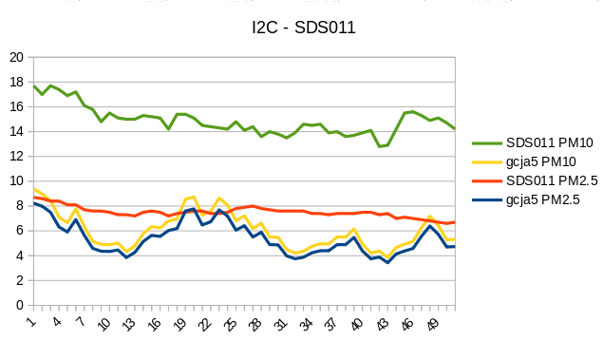
Looking at the chart for a number of samples output of the SN-GCJA5 is very close to each other and follows the same pattern. The output is nervous, something I have seen also when comparing against others like the SPS30.
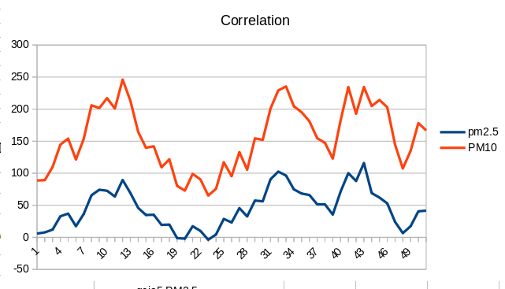
The SDS011 line is much more stable and measurement is much higher. (up to 250% difference) Especially the PM10. Again a behavior I have seen before in other tests.

6.4 compare SN-GCJA5-Serial SDS-011

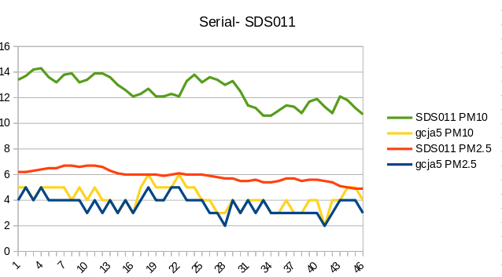
On serial, you see the SN-GCJA5 output is much more blocked, because of only digits before the decimal point. Still it is changing a lot (nervous).
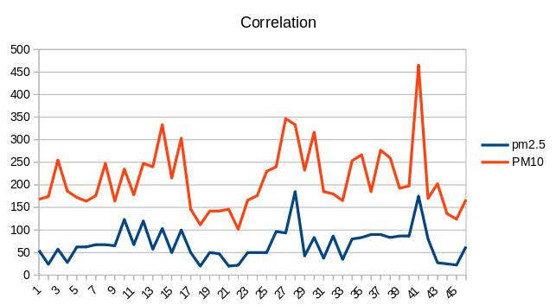
Again big differences in measurement between SDS011 and SN-GCJA5 sensor. Spikes up to 450%

7. Personal observation (November 2020)

Based on the tests done with the SN-GCJA5 on the Raspberry Pi, as well as tests done on MEGA2560 (https://github.com/paulvha/SN-GCJA5) I am not impressed by this sensor.

Parts of the remarks here are also in a document on the above referenced location.

The SN-GCAJ5 is “just another” sensor which uses light scattering with a laser diode and photo-diode and a fan. Having done different tests for over 2 weeks, I concerned if there was a good design document from the start or maybe different people worked in parallel and not together. Look at some of the (unnecessary) minus aspects.

7.1 Plus
Very simple protocol and command set to obtain the values. Simple interface.
Onboard pull-up resistors for I2C for easy connection to MCU boards.
Can communicate Serial and I2C at the same time.
Serial communication is at 9600 baud, so can be integrated in low-cost HW
Cheaper than SPS30 (about half in US).
Auto calibration function for laser diode and rotation speed fan.
Silent fan

7.2 Minus
Very nervous output values, jumps up and down in both I2C and Serial communication. If you want to drive an action on the output (e.g. higher fan power) you will need to include a longer time-out or different threshold to refer back and not directly react on “the next value” which might be much lower. None of the sensors I have worked with show this behavior.
No CRC check over the data on I2C communication, while there is on serial.
Both Serial and I2C have 4 bytes reserved for PM mass density data. BUT not using it completely. Maybe a float-value was expected.
On serial communication on PM mass density values are ONLY those before the decimal point. Not sure WHY, because the bytes to sent the same information as over I2C
Sometimes the numbers (mass density and Particle count) are huge ! Both on I2C and Serial.
Particle count numbers can not be correlated to other sensors (e.g. SPS30 and Dylos).
No definition of the particle count numbers anywhere, besides the size it would represent as a value.
PM10 density values do not seem to be in line with the PM2.5 density output.
The PM particle count numbers are not making sense especially if you compare that to the PM mass density numbers.
Shorter lifetime than many other sensors. While cheaper in sensor cost it will take more cost to replace during life-time in an overall solution.
Available documentation is the bare minimum and incomplete. (particle count)
Trying to read the registers directly following each on I2C, even at 100khz, can cause the sensor to “hang” and in locks with the SCL pulled low. You then need to remove and re-apply the power. You must preserve at least 300mS to prevent that happening and even then. This is NOT good if you use the sensor in an larger solution. You can’t continue to switch that off and on again.
No mounting capabilities to securely fasten the sensor. How difficult is that to consider ?
Always difficult to get / produce the right DST-connector, why not include for the 2cts a connector with small wires?
Last by not least : the name ! Why such a crazy name SN-GCJA5 ?? Is there NO marketing department ?

Appendix A: Inside SN-GCJA5
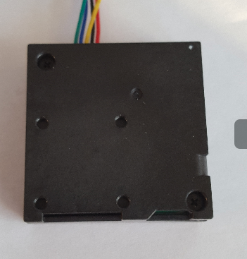
Remove the 2 screws

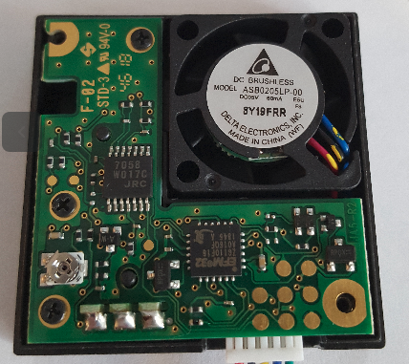
Remove the 3 small screws:

Carefully open up
