Appendix: Connecting between TTN and LuftDaten
Now that we have created the sketch and we can upload to TTN, we can also update the data to Luftdaten and/or store on a local server. For this we need to do a number of steps.

- Obtain the software to receive the data from TTN and forward to Luftdaten
- Set the parameters for that software
  - Set the right TTN url
  - get the TTN application id
  - get the TTN application access key
  - set local storage directory
  - set local file-extension
  - (optional) enable extended debug information
- Include a payload-decoder in TTN
- create an account and/or login to Luftdaten
- create a sensor on Luftdaten
- File format
- Raspberry PI setup remarks/errors
- Microsoft Windows remarks
- startup info

1. Obtain the software

1.1 The software
Based on the Java Forwarder from bertriksikken,https://github.com/bertrik/LoraLuftdatenForwarder
, a version has been created for the sketch to capture the SPS30 and BME280 data. It is available on : https://github.com/paulvha/SPS30_lora

Download the data and extract in a folder.

1.2. Compile & install
1.2.1 Compile
Within the folder :

cd LoraLuftdatenForwarder
cd gradle
chmod +x gradlew
./gradlew assemble

This might be slow…. especially the first time… just relax. It will download a zip and then perform some stuff.

When finalized a compressed distribution archive (.tar/.zip) is now available in folder ‘../LoraLuftdatenForwarder/build/distribution’

1.2.2 Install
The archive is extracted relative to it’s current path. For this example we will use a local directory. Go to your home directory and create a directory : testluft. Now extract the archive (tar or zip) in testluft.

1.3 Parameter setting
Go to testluft/LoraLuftdatenForwarder/bin. Now start for the first time : ./LoraLuftdatenForwarder (Linux/ Raspbian) or LoraLuftdatenForwarder.bat (windows)

After starting the LoraLuftdatenForwarder, it will check for a configuration file in the local directory: LoraLuftdatenForwarder.properties. If that does not exist, it will create one which can be edited with your information. I expect the forwarder will fail with the default information so stop it and change the configuration file first. Do not change the order of the lines, just change the values where needed.

The original content of loraluftdatenforwarder.properties will look like:

# URL of the MQTT server
mqtt.url=tcp://eu.thethings.network

# TTN application id
mqtt.appid=paulvha_app_a

# TTN application access key
mqtt.appkey=ttn-account-v2.VEpesR6uunR8lAZT1llsCkddPRKFt7aLxMhv0qOlhFHk

# The payload encoding
encoding=rudzl

# luftdaten server URL (empty to disable)
luftdaten.url=https://api.luftdaten.info

# luftdaten API timeout (milliseconds)
luftdaten.timeout=10000

# storage directory for local data files (empty to disable)
storage.dir=/tmp/

# Format date extension for local data file
file.ext=YYMMdd

# 1 will enable data flow messages, 0 will show program log only
enable.dbg=0

NOTE: If running on Windows, see section around Microsoft Windows for information about the storage.dir

2. Set the parameters for that software
You can change the following information in the configuration file. After change and saving restart the Loraluftdatenforwarder to read the configuration file

2.1. Set the correct TTN URL
In this example, as I am based in Europe, my mqtt.url starts with ‘eu’ . If you based in another part of the world, change according to the online TTN information.

2.1 Set your application name
In the Loraluftdatenforwarder.properties file change the ‘TTN application id’ to your ‘Application ID’ from the TTN console.

In TTN console go to applications → ‘application name’ (example : paulvha_app_a) Copy and paste this in the configuration file.

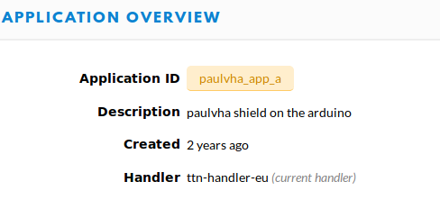

2.2 Set your TTN application access key

In the Loraluftdatenforwarder.properties file change the ‘TTN application access key’ to your ‘access key’.

In TTN console go to applications → ‘application name’ (example : paulvha_app_a) and at the bottom of the page you will find the access keys that you can copy with the button right to it. Copy and paste this in the configuration file.

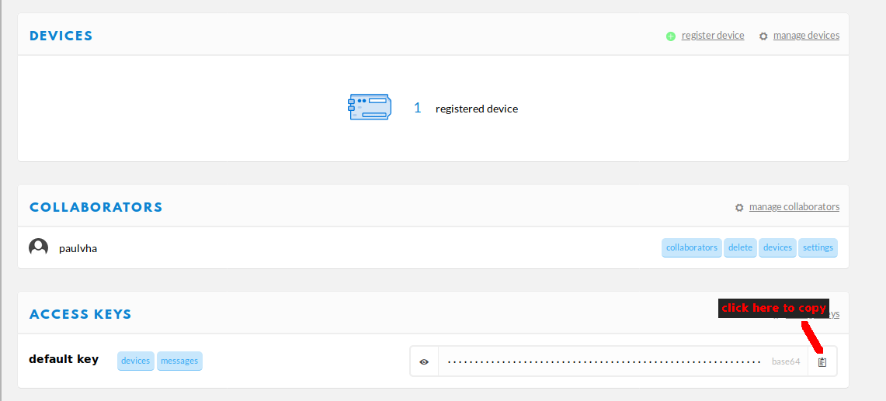

2.3 Set location for local data file
Next to uploading data from TTN to Luftdaten, the forwarder can also store the data from SPS30 and BME280 in a local file. The directory location is identified in storage.dir. The default is /tmp/, but in case you reboot the machine, this data might be lost. Change this to the directory you want the file to be stored. It you define empty : ‘storage.dir=’ NO saving of data is performed.

2.4 Set date file extension
The filename that is created locally has the format : TTN-Deviceid-DATEEXT
The DATEEXT is by default YYMMDD, such YEARMONTHDAY. As an example the result would be TTN-0910196025017080-191121.

You can change this to your needs, but bear in mind that a new file is created depending on your extension. E.g. if you set “YY” the data will be appended to that file for a year and 1 January a new file is created. It you set this to “MM” a new file is created every month or with “dd” everyday. In the default mode a new file is created every day and based on the extension you can derive which year and which month that day was. The possible options for format are described on https://docs.oracle.com/en/java/javase/11/docs/api/java.base/java/time/format/DateTimeFormatter.html in the chapter DateTimeFormatter.ofPattern()

2.6 Enable data flow debugging
The Loraluftdatenforwarder provides debug / progress data. This is both displayed as well saved in a file called ‘ loraluftdatenforwarder.log’ in the bin-directory. This can grow LARGE. Under normal working you do not need the extended debug / data information and as such the ‘enable.dbg=0’. But in case you want to check, change this into ‘enable.dbg=1’

2.7 Luftdaten and encoding parameters
You can change the Luftdaten URL and timeout, but under normal circumstances this is NOT needed. Encoding change will need a change in the source code to add a new encoding of the TTN message. I have left this in as it was in the original.

3. Insert payload decoder in TTN
The decoder will decode / parse different data from the uploaded message from a device and give it a name that can be used by the Loraluftdatenforwarder to Luftdaten.

This must match the data structure in the sketch. The Payload included is aligned with the Sketch version 1.2 / November 2019

In TTN console go to applications → ‘application name’ ( in this example paulvha_app_a) and at the top right hand of the page select “Payload formats”

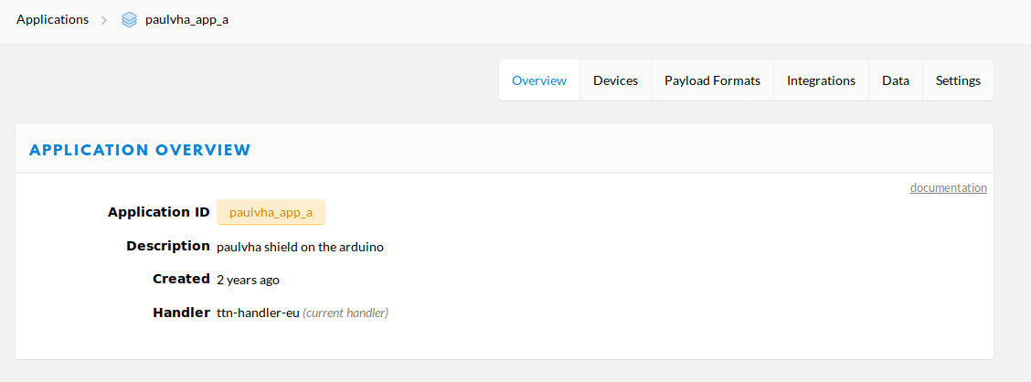

A new screen will pop and make sure to ‘decoder’ is select

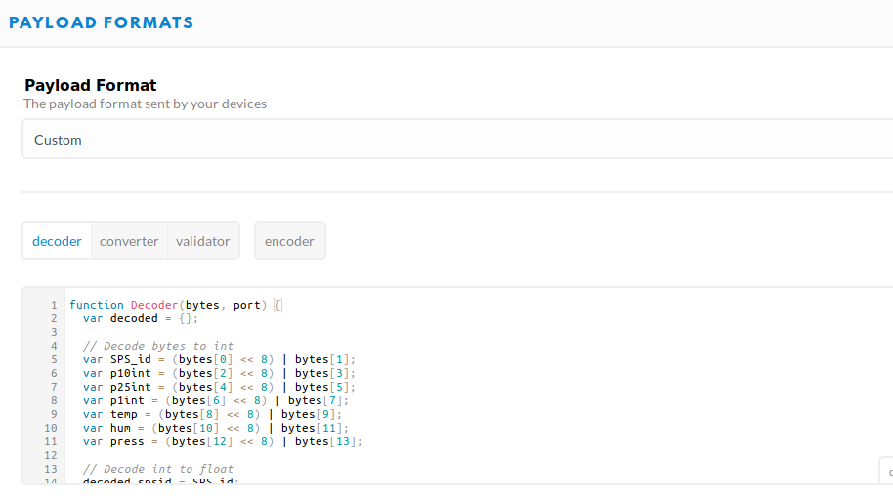
The decoder is aligned with the data sequence in the sketch and thus now paste into the top window :

function Decoder(bytes, port) {
var decoded = {};

// Decode bytes to int
var SPS_id = (bytes[0] << 8) | bytes[1];
var p10int = (bytes[2] << 8) | bytes[3];
var p25int = (bytes[4] << 8) | bytes[5];
var p1int = (bytes[6] << 8) | bytes[7];
var temp = (bytes[8] << 8) | bytes[9];
var hum = (bytes[10] << 8) | bytes[11];
var press = (bytes[12] << 8) | bytes[13];

// Decode int to float
decoded.spsid = SPS_id;
decoded.PM10_Avg = p10int / 100;
decoded.PM25_Avg = p25int / 100;
decoded.PM1_Avg = p1int / 100;
decoded.RH = hum / 100;
decoded.T = temp / 100;
decoded.P = press;

return decoded;
}

and after that click at the bottom on “save payload functions”

4. Create an Luftdaten account
Go to https://my.luftdaten.info/ and follow the instruction to create and account or login if you have already one.

5. Create sensor on Luftdaten

After you logged in, time to create the sensor.

The sensor on name for Luftdaten is set in the forwarder and is based on the the Device-DI in TTN.

In TTN console go to applications → ‘application name’ ( in this example paulvha_app_a) → devices and select the Device-ID. Here you see the Device-ID

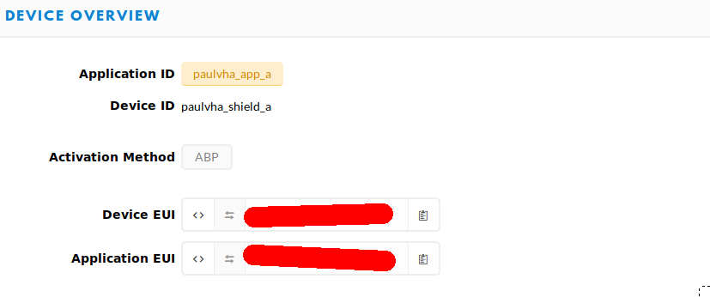
The device is created with following the steps after login :

Register New sensor
Sensor ID enter the Device EUI from TTN
Sensor Board select TTN
Basic Information enter what is valid
Additional Information enter what is valid
Hardware configuration select SPS30 PIN 1, select BME280 pin 11
enter the correct location
select : save settings

6. Local File content

The file that is being created is in the format of comma separated file (CSV). So it can be easily loaded a database or spreadsheet.

Each file will have a header and each line will contain a sample of the data. A content example below (time between samples ~30 seconds) :

yyyy:MM:dd:hh:mm,P0,P2,P1,Temp,Hum,Pressure
2019:11:23:02:08,10.15,10.56,10.56,22.0,37.95,1000.0
2019:11:23:02:09,10.18,10.59,10.59,22.0,37.74,1000.0
2019:11:23:02:10,11.48,11.94,11.94,21.98,37.82,1000.0
2019:11:23:02:10,12.15,12.65,12.67,21.97,37.88,1000.0

Format :

Time stamp
P0 (SPS30 PM1)
P2 (SPS30 PM2.5)
P1 (SPS30 PM10)
Temp (BME280 temperature)
Hum (BME280 Humidity)
Pressure (BME280 Pressure)

NOTE : If No BME280 was detected by the sketch the BME280 values will always be zero.

NOTE : each entry is 54 characters. If the sample interval is 3 minutes: 20 * 53 = 1060 characters are added each hour or 24 x 1060 = 25440 characters are added each day. After one year (365 days) 9MB.

7. Raspberry Pi setup

7.1 New MicroSD
If you already have an Micro-SD with Raspbian, skip this section
Follow the steps from : https://www.raspberrypi.org/documentation/installation/installing-images/README.md
Download from : https://www.raspberrypi.org/downloads/raspbian/ Raspbian Buster with desktop and recommended software.
Unzip… this might take some time..
Start the belena-etcher and flash the SD card
Insert the SD card in the Raspberrry PI and follow the installation instructions
Perform the update apt-get update, apt-get upgrade

7.2 check for Java
Check with :
ls /usr/lib/jvm OR javac -version
Should be at least Java 1.8 ( on a new image from September 2019 it was already Java 1.11)
more steps to install on : https://www.raspberrypi.org/blog/oracle-java-on-raspberry-pi/

7.3 Optional : update Java certificates
In case you get an error message :PKIX path building failed: SunCertPathBuilderException: unable to find valid certification path to requested target

This is described on http://magicmonster.com/kb/prg/java/ssl/pkix_path_building_failed.html

Go to your Java version in /usr/lib e.g.

cd /usr/lib/jvm/jdk-8-oracle-arm32-vfp-hflt/jre/lib/security

Copy the file luftdaten.der from the LoraLuftdatenForwarder ( assuming you have follow the steps in 1.2.2 ) :

cp ~/testluft/LoraLuftdatenForwarder/luftdaten.der .

keytool -import -alias luftdaten -keystore cacerts -file luftdaten.der

8. Microsoft Windows
If not available (test with type java in a cmd-prompt) you have to install the JDK from internet.
When trying to compile with:
cd LoraLuftdatenForwarder
cd gradle
gradlew assemble

8.1 tools.jar
After installing gradle, It first failed with the message : could not find tools.jar. On internet there are articles describing this issue with gradle. In my situation it turned out that on my system had 2 version of Java 11, both located in “c:\program files\java”. The latest version was used and it did not contain ‘tools.jar’ in the lib-directory, where the older version did. So I copied the tools.jar to the latest version and it worked. You can try to set Java environment variables, but that did not work for me and I did not want to spend a lot of time on this

8.2 Storage.dir
While I use the dutch language on windows, to set your storage.dir for the datafile location, I had to use the English path-name :

storage.dir=c:\\Users\\paul\\documents\\

instead path in Dutch
storage.dir=c:\\Gebruikers\\paul\\documenten\\

Also watch the double ‘\\’ to get to a single slash

Also none of the environment variables worked ( e.g. %TEMP%).

If you want to store in the local directory where the LoraLuftdatenForwarder is located, you can NOT leave this entry empty. In that case use a single character that will proceed your filename. (what’s in a name anyway…..)

9. Startup information

2019-11-26 14:07:02,172 INFO LuftdatenUploader:50 - Creating new REST client for 'https://api.luftdaten.info' with timeout PT10S
2019-11-26 14:07:02,686 INFO LoraLuftdatenForwarder:72 - Data files will be saved to /tmp/
2019-11-26 14:07:02,687 INFO LoraLuftdatenForwarder:78 - Dataflow debug information disabled
2019-11-26 14:07:02,690 INFO MqttListener:42 - Creating client for MQTT server tcp://eu.thethings.network
2019-11-26 14:07:02,782 INFO LoraLuftdatenForwarder:91 - Luftdaten forwarder version SPS30_November_2019-1.0.1
2019-11-26 14:07:02,782 INFO LoraLuftdatenForwarder:92 - Created new Luftdaten forwarder for encoding RUDZL
2019-11-26 14:07:02,783 INFO LoraLuftdatenForwarder:239 - Starting LoraLuftdatenForwarder application
2019-11-26 14:07:02,783 INFO LuftdatenUploader:92 - Starting Luftdaten.info uploader
2019-11-26 14:07:02,783 INFO MqttListener:56 - Starting MQTT listener
2019-11-26 14:07:02,783 INFO MqttListener:59 - Connecting to MQTT server as user paulvha_app_a
2019-11-26 14:07:03,219 INFO MqttListener:70 - Subscribing to topic '+/devices/+/up'
2019-11-26 14:07:03,249 INFO LoraLuftdatenForwarder:245 - Started LoraLuftdatenForwarder application

and after some time you should see :

2019-11-26 14:07:08,580 INFO MqttListener:84 - Message arrived on topic 'paulvha_app_a/devices/paulvha_shield_a/up'

