SPS30 & BME280 on Adafruit Feather 32U4 Lora

Table of Contents
1. Background 2
2. Project experience 3
2.1 Hardware 3
2.2 Software 3
3. Hardware connections 5
3.1 General connection remarks 5
3.1.1 Pull-up resistors 5
3.1.2 BME280 5
3.1.3 Connection advice 5
3.1.4 Correct Lora-Radio setup 5
3.2 SPS30 on 5V, BME280 5V, Feather pins get 5V 6
3.3 SPS30 on 5V, BME280 3V3, Feather pins get 3V3 7
4. The sketch 9
#define USE_LORA_SPECIAL 1 9
#define SP30_COMMS I2C_COMMS 9
#define SPS30_DEBUG 0 9
#define SKETCH_DEBUG 0 9
Lora Configuration settings 9
BME280 address 10
Interval timing 10
TTN Data format 10
5. A word about experience with Feather 32U4 11
5.1 Upload not starting 11
5.2 Upload failing 11
5.3 LMIC not working 11
6. Serial1 analyses 12
6.1 The baudrate 12
6.2 Reaction time 14
6.3 I suspect here goes wrong 14

1. Background
Got a question from Erwin Hartogsveld whether it would be possible to connect an SPS30 and BME280 to a Feather 32U4 Lora. The goal was to use that combination in the field (instead of SDS011) given the expected longer life-time of an SPS30. The results were to be send with LORA to https://www.thethingsnetwork.org/.

November 2019 : an loraforwarder has been added in sub-directory to read the results from TTN, forward to Luftdaten as well as the option to store this data locally.

Gotten feedback earlier from others who tested the successfully the SPS30 library on a 32U4, I expected it would be possible. In the end I did get it to work, but it was more challenging than expected.

In short the findings, documented in details in the following chapters:

- Forget Feather 32U4 Serial1 connection for the SPS30
- The LMIC library had a coding problem
- Fitting all the code in the 32KB In-System Self-Programmable Flash was a challenge
- Depending whether you have a BME280 that can handle 3V3 to 5V or only 3V3 makes the hardware configuration different.
- Lora Radio needs extra wire in order to work.

Paul van Haastrecht
paulvha@hotmail.com
December 2019

2. Project experience

2.1 Hardware
The SPS30 must have 5V to run stable which is provided through the VUSB pin.
As the BME280 is expected to run on 3V3 on I2C AND the Feather has a serial1 available, I decided to use UART connection for the SPS30.

Unfortunately I did not own a Feather 32U4 Lora in the beginning. As testing failed (see 2.2 software) I obtained a Feather Lora later in the project. Connected the RX to TX Feather, TX to RX Feather and GND. The Select line was not connected, so UART communication is selected.

Once detected that the Serial1 can not be used (see 2.2 software), I connected the SDA to SDA, SCL to SCL and Select & GND to GND on Feather. With I2C it is mandatory to have 10K pull-up resistors on both SDA and SCL in order for the SPS30 to work stable. For final connection options, depending on the situation see chapter 3. Hardware connection

2.2 Software

I started with the standard SPS30 library (version 1.3.7), the standard BME280 Arduino library and the Lmic library from https://github.com/matthijskooijman/arduino-lmic

Based on a provided sketch with SDS011 and BME280, which in turn was based on ttn_abp, I made adjustments to include SPS30 instead of SDS011.

After installing and selecting the Feather 32U4 library, there was an error that the code could NOT be compiled due to an error in the LMIC library.

Errors like : undefined reference to `table_get_u2' or undefined reference to `table_get_ostime'
Turned out that code in oslmic.h was in error. Around line 231 it states:
inline type table_get ## postfix(const type *table, size_t index) { \
where is SHOULD read (add static to beginning of line)
static inline type table_get ## postfix(const type *table, size_t index) { \
After fixing that and compile, the code was too large for 32KB (105%). I decided to make a special library that includes cut-down versions of the SPS30 and BME280 libraries.: lora_bme_sps.
Removing calls, changing functions and code that I deemed unnecessary for this implementation and provide less information back instead of all SPS30 data.

As that still it did not fit, I decided to change and reduce the sketch code including removing the ‘F -option’ in Serial.print(), which you normally use as your SRAM space is to small. In this case however I had enough to store the messages. Also reduced the number of Serial.print(). Finally it fitted in 99% of memory.

As I did not have a Feather 32U4, I tested on MEGA2560 the logic, the calculations, the program flow etc. That helped to further optimized and fine tune the sketch. I got SPS30 and BME280 data, I added a LORA shield (https://wiki.dragino.com/index.php?title=Lora_Shield) to the MEGA2560 and it was sending information.

After sharing this with Erwin, he tested on Feather 32U4 Lora and he replied that the SPS30 would not reset (which is the first command sent in the sketch). After turning on the SPS_DEBUG he got :

Sending: 0x7E 0x00 0xD3 0x00 0x2C 0x7E
TimeOut during reading
could not reset.
Program on hold

He had done special checks on the connections and the SPS30 was working when connected with a PC. He also tried the standard library (only SPS30) and only example1….... same error.

WHAT THE HECK ??????

I got hold of a Feather 32U4 LORA, compiled the example1 of the SPS30 standard library and got the same error. !!

Deep diving in the Arduino code for the serial connection as well in the SPS30 library,I put debug statements. I removed reset and asked for device information . Instead of a responds like :7E 00 d0 7d 31 33 36 ..…on 32U4 Serial1 however :7e d0 7d 4c 26 53 .......

it seems we are loosing bytes and get wrong bytes on Serial1

I checked with an oscilloscope and see clearly that the SPS30 is providing a good response.

I have then made a special sketch and connected the MEGA2560 Serial1 to 32U4 Serial1. With trial and error approach I increased the baudrate in the sketch on both sides. Connected on 9600, 19200, 38400, 57600 ..... NO PROBLEM. The string of data from the MEGA2560 to the 32U4 is received and displayed correctly. With 115200….. BIG problems only garbage.
On 100k baudrate : perfect !

Based on that I concluded there could be 2 reasons :

- The baudrate is not translated in a good enough sample rate.
- The processor could not read the received data from the USART in the 32U4 on time

See chapter 6 for a detailed analyses of this Serial1 situation, but after a lot of testing I decided that I2C is the right way to go as there is NO command to reduce the SPS30 baudrate.

After connecting the SPS30 to I2C (see 2.1 hardware) and setting the SPS30_COMMS to I2C in example1_bmesps, it worked immediately. A nice aspect is that the code now takes 91% of the memory OR 95% if you put SKETCH_DEBUG on. So some extra space to add code.

That said, one can now also use the standard libraries. In that case the 95% of program memory is used (or 99% with SKETCH_DEBUG). The special library can be used with defining USE_LORA_SPECIAL (see chapter 4)

3. Hardware connections
I have worked out 2 scenarios for connection, depending on your situation
- SPS30 work on 5V, BME280 works on 5V, the Feather pins get 5V.
- SPS30 work on 5V, BME280 works on 3V3, the Feather pins get 3V3.

3.1 General connection remarks

3.1.1 Pull-up resistors
In the I2C protocol a device will pull SCL or SDA to GND for a ZERO or sets to it’s SCL or SDA pin to tri-state for a ONE. Tri-state can be seen as the line is disconnected for writing, it is floating. If no device on an I2C line is pulling to GND, the pull-up resistors should raise the level to +3V3 or +5V (depending on the setup) for the line to be read as high.
SPS30 does not have good enough pull-up resistors. The resistors are around 50K, part of the onboard processor. Actually many I2C devices do not have pull-up resistor, in order enable more devices sharing the same line. If all of them would have pull-up resistors, the parallel resistor value could become to low causing damage to a device when pulling SCL or SDA to ground. Thus it requires 2 x 10K 1/4W pull-up resistors.
The SPS30 has to be powered always with 5V. The SDA and SCL lines, as they are pulled to GND, can either be pulled-up to 3V3 or 5V. So you do NOT need a level converter as the SPS30 works well with either pull-up level.

3.1.2 BME280
The Arduino BME280 board can be powered between 3.3V and 5V. The BME280 sensor itself works on 1.8V – 3.3V.The provided VCC to the board will be turned into 3V3 by the on-board MIC2552 for the BME280. The SDA and SCL lines have onboard level converters, in order to handle 5V pull-up. They will bridge the external level (same as VCC) for SDA & SCL to 3V3 level for BME280 and visa versa.

3.1.3 Connection advice
If your BME280 is accepting 5V only and you want the Feather to get 5V use setup 3.2, If your BME280 can handle 3V3 to 5V or only 3V3 use setup 3.3.
As some boards, like an Arduino BME280, have the pull-up resistors already on the board it might not be necessary to add those 2 again. If you do NOT know for sure: implement them ! I have include pictures of scoped signals which shows that adding does not harm (and even helps sometimes)

3.1.4 Correct Lora-Radio setup
See section 5.3 about the correct setup for LORA connection and an extra wire.

3.2 SPS30 on 5V, BME280 5V, Feather pins get 5V
I have only seen limitation about the current for the 32U4 pins and have successfully applied this setup for (longer term) testing.
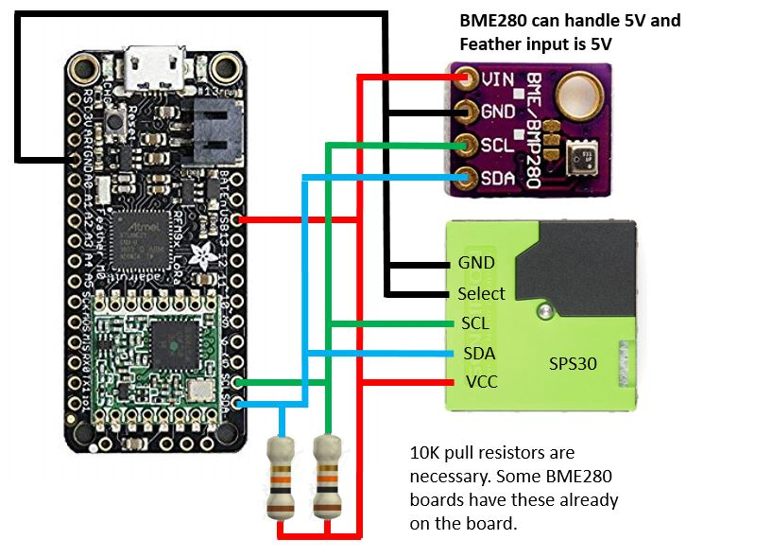
My BME280 board has on-board resistors. I have done testing WITH and WITHOUT the pull-up resistors.
WITHOUT external resistor
The raising and falling edge are steep and clearly the pull-up in the BME280 is strong enough and working.
WITH external resistor
The SCL (red in image) is a little more squared at the top, so not really necessary to add, but it does not harm either.

3.3 SPS30 on 5V, BME280 3V3, Feather pins get 3V3
The only difference to 3.2 is that the BME280 board and the pull-up resistor are connected to 3V3.
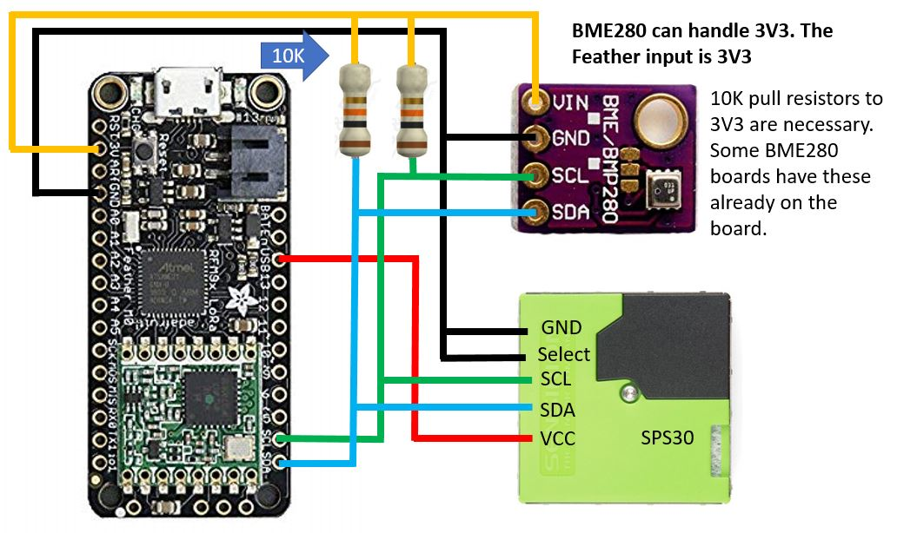
Also the test has been done WITH and WITHOUT the external pull-up resistor

With external resistor
The edge in the top of the SCL line are a little more rounded, but no worries.
Without external resistor
You can see the edges at the top of the SDA and SCL line are not sharp anymore, while this setup would still works. However adding external resistors does make the signal better.

4. The sketch
Time to talk about the sketch. It expect the following libraries :
- LMIC : https://github.com/matthijskooijman/arduino-lmic
- Using standard libraries :
- BME : Adafruit_BME280 and Adafruit_Sensor
- SPS30 : sps (https://github.com/paulvha/sps30)
- else :
- BME280 & sps30: lora_bme_sps

One can set the following parameters

#define USE_LORA_SPECIAL 1
Due to memory constraints a special cut-down version of the BME280 and SPS30 library was created call lora_bme_sps. With this library the program memory is used for 91% (or 95% with SKETCH_DEBUG).

However with I2C you can also use the standard libraries resulting in 95% program memory usage (99% with SKETCH_DEBUG.)

Advice is to use the standard libraries as updates/bug fixes may come in the future that are important for this implementation. The special lora_bme_sps library is not planned to be maintained on a regular base. BUT if you need to add more code and use SKETCH_DEBUG you might want to use lora_bme_sps.

By default the comments are included (//) before the define statement. By removing them you switch from the standard libraries to the special lora one (which you must have installed of course)

#define SP30_COMMS I2C_COMMS
I2C communication is the only interface allowed with the feather. I have left this in place just in case I need to make updates because of bugs that will be corrected in the 1.3.6. base of the driver. The UART code is excluded in the compiled version anyway because it detects 32U4-device.

#define SPS30_DEBUG 0
This will define whether or not to display SPS30 library debug information. Normally set to 0.

#define SKETCH_DEBUG 0
This will define whether or not to display measured debug information. Normally set to 0. The retrieved information and the packet as send to TTN will be shown.

Lora Configuration settings

LoRaWAN NwkSKey, network session key from TTN (use the same format as this example)
static const PROGMEM u1_t NWKSKEY[16] = { 0xAA, 0xAA, 0xAA, 0xAA, 0xAA, 0xAA, 0xAA, 0xAA, 0xAA, 0xAA, 0xAA, 0xAA, 0xAA, 0xAA, 0xAA, 0xAA };

LoRaWAN AppSKey, application session key From TTN (use the same format as this example)
static const u1_t PROGMEM APPSKEY[16] = { 0xAA, 0xAA, 0xAA, 0xAA, 0xAA, 0xAA, 0xAA, 0xAA, 0xAA, 0xAA, 0xAA, 0xAA, 0xAA, 0xAA, 0xAA, 0xAA };

LoRaWAN end-device address (DevAddr) from TTN (use the same format as this example)
static const u4_t DEVADDR = 0x03FF0001;

Pin mapping (make sure to connect IO1 (next to TX) to pin 6 (physical pin 27 or 2 second pin from SCL pin). See chapter 5

const lmic_pinmap lmic_pins = {
.nss = 8,
.rxtx = LMIC_UNUSED_PIN,
.rst = 4,
.dio = {7, 6, LMIC_UNUSED_PIN},
};

BME280 address
#define I2C_ADDRESS 0x76

Interval timing
Schedule TX every this many seconds (might become longer due to duty cycle limitations).
#define TX_INTERVAL170
#define MEAS_BME TX_INTERVAL - 5 // Measure Temp/RH/Pressure 5 sec before sending

TTN Data format
The data is sent as 14 bytes, 7 x uint6_t :

Byte[8] is MSB of the average PM10 value (e.g. 17.24 is sent as 1724, thus 17)
Byte[9] is LSB of the average PM10 value (e.g. 17.24 is sent as 1724, thus 24)
Byte[10] is MSB of the average PM2.5 value (e.g. 12.48 is sent as 1248, thus 12)
Byte[11] is LSB of the average PM2.5 value (e.g. 12.48 is sent as 1248, thus 48)
Byte[12] is MSB of the average PM1 value (e.g. 9.24 is sent as 924, thus 9)
Byte[13] is LSB of the average PM1 value (e.g. 9.24 is sent as 924, thus 24)
Byte[0] is MSB of the last 4 digits of the connected SPS30 serial number
Byte[1] is LSB of the last 4 digits of the connected SPS30 serial number
Byte[2] is MSB of the temperature (e.g. 24.43 is sent as 2443, thus 24)
Byte[3] is LSB of the temperature (e.g. 24.43 is sent as 2443, thus 43)
Byte[4] is MSB of the humidity (e.g. 44.50 is sent as 4450, thus 44)
Byte[5] is LSB of the humidity (e.g. 44.50 is sent as 4450, thus 50)
Byte[6] is MSB of the pressure (e.g. 1006.73 is sent as 1006, thus 10)
Byte[7] is LSB of the pressure (e.g. 1006.73 is sent as 1006, thus 06)

In TTN console these number will be shown in HEX values

5. A word about experience with Feather 32U4

5.1 Upload not starting
It first would not start to upload any code. With help of Internet I found out that you sometimes have to push the reset button twice to get it into bootloader. Then it detected the communication-port and started uploading.

5.2 Upload failing
After the upload started it did not work well and failed most of the time. Turned out that on Linux / Ubuntu you have to remove the modem manager.
Source : https://learn.adafruit.com/adafruit-arduino-ide-setup/linux-setup
sudo apt purge modemmanager

That solved most of the issue, but there is another one. When a program on the 32U4 is providing Serial.print(), the upload might fail as the responds it gets is the print-messages from the program. To solve that put after Serial.begin(115200); :while (! Serial);But still sometimes pushing reset twice is needed.

Sometimes however the led next to the USB is constant glowing, e.g. after reset. In that case you need to push reset one more time if not detected by the loader already.

5.3 LMIC not working
For getting going on LMIC library was an extra wire needed

const lmic_pinmap lmic_pins = {
.nss = 8,
.rxtx = LMIC_UNUSED_PIN,
.rst = 4,
.dio = {7, 6, LMIC_UNUSED_PIN},
};

The connections for the chip select (8), the reset (4) and IO0 / DIO[0] (7) are already done on the board, However you need to make an extra wire between IO1 (next to TX) and pin 6 (2 pins from SCL) to get LMIC library working. I expect this is done because the RFM95 can also work in FSK mode and then you need to set DIO[2].

Note: On a Feather LORA M0 the last line should read:.dio = {3, 6, LMIC_UNUSED_PIN}

6. Serial1 analyses
I concluded there could be 2 reasons for failing Serial1 on 115K:

1. The baudrate is not translated in a good enough sample rate.
2. The processor could not read the received data from the USART in the 32U4 on time

6.1 The baudrate
The way it works is that in the Serial1.begin (in HardwareSerial.cpp), the divider for the USART clock is calculated in double speed as:

uint16_t baud_setting = (F_CPU / 4 / baud - 1) / 2;

This is the same for all Arduino AVR and also documented in the ATmega16U4/32U4 [DATASHEET], page 190 . The CPU frequency on an 32U4 is 8Mhz, the CPU frequency for the MEGA2560 is 16Mhz.

The table 1 below shows the result of the calculation for the different baud rates. It also shows the percentage of error in the sample rate.

Table 1 : baudrate overview

How to read this : look at 115200 baudrate, the calculation result is a divider of 8. It is rounded down, and as such not 8.18 as that can NOT be loaded in the divider register for the the USART. The URRBH (8 bit)and URRBL (8 bit) are loaded in this case URRBH = 0, URRBL = 8.
This results in a real baudrate of 111K thus the incoming bits are sampled with an error rate of -3.55%.

With 115200 each bit takes 8.68uS (1000000/115200). Sampling the bit value(zero or one) is done at ½ the bit time (in the middle) so at 4.34uS.
With a real baudrate of111111 the sample happens every 9uS (1000000/111111) and as such 0.32uS (9 – 8.68uS) later out of the middle.

The timing synchronization is happening with each start-bit, so in worst case (start + 8 bits+ 1 stop ) after 10 bits that is 3.2uS off. This assumes a perfect condition of the 8Mhz clock, but well within the limits of the bit time.

ACTUALLY the implemented calculation is different from the datasheet (page 190)
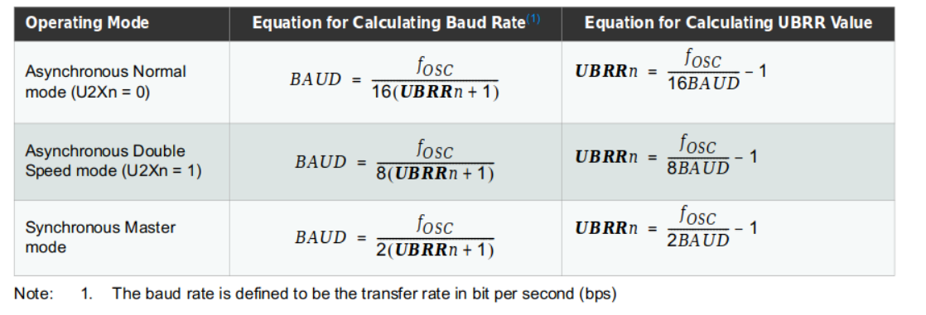
For Double Speed mode this not the same as : uint16_t baud_setting = (F_CPU / 4 / baud - 1) / 2;

BUT should apparently be uint16_t baud_setting = ((F_CPU / 4 / baud ) / 2)- 1 ;

If that would have been implemented the error rate for 115200 on 8Mhz would have become 8.5%
This would have translated in 0.68uS earlier sampling and after 10 bit that is 6.8uS.This is more than ½ bit time of 4.34uS and that would have caused more problems. (I assume a datasheet error)

The impact of using Double mode bit : (source : ATmega16U4/32U4 [DATASHEET], page 191) Setting this bit will reduce the divisor of the baud rate divider from 16 to 8, effectively doubling the transfer rate for asynchronous communication. Note however that the Receiver will in this case only use half the number of samples (reduced from 16 to 8) for data sampling and clock recovery, and therefore a more accurate baud rate setting and system clock are required when this mode is used.
So I have tried to use the Normal mode and changed the divider. However the result got worse results and the calculated error rate increased on the 32U4 to 8.51%

6.2 Reaction time

Maybe the processor could not read the received data from the USART in the 32U4 on time.

source : ATmega16U4/32U4 [DATASHEET], page 197

The Receiver starts data reception when it detects a valid start bit. Each bit that follows the start bit will be sampled at the baud rate or XCKn clock, and shifted into the Receive Shift Register until the first stop bit of a frame is received. A second stop bit will be ignored by the Receiver. When the first stop bit is received, i.e., a complete serial frame is present in the Receive Shift Register, the contents of the Shift Register will be moved into the receive buffer. The receive buffer can then be read by reading the UDRn I/O location

source : ATmega16U4/32U4 [DATASHEET], page 198

When the Receive Complete Interrupt Enable (RXCIEn) in UCSRnB is set, the USART Receive Complete interrupt will be executed as long as the RXCn Flag is set (provided that global interrupts are enabled). When interrupt-driven data reception is used, the receive complete routine must read the received data from UDRn in order to clear the RXCn Flag, otherwise a new interrupt will occur once the interrupt routine terminates

So once a USART has received complete byte, it will raise an interrupt to the main processor. Depending on the priority this interrupt gets,or temporarily disabled, the processor will now stop other activities, store it’s register contents and calls the _rx_complete_irq() (defined in HardwareSerial_private.h) This routine will read the UDRn-register, check for NO Parity error and store in a buffer in memory so it can be read later with a Serial.read().

This interrupt routine needs to be as short and as fast as possible, in order to keep a low impact on the main processor and therefor on other interrupts from other devices and it’s perceived user performance. As well as NOT to get another interrupt (because of a new byte that has arrived) while handling the current one.

For testing I have reduced the interrupt routine to the bare minimum, remove error and buffer overrun checks etc. Still the same result, same string in error that the SPS30 library gets.

6.3 I suspect here goes wrong
The 32U4 is 8Mhz and performs many tasks and interrupts. Given processor speed and internal structure it may be never be on time above 105K Serial baudrate to react on the raised interrupt that a new byte is ready. As a result bytes get lost or read while the content in the UDRn is in flux and thus invalid information. It might also take longer time on some moments before it can react depending on what it is doing when the interrupt is raised. Maybe serving an higher priority interrupt or interrupts temporarily disabled. However given the very light test program, I believe the internal structure is the main reason.

BTW sending is NOT a problem because the processor might take time to react on a tx_complete interrupt. It will then write the byte to send in the USART register and return. Not very time critical as the USART will take care of the sending and timing of start + byte + stop bits.

