URA Data extensions

The Univerisal Reader Assistant (URA) for the ThingMagic (a JADAK Brand. All Rights Reserved) readers has an option to share the data that is displayed on the screen over the network.

There are 2 options :

Stream to TCP port:
In this case the read tag-data is not only displayed, but immediately also sent to a TCP port.

HTTP post
In this case the data displayed will be sent with a regular interval as content to a URL.

Table of Contents
1.0 stream to TCP port 2
1.1 Settings 2
1.2 Data format 2
1.3 Additional selections 2
1.4 Receiving test 2
2.0 HTTP POST 3
2.1 Settings 3
2.2 Data Format 3
2.3 Additional selections 4
2.4 Receiving content in JAVA 4
Appendix A URA code 5

Regards,

Paul van Haastrecht
April 2018 / version 1.0

1.0 stream to TCP port

1.1 Settings
Select bottom left in the URA : data extensions

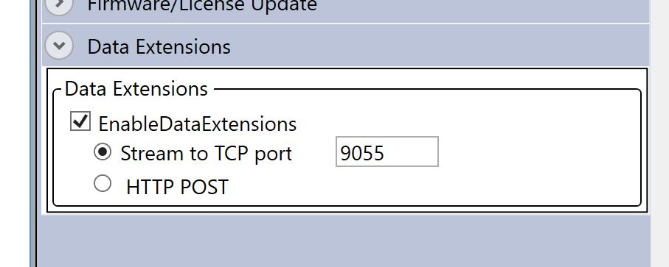
Stream to TCP port: set the port you want to stream to. (example 9055)

1.2 Data format
The default data format is:

EPC <\t> TimeStamp <\t> RSSI < \t> ReadCount <\n>

Example of received information :

E2000015860E026615507DBA 01:04:39.293 -53 1
E2000015860E026815507DBB 01:04:39.330 -42 1
E2000015860E028715408024 01:04:39.351 -39 1
E2000015860E026615507DBA 01:04:39.366 -54 1

Note : readcount will (nearly) always be 1 (as it is sent immediately)

1.3 Additional selections
In the URA => “Display Options” you can select options for displaying the information.

Any column that is added in option “Tag Result Column” is also appended, separated with a <TAB> , to the default data format. Additional columns that can be selected are Antenna, Frequency, Phase and Protocol.

Changing the “TimeStamp Format” will also change the TimeStamp format that is sent to the port.

Other selection in “Display Options” : “Big Num Selection” and “EPC Format” have NO impact on the content send to the port.

1.4 Receiving test
Use Telnet [Ip address] [ port] (example : telnet 192.168.1.148 9055)

2.0 HTTP POST

2.1 Settings
Select bottom left in the URA : data extensions

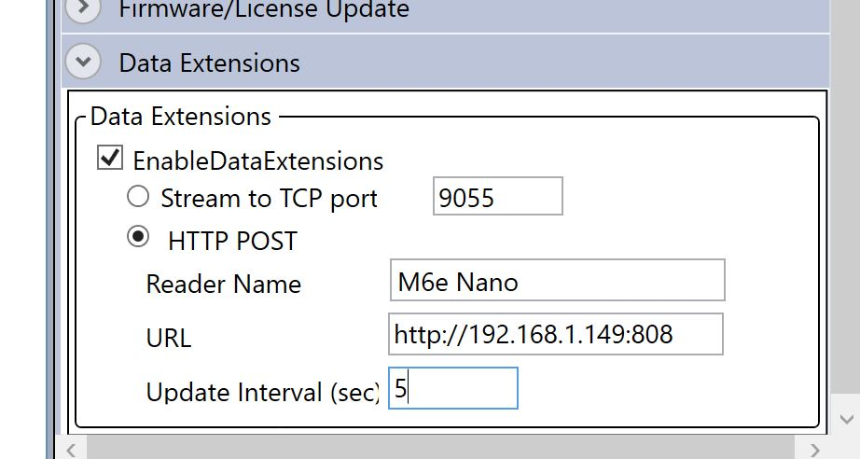

The setting has 3 options
- Reader Name:
This free text name will be included in the content that is sent (Example M6 e Nano)
- URL:
This is the URL to which the content will be sent. (example http://192.168.1.149:8080)
- Update Interval (sec):
How regular should the data that is displayed been sent in seconds. (default 1). This will only happen if the URA is reading. (Set at least 5 for stable performance)

Now press “Read”. The URA will perform a check that it can connect to the provided URL.

2.2 Data Format
By default the data format is presented as:

reader_Name=M6e Nano&mac_address=&line_ending=
&field_delim=,&field_names=EPC,TimeStamp,Peak RSSI,ReadCount&field_values=E2000015860E028815408029,24-4-2018 10:44:10,-50,342
E2000015860E026615507DBA,24-4-2018 10:57:20,-56,116
E2000015860E027715408013,24-4-2018 10:57:19,-47,77
E2000015860E026815507DBB,24-4-2018 10:57:18,-47,41
E2000015860E028715408024,24-4-2018 10:57:18,-50,23
E2000015860E028115507DE1,24-4-2018 10:57:18,-46,2

reader_Name : Reader name as provided in the settings
mac_address : MAC will always be empty (at least in the URA version 3.4.34.34)
line_ending : Separator between each tag : \n (0x0a) (FIXED)
field_delim : Separator between each field of a tag : , (comma) (FIXED)
field_names : Order of the fields in field_values: EPC, TimeStamp, Peak RSSI, Readcount
field_values : Data for each tag as displayed.

Note 1: The last field of a TAG-line in the field_values will be terminate with \r (0x0d) and then \n (0x0a) !!

Note 2: The content is based on what is displayed, ALSO the ‘grayed’ tags that were part of a previous read, but have not been (re-) detected yet during the current read, are included.

Note 3: readcount is the total readcount of the TAG since first detected.

2.3 Additional selections
In the URA => “Display Options” you can select options for displaying the information.

Any column that is added in option “Tag Result Column” is also appended in the content to the default data format. Additional columns that can be selected are Antenna, Frequency, Phase and Protocol.

Other selection in “Display Options” : “TimeStamp Format”, “Big Num Selection” and “EPC Format” have NO impact on the content in the HTTP post.

2.4 Receiving content in JAVA
A separate JAVA program is provided: ura.js. This Nodejs example program can receive, display and parse the data as sent by the HTTP POST. This program is open source, free of charge and without warranty. Please see the heading the source code.

Appendix A URA code

Source code of the MercuryAPI

The code where data extensions are handled is
…….\…\… mercuryapi-1.29.4.34\cs\Samples\UniversalReaderAssistant2.0\UniversalReaderAssistant.20\UI\main.xaml.cs

around line 11633 :

/// <summary>
/// Posts data to web server based on Update Interval value.
/// </summary>
/// <param name="sender"></param>
/// <param name="args"></param>
private void sendtags_Tick(Object sender, EventArgs args)
{
sendTagsToWeb(tagdb);
}

/// <summary>
/// Posts data to web server based on Update Interval value.
/// </summary>
public void sendTagsToWeb(TagDatabase tagdb)
{
DateTime now = DateTime.Now;
string tagData = string.Empty;
Dispatcher.Invoke(new ThreadStart(delegate()
{
lock (tagdb)
{
tagData = tagData + "reader_Name=" + HttpPostServiceReaderName + "&mac_address=" + GetMACAddress() + "&line_ending=\n" + "&field_delim=,"
+ "&field_names=" + GetFieldNames() + "&field_values=";
for (int i = 0; i < tagdb.UniqueTagCount; i++)
{
tagData = tagData + GetFieldValues(tagdb.TagList[i]);
}
}
}));
try
{
HttpWebRequest request = (HttpWebRequest)WebRequest.Create(HttpPostServiceUrl);
request.Method = "POST";
request.ProtocolVersion = HttpVersion.Version11;
byte[] byteArray = Encoding.UTF8.GetBytes(tagData);
request.ContentType = "application/x-www-form-urlencoded";
request.ContentLength = byteArray.Length;
request.Proxy = null;
//By making Expect100Continue as false client will not expect 100-continue response from server.
//By doing so we can send large amounts of data over the network.
System.Net.ServicePointManager.Expect100Continue = false;
using (Stream dataStream = request.GetRequestStream())
{
dataStream.Write(byteArray, 0, byteArray.Length);
dataStream.Flush();
dataStream.Close();
}
var response = request.GetResponse() as HttpWebResponse;
response.Close();
request.Abort();
request = null;
DateTime end = DateTime.Now;
if (Convert.ToDouble(end.Subtract(now).TotalMilliseconds) < HttpPostInterval)
HttpPostDispatchTimer.Interval = HttpPostInterval - Convert.ToDouble(end.Subtract(now).TotalMilliseconds);
else
HttpPostDispatchTimer.Interval = 1;
HttpPostDispatchTimer.Enabled = true;
}
catch (Exception ex)
{
HttpPostDispatchTimer.Enabled = false;
HttpPostDispatchTimer.Close();
MessageBox.Show("HttpPost:" + ex.Message, "Universal Reader Assistant Message", MessageBoxButton.OK, MessageBoxImage.Error);
broadcastOFF();
}
}

