Differences Sparkfun M6E and M7E

Beginning 2024 Thingmagic/Jadak has retired the M6E to be replaced by the compatible M7E-HECTO. Sparkfun has decided to make a number of changes to the board and software.

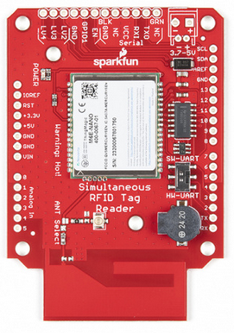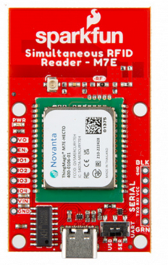

M6E NANO M7E-HECTO

There are a number of notable differences between the Sparkfun M6E and M7E RFID implementation to call out.

Paulvha

June 2024

# Hardware differences

The M6E board could be connected directly on-top-off an UNO-R3 compatible board to be used.

That is not the case anymore with the M7E board. It is NOT pin compatible anymore. You MUST use the M7E standalone and connect with loose wires.

The M6E board has the ability to add an external battery connector. This power input was passed through a diode to the VCC power source. The VCC from the FTDI connection could be detached with a (solder) jumper JP1.

The M7E board is powered from the USB connection. You can connect and external power to the VIN-connection or the VCC FTDI connection on the side and then select with a (solder) jumper, between the VCC (external power) or VUSB (USB powered).

On the M6E Nano the generated 3v3 was only available on the board itself.

On the M7E-HECTO the generated 3v3 is also made available to an pin (VO / Voltage Out) on the side. The reader is sensitive to a very good and stable power. The M7E 3v3 can handle max 1A and will shutdown when it is becomes to hot. Great care should be taken to use this 3v3.

My advice : rather NOT use it.

The power LED indicator on an M6E had a 1K serial resistor, the M7E has 4k7 and thus takes less current away from the 3v3.

On the M6E for RX/TX you could select pin 0/1 (set as HW-UART) or pin pin 2/3 (set as SW-UART) or use the FTDI connection RX/TX (not dependent on the switch).

On the M7E you can select to communicate using the USB connection or the RX/TX on the FTDI on the side of the board by selecting either USB or SER with the switch.

The M6E board required an external FTDI to make a connection with USB.

The M7E board has an USB-C connector and onboard CH340. The USB-C has 5.1K resistors and as such the power profile will be 5V.

You can still connect you own FTDI to the serial connections on side of the board. Set the switch to SER. If you provide VCC / external power with the FTDI make sure to change the (solder) jumper.

The M6E has an on-board level shifter (TXB0104) to make RX and TX 5V compatible.

The M7E does not have a level shifter and looks 3v3 compatible. The M7E datasheet indicates that as well : UART; 3.3V logic levels 9.6 to 921.6 kbps. Care should be taken when connecting to a 5V board (e.g. UNO-R3)

The M6E had an easy (solder) jumper to select between the on-board antenna or connect to an external connection.

The M7E requires a zero ohm resistor to between removed / added. Of course a solder-blib is the same as a zero ohm SMD resistor, but it is more complicated. A number of users have already damaged their board when trying to make the change

The M6E has a buzzer (D9/D10) to provide a different tone whether an RFID has been detected closely.

The M7E does not have a buzzer.

# Software differences

The new examples have been updated to indicate an M6E of M7E.

#define moduleType ThingMagic_M6E_NANO

// #define moduleType ThingMagic_M7E_HECTO

This will NOT impact the M7E, but only the M6E to select the NA-frequency backward compatible. From source code:

*// There are multiple North American regions, including NA, NA2, and NA3. A*

*// previous version of this library was written only for the M6E Nano, which*

*// only supports NA2 and NA3, and the macro REGION_NORTHAMERICA was defined*

*// for NA2. This version now defines the macro as NA, so for backwards*

*// compatibility, we need to change the region to NA2 if it's the M6E*

All existing M6E sketches will work unmodified with the new library and do not need an update. By default the M6E is assumed by the library and selects the NA2 band. Only the case you use an M7E-HECTO and you want to use the NA band, setting the moduleType to ‘ThingMagic_M7E_HECTO’ has an impact.

The library provides the support to set GPIO1 – GPIO4 output levels on the M7E/M6E. These are 3V3 GPIO that could be used for antenna selection. Example9_GPIO.ino has been added to demonstrate the usage.

The Range_Test.ino example is available for the buzzer, but this works only on the M6E as the M7E does not have buzzer.

There is a correlation between the Mercury API level and the firmware level:

In order to use Mercury API 1.37.2 the M7E-HECTO needs firmware version 2.1.3 or higher . The M6E needs level 1.25 or higher to support all the features the API offers. If the firmware level is lower use a previous / lower version ( e.g. Mercury API 1.35)

ThingMagic Universal Reader Assistant (URA) v6.2 desktop application has been build with Mercury API 1.37. When the firmware level on the M7E or M6E is lower as indicated above, it will work, but not all selected features are available (e.g. the new EU4 band).