COMBO : CCS811 & BME280

Table of Contents
1. Background 1
2. Hardware 2
2.1 Environmental Combo CCS811 / BME280 2
2.2 Dylos DC1700 3
3. Software 4
3. 1 Installation 4
3.1.1 BCM2835 library 4
3.1.2 Combo software 4
3.2 Sensor drivers 5
3.3 Combo program 6
3.3.1 Initialize variables 6
3.3.2 parse parameters 6
3.3.3 Initialize hardware 7
3.3.4 main loop 7
3.3.5 closeout 7
3.3.6 Parameter allowed 7
3.3.7 Output formatting 10
4.0 Results & early conclusions 11
Appendix A. Schema 14
Appendix B : example of parameter file 15

1. Background

This project is part of a number of projects to measure the air quality, I run into the CCS-811 sensor. This is sensor is self calibrating and takes as adjustment the temperature and humidity. The Spark fun combo breakout has, next to the CCS-811 sensor also a BME280 sensor from Bosch, which can measure temperature, pressure and humidity. The board and sensors are well documented and there is software available for Arduino.

As I also own an DC1700 Dylos air quality monitor, I want to find the relationship between the 2 measured instruments. Ready for the start

Paul van Haastrecht
paulvha@hotmail.com

2. Hardware

2.1 Environmental Combo CCS811 / BME280
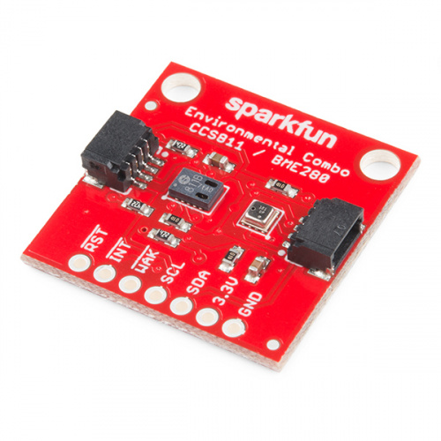
The CCS-811 measures TVOC (Total Volatile Organic Compounds) and CO2 levels in the air. Unfortunately there is NO common agreed definition around TVOC. The CCS811 can detect different gas types: Alcohols, Aldehyde, Ketone, Organic Acids, Amines, Aliphatic and Aromatic Hydrocarbons.

One could use the Sparkfun propriety Qwiic connections to quickly connect the board, but I have used the 7 pin connector.
Raspberry
GPIO / PIN
RST Input : Hardware Reset active LOW 12 / 32
INT Output : interrupt line active LOW 10 / 19 (optional *1)
WAK Input : Wake-up active LOW 11 / 23

SCL Serial Clock i2C 3 / 5
SDA Serial Data i2C 2 / 3

3.3V input: power 3V3 / 1
GND ground GND / 6

*1) Interrupt
The CCS-811 can be set to pull the INT output low, in case data is available. I have implemented both in the program: polling mode and using interrupt as a trigger. If you don’t want to use the interrupt, just do not specify an interrupt GPIO as parameter. Polling mode is by default set in the program.

In Appendix A the schema of the board is included. It is very straight forward with some pull-up / pull-down resistors and capacitors. Board is nice designed (as with other Sparkfun boards)

I left the hardware addresses to the standard ( CCS-81 : 0x5b , BME280 : 0x77). They could be changed by adding solder on the backside of the board to 0x5a / 0x76 if you want. Also I left the 2 resistors on the board to pull-up the i2C SCL and SDA lines. The CCS811 chip supports an optional temperature sensor circuit, but as the combo board has the BME280, this has not been implemented.

The CCS-811 needs a one-time burn-in time of 48 hours. Next to that at every start it needs at least 20 minutes condition time (time for the heater to warm up to the right temperature). As a result with every restart, it will take a time before it shows some reasonable results.

While the CCS-811 according to the data-sheet can work on 400Khz i2C, it proved to perform very unpredictable. More information about that in the section about the driver and how this has been addressed.

The CCS811 has an Automatic Baseline Correction to reduce noise and improve the quality of the CO2 and TVOC results. While the baseline is created and maintained by the CCS811, the quality correction can be speed-up by writing a known, last working, baseline value. The program will allow saving and loading from file and writing from the command line.

The BME280 has multiple ways to improve the results. So is there an (optional) IIR filter to level out sudden extremes (like a door smash that will impact temperature and pressure). Next to that it provides (optional) oversampling reading the data (multiple samples in a single read).

2.2 Dylos DC1700
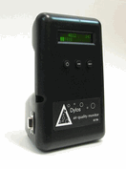

If you are as lucky as me and have a Dylos DC1700 or DC1100, it is connected through the USB port and comes in standard as /dev/ttyUSB0. For the program to work however this is an optional feature.

3. Software

3. 1 Installation

As with many of my projects I make use of the BCM23008 library to control the IO. The reason is that it is faster and more flexible than the wiringPi (which makes use of the official kernel drivers) and provides direct control and insight, which I like.

3.1.1 BCM2835 library
Install latest from BCM2835 from : http://www.airspayce.com/mikem/bcm2835/

1. wget http://www.airspayce.com/mikem/bcm2835/bcm2835-1.52.tar.gz
2. tar -zxf bcm2835-1.52.tar.gz // 1.52 was version number at the time of writing
3. cd bcm2835-1.52
4. ./configure
5. sudo make check
6. sudo make install

In order for this software to run you should NOT enable i2C in raspi-config to load the kernel drivers. It works directly on the hardware, but you’ll have to run program as root.

3.1.2 Combo software
Installation of Combo software :

1. cd /home/pi
2. tar -zxf combo-1.tar.gz
3. cd combo
4. create the executable : make
5. To run you have to be as root : sudo ./combo ….

In the software package you will find the following files

ccs811.cpp :
This is main driver for the CCS811. The driver is based on the original version from SparkFun written for the Arduino, but adjusted and extended to work on the Raspberry Pi. It also includes the drivers for the BCM2835.
bme280.cpp :
This is the main driver for the BME280. The driver is based on the original version from SparkFun written for the Arduino, but adjusted and extended to work on the Raspberry Pi. Some routines have been added, a number have been changed.
combo.cpp :
This is the user level program that will be discussed in detail in a next section.
dylos.c :
This is the driver for Dylos. It is a scaled down version of the Dylos Monitor that I have written before and adjusted for this project.
SparkFunCCS811.h :
This is the header file for the CCS811. It is based on the original version from SparkFun written for the Arduino, but adjusted and extended to work on the Raspberry Pi.
SparkFunBME280.h :
This is the header file for the BME280. It is based on the original version from SparkFun written for the Arduino, but adjusted and extended to work on the Raspberry Pi.
bcm2835.h :
This is the header file for connecting with the bcm2835.h
makefile :
script to compile the source and create an executable with the make command.

3.2 Sensor drivers

The CCS811 has a relative simple driver, split between a CORE-class and CSS811-class. In the CORE-class are all the low-level communication routines between the CCS811 and the Raspberry Pi. It is also here where I have made most changes and added the BCM2835 routines. In the CCS811-class are the routines to connect to the user program. Between the user program and the driver I have created a “settings” section to share the parameters. I have left as much as possible the same structure in place as with the original library, just in case some worked on that before. I did implement however that the WAK- signal is controlled by the program, as well as a RST / hardware-reset.
The i2C interface was a bit of challenge. When running the boot-loader program it responded well most of the time on 100Khz, but as soon as the application level was started, the response on a read-with-restart (which is supported according to the data-sheet) was always 0xff and sometimes NACK errors. Which is a surprise after many projects using the i2C connection, the CCS-811 seems to be a slow response chip. I had to reduce the speed to 20Khz to get it running… and even then I got NACK regular.

Especially for reading the CCS-811, I changed the driver to do a write of the address, wait some time, and perform a read. That “some time” turned out to be 2ms, which is nearly half a century if i2C speed is 400Khz (25us), but I could not get it better with less. On top of that I implemented a retry counter in case this would still fail, which kept happening 10% of the time with NACK. At least that created stability and with that I could run it at 400Khz for the BME280.

One could think that the i2C line was bad with the Raspberry PI, but the BME280, on the same i2C line & same board, was working like a star on 400KHZ. It could even run faster. Never had ANY issues with reading /writing the BME280. NONE !

The BME280 driver has one class. While there are less driver routines, the driver has a number of complex calculations to provide the temperature, humidity and pressure. These are IMPOSSIBLE to understand and nowhere explained. Also not in the original libraries from Bosch on the BMD280, SM500, BME085 etc. etc. They are documented in the data-sheet and that is what has been implemented. The temperature results look on the high-side (about 1 – 2 C off to the other 3 temperature meters I put around), the humidity looks lower ( 3% compared to the other 2 humidity readers I put around it), but the pressure looked good. There is a routine to read the altitude based on the pressure (either in meter or feet), but that was assuming the standard defined pressure at sea level. I have changed that so one can now provide that yourself (e.g. from different websites) and compare that the obtained local pressure. Next to that the Arduino library was mixing returning error messages and results. The check on error was not happening in many places. That has been changed.

The driver for the Dylos is a scaled down version of the Dylos monitor that I had created earlier. The Dylos provides an output of the reading every 1 minute. I have changed that so a child process reads constant the information from the USB port and provides the information to the combo program on request. The information will change max each minute.

3.3 Combo program

The program it self has a number of big blocks

- Initialize variables to default settings
- parse parameters
- Initialize hardware (BCM + sensors)
- Main-loop to provide output
- closeout()

3.3.1 Initialize variables
Default values for the different parameters are loaded and result variables reset. The defaults are hard coded, based on the different Arduino .ino files and only a few adjusted based on expected usage.

3.3.2 parse parameters
The program has a rich set of command line option (see 3.3.6 in detail later) to change many default settings. This can either be input on the command line, or loaded from files that have been created before with the stored values

3.3.3 Initialize hardware
The BCM2835 and CCS811 are always initialized with the different parameters. The BME280 can be deselected and the Dylos is optional. If interrupt GPIO has been provided, this program will adjusted to be triggered by a low on that GPIO.

3.3.4 main loop
The program will loop for reading, either a fixed number of times or endless (depending on the parameter). The output of can be defined with parameters by the user and will be displayed on the screen, but also be saved to a file if the user wants that.

3.3.5 closeout
Either close with Control-C or it will count down the number loops. After that the sensors CCS811 and BME280 will be put on hold and the BCM2835 reset to the standard values

3.3.6 Parameter allowed
Please make sure to check the data- sheet for CSS811 and/or BME280 for the exact impact of some of the parameters.

The following parameters can be set for the CCS811:

-a address :
The i2C address can be changed from the default 0x5b to 0x5a.

-r GPIO :
The RST GPIO can be adjusted from default GPIO12 to a GPIO between 6 and 26.

-w GPIO :
The WAK GPIO can be adjusted from default GPIO11 to a GPIO between 6 and 26.

-i GPIO :
The interrupt GPIO can be set a GPIO between 6 and 26. This will also change the program from polling for data available on the CCS811 to be interrupt driven.

-m level:
This will change the run mode from the default 2 (every 10 seconds) to a level between 1 and 4 (see data-sheet)

-b baseline:
Set a baseline as starting point. Baseline is an adjustment that is dynamically adjusted by the CCS811 to improve the results. With this option you can provide a (known) baseline from previous measurement to improve the results from the start.

-s file:
During the measurement cycle save the dynamically adjusted baseline to a file.

-g file:
Same as -b option , but now read the baseline starting point from a previous save (with -s) file

Parameters for the BME280:

-A address:
The i2C address can be changed from the default 0x77 to 0x76.

-F filter:
Adjust the filter coefficient setting from the default 4 (highest). With this option the IIR filter can be set to reduce the impact of sudden changes (e.g. slamming door) on temperature and pressure. The higher the value, the better smoothing out changes, but the more samples are needed to get to the real, current value. No impact on humidity.

-H oversampling:
Change the level of oversampling the humidity from level 5 (the highest x 16) to a lower level. The more oversampling the less noise on the results.

-M pressure:
Calculate the hight of the current location in meters compared to sea level. This is based on the provided current pressure of a place nearby at sea level (from an external website) and than compared against the local pressure.

-P oversampling:
Change the level of oversampling the pressure from level 5 (the highest x 16) to a lower level. The more oversampling the less noise on the results.

-T oversampling:
Change the level of oversampling the temperature from level 5 (the highest x 16) to a lower level. The more oversampling the less noise on the results.

Parameters for Dylos

-D device:
Enable Dylos input from device (e.g. /dev/ttyUSB0). The data will be updated with the speed of Dylos output (every minute)

Parameters for General

-B :
This will trigger to output results without color on the screen.

-C min:
This will change the default 20 minutes conditioning/wait time for the requested min.

-I speed:
This will change the default 25Khz i2C speed to a value between 1 (Khz) to 400 (Khz)

-L count:
This will change the default endless loop (0) to a number of loops for the mainloop before exiting

-U delay:
This will change the calculated delay to a forced delay in seconds. The default delay is depending on the CSS811 mode. If mode =1 → delay = 5, mode = 2 → delay = 15, mode = 3 → delay = 65 else 30 seconds. If an interrupt GPIO was provided (and connected) these are maximum values, as the interrupt will trigger new data available.

-N:
This will set to neglect/disable the BME280 readings

-O string:
This will allow flexible output formatting. See chapter 3.3.7.

-V level:
This will enable progress/debug information. The level can be set between 0 (default) and 3 (highest). The higher the more information.

-W file:
Append the displayed output to the file.

Parameters for special

-E file:
Save all the current parameters to a file (example of content in Appendix B)

-G file:
Re-load the parameters as saved with -E from a file earlier during program start-up. This will allow for easier switching between different operating modes instead of providing all the parameters on the command line every time. The file is readable and can be read and modified with an editor. (like nano)

3.3.7 Output formatting
By default the CO2 and TVOC values are only output

The user can (with the -O option) create their own output format :

CSS811 results:
c = C02
t = TVOC

BME280 results
T = temperature in C
H = humidity
P = pressure
M = height in meters (assumes that -M pressure was applied else 0)

Dylos results (assumes that Dylos and -D port was available else 0)
D = PM1 (small)
E = PM10

Markup
\l include local time
\t include tab
\s include space
\, include comma
\; include semicolon
\n include newline
\\\x include the character x (x can be any character, TRIPLE SLASH!!)

Example -O “\lctTP”, will result in :
Tue Dec 12 20:18:34 2017 CO2: 2000 TVOC: 300 Temp: 20.53 Pressure: 101247.53

Example -O “\lct\nT\,H”, will result in :
Tue Dec 12 20:18:34 2017 CO2: 2000 TVOC: 300
Temp: 20.53, Humidity: 34.93

4.0 Results & early conclusions
The first overview is the BME280 it self. Temperature ( x 100) and humidity (x 100) are nearly flat over the sample period of 3 hours. The pressure also flat, fluctuating from 991.0 to 990.5.

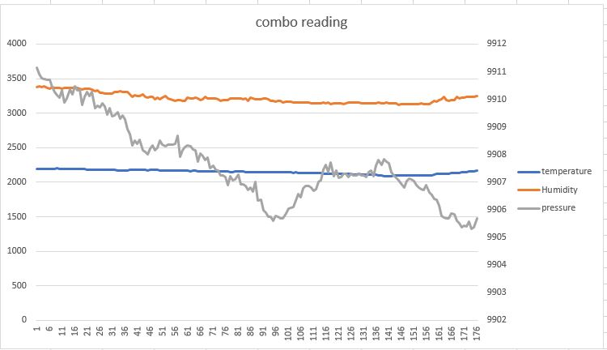
Comparing between Dylos and the CCS811 results:
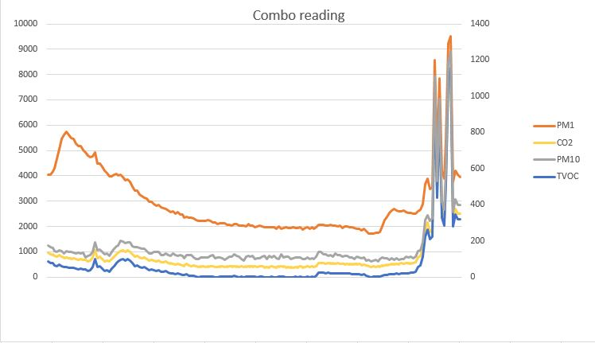
Looking at the PM1, with values on primary-ax, there is little correlation. After starting the test I left the room, closed the door and thus you see drop in PM1 particles. However near the end the air got more polluted due to some wine and nuts entering the room, which was detected by the sensors (and me :-)
Looking at CO2 (values on primary ax) and TVOC & PM10 (values on secondary ax). The TVOC / CO2 always have a correlation as the values are derived from the same sensor, but differently calculated. The TVOC has MUCH lower values, but these correlate well with the PM10
Putting the TVOC and PM10 next to each other:

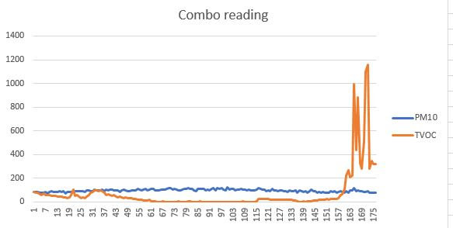
The average of the TVOC readings over this period is 69.6, while PM10 is 96.6.

Repeated the test on another moment. Below the results :
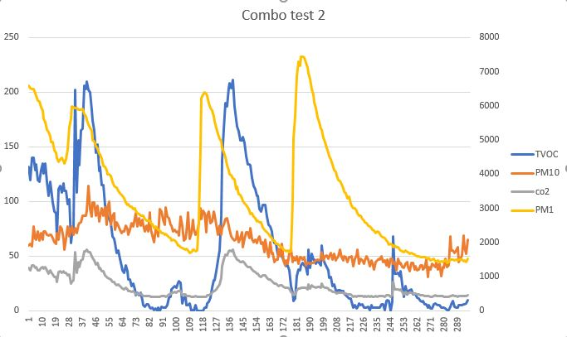
PM10 and TVOC values are against the primary ax (left), the CO2 and PM1 against the secondary ax (right). Again the same correlation in pattern between TVOC and CO2, with the CO2 being nearly a factor 15 higher. Again that is because they are related to same raw measurement, but calculated with different software algorithms.
We see a repeat that the values of PM10 and TVOC are close to each other. Taken the average of the results in this test (measurement per minute) TVOC is 53.5 , PM is 62.7.
However we also see a correlation between PM1 and TVOC (there for also CO2). We see same spikes in yellow and Blue, accept for the last yellow spike. This can happen as PM1 is a measuring a range of particle sizes and that range might be more than the CCS811 small particle measurement. It might also be depending on the kind of PM1 particles in the air and whether they are of a nature that CCS811 is able to detect those.
From both test we could draw the early conclusion that TVOC is a good indicator of PM10 pollution in the air as long as the air is not suddenly changing. It is not as good as a Dylos DC1700 (700 – 800 euro) , but this board with the sensor ~30 euro is not bad… not bad at all.
It will need more work however and testing to make this statistical significant and /or calculate the correlation in a better way. For those who are interested to do more work on this, the spreadsheet has been included with the details.

Appendix A. Schema

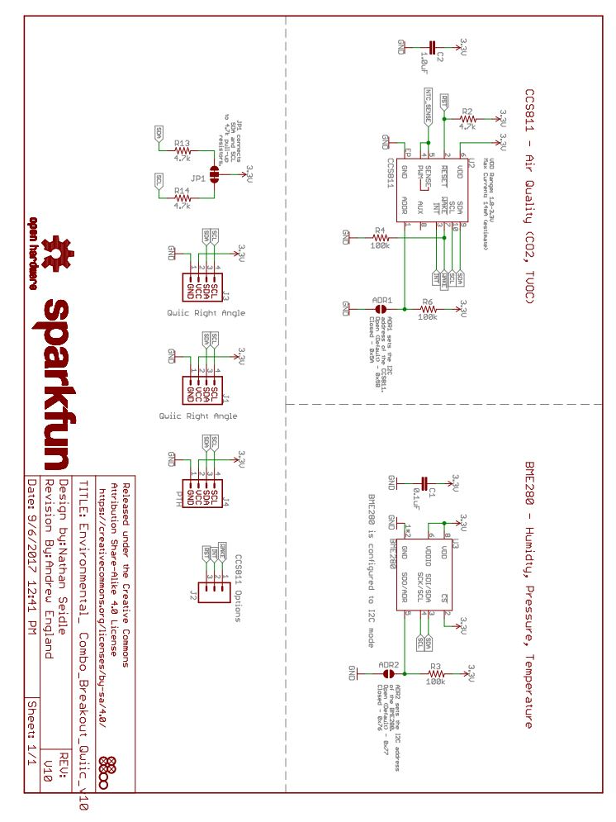
Source : https://www.sparkfun.com/products/14348

Appendix B : example of parameter file

# Parameter file. created Wed Dec 13 09:06:17 2017
VERSION:1
# CCS811 information
CCS811 i2C ADDRESS: -a 0x5b
RESET-GPIO: -r 12
WAKE-GPIO: -w 11
INTERRUPT-GPIO: -i 0
RUN-MODE: -m 2
BASELINE: -b 0

# BME280 information
BME280 i2C ADDRESS: -A 0x77
FILTER: -F 4
TEMPERATURE OVERSAMPLE: -T 5
PRESSURE OVERSAMPLE: -P 5
HUMIDITY OVERSAMPLE: -H 5
RUN MODE: -R 3
STANDBY: -S 4
SEALEVEL PRESSURE: -M 00000
DYLOS PORT: -D "/dev/ttyUSB0"

# DYLOS DC1700 information

# general information
BCM_BAUDRATE: -I 400
CONDITION_PERIOD: -C 0
LOOP COUNT: -L 0
FORCE LOOP DELAY: -U 60
BASELINE SAVEFILE: -s
VALUE SAVEFILE: -W
OUTPUT FORMAT STRING: -O \lctTPHDE
VERBOSE: -V 2

The format is :

Anything after a hash (#) on the line is treated as comments and skipped

Empty lines are skipped

The second line must be VERSION:[num]. [num] is the version number of the program when the file was created. This will help to detect in the future whether the file content can still be applied.

Other lines: start with general information ( e.g. LOOP COUNT), followed by colon (:) and then the option and option-argument. Only the option and option-argument are used for parameter setting.

