Apollo3 I2C clock stretch

Table of Contents
1. Background 2
2. Combined conclusions 2
3. Brief explanation I2C 3
4. Clock stretching 4
5. Compare clock stretch UNO to ATP 6
5.1 QWICC Button 6
5.2 CCS811 7
5.3 Conclusion 7
6. Apollo3 IOM I2C deepdive 9
6.1 I2C clocking 9
6.2 SDAENDLY 9
6.3 SCLENDLY 12
6.4 SDADLY 14
6.5 I2C clock stretching 14
6.5.1 STRDIS 15
6.5.2 SMPCNT 16
6.6 ARBEN 17
6.7 I2CLSB 17
6.8 ADDRSZ 17
7. BME680 no clock stretching 18
7.1 On Arduino Uno 18
7.2 On Artemis ATP 19
7.3 Conclusion 19
8. CCS811 and clock stretching 20
8.1 On Artemis ATP 20
8.2 On an UNO 21
8.3 Conclusion 21
9. QWIIC button and clock stretching 22
9.1 Scan On Artemis ATP 23
9.2 QWIIC Button test 23
9.2.1 On an ATP 23
9.2.2 On an UNO 25
9.2.3 QWIIC delay reasons 25
9.2.4 Conclusion 26
Appendix A: useful resources 27
Appendix B : I2C Scanner sample 28
Appendix C : Apollo3 rev A 29

1. Background

There have been a number of reports where the Apollo3 seems to be failing to handle clock stretching correctly.

Some issues have been raised for that e.g. https://github.com/sparkfun/Arduino_Apollo3/issues/400
and https://forum.sparkfun.com/viewtopic.php?f=168&t=55659&p=225584&hilit=I2C+issue#p225584

In this document I will deepdive on the IOM I2C settings to explain as much as possible what they do. I will then test I2C on an ATP and compare that against an Arduino UNO.

I am using a BME680 which does not do clock stretching and use 2 devices that do perform clock stretching : a QWIIC button red (BOB-15932) and CCS811.

2. Combined conclusions
- The Apollo3 does handle clock stretching very well.
- When using an I2C address scanner on a device which is performing clock stretch (like the QWIIC button and CCS811) the Apollo3 will ALWAYS return that it finds all addresses. The NAK are NOT correctly interpreted. HOWEVER if you add a dummy byte to send after the address it will work correctly. See chapter 5.
- The IOM I2C information in the datasheet is weak, sometimes wrong, and often ‘clear as mude’. See chapter 6.
- Change could happen to 1Mhz setting. Current settings will set for 863Khz, while this can be 920Khz with a better duty cycle (chapter 6.1)
- Change might need to happen to the 400Khz setting. The current setting in some versions of the library will result in an asymmetrical 263Khz cycle time (chapter 6.3)
- The CCS811 with it’s clock stretching is working without problems. See chapter 8.
- The QWIIC button is doing a (very) long clock stretch. It is part of the design of the firmware as well as the hardware. For more details see chapter 9.

Paulvha
December 2021

3. Brief explanation I2C
The protocol was development by Philips Corporation in the 1980. It is a was mend to perform communication on short distance between a master and slave.

Master and slave are introduced in a time where using these definitions were not a discussion. Not doing politics, but also not to offend anyone, these days we use controller instead of master and peripheral instead of slave.

The physical connection between the controller and peripheral(s) has 2 active lines : SDA and SCL. Next to that there is a common ground. The each peripheral has a unique address and there can be a maximum of 127 peripherals. Most of the time there is only one controller. Although there could be more that is not assumed in this document.

Parts taken from https://learn.sparkfun.com/tutorials/i2c/all

Each I2C bus consists of two signals: SDA and SCL. SDA (Serial Data) is the data signal and SCL (Serial Clock) is the clock signal. The clock signal is always generated by the current bus controller. As there are 2 active wires, this interface is also referred to as TWI or TwoWire. Of course you also need to have a common ground.

The I2C bus drivers are "open drain", meaning that they can pull the corresponding signal line low, but cannot drive it high. Thus, there can be no bus contention where one device is trying to drive the line high while another tries to pull it low, eliminating the potential for damage to the drivers or excessive power dissipation in the system. Each signal line has a pull-up resistor on it, to restore the signal to high when no device is asserting it low.

Messages are broken up into two types of frame: an address frame, where the controller indicates the peripheral to which the message is being sent, and one or more data frames, which are 8-bit data messages passed from controller to peripheral or vice versa.

Data is placed on the SDA line after SCL goes low, and is sampled after the SCL line goes high. The time between clock edge and data read/write is defined by the devices on the bus and will vary from chip to chip. Typical clock speeds at 100Khz, 200Khz, 400KHZ and 1Mhz but BOTH the controller and all the peripherals need to be able to handle these speeds.

For more information I recommend you to read the Sparkfun article and/or any of the other mentioned in Appendix A.

4. Clock stretching
Clock stretching was considered the root of the issue and therefor more detailed information.

Parts taken from https://learn.sparkfun.com/tutorials/i2c/all

At times, the controller's data rate will exceed the peripheral's ability to provide that data. This can be because the data isn't ready yet (for instance, the peripheral hasn't completed an analog-to-digital conversion yet) or because a previous operation hasn't yet completed (say, an EEPROM which hasn't completed writing to non-volatile memory yet and needs to finish that before it can service other requests).
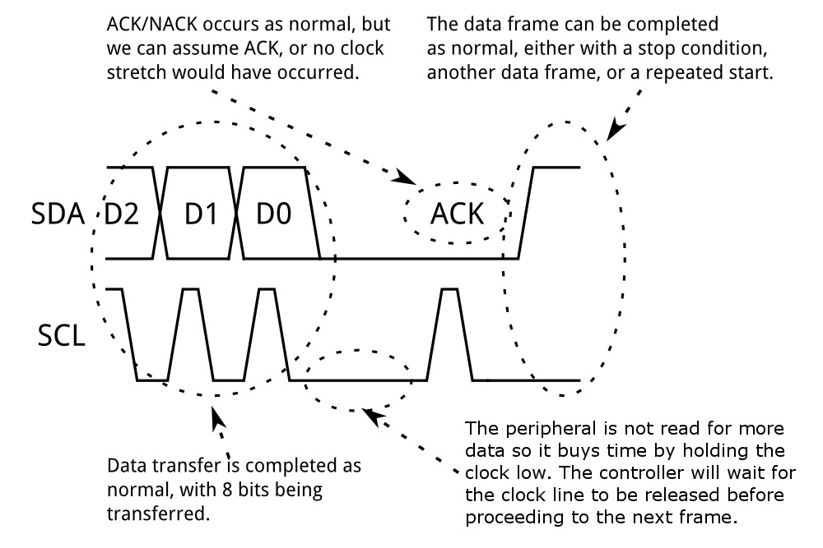
In order for a peripheral to let the controller know that the data is not ready yet it pulls the SCL low. This is called "clock stretching" and is described on the protocol page.

In this case, some peripheral devices will execute what is referred to as "clock stretching". Normally, all clocking is driven by the controller — peripherals simply put data on the bus or take data off the bus in response to the controller's clock pulses. At any point in the data transfer process, an addressed peripheral can hold the SCL line low after the controller releases it. The controller is required to refrain from additional clock pulses or data transfer until such time as the peripheral releases the SCL line.

While most of the time clock stretching will happen at the end of a byte received, it does NOT have to be.. it can be even after each bit.

It is not always clear whether a peripheral supports clock stretching. If it does not have data ready it could also send a NAK and then the controller has to retry later. Some peripherals have it described in the datasheet, but a number have not described.

According to NXP I2C-bus specification (https://www.nxp.com/docs/en/user-guide/UM10204.pdf)

Clock stretching pauses a transaction by holding the SCL line LOW. The transaction cannot continue until the line is released HIGH again. Clock stretching is optional and in fact, most slave devices do not include an SCL driver so they are unable to stretch the clock.

On the byte level, a device may be able to receive bytes of data at a fast rate, but needs more time to store a received byte or prepare another byte to be transmitted. Slaves can then hold the SCL line LOW after reception and acknowledgment of a byte to force the master into a wait state until the slave is ready for the next byte transfer in a type of handshake procedure.

On the bit level, a device such as a micro-controller with or without limited hardware for the I2C-bus, can slow down the bus clock by extending each clock LOW period. The speed of any master is adapted to the internal operating rate of this device.

As such clock stretching is a defined valid method and the controller needs to be able to handle. The Apollo3 chip does support clock stretching BUT is it good enough?

5. Compare clock stretch UNO to ATP

After doing many tests, it was one of the last things I did. It revealed a very important aspect that has a huge impact on the data and conclusions. I decided to bring it forward and share now. As a result I have re-done all my tests.

Below is taken with an I2C address scanner. It sends 0x70, the address is NOT valid for the QWIIC button nor the CCS811. (400Khz, STRDIS = 0, SMPCNT = 3)

5.1 QWICC Button
On an UNO the NAK is detected, same as on the logic analyzer and that is correct !!
Start : after SDA has been pulled it takes 1.26us before SCL is pulled low.
Stop : after SCL has been released it takes 0.7us before SDA is released.

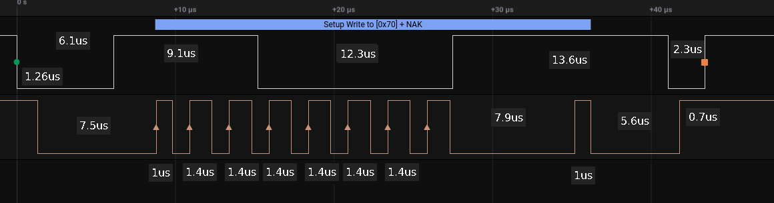
Next on an Artemis ATP again 0x70, the logic analyser again sees an NAK BUT Apollo3 reports an ACK. The sample of the ACK is clearly taking place when SDA is HIGH and thus Apollo3 is incorrect.

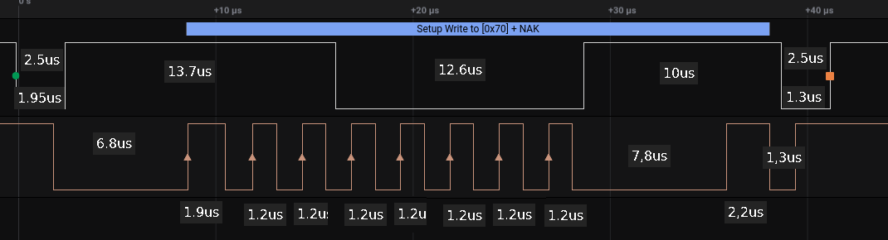
Start : after SDA has been pulled it takes 1.95us before SCL is pulled low.
Stop : after SCL has been released it takes 1.3us before SDA is released.

WHY oh WHY does the Apollo3 detect and ACK ?

5.2 CCS811
On an UNO the NAK is detected, same as on the logic analyzer and that is correct !!
Start : after SDA has been pulled it takes 1.3us before SCL is pulled low.
Stop : after SCL has been released it takes 1.7us before SDA is released.
Time from first change for start on SDA to the last change on SDA for stop : 35.5us
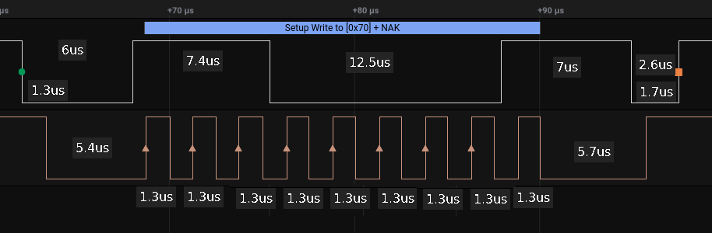
Next on an ATP again 0x70, the logic analyser again sees an NAK BUT Apollo3 reports an ACK
The sample of the ACK is clearly taking place when SDA is HIGH.

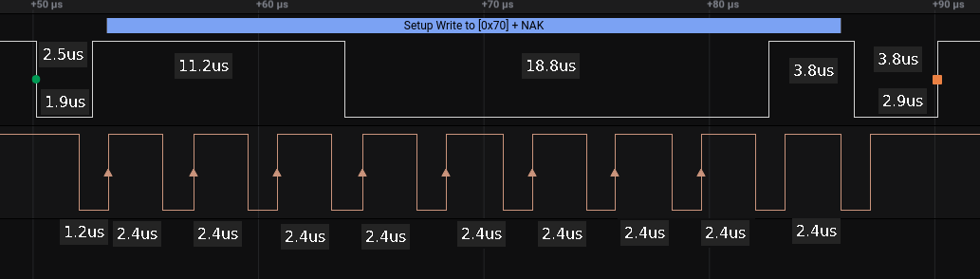
Start : after SDA has been pulled it takes 1.9us before SCL is pulled low.
Stop : after SCL has been released it takes 2.9us before SDA is released.
Time from first change for start on SDA to the last change on SDA for stop : 40us

5.3 Conclusion
When a peripheral is connected to the Apollo3 that is using clock stretching, it will always report an ACK on any address.

WRONG !!!

If you include a follow-up dummy byte like adding Wire.write(0x21); before Wire.endTransmission() the Apollo3 will correctly detect ACK and NAK at invalid addresses. ! When sending an invalid address (which get’s an NAK) the Apollo3 will not send the dummy byte and report an NAK !!

But if the address is valid.. it will also send the dummy byte and report an ACK.
I have put BOTH the CCS811 and QWIIC button on the same line, added the dummy byte and had it run:

I2C error 4 at address 0x57
I2C error 4 at address 0x58
I2C error 4 at address 0x59
I2C device found at address 0x5A // CCS811
I2C error 4 at address 0x5B
I2C error 4 at address 0x5C
I2C error 4 at address 0x5D
I2C error 4 at address 0x5E
I2C error 4 at address 0x5F
I2C error 4 at address 0x60
I2C error 4 at address 0x61
I2C error 4 at address 0x62
I2C error 4 at address 0x63
I2C error 4 at address 0x64
I2C error 4 at address 0x65
I2C error 4 at address 0x66
I2C error 4 at address 0x67
I2C error 4 at address 0x68
I2C error 4 at address 0x69
I2C error 4 at address 0x6A
I2C error 4 at address 0x6B
I2C error 4 at address 0x6C
I2C error 4 at address 0x6D
I2C error 4 at address 0x6E
I2C device found at address 0x6F // QWIIC button
I2C error 4 at address 0x70

I had BOTH the QWIIC button and CCS811 on the I2C channel, run the CCS811 sketch and it worked perfectly.

The right conclusion is that the Apollo3 does not react correctly if only the address is sent. It will always return an ACK. BUT with a dummy byte it will work correctly !

A standard I2C scanner does NOT have a dummy byte and thus all addresses will be detected incorrectly !

Hence I have run all test in the document with the dummy byte added. (see appendix B)

6. Apollo3 IOM I2C deepdive

6.1 I2C clocking
The I2C clock can be generated from a number of input sources. The fastest is 48Mhz (HFRC clock) and the other input sources are already a result of a divide of this 48Mhz.

HFRC = 0x1 - Selects the HFRC as the input clock.
HFRC_DIV2 = 0x2 - Selects the HFRC / 2 as the input clock.
HFRC_DIV4 = 0x3 - Selects the HFRC / 4 as the input clock.
HFRC_DIV8 = 0x4 - Selects the HFRC / 8 as the input clock.
HFRC_DIV16 = 0x5 - Selects the HFRC / 16 as the input clock.
HFRC_DIV32 = 0x6 - Selects the HFRC / 32 as the input clock.
HFRC_DIV64 = 0x7 - Selects the HFRC / 64 as the input clock.

The input source will be divided down to the needed I2C clock speed. Optionally the input source can first be divided by 3 and then it can optionally be divided by an 8 bit value: TOTPER. (actually it is TOTPER+1 value) The result is an IO_CLK speed which is double the wanted SCL speed.

The IO_CLK has a 50% duty cycle, 50% of the time high, 50% of the time low. By setting LOWPER (actually it is LOWPER+1 value) to a value that is different than half of TOTPER, you can make the low period of the SCL signal longer or shorter, while still running at a cycle time of the SCL frequency. This might be needed for some peripherals.

The Apollo3 datasheet is confusing the number of TOTPER is and LOWPER are in HEX, while in other datasheets versions of the Apollo3 they are in decimal. Also they seem to mistake in the source setting.

Sparkfun is using the following:

Note1: This is actually the 1Mhz setting which results in a line speed of 860Khz and a duty cycle of 57% low / 43% high. With a little different setting it could have been 960Khz (divide source by 2 , TOTPER 0x18 and LOWER 0xB) and duty cycle of 48% low / 52% high. Better in my mind….

Now you can further optimize the signal with SDAENDLY, SCLENDLY and SDADLY.

6.2 SDAENDLY
According to the datasheet (but we will prove this is not correct) :
Number of IOCLK cycles to delay the SDA output en (all transitions affected). Used to delay data relative to clock.

This is a 4 bit value and on different speeds I has a different value. Let’s use 400Khz example. The default value is 15. So you would expect 15 cycles of the IOCLK. This is double the SCL speed and thus 800Khz. At 800Khz the cycle time is 1 /8 = 1.25uS. 15 * 1.25us = 18.75uS.

Not really.. It gets about 0.6uS delay.

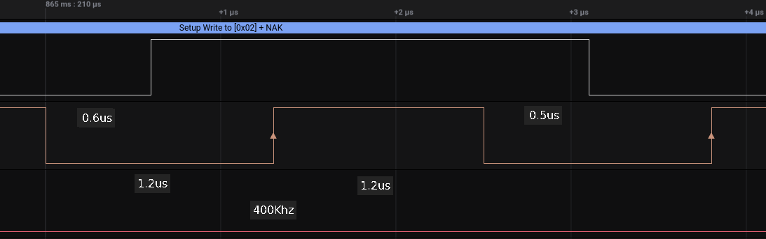
Calculating the clock frequency : 1 / (0.62us / 15 (SDAENDLY)) = 24.19Mhz

To see the impact I have set SDAENDLY to 1 instead of 15.

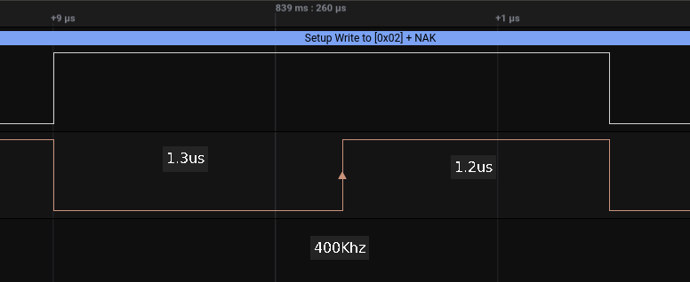
Clear enough to see what is happening… hardly a delay after SCL went low. So it DOES impact.

Now setting SDAENDLY to a value of 6.

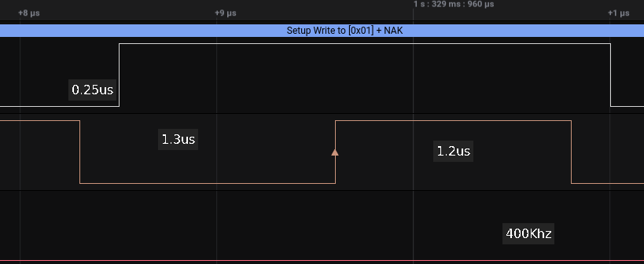
Alright we see the SDA start has move 0.25us.
To calculate the clock frequency : 1 / (0.25us / 6 (SDAENDLY)) = 24Mhz
NOW THAT LOOKS AS IF 24MHZ (our input clock source) is driving the delay. Doing a check on 100Khz, value 15 by default.

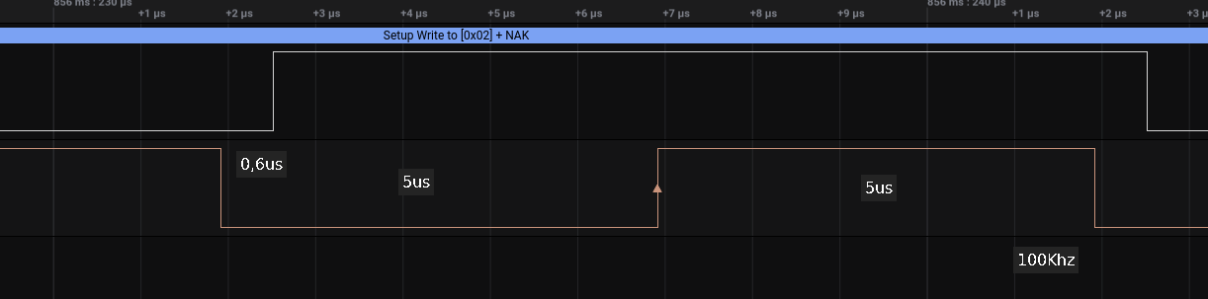
To calculate the clock frequency : 1 / (0.6us / 15 (SDAENDLY)) ~ 24Mhz

Next check : changing the input source to divide by 4 (so input frequency becomes 12Mhz) and use TOTPER as 0x3B and TOTLOW as 0x1D. This also gives us IO_CLCK of 200Khz and SCL 100Khz. NO change to SDAENDLY, still 15

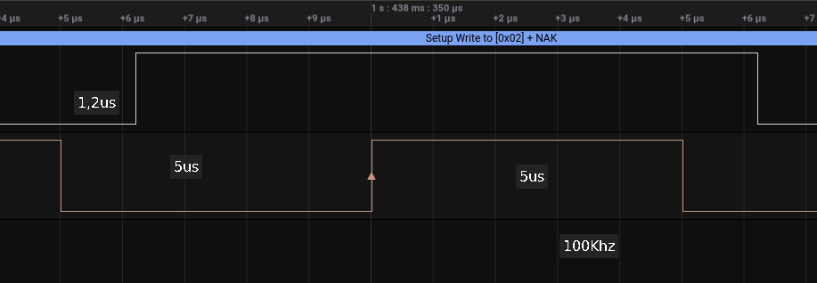
Now it is 1.2us and with and SDAENDLY the frequency is 12MHZ. (1 / (1.2us / 15))

Final check...changing the input source to divide by 8 (so input frequency becomes 6Mhz) and use TOTPER as 0x1D and TOTLOW as 0xe. This also gives us IO_CLCK of 200Khz and SCL 100Khz. NO change to SDAENDLY, still 15.

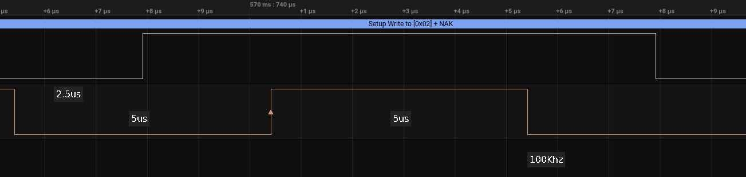
Now SDA start 2.5uS later and thus the frequency is 6 Mhz. ( 1 ( 2.5us / 15))

Conclusion the real definition :
Number of INPUT source clock cycles to delay the SDA output en (all transitions affected). Used to delay data relative to clock. (after the falling edge of SCL)

6.3 SCLENDLY

The definition according to the datasheet (IO_CLK is wrong again):

Number of IOCLK cycles to delay the rising edge of the SCL output en (clock will go low on this edge). Used to allow clock shaping.

Datasheet page 261 has additional info:

However, the timing specification of some I2C modes require an asymmetrical duty cycle on the SCL output, with the high period of the clock less than the low period of the clock. The clocking module allows a programmable delay prior to propagating the rising edge of the SCL output. This delay is in units of the source IO_CLK period (prior to any enabled division). This delay is
specified in the REG_IOM_MI2CCFG.SCLENDLY register field.

The default value is 100Khz 0, 400Khz 2 and 1Mhz 3.

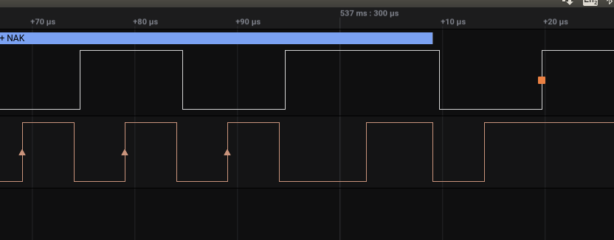
Above image is 100Khz.. SCLENDLY 0, the clock is 50% low and 50% high and SDA HIGH/LOW is 10us.
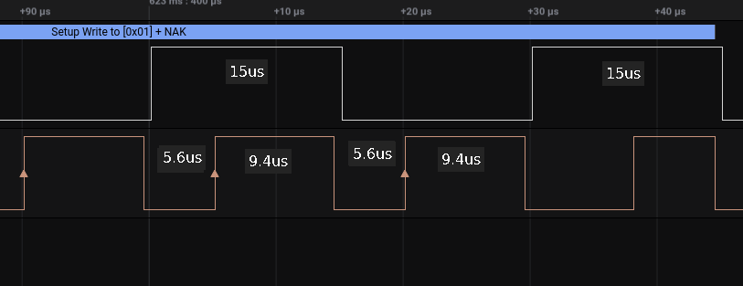
This is 100Khz.. SCLENDLY 15. Now look SDA time is now 50% more than original. The LOW time of the clock is 0.6us longer and the HIGH time is 4.4us longer. SO actually the HIGH time is now longer than the LOW (opposite to the datasheet info)
I have taken steps of 5 on both 100Khz and 400Khz :
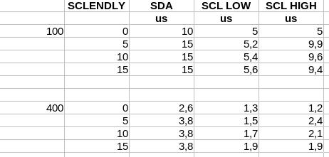
The SCL low is increasing as SCLENDLY increases with the same amount whether it is 100Khz or 400Khz. Both have an input source frequency of 24Mhz.
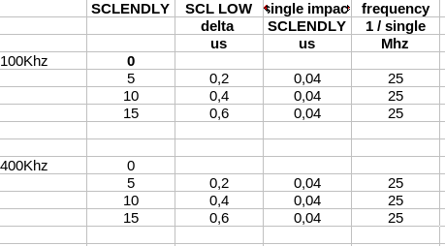
Looking at SCLENDLY for 400Khz step by step.
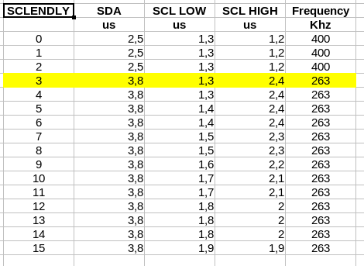
At the moment the SCLENDLY is 3 the real frequency drops as the SCL HIGH is doubling !
It looks like it needs to make enough room in cycle to have SCL LOW increase.

In some versions of the library SCLENDLY was set to 3 and that is causing incorrect frequency.

My Conclusion
I have no idea yet when to use this. If you have a device that needs asymmetrical high and low, then change LOWER value and keep the same frequency. Or just scrap that peripheral as it is NOT compatible with a normal way of operating I2C.

6.4 SDADLY
According to the datasheet :
Delay to enable on the SDA output. Values are 0x0-0x3.

Default value on 100Khz and 400Khz is 3, on 1Mhz it is zero.

But no idea what it does. I have looked at :
1. The START pulse maybe sooner or later in relation to SCL going low
2. SDA change later after SCL going low.
3. Tried and checked setting 0 and 3 on 100Khz, 400Khz and 1MHz

BUT found nothing ! No scope change.. No timing change... NO nothing… that would result in change, whether the SDADLY is set as 0 or as 3.

I have found no further documentation. Only that SDADLY abbreviation is also used in PCU9669 I2C controller from NXP. There is used in clock settings for Ultra Fast mode, a bit of what we experience here.

Maybe this can be updated in a later version of this document when more information becomes available.

6.5 I2C clock stretching
From the Apollo3 datasheet Page 261:

If clock stretching is done by the slave devices attached to the IOM interface, further restrictions must be observed during the setup of the clock controls. This is due to the possible clock stretch event done within a single cycle on the I2C SCL. In this case, the minimum SCL high time must be maintained, regardless of the time the slave releases the SCL. To detect the event within the single I2C cycle, the SCL signal needs to be sub-sampled. The source IO_CLK is used for this purpose also and allows for sampling of the SCL signal by a programmable number of source IO_CLK cycles. The sample granularity is determined by the ratio of the source IO_CLK to final IO_CLK frequency and must allow for synchronization time between the two domains. The recommended settings for each mode are below. Only speeds of 100KHz, 400KHz and 1MHz are supported. Contact Ambiq Micro for use of other frequencies.

Already learned that the ‘source IO_CLK’ is confusing and it actually means the INPUT source (48Mhz or division of that).

One important note.. if you happen to have an Apollo3 rev A.. you are out of luck. Look at Appendix C for more info and also a sketch to check the Apollo3 revision level.

As explained in chapter 3, clock stretching is the peripheral is holding the SCL low (after released by the controller) as it needs a ‘bit’ more time to do ‘something’.

Normally the controller will read the SCL before starting the next planned “high to low” pulse. If the SCL line is still low…. it will wait. Once released by the peripheral the controller will continue as planned. BUT the peripheral holding SCL low and releasing it COULD both happen within the time the controller had released the line, the high-time of the controller clock.

Say we are running 100Khz, thus 5us low / 5us high time on the clock. In case the controller clock goes from “low to high”, a peripheral might pull the line low for 2us and then release it. The following SCL high time-counter should now start 2us later in this case. Hence the chip should sample the SCL line, despite of what the controller’s clock expected level would be and start the 5us high clock-count once the peripheral has released.

There are 2 parameters that can be set : STRDIS and SMPCNT.

6.5.1 STRDIS
According to the datasheet the definition :
Disable detection of clock stretch events smaller than 1 cycle

Let’s see.. below sending an address and waiting to the QWIIC button (400Khz, STRDIS =0):
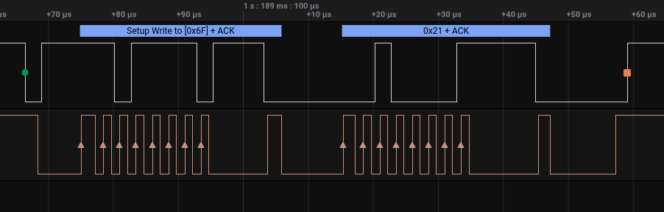
You see the delay in sampling after start, before the ACK’s and before the dummy byte.

Same setup, but NOW disabled the (400Khz, STRDIS =1)
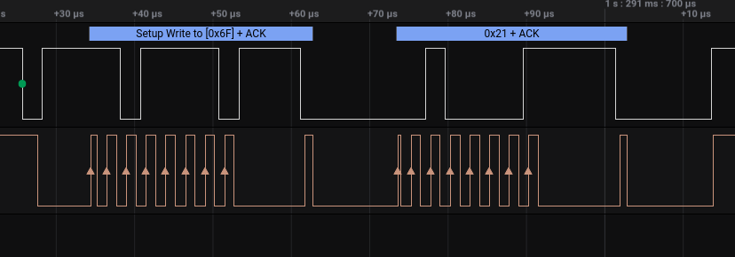
You see the delay in sampling for an ACK.

Hard to say what is different, but it looks that the Apollo3 SCL clock keeps running, while the SCL is pulled low by the QWIIC button. This results in shorter SCL pulse (instead of 1.3us) after each delay: 0.8us for first bit address, 1us for check address-ACK, 0.4us for first bit of dummy byte and 0.9us for checking dummy-byte ACK. But why does it keep running and not sample as if there is no clock stretch (because detection was disabled) ?

Anyway.. always set STRDIS to 0 to enable detection

6.5.2 SMPCNT

According to the datasheet the definition :

Number of Base clock cycles to wait before sampling the SCL clock to determine if a clock stretch event has occurred

This SMPCNT definition is ‘as clear as mude’.
What is “base clock cycles” is the ‘input source clock-cycles’ ?
How does this relates to STRDIS ?

What we know is :
The default value is 3 for 100Khz and 400Khz and 0x21 for 1Mhz.
This is an 8 bit value so it can be between 0 and 255.

I assume “base clock cycles” means “input source clock” as when looking at the datasheet “Recommended Mode Settings for Standard I2C Clock Speeds”, the SMPCNT value changes when different input source clock is selected. So what we read that it is the number * ‘input clock-cycle time’ to wait, after the controller released the line, to check whether a peripheral is holding the SCL line low.

Input frequency is HFRC / DIV-2 = 24 Mhz. Thus the input clock-cycle is 0.4us. Connecting the QWIIC button to the ATP gives the following results :

SMPCNT (at 100Khz)
0 – 110 only 0x6f found other nak (Correct)
112 – 255 all NAK
Doing the same but STRDIS = 1, all NAK.

SMPCNT (at 400Khz)
0 – 255 only 0x6f found other nak (Correct)
Doing the same but STRDIS = 1, all only 0x6f found other nak (Correct)

nput frequency is HFRC / DIV-4= 12 Mhz. Thus the input clock-cycle is 0.8us.
SMPCNT (at 1Mhz)
0 – 254 only 0x6f found other nak (Correct)
255 all NAK
Doing the same but STRDIS = 1, all only 0x6f found other nak (Correct) (except with 255)

So what is SMPCNT actually doing.. it does have a great impact at 100KHZ as STRDIS has at 100Khz, but apart from that ????? Maybe in a later version of this document more to update

6.6 ARBEN
It is possible to have more than one controller on a single I2C line. There is a well defined arbitration process as part of the i2c standard definition.

Setting this option to 1 it enables multi-master arbitration for the I2C master. If the bus is known to
have only a single master, this function can be disabled to save clock cycles on I2C transactions.

The default setting is hard coded to 0 (disabled).

6.7 I2CLSB
Direction of data transmit and receive, MSB(0) or LSB(1) first. Default per I2C specification is MSB first. This applies to both read and write data, and read data will be bit. This is hard coded in the library.

6.8 ADDRSZ
Originally the address size was 7 bits or a maximum 127 devices. Then it seems there was need to be able to address more devices and a 10 bit address was introduced or a maximum of 1023 devices.
The Apollo3 chip can be set as the I2C master device address size to either 7b (0) or 10b (1).
The hard coded default is 0 or 7b.

7. BME680 no clock stretching

7.1 On Arduino Uno
Taken a picture of an BME680 that does not use clock stretching on 400Khz.
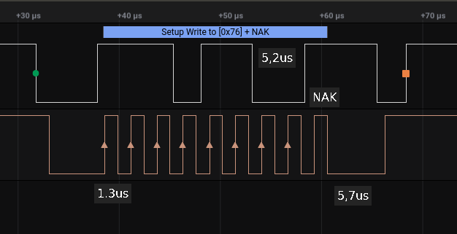
The clock keeps ticking.. no delay after the last bit, immediately sampling and looking for an ACK. As SDA we high, it is an NAK and the sketch is reporting that.

Now with the right address

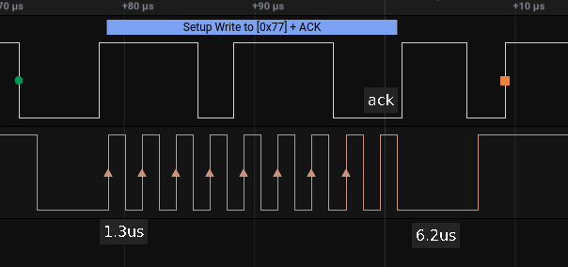
Same clock, immediately sampling after the last bit and as the line is pulled low by the peripheral we detect and ACK and the sketch is reporting that.

7.2 On Artemis ATP

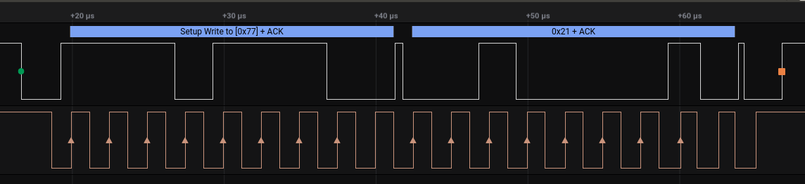
Same picture as on the UNO.. no delays before sampling an ACK and Apollo3 reports an ACK

7.3 Conclusion

Running a peripheral that is not performing clock stretching on an ATP or Uno gives the same correct results.

8. CCS811 and clock stretching
The CCS811 is another device of which it is known to perform clock stretching.

8.1 On Artemis ATP
400kHZ, STRDIS = 0, SMPCNT = 3
The program will constant read the status register to check whether data is ready. (bit 3 is set)
Now already here at SCL being held longer low (5.2us) right after the address ACK. The next SCL high is normal (2.3us).

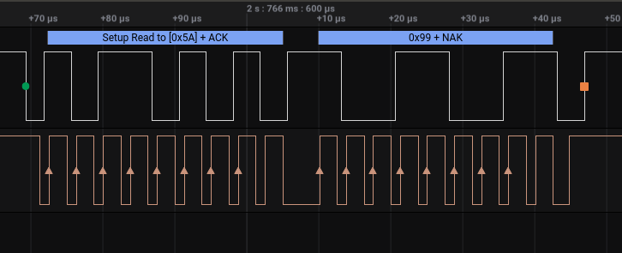
As bit 3 is set data is ready so the data register is written. SCL is again stretched for 6.7us before the clock is starting again with 2us high instead of 2.5us.
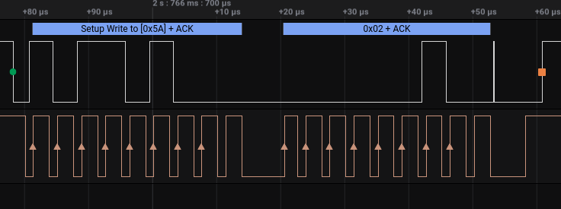
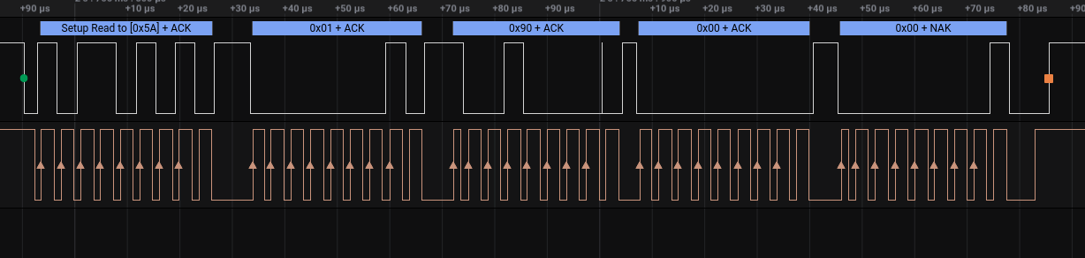
Now we start reading the data registers (4 of them) below. After each ACK there is short clock stretch (around 6.4us).

8.2 On an UNO
The constant polling. Also here the clock stretch (9.1us) after the ACK.

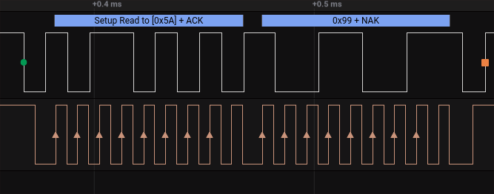
The write command to get the data and again the clock stretch after START and after the ACK’s.

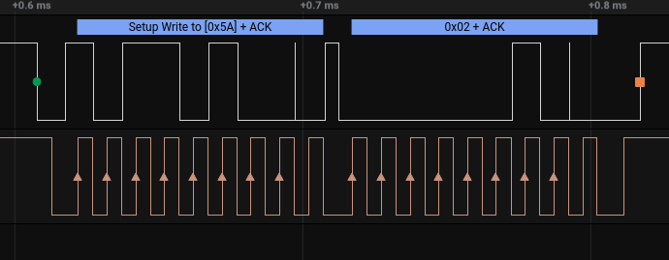
Now reading the 4 data bytes with a clock stretch happening after each ACK.

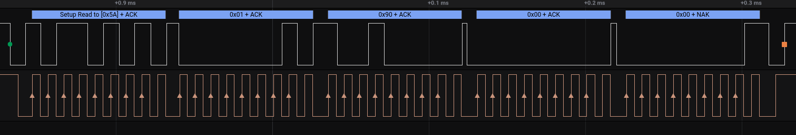

8.3 Conclusion
Did the same test on 100KHz and all worked good, no problems with clock stretching happening and using the default IOM I2C values.

9. QWIIC button and clock stretching
As mentioned before, clock stretching is a defined method, which is also used by the on-board ATTINY84 from ATMEL. BUT.. it is using clock stretching more often than I have ever seen before.
Below a high level description directly taken from the ATTINY84 datasheet (page 128)
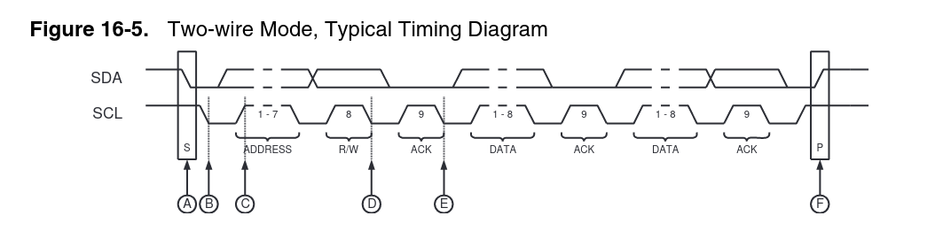
Referring to the timing diagram (Figure 16-5 on page 128), a bus transfer involves the following
steps:

1. The a start condition is generated by the Master by forcing the SDA low line while the SCL line is high (A). SDA can be forced low either by writing a zero to bit 7 of the Shift Register, or by setting the corresponding bit in the PORT Register to zero. Note that the Data Direction Register bit must be set to one for the output to be enabled. The slave device’s start detector logic detects the start condition and sets the USISIF Flag. The flag can generate an interrupt if necessary.

2. In addition, the start detector will hold the SCL line low after the Master has forced an negative edge on this line (B). This allows the Slave to wake up from sleep or complete its other tasks before setting up the Shift Register to receive the address. This is done by clearing the start condition flag and reset the counter.

3. The Master set the first bit to be transferred and releases the SCL line (C). The Slave samples the data and shift it into the Serial Register at the positive edge of the SCL clock.

4. After eight bits are transferred containing slave address and data direction (read or write), the Slave counter overflows and the SCL line is forced low (D). If the slave is not the one the Master has addressed, it releases the SCL line and waits for a new start condition.

5. If the Slave is addressed it holds the SDA line low during the acknowledgment cycle before holding the SCL line low again (i.e., the Counter Register must be set to 14 before releasing SCL at (D)). Depending of the R/W bit the Master or Slave enables its output. If the bit is set, a master read operation is in progress (i.e., the slave drives the SDA line) The slave can hold the SCL line low after the acknowledge (E).

6. Multiple bytes can now be transmitted, all in same direction, until a stop condition is given
by the Master (F). Or a new start condition is given. If the Slave is not able to receive more data it does not acknowledge the data byte it has last received. When the Master does a read operation it must terminate the operation by force the acknowledge bit low after the last byte transmitted.

So you after it 1) receives a Start-condition, 2) after receiving the address and potential after each data byte either 3) sending or 4) receiving.
Let’s look how that works using a sketch that is defined in Appendix B.

9.1 Scan On Artemis ATP

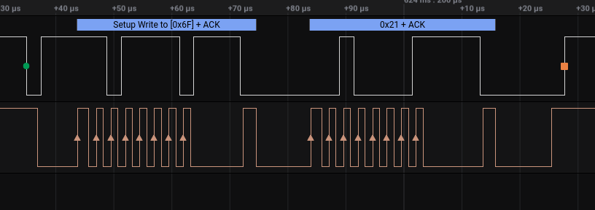
Notice the 9.6us before starting to sample the first bit of the address, also 9.1us before sample ACK and 9.5us AFTER samples the address ACK. Also the 10.5us before sampling the dummy byte ACK and 9.6us after this sample.

9.2 QWIIC Button test
Now that the device is detected correctly with a scanner (with added dummy byte), let’s try to read it with an example.

9.2.1 On an ATP

When you call button.begin() it does 2 functions to make sure the right device detected: Isconnected() and checkDeviceID().

For test : Commenting out checkDeviceID() and only performing Isconnected() and then followed by while(1) to stop other execution.

bool QwiicButton::isConnected()
{
_i2cPort->beginTransmission(_deviceAddress);
if (_i2cPort->endTransmission() == 0)
return true;
return false;
}

To do the right test you need the dummy byte (see chapter 5)

THE Isconnect() FUNCTION IS NOT NECESSARY. JUST KEEP THE checkDeviceID()
Now doing only checkDeviceID()

bool QwiicButton::deviceID() uint8_t QwiicButton::checkDeviceID()
{ {
//read and return the value in the ID register //Return true if the device ID matches
return readSingleRegister(ID); return (deviceID() == DEV_ID);
} }

It sends a write register 0x0 (the device ID register)
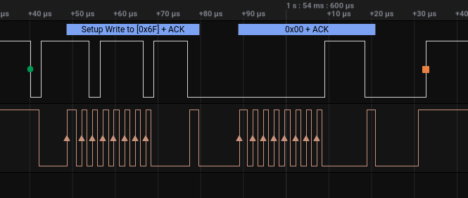
which is then following by a read request to get the content..

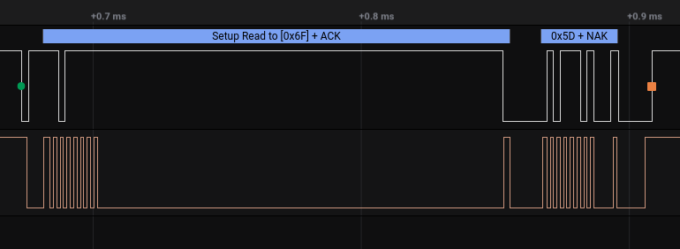
Something weird. The Apollo3 has sent a request for register 0 (ID), followed by read command. After the address + read bit was sent the SCL line is pulled low by the QWIIC button for 151.9us !! After that the SDA line is pulled low (resulting in an ACK) and then the content (0x5D) is send.

BUT…. I have seen moments where the SDA it stayed low as it wants to provide the first bit from register 0. However the Apollo3 clock stopped. There is no clock because Apollo3 detected a NAK. Any subsequent try to connect with the QWIIC button will fail as the QWIIC button believes it is still clocking out register 0. Trying to reproduce that more.. it just kept working very well.

9.2.2 On an UNO

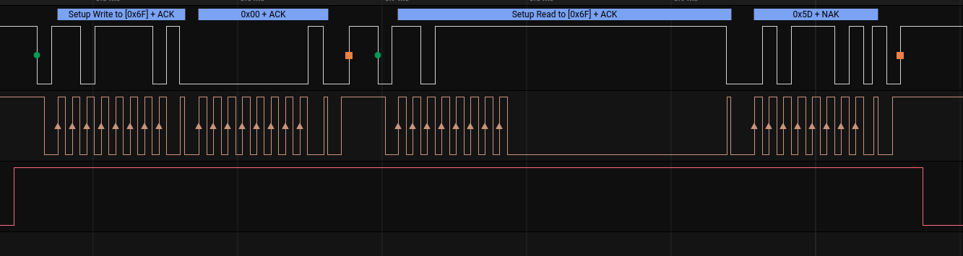
Nearly same picture : A write of register 0, followed by a read request. Again the QWIIC button pulls SCL low of 151.9us and once released the UNO will continue to clock the register content / device ID (0x5d).

The 151.9us is really caused by the QWIIC button and is actually a long delay. Still the Apollo3 copes with it in the same way as Arduino Uno.

9.2.3 QWIIC delay reasons
The firmware and hardware information is available on https://github.com/sparkfun/Qwiic_Button
This firmware can be compiled for an UNO, which I tried.

When sending the requested data from one register.. actually it is trying to send ALL registers STARTING from the register requested. So asking for the DEVID, register 0, it will copy all the register from 0x0 to register 0x1F (total of 32 bytes) to the wire-interface (while we only need the DEVID). If you ask the button status (register 3), it will copy register 3 to register 0x1F (29 bytes). This is done to enable to read multiple registers like with readDoubleRegister() or readQuadRegister(). But it comes with a time-price :

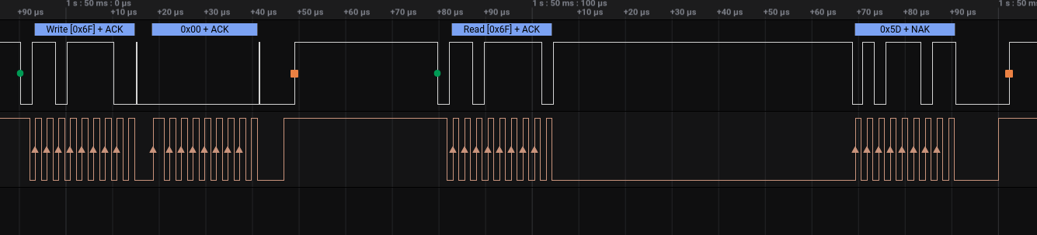
After the read has been submitted the clock- stretch is 65us where the SCL is held low. All the other registers that had been copied to the wire are not used as a STOP has been generated by the controller.

I am testing on an UNO (ATmega328), as I don’t have the tools to re-progam the QWICC button (and thus the ATTINY85) itself. I expect that an ATTINY85 needs an even longer time.

Making a change to write a single register (for test) is not that hard to make. In On Request() change :
Wire.write((registerPointer + registerNumber), sizeof(memoryMap) - registerNumber);
to a single byte :
Wire.write(*(registerPointer + registerNumber));

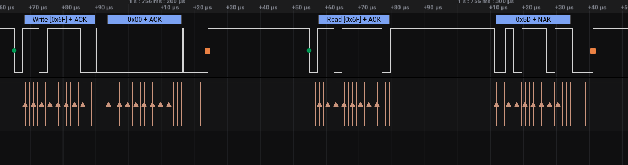
The clock-stretch is now HALF the time at 32.7us before the data is returned after sending a read. In the OnRequest() it does handle some other data before doing the Wire.write(). Even when removing all that and immediately after entering OnRequest() do the Wire.write() … it still is 32us. If making it a direct write : Wire.write(0x5d) still 32us… , disabling sleep function as used by the program… still 32us… Seems to be the minimum.

Also done the test (after some minor changes to the sketch to have it compiled) on an MEGA2560. The delay is still 37us.

9.2.4 Conclusion

The clock-stretch could be optimized in the code, but there still will be a clock-stretch delay. BUT the Apollo3 can handle it !
The main reason the QWIIC button is failing is the check without the dummy bit in the IsConnect() function. The good news is.. that check is not necessary.

It is what it is……..

Appendix A: useful resources

About I2C implementations:

https://en.wikipedia.org/wiki/I%C2%B2C
https://www.embedded.com/designing-with-proven-implementations-of-the-inter-ic-bus/
https://learn.sparkfun.com/tutorials/i2c/all

NXP I2C-bus specification
https://www.nxp.com/docs/en/user-guide/UM10204.pdf

redefinition of signal names:
https://www.oshwa.org/a-resolution-to-redefine-spi-signal-names

Link to ATTINY84 datasheet
https://www.hobbytronics.co.uk/datasheets/attiny84.pdf

Apollo3 datasheet
https://ambiq.com/wp-content/uploads/2020/10/Apollo3-Blue-Plus-MCU-Datasheet.pdf

Appendix B : I2C Scanner sample

#include <Wire.h>

void setup()
{
Serial.begin(115200);
Wire.begin();

// set wanted clock speed
Wire.setClock(400000);

for (byte address = 1; address < 127; address++ )
{
Wire.beginTransmission(address);
Wire.write (0x21); // see remarks in chapter 5
byte error = Wire.endTransmission();

if (error == 0)
{
Serial.print("I2C device found at address 0x");
Serial.println(address, HEX);
}
else
{
Serial.print("I2C error ");
Serial.print(error);
Serial.print(" at address 0x");
Serial.println(address, HEX);
}
}
}

void loop()
{
}

Appendix C : Apollo3 rev A

If you have a revision A Apollo3 chip clock stretching is NOT supported :
https://ambiq.com/wp-content/uploads/2020/08/Apollo-MCU-Silicon-Errata.pdf

You can check your revision with the following sketch :

#include "am_util_id.h"

void setup() {

am_util_id_t info;

Serial.begin(115200);

Serial.println("get device info");

uint32_t dev = am_util_id_device(&info);

if (dev == AM_UTIL_ID_APOLLO) {
Serial.println("device is AM_UTIL_ID_APOLLO");
}
else if (dev == AM_UTIL_ID_APOLLO2) {
Serial.println("device is AM_UTIL_ID_APOLLO2");
}
else if (dev == AM_UTIL_ID_APOLLO3) {
Serial.println("device is AM_UTIL_ID_APOLLO3");
}
else if (dev == AM_UTIL_ID_APOLLO3P) {
Serial.println("device is AM_UTIL_ID_APOLLO3P");
}
else
Serial.println ("Unkown");

Serial.print ("Major revision ");
Serial.println((char) info.ui8ChipRevMaj);

Serial.print ("Minor revision ");
Serial.println((char) info.ui8ChipRevMin);
}

void loop() {
// put your main code here, to run repeatedly:

}

