SMBUS compatibility Apollo3

Different challenges with SMBus / I2C on Apollo3 . This document is investigating that.

Table of Contents
V1 library performance 2
V2 library performance 4
Comparing V1 and V2 5
100Khz frequency 5
200Khz frequency 6
400Khz frequency 7
Compare to I2C on Arduino Uno 8
SMBus specification 9
What is the impact on SMBus compliance? 11
Impact with Apollo3 V1.X 11
Impact with Apollo3 V2.X 11
Impact with Uno 11
Appendix A: Sketch 12

Disclaimer

While the recorded timing is correct and reproducible, performing the pin -setting and clearing also add about 1.3us each time.

Don’t expect the timing behind the decimal point to be 10000% correct, but it is correct enough to support the conclusions.

I have used a sample sketch for the MLX90615 which is attached in Appendix A for all measurements. Also for the UNO. In order to get it to work on the Apollo3 I had make changes to the https://github.com/Seeed-Studio/Digital_Infrared_Temperature_Sensor_MLX90615 and remove all the references to the propriety i2cMaster.cpp, which works on AVR only.

V1 library performance

The following is taking from library version 1.2.1.

Line 1 is SCL (white), line 2 is SDA (orange).

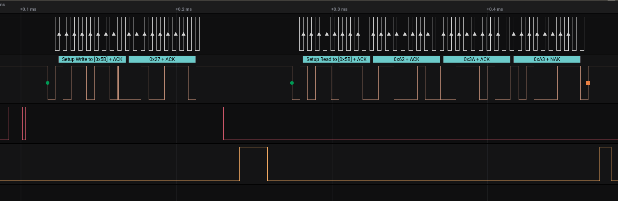

The 3rd line, red line is showing the timing during write. A write address + register that we want to read in the next call. When set high first it is doing different checks, it then goes low writing the data to be sent (address + register) and returns high when the waiting for “send” command that has been written to the IO-Module (IOM) to complete. The IOM will start sending and the program then polls the data from status and when detected the IOM is completed/idle it returns low.

The 4th line, yellow line is showing timing during reading. This is reading the 3 bytes from the registers. When set high first it is doing different checks and it is set low when the “read” command has been written to the IOM. When the 3 bytes have been received it returns high. The program then polls the data from status and when detected the IOM is completed/idle it returns low.

There are some interesting time delays, where the time delay is depending on the clock-speed of the SCL. In general it takes 3 SCL clock-cycles from the moment a write command was set (the red line) and it will take 4 SCL clock-cycles from the moment a READ command was set (the yellow line).

This in real numbers :

 | 100KhZ | 200KHZ | 400KHZ
After write command set & before start SDA (start) | 30 us | 14 us | 7 us
Write command IDLE after last SCL | 30 us | 14 us | 10 us
Return from Wire.cpp after Write to Read | 10 us | 10 us | 10 us
Checks before Read submitting command | 8 us | 8 us | 8 us
After read command set & before start SCL | 40 us | 20 us | 10.5 us
Read command IDLE after last SDA (stop) | 12.8 us | 7 us | 4.3 us
SCL cycle time | 10 us | 5 us | 3.8 us
# SCL cycles after write command and SDA (start) | 3 | 3 | 2
# SCL cycles after write command finished (Idle) | 3 | 3 | 3
# SCL cycles after read command and start SCL | 4 | 4 | 4
# SCL cycles after last read SDA (stop) and Idle | 1 | 1 | 1

There is NO configuration register has been found that can be set to reduce or impact this timing.

To show on a picture (taken at 400Khz)

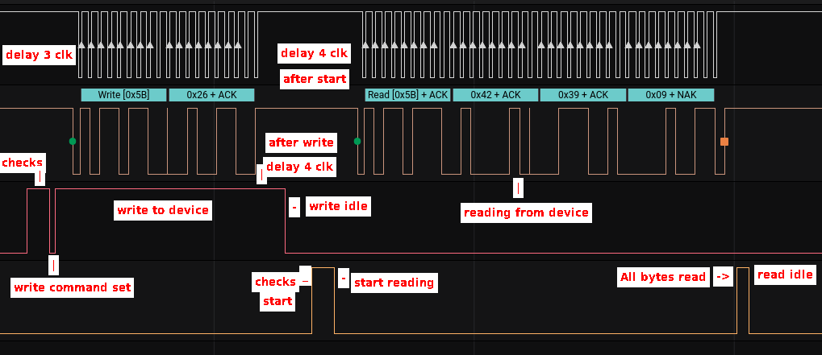

V2 library performance

This measurement has been performed on library version 2.1.1.

The major difference is that V2 is build around a version of MBED (https://os.mbed.com/mbed-os/). It is based on a frozen version of MBED-5. Not only does this mean that more calls and code is between the application layer (Wire.cpp) and the hardware layer (HAL) functions, but also MBED brings overhead in performing a number of house keeping functions to enable “multi-tasking”.
E.g. every microsecond Mbed is triggered to see whether there is something pending to do.

 | 100KhZ | 200KHZ | 400KHZ
After write command set & before start SDA (start) | 25.5 us | 12 us | 6 us
Write command IDLE after last SCL | 32.2 us | 18 us | 14 us
Return from Wire.cpp after Write to Read | 60 us | 60 us | 60 us
Checks before Read submitting command | 15.2 us | 15.2 us | 15.2 us
After read command set & before start SCL | 40 us | 20 us | 11 us
Read command IDLE after last SDA (stop) | 24.4 us | 20.4 us | 22 us
SCL cycle time | 10 us | 5 us | 3.8 us
# SCL cycles after write command and SDA (start) | 3 | 3 | 2
# SCL cycles after write command finished (Idle) | 3 | 3 | 3
# SCL cycles after read command and start SCL | 4 | 4 | 4
# SCL cycles after last read SDA (stop) and Idle | 3 | 4 | 5

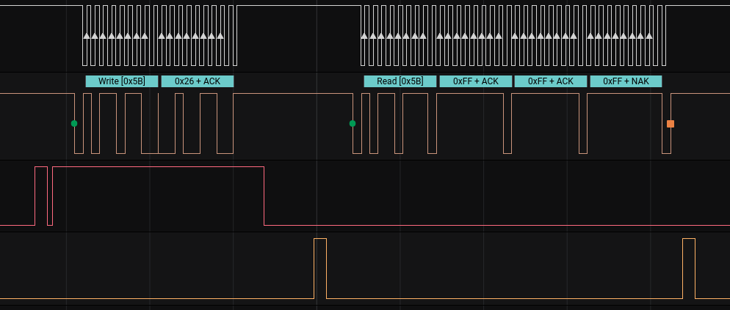
Please note that the “read” is showing oxff for all 3 bytes. It is not that the device can not handle this speed (100Khz) as it provides ‘ack’ but because of the SMBus timing. See later chapter.

Comparing V1 and V2

When comparing V1 and V2 keep in mind we are using exactly the same sketch, exactly the same hardware and timing taken around the same Apollo3 Hal-function.

100Khz frequency

100Khz | V1 | V2
After write command set & before start SDA (start) | 30 us | 25.5 us
Write command IDLE after last SCL | 30 us | 32.2 us
Return from Wire.cpp after Write to Read | 10 us | 60 us
Checks before Read submitting command | 8 us | 15.2 us
After read command set & before start SCL | 40 us | 40 us
Read command IDLE after last SDA (stop) | 12.8 us | 24.4 us
SCL cycle time | 10 us | 10 us
# SCL cycles after write command and SDA (start) | 3 | 3
# SCL cycles after write command finished (Idle) | 3 | 3
# SCL cycles after read command and start SCL | 4 | 4
# SCL cycles after last read SDA (stop) and Idle | 1 | 3

You can see the overhead of MBED on the time:

Between Write of address + register happened and return to start reading. It is 6 x longer !
Performing the checks before reading is 2 x longer !

Also interesting that the time to becoming idle after the last SDA change after read (stop) takes about 2 times are much time. This done by polling the status register. While MBED could have an impact here, the same polling is performed waiting on the IOM to become idle after write address + register.

200Khz frequency

200Khz | V1 | V2
After write command set & before start SDA (start) | 14 us | 12 us
Write command IDLE after last SCL | 14 us | 18 us
Return from Wire.cpp after Write to Read | 10 us | 60 us
Checks before Read submitting command | 8 us | 15.2 us
After read command set & before start SCL | 20 us | 20 us
Read command IDLE after last SDA (stop) | 7 us | 20.4 us
SCL cycle time | 5 us | 5 us
# SCL cycles after write command and SDA (start) | 3 | 3
# SCL cycles after write command finished (Idle) | 3 | 3
# SCL cycles after read command and start SCL | 4 | 4
# SCL cycles after last read SDA (stop) and Idle | 1 | 4

As with 100Khz you can see the overhead of MBED on the time:

Between Write of address + register happened and return to start reading. It is 6 x longer !
Performing the checks before reading is 2 x longer !

Also interesting that the time to becoming idle after the last SDA change after read (stop) takes about 3 times are much time. This done by polling the status register. While MBED could have an impact here, the same polling is performed waiting on the IOM to become idle after write address + register. On V1 there is a clear correlation between the SCL speed and this delay, but on V2 it is highly impacted by something else.

400Khz frequency

400Khz | V1 | V2
After write command set & before start SDA (start) | 7 us | 6 us
Write command IDLE after last SCL | 10 us | 14 us
Return from Wire.cpp after Write to Read | 10 us | 60 us
Checks before Read submitting command | 8 us | 15.2 us
After read command set & before start SCL | 10.5 us | 11 us
Read command IDLE after last SDA (stop) | 4.3 us | 22 us
SCL cycle time | 3.8 us | 3.8 us
# SCL cycles after write command and SDA (start) | 2 | 2
# SCL cycles after write command finished (Idle) | 3 | 3
# SCL cycles after read command and start SCL | 4 | 4
# SCL cycles after last read SDA (stop) and Idle | 1 | 5

As with 100Khz and 200Khz you can see the overhead of MBED on the time:

Between Write of address + register happened and return to start reading. It is 6 x longer !
Performing the checks before reading is 2 x longer !

Also here the time to becoming idle after the last SDA change after read (stop) takes about 5 times are much time on V2 than V1. This done by polling the status register. While MBED could have an impact here, the same polling is performed waiting on the IOM to become idle after write address + register. On V1 there is a clear correlation between the SCL speed and this delay, but on V2 it is highly impacted by something else.

Compare to I2C on Arduino Uno

Just to compare I have taken an Arduino Uno and programmed the sketch using library version 1.8.3

Included is the timing for 100KHZ. On the Uno there as no noticeable different in the delay timing mentioned whether running on 100Khz or 400Khz. The only place where a noticeable differences were found “After read command set & before start SCL” which is 1.7uS on 400Khz and of course the transfer was faster .

100KHZ | V1 | V2 | UNO
After write command set & before start SDA (start) | 30 us | 25.5 us | 2 us
Write command IDLE after last SCL | 30 us | 32.2 us | 10.5 us
Return from Wire.cpp after Write to Read | 10 us | 60 us | 5.4 us (*1)
Checks before Read submitting command | 8 us | 15.2 us | 13.5 us (*2)
After read command set & before start SCL | 40 us | 40 us | 5.5 us (*3)
Read command IDLE after last SDA (stop) | 12.8 us | 30 us | 10.2 us
SCL cycle time | 10uS | 10uS | 10uS
# SCL cycles after write command and SDA (start) | 3 | 3
# SCL cycles after write command finished (Idle) | 3 | 3
# SCL cycles after read command and start SCL | 4 | 4
# SCL cycles after last read SDA (stop) and Idle | 1 | 3

*1 : While the Uno processor is much less power-full and slower than an Apollo, the software in the library is working mostly directly on the hardware without a lot of calls and hand-offs.

*2 : The check before read submitting command is longer. That is because on an UNO the I2C interface is interrupt driven and in case this is a repeated start (which it is) it needs to take extra care on no previous pending interrupts.

*3 : on 400Khz this timing was 1.7uS for an Uno

When comparing V1 and V2 keep in mind we are using exactly the same code, exactly the same hardware. The Arduino library works directly on the hardware registers BUT is amazing to see the differences in the delay time !!

SMBus specification

Some devices, like MLX90614 and MLX90615, are based on the SMBus specifications. (http://smbus.org/specs/smbus20.pdf).

The System Management Bus (SMBus) is a two-wire interface through which various system component chips can communicate with each other and with the rest of the system. It is based on the principles of operation of I2C

SMBus is defining strict timing around the interaction of Master and Slave. or Controller and peripheral in new terms to be more political correct.
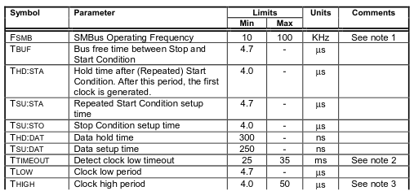
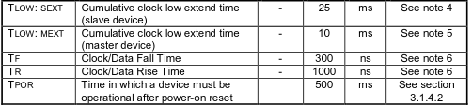

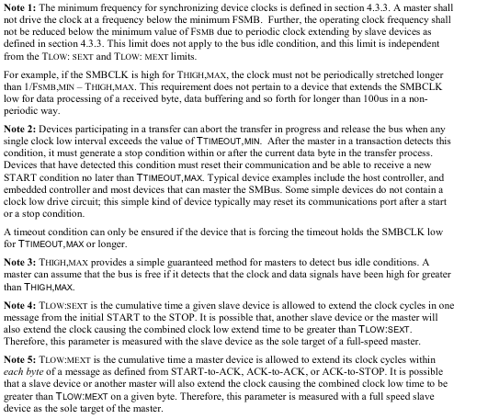

What is the impact on SMBus compliance?

The SMBus states that after 50us it assumes the bus is idle / free and resets. (see Note 3)

This timing is very important for the time AFTER writing the address + register and STARTING to read the data from that register.

Impact with Apollo3 V1.X
After the address + register has been written it takes 3 clock cycles before it is detected that writing has been completed.

After setting the read command, it takes 4 clock cycles before SCL is starting to enable reading.

In total 7 clock cycles delay. On 100kHz that is 7 * 10us = 70us, on 200kHZ that is 35uS and on 400Khz that is 20.5uS.

This means that SMBus timing is missed already on 100Khz and a SMBus compatible device is failing.

Not only the delay should be taken into account. In an application you first write the address + register. On return you do a requestFrom() call to get the data. The time between returning from write and requesting the “read” takes 10us programming time. Before performing the “read” command a number of checks are done to make sure the right parameters and conditions are in place. This takes 8us programming time. In total 18us.

Already ruling out 100Khz.

With 200kHz we are at 35us (delay) + 18us (programming time) = 53us.
A device MIGHT just accept this…..and please also note that setting / clearing a level on a debug-pin takes 1.3us. In either case we are JUST at the boundary.

On 400Khz we are at 20.5us (delay) + 18us (programming time) = 38.5us. This means we are good, BUT only if the device is supporting 400Khz,

Impact with Apollo3 V2.X
We can be very short here… will not work. The time after writing the address +register and returning to read (requestFrom() ) is already 60us. The 50us SMBus time-out will happen..
On 100Khz the time between idle after writing and starting read is 147us. (32 + 60 + 15 + 40). Even if we could optimize the 60us, it is still taking too long,

Impact with Uno
NO problem at all as the timing takes about 30us

Appendix A: Sketch

#include "MLX90615.h"
#define MLX MLX90615_DefaultAddr
MLX90615 mlx90615(MLX, &Wire);

void setup() {
Serial.begin(115200);
while (!Serial); // Only for native USB serial
delay(2000); // Additional delay to allow open the terminal to see setup() messages
Serial.println("Setup...");

Wire.begin();
Wire.setClock(100000);

if (mlx90615.isConnected()) Serial.println("we are connected\r");
else Serial.println("we are NOT connected\r");
}
void loop() {
Serial.print("Object temperature: ");
Serial.println(mlx90615.getTemperature(MLX90615_OBJECT_TEMPERATURE));
Serial.print("Ambient temperature: ");
Serial.println(mlx90615.getTemperature(MLX90615_AMBIENT_TEMPERATURE));
delay(1000);
}

