Apollo3 & IOS
Table of Contents
1. Background 1
2. New Naming 2
3. Documentation 2
4. Hardware connection 2
5. LRAM 3
5.1 Direct Area for direct communication 3
5.2 FIFO 3
5.3 RAM 4
6. Direct Accessible registers 4
6.1 Writing 4
6.2 Reading 4
6.3 Interrupts 5
6.4 Peripheral example 5
6.5 Advice on Direct access registers 6
7. FIFO 7
7.1 Complete Interrupts 7
7.2 IOINT 8
8. Specials 9
8.1 General address 9
8.2 Rearranging the FIFO 9
9. My Conclusion 10

1. Background

IOS stands for Input Output Slave. In short to use a board with an Apollo3 chip as a slave device either supporting SPI or I2C communication. It is the counter part of the Apollo3 Input Output Master (IOM).

In the SparkFun library there is no implemented use for IOS while in the AMBIQ SDK there are 2 examples. Both of them have the major function defined in the Hardware Abstraction Layer (HAL), but not all of them.

I wondered why there is no better implementation and also wanted to better understand how a slave device would work.

Hence this project. I’ll share my learning, observation and make sure to read my conclusion.

Regards,
Paul van Haastrecht
april 2023

2. New Naming

Before going in details, the Master / Slave terminology changed. An article about this can be found on https://www.sparkfun.com/spi_signal_names.

Instead of MASTER we use “controller”. In Ambiq documentation also referred to as “host”.

Instead of SLAVE we use “peripheral”. Ambiq documenation is also use MCU to indicate the local Apollo3 program in the peripheral.

So from here on in the document I will use the new terminology, except for register naming to keep the link with the datasheet.

3. Documentation

The Apollo3 datasheet chapter 9 handles the IOS. Opposite to the 6 x IOM’s an Apollo3 has, there is only one IOS. Also the IOS can only be connected to single set of pads on the Apollo3 chip. (see Hardware connection)

The module contains 256 bytes of ram (referred to as local RAM or LRAM), through which all data flows between the MCU / CPU AHB and the IO interface. The communication between peripheral and controller can done with direct addressable registers or FIFO.

IOS can be configured in SPI or I2C mode operation. The clock is determined by the controller / host and, according to the datasheet, can be maximum 1Mhz for I2C and 12Mhz for SPI mode.

Large parts of the text is coming from the Apollo3 Datasheet chapter 9. Where needed I have extended to explain the context, and added sharing the learning and observations.

To support this documentation I have written a library with workingexamples for peripheral (tested on Artemis ATP) and host (tested on Artemis Micromod, ESP32 Micromod and nrf52840 Micromod). Either connected with I2C or SPI.

4. Hardware connection

There is NO flexibility in selecting pads for the IOS. There is ONLY a single way to connect.

SPI: I2C:
PAD function function Select PAD function function Select
0 SPI SCK 1 0 I2C SCL 0
1 SPI COPI 1 1 I2C SDA 0
2 SPI CIPO 1 4 SPI INT 1
3 SPI CS 1
4 SPI INT 1

The INTerrupt pin is optional with FIFO and described in chapter IOINT.

5. LRAM

This RAM may be flexibly configured into three spaces: a block directly accessible via the I/O interface, a block which functions as a FIFO for read operations on the interface, and a block of generally accessible RAM used to store parameters during deep sleep mode. The data in the LRAM is maintained in Deep Sleep Mode.

The 256 bytes LRAM is divided into three separate areas on 8-byte, 64 bit, boundaries.
A challenge is the 5-bit registers. So we need to mention the 5-bit value or the real register number on the 8 byte boundary. So you I use 5-bit (register), e.g. 0x0A (0x50). 0X0A => 10 * 8 = 80 dec => 0x50 hex.

These areas are:

5.1 Direct Area for direct communication
A Direct Area for direct communication between the host and the MCU, which is mapped between
the MCU address space and the I/O address space. This area is from LRAM address 0x00 to the
address calculated from the 5-bit FIFOBASE field in the FIFO configuration register (FIFOCFG),
minus 1. This 5-bit field (IOSLAVE_FIFOCFG_FIFOBASE) should contain a value that represents
the start of the FIFO Area and, in so doing, defines the size of the Direct Area in 8-byte segments.

Part of this area can be defined as IOS Read-Only starting at any 8-byte segment defined by
IOSLAVE_FIFOCFG_ROBASE and extending through the end of the Direct Area at FIFOBASE*8-1.

I/O writes from the host to this ROBASE-address space will not change the LRAM, only writes from the MCU will change it. This allows the space to be used for returning status to the I/O Host.
ROBASE should have a minimum value of 0x0A, representing a start address of 0x50 to allow space for special commands and burst writes in lower Direct Area space.

Now you can set the ROBASE value to 0x0F (0x78), so the entire Direct area can be used for IO with the host, but still only writes from the host can be done and detected up to register address 0x4F.

5.2 FIFO
A FIFO Area which is used to stream data from the Apollo3 Blue MCU. This memory is directly
addressed from the MCU / AHB, but accessed from the I/O Interface using a single I/O address 0x7F as a streaming port. The FIFO area is from the LRAM address calculated from the value in the
FIFOBASE field, FIFOBASE*8, to the LRAM address calculated from the value in the FIFOMAX
field of the FIFOCFG register, IOSLAVE_FIFOCFG_FIFOMAX.
The upper FIFO Area address is FIFOMAX*8-1. The maximum value for FIFOMAX is 0x20, which would result in an upper FIFO Area address of 0xFF. ( 0x20 => 32 * 8 = 256 -1 => 0xFF)

5.3 RAM
A RAM area which is accessible only from the MCU. The RAM area is from the LRAM
address calculated from the value in the FIFOMAX field of the FIFOCFG register, IOSLAVE_FIFO-CFG_FIFOMAX, to address 0xFF. Setting FIFOMAX to 0x20(0xFF) would result in a RAM area of zero size. This could be used to store parameters during deep sleep mode.
In the provided library I have not used this part this way, but extended the FIFO area.

6. Direct Accessible registers
In SPI or I2C communication during read or write operation, you normally first send the register to read or write from. That is what is called ‘Direct accessible registers’.

6.1 Writing
The registers on address 0x0 – 0x0F should be seen as 8 bit registers. A controller / host write to these addresses which will set a single bit in the REGACCINTSTAT register for each register location written. The local MCU can read or write to it as well.

The registers starting from address 0x10 should be seen as 32 or 16 bit registers. So when writing on 4 bytes starting address 0x10, will write 0x10, 0x11, 0x12, 0x13. As soon as 0x13 is written a bit will be set in the REGACCINTSTAT register. If you write to address 0x14 a bit will be set when 0x17 is written. If you write at register offset +2 (e.g. 0x12) as soon as you then write the second byte (0x13) it will trigger as well.
So this gives you 16 * 32 or 16 bit registers to detect writing (0x4F – 0x10 = 0x3f => offset max 63 / 4 bytes = 16 registers). The MCU can read or write to it as well.
By reading the REGACCINTSTAT the MCU can detect which register was written.

Part of this area, above the previous registers starting atleast at address 0x50, an IOS Read-only area starting at any 8-byte segment can be defined. The MCU can read/write to these addresses and the HOST can only read. You could exchange return codes or other information that you do not want the host to change. BUT WHY WOULD YOU ?? In the provided library I have disabled this part.

6.2 Reading
Described in the Apollo3 datasheet 9.3 “Each REGACC interrupt status bit will be set whenever there is a read or write over the I2C or SPI interface in the Direct Area with an offset address which corresponds to a particular REGACC interrupt.”.
This is NOT correct. The bit is ONLY set when the register is written by the controller / host as the rest of the datasheet also refers to.

No REGACC interrupt will be raised for a SPI or I2C read operations, NO STAT will be set either

There is NO possibility to detect a read request for a specific location !!

This also means that the common implementation of a read on peripheral resulting in a onRequest() call in a sketch can NOT be implemented.

6.3 Interrupts
You can enable an MCU interrupt when a direct register has been IO written by setting the corresponding bit in the REGACCINTEN, NVIC_EnableIRQ(IOSLAVEACC_IRQn). In the interrupt routine ‘am_ioslave_acc_isr()’ read REGACCINTSTAT and use REGACCINTCLR to clear the bits in REGACCINTSTAT. Then act upon the register that was written.

THIS ONLY WORKS correct if registers 0x00 - 0x0F are used as 8 bit registers and 0x10 - 0x4C are used as either 16 or 32 bits registers. For usage as 16 bit, start writing with 2 bytes offset e.g. 0x12 instead of 0x10. Interrupt will trigger at 4th byte ( e.g. 0x13) !

There is also a priority in setting the bits in the REGACCINTSTAT. Writing register 0, which will cause bit 31 in the REGACCINTSTAT to be set, is the highest priority. Writing register 1, bit 30 in the REGACCINTSTAT is the next etc. There is a register called PRENC, Priority Encoding. It should help to determine which is the register with the highest priority should be handled first. If register 0 was written, it should read 1. BUT it reads 0x1F ! If register 1 was written, PRENC reads 0x1E etc. So it seems to work the opposite and thus useless.

For the Direct access registers there are 2 other important complete interrupts that CAN be set:
XCMPWR : Transfer complete interrupt, write to register space by the controller / host
XCMPRR : Transfer complete interrupt, read from register space by the controller / host
These interrupts can be enabled by setting the right bits in the INTEN Register register, then enable NVIC_EnableIRQ(IOSLAVE_IRQn). The interrupt routine ‘am_ioslave_ios_isr()’ will called. From there you read the INTSTAT Register and then write to the INTCLR register. The info from the INSTAT indicates what caused the trigger.
When you get an XCMPWR interrupt, means that the SPI or I2C write transaction has been completed. If you ALSO have set REGACCINTEN, this XCMPWR will trigger FIRST and THEN the REGACCINT. If you read and clear the REGACCINTSTAT in both you get in troube BUT also WHY would you enable both.
When you get an XCMPRR interrupt, means that the SPI or I2C READ transaction has been completed. BUT you can’t detect WHICH register has been read as REGACCINTSTAT is only updated with WRITE transaction. As result this is as good as worthless.
Given there is NO interrupt when a SPI or I2C requested has been started with a write of register before reading, with the Apollo3 you can not perform a onRequest() sequence with the sketch.

6.4 Peripheral example
The IOS-library and examples when setting UseFiFo = false, it is using REGACCINT only. So it is NOT using XCMPWR / XCMPRR. It will detect which register is written FIRST and how many bytes have been written. The information (register and data) is available with an IOS.read(). The examples expect the starting register 0 (command register) can be written by the host. Other registers are neglected. Also it only uses the byte written to the command register. However… it is an example and easy to change to your needs

6.5 Advice on Direct access registers
Do NOT set BOTH IOSLAVEACC_IR and IOSLAVE_IRQ !
ALWAYS make a clear register map that is shared between controller and peripheral. Be very clear about the length of each register (8, 16 or 32 bits), the meaning of each register, the meaning of each bit in status registers and thus commands that can be set by the controller to a command register.
When you IOSLAVEACC_IR : ONLY USE REGISTER 0X00 – 0X0F only for 8 bit. Else you have to make sure to enable ONLY the right bits in REGACCINTEN. (call function IOS.ios_setRegAccEnable())
Use the addresses 0x10 – 0x4c for 32 bit OR 16 bit registers. If you want to use it for 16 bit, start writing with 2 bytes offset (e.g. 0x12 instead of 0x10), as the interrupt will on trigger on the 4th byte (at address 0x13 in this case)
Apply a certain sequence between Controller and Peripheral. E.g.
- Controller will reset data-ready-bit in register 0
- Controller writes to register 1 to request some data.
- This will cause an interrupt / trigger for the peripheral MCU
- Peripheral will handle the request and store the 32 bit result in register 0x10
- Peripheral will set data-ready-bit in register 0
- Controller has been looping / reading to wait for data-ready-bit in register 0
- Controller will detect data-ready-bit in register 0
- Controller will read register 0x10
- got back to step 1

7. FIFO
The FIFO is used to provide very efficient flow of data from the Apollo3 Blue MCU to the I/O Host
processor with minimal CPU interaction. A FIFO of up to 1023 bytes can be easily maintained by software, with the oldest bytes residing in the LRAM FIFO Area and the newer data being held in system SRAM and transferred to the I2C/SPI Slave on demand.

The LRAM FIFO holds the oldest-data and thus the data to be transferred first. The FIFO is ONE way, peripheral OUT, controller IN. A controller can NOT write into a FIFO, only the MCU / peripheral can !

There are a number of pointers:
FIFOPTR : points to the next byte to be read on the I/O interface.
FIFOSIZ : holds the current number of valid bytes in the FIFO on the LRAM / IOS.
FIFOCTR : holds the total number of bytes in the FIFO. (SRAM + LRAM)
FIFOINC : the amount add to the FIFOCTR when additional data is written.

The value in FIFOCTR may be read indirectly at any time by the Host processor via the FIFOCTRUP_FIFOCTRLO and FIFOCTRUP (upper 2 bits) registers to determine if there is FIFO data available (and how much is currently in the FIFO).

There are a number of errors that can cause an interrupt:
FOVFL : FIFOCTR >1023 : MCU / peripheral trying to write more then 1023 in the FIFO.
FUNDF : FIFOSIZ == 0 : Controller / host trying to read when there is no data available.
FRDERR : FIFOUPD is set : Controller trying to read while peripheral is rearranging FIFO.

When FIFOSIZ drops below the configured threshold IOSLAVE_FIFOTHR (set by the user) the FSIZE interrupt flag is set and if enabled an interrupt is sent to the CPU which will wake it up. At that point, the CPU can move as much data from the SRAM FIFO-space to the IOS FIFO-space as possible in a single operation and then go back to sleep.

The controller / host always reads the next available byte from IO address 0x7F.

All these pointers make it confusing and hence even the original driver from Ambiq is keeping track in seperate variables of the amount of data that is SRAM or LRAM. The pointers in the registers are updated from those variables only at the right time before informing the host.

7.1 Complete Interrupts
XCMPRF : Transfer complete interrupt, read from FIFO space.
XCMPWF : Controller / host FIFO write is complete (1)
IOINTW : IO Write interrupt. (2)

(1) The prescribed usage of IOS FIFO is only for READ by the host, and hence writing to the FIFO is generally an invalid operation. So, even though XCMPWF flag/interrupt is defined, it is likely never going to be used.

(2) see chapter 7.2. for more information

7.2 IOINT
Eight interrupts are available to be combined into the IOINT interrupt that can cause an trigger on the interrupt pad. The host can enable, read, clear and set these interrupts via the I/O interface. Software on the peripheral CPU can set 6 of the interrupts (SWINT0 through SWINT5) to communicate / trigger a variety of situations to the host. As both can read, set and clear it can be used for inter-program communication if BOTH peripheral and controller/host have a common understanding about the SWINTx. The other two interrupts indicate errors such as an attempt by the Host to read the FIFO when it is empty. (see chapter 8.2)

The pad 4 is the only one that can be set as interrupt pin and should be connected from the peripheral to the controller/host and signal that an interrupt has been raised on either of those 8 interrupts.

The following HOST registers are available for the host:

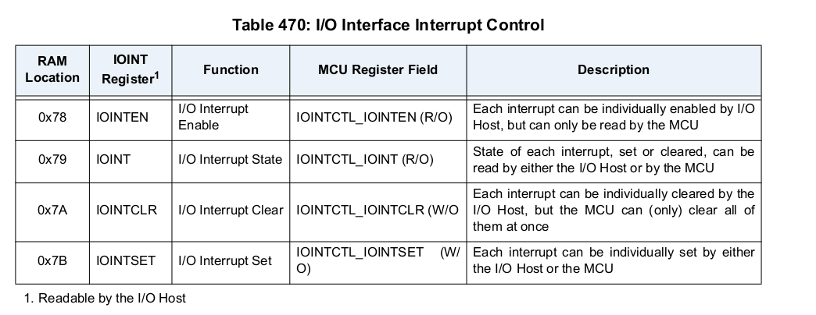
The peripheral MCU can not enable any of these interrupts, but can set, read and clear them as well. This can be done in the IOINTCTL register for the MCU.

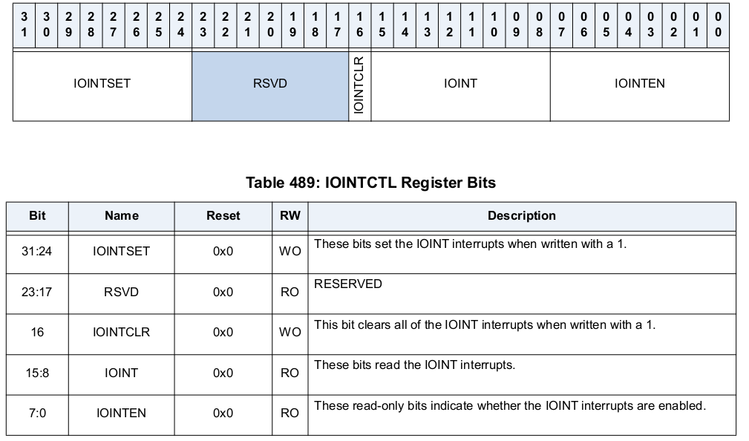
An MCU interrupt can be generated whenever the controller / host writes any IOINTW registers (for example, to clear an interrupt) so the MCU can manage the interrupt interaction. In the library this can only used for FYI. No further action is taken

8. Specials

8.1 General address
In case of I2C communication a host can write a byte/instruction to address 0x0. In the library this call is translated as if register 0x80 has been written. With a IOS.read() the byte/instruction can be obtained.

8.2 Rearranging the FIFO
When working in FIFO mode, the oldest information is obtained first (first-in, first out). The IOS has the option to push data infront of the queue instead of end and thus making it a LIFO (last in, first out). That options is NOT implemented in the library. One could use a bit in a status register to set an alert if needed.

9. My Conclusion
The IOS module is NOT able to implement a standard peripheral as I have seen on other boards.
Reason for stating this :
- Onrequest() can not be implemented. There is NO possibility to trigger this.
- The usage of FIFO and HOST registers is something special. Both peripheral and host needs to have a common understanding of the SWINTx usage.
- Only a few Apollo3 pads 0, 1, 2, 3 or 4 can be used, mainly the ATP (All The Pins) This means that IOS can not be used on these boards.

Looks to me the IOS has been written to work between two Apollo3 chips. The IOS-library opens doors to use between other boards/processors, but the implementation will be limited.

There are working examples in the library. Example1 communicates on I2C between peripheral and controller, where Exampl2 is using SPI. Both examples can be used for direct register access or FIFO interaction.

At the same time I wonder about the usage scenarios. Why would one use a board with Apollo3 as a peripheral, if you can connect a sensor directly. Also the Apollo3 has BLE standard available to exchange data.

All in all this looks a bit nice to have… and now you have it .. with working peripheral / host examples. Check it out :-)

