OneWire with UART

Table of Contents
1. Background 2
2. 1-Wire insight 3
3. The Timing Challenge 3
4. DS18S20 on V1.2.3 4
4.1 V1. Test 1 4
4.2 V1. Test 2 6
4.3 V1. Optimized setting 7
5. DS18S20 on V2.1.1 8
5.1 V2. Test 1 8
5.2 V2. Test 2 9
5.3 V2. Optimized setting 11
6. DS18S20 on Uno 1.8.4 12
6.1 Uno Test 1 12
6.2 Uno Test 2 13
6.3 Uno Not optimized 15
7. Conclusions on 1-Wire library 16
8. DS18S20 on UART 17
8.1 Hardware connection 17
8.2 Basic explanation 17
8.2.1 Reset pulse 17
8.2.2 Writing a bit 18
8.2.3 Reading a bit 18
8.3 Theory in practice 18
8.3.1 software changes 18
8.3.2 Test with library V2.1.1 19
8.3.3 Test with library V1.2.3 21
8.4 Parasite mode 22
8.5 Conclusions on UART 22
Appendix A. useful resources 23
Appendix B. DS18S20 GPIO connection 24
Appendix C. Optimized Artemis / Apollo3 setting 25
Appendix D. DS18S20 UART connection 26
Appendix E. OneWire library changes for UART 27

1. Background

OneWire is also written as 1-Wire®.

1-Wire is a communication channel that is used for a number of devices like Maxim DS18x20 temperature sensors and ibuttons. There is well known and has a great library (https://github.com/PaulStoffregen/OneWire) that works on many boards without any problem.

This library also works well on a Sparkfun® Artemis / Apollo3 board with the Sparkfun® V1.x.x library BUT NOT with the V2.x.x library.

This document will explain the root cause and provides an alternative solution by leveraging a UART to perform 1-Wire.

paulvha@hotmail.com
December 2021

Trademarks
1-Wire is a registered trademark of Maxim Integrated Products, Inc.
Maxim Integrated and the Maxim Integrated logo are trademarks of Maxim Integrated Products, Inc
Sparkfun trademark is covered on https://www.sparkfun.com/news/300

2. 1-Wire insight

Not trying to teach you everything about 1-Wire, for that there are good resources mentioned in Appendix A, but trying to provide some insight to understand the basics.

Actually there are 2 or 3 wires. The communication happens using ONE active wire and GND. The third wire is VCC (5V), although you could use the parasite mode to “steal” power from the active wire. On the active wire the master (a processor board) communicates with the slave (a device).

Master and slave are from the time where using these definitions were not an issue. Not doing politics, but also not to offend anyone, I will use controller instead of master and peripheral instead of slave. Similar approach has been taken with I2C. MOSI is now called COPI (Controller Out , peripheral In) and MISO is now called CIPO (Controller In Peripheral Out)

It all starts with the controller checking for peripherals by sending a low reset pulse of at least 480µs. When it releases the line, it checks after 70µs whether a peripheral is available as it will pull the line low. Nothing pulled low… No peripheral...

Every bitvalue discovery starts with a line change from high to low of at least 1 µs and each bit slot-time is at least 60µs. The line is sampled 15µs after the line was low. If the line is still low on the sample moment that means a logical ‘0’ (zero). If the line was released before and thus high on the sample moment that means a logical ‘1’ (one).

Either the controller or the peripheral can pull the line low and based on the protocol they both know when they are supposed to ‘listen’ to the line or ‘control’ the line level.

For a peripheral to know that the master is listening and it can start sending a byte, the controller will generate a read-time slot of at least 60µs. The controller will pull the line low for at least 1µs, once released the peripheral will now keep the line low for 15µs for a ‘0’ or does not do anything so the line stays high.

3. The Timing Challenge

We are here in the microseconds world, but still 1-Wire is only time critical on after releasing the line and the moment of performing the sample. You can extend the time-slots, you can extend the reset signal, you can extend the time the controller is pulling the line low, you can extend bit time-slots BUT once the line has been released and the controller starts listening to a peripheral the timing is what it is. It is 70µs with the presence detection after reset and 15µs to detect a ‘0’ or a ‘1’.

Let me give away the root cause on the V2.x.x Sparkfun library: due to the overhead of the integrated MBED-OS in the V2 library, it can NOT perform the 15µs sampling on time.

In this document we will demonstrate this by showing the timing on V1 and V2. Same board (Artemis ATP), same sketch, same pins BUT not the same timing. As reference I have also run the same sketch on an Arduino UNO.

4. DS18S20 on V1.2.3
When you compile the standard library you will get a warning:

#warning "OneWire. Fallback mode. using API calls for pinMode,digitalRead and digitalWrite. Operation of this library is not guaranteed on this architecture."

In the file OneWire_direct_gpio.h which is part of the standard library, the macro’s that are used can be optimized for different processors. Great work has been done to achieve the critical timing on the different platforms. However Apollo3 / Artemis platform is not recognized and hence the standard mentioned API’s will be used. This is just a warning...

For the hardware connection see Appendix B.

4.1 V1. Test 1
Concentrate on the code to read a bit. I have numbered the line, they are not in the original code

uint8_t OneWire::read_bit(void)
{
IO_REG_TYPE mask IO_REG_MASK_ATTR = bitmask; //1
volatile IO_REG_TYPE *reg IO_REG_BASE_ATTR = baseReg; //2
uint8_t r; //3

noInterrupts(); //4
DIRECT_MODE_OUTPUT(reg, mask); //5
DIRECT_WRITE_low(reg, mask); //6
delayMicroseconds(3); //7

DIRECT_MODE_INPUT(reg, mask); // let pin float, pull up will raise //8
delayMicroseconds(10); //9
r = DIRECT_READ(reg, mask); //10
interrupts(); //11
delayMicroseconds(53); //12
return r; //13
}

Line 1 and 2 get the information about the pin. This info was obtained at the creation of the instance and on some boards used for fast access.
Line 4 will disable NVIC interrupts. Line 5 will set the pin in output and drive it low (line 6) for 3 µs (line7) before releasing (line 8). Now it waits 10µs before doing the sample (line 10). Then enabling interrupts again (line 11) and wait 53 µs to make the at least 60µs bit slot-time.

In the picture below you can see the pulses taken before each line referenced.
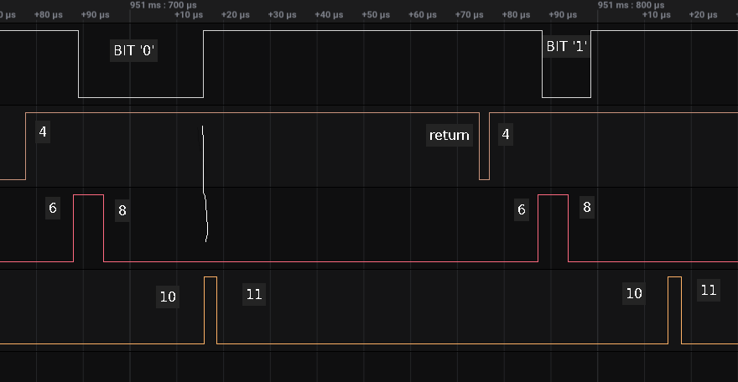
In the top while line we have 2 bits. First is a ‘0’, as the line was pulled low, and a then a ‘1’ .
On the orange line at 4, we start NoInterrupts() and setting the pin as output.
At point 6 driving the pin low and then a delay of 3µs
At point 8 the pin is set as input and a 10µs delay follows
At point 10 the sample taking starts
At point 11 the sample taking ends and start the 53µs delay
And finally it returns from read_bit() on the orange line

Now you notice that the 15µs to take the sample (pull low for a bit ‘0’) has passed (tried to indicate with line A) and at point 10 we read a “high” and determine an incorrect ‘1’.

If you look at the same steps on the second bit, the timing is the same, but as this was a ‘1’ already it would have read as 1 any way.

BUT …. let me repeat BUT… this is not completely correct. Generating a debug pulse (setting a rise and then a low) takes 3µs. Now after removing many of the pulses and shorten the delay for 3µs to take in account the read pulse.. you can see it is now just WITHIN the window !!

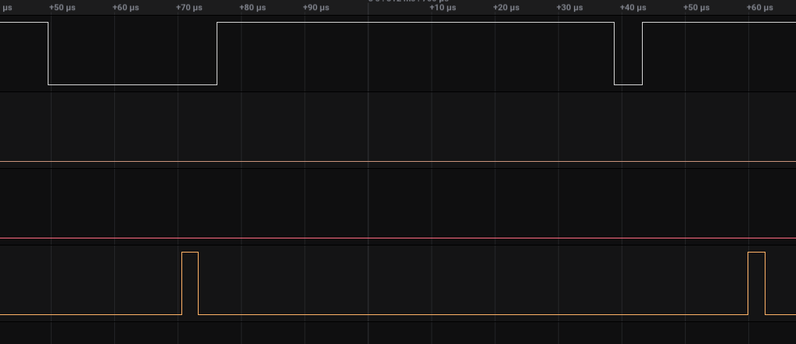

4.2 V1. Test 2
Now we do the same, BUT with removing the delays before making the sample.

uint8_t OneWire::read_bit(void)
{
IO_REG_TYPE mask IO_REG_MASK_ATTR = bitmask; //1
volatile IO_REG_TYPE *reg IO_REG_BASE_ATTR = baseReg; //2
uint8_t r; //3

noInterrupts(); //4
DIRECT_MODE_OUTPUT(reg, mask); //5
DIRECT_WRITE_low(reg, mask); //6
// delayMicroseconds(3); //7

DIRECT_MODE_INPUT(reg, mask); // let pin float, pull up will raise //8
// delayMicroseconds(10); //9
r = DIRECT_READ(reg, mask); //10
interrupts(); //11
delayMicroseconds(53); //12
return r; //13
}

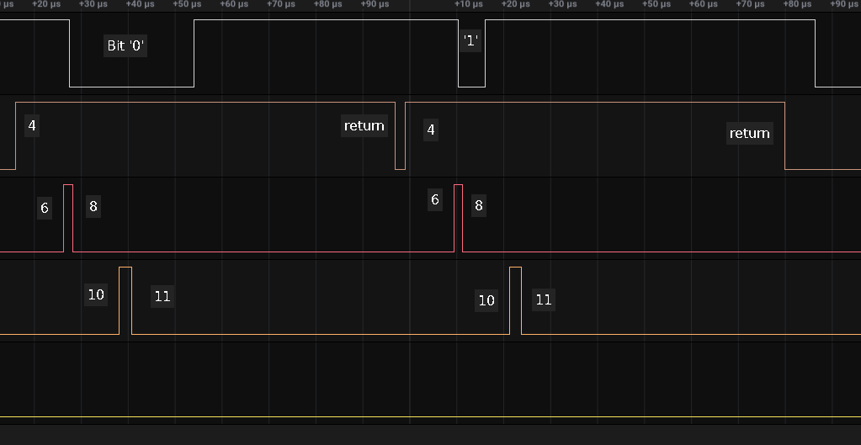
In the top while line we have 2 bits. First a ‘0’, as the line was pulled low, and a then a ‘1’ .
On the orange line at 4, we start NoInterrupts() and setting the pin as output.
At point 6 driving the pin low
At point 8 the pin is set as input
At point 10 the sample taking starts
At point 11 the sample taking ends and start the 53µs delay
And finally it returns from read_bit() on the orange line

Now you notice now at point 10 we take sample within the 15µs (pull low for a bit ‘0’) and thus it now reads correctly.

If you look at the same steps on the second bit, the timing is the same, as this is ‘1’ it read a “high”

Let ‘s note down timing :

point 4 to 6 : 12µs NoInterrupts() + pinmode change
point 6 to 8 : 2µs driving output low
point 8 to 10: 10µs pinmode change
point 10 to 11: 3µs read line
point 11 to return : 55µs the bit-time delay

4.3 V1. Optimized setting
As mentioned before in OneWire_direct_gpio.h they have optimized the reading and writing for many boards. I tried to do the same for the Artemis/ Apollo3 and I have included an entry as defined in Appendix C.

The result was that you can read the DS18S20 sensor. The timing is as follows:

point 4 to 6 : 7µs NoInterrupts() + pinmode change
point 6 to 8 : 2µs driving output low
point 8 to 10: 6µs pinmode change
point 10 to 11: 2µs read line
point 11 to return : 55µs the bit-time delay

So a little bit faster as we bypass a number of code and checks with the optimized settings.

5. DS18S20 on V2.1.1

When you compile the standard library you will get a warning:

#warning "OneWire. Fallback mode. using API calls for pinMode,digitalRead and digitalWrite. Operation of this library is not guaranteed on this architecture."

In the file OneWire_direct_gpio.h which is part of the standard library, the macro’s that are used can be optimized for different processors. Great work has been done to achieve the critical timing on the different platforms. However Apollo3 / Artemis platform is not recognized and hence the standard mentioned API’s will be used. This is just a warning...for now..

BUT worse.. you get errors and compile fails:

error: 'noInterrupts' was not declared in this scope
error: 'interrupts' was not declared in this scope

These functions are not defined in V2.1.1 apparently which was also noted in the github case https://github.com/sparkfun/Arduino_Apollo3/issues/431

For now the workaround is to define these functions in the top of OneWire.cpp just below the line #include "util/OneWire_direct_gpio.h"

void interrupts() {am_hal_interrupt_master_enable();}
void noInterrupts() {am_hal_interrupt_master_disable();}

It will all compile now.

For the hardware connection see Appendix B.

5.1 V2. Test 1
It is not even worth the effort to do a test with the standard delays. Look at the timing in test 2 and you will understand why.

5.2 V2. Test 2
Now we do the V1 test, BUT with removing the delays before making the sample.

uint8_t OneWire::read_bit(void)
{
IO_REG_TYPE mask IO_REG_MASK_ATTR = bitmask; //1
volatile IO_REG_TYPE *reg IO_REG_BASE_ATTR = baseReg; //2
uint8_t r; //3

noInterrupts(); //4
DIRECT_MODE_OUTPUT(reg, mask); //5
DIRECT_WRITE_low(reg, mask); //6
// delayMicroseconds(3); //7

DIRECT_MODE_INPUT(reg, mask); // let pin float, pull up will raise //8
// delayMicroseconds(10); //9
r = DIRECT_READ(reg, mask); //10
interrupts(); //11
delayMicroseconds(53); //12
return r; //13
}

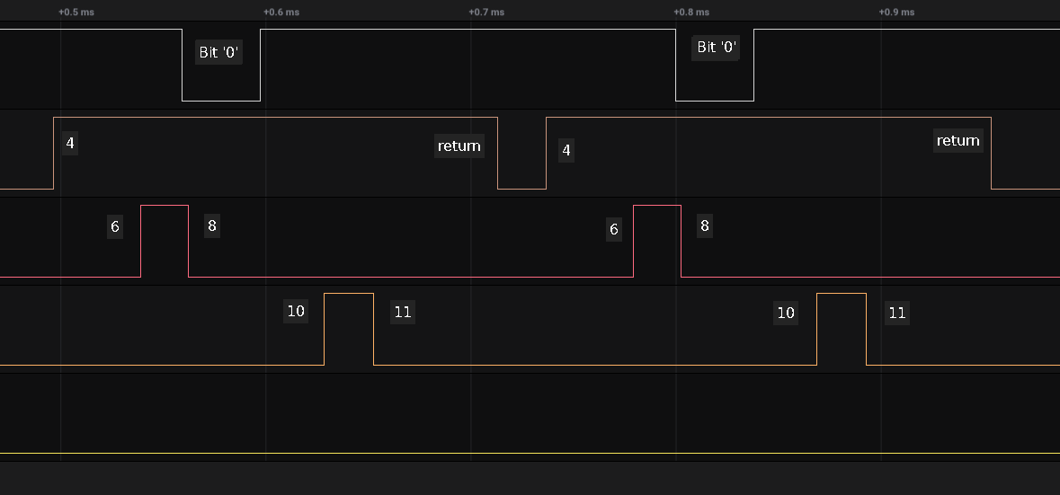
In the top while line we have 2 bits, both 0 as they are 38µs
On the orange line at 4, we start NoInterrupts() and setting the pin as output.
At point 6 driving the pin low
At point 8 the pin is set as input
At point 10 the sample taking starts
At point 11 the sample taking ends and start the 53µs delay
And finally it returns from read_bit() on the orange line

Now you notice now that the sample at point 10 is NOW FAR beyond the sample time of 15µs and of course the reading is wrong. Same in the second bit.

Let ‘s note down timing :

point 4 to 6 : 43µs NoInterrupts() + pinmode change
point 6 to 8 : 23µs driving output low
point 8 to 10: 65µs pinmode change
point 10 to 11: 24µs read line
point 11 to return : 60µs the bit-time delay

I have removed the different pulses (as done with V1) to check, but then still the sample is taken 50µs too late.

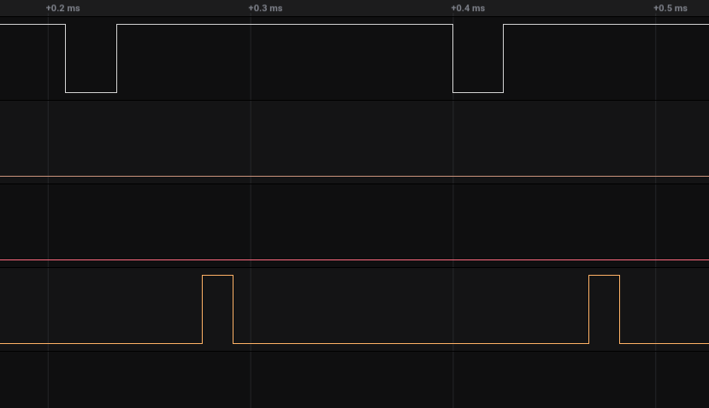

5.3 V2. Optimized setting

As mentioned before in OneWire_direct_gpio.h they have optimized the reading and writing for many boards. I tried to do the same for the Artemis and I have included an entry as defined in Appendix C.

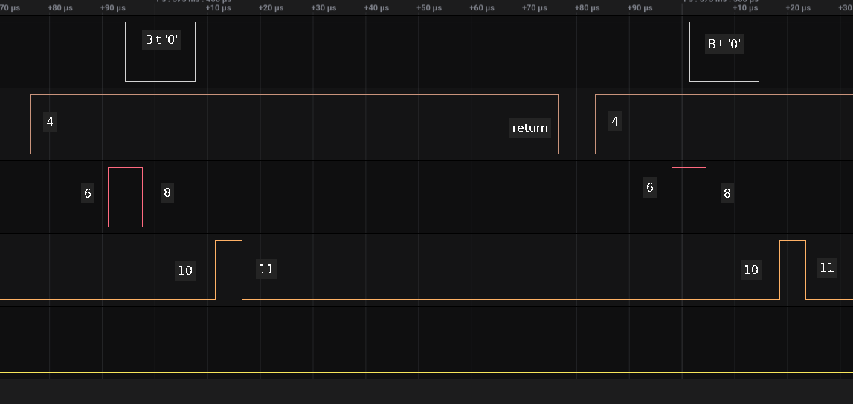
The result was that you can still NOT read the DS18S20 sensor with removing the delays (as in test2). The timing is as follows:

point 4 to 6 : 15µs NoInterrupts() + pinmode change
point 6 to 8 : 6µs driving output low
point 8 to 10: 14µs pinmode change
point 10 to 11: 5µs read line
point 11 to return : 55µs the bit-time delay

Even with removing all the debug pulses and compensating for the 3µs a debug pulse takes.. but keeping the 10µs delay.. it is still we are too late for ~20µs.
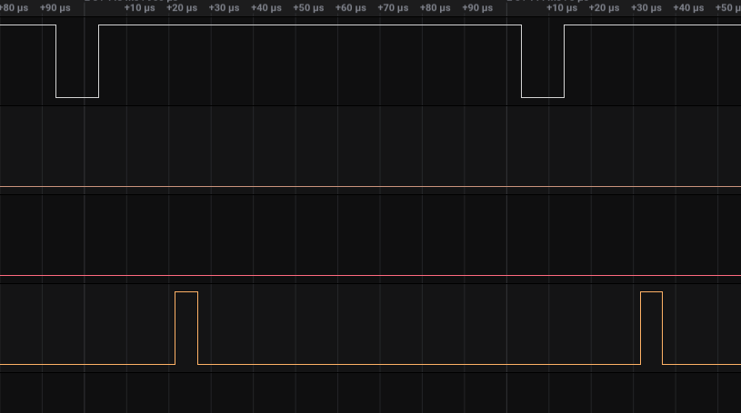
Even after removing also the 10µs delay, it is still 10µs to late..

6. DS18S20 on Uno 1.8.4
Just for compare I have taken my UNO and done both tests.

No warnings, no errors.. Just compiles.. with the speed of light.

For the hardware connection see Appendix B.

6.1 Uno Test 1
Concentrate on the code to read a bit. I have numbered the line, they are not in the original code

uint8_t OneWire::read_bit(void)
{
IO_REG_TYPE mask IO_REG_MASK_ATTR = bitmask; //1
volatile IO_REG_TYPE *reg IO_REG_BASE_ATTR = baseReg; //2
uint8_t r; //3

noInterrupts(); //4
DIRECT_MODE_OUTPUT(reg, mask); //5
DIRECT_WRITE_low(reg, mask); //6
delayMicroseconds(3); //7

DIRECT_MODE_INPUT(reg, mask); // let pin float, pull up will raise //8
delayMicroseconds(10); //9
r = DIRECT_READ(reg, mask); //10
interrupts(); //11
delayMicroseconds(53); //12
return r; //13
}

Line 1 and 2 get the information about the pin. This info was obtained at the creation of the instance and on some boards it will allow for fast access.
Line 4 will disable NVIC interrupts. Line 5 will set the pin in output and drive it low (line 6) for 3 µs (line7) before releasing (line 8). Now it waits 10µs before doing the sample (line 10). Then enabling interrupts again (line 11) and then wait 53µs to make the at least 60µs bit-time.

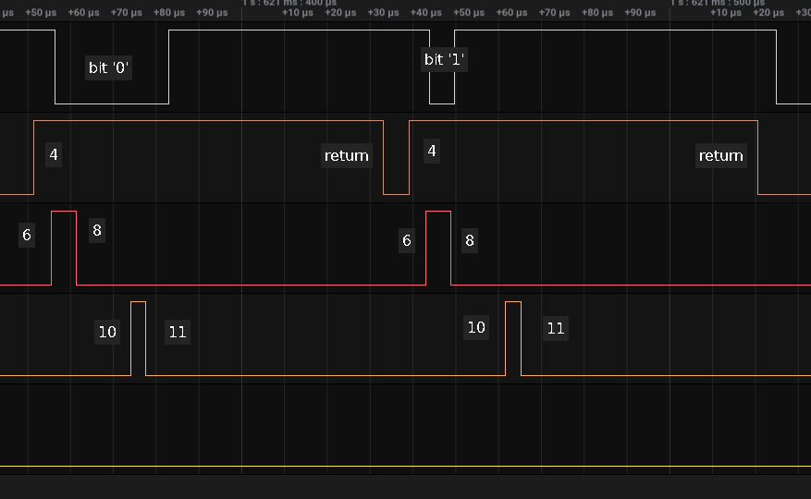
In the picture below you can see the timing taken before each line.

In the top while line we have 2 bits. First a ‘0’, as the line was pulled low, and a then a ‘1’ .
On the orange line at 4, we start NoInterrupts() and setting the pin as output.
At point 6 driving the pin low and then a delay of 3µs
At point 8 the pin is set as input and a 10µs delay follows
At point 10 the sample taking starts
At point 11 the sample taking ends and start the 53µs delay
And finally it returns from read_bit() on the orange line

Now you notice that the sample (pull low for a bit ‘0’) is perfectly taken within the window. And the sample for the second bit is also on the right time.

6.2 Uno Test 2
Now we do the same, BUT with removing the delays before making the sample.

uint8_t OneWire::read_bit(void)
{
IO_REG_TYPE mask IO_REG_MASK_ATTR = bitmask; //1
volatile IO_REG_TYPE *reg IO_REG_BASE_ATTR = baseReg; //2
uint8_t r; //3

noInterrupts(); //4
DIRECT_MODE_OUTPUT(reg, mask); //5
DIRECT_WRITE_low(reg, mask); //6
// delayMicroseconds(3); //7

DIRECT_MODE_INPUT(reg, mask); // let pin float, pull up will raise //8
// delayMicroseconds(10); //9
r = DIRECT_READ(reg, mask); //10
interrupts(); //11
delayMicroseconds(53); //12
return r; //13
}

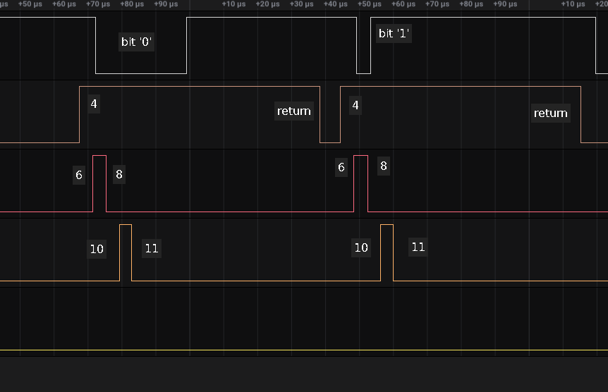
In the top while line we have 2 bits. First a ‘0’, as the line was pulled low, and a then a ‘1’ .
On the orange line at 4, we start NoInterrupts() and setting the pin as output.
At point 6 driving the pin low
At point 8 the pin is set as input
At point 10 the sample taking starts
At point 11 the sample taking ends and start the 53µs delay
And finally it returns from read_bit() on the orange line

Now you notice now at point 10 we take sample early 7µs (pull low for a bit ‘0’) and we now read it correctly.

If you look at the same steps on the second bit, the timing is the same, as this is ‘1’ it read a “high” as the line was released after 4µs

Let ‘s note down timing :

point 4 to 6 : 4µs NoInterrupts() + pinmode change
point 6 to 8 : 4µs driving output low
point 8 to 10: 4µs pinmode change
point 10 to 11: 4µs read line
point 11 to return : 55µs the bit-time delay

6.3 Uno Not optimized
OK.. now you can say that the library has been optimized for the UNO / AVR and thus high speed.
Just to test I made a small change so the default API’s would be used, same as for the Artemis, as re-run Test2. It was reading perfectly...

point 4 to 6 : 9µs NoInterrupts() + pinmode change
point 6 to 8 : 10µs driving output low
point 8 to 10: 10µs pinmode change
point 10 to 11: 8µs read line
point 11 to return : 54µs the bit-time delay

7. Conclusions on 1-Wire library
Comparing the different times (in µs)

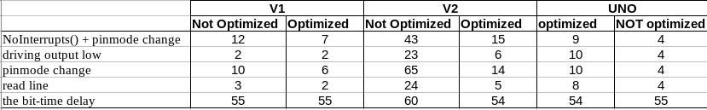
Sparkfun V1 : can run OneWire. You do NOT have to remove the delays (as with test2) or apply the optimized settings. The optimized settings can just make it more stable.

Sparkfun V2 : No chance that even with the optimized settings AND the removed the delays (as in test2) that it works. The timing just takes too long it will not work. BUT amazing to see the difference between optimized and not-optimized (e.g. bypassing MBED as much as possible). Couple of reasons :
- Everytime you use the standard API’s (pinMode, digitalRead, digitalWrite) extensive checks are done to make 100% sure it is all correct and good before making the changes on Apollo3 chip.
- There is even more code to be executed as MBED-OS is in between. Adding checks, additional code and calls.
- Even without the additional code, by comparing V1 optimized against V2 optimized, there is also impact for the MBED housekeeping. E.g. every microsecond it checks whether a task is pending to be executed, updates different variables etc. Actions of which many are NOT necessary nor used for this program.

This difference in timing I have observed also when writing SoftwareSerial for V2 and MLX90614. As soon as you get with a program in microsecond timing it has a high chance to fail on V2.

Uno : works without issues. It is faster because the board runs on very light code which directly controls the hardware without a lot of code layers in between.

8. DS18S20 on UART
As demonstrated, measured and explained in the previous chapters the famous 1-Wire libraries that all work with bit-banging do NOT work on V2 SparkFun library.

But then I found article that explained how one could use a UART to perform 1-Wire. The link to the article is mentioned in Appendix A.

To keep your attention, I’ll give away right that it DOES work on V2.

8.1 Hardware connection
In Appendix D is the hardware connection detailed.

The 1-Wire pin from the peripheral is directly connected to the controller UART RX line.
There is also a 470Ω resistor between the UART-TX and UART-RX.

When the UART-TX is idle it’s output is high and the 470Ω resistor acts as pull-up. Thus UART-RX AND the 1-Wire from the peripheral are both high.

When the UART sends a ‘0’ it pulls the UART-TX output low, thus UART-RX and the 1-Wire go low. This low will be read by BOTH the UART-RX and the peripheral.

When the peripheral sends a ‘0’ it will pull the line low and UART-RX will read that. The UART- TX stays high and the 470Ω resistor makes sure that the current stays low. When the peripheral wants to send a ‘1’ it will not touch the line, which continued to be pulled-up by the 470Ω resistor.

The nice aspect about a UART is that it can send and receive bytes at the same time.

8.2 Basic explanation
In chapter 2 is already the 1-Wire timing explained and I will use 3 examples,

A UART running a baudrate of 9600 bps has a UART-bit-time is 104.2 µs ( 1/9600). Also important to know that sending a byte always starts with the least significant bit (LSB) first AND before sending the LSB it will always generate a low start-pulse equal to the UART-bit-time. The UART is set for for 8 data bits, No parity, 1 stop bit. In total a byte takes 10 UART-bit-times to complete.

8.2.1 Reset pulse
This has to be at least 480 µs. So if we have UART-bit-time of 104.2 µs, we need to sent at least 5 UART-bit-times. The start-pulse is always generated and we need to add 4 more UART-bit-times. Remember LSB first thus setting a byte with bit 0 - 3 at ‘0’ we generate a reset pulse of 520µS. Hence we send 0xF0, pulling the line low for 521µs (sending the lower 4 bits) and then generate a HIGH, done by the pull-up resistor for 416us.(sending the 0xF part of the byte)
Now as the line goes high after the reset pulse a peripheral will generate a low on the line after about 25µs and last 100µs. This low will be read by the UART-RX and depending on after how many microseconds the low started and released, it will generate a 0x9 or 0xE0 to be read by the UART-RX. This means that if after sending the reset signal the UART has read a 0xF0, there was NO device on the line, as no low was detected.

8.2.2 Writing a bit
When reading of writing the bit-value is sampled 15µs after the line was low. When setting a UART baudrate to 115200 bps, the UART-bit-time is 8.7µs ( 1 / 115200).
When writing 0xFF, the line is first pulled low with start-pulse of 8.7µs, then the line is kept high and the peripheral and UART-RX will read a high line for 8 UART-bit-times = 69µs. This is more than the minimum 60µs for 1-wire and thus we comply with the rule. The ‘1’ bit has been successfully been sent on the wire.

When writing 0x00, the line is first pulled low with start-pulse of 8.7µs, then the line is kept low by UART-TX and the peripheral and UART-RX will read a low line for 8 UART-bit-times = 69µs + 8.7µs start-pulse = 77.7µs. This is more than the minimum 60µs for 1-wire and thus we comply with the rule. The ‘0’ bit has been successfully been sent on the wire.

8.2.3 Reading a bit
When reading of writing the bit-value is sampled 15µs after the line was low. When setting a UART baudrate to 115200 bps, the UART-bit-time is 8.7µs ( 1 / 115200).
Due to the protocol both the peripheral and the controller know who is supposed to ‘listen’ and who is supposed to ‘drive’ the line. When the peripheral is supposed to ‘drive’ and thus send a bit, it needs to get a low pulse indicating the controller is ready to listen.

When writing 0xFF, the line is first pulled low with start-pulse of 8.7µs, and with the keeps high for the 69µs. This will cause a line up with the 470Ω resistor. The peripheral got the read-time-slot start signal (the start-pulse) and if it sends a ‘0’ it will pull the line low. The UART-RX will read this ‘0’ and the read byte is something different than 0xFF.
If the peripheral planned to sent a “1’, it would not have touched the line and the UART-RX reads 0xFF.

8.3 Theory in practice

8.3.1 software changes
Started with the great standard library that is already working on soo many boards. It has good logic, good examples, works stable. So no need to reinvent and actually the changes to apply were only on a couple of places:

The 1-Wire bit-reading and bit-writing is handled in 3 low level routines.
I have added in read_bit(), write_bit() and reset() a pre-processor check. If ‘USE_UART_COMMS’ is defined they will redirect to Uart_read_bit(), Uart_write_bit() and Uart_reset().

Then there were 3 other places were a define ‘USE_UART_COMMS’ check was needed, which had to do with parasite handling. It is write(), write_bytes() and depower().

To set ‘USE_UART_COMMS’ a check on the board & V2 library is included in OneWire.h.

No need to include NoInterrupts() or interrupts() nor to add the optimized settings as defined in Appendix C, as we are not using that for Sparkfun V2 UART anymore.

A copy and instructions of the changes and the new routines are included in Appendix E.

8.3.2 Test with library V2.1.1

Connected the DS18S20 as indicated in Appendix D.

On the Artemis ATP the Serial1 was used.

Reset pulse

As in chapter 8.2.1, we write 0xF0 which sets the line low of 521us, then released by writing 0xF.

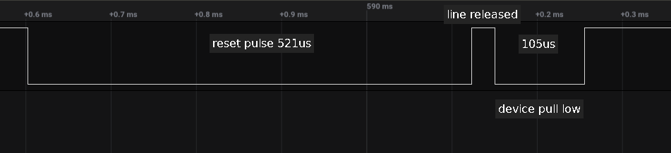

Write bit

So we first write a ‘0’ bit and then a ‘1’.
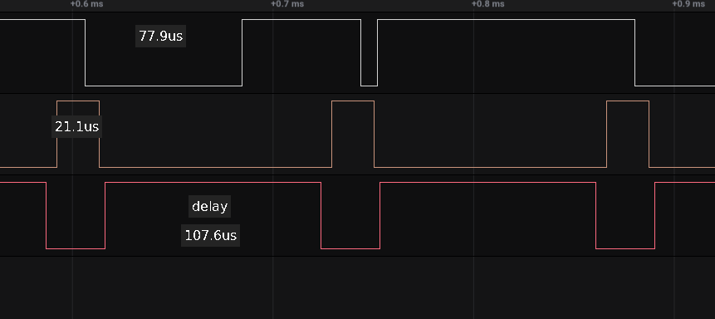
The ‘0’ bit takes 77.9µs low time. That is the start-pulse + 8 UART-bit-time low, 9 * 8.68 = 78,1µs. Close enough there is always some deviation.

The 21.1µs pulse it the time it takes to write the 0x00 byte to the UART. If we would return with the delay the complete byte would not have been sent yet. The delay is actually 100µs, but again here an overhead from MBED, so it is 107.6µs

As it writes the second byte, you see a low pulse of 8.7µs (the start-pulse) and then it writes 0xFF.

Read-bit

Here an example about receiving a ‘1’, with the length of 26.5us and a ‘0’, only the 8.7us start-pulse

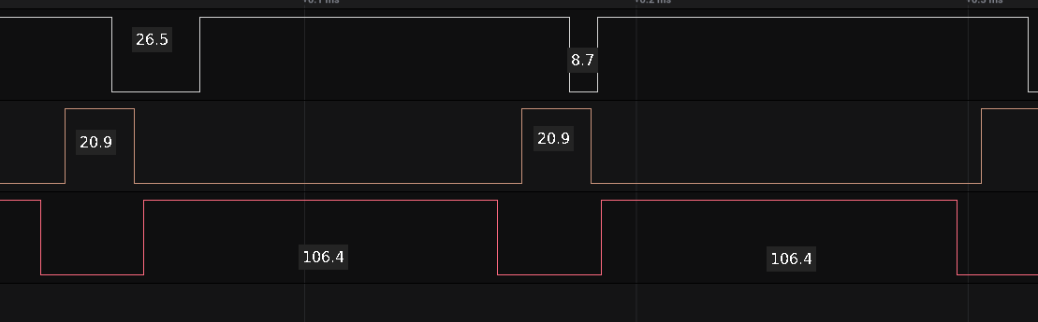
The 20.9us is the time it takes to write 0xFF and after 10.9µs the (top) white line the start-pulse can be seen from high to low. The read line shows the check for available() loop and it takes 106.4µs

The complete write of 0xFF takes 10 * 8.68 = 86.8µs. The start-pulse begins 10us before “wait for available” and hence it the character is complete in the UART 86.8 – 10 = 76.8µs in the wait cycle. It then takes about 30µs before it is received in the program.

8.3.3 Test with library V1.2.3
As I have the setup anyway and switching between the libraries is just 3 minutes of work… why not give it try.

Write -bit
This example writes 0x00 (the 78.1µs pulse on the white line). The write-call takes 23.5µs, 2.4µs longer than V2. The delay 100µs call takes 121µs, where on the V2 it was taking 107uS.

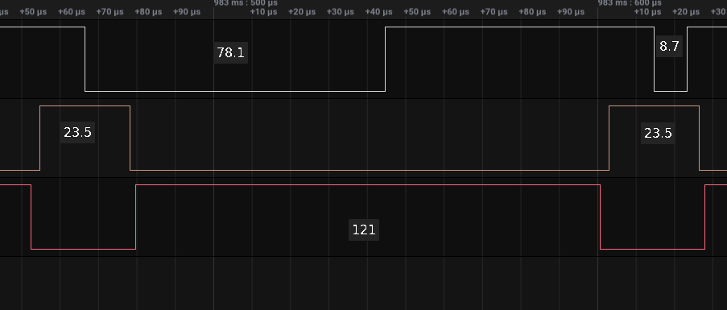
To better understand the delayMicroseconds() I have made a separate sketch just setting a pulse every 100µs. On the V1 the delay was 103µs and on V2 109.5µs. Not sure what is happening here.

Read-bit

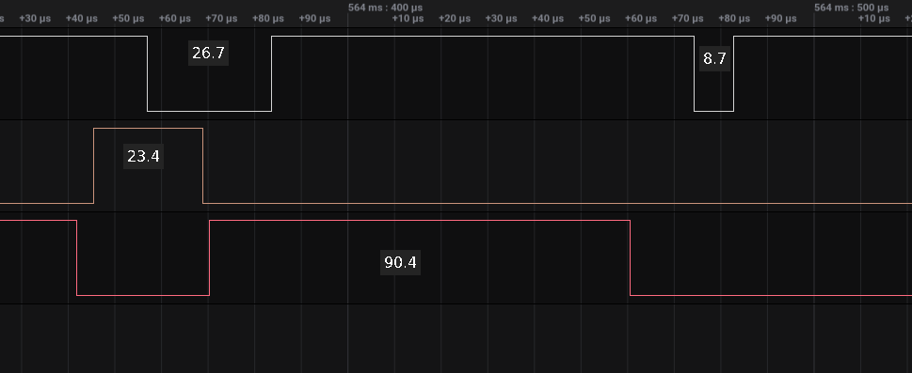
Again we see reading of a ‘0’. Performing the write takes 23.4µs which takes funny enough 2.5µs longer than on V2. The wait for available takes 90.4µs which is 16µs shorter than on V2.

The complete write of 0xFF takes 10 * 8.68 = 86.8µs. The start-pulse begins 4.5us before “wait for available” and hence it the character is complete in the UART 86.8 – 4.5 = 82.3µs after the start of the wait cycle. It then takes about 8µs before it is received in the program.

8.4 Parasite mode
Parasite mode is a trick where the DS18S20 “powered” from the active line. From the datasheet:

Another feature of the DS18S20 is the ability to operate without an external power supply. Power is instead supplied through the 1-Wire pullup resistor via the DQ (sense) pin when the bus is high. The high bus signal also charges an internal capacitor (CPP), which then supplies power to the device when the bus is low.

An idle UART-TX is high and through the 470Ω the 1-Wire is high. If you now connect a 4K7Ω between the DS18S20 1-Wire and VCC you can power the sensor.

BUT do NOT connect the VCC line at the same time to another power source !!

8.5 Conclusions on UART
The good news… 1-Wire protocol with Sparkfun library V2 can be done.. however it comes with a price as you have to sacrifice a UART port for it. You can apply this to both Sparkfun V1 and V2 library and maybe many other boards by just making a change on the OneWire.h (see Appendix E) and add the platform selection.

Appendix A. useful resources

The Ibutton book with the communication protocol:

https://pdfserv.maximintegrated.com/en/an/AN937.pdf

The DS18X20 datasheet :

https://datasheets.maximintegrated.com/en/ds/DS18S20.pdf

Description of using a UART for 1-wire:

https://www.maximintegrated.com/en/design/technical-documents/tutorials/2/214.html

The good 1-Wire library

https://github.com/PaulStoffregen/OneWire

Appendix B. DS18S20 GPIO connection

DS18S20 ATP

GND GND
VCC 5V
SENSE GPIO 23 (or the pin you selected in top of sketch)

Between SENSE and VCC have 4k7Ω pull-up resistor.

Appendix C. Optimized Artemis / Apollo3 setting

Added in the file util/OneWire_direct_gpio.h the following definition option

// Artemis / Apollo3
#elif defined (ARDUINO_ARCH_APOLLO3)

static inline __attribute__((always_inline))
uint8_t directRead(uint8_t pin)
{
uint32_t ui32PinState;
am_hal_gpio_state_read(pin, AM_HAL_GPIO_INPUT_READ, &ui32PinState);

return((uint8_t) ui32PinState);
}

#define PIN_TO_BASEREG(pin) (0)
#define PIN_TO_BITMASK(pin) (pin)
#define IO_REG_TYPE unsigned int
#define IO_REG_BASE_ATTR
#define IO_REG_MASK_ATTR
#define DIRECT_READ(base, pin) directRead(pin)
#define DIRECT_WRITE_low(base, pin) am_hal_gpio_state_write(pin, AM_HAL_GPIO_OUTPUT_CLEAR)
#define DIRECT_WRITE_high(base, pin) am_hal_gpio_state_write(pin, AM_HAL_GPIO_OUTPUT_SET)
#define DIRECT_MODE_INPUT(base, pin) am_hal_gpio_pinconfig(pin, g_AM_HAL_GPIO_INPUT)
#define DIRECT_MODE_OUTPUT(base, pin) am_hal_gpio_pinconfig(pin, g_AM_HAL_GPIO_OUTPUT)
//#warning "OneWire for Artemis & Apollo3 V1"

#endif //ARDUINO_ARCH_APOLLO3

Appendix D. DS18S20 UART connection

DS18S20 ATP

GND GND
VCC 5V
SENSE UART RX – 470Ω – UART TX

Between UART RX and UART TX have 470Ω pull-up resistor.

NO PULL-UP BETWEEN VCC AND SENSE !

Parasite mode See chapter 8.4 !

DS18S20 ATP

GND GND
VCC - 4K7Ω – SENSE
SENSE UART RX – 470Ω – UART TX

Between UART RX and UART TX have 470Ω pull-up resistor.
Between SENSE and VCC have a 4K7Ω pull-up resistor.

NO CONNECTION BETWEEN VCC AND EXTERNAL POWER SOURCE.

Appendix E. OneWire library changes for UART

Changes are made in 2 files of the library: OneWire.cpp and OneWire.h

OneWire.h : 2 changes !

In the top added :

//*****************************************************************
// On V2 Apollo3, with MBED included, the timing is NOT possible
// hence a UART interface has been included.
// Idea based on
// https://www.maximintegrated.com/en/design/technical-documents/tutorials/2/214.html
//
// December 2021 / paulvha
//******************************************************************
#if defined (ARDUINO_ARCH_APOLLO3) && defined (ARDUINO_ARCH_MBED)
#define USE_UART_COMMS 1
#endif

This can be extended to add other boards

In the private section :

#if USE_UART_COMMS // special add for UART
#define UART_SERIAL Serial1
uint8_t Uart_read_bit();
uint8_t Uart_reset();
void Uart_write_bit(uint8_t v);
void Uart_set_serial(unsigned long baudrate);
#endif

OneWire.cpp : 10 changes

In read_bit() add at the top:

#if defined (USE_UART_COMMS)
return(Uart_read_bit());
#else

In write_bit() add at the top :

#if defined (USE_UART_COMMS)
Uart_write_bit(v);
#else

In reset() add at the top:

#if defined (USE_UART_COMMS)
return(Uart_reset());
#else

add the end in the routines write_bit() AND read_bit() and reset() add:

#endif

You can add this anywhere in OneWire.cpp.

/********************************************************************
* Special addition for using UART instead of GPIO
* version 1.0 / December 2021 / paulvha
*******************************************************************/
#if defined (USE_UART_COMMS)

/*
* will reset the bus and check for a device presence flag
* return : 1 if present else 0
*/
uint8_t OneWire::Uart_reset()
{
// Send reset pulse (at least 480us) and read the response
// At 9600 the bit time is 104us
// the UART start bit is always low and then sending starting LSB first
// setting bits 0 - 3 as zero + start low = 5 x 104 = 520us low
// Hence sending 0xF0

Uart_set_serial(9600);

UART_SERIAL.write((uint8_t) 0xF0); // send reset bit time

// the Reset Time High of min 480us needs to happen
// 0XF is 4 x 104 = 404us to at least another 80 to go
// 100 to be save
delayMicroseconds(100);

while (!UART_SERIAL.available());

// During sending the MSB portion (0xF) a device
// on the bus will pull the line low.
// The read value should have the LSB portion (0) and
// then the MSB will read something like 0xE0 or 0x90

char c = UART_SERIAL.read();

// the Reset Time High of min 480us needs to happen
delayMicroseconds(400);

// if no MSB bit was low, there is NO device
if (c == 0xF0) return 0;

// printf("DS18x20 device presence %x\r\n", c & 0xff);
return 1;
}

/* Generates the read-time slot and reads a bit-value from the device.
* return 1 or 0
*/
uint8_t OneWire::Uart_read_bit()
{
// A read-time slot is initiated by the master device pulling the
// 1-Wire bus low for a minimum of 1μs and then releasing
// the bus. Now look for a '1' (high) or '0' (low) in 15us.

// setting the clock to 115200 will generate a bit time of 8.7us.
// the start bit is already low, so writing 0xff will generate the
// read-time slot.
// A '1' or '0' will follow and can be read.

Uart_set_serial(115200);

// flush anything that has been received before
while (UART_SERIAL.available()) UART_SERIAL.read();

UART_SERIAL.write((int8_t) 0xFF); // check pattern

while (!UART_SERIAL.available());

char c = UART_SERIAL.read();

// The read value change should be in the LSB portion.
// The device will keep the line low for 15us for a '0'. As LSB is
// send first the first 15 / 8.7us = 2 bits will be zero thus
// the character read is 0xFC.
//
// For a '1' the device will NOT pull the line low and thus 0xff.

if (c == 0xFF) return 1;

return 0;
}

// Generates the bit timing to simulate a '0' or a '1' bit.
// @param v : bit value to write
void OneWire::Uart_write_bit(uint8_t v)
{
Uart_set_serial(115200);

if (v & 1) UART_SERIAL.write((uint8_t) 0xFF); // write '1'
else UART_SERIAL.write((uint8_t) 0x00); // write '0'

// wait for write of Byte (representing bit timing) completes
// at 115200 that is 86.8us. 100us is taken to be save
delayMicroseconds(100);
}

// set Serial UART in specified baudrate
void OneWire::Uart_set_serial(unsigned long baudrate)
{
static unsigned long current_baudrate = 0;

// only change speed if not in requested speed
if (current_baudrate == baudrate) return;

UART_SERIAL.begin(baudrate);

current_baudrate = baudrate;

// It happens that the spontanious character is
// generated when setting the UART.
// this removes anything that was generated
while(UART_SERIAL.available()) UART_SERIAL.read();
}

#endif //USE_UART_COMMS

In write() AND in write_bytes () make the change in BOTH routines to disable parasite usage
change :

if (!power) {
noInterrupts();
DIRECT_MODE_INPUT(baseReg, bitmask);
DIRECT_WRITE_LOW(baseReg, bitmask);
interrupts();
}

to:

#ifndef USE_UART_COMMS
if (!power) {
noInterrupts();
DIRECT_MODE_INPUT(baseReg, bitmask);
DIRECT_WRITE_LOW(baseReg, bitmask);
interrupts();
}
#endif

In depower() to disable parasite

change:
noInterrupts();
DIRECT_MODE_INPUT(baseReg, bitmask);
interrupts();

To:

#ifndef USE_UART_COMMS
noInterrupts();
DIRECT_MODE_INPUT(baseReg, bitmask);
interrupts();
#endif

