BME280 connected to Raspberry Pi

Table of Contents
1. Background 1
2. Board layout 2
3. Installation 3
3.1 BCM2835 library 3
3.2 twowire library 3
3.3 BME280 software 3
4 Sensor driver 4
5 BME280 program 4
5.1 Initialize variables 5
5.2 parse parameters 5
5.3 Initialize hardware 5
5.4 main loop 5
5.5 closeout 5
5.6 Parameter allowed 5
5.7 Output formatting 7
6 A word on the twowire library 8
Appendix 1 Schematics 9

1. Background

This project is part of a number of projects to measure the air quality I run into BME280 sensor from Bosch, which can measure temperature, pressure and humidity. The board is the Adafruit BME280 I@C/SPI temperature Humidity Pressure Sensor (ada-2652)

The board and sensors are well documented and there is software available for Arduino. I have studied that code and made a version for the Raspberry PI.

In a separate project I have connected the Sparkfun Combo board as well as a separate CCS811 board. All code has been ported to Raspberry Pi and is available on github.

Paul van Haastrecht
paulvha@hotmail.com

2. Board layout

Source : https://learn.adafruit.com/adafruit-ccs811-air-quality-sensor/arduino-wiring-test

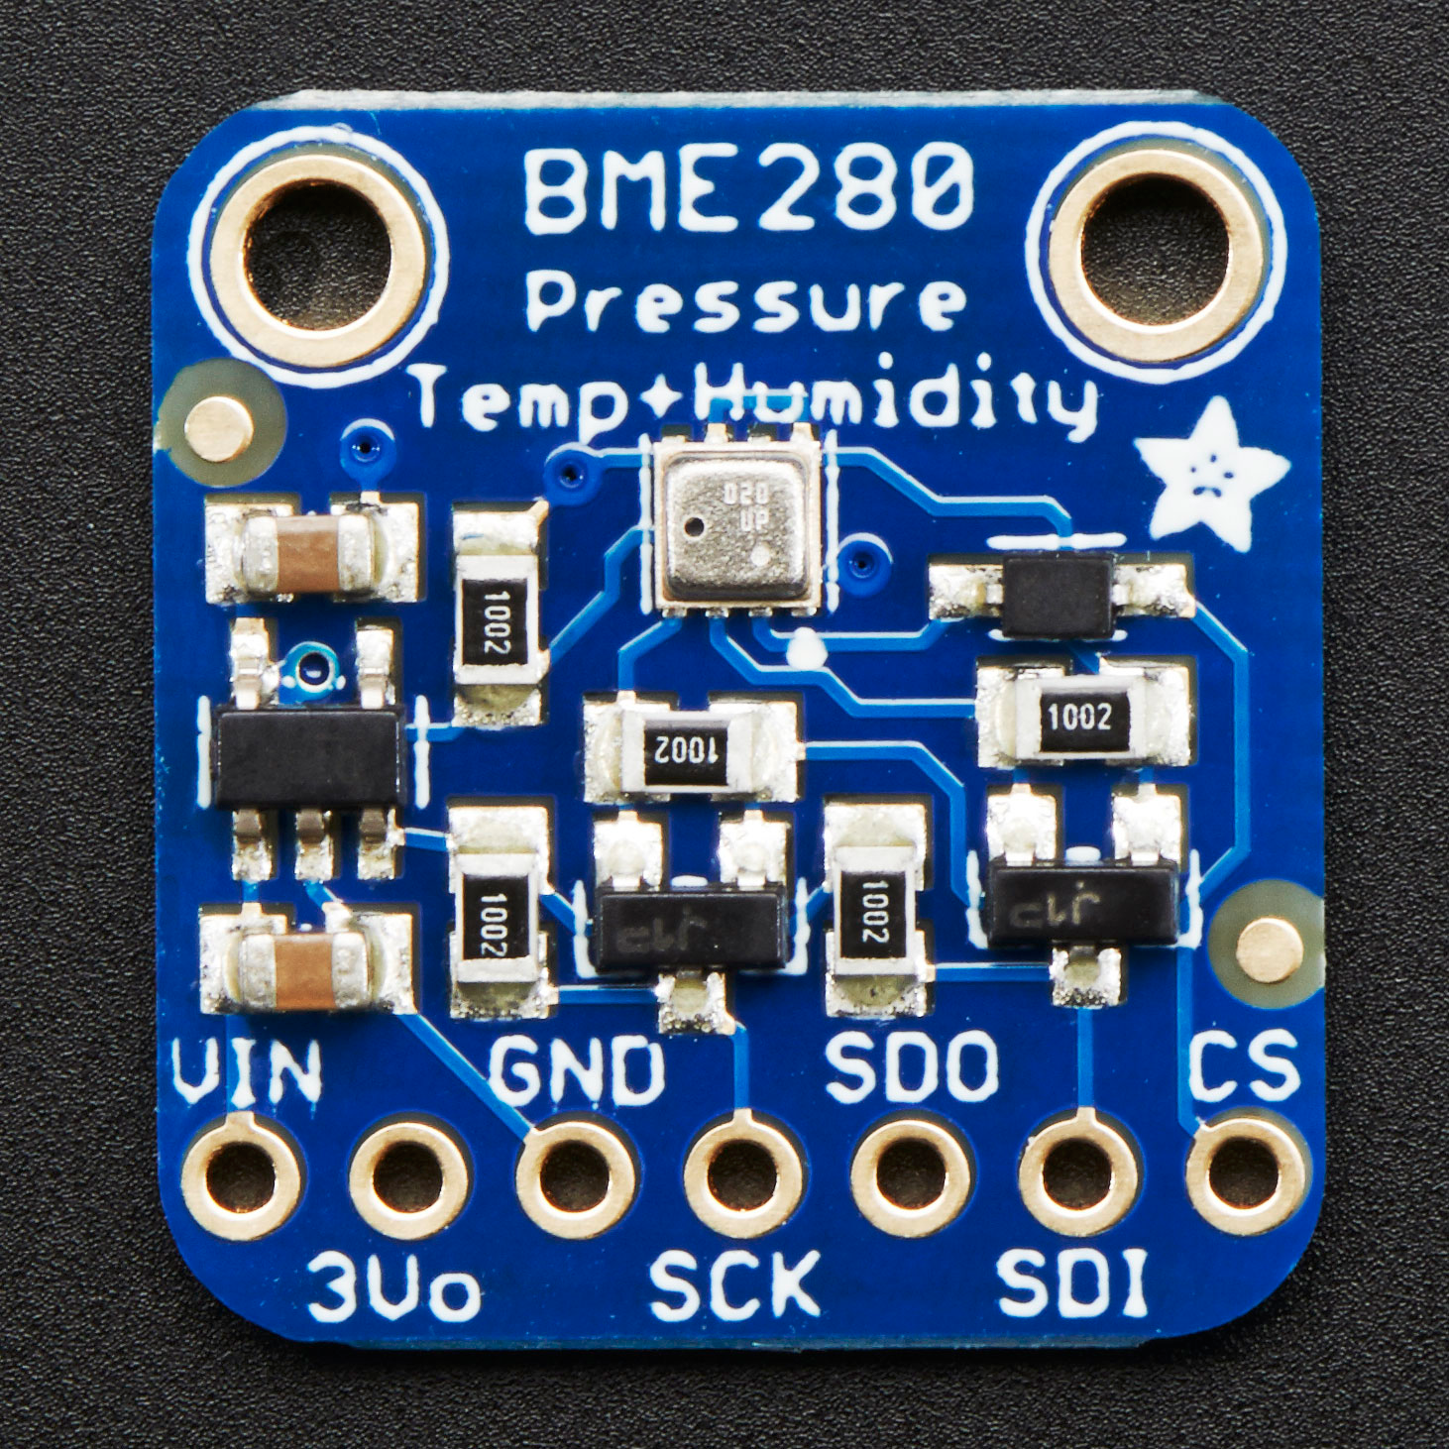
Power Pins:
- Vin - this is the power pin. Since the sensor chip uses 3 VDC, we have included a voltage regulator on board that will take 3-5VDC and safely convert it down. To power the board, give it the same power as the logic level of your microcontroller - e.g. for a 5V micro like Arduino, use 5V
- 3Vo - this is the 3.3V output from the voltage regulator, you can grab up to 100mA from this if you like
- GND - common ground for power and logic
SPI Logic pins:

All pins going into the breakout have level shifting circuitry to make them 3-5V logic level safe. Use whatever logic level is on Vin!
- SCK - This is the SPI Clock pin, its an input to the chip
- SDO - this is the Serial Data Out / Master In Slave Out pin, for data sent from the BMP183 to your processor
- SDI - this is the Serial Data In / Master Out Slave In pin, for data sent from your processor to the BME280
- CS - this is the Chip Select pin, drop it low to start an SPI transaction. Its an input to the chip
If you want to connect multiple BME280's to one microcontroller, have them share the SDI, SDO and SCK pins. Then assign each one a unique CS pin.
I2C Logic pins:
- SCK - this is also the I2C clock pin, connect to your microcontrollers I2C clock line.
- SDI - this is also the I2C data pin, connect to your microcontrollers I2C data line.
Leave the other pins disconnected
By default, the i2c address is 0x77. If you add a jumper from SDO to GND, the address will change to 0x76.3. Software

3. Installation

As with many of my projects I make use of the BCM23008 library to control the IO. The reason is that it is faster and more flexible than the wiringPi (which makes use of the official kernel drivers) and provides direct control and insight, which I like.

3.1 BCM2835 library
Install latest from BCM2835 from : http://www.airspayce.com/mikem/bcm2835/

1. wget http://www.airspayce.com/mikem/bcm2835/bcm2835-1.56.tar.gz
2. tar -zxf bcm2835-1.56.tar.gz // 1.56 was version number at the time of writing
3. cd bcm2835-1.56
4. ./configure
5. sudo make check
6. sudo make install

In order for this software to run you should NOT enable i2C in raspi-config to load the kernel drivers. It works directly on the hardware, but you’ll have to run program as root.

3.2 twowire library
Obtain the latest version from : https://github.com/paulvha/twowire

1. download the zip-file (clone or download / download zip-file) in the wanted directory
2. unzip twowire-master.zip (*1)
3. cd twowire-master
4. make install

*1) if you do not have unzip : sudo apt-get install zip unzip

3.3 BME280 software
Obtain the latest version from : https://github.com/paulvha/bme280

1. Download the zip-file (clone or download / download zip-file) in the wanted directory
2. unzip bme280-master.zip (*1)
3. cd bme280-master
4. create the executable : make
5. To run you have to be as sudo ./bme280 -h ….

In the software package you will find the following files

bme280_lib.cpp :
This is the main driver for the BME280. The driver is based on the original version from SparkFun written for the Arduino, but adjusted and extended to work on the Raspberry Pi. Some routines have been added, a number have been changed.

bme280.cpp :
This is the user level program that will be discussed in detail in a next section.

BME280.h :
This is the header file for the BME280. It is based on the original version from SparkFun written for the Arduino, but adjusted and extended to work on the Raspberry Pi.

makefile :
script to compile the source and create an executable with the make command.

4 Sensor driver

The BME280 driver has one class. While there are less driver routines, the driver has a number of complex calculations to provide the temperature, humidity and pressure. These are IMPOSSIBLE to understand and nowhere explained. Also not in the original libraries from Bosch on the BMD280, SM500, BME085 etc. etc. They are documented in the data-sheet and that is what has been implemented.

The temperature results looked correct comparing to other sensors running at the same time, the humidity looked lower ( +8%), but the pressure looked good.

There is a routine to read the altitude based on the pressure (either in meter or feet), but that was assuming the standard defined pressure at sea level. I have changed that so one can now provide that yourself (e.g. from different websites) and compare that the obtained local pressure. Next to that the Arduino library was mixing returning error messages and results. The check on error was not happening in many places. That has been changed.

5 BME280 program

The program it self has a number of big blocks

- Initialize variables to default settings
- parse parameters
- Initialize hardware (BCM2835 + sensor)
- Main-loop to provide output
- closeout()

5.1 Initialize variables
Default values for the different parameters are loaded and result variables reset. The defaults are hard coded, based on the different Arduino .ino files and only a few adjusted based on expected usage.

5.2 parse parameters
The program has a rich set of command line option (see 3.3.6 in detail later) to change many default settings. This can either be input on the command line, or loaded from files that have been created before with the stored values

5.3 Initialize hardware
The BCM2835 is initialized with the different parameters.

5.4 main loop
The program will loop for reading, either a fixed number of times or endless (depending on the parameter). The output of can be defined with parameters by the user and will be displayed on the screen, but also be saved to a file if the user wants that.

5.5 closeout
Either close with Control-C or it will count down the number loops. After that the sensor BME280 will be put on hold and the BCM2835 reset to the standard values

5.6 Parameter allowed
Please make sure to check the data sheet BME280 for the exact impact of some of the parameters.

-A address:
The i2C address can be changed from the default 0x77 to 0x76.

-F filter:
Adjust the filter coefficient setting from the default 4 (highest). With this option the IIR filter can be set to reduce the impact of sudden changes (e.g. slamming door) on temperature and pressure. The higher the value, the better smoothing out changes, but the more samples are needed to get to the real, current value. No impact on humidity.

-H oversampling:
Change the level of oversampling the humidity from level 5 (the highest x 16) to a lower level. The more oversampling the less noise on the results.

-M pressure:
Calculate the hight of the current location in meters compared to sea level. This is based on the provided current pressure of a place nearby at sea level (from an external website) and than compared against the local pressure. Must bee 6 digitis (like 102300)

-P oversampling:
Change the level of oversampling the pressure from level 5 (the highest x 16) to a lower level. The more oversampling the less noise on the results.

-R run mode
Change the default (3 normal mode for continuous measurement) to mode 1 or 2 which is a forced one time measurement.

-T oversampling:
Change the level of oversampling the temperature from level 5 (the highest x 16) to a lower level. The more oversampling the less noise on the results.

Parameters for General

-B
This will trigger to output results without color on the screen.

-L count:
This will change the default endless loop (0) to a number of loops for the mainloop before exiting

-D delay:
This will change the calculated delay to a forced delay in seconds. The default delay is 5 seconds. Maximum is 16 bits..

-O string:
This will allow flexible output formatting. See chapter 3.3.7.

-V verbose:
This will enable progress/debug information.

-W file:
Append the displayed output to the file.

Parameters for I2C

-i
This will trigger the twowire library to use hardware I2C instead of software I2C ( *1)

-I speed:
This will change the default 100Khz i2C speed to a value between 1 (Khz) to 400 (Khz)

-s #
change the soft_I2C SDA from default (GPIO 2) to another GPIO.

-d #
change the soft_I2C SCL from default (GPIO 3) to another GPIO

Note :
*1 if you set as hard_I2C you must run the program as root/super user.

5.7 Output formatting
By default the temperature and humidity values are only output

The user can (with the -O option) create their own output format :

BME280 results
T = temperature in C
H = humidity
P = pressure
M = height in meters (assumes that -M current pressure was applied else 1023mBar)

Markup
\l include local time
\t include tab
\s include space
\, include comma
\; include semicolon
\n include newline
\\\x include the character x (x can be any character, TRIPLE SLASH!!)

Example -O “\lctTP”, will result in :
Tue Dec 12 20:18:34 2017 Temp: 20.53 Pressure: 101247.53

Example -O “\lct\nT\,H”, will result in :
Tue Dec 12 20:18:34 2017
Temp: 20.53, Humidity: 34.93

6 A word on the twowire library

The BCM2835 chip provides I2C communication protocol from the hardware. However the clock stretching implementation is bad, leading to many issues with slave devices that depend on or use clock stretching to handle the requests. (e.g. CCS811, SCD30 ) This library can handle that.

This library for the Raspberry Pi can be instructed to use the standard (hardware) I2C communication OR use a software version that supports clock stretching on any of the GPIO pins. This also supports for you to run multiple I2C channels at the same time on different GPIO. To have low processor load and increase stability, the maximum speed that is supported for the soft_I2C is 200Khz. However for compatibility reasons a higher speed request (max. 400Khz) will be accepted, which can be executed by hardware I2C communication, but for software I2C the maximum executed will be around 200Khz.

Note : The BME280 does NOT use clock stretching however and can be used to run with the hardware I2C communicator without any problems.

software version :
advantage:
can run multiple I2C channels for different programs in parallel
flexible on GPIO’s to use
run as any user (does not need root permission)
supports proper clock-stretch

disadvantage:
generates some process load (although acceptable low)
quality of communication depending on total processor load
supports speeds up to max 200Khz

hardware version :
advantage
generates lower process load
less / no dependency on processor load from other programs
supports speeds up to max 400Khz

disadvantage
single channel
fixed GPIO’s ( 2 and 3)
must be root or super user.
No clock-stretch support

Appendix 1 Schematics

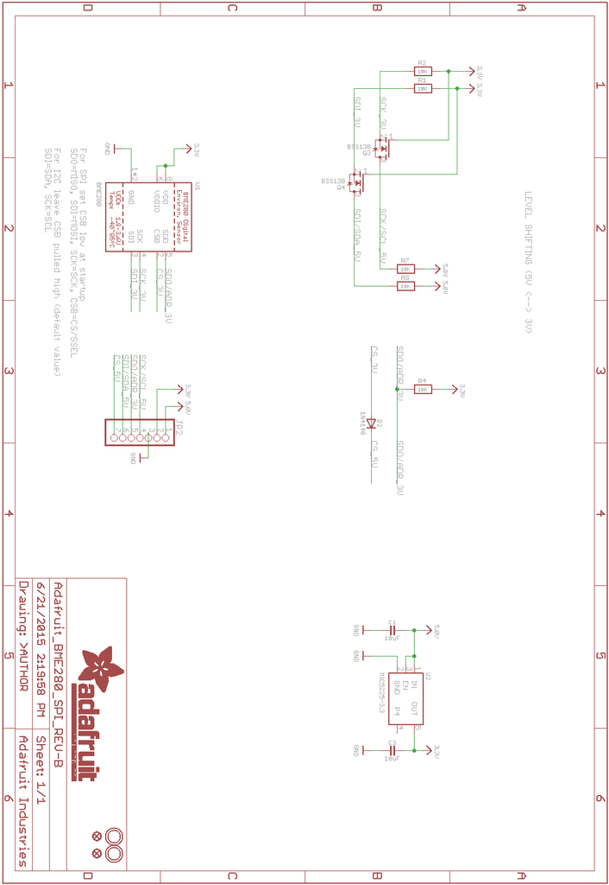
Source : https://learn.adafruit.com/adafruit-ccs811-air-quality-sensor/arduino-wiring-test

