CCS811 connected to Raspberry PI

Table of Contents
1. Background 2
2. Board information 3
2.1 Board connections 3
2.2 Connection to Raspberry Pi 4
3. software installation 4
3.1 BCM2835 library 4
3.2 twowire library 5
3.3 CCS811 software 5
4. Sensor program structure 6
4.1 Sensor Driver 6
4.2 CCS811 program 6
4.2.2 Initialize variables 6
4.2.2 parse parameters 6
4.2.3 Initialize hardware 7
4.2.4 main loop 7
4.2.5 closeout 7
4.3 CCS811 program parameters 7
4.4 CCS811 program output formatting 9
5. A word on the twowire library 10
Appendix A. CCS811 Schema 11
Appendix B : example of parameter file 12

1. Background

This project is part of a number of projects to measure the air quality I run into CCS811 sensor , which can measure temperature, CO2 and TVOC. The board is the Adafruit CCS811 I2C/SPI Adafruit CCS811 Air Quality Sensor

The board and sensors are well documented and there is software available for Arduino. I have studied that code and made a version for the Raspberry PI.

In a separate project I have connected the Sparkfun Combo board as well as a separate BME280 board. All code has been ported to Raspberry Pi and is available on github.

Paul van Haastrecht
paulvha@hotmail.com

2. Board information

Source : https://learn.adafruit.com/adafruit-ccs811-air-quality-sensor

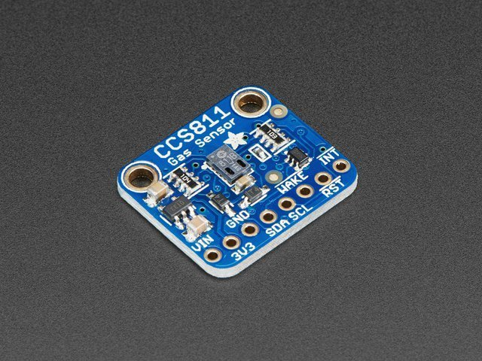

2.1 Board connections
- Connect Vin to the power supply, 3-5V is fine. Use the same voltage that the microcontroller logic is based off of. For most Arduinos, that is 5V
- Connect GND to common power/data ground
- Connect the SCL pin to the I2C clock SCL pin on your computer.
- Connect the SDA pin to the I2C data SDA pin on your computer.
- Connect the WAKE pin to GPIO pin
- connect the RST pin to GPIO

This sensor uses I2C address 0x5A.

2.2 Connection to Raspberry Pi

CCS811 description Raspberry Pi
GPIO / PIN
Vin power in 3 -5 V 3V3 or 5V / 1 or 2
3V3 power out 3V3 (100mA) Not connected
GND ground GND / 6
SDA Serial data 2 / 3 (*2)
SCL Serial Clock 3 / 5 (*2)
WAK Input : Wake-up 6 / 30 (*3)

RST Input : Hardware Reset 5 / 29 (*3)

INT Output : interrupt line 0 (optional *1)

*1) Interrupt line
The CCS-811 can be set to pull the INT output low, in case data is available. I have implemented both in the program: polling mode and using interrupt as a trigger. If you don’t want to use the interrupt, just do not specify an interrupt GPIO as parameter. Polling mode is by default set in the program.

*2 SDA/SCL
When using soft_I2C (which is default) SDA or SCL can be set to any GPIO, see chapter 4

*3 WAKE and RST
This can be set to any GPIO, see chapter 4

3. software installation
As with many of my projects I make use of the BCM23008 library to control the IO. The reason is that it is faster and more flexible than the wiringPi (which makes use of the official kernel drivers) and provides direct control and insight, which I like.

3.1 BCM2835 library
Install latest from BCM2835 from : http://www.airspayce.com/mikem/bcm2835/

1. wget http://www.airspayce.com/mikem/bcm2835/bcm2835-1.56.tar.gz
2. tar -zxf bcm2835-1.56.tar.gz // 1.56 was version number at the time of writing
3. cd bcm2835-1.56
4. ./configure
5. sudo make check
6. sudo make install

In order for this software to run you should NOT enable i2C in raspi-config to load the kernel drivers. It works directly on the hardware, but you’ll have to run program as root.

3.2 twowire library
Obtain the latest version from : https://github.com/paulvha/twowire

1. download the zip-file (clone or download / download zip-file) in the wanted directory
2. unzip twowire-master.zip (*1)
3. cd twowire-master
4. make install

*1) if you do not have unzip : sudo apt-get install zip unzip

3.3 CCS811 software
Obtain the latest version from : https://github.com/paulvha/ccs811

1. Download the zip-file (clone or download / download zip-file) in the wanted directory
2. unzip ccs811-master.zip (*1)
3. cd ccs811-master
4. create the executable : make
5. To run you have to be as sudo ./ccs811 -h ….

In the software package you will find the following files

ccs811_lib.cpp :
This is the main driver for the CCS811. The driver is based on the original version from SparkFun written for the Arduino, but adjusted and extended to work on the Raspberry Pi. Some routines have been added, a number have been changed.

ccs811.cpp :
This is the user level program that will be discussed in detail in a next section.

ccs811.h :
This is the header file for the CCS811. It is based on the original version from SparkFun written for the Arduino, but adjusted and extended to work on the Raspberry Pi.
Dylos.c
This is the driver to read a the data from a Dylos 1700 device and then display with the ccs811.cpp program

makefile :
script to compile the source and create an executable with the make command.

4. Sensor program structure

4.1 Sensor Driver
The CCS811 has a relative simple driver, split between a CORE-class and CSS811-class. In the CORE-class are all the low-level communication routines between the CCS811 and the hardware of the Raspberry Pi. It is also here where I have made most changes and added the BCM2835 routines. In the CCS811-class are the routines to connect to the user program.

Between the user program and the driver I have created a “settings” section to share the parameters. I have left as much as possible the same structure in place as with the original library, just in case someone worked on that before. I did implement however that the WAKE- signal is controlled by the program, as well as a RST / hardware-reset.

The I2C interface was a bit of challenge. When running the boot-loader program it responded well most of the time on 100Khz, but as soon as the application level was started, the response on a read (which is supported according to the data-sheet) was always 0xff and sometimes NACK errors. It turned out that the CCS811 is using clock-stretch and this very badly implemented in the BCM2835 chip. Hence I has created the twowire library that does support clock stretching as it should. (see more in later chapter). Now it works as a charm.

4.2 CCS811 program

The program it self has a number of big blocks

- Initialize variables to default settings
- parse parameters
- Initialize hardware (BCM + sensors)
- Main-loop to provide output
- closeout()

4.2.2 Initialize variables
Default values for the different parameters are loaded and result variables reset. The defaults are hard coded, based on the different Arduino .ino files and only a few adjusted based on expected usage.

4.2.2 parse parameters
The program has a rich set of command line option (see 4.3 in detail later) to change many default settings. This can either be input on the command line, or loaded from files that have been created before with the stored values

4.2.3 Initialize hardware
The BCM2835 and CCS811 are always initialized with the different parameters. The Dylos is optional. If interrupt GPIO has been provided, this program will adjusted to be triggered by a low on that GPIO.

4.2.4 main loop
The program will loop for reading, either a fixed number of times or endless (depending on the parameter). The output of can be defined with parameters by the user and will be displayed on the screen, but also be saved to a file if the user wants that.

4.2.5 closeout
Either close with Control-C or it will count down the number loops. After that the sensor CCS811 will be put on hold and the BCM2835 reset to the standard values

4.3 CCS811 program parameters
Please make sure to check the data- sheet for CCS811 for the exact impact of some of the parameters.

The following parameters can be set for the CCS811:

-a address :
The i2C address can be changed from the default 0x5A to 0x5B. 0x5A is default for the Arduino CCS811, while 0x5B is for the combo from Sparkfun

-r GPIO :
The RST GPIO can be adjusted from default GPIO 6 to a GPIO between 2 and 27.

-w GPIO :
The WAKE GPIO can be adjusted from default GPIO5 to a GPIO between 2 and 27.

-i GPIO :
Optional. The interrupt GPIO can be set a GPIO between 2 and 27. This will change the program from polling for data available on the CCS811 to be interrupt driven.

-m level:
This will change the run mode from the default 2 (every 10 seconds) to a level between 1 and 4 (see data-sheet)

-b baseline:
Set a baseline as starting point. Baseline is an adjustment that is dynamically adjusted by the CCS811 to improve the results. With this option you can provide a (known) baseline from previous measurement to improve the results from the start.

-S file:
During the measurement cycle save the dynamically adjusted baseline to a file.

-G file:
Same as -b option , but now read the baseline starting point from a previous save (with -S) file

-o number
The temperature reading can be overstated due to heating of the components on the CCS811. The number provided will subtracted from the reading/ calculation. (note : Sparkfun combo does not have an NTC and does not support this !)

-t number
Compensate the CCS811 CO2 results with a temperature.

-u number
Compensate the CCS811 CO2 results with humidity

Parameters for Dylos

-D device:
Enable Dylos input from device (e.g. /dev/ttyUSB0). The data will be updated with the speed of Dylos output (every minute)

Parameters for General

-B :
This will trigger to output results without color on the screen.

-C min:
This will change the default 20 minutes conditioning/wait time for the requested min.

-L count:
This will change the default endless loop (0) to a number of loops for the mainloop before exiting

-U delay:
This will change the calculated delay to a forced delay in seconds. The default delay is depending on the CSS811 mode. If mode =1 → delay = 5, mode = 2 → delay = 15, mode = 3 → delay = 65 else 30 seconds. If an interrupt GPIO was provided (and connected) these are maximum values, as the interrupt will trigger new data available.

-O string:
This will allow flexible output formatting. See chapter 4.1.

-V level:
This will enable progress/debug information. The level can be set between 0 (default) and 3 (highest). The higher the more information. On level 3 there will be driver messages.

-W file:
Append the displayed output to the file.

Parameters for I2C

-H :
This will select hardware I2C.

-I number
Set the I2C speed between 1 and 400Khz (default 100 Khz)

-s GPIO
set the soft_I2C GPIO for SDA (default 2)

-d GPIO
set the soft_I2C GPIO for SCL (default 3)

Parameters for special

-E file:
Save all the current parameters to a file (example of content in Appendix B)

-K file:
Re-load the parameters as saved with -E from a file earlier during program start-up. This will allow for easier switching between different operating modes instead of providing all the parameters on the command line every time. The file is readable and can be read and modified with an editor. (like nano)

4.4 CCS811 program output formatting
By default the CO2, TVOC and temperature values are only output

The user can (with the -O option) create their own output format :

CSS811 results:
c = C02
t = TVOC
T = Temperature

Dylos results (assumes that Dylos and -D port was available else 0)
D = PM1 (small)
E = PM10

Markup
\l include local time
\t include tab
\s include space
\, include comma
\; include semicolon
\n include newline
\\\x include the character x (x can be any character, TRIPLE SLASH!!)

Example -O “\lctT”, will result in :
Tue Dec 12 20:18:34 2017 CO2: 2000 TVOC: 300 Temp: 20.53

Example -O “\lct\nT”, will result in :
Tue Dec 12 20:18:34 2017 CO2: 2000 TVOC: 300
Temp: 20.53

5. A word on the twowire library

The BCM2835 chip provides I2C communication protocol from the hardware. However the clock stretching implementation is bad, leading to many issues with slave devices that depend on or use clock stretching to handle the requests. (e.g. CCS811, SCD30 )

For a detailed overview of the findings, read the document “CCS811_clock_stretch”.

This library can handle clock stretch.

This library for the Raspberry Pi can be instructed to use the standard (hardware) I2C communication OR use a software version that supports clock stretching on any of the GPIO pins. This also supports for you to run multiple I2C channels at the same time on different GPIO. To have low processor load and increase stability, the maximum speed that is supported for the soft_I2C is 200Khz. However for compatibility reasons a higher speed request (max. 400Khz) will be accepted, which can be executed by hardware I2C communication, but for software I2C the maximum executed will be around 200Khz.

software version :
advantage:
can run multiple I2C channels for different programs in parallel
flexible on GPIO’s to use
run as any user (does not need root permission)
supports proper clock-stretch

disadvantage:
generates some process load (although acceptable low)
quality of communication depending on total processor load (note 1)
supports speeds up to max 200Khz

hardware version :
advantage
generates lower process load
less / no dependency on processor load from other programs
supports speeds up to max 400Khz

disadvantage
single channel
fixed GPIO’s ( 2 and 3)
must be root or super user.
No clock-stretch support

Note 1: I have had 3 programs running in parallel, each using soft_I2C on different GPIO pins with 100Khz. The programs generated a total processor load of 26% and all continued to run without any problem.

Appendix A. CCS811 Schema
Source : https://learn.adafruit.com/adafruit-ccs811-air-quality-sensor

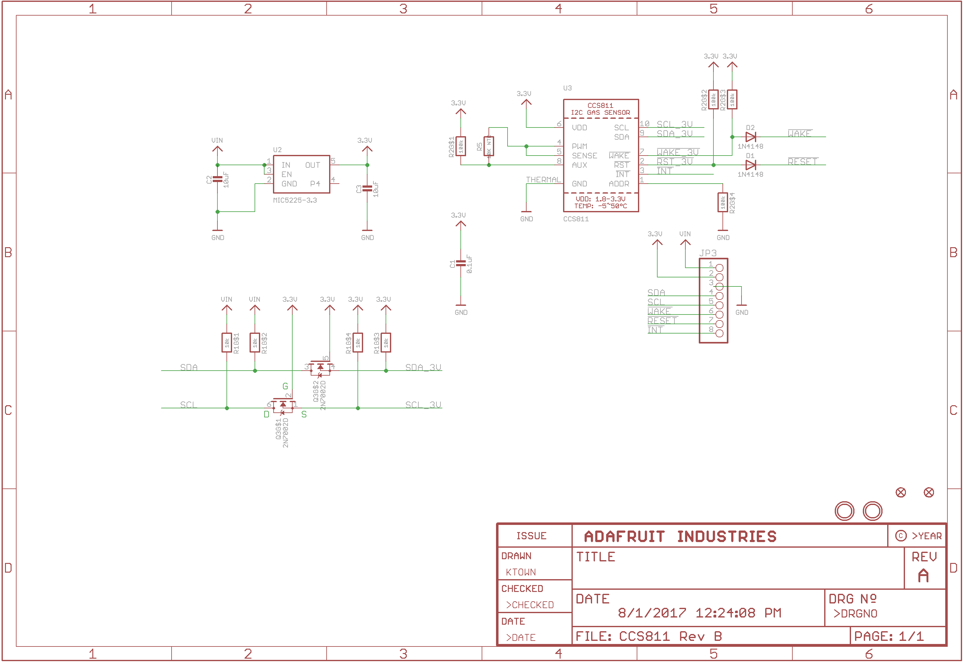

Appendix B : example of parameter file

# Parameter file. created Tue Oct 2 13:50:28 2018
VERSION:2
# CCS811 information
CCS811 i2C ADDRESS: -a 0x5a
RESET-GPIO: -r 5
WAKE-GPIO: -w 6
INTERRUPT-GPIO: -i 0
RUN-MODE: -m 2
BASELINE: -b 0

# DYLOS DC1700 information
DYLOS PORT: -D "/dev/ttyUSB0"

# general information
CONDITION_PERIOD: -C 0
LOOP COUNT: -L 0
FORCE LOOP DELAY: -U 0
BASELINE SAVEFILE: -S
VALUE SAVEFILE: -W
OUTPUT FORMAT STRING: -O ctTDE
VERBOSE: -V 2

# I2C information
I2C BAUDRATE: -I 100
SOFT_I2C SDA: -s 2
SOFT_I2C SCL: -d 3

