DHT11 connected to Raspberry PI

Table of Contents
1. Background 2
2. Board information 3
2.1 Board connections 3
2.2 Connection to Raspberry Pi 3
3. Software installation 4
3.1 BCM2835 library 4
3.2 DHT software 4
4. Sensor program structure 5
4.1 dht program 5
4.1.2 Initialize variables 5
4.1.2 Parse parameters 5
4.1.3 Initialize hardware 5
4.1.4 Main loop 5
4.1.5 Closeout 5
4.2 dht program parameters 6
5. Driver dht_lib.cpp 7
5.1 High level protocol 7
5.2 The challenge 7
5.3 How to handle ? 8
5.3.1 changing the process priority 8
5.3.2 Implementing a retry count 8
5.3.3 Guess / assumption mechanism 8
5.3.4 Forced read or not 8

1. Background

This project is part of a number of projects to measure the air quality I run into DHT11 sensor , which can measure temperature and humidity. The board is the Xinda or Keues. It is available under many different brands, but the DHT11 is the same.

The sensor are well documented and there is software available for Arduino. I have studied that code and made a version for the Raspberry PI. The challenge is capturing all the bits from the device in one read. See driver explanation

All code has been ported to Raspberry Pi and is available on github.

Paul van Haastrecht
paulvha@hotmail.com

2. Board information

Source : https://arduinomodules.info/ky-015-temperature-humidity-sensor-module/

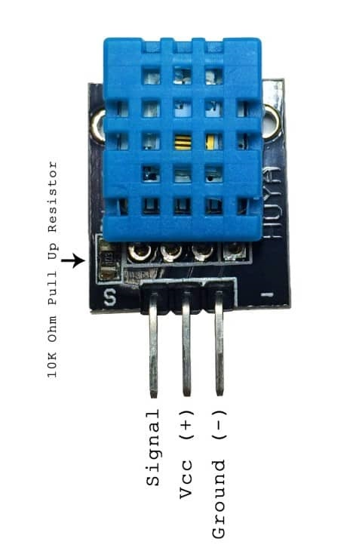
2.1 Board connections
- Connect Vin to the power supply, 3-5V is fine. Use the same voltage that the microcontroller logic is based off of. For most Arduinos, that is 5V
- Connect GND to common power/data ground
- Connect SIGNAL to one of the GPIO on the Raspberry Pi

2.2 Connection to Raspberry Pi

DHT description Raspberry Pi
GPIO PIN
Vin power in 3 -5 V 3V3 or 5V / 1 or 2
GND ground GND / 6
SIGNAL Serial data 8 / 24 (*1)

*1) signal GPIO is configurable with the ‘-p’ option

3. Software installation
As with many of my projects I make use of the BCM2835 library to control the IO. The reason is that it is faster and more flexible than the wiringPi (which makes use of the official kernel drivers) and provides direct control and insight, which I like.

3.1 BCM2835 library
Install latest from BCM2835 from : http://www.airspayce.com/mikem/bcm2835/

1. wget http://www.airspayce.com/mikem/bcm2835/bcm2835-1.56.tar.gz
2. tar -zxf bcm2835-1.56.tar.gz // 1.56 was version number at the time of writing
3. cd bcm2835-1.56
4. ./configure
5. sudo make check
6. sudo make install

3.2 DHT software
Obtain the latest version from : https://github.com/paulvha/dhtxx-on-raspberry

1. Download the zip-file (clone or download / download zip-file) in the wanted directory
2. unzip dhtxx-on-raspberry-master.zip (*1)
3. cd dhtxx-on-raspberry-master
4. create the executable : make
5. To run you have to be as sudo ./dht -h ….

*1) if you do not have unzip : sudo apt-get install zip unzip

In the software package you will find the following files

dht_lib.cpp :
This is the main driver for the dht. The driver is based on the original version from Arduino but adjusted and extended to work on the Raspberry Pi. Some routines have been added, a number have been changed.

dht.cpp :
This is the user level program that will be discussed in detail in a next section.

DHT.h :
This is the header file for the dht. It is based on the original version from Arduino, but adjusted and extended to work on the Raspberry Pi.

makefile :
script to compile the source and create an executable with the make command.

4. Sensor program structure

4.1 dht program

The user program it self has a number of big blocks

- Initialize variables to default settings
- parse parameters
- Initialize hardware (BCM2835) & driver
- Main-loop to provide output
- Closeout()

4.1.2 Initialize variables
Default values for the different parameters are loaded. The defaults are hard coded and are adjustable based on expected usage.

4.1.2 Parse parameters
The program has a rich set of command line option (see 4.2 in detail later) to change many default settings.

4.1.3 Initialize hardware
The BCM2835 and driver are initialized with the different parameters.

4.1.4 Main loop
The program will loop for reading, either a fixed number of times or endless (depending on the parameter).

4.1.5 Closeout
Either close with Control-C or it will count down the number loops. The BCM2835 is reset to the standard values

4.2 dht program parameters

The following parameters can be set for the program:

-t # :
The sensor type can be set to either DHT11, DHT21, DHT22 or AM2301. Default is 1 : DHT11.

-p # :
The GPIO can be adjusted from default GPIO 8 to a GPIO between 2 and 27.

Parameters for General

-B :
This will trigger to output results without color on the screen.

-L #:
This will change the default endless loop (10) to a number of loops for the main-loop before exiting

-w #:
This will change the delay in seconds from the default of 5.

-v #:
This will enable progress / debug information. The level can be set between 0 and 2 (highest). Level 0 is disabled (default), Level 1 shows user program information, level 2 adds driver information.

-T:
will add timestamp to output.

-I:
will add heat-index, the temperature it feels like, to output. The calculations are based on both Rothfusz and Steadman’s equations.

-D:
will add dew-point temperature to the output. The calculations are based on the August-Roche-Magnus approximation.

-F:
will display all temperatures in Fahrenheit instead of Celsius

5. Driver dht_lib.cpp

The DHTxx devices has an simple protocol that requires a (near) real-time operating system.
On an Arduino that is not an issue, but on a Raspberry Pi with Linux it is a different aspect.

5.1 High level protocol
The protocol is started by the computer pulling the sense line low for at least 18 mS. The DHTxx will respond with 80uS low-pulse, followed by 80uS high-pulse. Without any further waiting the DHTxx will now sent a stream of 40 bits. Each bit starts with a 50uS low-pulse leader, followed by either a 28uS high-pulse for a ‘0’ or 70uS high-pulse for a ‘1’. The 40 bits make up 5 bytes: 4 data bytes + 1 CRC. The 4 data-bytes are interpreted differently depending on type of sensor, but the first 2 bytes are for humidity, the second 2 bytes are for temperature. The CRC is a result of “adding” the 4 data bytes together. (see the data-sheet for more details)

5.2 The challenge
It is down to catching all the 40 bits on-time and correctly. The core mechanism applied is a counter. In the routine expectPulse() it will count how long the sense-line was in the expected level (high or low). That information for the (50uS) leader-low and bit - high is stored in an array.
After the 40 bits have been read, the array is investigated. It assumes that if the high-time is longer than the 50uS leader, the bit is ‘1’, else it is ‘0 ‘.

The challenge is that Linux is not real-time and as such the dht-program when running maybe scheduled out for a short time for another task in Linux or checking for it. A clear example to demonstrate this issue is with a debug pulse (in red) when the Raspberry Pi starts reading the GPIO. You can see that the red pulse starts every time high with the start of the 50uS low leader pulse and is pulled low at the start of the bit-high-time :

As you can see it all works fine until it gets past half way the picture.

The checking does NOT start when the 50uS pulse starts, but just at the end, it is like a short spike. As a result the count is VERY low and can not be used to determine the ‘1’ or the ‘0’.

This can happen any moment, either when reading the 50uS leader-low (as in the example) or reading the bit-high counter.

5.3 How to handle ?

A couple aspects have been done to handle this in library

5.3.1 changing the process priority
By setting the process priority to SCHED_FIFO, this is the highest level of near-real-time you can get on a Linux system. The priority is set to a maximum around the critical moment and restored to default after that.

5.3.2 Implementing a retry count
The driver has a retry counter that is hard coded to 5 retries before returning a failure to the user program. I have not seen that fail 5 times in a row.

5.3.3 Guess / assumption mechanism
The dht-xx are slow devices and information does not change that quickly. This the data that is send or regular base is not so much different from previous.

First get a minimum amount of good samples (good meaning: correctly captured the 40 bits without exception and good CRC). From these samples store the minimum and maximum count for both the leader-pulse-low and bit-high. Also store the count of ‘1’ and ‘0’ in each of the 40 bit-position. If the ‘1’ was most in of the time in that bit -position, store that as a guess, else store a ‘0’ as a guess. If the minimum amount of good samples has been reached, also check that the count-ranges still make some sense and assume the minimum count should be NO less that 20% of the average ( either leader-pulse-low or bit-high). Else restart. This process will go on until a maximum samples have been reached. From there on the reference information is stale.

If the minimum samples had been reached, for the subsequent reading it is checked that the counter for either leader-pulse-low or bit-high is within the earlier detected count range ( minimum and maximum). If so, compare leader-pulse-low to bit-high counter and return the result. If not however, use the guess value and indicate an exception.

5.3.4 Forced read or not
The read() call has an option to force a new read OR return if the last read was done less than 2 seconds ago. In that case it will use the last read information and return that to the user program.

While all options are implemented, it is still happening that a bit is missed or wrongly interpreted, however that is only visible with the verbose option ( -v) of the program. Otherwise the driver handles the correction and is providing a correct results.

