Uno Door-opener
Uno, LCD, keypad, serial and NFC MFRC522

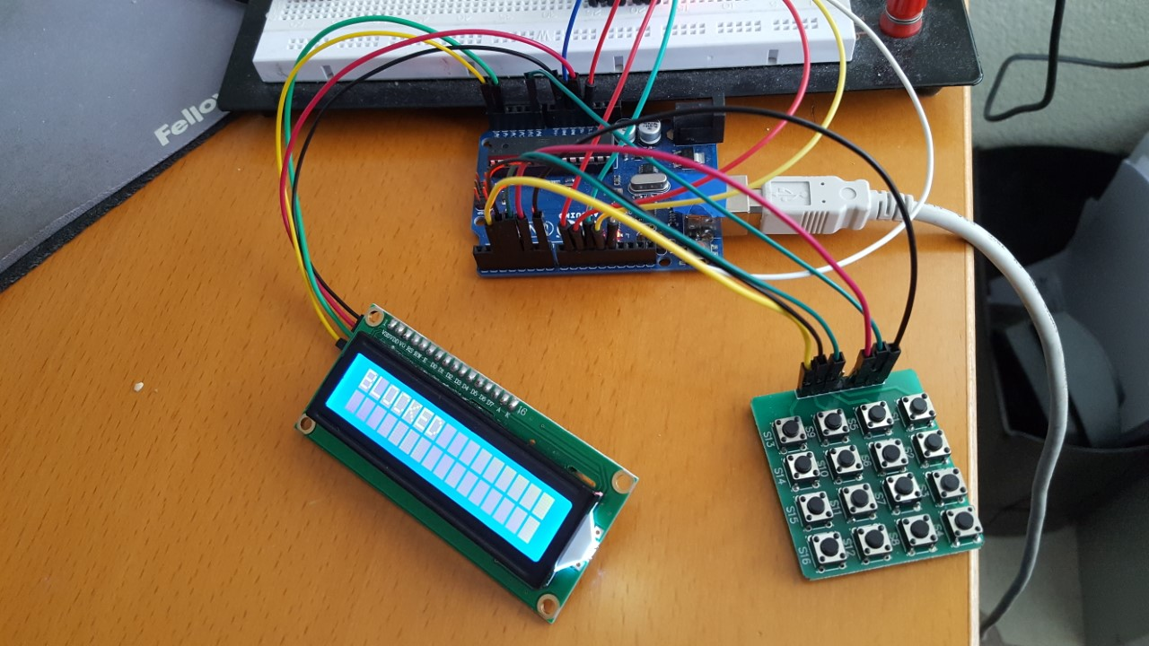

1. Foreword

There was someone on a forum looking for help to get a door-opener, based serial, keypad and MRFC522 card. He had some code, which was not working, copy / pasted together. The project looked interesting me, also I had all the components, except a door opener, and had couple of hours on my hand. I have extended the code with more functions and this document is the write up of the small project.

Please be aware that I have NOT written much of the code. It is coming from different sources from Internet, developed by others. I do not know who or where the real sources are coming from. Hence I do not claim copyright or apply a license. This is grapware… for you to play around and enjoy. No Support, no warranty, no obligations. Just source code as-is !

June 2020
Paul van Haastrecht
paulvha@hotmail.com

Table of Contents
1. Foreword 1
2. Hardware 3
2.1 Arduino Uno 3
2.2 MFRC522 3
2.3 Chrystal LCD I2C 3
2.4 Keypad 3
2.5 Relay 3
2.6 How to connect it all ? 4
2.6.1 LCD 4
2.6.2 MFRC 522 4
2.6.3 KEYPAD 4
2.6.4 Door Opener relay 4
3.0 Install software 5
3.1 LCD 5
3.2 MFRC522 5
3.3 Keypad 5
4.0 Sketch 6
4.1 usage 6
4.2 Parameters 7
4.2.1 Passwords 7
4.2.2 Door opening 7
4.2.3 Keypad 7
4.2.4 enable debug messages 7
By setting DEBUG to 1 you will get some debug messages on the serial output 7
5.0 subroutines 8
5.1 void blocked(unsigned long t) 8
5.2 void ExtractNFC() 8
5.3 void pairNFC() 8
5.4 void InitProm() 8
5.5 boolean validateNFC() 8
5.6 int ComparePswd(String a) 8
5.7 String GetKeyPad(char x, bool show) 8
5.8 void open_door() 8
5.9 void SetNewPswd() 8
6. Keypad setup 9
6.1 Current Definition 9
6.2 Software extend to 4 x 4 9
6.3 Hardware connection 4 x 4 10

2. Hardware

The following well-known hardware was used.

2.1 Arduino Uno
Actually this should not need introduction. If you never heard about an Uno you have been living under a stone. That said.. it could be any board, but you may need to change the pins. (https://store.arduino.cc/arduino-uno-rev3)

2.2 MFRC522
This board contains the NXP/ Mifare 125Khz NFC reader. It is well known and largely used for access control. It is so well known and documented, that people found a way to crack the security. Hence one should not use this for payment, but for access control it more than good enough. I could add 1000 URL’s on Internet, just stick with https://playground.arduino.cc/Learning/MFRC522/

2.3 Chrystal LCD I2C
Another piece of hardware that is described in many projects and URL’s. This is an I2C LCD, 16 character per row, 2 rows. Look it up on internet, e.g. https://www.makerguides.com/character-i2c-lcd-arduino-tutorial/ or https://www.makerguides.com/character-i2c-lcd-arduino-tutorial/

2.4 Keypad
Where to start looking for an URL about keypad for an Arduino? There NO end to it. My keypad is 4 x 4, but code is only using 3 columns. See chapter 6 how to use 4 x 4.

2.5 Relay
To control the door opener an external relay can be applied. Again MANY MANY URL’s that talk about this e.g. https://arduinogetstarted.com/tutorials/arduino-relay

2.6 How to connect it all ?

While there is a large flexibility in using the different pin, the current sketch expects the following by default. (but of course you can change some)

2.6.1 LCD
LCD UNO
SCL A5 // this is where SCL is on a UNO
SDA A4 // this is where SDA is on a UNO
VCC 5v
GND GND

2.6.2 MFRC 522
UNO MRFC522
Reset 9 RST // defined in Sketch
SPI SS 10 SDA // defined in Sketch
SPI MOSI 11 MOSI // that is where MOSI is on an UNO
SPI MISO 12 MISO // that is where MISO is on an UNO
SPI SCK 13 SCK // that is where SCK is on an UNO
GND GND GND

2.6.3 KEYPAD
ROW = {5, A0, 7, 8}; // Rows 0 to 4 defined in the sketch
Columns = {2, 3, 4}; // Columns 0 to 3 defined in the sketch

2.6.4 Door Opener relay
pin 6 (defined by DOORPIN) of the UNO . Active HIGH, thus connect the other side of the relay to GND.

3.0 Install software

The following libraries are necessary to install in order to compile correctly withe IDE.

3.1 LCD
https://www.makerguides.com/character-i2c-lcd-arduino-tutorial/
https://www.arduinolibraries.info/libraries/liquid-crystal-i2-c
https://github.com/marcoschwartz/LiquidCrystal_I2C

3.2 MFRC522
https://playground.arduino.cc/Learning/MFRC522/
https://github.com/miguelbalboa/rfid

3.3 Keypad
https://github.com/Chris--A/Keypad
http://playground.arduino.cc/Code/Keypad

4.0 Sketch

4.1 usage

If this is the first time the program ever runs on this board, you need to reset the EEPROM count to zero, as we do NOT know what is currently in the length location. Enter the InitPromCode (defined in the sketch) on the keypad to set the length to zero. This can also be used to wipe out any earlier registered cards.

To prevent an EEPROM overrun, the maximum size of the EEPROM can be set with MAXPOSTEEPROM.

You first need to pair a NFC card in the system. Enter the PairingCode (defined in the sketch) and then hold the card for the reader.

If you set TRIGGERMOMENT to EITHER, you can open the door with EITHER a valid NFC card OR valid access password AccessCode (defined in the sketch).

If you set TRIGGERMOMENT to BOTH, you can only open the door with BOTH a valid NFC card AND valid access password AccessCode (defined in the sketch). It does not matter which you apply first.

The access password AccessCode (defined in the sketch) can be entered from remote over the serial port to open the door as well.

A new entry access code can be changed by entering the ChangePswCode (defined in the sketch). You will be prompted to enter a new access password from the keypad and get 5 seconds to start entering the new password.
If that password is already use, the operation will cancel. Else you will be asked to enter '#' on the keypad to confirm the new password. If any character is received, the operation will cancel.

4.2 Parameters
There are a number of parameters that can be set in the sketch.

4.2.1 Passwords
You can set different passwords for
- Reset EEPROM length to zero
- Access password
- Pairing password
- Change password

4.2.2 Door opening
You can set TRIGGERMOMENT to indicate that EITHER a valid NFC card OR valid access password will open the door, OR that BOTH a valid NFC card AND valid access password will open the door. An access password entered on the Serial will also open the door.

The DOORPIN cdefines the pin on which a relay (or other electronic circuit) is connected to open the door

The DOOR_OPEN_TIME will determine the number of milliseconds the relay (or other electronic circuit) is triggered to open the door.

To prevent overrun, define the maximum size of the EEPROM in bytes with MAXPOSTEEPROM.

4.2.3 Keypad
You can define the row and column pin to use, as well as the keyboard layout to use.
See chapter 6 in case you have another keypad

4.2.4 enable debug messages

By setting DEBUG to 1 you will get some debug messages on the serial output

5.0 subroutines

5.1 void blocked(unsigned long t)
Delay for ‘t’ milliseconds, then clear the LCD and show “blocked”.

5.2 void ExtractNFC()
Will read the UID from the NFC card.

5.3 void pairNFC()
Add a card to EEPROM, if not already there to be recognized as a valid NFC card later.

5.4 void InitProm()
Will reset the counter in EEPROM to zero cards.

5.5 boolean validateNFC()
Check there is an NFC card stored in EEPROM / earlier paired and thus valid.

5.6 int ComparePswd(String a)
Check for a valid password. This can be either the access password, pairing password or the initEEprom password.

5.7 String GetKeyPad(char x, bool show)
Read the complete password (8 characters) from the keypad. You MUST enter 8 characters.
If show is true, the entered digits will be shown, else it will show ‘X’.

5.8 void open_door()
Set the DOORPIN high to open the door for DOOR_OPEN_TIME (mS).

5.9 void SetNewPswd()
Will allow for changing the access password.

6. Keypad setup

In the sketch a 4 x 3 keypad is assumed. My Keypad is 4 x 4. how to handle ??

6.1 Current Definition

First you define the number of rows and columns
#define numRows 4 // number of rows on the keypad
#define numCols 3 // number of columns on the keypad

Now define the character to find on each crossing
The keymap defines the key pressed according to the row and columns just as it appears on the keypad.

char keymap[numRows][numCols]= {
{'1', '2', '3',},
{'4', '5', '6',},
{'7', '8', '9',},
{'*', '0', '#',}};

Define the pins to which the rows and columns are connected
The code that shows the keypad connections to the arduino terminals
byte rowPins[numRows] = {5, A0, 7, 8}; // Rows 0 to 4
byte colPins[numCols] = {2, 3, 4}; // Columns 0 to 3

Finally create instance with the information above
Keypad myKeypad= Keypad(makeKeymap(keymap), rowPins, colPins, numRows, numCols);

6.2 Software extend to 4 x 4

#define numRows 4 // number of rows on the keypad
#define numCols 4 // number of columns on the keypad

Now define the character to find on each crossing
The keymap defines the key pressed according to the row and columns just as it appears on the keypad

char keymap[numRows][numCols]= {
{'1', '2', '3', 'A'},
{'4', '5', '6', 'B'},
{'7', '8', '9', 'C'},
{'*', '0', '#', 'D'}};

Define the pins to which the rows and columns are connected
//Code that shows the keypad connections to the arduino terminals
byte rowPins[numRows] = {5, A0, 7, 8}; // Rows 0 to 4
byte colPins[numCols] = {2, 3, 4, A1}; // Columns 0 to 4

Finally create instance with the information above
Keypad myKeypad= Keypad(makeKeymap(keymap), rowPins, colPins, numRows, numCols);

6.3 Hardware connection 4 x 4
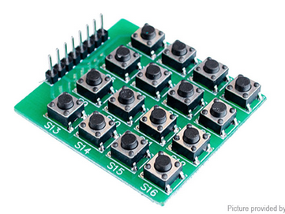
So my keypad looks like this:
Pin 1 = left (connected to S13)
Pin 8 = right (connected to S4)

Keeping connector a top

Col 1 : S13 – S16
Col 2 : S9 – S12
Col 3 : S5 – S8
Col 4 : S1 – S4

Pin Arduino pin
1 = Column 1 2
2 = Column 1 3
3 = Column 1 4
4 = Column 1 A1
5 = ROW 1 5
6 = ROW 2 A0
7 = ROW 3 7
8 = ROW 4 8

