MCP23008 & Raspberry Pi
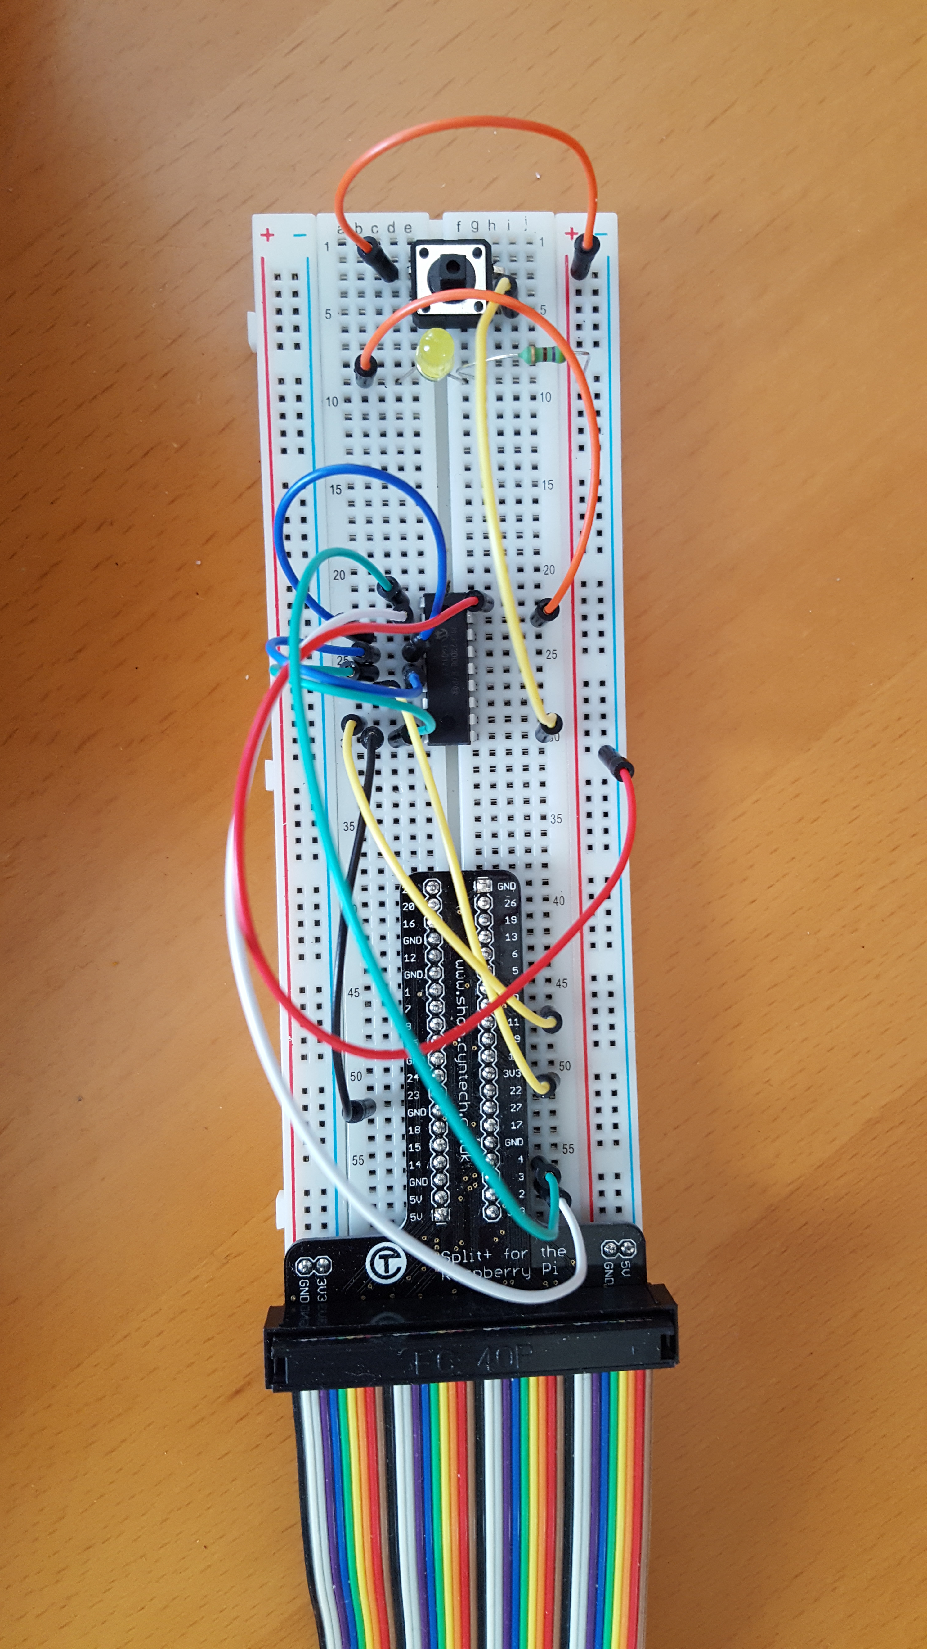
As part of my learning on Internet of Things (IOT) I am focusing learning efforts on the area where “hardware meets software”. I2C communication is a common method to connect devices to the a computer and I wanted to understand how that works and how to connect hardware & software.

Disclaimer
MCP23008 is trademark from Microchip Technology inc. I have used data-sheet MCP23008 / MCP23S08 from Microchip Technology inc. from 2007 and info other from Internet.

The sample program has been written from scratch. There was no (working) sample program that I could find on the Internet. MCP23008 sample program is free software: you can redistribute it and/or modify it under the terms of the GNU General Public License as published by the Free Software Foundation, either version 3 of the License, or (at your option) any later version.

MCP23008 is distributed in the hope that it will be useful, but WITHOUT ANY WARRANTY; without even the implied warranty of MERCHANTABILITY or FITNESS FOR A PARTICULAR PURPOSE. See the GNU General Public License for more details.

You should have received a copy of the GNU General Public License along with MCP23008. If not, see <http://www.gnu.org/licenses/>.

Paul van Haastrecht, May 2016
Table of Contents
1. Hardware setup 2
2. Software setup 3
BCM2835 library 3
Install the MCP23008 sample program 3
Sample program explanation 4
4. Issues encountered and solutions 5
Which I2c ? 5
Writing and reading a register 5
I2C speed 5
5. Handling interrupts 6
Setting up interrupt 6
Reading interrupt 7
Raspberry Pi and handling MCP23008 interrupts 8

1. Hardware setup

The connection to the Raspberry is very simple:

MCP23008 Raspberry Description
1 3 SCL
2 2 SDA
3 6 or 14 A2 (ground) (*3)
4 6 or 14 A1 (ground) (*3)
5 6 or 14 A0 (ground)( *3)
6 22 Reset (*1)
7 Not used
8 11 INT (*2)
9 6 or 14 VSS (ground)
10 GP0 (*4)
11 GP1
12 GP2
13 GP3
14 GP4
15 GP5
16 GP6
17 GP7
18 2 or 4 VDD (+5V)

*1: optional. In the sample program I reset the MCP23008 every time when the program is started, to have a clean starting point, using GPIO22. However during normal power-up the MCP23008 would reset it self once the minimum power-level have been reached. If not used, connect this reset to ground. The GPIO can be changed with the sample program.

*2: optional. Only necessary when using the interrupt function. See description “5. handling interrupts” in document below. The GPIO can be changed and tested with the sample program.

*3: The base address (in the proposed setup) is 0x20 for the MCP23008. However A0, A1, A2 enables the option to have 8 different MCP23008 in the address range 0x20 – 0x27. This way it is possible to have 8 x 8 = 64 GP pins. For testing this can be changed in the sample program.

*4: The GP pins are very sensitive when set as input. When floating (e.g. not pulled-up or down or not connected to ground or VDD) they can easily pick up and provide a wrong HIGH value or keep a HIGH value that was provided even after the value has been removed. Make sure that they when using for reading they are not floating.

2. Software setup

In this project I make use of the BCM23008 library to control the IO. The reason is that it is faster than the wiringPi (which makes use of the official kernel drivers) and provides direct control and insight, which was the key reason to do this project.

BCM2835 library
Install latest from BCM2835 from : http://www.airspayce.com/mikem/bcm2835/

1. wget http://www.airspayce.com/mikem/bcm2835/bcm2835-1.50.tar.gz
2. tar -zxf bcm2835-1.50.tar.gz // 1.50 was version number at the time of writting
3. cd bcm2835-1.50
4. ./configure
5. sudo make check
6. sudo make install

Install the MCP23008 sample program
1. cd /home/pi
2. tar -xzvf mcp23008.tar.gz
3. cd mcp23008
Copy the latest BCM2835.h to MCP23008:
1. cd /home/pi
2. cp bcm2835*/src/bcm2835.h mcp23008

To compile : ./mc
Make sure you are root (*1) and then you should be able to run ./MCP23008.

*1: BCM2835 will try to open /dev/gpiomem in case you are NOT root. That will only provide access to the GPIO pin setup, not to the divider for speed I2c etc.

Sample program explanation

It is a straight forward C-program without a fancy interface. The options it provides :
1. change the slave address.
This will allow to set a different slave than the 0x20. This will help to test in case you want to use A0, A1 or A2 (see hardware setup). In case you set a wrong address you will get a NACK error, in case the correct one, it will display the configuration and status registers from the MCP23008.

2. change the divider/speed.
This will allow to test on 100kHz, 400kHz or 1.7MHZ. The primary clock is 250Mhz and the frequency will be 250 Mhz / divider. Default is 2500 => 100kHz.

3. change reset_GPIO on Raspberry.
When this program starts, it resets the MCP23008. That was implemented to make sure that during testing, the starting point was the same. Normally a MCP23008 resets at start-up and waits until the minimum power-level has been reached.

4. set a GP pin on MCP23008.
This allows to set a GP as either input or output. In case of input an internal pull-up resistor can be added and in case of output it can be set as either high or low.

5. set/reset interrupt on a GP pin of the MCP23008.
This will allow to set or remove the trigger for the INT signal from the MCP23008. In case of set, it can trigger either when the value is high, or low or when the value is changing ( high to low or opposite). It will also the IOCON to enable active-high or active-line INT signal (see 5. handling interrupts)

6. Display configuration and control registers MCP23008
Reads and displays the control registers from the MCP23008.

7. set / reset automatic display registers after option 1-5.
By default the registers are displayed after performing option 1 – 5, this will disable that (or re-enable in case it was disabled

8. setup Raspberry to receive interrupt from MCP23008.
Select the Raspberry GPIO to handle the interrupt signal from MCP23008, either as active-high or active-low. (see 5. handling interrupts)

9. read selective register(s) from MCP23008
Select the first register to read and the number of registers to read from there. The content will be displayed in hex format.

4. Issues encountered and solutions

Which I2c ?
I2C0 or I2C1: the earlier board (rev 1) have I2C0 on pin 2 and 3, the later versions have I2C1 on pin 2 and 3, with I2C0 on the camera connector. BCM2835 takes care of that. As I have build my own IO monitor (raspio), I was first looking to the wrong values.

Writing and reading a register
Reading the values from the MCP23008 was actually very much straight forward with every start of the program. I used the IOCON-SEQOP function, so that after every read the address pointer was automatically incremented and could read the default values easily.

Reading after write however... that was a complete different experience. It was not getting correct information when doing a read after write, the register values were randomly on the right place. It was just a gamble.

The core of the issue turned out to be in the RESTART function. Normally for a read there is a START, Device Opcode ( = device slave address), read BIT, and then start writing until you sent a STOP.
- According to the documentation (Microchip Technology Datasheet), we should be able to perform the SEQOP read after write. Well... no !
- The address pointer should automatically return to 0 after 0xa (last register).. maybe... but reading would not result in the values on the right place. I tested the later to set a value on GP6 (default is input). I saw that value, but then in a register 2 or 3 places up or down.

I learned from the Internet about restart: basically that means you do not sent a STOP, but another START and continue. Many I2C devices seemed to need that. There is VERY limited documentation on HOW to handle that with the BCM2835-BSC. (only some in chapter 3.3 in case of 10 bit addressing). It works with sending a register address to the I2C device, polling to detect the BSC has started to sent, then sent additional information into some the BSC registers and hope you did all of that on time before the BSC was finished.
I had first build my own routine to handle it, but that worked once so often. I used a oscilloscope and generated a pulse to see how many bits the BSC had sent, before detect and providing additional information. I was WELL within the time, but still not working stable. Again the BCM2835 library came to help, as I NOW understood why there is the BCM2835_i2c_read_rs() and BCM2835_i2c_write_rs(). My issue was that AFTER polling detect and I had provided the additional information, I started to check for “DONE” TO EARLY. I detected the DONE from the WRITE of the register address, while I should have waited until after the restart and check for the DONE coming from the second part (read). The BCM2835 library handles this greatly with a calculated delay based on the I2C speed.

I2C speed
Divider speed worked well for 100kHz and 400kHz, but while the specification state that the MCP23008 can also on 1.7MHz, that failed constant. I think that is because of restart-polling as explained above. A program running in user-land might not be able to detect on-time.

5. Handling interrupts

In order to set interrupts on a specific pins, at least 2 but maybe 7 registers need to be set.

Setting up interrupt

MUST : GPINTEN
This register is used to enable an interrupt on a specific pin.
1 : is to enable the interrupt on the pin
0 : is to disable the interrupt on the pin

MUST: INTCON
This register is used to control how the associated pin value is compared. It can be against a fixed value ( 1 or 0 based depending on the setting of DEFVAL) or it can cause a interrupt when the pin value changes (high to low, or low to high).
1 : interrupt is based on the value defined in DEFVAL
0 : interrupt is based on the a change of value

Depends: IODIR
Set the pin as input, reading a pin that is output does not make sense.
1 : pin is configured as an input (default)
0 : pin is configured as an output

Depends: GPPU
Controls the pull-up register, in case you want to detect against 0/ground. Setting a 1 will cause a 100K internal register to pull up the signal. Of course you could use an external resistor either to detect 0 (as pull-up to +) or to detect a 1 (as a pull-down to -). Normally a 10K ohm will do the trick in a save way.

Depends: IPOL
This register (input polarity) allows the user to configure to read the polarity at the pin to be the real value or opposite.

Depends: DEFVAL
This register contains the default compare value by pin. This is only necessary in case INTCON is set to 1. If the associated pin level is the opposite from the register bit an interrupt occurs.

Depends: IOCON
This configuration register MIGHT already have been set or the default is the situation that is wanted. The default setup:
ODR = 0 : active driver output (INTPOL bit sets the polarity)
INTPOL =0 : active-low.

For interrupt-line to work ODR MUST be 0.

Reading interrupt

The INTF ( interrupt flag register) reflect which pin(s) that have caused an interrupt. It will also show if a pin that would have caused interrupt if there was not one pending already (e.g. the condition on that pin changed AFTER the interrupt was raised but not cleared yet).

The INTCAP (interrupt capture register) reflect the pin value at time the interrupt occurred. This register is updated only at the time of interrupt. As such if another pin would have caused an interrupt, but there was an interrupt already pending and not cleared, INTF WOULD reflect that pin, but INTCAP would NOT reflect the value. This makes the real value of this register questionable. Reading this register OR the GPIO register will reset the interrupt-line to the value that is opposite of the active value and clear INTF.

The GPIO register will reflect the value on the pin at the time of reading. Reading this register OR the INTCAP register will reset the interrupt-line to the value that is opposite of the active value and clear INTF.

Note 1
The interrupt level is cleared by reading either INTCAP of GPIO. However in case INTCON is set to compare against a defined value, if the pin is still holding the opposite value, the interrupt is raised immediately again. It is a VALUE compare, not falling or rising edge. This can cause MANY repeated interrupts that need to be handled by the program. E.g. you can continue to read the GPIO level until that changes back to the opposite value, before performing a new action based on the interrupt.

Note 2
In case the interrupt is raised because of change in pin value, it will cause a interrupt on BOTH changes high to low & low to high. This means if you have connected a switch to the pin you will get 2 interrupts as both pressing and releasing the pin will cause an interrupt.

Note 3
If you expect the pin change to be a pulse, use interrupt against fixed value. If you expect the pin change to be of longer duration yo can use interrupt either way, but include a check on current GPIO level to consider to perform an action.

Raspberry Pi and handling MCP23008 interrupts

I am using the BCM2835 library, which is one of the best libraries that I know to handle the Raspberry I/O channels. It is faster than WiringPi in most situations as the later is working through/with the official kernel drivers. BCM2835 works directly on the hardware, does not need/expect the kernel IO drivers to be loaded and provides complete transparency and control. If you want to really understand how “hardware meets software” : BCM2835. However in this case I run into a challenge that I want to act on the MCP23008 interrupts. WiringPi provides a call back function, but BCM2835 does not.

The best way to handle that is a child process, that checking in a loop on interrupt. A Raspberry GPIO has been initialized for input, to detect either the falling edge (in case of active-low MCP23008) or rising edge (in case of active-high MCP23008). When the MCP23008 triggers, it will trigger on a Raspberry GPIO, the child process will read the control registers and display/trigger an action based on INTF register.

I have implemented this in the sample program and to test this perform the following steps

Assumptions :
- using GPIO 11 on Raspberry to receive the interrupt from MCP23008
- using GP0 on MCP23008 (pin 9) to trigger the interrupt to happen.
- Interrupt is active-high.

Hardware :
- connect a switch to GP0 (pin 9) on the MCP23008 that will connect to ground when pressed
- Connect the pin 8 (INT) from the MCP23008 to pin 23 (GPIO 11) of the Raspberry.

Software:
- select option 4: set a GPIO pin on MCP23008
- select 0 (= pin)
- select 1 ( = input)
- select 1 ( = pull-up)

- select option 5 : set/reset interrupt on a GPIO pin MCP23008.
- select 0 (= pin)
- select 1 ( = set)
- select 2 (= any change)
- select 1 (= active high) *1

- select option 8: setup Raspberry to receive interrupt from MCP23008
- select 11 (= GPIO)
- select 1 (= active high) *1
*1: The active-level (high or low) need to match.

Pressing the switch should show the following on the display:
Interrupt from MCP23008
The interrupt was driven from the following GP on MCP23008
GP-0

Note

The Raspberry will execute the code reading and handling the interrupt from MCP23008 very fast, so in case of compare against a fixed value or using a loose line it will re-trigger the interrupt causing repeated action. Hence I have included a sleep of 2 seconds, re-reading the registers to remove any interrupt before checking the interrupt line again.

