MLX 90615 on Raspberry Pi

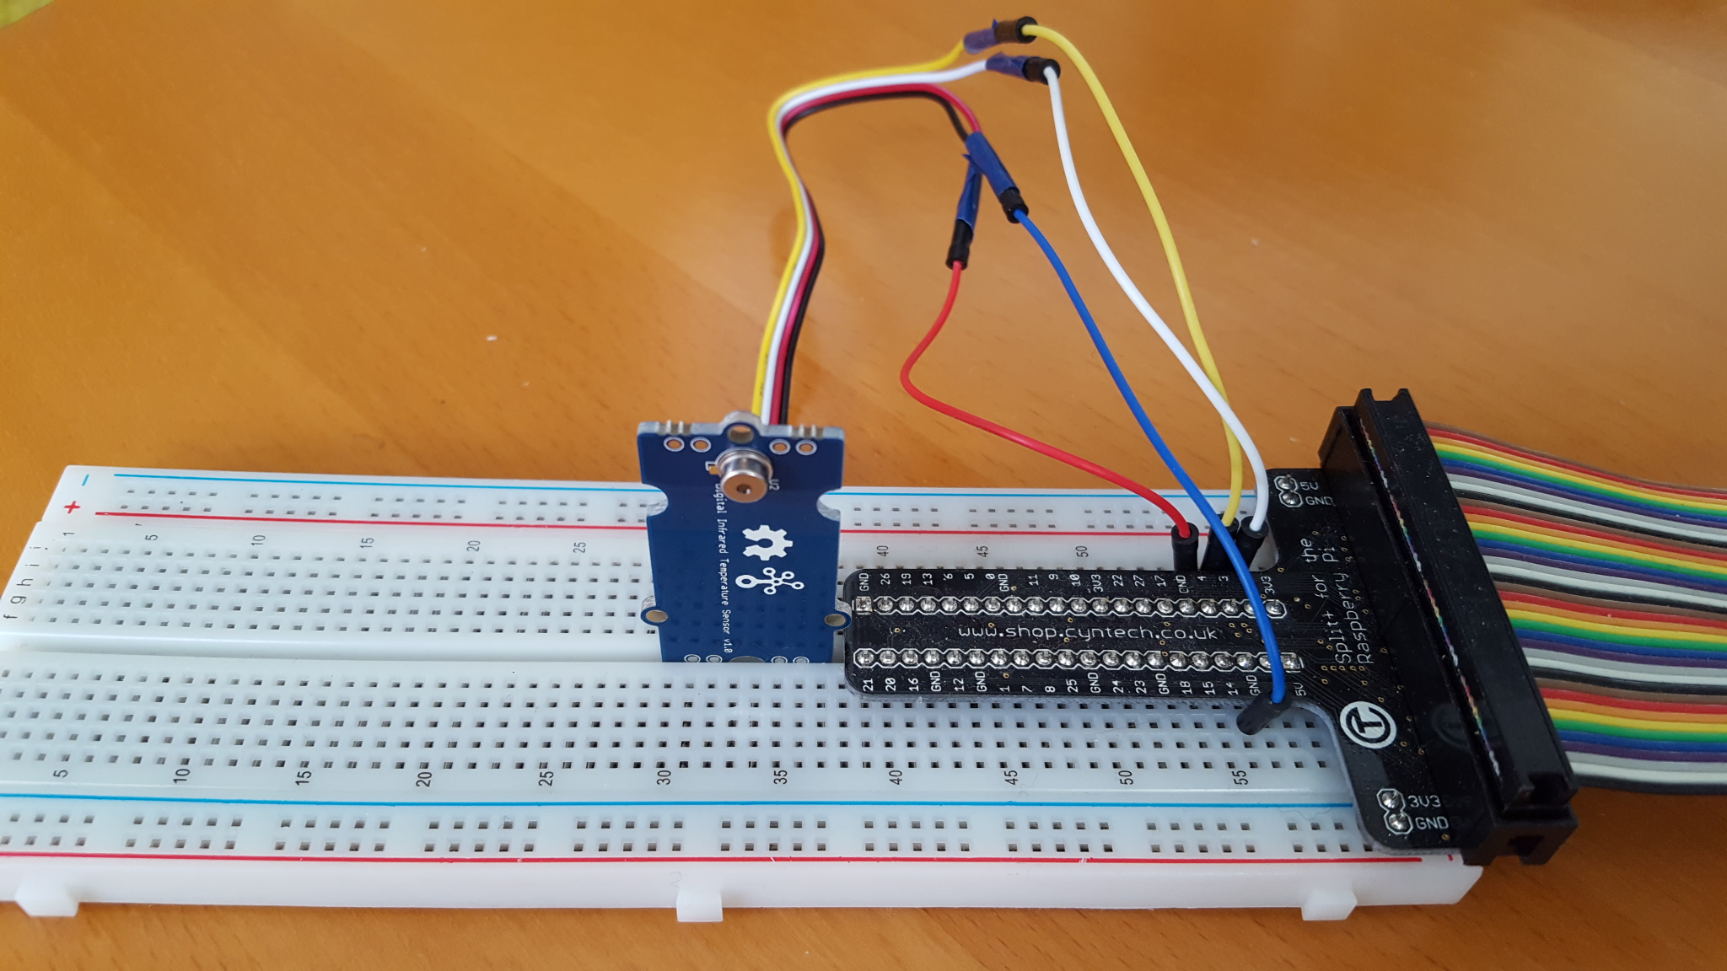

Table of Contents
Background 2
Hardware 2
Software 4
mlx.c module 4
mlx_lib.c 6
Enter / exit sleep mode 8
mlx_emiss.c 9
Emissivity 9
mlx_pwm.c 10
PWM mode 10
Installing the software 14
Recovering the MLX90615 config register 15
Literature 15

Background

The MLX90615 is like an Infra_Red ( I.R.) temperature sensor. Having seen a commercial IR temperature meter, I wanted to better understand how it works.

The MLX90615 is available at low cost as part of the GROOVE family from Seed-Studio. There is a great, detailed, data-sheet available on-line that provide a lot of insights. I was, and I am, impressed by the possibilities and flexibility of the sensor.

I saw a number of libraries and programs available for the Arduino, but I did not find a good programs for the Raspberry Pi. Hence I to created a program that makes use of the complete capabilities.

My focus of interest is the area ”where hardware meets software” and the program developed is focused on exactly that. It does not have a fancy interface, but it does work and is able to explore the complete capabilities of the MLX90615. A next step could be the expansion with a graphical interface.

April 2017
Paul van Haastrecht (paulvha@hotmail.com)

Hardware
While the heart of the groove IR sensor is the MLX90615, it has a number of electronic components to enable an easy connection. A high-level overview of the Groove schema:

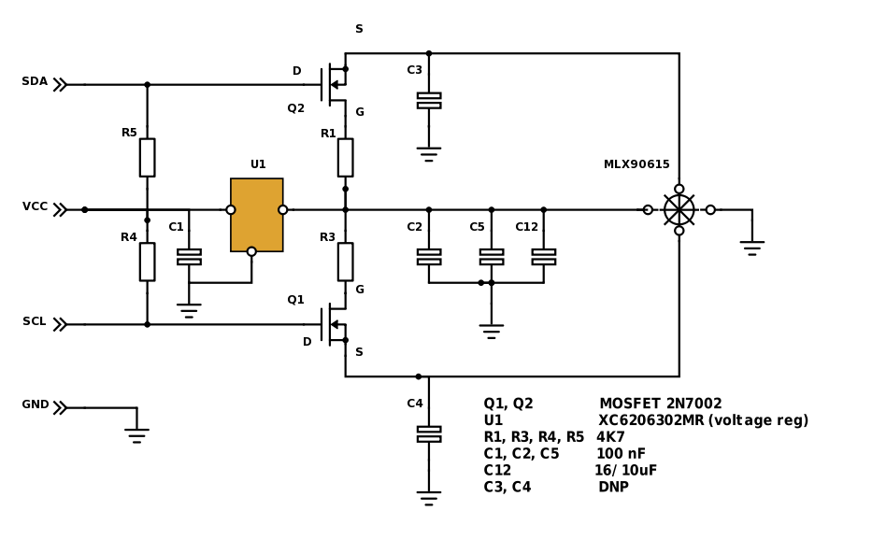
The sensor it self is very small (TO-46 housing) and has very rich capabilities. I have used the data-sheet from Melexis for the MLX90615, dated 8 November 2013. This has a very detailed description of the hardware and user definable registers and bits, but unfortunately nothing around the Melexis reserved data. Next to that, this data-sheet has errors that should be corrected, or omission that should be added. More information on different places in this document.

The MLX90615 has different registers and ram locations than the others from the same family ( 90614, 90616-x etc), so it can NOT been used without modification for others. However the RAM locations for the ambient and object temperature are the same across the family.

The I2C communication is well described in many articles on the Internet. Thus the description is not part of this document. The connection to the Raspberry PI-3 was as follows:

MLX-board Raspberry PI

GND GND
SDA GPIO 2
SDL GPIO 3
VCC GPIO 4

One could connect the MLX90615 directly to the 3.3V, but I wanted to be able to switch the MLX90615 ON and OFF. The power consumption is 1 – 1.5mA only, so no issue for the Raspberry Pi. Another advantage is that we can now switch between SMB and PWM mode, without the need to remove the connector, but do a Power-on-reset from the software.

The project was performed on a Raspberry PI-3, running Linux (Jessie).

Software

As with many projects I make use of the great BMC2835-Library. This allows to be working directly on I/O of the Raspberry PI hardware (BCM2835/BCM2837), instead of working through the kernel drivers. It is fast and brings the flexibility & insight that I am looking for.

The program is written in C and the following modules make it to one executable:

mlx.c main user menu program
mlx_lib.c access routines to MLX90615
mlx_emiss.c emissivity routines
mlx_pwm.c routines handling PWM on MLX90615
mlx90615.h header file to glue it all together.

mlx.c module

This is a primary command line processor and user interface & routines.

On the command line there are different options:
./mlx [-m #] [-r #] [-h] .....

PWM options :
-p, start in PWM menu & try to read attributes from MLX
-P, start in PWM menu & overwrite attributes in the MLX
-m, set minimum temperature for PWM (in Celsius)
-r, set range temperature for PWM (in Celsius)
-a, set for ambient temperature
-o, set for object temperature
-l, set for low frequency (10hz)
-h, set for high frequency (1khz)

SMB options :
-s, slave address to use
-n, no PEC check on read

General options
-t, enable debug tracking
-d, enable detailed display
-H, display this help text

Special options
-C, recovery of config register. (CAREFULL !!!)

The main menu (after starting ./mlx):

What do you want to do ?

1 Change slave address
2 Display ambient temperature information
3 Display object temperature information
4 Display RAW-IR data
5 Display the configuration register MLX90615
6 Display ALL registers of MLX90615
7 Display ALL RAM locations of MLX90615
8 Display unit ID
9 Show PWM menu
10 Enter / exit sleep mode
11 set emissivity
12 Toggle to show details (where possible)
13 Toggle debug messages

99 exit program

1. Change slave address
This will allow to set a different slave address.. The program will check for the current slave address and whether there is only ONE MLX90615 connected to the I2C line. If you have provided a different slave address (with -s option on command line) it will use that as an option to change to, otherwise default (0x5b). This can help to recover an MLX90615 if you have lost the slave address or want to set a different slave address.

2 / 3 / 4. Display the ambient. Object or RAW-IR temperature
It will read the RAM location and display the current requested temperature. To be fair, I don’t know what to do with the RAW-IR. The documentation is not clear.

5. Display the configuration register
It will display and decode the configuration register. If you have enabled option 12 (toggle details) it will show more information. Based on the status of the user definable bits, it will show different information.

6. Display ALL registers
The name has it all, it will show content of all registers. Many of them are NOT user definable, BUT I would recommend you to make a copy and store that somewhere, just in case you overwrite. I have left the copy of the values of my MLX90615 in the mlx90615.h. If you have enabled option 12 (toggle details) it will show more information what is known.

7. Display ALL RAM
The name has it all, it will show content of all ram location. None are user definable, BUT I would urge you to make a copy and store that somewhere, just in case you overwrite. I have left the copy of the values of my MLX90615 in the mlx90615.h.

8. Display unit ID
This will just show the ID values of your MLX90615

9 / 10 / 11. Show PWM menu, Enter / exit sleep mode, set emissivity
see separate chapters

12. Toggle to show details (where possible)
Where possible more details will be displayed (toggle on/off)

13. Toggle debug messages
Where possible debug messages will be displayed (toggle on/off)

mlx_lib.c

This contains the routines to access the MLX90615. A number of structures and routines are based on the official Seed-Studio library for the Arduino (C++), but adjusted for the Raspberry Pi:
( https://github.com/Seeed-Studio/Digital_Infrared_Temperature_Sensor_MLX90615)

read_reg()
Will read a register after a check is done that the register is between 0 and 0x0f. It will add the opcode that an EEPROM location needs to be added and perform a read_mlx().

read_ram ()
Will read a ram location after a check is done that the location is between 0 and 0x0f. It will add the opcode that a RAM location needs to be added and perform a read_mlx().

read_mlx()
Will read a location (EEPROM or RAM) from the MLX90615. A harder part to understand was the usage or the Packet Error Checking (PEC) code. This is a CRC check with a polynomial x8+x2+x1+1. It is interesting to see that this PEC on read is NOT performed by the official Seed-Studio library on the Arduino. By default the program on the Raspberry Pi will do so (unless -n was provided on the command line). In case of error, it might help to set debug on (either command line or menu) to get more error messages.

crc8Msb()
This calculates the PEC code and is coming from the original library from Seed-Studio for the Arduino.

write_reg()
This will write to a specific register. It will not allow to overwrite the Melexis reserved registers and reserved bits in the config register. A write is performed in 2 separate steps
1. Erase the register (writing 0x0000)
2. Write the value to the register.

The real writing is done by calling write_mlx() with EEPROM opcode.

Caution is taken when setting a new slave address. For security reasons I don’t like to write to slave address 0x0 by default, as ANY MLX90615 would react on that. However when setting a new slave address you first have to erase the register (like any other). NOW your slave address is 0x0. In order to write the new value, you have to set first for slave address 0x0 and then set the new value. This would have been a nice addition in the data-sheet. This also means you can NOT update the slave address when there are more MLX90615 connected as they would ALL respond to 0x0 and ALL end up with same slave address. (hence this is checked as part of mlx.c routines)

write_mlx()
Again based on the original library from Seed-Studio for the Arduino. 2 aspects took me a longer time however:

1. In order to calculate the correct PEC code, you MUST include the slave address + write command, however at user level you should NOT include this slave address + write command in the data to be sent, as that is already done by the BCM2835/ BCM2837.

2. An omission/error in the data-sheet is that the EEPROM will need some time to settle or handle a write command. Without this delay the register has been erased, but the new value can not be written. In the specifications data-sheet (page 6) it is states that erase cell time & write cell time are 5ms. However a delay is not mentioned elsewhere in the data-sheet, nor part of the Arduino library as that only shows a write of an emissivity value, without an erase. (so I wonder whether that really works ?). It was mentioned in the issues tab on the same library, but it does not tell how long it should really be. By imperial research (just trial and error), it proved that with 50ms delay there are no error messages anymore. Just to be save the program currently has a delay of 100ms.

Please be aware there is NO write_ram(), as the RAM has no user definable locations to write to, although this can easily be implemented. But without any information on what the function of those locations are, you could damage the MLX90615.

valid_config()
This routine is called by write_reg() and will allow only the user definable bits ( 0,1,2) of the config register to be changed, protecting Melexis reserved bits from accidental overwriting.

enter_sleep()
This will sent the sleep command to the MLX90615 (see chapter in this document) and is much the same as write_mlx(), but only one sleep command is sent.

wake_up()
Will create a low pulse on the SCL line which is needed to return from sleep() or set PWM communication back to SMB communication. The pulse will last 50ms to allow the MLX90615 to react before continuing (see chapter in this document). As a last action it will call set_mlx_i2c()

set_mlx_i2c()
It will set the Raspberry Pi up for I2C communication. The maximum bus speed (100Khz) is set, as defined on page 14 of the data-sheet.

por()
Will perform a power-on reset and is needed to switch MLX90615 to PWM mode after this was set in the config register.

mlx_power()
Will turn the power on or off to the MLX90615

Enter / exit sleep mode

This feature is only interesting if running on a battery to extend its duration. According to the data-sheet, in normal measurement operation the MLX90615 takes 1.5mA. In sleep mode it takes 3µA.

While connected to a Raspberry Pi , both of these consumptions can be a neglected. But as the MLX90615 has this option, it has been implemented. The MLX90615 does not respond to anything in SLEEP mode.

An error in the document comes with the wake-up. On page 15 of the data-sheet it states that a >8ms is needed to exit from sleep. Measured with an oscilloscope it shows that by imperial research that needs to be at least 17ms. The drawing shows 39ms from sleep to normal mode ??? If that is including the 0.3 seconds before valid data is available it should be 300ms + 8 ms = 309ms. It looks however the same picture as on the next page for “switching from PWM to SMBus mode”. Anyway… the program has 50ms wake-up (in mlx_lib.c) to be save. It is not expected that this will happen very often during normal usage.

If the MLX90615 was set in sleep mode, the program will sent a wake-up before closing. It will also do a wake-up before starting in none PWM mode ( e.g. starting without -p or -P option on the command line). Not only to recover a potential left-over sleep condition, but also to overrule PWM (in case this was set in config register as an MLX90615 start-up condition).

mlx_emiss.c

Emissivity

This was a ‘interesting’ challenge to understand (let alone to pronounce) BUT I got it :-). The data-sheet refers to the including FAQ to better understand it. Honestly it got more lost there than before.

After reading many articles on the Internet I think I got it. In short : the principle is based on the fact that black material will not reflect any light / energy. Every material has its own heat reflection factor, which needs to be taken into account when doing a measurement with an IR sensor, as that works with reflection measurement. It is based on the work of Stefan-Boltzmann and it is a correction factor that needs to be applied on the results of the measurement. It does not impact ambient temperature reading. It of course only impacts the object temperature, as an object might reflect more or less temperature depending on material or color.

The emissivity is a number between 0 and 1. The way to calculate the MLX90615 value is by 16384 * emissivity. As 16384 decimal is 0x4000 Hex and with a MLX90615 emissivity value stored of 0x4000 (default), the correction factor it will result in 1.0 (no correction or off).

In the program you can provide your own number or lookup the emissivity based on the type of material. The look-up table has been based on the table from Scigiene Corp Canada (www.scigiene.com)

The supporting routines are stored in mlx_emiss.c

find_emiss() and select_emiss()
This will help your find the emissivity of type and material with a structured search in the table, or allow a wild-card text search on the table.

read_emis_int()
Will allow you to enter an emissivity factor between 0 and directly.

mlx_pwm.c

PWM mode

While the communication is standard set as i2C or SMBus, the MLX90615 can also provide a value as the percentage of time the SDA line is high. PWM is Pulse Width Modulation.

Once set in PWM it will make it easier/cheaper for applying MLX90615 as an IR temperature sensor as you need less/cheaper hardware ( e.g. no i2c, slower speed etc).

But when in PWM mode you can ONLY get a value for the predefined temperature measurement from the MLX90615 and you are not able to change anything to the parameters nor configuration. You also need to know what the type of temperature (ambient or object) and the minimum and range temperature that was set. To read that, you have to switch back to SMB communication. This program will allow to read the information as stored in the MLX90615 and it will display that in blue in the menu.

As the EEPROM register 0x0 is used for BOTH T_min (the minimum temperature to measure) and slave address, switching back to SMB has to be done with using slave address 0x0 and thus this should never be done with more than a single MLX90615 connected.

As a prove of concept the program will allow you to set parameters and move in and out PWM mode. It is actually done just to understand how it works and that it works. If you want, you could program and MLX90615 and make it ready to include in another setting.

The PWM menu is like this:

MLX90615 DOES NOT PROVIDE A PWM SIGNAL

What do you want to do ?

1 Change PWM frequency (set to 1Khz)
2 Change PWM temperature minimum or range (Min 0.00 / Range 50.00 / max 50.00)
3 Set to display object temperature
4 Set to display ambient temperature (selected)
5 Enter PWM mode (only overwrite t_min)
6 Enter PWM mode & reset all parameters to current.
7 Exit PWM mode
8 Display selected temperature
12 Toggle to show details (where possible)
13 Toggle debug messages

99 to return.

If the PWM menu is entered with ‘-P’ (capital P) AND the MLX90615 was already set ready for PWM mode before, the values in the MLX90615 will be overwritten first with the values in the program. These are either the default values or the values provided with the command line options.

In case you entered the PWM menu from the main menu or directly with ‘-p’ (lowercase p) on the command line AND the MLX90615 was already set ready for PWM mode before, the step above is skipped and the values for PWM will be taken from the MLX90615 and overwrite the values in the program.

If the values are in blue, they have been read from the attached MLX90615 and menu option 5 and 6 are not available. If values are displayed in yellow they are from the variables in the program as the MLX90615 is not found to be in PWM mode.

1. change PWM frequency
The PWM frequency can be set to either 1khz (high) or 10hz (low). There is an error in data-sheet on page 10 about the config register. It shows that the PWM frequency is either 1 khz or 10Khz. It is really only 10hz as pointed out on page 16, allowing even slower processor to read the PWM. The value is stored as a bit in the config register.
A 1khz frequency will give a cycle time (T) of 1ms, where 10hz gives a cycle time (T) of 100ms, however when the MLX90615 is providing a PWM signal, the frequency is measured from the signal and displayed in blue.

2. Change PWM temperature minimum or range
The temperature measurement can be set within a range, allowing better accuracy when calculating the final result. The smaller the range, the better the accuracy (especially with cheaper hardware to read), but the temperature has to stay within these boundaries.

The chapter “8.6.2. Customizing the temperature range for PWM output” in the data-sheet is challenge to understand. Suddenly there is a T_max_EEPROM (which do not exists) and more information than needed. I am sure there is a lot more complexity in the MLX90615, but let me try to explain the concept of T_min and T_range differently.

First determine the minimum temperature and maximum temperature values you expect to measure.
The range temperature is defined as maximum – minimum temperature. Assume minimum temperature is 20ºC, maximum temperature is 50ºC, the range temperature is 30ºC (50ºC – 20ºC )

The temperature value in the RAM location is stored in 0.02ºK increments per bit. (LSB = Least Significant Bit). The RAM value * 0.02 is the temperature in Kelvin. To get to Celsius 273.15 must be subtracted (as 0ºC is 273.15ºK). (see page 10 of the data-sheet)

When the PWM output time is calculated by the MLX90615, the stored T_min value is first subtracted from the RAM value. We need to make sure that T_min value is calculated in the same way, otherwise we are not subtracting values of equal definition (“apples – peers”). So we need to do a reverse calculation.
- Take the minimum temperature in Celsius + 273.15 = minimum temperature in Kelvin
- T_min = minimum temperature in Kelvin / 0.02 = minimum temperature in Kelvin * 50
- T_min = 50 x (minimum temperature in Celsius + 273.15)

The range value (T_range) has to be calculated to the same definition. T_min is already set to Kelvin and T-range is a value ON-TOP of minimum, T_range is calculated as
T_range = range temperature value / 0.02 = range temperature * 50

The result of (T_ram – T_min) is divided by T_range and stored into a 10-bit word.
10 bits can hold a decimal value of maximum decimal 1023 ( 2 ^10).

(T_ram – T-min ) (T_ram – T-min) * 1023 (T_ram – T-min) * 1023
The formula is : ----------------- == ---------------------------- == ----------------------------
T_range T_range * 1023 T_range
--------- --------
1023 1023

Assume: T_min = 20 C => 0x3942 / T_range = 30 C => 0x5dc

As such: T_max = T_min + T_range = 50C

Some examples to translate T_ram into 10 bit decimal number :
((T_ram - T_min) * 1023) / T_range
T_ram = 0x3942 (20C) >> ((0x3942 – 0x3942) * 1023) / 0x5dc >> 0 * 1023 / 0x5dc = 0

T_ram = 0x3F1E (50C) >> ((0x3F1E – 0x3942) * 1023 / 0x5dc >> 0x5dc * 1023 / 0x5dc = 1023

T_ram = 0x3b36 (30C) >> ((0x3b36 – 0x3942) *1023 / 0x5dc >> 0x1f4 * 1023 / 0x5dc = 341

If the result of (T_ram – T_min) is either negative or larger than the T_range, the result is either stored as 0 or 1023.

How is that translated to PWM time?
(also see page 16 and 17 of the data-sheet).

- By definition the duty time (= high time) can be maximum 0.625 T. (where T is the cycle time based on the frequency)
- t1 is always high for 0.125T, so the 10-bit value has to fit within the 0.5T.
- The 10-bit value is multiplied by 0.5 to fit in the maximum allowed cycle time as part of the duty time.
- The duty time is calculated as : (0.125 + (10-bit-value / 1023) * 0.5) ) * cycle time.

P.s. you should wonder: why first multiply with 1023 and later divide by 1023? Why is this 10-bit word information important? The answer is: it is not important at all. Too many details in my mind, too much insight, but now that you understand it is easier to say:
duty time = (0.125 + ((T_ram – T_min) / T_range ) * 0.5)) * cycle-time.

3 / 4 : Set to display temperature
You have to select which temperature value will be used in PWM more. Either the ambient temperature or the object temperature. The value is stored as a bit in the config register.

5 / 6 : Entering MLX90615 in PWM mode.
If these options are not available, the MLX90615 is already in PWM mode. With option 5, you can set the MLX90615 in PWM mode with only overwriting the T_min (which you have to do at minimum as this register is also used for the slave address). Option 6 will set the MLX90615 in PWM mode writing all the configuration values as set for the frequency, object or ambient temperature, the T_min and T_range.

The PWM mode will only become active AFTER a power-on sequence of the MLX90615. At the same time you need to make sure to keep the SCL line high. Once in PWM mode the SDA output from the MLX90615 will provide a constant repeating PWM signal, where the high-time represents a value as a base to calculate the requested temperature.

7 Exit PWM mode
This will change the MLX90615 permanent back to SMB mode and exit the menu. If you want leave the MLX90615 in PWM mode, exit the menu with option 99.

Switching back to SMB mode, is done by providing a low signal for > 36ms. You can now access the registers and ram locations as you used to do before. Make the change permanent is by flipping the bit 0 in the config register back to 1.

8 Display the selected temperature requires translation.
The PWM value is not a the temperature, but an offset into the range temperature. Page 18 of the data-sheet holds an example, but unfortunately it contains a number of typing errors which makes it unnecessary complex.

Start with the duty cycle (the time high as percentage of the cycle time), subtract the always high start period 0.125. Multiply what is left * 2, which should then be multiplied by the range temperature. Now add that to the starting point (minimum temperature) and you are done.

So in case of the example on page 18:

D= t / T = 392/1004 = 0.3904

Temperature = 2 * ( 0.3904 – 0.125) * 50ºC + 0ºC = 2 x 0.2654 * 50 + 0 = 26.54C
2 * ( data - start ) * range + min

Be aware that the minimum and range temperature values must be the same as stored into the MLX90615 before. This program will read it from the MLX90615, but otherwise you need to have that as pre-knowledge, same for type of temperature (ambient or object) and frequency.

The program will detect the duty-time and cycle-time from the signal it self to improve the accuracy from the reading, as the MLX90615 does not seem have a stable oscillator. According to specification (page 6) it can be between -15% and +15%.

Installing the software
Make your self superuser : sudo bash
BCM2835 library
Install latest from BCM2835 from : http://www.airspayce.com/mikem/bcm2835/
- cd /home/pi
- wget http://www.airspayce.com/mikem/bcm2835/bcm2835-1.50.tar.gz
- tar -zxf bcm2835-1.50.tar.gz // 1.50 was version number at the time of writing
- cd bcm2835-1.50
- ./configure
- sudo make check
- sudo make install

Install the MLX utility
- cd /home/pi
- tar -xzvf mlx90615.1.tar.gz
- cd mlx
- ./mmlx.sh

To run the software you MUST be root/super user given the Linux permission: sudo ./mlx

To get help : ./mlx -H

Recovering the MLX90615 config register

I screwed up… I did…. during testing I erased the config register (set to 0x0000), but was not able to write a new value.

What happened was that in an early version of the program I started in standard SMB-mode (so NO -p / -P option) assuming that the MLX90615 was not in PWM mode. (BUT it was in PWM mode!!) I got regular read errors on the different registers, sometimes it worked… sometimes not. I did not understand why. While testing to understand I decided to ENTER PWM mode in the pwm-menu. That was a big mistake.

Because when trying to update the config register (to set PWM), you first need to erase it. That erase worked OK, but writing the new value failed. After I had connected my oscilloscope I discovered the MLX90615 was in PWM mode. Presumable it was just in the ”low”of the SDA output when erasing and the MLX90615 accepted that. TROUBLE….. how to recover ??? The MLX90615 was more patient then me.
P.s. Later I have adjusted the program and now have a series of safety checks and action to prevent this happening again, but it is of course not 100% “fool”-proof.

I sent a wake-up pulse and the MLX90615 went temporarily in SMB mode, stop sending PWM output. Trying to read any of the RAM or registers locations resulted in PEC errors. E.g. Where the MLX90615 sent a PEC 0x10, the (unchanged) program calculated 0x20. When toggling debug mode on, I saw that data was what I expected (I had made a safety copy of the register and ram content before – stored in mlx90615.h for your info). So the issue is not the data, but the PEC calculation. I have added skipping the PEC check on read option on the command line (-n), wrote this routine to overwrite the complete config value (bypassing my own checks in the program to prevent that) and restored the original value. After that it all worked again like expected (also PEC check was good again). Back in business :-)

I could have left this routine out, but decided to keep it in as a command line option … just in case this happens again to me (or you). However USE THIS AS A LAST RESORT and TRY TO MAKE USE THE CONFIG VALUE THAT WAS IN YOUR MLX90615.

Literature

Melexis MLX90615 data-sheet / 3901090615 / Rev 005/ 8 November 2013
Infrared Thermometer Emissivity tables / Scigiene Corp. Canada

