Connecting PPD42 to a Raspberry PI

Background
Given the focus on cleaner air, I decided to test a PPD42 to measure the air-pollution. There is a lot of information on the Internet around PM10 and PM25 and why that is bad etc, that I will not repeat here. The PPD42NJ is a cheap sensor ( ~15 euro) which can detect 1µm and apparently also 2.5µm. However the sensor is (or seems to be) calibrated for 1µm only.
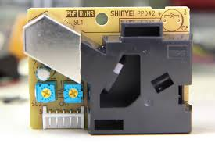
This sensor is the GROOVE Dust sensor from the SEED STUDIO. There are many documents on the Internet. Also a number of programs available for the Arduino, but did not find for the Raspberry Pi. The reason is that the measurement should be nearly real-time, as the low pulse out (LPO) time should be captured, and the Linux on Raspberry is not a real-time system. Time to take on the challenge....
Paul van Haastrecht (paulvha@hotmail.com)
March 2017

Table of Contents
Connecting PPD42 to a Raspberry PI 1
Background 1
The Hardware 2
The software 4
Conclusion on project 6
Software installation 7
Understanding the PPD42 sensor 8
Appendix A. 16

The Hardware
First I read a lot of documents and details about the PPD42NJ. A great explanation has been done by Tracy Allen ( http://takingspace.org/wp-content/uploads/ShinyeiPPD42NS_Deconstruction_TracyAllen.pdf).
I even took one sensor apart and with that I discovered however a number of small errors in that document. I extended that document with explanation and scope pictures. For this see the chapter “Understanding the PPD42 sensor”.
The PPD42 comes with a connector with 3 wires: GND, 1um, 5V. For the project I have added wires to the other 2 pins : 2.5um and threshold
Wiring connection :
PPD42 Raspberry PI
1 = GND GND
2 = 2.5µm - 5.6K - GPIO-23 – 10K - GND GPIO-22
3= +5V +5V
4 = 1µm - 5.6K - GPIO-22 – 10K - GND GPIO-23
5 = Threshold Not connected

The output of the 2.5µm and the 1µm can not be directly connected to the Raspberry Pi given the maximum voltage of the PPD42 is higher than 3.3V. Thus the voltage is divided in 2/3 with a 5.6K and 10K resistor.
The 5V has to be very stable. Any change, will change the results. As the PPD42 needs ~83mA, it is not switched on/off with a GPIO, but directly connected to the 5V.
The PPD42 is very sensitive to external light. This is extremely important to handle as it has high impact on the results. It can be tested with running the program in debug (-d) mode, wave your hand between the external (outside) light and sensor and watch the readings. I had put it in a box to make it darker but even then it is difficult. However if you put it in a completely close box, then there is no new air coming in and you are not measuring the current air quality.
The way the air gets to move between the LED and photo-diode is because of heat, caused by a resistor in the black cabinet, as such the PPD42 should have time to warm up. Default is the recommendation of 3 minutes, but on the command line this can be changed to no wait-pass (-w0).

The program will allow for a test pulse to happen (-t option) on a separate pin 24 by default in pdd42.h. In the picture below red is the 1µm output and yellow the test-pulse.

The software

Having done other projects I know that the fastest IO library for the Raspberry Pi is the beautiful BCM2835- library which I choose again for this project. This library will work directly on the BCM2835 hardware, bypassing many kernel routines that could impact detection timing
Both pin (1µm and 2.5µm) are read as I added the wire for that. If you only want to see one (either 1 or 2.5µm ) this can be done by excluding on the command line with either ‘-x’ or ‘-n’.
To facilitate fast discovery of GPIO level change, the “Low Detect Enable” and “High Detect Enable” register functions of the BCM2835 are used. The “Event Detect Status” register is read to detect a change in level. When triggering low, the start time of the low pulse is set, when triggered on high, it will calculate the time low and add to the total low time for that pin. At the end of a total measurement cycle, typically 30 seconds, the total low time is translated into particle count, using the formula from the supplier, and displayed (and logged).
If Dylos readings need to be included, this can be done by using the right compiling instruction (see software installation) and including the ‘-D’ option on the command line. When including Dylos you must be superuser or root to run the program, given the permissions that are set by Linux on the USB port.
Use “./ppd42 -h” to get the complete overview of the options available.

Starting first time, I would let the PPD42 warm up :
ppd42 -d (start with debug messages)

If the ppd42 is connected for longer time I skip the wait, as the resistor was/should be warm:
ppd42 -d -w0 : will cause no wait cycle

False readings
At the start there were a number of false readings of pulse time, which took effort to analyze and understand. Apart from the mentioned issues in the hardware section, there are basically 2 reasons:
1. Normal low pulse output (LPO) time is > ~75ms on avg. However with sometimes very fast pulse time (spikes), the Raspberry will detect this and trigger on low, BUT the output is already high before able to process.
Below is a great example of that. The red line is PPD42 1µm output and the yellow is a test-pulse. The 1µm triggers low, the first test-pulse show detection BUT immediately after going low the 1µm goes (unstable) high again, to go low again after ~4ms and again detected.
As a result the program will only calculate a low pulse out (LPO) if a low pulse start time was recorded first, before a high level is detected. Even with this change you might see values (with -d option) of 0ms being measured. You'll find the same in some Arduino programs.
2. As can be seen within test-pulse the picture above, the program on the Raspberry reacts within ~1ms (because of a delay in the main loop otherwise it would react in 0.4ms). However the level change has not settled yet and the program was reading the level while it was still changing. This can be seen very well in the second test-pulse. Hence a delay of 2ms has been included after level change and before establishing whether it was “high to low” or “low to high”. (checking very close to the trailing edge of the test-pulse). As we do this on both level changes, there is no impact on the total LPO reading.

Conclusion on project

Given all the above one would expect that the sensor could have some use. However I come to a different conclusion..
As I had bought 2 PPD42NJ sensors, I put them both in the same small box, completely closed and in the dark. Then registered the 1µm result from both at the same time. The results are in Appendix A and shows how far apart and random the results are from each other, but also sequential read on each sensor is random. (remember box is closed, no change in internal nor external conditions, sensors 3 centimeters apart, next to each other). However in this measurement period the total of 1µm recordings is only 5% apart between the sensors.
Also running the program with the -d option, it shows a big difference in LPO timing happening and the length of time. This has been validated with a separate oscilloscope tracing as well. One should not expect to see the same timing happening, but there is NO correlation at all. If the results come close it seems to be because of sheer luck.
It was not possible for me to validate the 1µm results in a different way, as I don’t have other reference systems for 1µm.
I have tried really hard, and failed, to get the reasonable stable 2.5µm output results from a PPD42 by automatic adjusting the threshold for the 2.5µm output with an LDR, LED. For this I had changed the program (and removed those changes in the final version) so it was reading a DC1700, comparing to the PDD42 2.5µm output, then increasing / decreasing the LED brightness (PWM), thus changing LDR resistor value and thus decreasing or increasing the trigger level of the PPD42. Honestly it was impossible to get anything close to stable results as the results are random.
After the project with many different experiments I really, really wonder about the sensor.
1. Given the huge randomness in a large sequential number of 30 seconds results from a single PPD42, for both 1µm and 2.5µm, with no change of surrounding condition (even in a complete black closed box).
2. When comparing 2 PPD42 sensors, under same conditions ( &closed box) the results are random and do not match even close to each other.
3. The randomness when trying to calibrate the 2.5um output
This is sensor does not look to make sense to me and is just a toy.
I am OK with a toy… but then position it as such… then again… what else to expect from a 15 euro sensor ...

Software installation

BCM2835 library installation
Install latest from BCM2835 from : http://www.airspayce.com/mikem/bcm2835/
- wget http://www.airspayce.com/mikem/bcm2835/bcm2835-1.50.tar.gz
- tar -zxf bcm2835-1.50.tar.gz // 1.50 = version at current time
- cd bcm2835-1.50
- ./configure
- sudo make check
- sudo make install

PPD42 software installation

- tar -zxf ppd42-1.1.tar.gz
- cd ppd42
- compile to handle PPD42 only : “./setup.sh ppd42”
- compile including Dylos support : “./setup.sh +DYLOS”
- start ./ppd42 -h for help options

The following software files can be found:

ppd42.c and ppd42.h : Needed for PPD42.
dylos.c and dylos.h : Needed for Dylos access.
setup.sh : compile program correctly.

Understanding the PPD42 sensor
Great work has been done by Tracy Allen and well documented in: De-construction of the Shinyei PPD42NS dust sensor.( ShinyeiPPD42NS_Deconstruction_TracyAllen.pdf). If you have not read it yet, I urge you to do so first although all of that text and explanations have been copied in this part of “understanding the PPD42 sensor”.
ALL credit is going to Tracy Allen. I have added pictures (taken with an oscilloscope) and context where possible. Also the schema of the PPD42 has been adjusted a little. First to be better able to find the test-points, but also the resistors R14 and R15 are pull-up instead of pull-down as in Tracy’s schema.
1
2
3
4
5

1 = GND
2 = 2.5µm
3= +5V
4 = 1µm
5 = Threshold

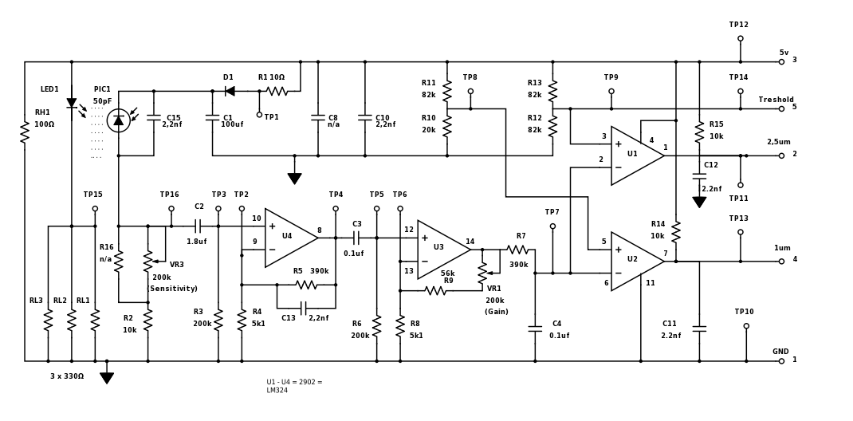

Circuit description:

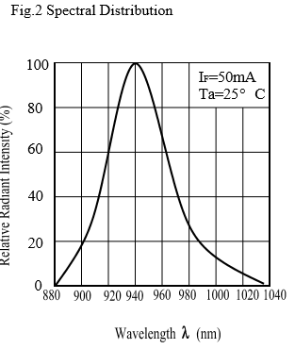
LED1 is serial with the 5V power supply and 110Ω of resistance, provided by 3*330Ω in parallel. The forward voltage of the diode was measured as 1.41V and the diode current was 33mA continuous. Note that the 5V power supply applied at the input connector should be well filtered, because fluctuations in power supply voltage will translate directly to fluctuations in light output from the LED, which will be indistinguishable from actual signal. In the devices tested, large supply filter capacitor C8 was not installed on the circuit board. C10 is a much smaller ceramic type, filtering out high frequency spikes.
The led is provides infra-red light, so it is not visible. A typical distribution is for an infra-red led is like the left figure (taken from a IR333C fact-sheet)

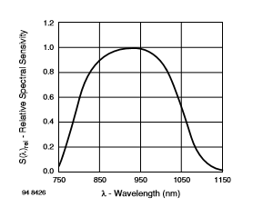
Power to the photo-diode is filtered by resistor R1, diode D1 and 100µF capacitor C1. I am assuming that PIC1 is a standard photo-diode, rather than an integrated circuit. The name, PIC1, is puzzling. It has a forward voltage of 0.7V and its position in the circuit is consistent with it being a standard photo-diode. The photo-diode is reverse biased and is in series with a variable resistance comprised of R2, R16 and VR3. Tracy wrote “ In the two that I tested, VR3 was set close to 50kΩ, and R16 was not installed on the circuit board.” Actually the VR3 resistor reading should be the opposite, see “estimating VR1 and VR3 values” chapter below. As such the value is 150K (200k – 50k)
As the led provides in infra-red light this photo-diode will be most sensitive to that light spectrum. E.g. see the example of an BPV10NF photo-diode from Vishay Semiconductors

Changes in light cause changes in current from the photo-diode, and that develops changes in voltage across the combined resistance of R2,R16 and VR3. Adjusting VR3 to a higher resistance (right TURN) would increase the sensitivity. LEFT turn REDUCES sensitivity. (see estimating VR1 and VR3 values) Capacitor C15 is in parallel with the photo-diode and slows down and integrates the response on a time scale of a millisecond or so, and that time constant increases along with increases in the sensitivity adjustment.
The photo-diode is very (read VERY) sensitive to direct external light. As soon as you wave your hand in front of the gap, with external light shining on it, it detects a “particle”. This sensor should be used in a dark area, which is a challenge, as you want to get the external / fresh flow airflow as well. Fluctuations in voltage are coupled through capacitor C2 and R3 into section a of the op-amp, which provides non-inverting low frequency voltage gain of x76.5. (390k/5.1k) Low frequency here means everything above 0.5 Hz, based on the values of C2 and R3. C13 in the feedback path provides AC stability and makes a sharp pulse from the input.

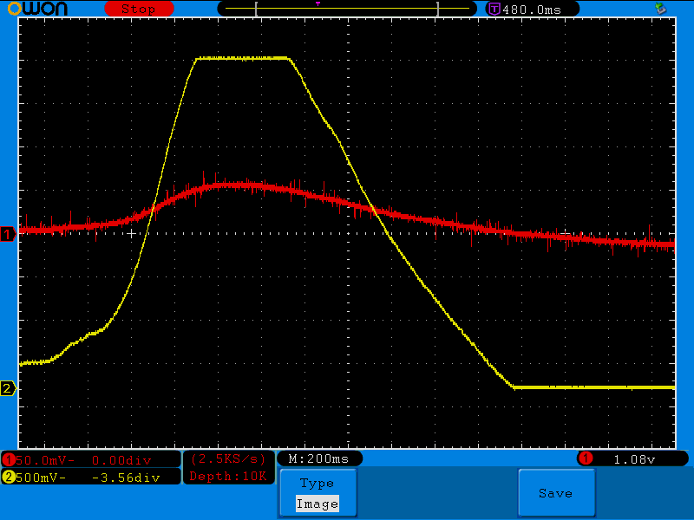
The figure right shows in red TP3 and in yellow TP4 (U4 in work). It also shows that the voltage from change from the photo-diode is in the order of 50mV, which is already forcing U4 to clip to the maximum output.

Fluctuations at the output of section U4, are fed through capacitor C3 and R6 to section U3 of the opamp, and this section provides adjustable DC gain from x11 (0(VR1) + 56K(R9) / 5.1(R8) = 11) to x51(200K(VR1) + 56K(R9) / 5.1(R8) = 51) with VR1 in combination with R8 and R9. Tracy wrote :”In the two that I measured, VR1 was set at near 50kΩ, for a second stage gain of x22”. Actually we are again looking in the opposite way to the resistance, and VR1 is closer to 135K. The combination of C3 with R6 attenuates frequencies below 8Hz.
The output of section U3 feeds into a first order low pass filter, R7 and C4. This section attenuates frequencies above 4Hz. The result of the combined high-pass C3:R6 and low-pass C4:R7 suggests that frequencies around 6 Hz are the least attenuated, and that pulses of a certain length and frequency are more apt to pass through to the output. This needs further analysis and experiment.

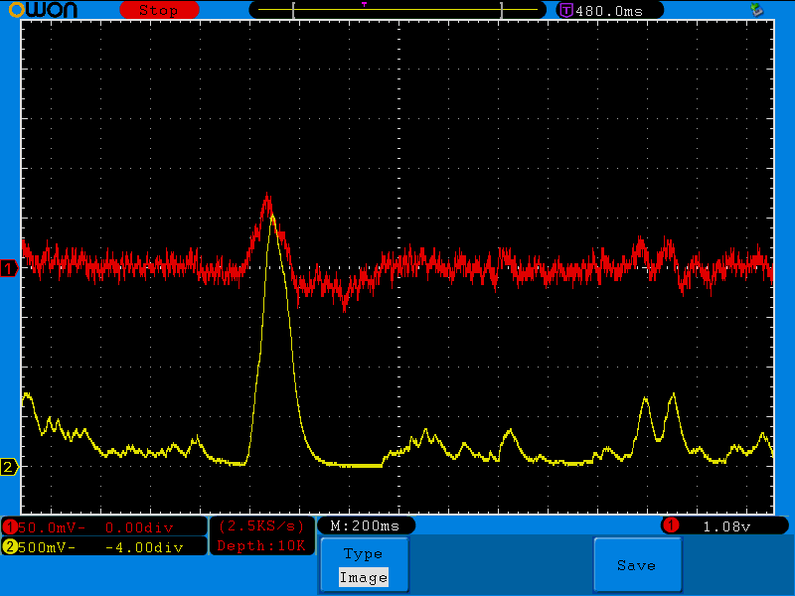
The figure right shows the work of U3 + low pass. In red (TP5) and yellow TP7). What is interesting is that the output is 5 x 500mV = 2.5V (in yellow). The input (red) is 75mV, which means a gain of ~33 without clipping ( E.g. achieving the maximum out). With a resistance of ~135K on VR1, the gain should be around 38. The trimmer values are aboutisch, but close enough.

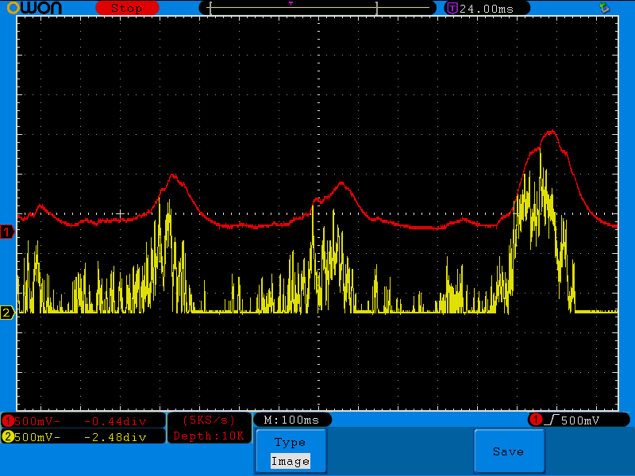
To see the low pass filter only in work, figure right shows in red (TP7) and yellow output of U3, pin 14.

Sections U2 and U1 of the op-amp are set up as comparators to provide output pulses for the P1 and P2 outputs at the connector. Voltage divider R10 and R11 determine a threshold of 1.09V for P1. Similarly, R12 and R13 determine a threshold of 2.5V for P2, P1 and/or P2 will pulse low so long as the input voltage exceeds their respective thresholds. Note that any time the signal is high enough to activate P2, P1 will be active also. Applying an additional resistor or a voltage to the external threshold input could adjust the P2 threshold either up or down.
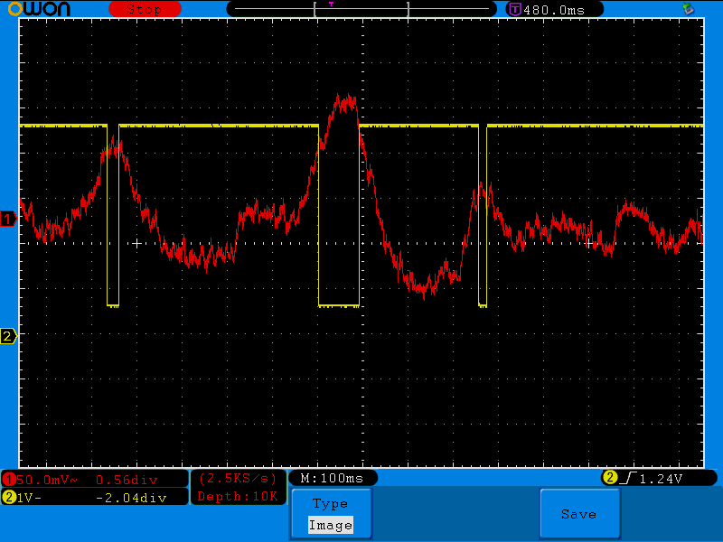
The figure right shows in red TP4 and in yellow the 1µm output (TP13). The output is inverted due to U2 receiving the signal from the photo-diode on the negative input, comparing to the positive reference voltages.

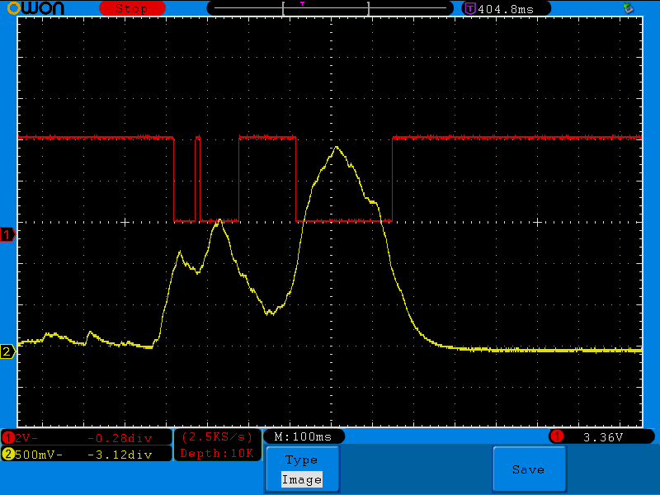
The figure right show in red 1µm (TP13) and in yellow TP7. It clearly shows that as soon the trigger compared to the 1V reference voltage.

There are a number of test point TP1...TP16 scattered around the circuit board, and most of those are also marked on the schematic. Note that there are not official test points at the op-amp outputs at the corners of the 14-pin package, but the op-amp outputs are probably the best place for monitoring the circuit performance.
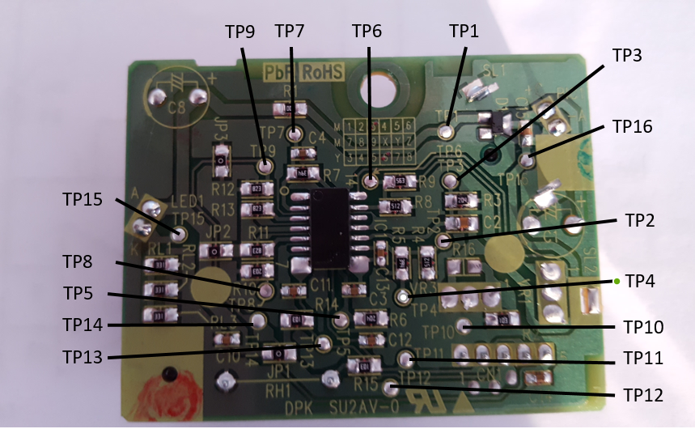

The op-amp is a generic NJM2902, which is essentially the same as the ubiquitous LM324. The circuit is very straightforward, as you can see, and does not involve tricks except for the clever heat pump and the nice optical chamber. There is no fancy large scale integrated circuit or microprocessor. Quite the contrary, and all the electronic parts are standard issue.
The PPD42 power drain is determined almost completely by the combination of the heater RH1, 50mA and LED1, 33mA.
Shinyei literature and other communications suggest that pulses at the P1 output correspond to 1µm particles, and pulses at the P2 output correspond to 2.5µm particles. That would seem to compare with the 1V and 2.5V thresholds set on the comparator inputs. There is presumably a calibration adjustment made to the sensitivity and gain trimmers in order to adjust the calibration to a standard maintained at Shinyei. Calibration would be necessary if only to account for variations in the components, and especially to adjust for the LED output and photo-diode sensitivity.

Estimating VR1 and VR3 values.
Looking from the top (like the picture) on VR1 the bottom and middle pin of the trimmer are connected together, so the resistance is coming through the top pin. The VR3 has the right and middle pin connected and thus the resistance is coming from the left pin.
Turning VRx to the right will increase the resistance and the sensitivity or gain. Hence I have put a 0 on the least resistance and a 10 on the highest resistance in the figure.
The trimmer has 11 positions and the following overview shows the resistance at each position (aboutisch ☺)
Trimmer pos. Resistance
0 0k
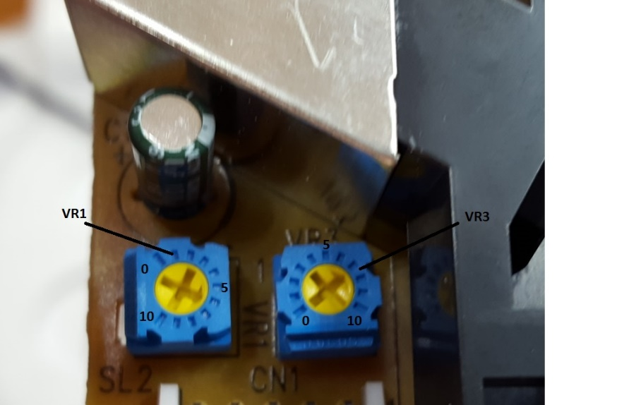
- 0K
- 10K
- 40K
- 72k
- 95K
- 128K
- 150K
- 175K
- 183K
- 200k

In the picture is looks that VR1 in position which is just a little above 6: 135K (gain) and VR3 in position 7: 150K (sensitivity). Checking different sensors and pictures of the PPD42 on Internet it looks that VR1 is nearly always on this position 6, while VR3 can be found between position 4 and 8. Probably the VR3 needs to compensate more for mechanical setup (like lens etc.).

Final words
We should be skeptical though about any quantitative link to real particles in all their variety. The usual issues in interpretation of optical scattering apply here. Optical scattering properties of aerosols vary widely among different classes of particles. Also there is great variation within a heterogeneous aerosol of one type or from one source dependent on a host of factors and over the course of time. The electronics suggest that the response is an average of clouds of many smaller or fewer larger particle that pass through the detection area in a sustained concentration large enough to push one or both of the outputs over their thresholds to give a pulse at the P1 or P2 outputs.
It is not a particle counter in the sense of the Dylos, which does in fact count the pulses caused by individual particles, nor is it a photometer, that quantifies the an overall level of light scattering in a larger volume. It is a hybrid. The response of this sensor to specific aerosols will have to come from experiments and from collocations with standard instruments.

Reference material
The great work of Tracy Allen to unravel the PPD42 sensor electronics: http://takingspace.org/wp-content/uploads/ShinyeiPPD42NS_Deconstruction_TracyAllen.pdf
Infra-led light : http://www.everlight.com/file/ProductFile/201407061520477674.pdf
Photo-diode info : http://www.vishay.com/docs/81503/bpv10nf.pdf

Appendix A.
Result of comparing two PPD42NJ sensors to each other at the same time in a closed dark box, no change in internal and external environment etc.

