SCD30 connected to Raspberry PI
Table of Contents
1. Background 3
2. Board information 4
2.1 Board connections 4
2.2 Connection to Raspberry Pi 5
2.3 Pull-up resistors 5
3. software installation 7
3.1 BCM2835 library 7
3.2 twowire library 7
3.3 SCD30 software 7
4 scd30 program 9
4.1 Initialize variables 9
4.2 parse parameters 9
4.3 Initialize hardware 9
4.4 main loop 9
4.5 closeout 9
4.6 scd30 program parameters 10
5.1 Sensor Driver 12
5.1.1 sharing I2C data settings 12
5.1.2 perform single measurement 12
5.1.3 read article code 12
5.1.4 read serial number 12
5.2 Driver calls 13
5.2.1 scd30 (void) 13
5.2.2 begin (asc, interval) 13
5.2.3 beginMeasuring(pressureOffset) 13
5.2.4 SoftReset() 13
5.2.5 StopMeasurement() 13
5.2.6 StartSingleMeasurement() 13
5.2.7 getSerialNumber() 13
5.2.8 dataAvailable() 13
5.2.9 getTemperature(), getTemperatureF() 13
5.2.10 getHumidity() 13
5.2.11 getCO2() 13
5.2.12 setMeasurementInterval(). 13
5.2.13 setAmbientPressure(). 13
5.2.14 setAltitudeCompensation() 13
5.2.15 setAutoSelfCalibration() 14
5.2.16 setForceRecalibration() 14
5.2.17 SetTemperatureOffset() 14
5.2.18 close() 14
5.2.19 setDebug() 14
5.2.20 DispClockStretch() 14
5.2.21 Calc_dewpoint() 14
5.2.22 computeHeatIndex() 14
6. A word on the twowire library 15
Appendix A: NDIR Sensor Module Principle 16

1. Background

This project is part of a number of projects to measure the air quality I run into SCD30 sensor , which can measure temperature, CO2 and TVOC. The board is the SCD30 from Sensirion. ( https://www.sensirion.com/en/environmental-sensors/carbon-dioxide-sensors-co2/)

The board is relative new at the time of writing this documentation and as such a lot of preliminary documents from supplier. There is a driver software available for Arduino from Sparkfun and reference driver from Sensirion ( https://www.sensirion.com/en/download-center/carbon-dioxide-sensors-co2/co2-sensor/. I have studied that code and found many conflicting information and errors. Still made a working versions for the ESP8266 and Raspberry PI. I expect updates as we go along and information improves.

As the SCD30 is using clock-stretching, which is not/badly supported by the BCM835 chip on the Raspberry Pi, a special library has been added : twowire

This document is discussing the Raspberry Pi implementation.
Version 1 : October 2018
initial version

Version 2 : October 2018
- bug fixes and code enhancements
- added softreset
- changed single measurement (see chapter 4.1)
- added option for temperature in Fahrenheit (see 4.3)

Version 3 : October 2018
- add dew-point and heat-index

Paul van Haastrecht
paulvha@hotmail.com

2. Board information

Source : https://www.sensirion.com/en/environmental-sensors/carbon-dioxide-sensors-co2/

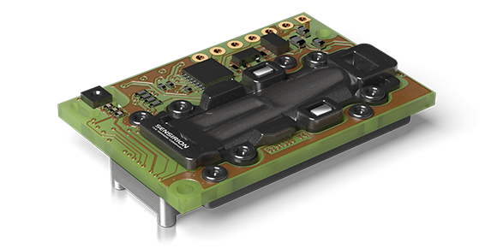

2.1 Board connections

Source : Sensirion_CO2_Sensors_SCD30_Datasheet.pdf

Component side up, as in the picture : pin 1 is right, pin 7 is left

PinOut Diagram Pin Comments
VDD 1 Supply Voltage
GND 2 Ground
TX/SCL 3 Transmission line Modbus / Serial clock I2C
RX/SDA 4 Receive line Modbus / Serial data I2C
RDY 5 Data ready. High when data is ready for read-out (*1)
PWM 6 PWM output of CO2 concentration measurement (*1)
(PWM not supported yet )
SEL 7 Interface select pin. Pull to VDD for selecting Modbus,
leave floating or connect to GND for selecting I2C. (*1)

This sensor uses I2C address 0x61.

Note *1 : none of these lines are connected or used.

2.2 Connection to Raspberry Pi

SCD30 Description Raspberry Pi
GPIO / PIN
VDD power in 3 -5 V 3V3 or 5V / 1 or 2
GND ground GND / 6
SCL Serial Clock 3 / 5 (*2)
SDA Serial data 2 / 3 (*2)
RDY data ready Not Connected

PWM PWM output Not Connected

SEL Interface Select Not Connected

Note *2 SDA/SCL
When using soft_I2C (which is default) SDA or SCL can be set to any GPIO, see chapter 4

2.3 Pull-up resistors

Normally an I2C slave device has the pull-up resistors as they are supposed to be at the end of the line. On most devices these can be disabled, to allow multiple devices on the same line BUT there should only be one pull-up resistor on the SCL and SDA. The SCD30 is lacking pull-up resistors completely. This is NOT documented, but detected.

The SDA/SCL signal with an SCD30 without pull-up resistors will not have the right voltage level and chances of misreadings is very high:

The SDA/SCL signal with an SCD30 + external 10K pull-up, is preferred as this much more digital and correct.

It will support longer lines and stability. The signal will look like:

The Raspberry PI already as on-board pull-up resistors (1k8) on GPIO 2 (pin3) and GPIO 3 (pin5). This is because these are the standard for the hardware I2C pins, however it is also known to be a design issue as they should NOT be on the master. Still…in that case you would not need them.
Because of the lack of clock-stretching the hardware-I2C has, we have to use the soft-I2C with the twowire library. That provides the option to use any of the other GPIO.

With soft_I2C you can still use GPIO 2 and GPIO 3, but if wanted on other GPIO’s, you could use the internal Raspberry PI pull-up resistors (around 50K) on those GPIO with the -P option.

The signal will not be as clean, but voltages are correct, and will look like :

3. software installation
As with many of my projects I make use of the BCM23008 library to control the IO. The reason is that it is faster and more flexible than the wiringPi (which makes use of the official kernel drivers) and provides direct control and insight, which I like.

3.1 BCM2835 library
Install latest from BCM2835 from : http://www.airspayce.com/mikem/bcm2835/

1. wget http://www.airspayce.com/mikem/bcm2835/bcm2835-1.56.tar.gz
2. tar -zxf bcm2835-1.56.tar.gz // 1.56 was version number at the time of writing
3. cd bcm2835-1.56
4. ./configure
5. sudo make check
6. sudo make install

In order for this software to run you should NOT enable i2C in raspi-config to load the kernel drivers. It works directly on the hardware, but you’ll have to run program as root.

3.2 twowire library
Obtain the latest version from : https://github.com/paulvha/twowire

1. download the zip-file (clone or download / download zip-file) in the wanted directory
2. unzip twowire-master.zip (*1)
3. cd twowire-master
4. make install

*1) if you do not have unzip : sudo apt-get install zip unzip

3.3 SCD30 software
Obtain the latest version from : https://github.com/paulvha/scd30_on_raspberry

1. Download the zip-file (clone or download / download zip-file) in the wanted directory
2. unzip scd30_on_raspberry-master.zip (*1)
3. cd scd30_on_raspberry-master
4. create the executable : make
5. To run you have to be as sudo ./scd30 -h ….

The “make” command will create an SCD30 monitor only. The command “make BUILD=DYLOS” will create an executable that is able to monitor both the SCD30 as well as the DYLOS 1700.

In the software package you will find the following files

scd30_lib.cpp :
This is the main driver for the scd30. The driver is based on the original version from SparkFun written for the Arduino, but adjusted and extended to work on the Raspberry Pi. Some routines have been added, a number have been changed. (see chapter 5)

scd30.cpp :
This is the user level program that will be discussed in detail in a chapter 4.

scd30.h :
This is the header file for the scd30. It is based on the original version from SparkFun written for the Arduino, but adjusted and extended to work on the Raspberry Pi.

dylos.c
This is the driver to read a the data from a Dylos 1700 device and then display with the scd30.cpp program. It is not described further here.

makefile :
script to compile the source and create an executable with the make command.

4 scd30 program

The program it self has a number of big blocks

- Initialize variables to default settings
- parse parameters
- Initialize hardware (BCM2835 + sensor)
- Main-loop to provide output
- closeout()

4.1 Initialize variables
Default values for the different parameters are loaded and result variables reset. The defaults are hard coded, based on the SparkFun, generic driver software, what I have learned along the way and setting the program structure. The Dylos parameters are only included if requested during compile. (See chapter 3.3)

4.2 parse parameters
The program has a rich set of command line option (see 4.6 in detail later) to change many default settings. This can either be input on the command line, or loaded from files that have been created before with the stored values

4.3 Initialize hardware
The twowire library and scd30 settings are initialized with the different parameters. The Dylos is optional.

4.4 main loop
The program will loop for reading, either a fixed number of times or endless (depending on the parameter). It will call do_output() to display the results.

4.5 closeout
Either close with Control-C or it will count down the number loops. After that BCM2835 reset to the standard values but there is NO change requested to the stored scd30 values.

4.6 scd30 program parameters
Make sure to check the data- sheet for SCD30 for the exact impact of some of the parameters.

The following parameters can be set for the SCD30:

-a :
set Automatic Self Calibration (ASC) . This is already default

-n :
set for NO Automatic Self Calibration (ASC) . Default is to set ASC.

-i # :
Set the measurement interval period on the SCD30. Default is 2 seconds. Can be between
2 and 1800 seconds.

-f #:
Will set forced calibration. The PPM provided has to be between 400 and 2000 PPM

-m #:
set the current altitude in meters above sealevel to impact CO2 reading as the air is more or less compressed. Use this OR pressure, but not both as one overrules the other.

-o #:
Set temperature offset. This does NOT influence the CO2 reading, but only the temperature and humidity reading. It is to compensate for to high reading due to components on the board warming up and overstate the real temperature.

-p #:
set the current pressure in mbar to impact CO2 reading as the air is more or less compressed. Use this OR altitude, but not both as one overrules the other.

-k:
Stop continuous measurement. This will be stored in the SCD30 and impact also on a next power-on.

-c:
Start continuous measurement. This will be stored in the SCD30 and impact also on a next power-on. It is set by default.

-S:
Perform a single measurement. It is assumed that continuous measurement has been stopped and this will perform a one-time read.

Parameters for program

-B :
This will trigger to output results without color on the screen.

-l #:
This will change the default endless loop (0) to a number of loops for the main-loop before exiting.

-w #:
Change the wait-time (seconds) between the measurements. Default is 5 seconds

-v level:
This will enable progress/debug information. The level can be set between 0 (default) and 2 (highest). The higher the more information.

-t :
Add timestamp to output.

-u:
Add dew-point to output.

-x:
Add heat-index (feeling temperature) to output.

-F:
Output temperatures in Fahrenheit instead of Celsius

Parameters for Dylos

-D device:
Enable Dylos input from device (e.g. /dev/ttyUSB0). The data will be updated with the speed of Dylos output (every minute).

Note: this is only included/supported if DYLOS monitor was included in the build (see chapter 3.3)

Parameters for I2C

-H:
use hardware_I2C instead of software_I2C (see chapter ?????? for more information). This option is NOT recommended to use for the SCD30.. but just in case..

-q #:
Set I2C speed between 1 and 400Khz (default is 100Khz). In case of software_I2C the maximum is 200KHz (even if higher requested)

-s #:
Set the SDA GPIO number. Default is GPIO 2.

-d #:
Set the SCL GPIO number. Default is GPIO 3.

-P:
Sets a pull-up internal resistor on SDA and SCL, unless it is GPIO 2 or 3. Some slave devices do not have them. Although this option is available external resistors are preferred , especially for longer I2C lines. (see chapter 2.3)5. Sensor program structure

5.1 Sensor Driver
The scd30 has a relative simple driver. It contains all the low-level communication routines between the scd30 and the hardware of the Raspberry Pi. It is also here where I have made most changes and added the twowire routines. Other routines to connect to the user program: setting parameters and reading results.

The I2C interface was a bit of challenge as the SCD30 is using clock-stretch and this very badly implemented in the BCM2835 chip. Hence I has created the twowire library that does support clock stretching as it should. (see more in later chapter). Now it works as a charm.

5.1.1 sharing I2C data settings
Between the user program and the driver I have created a “settings” section (defined in SCD30.h) to share the I2C parameters between user program and driver

- I2C_interface : hard_I2C or soft_I2C
- I2C_Address : slave address to use
- baudrate : I2C speed (between 100 and 400Khz)
- sda : GPIO for SDA to use (soft_I2C only)
- scl : GPIO for SCL to use (soft_I2C only)
- pull-up : enable Raspberry PI. See chapter 2.1.3 (soft_I2C only)

5.1.2 perform single measurement
There is a problem with the single measurement command (0x0006). It is not providing the right result. When performed first time it will show the correct value (left over from previous continuous mode) and then in subsequent readings nearly only zero’s. This is known issue with supplier and was actually already undocumented in the interface description. (only in the sample code.) The driver now has a pseudo implementation where it starts the continuous mode, performs one reading and then stops. The user only has to call the getTemperature(), getHumidity() or getCO2().

5.1.3 read article code
The command read article code (0xD025) always returns zeros. It is NOT implemented on the SCD30 and was not documented in the interface document. It was part of the sample code, but as it will not provide data, the call is not implemented in the driver.

5.1.4 read serial number
The command read serial number (0xD033) is working and provide the serial number. It was not implemented in the interface document, but part of the sample code. As it is working the call has been implemented in the driver.

5.2 Driver calls

5.2.1 scd30 (void)
This is the constructor used to create the access to the driver. Normally this done globally as with SCD30 program : SCD30 MySensor;. The calls below can be accessed like MySensor.begin()

5.2.2 begin (asc, interval)
This will initialize the hardware, the twowire library and the SCD30. It will also set for clock_stretch in the twowire-library and potential pull-up

5.2.3 beginMeasuring(pressureOffset)
This will set SCD30 in continuous mode of measuring, optionally with compensation for pressure (between 700 ... 1200 mbar)

5.2.4 SoftReset()
This perform a soft-reset on the SCD30 (same as power off/on) and reload the earlier requested options for ASC setting, continuous mode and the interval values.

5.2.5 StopMeasurement()
Will stop continuous measurement.

5.2.6 StartSingleMeasurement()
Will perform a single measurement. See 5.1.2 for more information.

5.2.7 getSerialNumber()
Will read the 6 digits serial number for the SCD30. Buffer needs to be at least 7 digits. See 5.1.4.

5.2.8 dataAvailable()
Will read the SCD30 register to check whether new data is available (= true)

5.2.9 getTemperature(), getTemperatureF()
Obtain the latest value of the temperature from the SCD30 in either Celsius or Fahrenheit.

5.2.10 getHumidity()
Obtain the latest value of the humidity from the SCD30.

5.2.11 getCO2()
Obtain the latest value of the CO2 from the SCD30.

5.2.12 setMeasurementInterval().
Will set the SCD30 measurement interval between 2 and 1800 seconds.

5.2.13 setAmbientPressure().
Will set the SCD30 to compensation for pressure. The value has to be between 700 and 1200 mbar.
Either use pressure or altitude (5.2.14), both not both as they overwrite each other.

5.2.14 setAltitudeCompensation()
Will set the SCD30 to compensation for pressure. The value has to be between -1520 and 3040 meter. (this correlates with 700 and 1200 mbar). Either use pressure (5.2.13) or altitude, both not both as they overwrite each other.

5.2.15 setAutoSelfCalibration()
Will enable of disable auto self calibration (ASC). Will overwrite ForceCalibration (5.2.16). See data-sheet for information and principle of operation appendix A.

5.2.16 setForceRecalibration()
Forced re-calibration (FRC) is used to compensate for sensor drifts when a reference value of the CO 2 concentration in close proximity to the SCD30 is available. The value has to be between 400 and 2000PPM. Will overwrite ASC (5.2.15) see data-sheet for information.

5.2.17 SetTemperatureOffset()
Will adjust the temperature / humidity reading. The temperature might be read to high as a result of on-board component reading. The provided value will be subtracted from the results. Value between 0 and 25 Celsius.

5.2.18 close()
will close out and reset the hardware and twolibrary correctly. Should be called at the end of the program. Any stored values on the SCD30 will stay unchanged.

5.2.19 setDebug()
Will enable or disable debug messages. If value is 2 also debug messages from the twolibrary are enabled.

5.2.20 DispClockStretch()
Will display the clock-stretch statistics from the twolibrary. This can be used for debug and check the clock-stretch value

5.2.21 Calc_dewpoint()
Will calculate the dewpoint based on temperature and humidity

5.2.22 computeHeatIndex()
Will calculate the heatindex, feeling temperature, based on temperature and humidity

6. A word on the twowire library

The BCM2835 chip provides I2C communication protocol from the hardware. However the clock stretching implementation is bad, leading to many issues with slave devices that depend on or use clock stretching to handle the requests. (e.g. CCS811, SCD30 )

The SCD30 document “Interface Description Sensirion SCD30 Sensor Module” describes clearly where and when to expect clock-stretch

This library for the Raspberry Pi can be instructed to use the standard (hardware) I2C communication OR use a software version that supports clock stretching on any of the GPIO pins. This also supports for you to run multiple I2C channels at the same time on different GPIO. To have low processor load and increase stability, the maximum speed that is supported for the soft_I2C is 200Khz. However for compatibility reasons a higher speed request (max. 400Khz) will be accepted, which can be executed by hardware I2C communication, but for software I2C the maximum executed will be around 200Khz.

software version :
advantage:
can run multiple I2C channels for different programs in parallel
flexible on GPIO’s to use
run as any user (does not need root permission)
supports proper clock-stretch

disadvantage:
generates some process load (although acceptable low)
quality of communication depending on total processor load (note 1)
supports speeds up to max 200Khz

hardware version :
advantage
generates lower process load
less / no dependency on processor load from other programs
supports speeds up to max 400Khz

disadvantage
single channel
fixed GPIO’s ( 2 and 3)
must be root or super user.
No clock-stretch support

Note 1: I have had 3 programs running in parallel, each using soft_I2C on different GPIO pins with 100Khz. The programs generated a total processor load of 26% and all continued to run without any problem.

Appendix A: NDIR Sensor Module Principle
Source : https://www.soselectronic.com/articles/sensirion/scd30-is-more-than-just-the-ndir-co2-sensor-2152
NDIR (Non Dispersive Infra-Red) sensor uses the fact that CO2 molecules absorb infrared radiation of certain wavelengths. The higher the CO2 concentration, the more radiation CO2 absorbs. The wavelength of 4.3μm has the maximum absorption for CO2 and minimal absorption for other gases in the air.
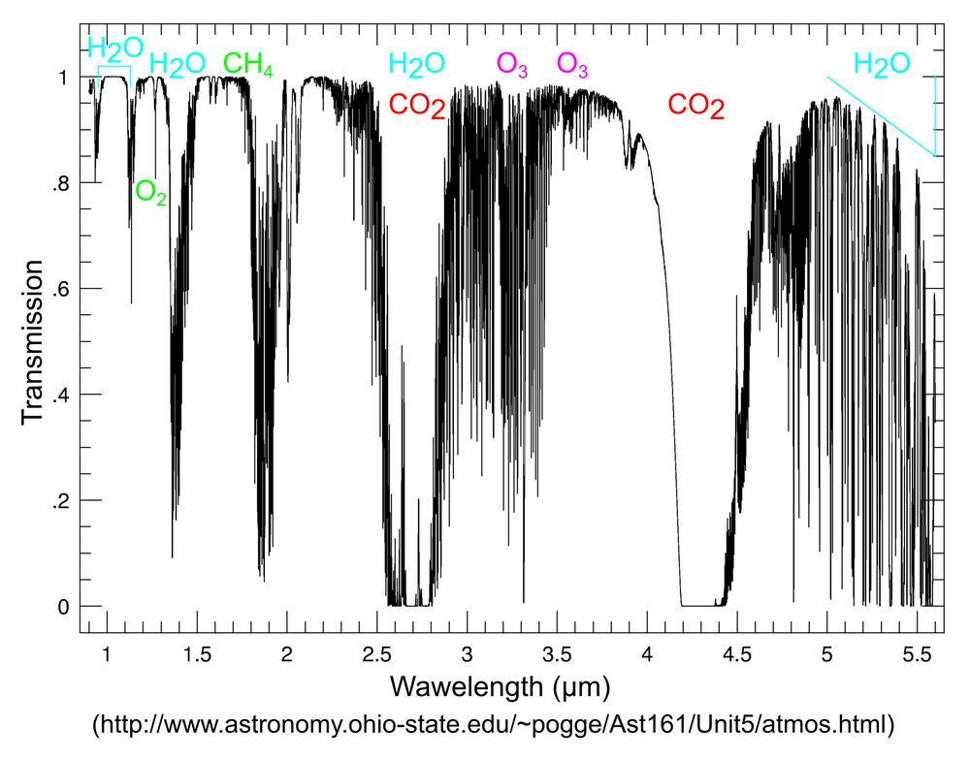

Infrared radiation source (light bulb) is placed on the one side of the tube. On the opposite side, two sensors with optical filters are placed. The first sensor (CO2) has band-pass filter for wavelength 4.3µm; it measures intensity of radiation Id. The second sensor (reference) has band-pass filter for wavelength, which is minimally absorbed by gases in the air (typically 4µm); it measures intensity of radiation I0.
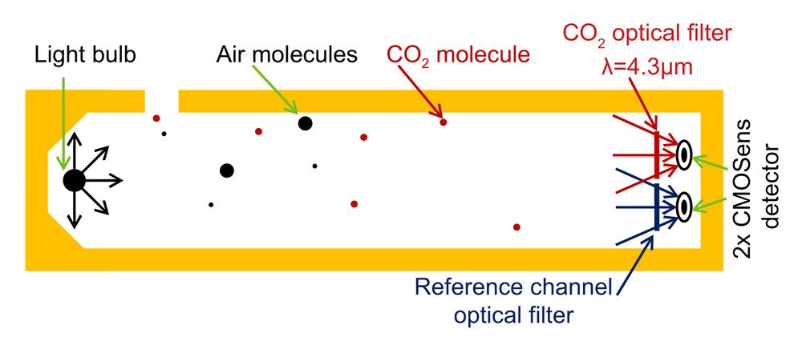
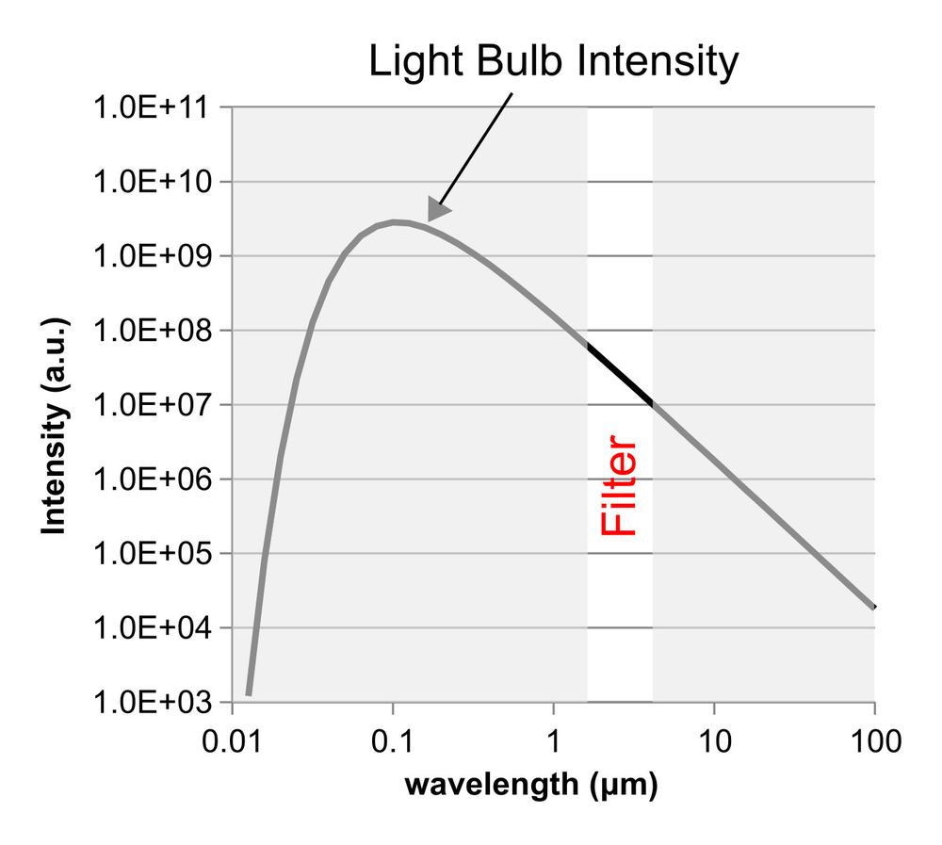

Measured intensity of radiation at these wavelengths is then associated with CO2 concentration via the Beer-Lambert Law that is given with the following equation:
Id/I0=e^KCL
where Id is the intensity of radiation at 4.3μm, I0 is the intensity of the reference radiation, K is the absorption co-efficient for CO2, C is the CO2 concentration , and L is the path length between the radiation source and the light detectors.
The reference sensor compensates for the effect of the radiation intensity variation. When intensity changes, both Id and I0 change identically, so Id / I0 remains unchanged.

