SDS011 on Raspberry Pi & Ubuntu

Table of Contents
1. Introduction 1
2. Connections 2
3. Program parameters 3
4. Results 5
4.1 Humidity 5
4.1.1 How much is the impact ? 6
4.2 Over-estimating 7
4.3 Particle Density 8
4.3.0 NO CONCLUSIONS (YET) 8
4.3.1 Molecule Weight 9
4.3.2 Mol to Density 9
4.3.3 What mass are measuring ? 10
Appendix A : Reference material 11

1. Introduction

The SDS-011 sensor has been around for a longer time and there are many articles and drivers to connect to Arduino and/or from Python. However I wanted to create a C-language version to connect the DYLOS 1700 and SDS30 at the same time and compare the results. The challenge was larger than expected.

In an earlier project I have used the PPD42, but I could only conclude that the sensor is not up to the job, which seems to be the conclusion of many others around the world now and replacing to the SDS011.

That said… the SDS011 is providing output in ug/m3… but how would you know if you the weight if you only measure size of particles? Also the SDS011 seems to have an impact from vapor in the air. How to deal with that ?

At this moment (January 2019) I have not been able to make a conclusion about the translation of particles to ug/m3 of the SDS011. See chapter 4.3

October 2019 : I have stopped working with the SDS011 a long time ago in favour of the SDS30. However due to a problem with wakeup after sleep the source code has been updated. With V2.1 some changes in the command-line options compared to V1.

Paul van Haastrecht
paulvha@hotmail.com

2. Connections

The connection is done on Linux with /dev/ttyUSB0, USB serial.

First the program would “hang” during trying to open the port. It turned out that the driver for the USB chip, the HL-341, had to be loaded first : sudo modprobe ch341.
Now the port would open. Instead of having to do this all the time, one can add to load by default, but in my case I have included a system() call in the program to handle.

I also tried to remove it (to have a clean start next time) by adding in closeout() : modprobe -fr ch341. However if the sensor is still connected, it will cause an unpredictable behavior.

Despite all actions there it is a known issue with the serial-USB that there might be old communication / URB’s / pending messages have send / still impact a good new start with the HL- 341. ( https://stackoverflow.com/questions/13013387/clearing-the-serial-ports-buffer )

I have done extensive testing with a modified usbserial.c, generic.c and ch341.c modules, providing pr-info and dev-info messages that can be read with ‘dmesg’. I have seen that “somehow” the usb_serial_generic_write() starts sending TO the ch341 parts of a RECEIVED buffer. (starting with AA C0 59 … which is a received data-package). Also see many messages with 25 or 26 zero in usb_serial_generic_read_bulk_callback (generic.c) that never made it to user-level. Makes me believe there is still some bugs in the whole URB / USB serial handling. To try to overcome that, the following has been implemented in the program:

1. Based on the remarks in https://bugzilla.kernel.org/show_bug.cgi?id=5730 added in main ():

usleep(10000); // try to make flush work, for some reason
tcflush(fd,TCIOFLUSH);

2. Added a Try_Connect() routine.
It that will try to read the firmware version or get an acknowledgment from the HL-341 before sending the real request. As a result it might take couple of seconds as it will re-try couple of times.

I have not been able to obtain good documentation about the HL-341 nor CH340 nor CH341. Most of the driver sources that I have seen for this chip all do the same. I was looking whether I could sent a reset or something like that, as despite the adjustments it will SOMETIMES0 still need the SDS-011 to be removed and re-insert again.

3. Program parameters
./sds [options] (version 1.0 / January 2019 / paulvha)

SDS-011 Options:

-m get current working mode
-p get current working period
-r get current reporting mode
-d get Device ID
-f get firmware version
-q use query reporting mode (default : continous)

SDS-011 setting:

-M [ S / W ] Set working mode (sleep or work)
-P [ 0 - 30 ] Set working period (minutes)
-R [ Q / R ] Set reporting mode (query or reporting)
-D [ 0xaabb ] Set new device ID

Program setting:

-l x loop x times ( 0 = endless) (default : 10 loops)
-w x x seconds between query data ( default : 5 seconds)
-H # set correction for humidity (e.g. 33.5 for 33.5%)
-u device set new device (default : /dev/ttyUSB0)
-b set no color output (default : color)
-h show help info
-v set verbose / debug info (default : NOT set)

Working mode
The working mode is either WORK or SLEEP. To get the current state use ‘-m’ ( lower case m),
to set, use ‘-M’ (capital M) followed by S/s = sleep or W/w = work.

Working period
The working period is the time it will ‘work’ followed by the same time ‘sleep’. To get the current setting use ‘-p’ (lowercase p), to set use ‘-P’ (capital P) followed by a number 0 – 30 minutes. ‘0’ will set to continues mode.

Reporting mode
The reporting mode is either Query, a separate command for data will be send later, or streaming / reporting. The get the current setting use ‘-r’ (lowercase r). To set use ‘-R’ (capital R) followed by Q/q = query or R/r = reporting.

Device ID
The current device ID can be obtained with ‘-d’ (lowercase d). It can also be changed/set with ‘-D’ followed by a hexadecimal number like ‘0xaabb’.

Firmware version
The current firmware version data can be obtained with ‘-f’ (lowercase f). It will show the date.

Getting data
The data is by default providing in continuous reporting mode. The number of loops is default 10 and can be changed with the ‘-l’(lower case l) option
If you want to change to query add ‘-q’ (lower case q) option.
With the ‘-w’ (lower case ww) you can set different than 5 seconds between query of the data.

Apply Humidity Correction
See chapter 4.1 for more information.

Change device
In case your device is not /dev/ttyUSB0, you can overrule the default with ‘-u’ (lower case u) followed by the new device name.

No color
The output is displayed in color. With the ‘-b’ ( lowercase b) you can prevent that

Debug/verbose
To add debug/verbose information use the ‘-v’ (lowercase v) option.

All the options can be used together. The order of execution is : first get / display then set / change to finally query or continuous read.

4. Results

4.1 Humidity
A number of measurements have been done with the SDS-011 around the world. There is some good reference material around impact. Most of them indicate the impact on humidity in the air. As one can see on the picture below H₂0 (vapor) is also around the PM 2.5uM and thus detected by the sensor.

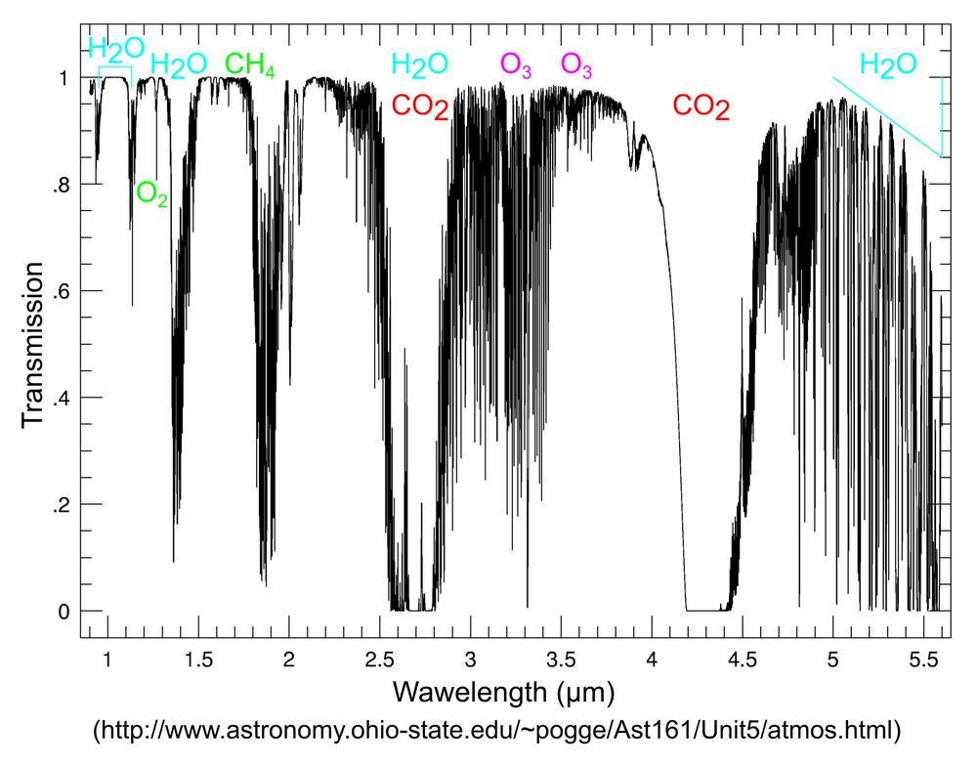

The atmosphere is a combination of different gases. Which is illustrated in the picture below and shows the overlap:

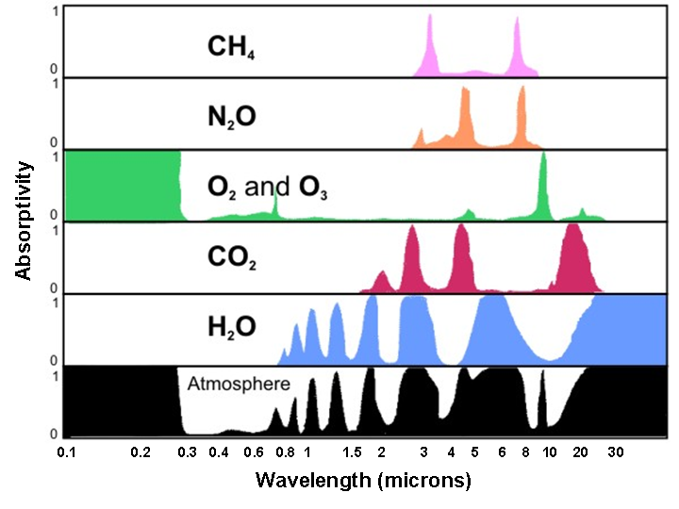
source : https://learningweather.psu.edu/node/23

The higher the relative humidity, the higher the reading, due to misreading of the H₂0 particles.

4.1.1 How much is the impact ?

A number of studies were done to understand how much the impact is.

In Hindawi document (see references) they compared the SDS011 against professional TEOM. ( pag 12.)

For SDS011 (Figure 10(a)), the value of slope changed from a level of 0.47 for RH below 80% to 0.41 for RH range 80%–90% and around 0.37 when RH was higher than 90%.
Therefore, the overestimation of outputs was observed when measurements were conducted in very humid air.

The RIVM in the Netherlands have done a study to compare a large number of SDS011 in different cities against a BAM. They have then compared the result of all low-cost sensors and made a correlation of the differences with the relative humidity, they have come to a similar conclusion.

Conclusion : The relative humidity (RH) above is 80% starts to have a real impact.

4.2 Over-estimating
What is very interesting at the same time in the correction ratio is that when there is LOW humidity the SDS011 seems to OVERESTIMATE the results. It was also after applying the correction ratio, the results of the SDS011 continued to be higher. Even more interesting that this was also observed by earlier Hindawi investigation (page 7)

raw outputs from sensors overestimated TEOM data by a factor of about 2.5 in case of Nova Fitness devices

Probably this has to do with the conditions /assumptions the calibration has been done. It could have to do with the assumed particle density weight.

SO it is important to correct, but there is not a single formula to apply for that. For lack of anything better, I have taken the average of the corrections done by RIVM for the period January – July 2018 in the Netherlands for Amsterdam, Amersfoort and Venlo.

The formula applied is 2,8*(100-RH) ^ -0,3745. The blue line shows the correction ratio by Relative Humidity%, where the red line shows the accuracy to the average. (value left Xas)

As there are many different humidity sensors, I have decided to add extra call (Set_Humidity_Cor) to enable humidity correction, where the humidity can be obtained from different sources by the user program.

4.3 Particle Density

While the SDS-011 sensor counts particles, it provides the outcome in ug/m3. This means that they have made assumptions about the weight / mass or density. It is very difficult to assess what they have applied as we do not know the PPM that was measured.

4.3.0 NO CONCLUSIONS (YET)
At this moment (January 2019) I have not been able to make a conclusion about the translation of particles to ug/m3 of the SDS011.

The SDS011 running in-house without humidity compensation show PM2.5: 2.50, PM10: 6.90.

At the same time I have an SCD30 in-house. It provide CO2 measurement (which is near 2.5um), Humidity and Temperature. The humidity and temperature I can compare against other sensor and are very close. The CO2 reading is 680 -700PPM. Looking at https://www.kane.co.uk/knowledge-centre/what-are-safe-levels-of-co-and-co2-in-rooms it seems to be a normal level. I can not correlate the outputs.

A CSS-811 running at the same time, for hours, will only show the value of 400 (which is its lower limit). So actually it does not measure anything that I can use.

Also a Dylos1700 is running at the same time PM2.5 : around 1300 – 1400, PM10: 60 – 120. The Dylos output is in cubic ft and even when translation to cubic meter (*0,028) I can ‘t make a correlation.

MAYBE it is luck, but when I take the um/m3 output from the sds011, use the CO2 density and calculate back the PPM (sds011 / density) the result is near the Dylos PPM/ ft3. But this feels like counted “apples and peers” together ??

After reading read many articles and tests from the Internet, many calculations for days on this moment I am stuck. Maybe I have more luck in the future, maybe there is someone who finds the correlation (PLEASE REACH OUT).

I HAVE LEFT THE CHAPTERS IN BELOW OF THE WORK THAT I HAD DONE JUST FOR REFERENCE AND MAYBE USE-FULL IN THE FUTURE.

4.3.1 Molecule Weight

The molecular weight of a substance, also called the molar mass, M, is the mass of 1 mole of that substance, given in M gram. The molecular weight of a pure compound is determined from its chemical formula and the atomic weights of its elements. (source : https://www.engineeringtoolbox.com/molecular-weight-gas-vapor-d_1156.html. )
This page has a comprehensive overview of the molar mass.

There are already MANY different gasses in clean dry-air already. The table on https://eesc.columbia.edu/courses/ees/slides/climate/table_1.html provides an overview.

Oxygen O₂ = 31.9988 [kg/kmol]
Nitrogen N2 = 28.0134 [kg/kmol]
Argon AR = 39.948 [kg/kmol]

Using the information about we can calculate avg kg/kmol of dry air at 28.960 kg/kmol. (I deemed 99.965% enough for the exercise). You often see a number of 29 quoted as well.

Also note the Water Vapor - Steam, H2O ( 18.02 [kg/kmol]) as we will reference later.

4.3.2 Mol to Density
On https://www.brisbanehotairballooning.com.au/calculate-air-density/ it is explained how to translate molecule mass to density. The density of dry air can be calculated using the ideal gas law, expressed as a function of temperature and pressure.

The pressure of air on earth is : 101.325 kPa (abs)

ρ = P ÷ RT.
P = Pressure : 101.325 kPa
R = (8.3145 J / ( mole x K) : 83145 / ( 28.90 * 1000)
T = Temperature : 273.16K + X

X= temp in C

4.3.3 What mass are measuring ?

If we would be measuring dry air all the time, we would know the density and could calculate the weight of a 2.5um and 10um easily.

However we don know the gas mixture. If there is vapor in the air (which there normally is) the air is LIGHTER :

source : https://en.wikipedia.org/wiki/Density_of_air
The addition of water vapor to air (making the air humid) reduces the density of the air, which may at first appear counter-intuitive. This occurs because the molar mass of water (18 g/mol) is less than the molar mass of dry air[note 2] (around 29 g/mol). For any ideal gas, at a given temperature and pressure, the number of molecules is constant for a particular volume (see Avogadro's Law). So when water molecules (water vapor) are added to a given volume of air, the dry air molecules must decrease by the same number, to keep the pressure or temperature from increasing. Hence the mass per unit volume of the gas (its density) decreases.

Between 40 and 95% of the mass of particles consist of particles that are less than 2.5um, while particles larger than 2.5um but smaller than 10um, account for 10% of the particles mass

https://www.co2meter.com/blogs/news/15164297-co2-gas-concentration-defined
You can make a quick, approximate conversion (assuming 77 degrees F and sea level) for CO2 only by multiplying the ppm by 1.8 to get mg/m³, or dividing mg/m³ by 1.8 to get ppm.
You will get this number by applying the ideal law formula that we used earlier with the MOL for CO2 (44). This can NOT be used for PPM calculation

Appendix A : Reference material

https://www.researchgate.net/publication/320290219_Assessment_of_Measurement_Uncertainties_for_a_SDS011_low-cost_PM_sensor_from_the_Electronic_Signal_Processing_Perspective

https://www.hindawi.com/journals/js/2018/5096540/

https://www.samenmetenaanluchtkwaliteit.nl/media/4151

Many, many many internet articles have been read some are stored in documents folder for potential later use.

