Example 2
Sodaq, SPS30 and BME280

Table of Contents
1. Foreword 3
2. Solution 4
2.1 Hardware 4
2.1.1 Serial and I2C 4
2.1.2 I2C connection only 4
2.2 Software 5
3 Configure Sketch 5
3.1 Enable CBOR data format 5
3.2 Select SPS30 connection 5
3.3 Select the size of the SPS30 ID 5
3.4 Select provider & information 6
3.5 Debug information 7
3.6 Measurement interval 7
3.7 BME280 constants 7
3.8 Authentication 8
4. configure AllThingsTalk 9
4.1 login 9
4.2 Create a new ground 9
4.3. Create a new device 9
4.4. Create assets 11
4.5 Authentication 12
4.6 Jason or CBOR data format 15
4.7 ABCL data format 16
5. Configure T-Mobile 19
5.1 Configure T-Mobile 19
5.1.1 Login 19
5.1.2 Register device FIRST 19
5.1.3 Forwarding data to AllThingsTalk 19
5.2 AllThingsTalk login 22
5.2.1 Create a new ground 22
5.2.2 Create a new device 22
5.2.3 Create assets 24
5.2.4 Jason or CBOR data format 25
5.2.5 ABCL data format 26
6 Usage 29
6.1 Sketch usage 29
6.1.1 LED 29
6.1.2 No Debug selected 29
6.1.3 Debug selected 29
5.1.4 Idle mode 29
6.2 AllThingsTalk 30
6.2.1 DEBUG 30
6.2.2 CHARTS or LIVE 30

1. Foreword
April 2020
First tests to sent SPS30 and BME280 results to AllThingsTalk. The SPS30 library I have developed already a year ago and is used in many situations. This is the first time connect with SODAQ board of NB-IoT connection with Vodafone.

September 2020
Now added support for T-Mobile as well as sending the data in either Jason, ABCL or CBOR data format.

Paul van Haastrecht
paulvha@hotmail.com

2. Solution

2.1 Hardware

2.1.1 Serial and I2C

SPS30 pin BME280 SODAQ
1 VCC -------- 5V --------- 5V
2 RX ------------------------ 1 TX
3 TX ------------------------- 0 RX
4 Select---------------------- NOT CONNECTED (Select Serial)
5 GND ------- GND ------- GND
SCK ------- SCL (next to SDA/ARF NOT A5 / SCL1)
SDI ------- SDA (next to ARF NOT A4 / SDA1)

P.S. you can also connect the BME280 from the 3V3 on the BME280 to the 3V3 on the Sodaq.

2.1.2 I2C connection only
The connection for the SPS30 and BME280 is with I2C. The SODAQ AFF/SARA has 2 I2C channels; SDA/SCL and SDA1/SCL1. When connecting as indicated below to SDA and SCL those pull-up resistors are already on the SODAQ board. This is the only connection that is supported with this library.

SPS30 pin BME280 SODAQ
1 VCC -------- 5V ------- 5V
2 SDA -------- SDI ------- SDA (next to ARF NOT A4 / SDA1)
3 SCL -------- SCK ------- SCL (next to SDA/ARF NOT A5/ SCL1)
4 Select ------ GND ------- GND (select I2c)
5 GND ---------------------- GND

The BME280 sensor is from Adafruit (https://www.adafruit.com/product/2652)

2.2 Software
Apart from this sketch the following libraries are necessary :

The following SODAQ drivers :
https://github.com/SodaqMoja/Sodaq_R4X
https://github.com/SodaqMoja/Sodaq_wdt

The latest SPS30 driver version: https://github.com/paulvha/sps30
For detailed description of setup and configuration see the SPS30.odt on the github

The latest versions of :
Adafruit BME280 Library: https://github.com/adafruit/Adafruit_BME280_Library
Adafruit Unified Sensor: https://github.com/adafruit/Adafruit_Sensor
They are available from the Arduino library manager so I recommend using that.

If CBOR is required (see 3.1). This is available from the Arduino library manager so I recommend using that or you can download https://github.com/telecombretagne/YACL

The solution has been tested on IDE version 1.8.12 / 1.8.13

3 Configure Sketch

3.1 Enable CBOR data format
Concise Binary Object Representation (CBOR) is a standardized data format that allows shorter message which are translated on the server to Jason. To enable remove the comments before :
//#define INCLUDE_CBOR 1

3.2 Select SPS30 connection
Around line 85 select either SPS30 serial (chapter 2.1.1) OR i2c (chapter 2.1.2)
#define SP30_COMMS SERIALPORT
I2C -> I2C_COMMS
serial -> SERIALPORT

3.3 Select the size of the SPS30 ID
By default the last 4 digits are taken from the SPS30 serial number to form the unique sensor-id that is transmitted as part of the payload. You can change that up to the maximum size of serial number.
#define SPSID 4

3.4 Select provider & information
You need to select the provider and connection information. Remove the comments, as done for T-Mobile :

// NL VODAFONE NB-IoT
/*
const char* provider = "NL VODAFONE NB-IoT";
const char* apn = "nb.inetd.gdsp";
const char* forceOperator = "20404"; // optional - depends on SIM / network
const char* urat = "8";
const char* API_ENDPOINT = "api.allthingstalk.io";
const uint16_t API_PORT = 8891;

Select_Operator Operator = S_VODAFONE; // use Jason format
//Select_Operator Operator = S_VODAFONE_A; // use ABCL format
//Select_Operator Operator = S_VODAFONE_C; // use CBOR format
*/
// NL VODAFONE LTE-M (not tested)
/*
const char* provider = "NL VODAFONE LTE-M";
const char* apn = "live.vodafone.com";
const char* forceOperator = "20404"; // optional - depends on SIM / network
const char* urat = "7";
const uint16_t API_PORT = 8891;

Select_Operator Operator = S_VODAFONE; // use Jason format
//Select_Operator Operator = S_VODAFONE_A; // use ABCL format
//Select_Operator Operator = S_VODAFONE_C; // use CBOR format
*/

// NL KPN (not tested)
/*
const char* provider = "NL KPN";
const char* apn = "internet.m2m";
const char* forceOperator = "20408"; // optional - depends on SIM / network
const uint16_t API_PORT = 8891;
Select_Operator Operator = S_KPN;
Select_Operator Operator = S_KPN; // use Jason format
//Select_Operator Operator = S_KPN_A; // use ABCL format
// Select_Operator Operator = S_KPN_C; // use CBOR format
*/

// NL T-Mobile
// * <<<<< HERE EXTRA COMMENTS
const char* provider = "NL T-MOBILE NB-IoT";
const char* apn = "cdp.iot.t-mobile.nl";
const char* forceOperator = "20416"; // optional - depends on SIM / network
const char* urat = "8";
const char* API_ENDPOINT = "172.27.131.100";
const uint16_t API_PORT = 15683;

Select_Operator Operator = S_TMOBILE; // use Jason format
//Select_Operator Operator = S_TMOBILE_A; // use ABCL format
// Select_Operator Operator = S_TMOBILE_C; // use CBOR format
// */ <<<<< HERE EXTRA COMMENTS

NOTE1: you need to select ONE operator. Depending the selection the data is either formatted in Jason, ABCL or CBOR.

3.5 Debug information
Optionally you can get debug information :
#define SPS30_DEBUG 0
A 1 (ONE) will show sending receiving data between board and SPS30. Setting as 2 (TWO) you can also get protocol errors. (if any)

#define SODAQ_DEBUG 0
A 1 (ONE) will show sending receiving data. You need to define “DEBUG” in top of , around 36 (#define DEBUG ) in Sodaq_R4X.cpp

#define SKETCH_DEBUG 0
A 1 (ONE) will show debug data from the sketch.

3.6 Measurement interval

#define MEASUREMENTPERIOD 60000
time between sending update to AllTHingSTalk (ms) (60000 = 60 sec)

#define MEASUREINTERVAL 5000
delay between measurement in mS (5000 = 5 seconds)

3.7 BME280 constants
#define SEALEVELPRESSURE_HPA (1013.25)
This will impact the altitude results from BME280

#define BME280_ADDRESS 0x77
Set the BME280 address. Alternative is 0x76

3.8 Authentication
After you opened the Example in the Arduino IDE, you will a second tab “ keys.h”. In order to
access you device on AllThingsTalk, you will need to copy the authentication information here :

char* DEVICE_ID = "yourdeviceid";
char* DEVICE_TOKEN = "yourdevicetoken";

See chapter 4.5 where to obtain this information.

This is NOT necessary when using T-Mobile!!

4. configure AllThingsTalk

4.1 login

https://vodafone.allthingstalk.com

Sign in or sign up.

NOTE : This is a DIFFERENT URL than for T-Mobile. Completely different environment and as such the login credentials and password are unique for this environment (and thus different to T-Mobile)

4.2 Create a new ground

The back-end is organized in so-called “grounds”. A ground is a group of devices. For this
document I will call it “sps30”. Then double click on “sps30” and you will see the following:

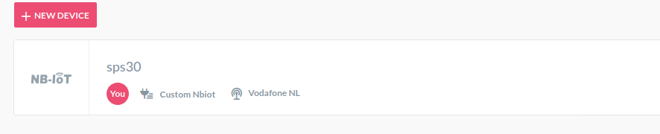

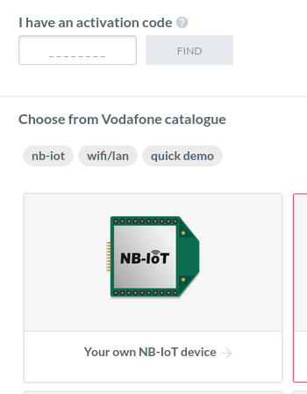
4.3. Create a new device

Click on “+NEW DEVICE”, and you will get something like. >>>>>>>>>>>>>>>>>>>>>>>

I select “your own NB-IoT device” and you can select Vodafone: vvvvvvvvv
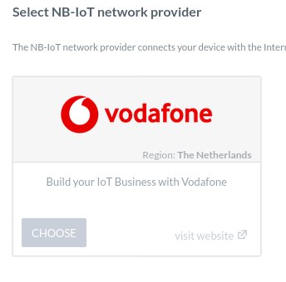

The following information is requested :

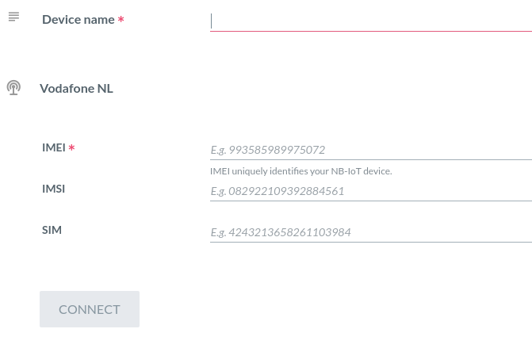
Enter a name >>>
( e.g. SPS30+BME280)

Printed on the card >>>

Optional >>>>

Optional >>>

Last press >>>>>>>>>

IMEI can be obtained from the sim card : AT+CGSN (already printed on the card)
IMSI can be obtained from the sim card : AT+CIMI
SIM can be obtained from the sim card : AT+CCID (already printed on the card)

4.4. Create assets

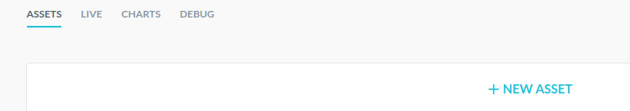
Now create new asset, press “+NEW ASSET”
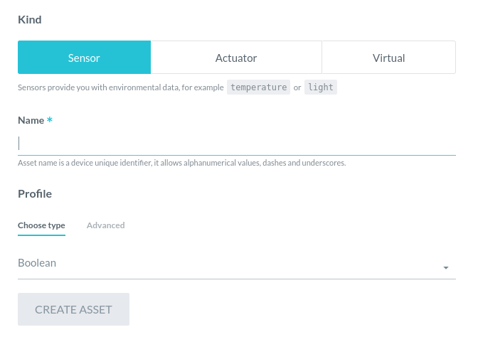
For Example2 you need to add the following information:

name Choose type CREATE ASSET
ID String x
M1 Number x
M2 Number x
M10 Number x
TEMP Number x
HUM Number x
PRES Number x

- Each asset needs to be created separate.
- Use capitals for the name as shown.
- If you change or add in the Example2, make sure to change/add here as well.

4.5 Authentication

If you are done with creating assets as defined in 4.4, the DEVICE will all it’s assets like :

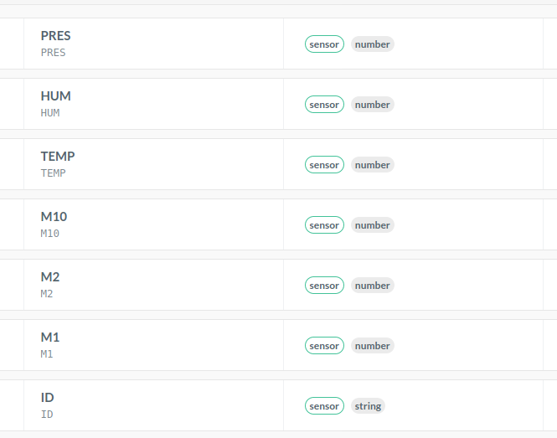
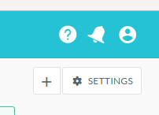
Now we need to get the authorization information, select
“ * SETTINGS ” top right in the screen:

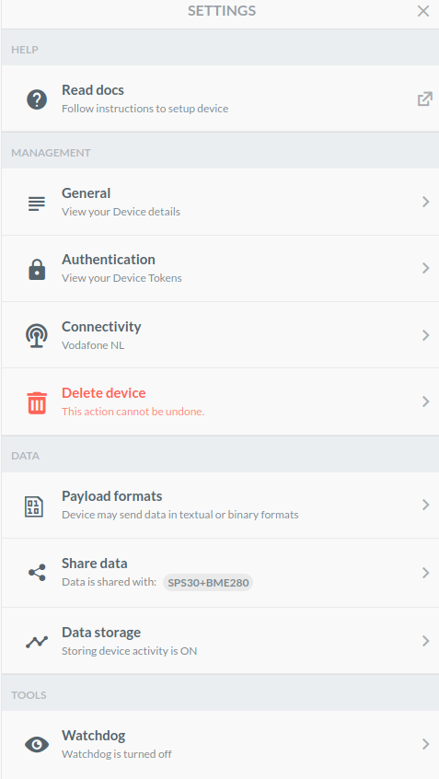
The drop down menu will appear , now select ” Authentication”

>>>>>>>>>>>>>>>>>>
>>>>>>>>>>>>>>>>>>
>>>>>>>>>>>>>>>>>>

The following screen will appear :

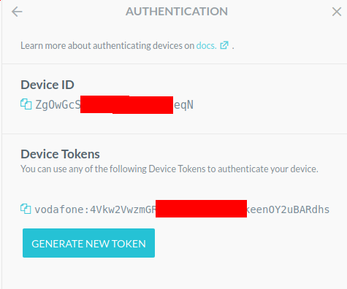
Copy Device ID

Click on the 2 blue sheets before “Zg0..”
and paste in keys.h, part off the Example directory.
>>>>>>>>>>>>>>

Copy the Device Tokens. Click on the 2 blue sheets before “Vodafone” and paste in keys.h, part off the Example directory.

>>>>>>>>>>>>>>

If NO token >>>>>>>

See chapter 3.8 for the correct location in keys.h.

4.6 Jason or CBOR data format

You are done.

If you finished press DEBUG to see the packages coming in, once the board starts sending.

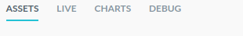

Jason :

Binary Conversion | 2020-09-05T18:27:48 | INFO | Parsed {"ID": {"value": "D2B1"}, "M1": {"value": 1.36}, "M2": {"value": 1.44}, "M10": {"value": 1.44}, "TEMP": {"value": 22.79}, "HUM": {"value": 45.3}, "PRES": {"value": 1021.67}} using JSON

CBOR :

Binary Conversion | 2020-09-05T18:34:01 | INFO | Parsed {"ID": {"value": "D2B1"}, "M1": {"value": 6.672868728637695}, "M2": {"value": 14.014008522033691}, "M10": {"value": 20.900772094726562}, "TEMP": {"value": 22.6200008392334}, "HUM": {"value": 46.38671875}, "PRES": {"value": 1021.5610961914062}} from payload a7 62 49 44 64 44 32 42 31 62 4d 31 fa 40 d5 88 24 62 4d 32 fa 41 60 39 61 63 4d 31 30 fa 41 a7 34 c8 64 54 45 4d 50 fa 41 b4 f5 c3 63 48 55 4d fa 42 39 8c 00 64 50 52 45 53 fa 44 7f 63 e9 using CBOR

4.7 ABCL data format

With AllThingsTalk Binary Conversion Language ​(ABCL) only the data bytes are send and the payload needs to be parsed by AlthingsTalk server.

Click on settings (as instructed on chapter 4.5)

Now select from the drop down menu “ payload formats”

>>>>>>>>>>>>>>>>>>>>>>>>>>

In the screen that appears copy/paste the following :

{
"sense": [
{
"asset": "ID",
"value": {
"byte": 0,
"bytelength": 4,
"type": "string"
}
},
{
"asset": "M1",
"value": {
"byte": 4,
"bytelength": 4,
"signed": false,
"byteorder": "little",
"type": "number"
}
},
{
"asset": "M2",
"value": {
"byte": 8,
"bytelength": 4,
"signed": false,
"byteorder": "little",
"type": "number"
}
},
{
"asset": "M10",
"value": {
"byte": 12,
"bytelength": 4,
"signed": false,
"byteorder": "little",
"type": "number"
}
},
{
"asset": "TEMP",
"value": {
"byte": 16,
"bytelength": 4,
"signed": false,
"byteorder": "little",
"type": "number"
}
},
{
"asset": "HUM",
"value": {
"byte": 20,
"bytelength": 4,
"signed": false,
"byteorder": "little",
"type": "number"
}
},
{
"asset": "PRES",
"value": {
"byte": 24,
"bytelength": 4,
"signed": false,
"byteorder": "little",
"type": "number"
}
}
]
}

Press “save” and you are done.

If you finished press DEBUG to see the packages coming in, once the board starts sending.

With ABCL it should look like:

Binary Conversion | 2020-09-05T19:00:41 | INFO | Parsed {"ID": {"value": "D2B1"}, "M1": {"value": 14.949806213378906}, "M2": {"value": 19.670848846435547}, "M10": {"value": 23.506834030151367}, "TEMP": {"value": 22.5}, "HUM": {"value": 49.859375}, "PRES": {"value": 1021.6220092773438}} from payload 44 32 42 31 41 6f 32 68 41 9d 5d e6 41 bc 0d ff 41 b4 00 00 42 47 70 00 44 7f 67 cf using ABCL

5. Configure T-Mobile

5.1 Configure T-Mobile

5.1.1 Login
https://portal.iotcreators.com/auth/login

Sign in or sign up.

5.1.2 Register device FIRST

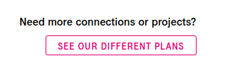
BEFORE DOING ANYTHING ELSE MAKE SURE TO REGISTER THE DEVICE

Sign up to a plan / project if you have not done so:

If you have a project , double on that and now register you device with the IMEI
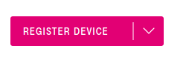

After signing up you should see the device showing up in the device overview of the project.

5.1.3 Forwarding data to AllThingsTalk

Actually the T-Mobile portal is only storing and forwarding the data to a place for further processing. Here we use the forward to AllThingsTalk. To setup the forwarding link see : https://docs.iotcreators.com/docs/integration-with-allthingstalk
The most important part is to have your screen look like this :
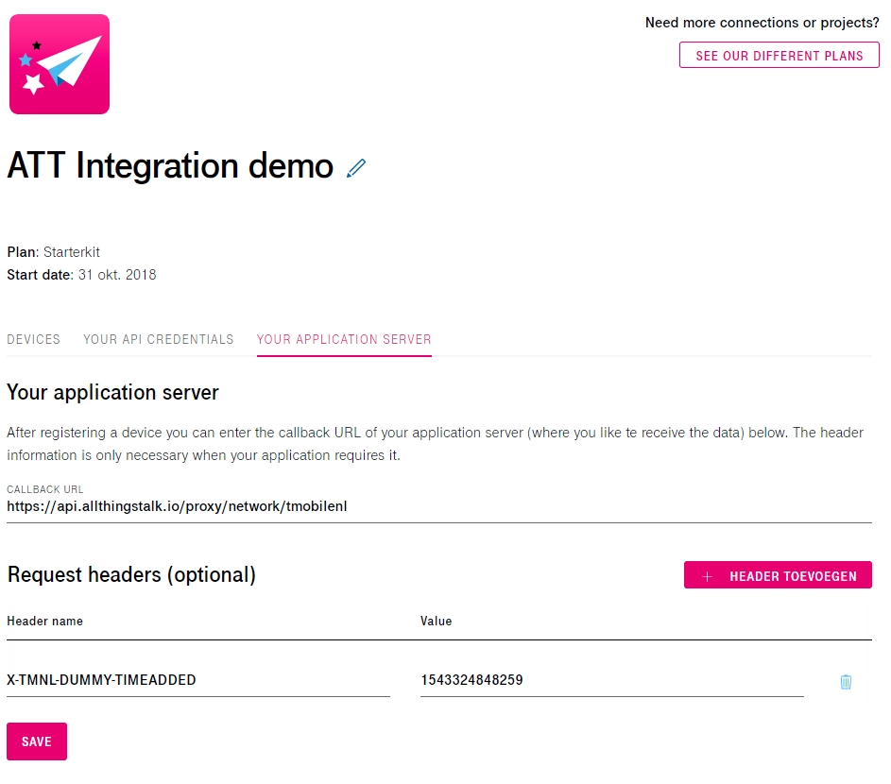

5.2 AllThingsTalk login

https://maker.allthingstalk.com/signin

Sign in or sign up.

NOTE : This is a DIFFERENT URL than for Vodafone. Completely different environment and as such the login credentials and password are unique for this environment (and thus different to Vodafone)

5.2.1 Create a new ground

The back-end is organized in so-called “grounds”. A ground is a group of devices. For this
document I will call it “sps30”. Then double click on “sps30” and you will see the following:

5.2.2 Create a new device

Click on “+NEW DEVICE”
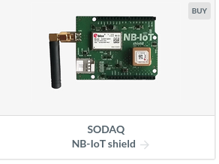
I select “SODAQ” and you can select T-mobile:
vvvvvvvvv

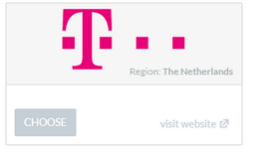

The following information is requested :

Enter a name >>>
( e.g. SPS30)

Printed on the card >>>

Optional >>>>

Optional >>>

Last press >>>>>>>>>

IMEI can be obtained from the sim card : AT+CGSN (already printed on the card)
IMSI can be obtained from the sim card : AT+CIMI
SIM can be obtained from the sim card : AT+CCID (already printed on the card)

5.2.3 Create assets

Now create new asset, press “+NEW ASSET”
For Example2 you need to add the following information:

name Choose type CREATE ASSET
ID String x
M1 Number x
M2 Number x
M10 Number x
TEMP Number x
HUM Number x
PRES Number x

- Each asset needs to be created separate.
- Use capitals for the name as shown.
- If you change or add in the Example2, make sure to change/add here as well.

5.2.4 Jason or CBOR data format

You are done !

If you finished press DEBUG to see the packages coming in, once the board starts sending.

JUST BE AWARE IT CAN TAKE UP TO 10 MINUTES AFTER THE DATA IS SHOWING UP IN T-MOBILE DEVICE OVERVIEW IS SHOWING UP IN ALLTHINGSTALK

Jason :

Binary Conversion | 2020-09-05T18:27:48 | INFO | Parsed {"ID": {"value": "D2B1"}, "M1": {"value": 1.36}, "M2": {"value": 1.44}, "M10": {"value": 1.44}, "TEMP": {"value": 22.79}, "HUM": {"value": 45.3}, "PRES": {"value": 1021.67}} using JSON

CBOR :

Binary Conversion | 2020-09-05T18:34:01 | INFO | Parsed {"ID": {"value": "D2B1"}, "M1": {"value": 6.672868728637695}, "M2": {"value": 14.014008522033691}, "M10": {"value": 20.900772094726562}, "TEMP": {"value": 22.6200008392334}, "HUM": {"value": 46.38671875}, "PRES": {"value": 1021.5610961914062}} from payload a7 62 49 44 64 44 32 42 31 62 4d 31 fa 40 d5 88 24 62 4d 32 fa 41 60 39 61 63 4d 31 30 fa 41 a7 34 c8 64 54 45 4d 50 fa 41 b4 f5 c3 63 48 55 4d fa 42 39 8c 00 64 50 52 45 53 fa 44 7f 63 e9 using CBOR

5.2.5 ABCL data format

With AllThingsTalk Binary Conversion Language ​(ABCL) only the data bytes are send and the payload needs to be parsed by AlthingsTalk server.

Click on settings:

Now select from the drop down menu “ payload formats”

>>>>>>>>>>>>>>>>>>>>>>>>>>

In the screen that appears copy/paste the following :

{
"sense": [
{
"asset": "ID",
"value": {
"byte": 0,
"bytelength": 4,
"type": "string"
}
},
{
"asset": "M1",
"value": {
"byte": 4,
"bytelength": 4,
"signed": false,
"byteorder": "little",
"type": "number"
}
},
{
"asset": "M2",
"value": {
"byte": 8,
"bytelength": 4,
"signed": false,
"byteorder": "little",
"type": "number"
}
},
{
"asset": "M10",
"value": {
"byte": 12,
"bytelength": 4,
"signed": false,
"byteorder": "little",
"type": "number"
}
},
{
"asset": "TEMP",
"value": {
"byte": 16,
"bytelength": 4,
"signed": false,
"byteorder": "little",
"type": "number"
}
},
{
"asset": "HUM",
"value": {
"byte": 20,
"bytelength": 4,
"signed": false,
"byteorder": "little",
"type": "number"
}
},
{
"asset": "PRES",
"value": {
"byte": 24,
"bytelength": 4,
"signed": false,
"byteorder": "little",
"type": "number"
}
}
]
}

Press “save” and you are done.

If you finished press DEBUG to see the packages coming in, once the board starts sending.

With ABCL it should look like:

Binary Conversion | 2020-09-05T19:00:41 | INFO | Parsed {"ID": {"value": "D2B1"}, "M1": {"value": 14.949806213378906}, "M2": {"value": 19.670848846435547}, "M10": {"value": 23.506834030151367}, "TEMP": {"value": 22.5}, "HUM": {"value": 49.859375}, "PRES": {"value": 1021.6220092773438}} from payload 44 32 42 31 41 6f 32 68 41 9d 5d e6 41 bc 0d ff 41 b4 00 00 42 47 70 00 44 7f 67 cf using ABCL

6 Usage

6.1 Sketch usage

6.1.1 LED

The led on the board can show the following :

During start-up :
GREEN : Detecting BME280.
YELLOW : Detected BME280 now detecting SPS30.
BLUE : Detected SPS30 now initializing SARA and connecting with provider.
OFF : Start-up complete

Normal working
Led is flashing MAGENTA after every 5 readings for the MEASUREINTERVAL (still-alive-signal)
Led is flashing GREEN when sending data. (very short)
Led is flashing RED, sending failed retry is planned.

Error
Led is blinking on and off RED (1 second frequency), something went wrong. On hold !

6.1.2 No Debug selected

After compiling and uploading you do NOT have to connect a terminal. If you do however, you will see progress messages and measurement information from the SPS30. Be reminded that you can connect a terminal later on if you want, set to 115200, and it will show SPS30 measured information.

6.1.3 Debug selected

If either SKETCH_DEBUG, SPS30_DEBUG or SODAQ_DEBUG is selected, you must connect a terminal. The sketch will wait for you to press <enter> before start-up. It will show, next to the normal progress messages and measurement information from the SPS30, debug information about the selected area(s). Once you are done, you must disable the debug in the source code and recompile.

5.1.4 Idle mode

While the SPS30 is planned to > 8 year lifetime, if the interval between measurements is larger than 60 seconds the SPS30 will be put idle. The ventilator will stop spinning and no measurements are performed. The interval time is reduced with 10 seconds, as a 10 second delay will be applied after the SPS30 is started when the interval time expires.

6.2 AllThingsTalk

6.2.1 DEBUG
If you are in DEBUG view, you should see regular (depending on the settings in chapter 3.3) the following information :

Binary Conversion | 2020-04-03T18:35:45 | INFO | Parsed {"ID": {"value": "1A76"}, "M1": {"value": 3.02}, "M2": {"value": 3.34}, "M10": {"value": 3.57}, "TEMP": {"value": 23.47}, "HUM": {"value": 30.19}, "PRES": {"value": 1021.37}} using JSON

If you only hex-decimal numbers… something is wrong in the formatting of the data that is sent.

6.2.2 CHARTS or LIVE

Selecting LIVE you will get the information received over the past minutes, where CHARTS can provide the information received over a longer period.

Select in the top the values you want to monitor. In the example below that is humidity, M10, M2 and M1

