Example 5
Sodaq, SPS30 and DHT-XX

Table of Contents
1. Foreword 1
2. Solution 2
2.1 Hardware 2
2.1.1 Serial connection 2
2.1.2 I2C connection 3
2.2 Software 4
3 Configure Sketch 5
3.1 Select SPS30 connection 5
3.2 Select provider information 5
3.3 Debug information 5
3.4 Measurement interval 5
3.5 DHT-XX parameters 6
3.6 Authentication 6
4. configure AllThingsTalk 7
4.1 login 7
4.2 Create a new ground 7
4.3. Create a new device 7
4.4. Create assets 9
4.5 Authentication 10
4.6 You are done 12
5 Usage 13
5.1 Sketch usage 13
5.1.1 LED 13
5.1.2 No Debug selected 13
5.1.3 Debug selected 13
5.1.4 Idle mode 13
5.2 AllThingsTalk 14
5.2.1 DEBUG 14
5.2.2 CHARTS or LIVE 14

1. Foreword
First tests to sent SPS30 and DHT-XX results to AllThingsTalk. The SPS30 library I have developed already a year ago and is used in many situations. This is the first time connect with SODAQ board of NB-IoT connection with Vodafone.

June 2020
Paul van Haastrecht
paulvha@hotmail.com

2. Solution

2.1 Hardware

2.1.1 Serial connection

SPS30 pin SODAQ
1 VCC -------- 5V
2 RX ---------- 1 TX
3 TX ---------- 0 RX
4 Select------- NOT CONNECTED (Select Serial)
5 GND ------- GND

The DHT-xx sensor :

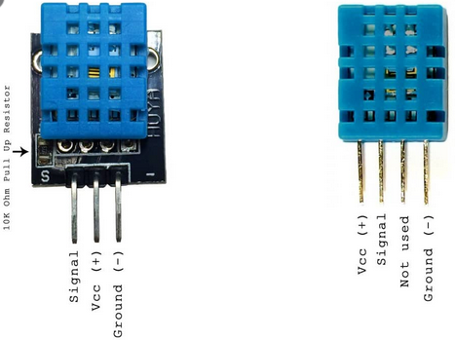

DHT-XX SODAQ
------ GND -------- GND
|-| 10K |-- VCC -------- 3V3
| ------
|----------- SIGNAL ------ D4

You MUST connect a resistor of at least 10K between data and VCC for pull-up.

2.1.2 I2C connection
The connection for the SPS30 is with I2C. The SODAQ AFF/SARA has 2 I2C channels; SDA/SCL and SDA1/SCL1. When connecting as indicated below to SDA and SCL those pull-up resistors are already on the SODAQ board. This is the only connection that is supported by the driver.

SPS30 pin SODAQ
1 VCC --------------- 5V
2 SDA --------------- SDA (next to ARF NOT A4 / SDA1)
3 SCL ---------------- SCL (next to SCL/ARF NOT A5/ SCL1)
4 Select -------------- GND (select I2c)
5 GND --------------- GND

DHT-XX SODAQ
------ GND -------- GND
|-| 10K |-- VCC -------- 3V3
| ------
|----------- SIGNAL ------ D4

You MUST connect a resistor of at least 10K between data and VCC for pull-up.

2.2 Software
Apart from this sketch the following libraries are necessary :

The following SODAQ drivers :
https://github.com/SodaqMoja/Sodaq_R4X
https://github.com/SodaqMoja/Sodaq_wdt

The latest SPS30 driver version 1.3.10: https://github.com/paulvha/sps30
For detailed description of setup and configuration see the SPS30.odt on the github

The DHT-XX sensor
- DHT Sensor Library: https://github.com/adafruit/DHT-sensor-library
- Adafruit Unified Sensor Lib: https://github.com/adafruit/Adafruit_Sensor
- more info : https://learn.adafruit.com/dht/overview

The solution has been tested on IDE version 1.8.12

3 Configure Sketch

3.1 Select SPS30 connection
Around line 115 select either SPS30 serial (chapter 2.1.1) OR i2c (chapter 2.1.2)
#define SP30_COMMS SERIALPORT
I2C -> I2C_COMMS
serial -> SERIALPORT

3.2 Select provider information
you need to select the provider and connection information for my situation I select :

// NL VODAFONE NB-IoT
const char* provider = "NL VODAFONE NB-IoT";
const char* apn = "nb.inetd.gdsp";
const char* forceOperator = "20404"; // optional - depends on SIM / network
const char* urat = "8";

3.3 Debug information
Optionally you can get debug information :
#define SPS30_DEBUG 0
A 1 (ONE) will show sending receiving data between board and SPS30. Setting as 2 (TWO) you can also get protocol errors. (if any)

#define SODAQ_DEBUG 0
A 1 (ONE) will show sending receiving data. You need to define “DEBUG” in top of , around line 36 (#define DEBUG ) in Sodaq_R4X.cpp

#define SKETCH_DEBUG 0
A 1 (ONE) will show debug data from the sketch.

3.4 Measurement interval

#define MEASUREMENTPERIOD 60000
time between sending update to AllThingsTalk (ms) (60000 = 60 sec)

#define MEASUREINTERVAL 5000
delay between measurement in mS (5000 = 5 seconds)

3.5 DHT-XX parameters

#define DHTPIN 4
Digital pin connected to the DHT sensor

#define DHTTYPE DHT11 // DHT 11
#define DHTTYPE DHT22 // DHT 22 (AM2302)
#define DHTTYPE DHT21 // DHT 21 (AM2301)
Only uncomment 1 line for the sensor selection

#define TEMP_TYPE 0
Define reading in Fahrenheit or Celsius
1 = Celsius, 0 = Fahrenheit

3.6 Authentication
After you opened the Example5 in the Arduino IDE, you will a second tab “ keys.h”. In order to
access you device on AllThingsTalk, you will need to copy the authentication information here :

char* DEVICE_ID = "yourdeviceid";
char* DEVICE_TOKEN = "yourdevicetoken";

See chapter 4.5 where to obtain this information.

4. configure AllThingsTalk

4.1 login

https://vodafone.allthingstalk.com

Sign in or sign up.

4.2 Create a new ground

The back-end is organized in so-called “grounds”. A ground is a group of devices. For this
document I will call it “sps30”. Then double click on “sps30” and you will see the following:

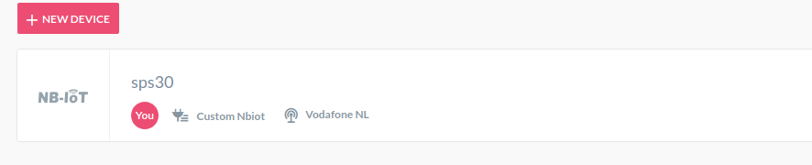

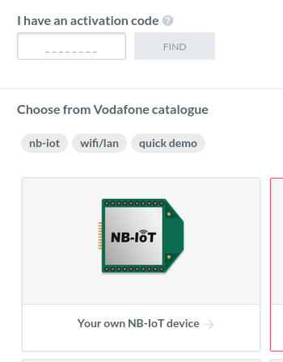
4.3. Create a new device

Click on “+NEW DEVICE”, and you will get something like. >>>>>>>>>>>>>>>>>>>>>>>

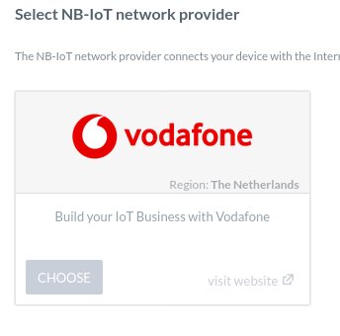
I select “your own NB-IoT device” and you can select Vodafone: vvvvvvvvv

The following information is requested :

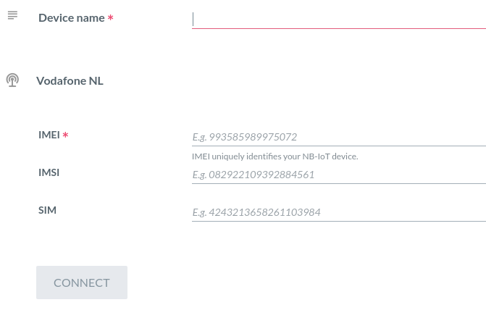
Enter a name >>>
( e.g. SPS30+DHT)

Printed on the card >>>

Optional >>>>

Optional >>>

Last press >>>>>>>>>

IMEI can be obtained from the sim card : AT+CGSN (already printed on the card)
IMSI can be obtained from the sim card : AT+CIMI
SIM can be obtained from the sim card : AT+CCID (already printed on the card)

4.4. Create assets

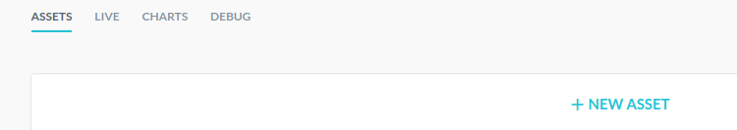
Now create new asset, press “+NEW ASSET”
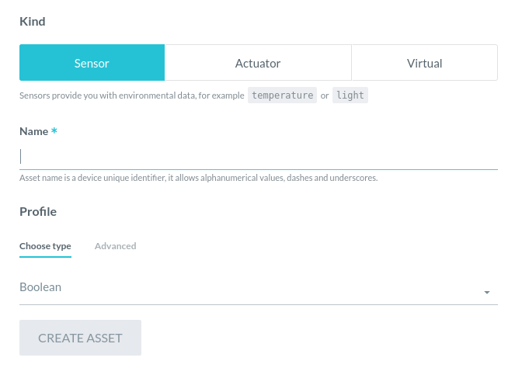
For Example4 you need to add the following information:

name Choose type CREATE ASSET
ID String x
M1 Number x
M2 Number x
M10 Number x
TEMP Number x
HUM Number x

- Each asset needs to be created separate.
- Use capitals for the name as shown.
- If you change or add in the Example5, make sure to change/add here as well.

4.5 Authentication

If you are done with creating assets as defined in 4.4, the DEVICE will all it’s assets like :

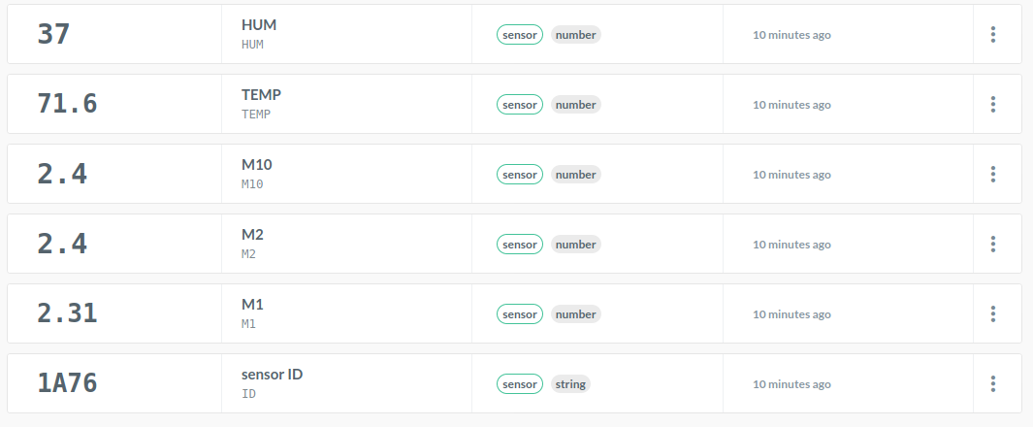
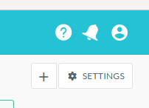
Now we need to get the authorization information, select
“ * SETTINGS ” top right in the screen:

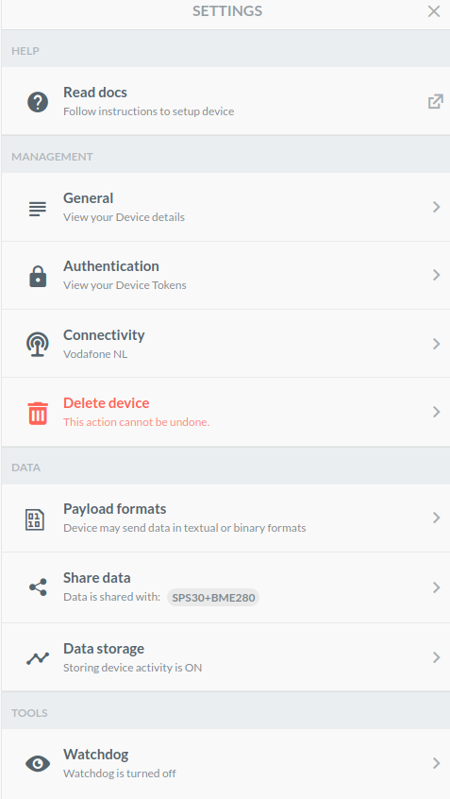
The drop down menu will appear , now select ” Authentication”

>>>>>>>>>>>>>>>>>>
>>>>>>>>>>>>>>>>>>
>>>>>>>>>>>>>>>>>>

The following screen will appear :

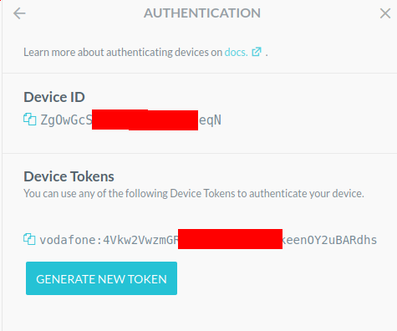
Copy Device ID

Click on the 2 blue sheets before “Zg0..”
and paste in keys.h, part off the Example5 directory.
>>>>>>>>>>>>>>

Copy the Device Tokens. Click on the 2 blue sheets before “Vodafone” and paste in keys.h, part off the Example5 directory.
>>>>>>>>>>>>>>

If NO token >>>>>>>

See chapter 3.6 for the correct location in keys.h.

4.6 You are done

If you finished press DEBUG to see the packages coming in, once the board starts sending

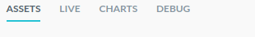

5 Usage

5.1 Sketch usage

5.1.1 LED

The led on the board can show the following :

During start-up :
GREEN : Detecting DHT-XX.
YELLOW : Detected DS18x20 now detecting SPS30.
BLUE : Detected SPS30 now initializing SARA and connecting with provider.
OFF : Start-up complete

Normal working
Led is flashing MAGENTA after every 5 readings for the MEASUREINTERVAL (still-alive-signal)
Led is flashing GREEN when sending data. (very short)
Led is flashing RED, sending failed retry is planned.

Error
Led is blinking on and off RED (1 second frequency), something went wrong. On hold !

5.1.2 No Debug selected

After compiling and uploading you do NOT have to connect a terminal. If you do however, you will see progress messages and measurement information from the SPS30. Be reminded that you can connect a terminal later on if you want, set to 115200, and it will show SPS30 measured information.

5.1.3 Debug selected

If either SKETCH_DEBUG, SPS30_DEBUG or SODAQ_DEBUG is selected, you must connect a terminal. The sketch will wait for you to press <enter> before start-up. It will show, next to the normal progress messages and measurement information from the SPS30, debug information about the selected area(s). Once you are done, you must disable the debug in the source code and recompile.

5.1.4 Idle mode

While the SPS30 is planned to > 8 year lifetime, if the interval between measurements is larger than 60 seconds the SPS30 will be put idle. The ventilator will stop spinning and no measurements are performed. The interval time is reduced with 10 seconds, as a 10 second delay will be applied after the SPS30 is started when the interval time expires.

5.2 AllThingsTalk

5.2.1 DEBUG
If you are in DEBUG view, you should see regular (depending on the settings in chapter 3.3) the following information :

Binary Conversion | 2020-04-03T18:35:45 | INFO | Parsed {"ID": {"value": "1A76"}, "M1": {"value": 2.22}, "M2": {"value": 2.31}, "M10": {"value": 2.31}, "HUM": {"value": 37.0}, "TEMP": {"value": 71.6}} using JSON

If you only hex-decimal numbers… something is wrong in the formatting of the data that is sent.

5.2.2 CHARTS or LIVE

Selecting LIVE you will get the information received over the past minutes, where CHARTS can provide the information received over a longer period.

Select in the top the values you want to monitor. In the example below that is temperature, M10, M2 and M1

