SPS30 sensor on Raspberry PI

Table of Contents
1. Background 2
2. Hardware connection 3
2.1 I2C communication 3
3. Software 3
3.1 Installing the software 3
3.1.1 Install BCM2835 library 3
3.1.2 Install program 3
3.2 Program options 5
4.0 Overview of SPS30 library calls 6
4.1 void EnableDebugging(uint8_t act) 6
4.2 uint8_t begin() 6
4.3 void close() 6
4.4 bool probe() 6
4.5 bool reset() 6
4.6 bool start() 6
4.7 bool stop() 6
4.8 bool clean() 6
4.9 uint8_t GetAutoCleanInt(uint32_t *val) 6
4.10 uint8_t SetAutoCleanInt(uint32_t val) 6
4.11 void GetErrDescription(uint8_t code,char *buf, uint8_t len) 7
4.12 uint8_t GetSerialNumber(char *buf, uint8_t len) 7
4.13 uint8_t GetArticleCode(char *buf, uint8_t len) 7
4.14 bool Check_data_ready() 7
4.15 uint8_t GetValues(struct sps_values *v) 7
4.16 float GetSpecific value() 8
4.17 sleep() 8
4.18 wakeup() 8
4.19 GetVersion() 8
4.20 GetStatusReg() 9
4.21 Fwcheck(major, minor) 9
5. Difference PM10 and PM2.5 10
6. Compare against Dylos 11
6.1 DC-1700 definition 11
6.2 SPS30 definition 11
6.3 Comparing results 11
6.3.1 Interpreting the correlation info 13
7. Compare against SDS-011 14
7.1 SDS-011 definition 14
7.2 SPS30 definition 14
7.3 Comparing 14
7.3.1 Interpreting the correlation info 15
7.4 previous compare SPS30 SDS-011 15
8. compare against SDS-011 AND DYLOS 16
8.1 Comparing 16
8.2 comments 17
9. Careful conclusion 18
9.1 Personal (May 2019) 18
9.2 Additional / external PMx remarks 18
Appendix A : Error messages 19
Appendix B : inside SPS30 20

1. Background

This project is part of a number of projects to measure the air quality. I bought a new sensor : SPS30 from Sensirion. Having worked on another sensor from them (SCD30) before the quality is normally good. The aim is to compare the output with other sensors and provide the learning.

May 2019 : The board is relative new at the time of writing this documentation and as such a lot of preliminary documents from supplier.

I have already written a real working driver for Arduino/ESP32, but wanted to connect to a Raspberry PI over I2C. The monitor can optionally be extended to include a DYLOS DC1700 and /or SDS011 monitor and provide common output.

April 2020 : In March 2020 an updated datasheet was made available. It contained information about updated SPS30 function and new functions, of which some depend on firmware revisions. The library has been updated with new functions : sleep(), wakeup(), GetVersion(), FWcheck() and GetStatusReg(). Also some existing functions have been updated and new options added to the command line.

April 2026 : tested on RPI4 and trixie ( 6.12.xx) release

In this document I will also discuss the outcome of the first compare off these sensors. Now also added some external information about

Paul van Haastrecht
paulvha@hotmail.com

2. Hardware connection

2.1 I2C communication

As documented in the datasheet, make sure to use external pull-up resistor on both the SDA and SCL lines. On a Raspberry PI on the GPIO2 / SDA / Pin 3 and GPIO3 / SCL / Pin 5 there are already 1.8K resistors. No further resistors are needed.

SPS30 pin Raspberry Pi
1 VCC -------- 5V
2 SDA -------- SDA (pin 3)
3 SCL -------- SCL (pin 5)
4 Select ------ GND (select I2c)
5 GND ------- GND

3. Software
Th library software has been written based on my earlier driver for Arduino / ESP32.

3.1 Installing the software

3.1.1 Install BCM2835 library
Install latest from BCM2835 from : http://www.airspayce.com/mikem/bcm2835/

1. wget http://www.airspayce.com/mikem/bcm2835/bcm2835-1.75.tar.gz
2. tar -zxf bcm2835-1.75.tar.gz // 1.75 was version number at the time of writing
3. cd bcm2835-1.75
4. ./configure
5. sudo make check
6. sudo make install

3.1.2 Install program
The following files (part of the basic package) in a directory SPS30

sps30.cpp
This is the user level / interface program

sps30lib.h and sps30lib.cpp
These contain the connection between the user level program and the SPS30. The library calls are described in chapter 4

makefile
The makefile for the program

The following programs are included as well but are optional

dylos folder:
dylos.c & dylos.h : Dylos monitor

sds011 folder:
sds011_lib.cpp sds011_lib.h : SDS-011 driver
sdsmon.cpp sdsmon.h : SDS-011 monitor
serial.c serial.h : serial setting

To compile the program, go in the directory (sps30) and type
make

To create a build the SPS30 with Dylos monitor (in case you have one)
make BUILD=DYLOS

To create a build the SPS30 with SDS011 monitor (in case you have one)
make BUILD=SDS011

To create a build the SPS30 with BOTH SDS011 & Dylos monitor
make BUILD=BOTH

3.2 Program options
When you type : ./sps30 -h the following information is displayed:

./sps30 [options] (version 1.4)

SPS30 settings:
-a # set Auto clean interval in seconds
-A set Auto clean interval to factory setting (604.800)
-m perform a manual clean
-d display serial-number, product type and firmware level only

program settings
-B do not display output in color
-l # number of measurements (0 = endless) (default 10)
-w # wait-time (seconds) between measurements(default 5)
-v # verbose / debug level (0 – 2) (default 0)
-T add / remove timestamp to output (default removed)
-E add / remove display device errors (*1) (default removed)
-F add / remove sleep during wait-time (*2) (default removed)
-M add / remove MASS info to output (default added)
-N add / remove NUMBERS info to output (default added)
-P add / remove Partsize info to output (default removed)

*1 : requires SPS30 firmware level 2.2 or higher
*2 : requires SPS30 firmware level 2.0 or higher

If compiled with Dylos the following is added:

Dylos DC1700:
-D port Enable Dylos input from port (No default)
-C add correlation calculation (default removed)

If compiled with SDS011 the following is added:

SDS011:
-S port Enable SDS011 input from port (No default)
-C add correlation calculation (default removed)

4.0 Overview of SPS30 library calls

4.1 void EnableDebugging(uint8_t act)
Will enable or disable driver debug messages. Valid options for level of debug
0 : no debug message (default)
1 : sending and receiving data
2 : 1 + protocol progress

4.2 uint8_t begin()
This will initialize I2C. Will return ERR_OK is successful else an error message as in Appendix A

4.3 void close()
This will reset the hardware and release the memory

4.4 bool probe()
Will return ‘true’ if connection with the SPS30 could be made, else ‘false’

4.5 bool reset()
This will sent a soft-reset to the SPS30.
Will return ‘true’ if successful, else ‘false’.

4.6 bool start()
This will sent a start-measurement command to the SPS30.
Will return ‘true’ if successful, else ‘false’.

4.7 bool stop()
This will sent a stop-measurement command to the SPS30.
Will return ‘true’ if successful, else ‘false’.

4.8 bool clean()
This will sent a manual clean fan command to the SPS-30. The fan will spin faster for 10 seconds.
The SPS30 must be in measurement mode. Will return ‘true’ if successful, else ‘false’.

4.9 uint8_t GetAutoCleanInt(uint32_t *val)
This will read the current Auto Fan clean interval from the SPS30 and return that in pointer to ‘val’.
Will return ‘ERR_OK’ if successful read, else on the error messages documentation in Appendix A.

4.10 uint8_t SetAutoCleanInt(uint32_t val)
This will SET the Auto Fan cleaning interval on the SPS30 to the value defined in ‘val’. Will return ‘ERR_OK’ if successful else an error code as documented in Appendix A.

4.11 void GetErrDescription(uint8_t code,char *buf, uint8_t len)
This will provide a description of an error code as documented in Appendix A. ‘Code’ the error code, ‘buf’ is a buffer to store the message and ‘len’ is the length of the buffer. Length is maximum 80 characters.

4.12 uint8_t GetSerialNumber(char *buf, uint8_t len)
This will try to read the serial number from the device and store that in buffer ‘buf’ with a maximum number of bytes ‘len’. The maximum can be 32 bytes. Will return ‘ERR_OK’ if successful else an error code as documented in Appendix A.

4.13 uint8_t GetArticleCode(char *buf, uint8_t len)
This will try to read the Article code from the device and store that in buffer ‘buf’ with a maximum number of bytes ‘len’. The maximum can be 32 bytes. Will return ‘ERR_OK’ if successful else an error code as documented in Appendix A.

4.14 bool Check_data_ready()
Will check for new data ready on the SPS30. Return true if ready else false.

4.15 uint8_t GetValues(struct sps_values *v)
This will try to read all the values from the SPS30 and store those in structure pointer v. Will return ‘ERR_OK’ if successful else an error code as documented in Appendix A.
The structure is defined in sps30.h, for details read the datasheet
typedef struct sps_values
{
float MassPM1; // Mass Concentration PM1.0 [μg/m3]
float MassPM2; // Mass Concentration PM2.5 [μg/m3]
float MassPM4; // Mass Concentration PM4.0 [μg/m3]
float MassPM10; // Mass Concentration PM10 [μg/m3]
float NumPM0; // Number Concentration PM0.5 [#/cm3]
float NumPM1; // Number Concentration PM1.0 [#/cm3]
float NumPM2; // Number Concentration PM2.5 [#/cm3]
float NumPM4; / / Number Concentration PM4.0 [#/cm3]
float NumPM10; // Number Concentration PM4.0 [#/cm3]
float PartSize; // Typical Particle Size [μm]
};
NOTE 1: As mentioned in chapter 4, when the communication channel is I2C, depending on the receive buffer size in wire.h, only the MassPMx may be available. The others will be zero.
NOTE 2: Although the SPS30 can provide the different values as unsigned 16 bits, this library is only reading and providing the float values. Why settle for less ?

4.16 float GetSpecific value()
This will try to return a specific value as a float. In case of error a ‘-1’ value will be returned.
The following calls are valid :
GetMassPM1()
GetMassPM2()
GetMassPM4()
GetMassPM10()
GetNumPM0()
GetNumPM1()
GetNumPM2()
GetNumPM4()
GetNumPM10()
GetPartSize()
The driver will perform a GetValues() and report the specific requested value. If another value is requested this will be provided from cache. As such the different values are a snap-shot taken at the same time. If a value is requested that has been reported already all the values will be refreshed.

4.17 sleep()
This functions requires minimum firmware level 2.0. It will set the SPS30 to sleep, using even less power < 50uA according to datasheet (March 2020)

4.18 wakeup()
This functions requires minimum firmware level 2.0. It will wakeup the SPS30 after it was set to sleep.

4.19 GetVersion()
This function will read the firmware and hardware levels from the SPS30 and provide the library version level.

struct SPS30_version {
uint8_t major; SPS30 Firmware levels
uint8_t minor;
uint8_t DRV_major; The library version level
uint8_t DRV_minor;
};

4.20 GetStatusReg()
This functions requires minimum firmware level 2.2. This function will read the device status register. The status return is an “orred” value
STATUS_OK = 0
STATUS_SPEED_ERROR = 1 (0b00000001)
STATUS_LASER_ERROR = 2 (0b00000010)
STATUS_FAN_ERROR = 4 (0b00000100)

4.21 Fwcheck(major, minor)
New firmware levels have been slipped streamed into the SPS30. The datasheet from March 2020 shows added / updated functions on new firmware level. E.g. sleep(), wakeup(), status register are new. The required level is defined in the datasheet and a check can be performed to the SPS30 firmware. It will return TRUE if the firmware is sufficient, else FALSE.

5. Difference PM10 and PM2.5

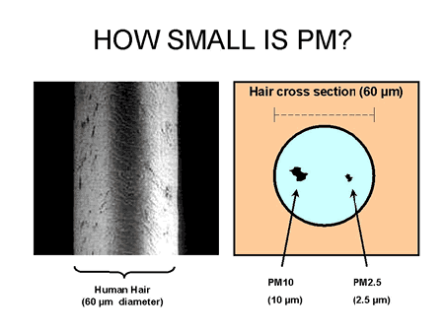
https://www.arb.ca.gov/research/aaqs/pm/pm.htm
An PM10 surface is 16 x PM2.5, while the PM10 volume is 64 x PM2.5. This means that the <PM 2.5 as much smaller, much lighter than the PM25 <> PM10 particles. And while the PM2.5 <> PM10 numbers are much less they have a size-able impact on the numbers.
The PM10 number INCLUDE the PM2.5 numbers. Different investigations have provided information around the relationship between PM2.5 and PM10 ug/m3.
The university of Montana 70% of the weight of PM10 constitutes of PM2.5.
HongKong:
Annual(μg/m3) | Daily(μg/m3)
PM2.5 = 0.71 x PM10 | PM2.5 = 0.75 x PM10

(https://www.epd.gov.hk/epd/english/environmentinhk/air/guide_ref/guide_aqa_model_g5.html)
Scotland:
The annual average ratio of daily mean PM2.5 concentration to daily mean PM10 concentration typically varied from 0.51 to 0.69 with a mean of 0.63

This was supported by the PCM modeled data, which indicated that the ratio of annual mean PM2.5 / PM10 ranged from 0.63 to 0.69

(http://www.scottishairquality.scot/assets/documents/technical%20reports/pm2.5-pm10ratio_29Mar2016-FINAL_Version_Approved.pdf)

6. Compare against Dylos

6.1 DC-1700 definition
A DYLOS DC-1700 is providing information particle information per 0.01 cubic foot. It has 2 numbers:
A. Particle count > 0.5 μm
B. Particle count > 2.5 μm. This is a good representation of the PM10 value.(different tests)
From this you can calculate the Particle count between 0.5μm and 2.5μm: C = A - B
DYLOS numbers from cubic feet to cm3: 0.01 ft³ / 283.1685 => cm³

6.2 SPS30 definition
The SPS30 numbers show in cm³ the particle count SMALLER than the size. Datasheet pag 2
PMx defines particles with a size smaller than “x” micrometers (e.g., PM2.5 = particles smaller than 2.5 μm).
The SPS30 starts measurement from 0.3um

6.3 Comparing results
We can compare the values of the SDS30 and DYLOS within the program:
./sds30 -D /dev/ttyUSB0 -CM
-D /dev/ttyUSB0 : enable Dylos connected to /dev/ttyUSB0
-C : include correlation calculation
-M : toggle to exclude SPS30 MASS values
NOTE : adding ‘-l0’ to the command-options it will loop for ever (default 10 times)
This will result is output like :
NUM PM0: 141.6473 PM1: 164.0723 PM2.5: 164.9880 PM4: 165.0512 PM10: 165.0663
DYLOS waiting new sample within 1 minute

NUM PM0: 139.8236 PM1: 161.9195 PM2.5: 162.8007 PM4: 162.8602 PM10: 162.8745
DYLOS PM1: 7244 PM10: 81 PPM (update every minute)
Correlation PM2.5: DYLOS 25.295893 (avg) SPS30 24.945415 part/cm3 (1.40%)
>PM2.5: DYLOS 0.286049 (avg)SPS30 0.088342 part/cm3 (223.80%)
PM10 : DYLOS 25.581942 (avg)SPS30 25.033756 part/cm3 (2.19%)

NUM PM0: 158.3956 PM1: 183.6688 PM2.5: 184.8031 PM4: 184.8884 PM10: 184.9079
DYLOS waiting new sample within 1 minute

NUM PM0: 157.2319 PM1: 182.4456 PM2.5: 183.6424 PM4: 183.7365 PM10: 183.7575
DYLOS waiting new sample within 1 minute

NUM PM0: 159.4031 PM1: 185.0023 PM2.5: 186.2366 PM4: 186.3348 PM10: 186.3566
DYLOS waiting new sample within 1 minute

NUM PM0: 162.7019 PM1: 188.8667 PM2.5: 190.1466 PM4: 190.2495 PM10: 190.2722
DYLOS waiting new sample within 1 minute

NUM PM0: 167.6228 PM1: 194.5420 PM2.5: 195.8399 PM4: 195.9431 PM10: 195.9660
DYLOS waiting new sample within 1 minute

NUM PM0: 168.7616 PM1: 195.8437 PM2.5: 197.1391 PM4: 197.2416 PM10: 197.2644
DYLOS waiting new sample within 1 minute

NUM PM0: 171.8520 PM1: 199.6316 PM2.5: 201.0640 PM4: 201.1833 PM10: 201.2092
DYLOS PM1: 7642 PM10: 89 PPM (update every minute)
Correlation PM2.5: DYLOS 26.673164 (avg) SPS30 26.862604 part/cm3 (-0.71%)
>PM2.5: DYLOS 0.314301 (avg)SPS30 0.113634 part/cm3 (176.59%)
PM10: DYLOS 26.987465 (avg)SPS30 26.976238 part/cm3 (0.04%)

NUM PM0: 174.3946 PM1: 202.6811 PM2.5: 204.1886 PM4: 204.3167 PM10: 204.3443
DYLOS waiting new sample within 1 minute

NUM PM0: 176.1588 PM1: 204.8256 PM2.5: 206.4010 PM4: 206.5375 PM10: 206.5666
DYLOS waiting new sample within 1 minute

The above as a real example and illustrative even if you let this run for a longer time. The PM2.5 particles numbers are close, the > PM25 is WAY-off, while the overall PM10 values are close. That said, this example show very close numbers. Normally around 10% to 20%.

6.3.1 Interpreting the correlation info
As the DYLOS is only providing every minute the average results over the past minute, the SPS30 values are captured / counted and the average is displayed in correlation.
PM2.5
The Dylos starts at 0.5 μm and has 2 values :
A) particles > 0.5
B) particles > 2.5
As such we can define C-value as A – B, which leads to a number of >0.5 to 2.5 μm. The displayed DYLOS value is the result of dividing the C-value by 283.1685 to convert particle per cubic feet to cubic centimeter.

The SPS30 starts at 0.3 μm. The PM0.5 value is 0.3 to 0.5 μm, PM2.5 is 0.3 to 2.5 μm. Defining PMx as PM2.5 – PM0.5 will lead to a number of 0.5 – 2.5 μm. The displayed SPS30 value is the average of the PMx samples captured during the previous minute.

The percentage is the displayed (DYLOS / SPS30 -1)

> PM2.5
The displayed DYLOS value is the result of dividing the B-value (see above) by 283.1685 to convert particle per cubic feet to cubic centimeter.

With the SPS30 PM-y is defined as PM10 – PM2.5 leading to a number of 2.5 – 10 μm. The displayed SPS30 value is the average of the PM-y samples captured during the previous minute.

The percentage is the displayed (DYLOS / SPS30 -1)

PM10
The displayed DYLOS value is the result of dividing the A-value (see above) by 283.1685 to convert particle per cubic feet to cubic centimeter.

With the SPS30 PM-z is defined as PM10 – PM0.5 leading to a number of 0.5 – 10 μm. The displayed SPS30 value is the average of the PM-z samples captured during the previous minute.

The percentage is the displayed (DYLOS / SPS30 -1)

7. Compare against SDS-011

7.1 SDS-011 definition
The SDS011 using principle of laser scattering,can get the particle concentration between 0.3 to 10μm in the air. It provides the mass of 2.5 μg/m³ and 10 μg/m³ .

7.2 SPS30 definition
The SPS30 numbers show in cm³ the particle count SMALLER than the size. Datasheet pag 2
PMx defines particles with a size smaller than “x” micrometers (e.g., PM2.5 = particles smaller than 2.5 μm).
The SPS30 starts at 0.3 μm as well and provides mass numbers as 1 μg/m³ , 2.5 μg/m³ , 4 μg/m³ and 10 μg/m³

7.3 Comparing
./sds30 -S /dev/ttyUSB0 -CM
-S /dev/ttyUSB0 : enable SDS011 connected to /dev/ttyUSB0
-C : include correlation calculation
-N : toggle to exclude SPS30 Number values
NOTE : adding ‘-l0’ to the command-options it will loop for ever (default 10 times)
This will result is output like :
MASS PM1: 3.2417 PM2.5: 3.4884 PM4: 3.5851 PM10: 3.6205
SDS PM2.5: 3.8000 PM10: 7.5000
Correlation PM2.5: 8.93% PM10: 107.16%

MASS PM1: 3.3928 PM2.5: 3.6477 PM4: 3.7461 PM10: 3.7821
SDS PM2.5: 3.8000 PM10: 8.0000
Correlation PM2.5: 4.18% PM10: 111.52%

MASS PM1: 3.3794 PM2.5: 3.6242 PM4: 3.7146 PM10: 3.7477
SDS PM2.5: 3.8000 PM10: 7.7000
Correlation PM2.5: 4.85% PM10: 105.46%

MASS PM1: 3.4153 PM2.5: 3.6571 PM4: 3.7438 PM10: 3.7755
SDS PM2.5: 3.8000 PM10: 7.5000
Correlation PM2.5: 3.91% PM10: 98.65%

7.3.1 Interpreting the correlation info

PM2.5 is defined as ( SDS011_PM2.5 / SDS30_PM2.5 -1)
PM10 is defined as ( SDS011_PM10 / SDS30_PM10 -1)

7.4 previous compare SPS30 SDS-011
We had the 2 sensors run side by side for ~3500 samples, every 3 seconds.
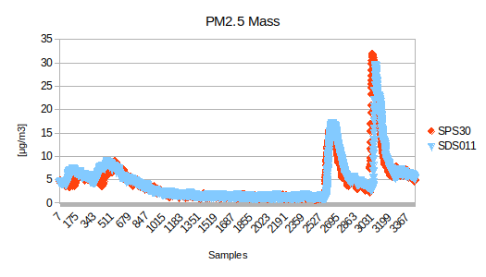
The 2.5 μ/m³ numbers are extremely close. They follow the same pattern, same reaction to change and the average over the 3500 samples is SPS30 : 4.27 μg/m³ where the SDS011 is showing : 4.45 μg/m³
Actually over a longer time it > 95% the same.

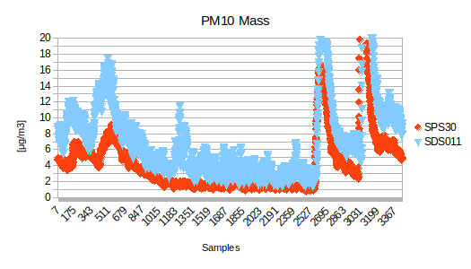
For the 10 μ/m³ the numbers are different
While they follow the same pattern and reaction, the values of SPS30 are nearly 50% of the SPS011. Over the 3500 samples on average the SPS30 is 4.35 μg/m³ where the SDS011 is 7.52 μg/m^{3.}

8. compare against SDS-011 AND DYLOS

For the definitions please see chapter 6 and 7.
The SPS30 monitor is able, if compiled with make BUILD= BOTH, to add both SDS-011 and DYLOS information next to the SPS30 information.

8.1 Comparing
./sds30 -S /dev/ttyUSB1 -D /dev/ttyUSB0 -C
-S /dev/ttyUSB1 : enable SDS011 connected to /dev/ttyUSB1
-D /dev/ttyUSB0 : enable DYLOS connected to /dev/ttyUSB0
-C : include correlation calculation
NOTE : adding ‘-l0’ to the command-options it will loop for ever (default 10 times)
This will result is output like :
MASS PM1: 1.5614 PM2.5: 1.7008 PM4: 1.7645 PM10: 1.7878
NUM PM0: 10.6602 PM1: 12.4401 PM2.5: 12.5608 PM4: 12.5724 PM10: 12.5747
DYLOS waiting new sample within 1 minute
SDS PM2.5: 2.0000 PM10: 4.7000
Correlation PM2.5: 17.59% PM10: 162.90%

MASS PM1: 1.7108 PM2.5: 1.8613 PM4: 1.9293 PM10: 1.9541
NUM PM0: 11.6868 PM1: 13.6337 PM2.5: 13.7635 PM4: 13.7759 PM10: 13.7784
DYLOS waiting new sample within 1 minute
SDS PM2.5: 2.1000 PM10: 4.8000
Correlation PM2.5: 12.82% PM10: 145.63%

MASS PM1: 1.8085 PM2.5: 1.9643 PM4: 2.0333 PM10: 2.0586
NUM PM0: 12.3631 PM1: 14.4160 PM2.5: 14.5496 PM4: 14.5622 PM10: 14.5648
DYLOS PM1: 723 PM10: 71 PPM (update every minute)
Correlation PM2.5: DYLOS 2.302516 (avg)SPS30 2.112721 part/cm3 (8.98%)
>PM2.5: DYLOS 0.250734 (avg)SPS30 0.015705 part/cm3 (1496.51%)
PM10 : DYLOS 2.553250 (avg)SPS30 2.128426 part/cm3 (19.96%)
SDS PM2.5: 2.2000 PM10: 5.2000
Correlation PM2.5: 12.00% PM10: 152.60%

MASS PM1: 1.8241 PM2.5: 1.9782 PM4: 2.0453 PM10: 2.0698
NUM PM0: 12.4788 PM1: 14.5448 PM2.5: 14.6762 PM4: 14.6885 PM10: 14.6910
DYLOS waiting new sample within 1 minute
SDS PM2.5: 2.4000 PM10: 6.7000
Correlation PM2.5: 21.32% PM10: 223.70%

MASS PM1: 1.8681 PM2.5: 2.0201 PM4: 2.0841 PM10: 2.1075
NUM PM0: 12.7955 PM1: 14.9026 PM2.5: 15.0309 PM4: 15.0427 PM10: 15.0452
DYLOS waiting new sample within 1 minute
SDS PM2.5: 2.4000 PM10: 6.0000
Correlation PM2.5: 18.80% PM10: 184.70%

8.2 comments
It you let this run for a longer time, the PM2.5 Mass values (SPS30 and SDS011) will be about <15% different, but the PM2.5 numbers (SPS30 and DYLOS) < 10% different. However the PM10 mass values ( SPS30 and SDS011) are about 60 – 100% different (under estimated by SPS30, but the numbers ( SPS30 – DYLOS) are 800+% different.

9. Careful conclusion

9.1 Personal (May 2019)
With reference to chapter 6, 7 and 8:
Looking at the PM25 results of the current program (either number or MASS) the PM25 results are close between 5 and 15% different.
Checking the relationship of SPS30 results shows over 3500 samples a factor between PM 2.5 of 0.967, often 0.99 or 100% with lowest around 0.92.
However looking at the > PM25, the number of particle is often more than 800+% different , where the mass values are around 100% different. Both under-estimated by the SPS30.
I believe the SPS30 mass and volume numbers up to 2.5um are well representing the environment. But I wonder whether the sensor is able to detect / report above 2,5 μm particle size the average weight and/or the number of particles in the right way.

9.2 Additional / external PMx remarks
Since the release of the SPS30 a number of people and instances have tested this device and the remarks about PM10 measurement have been the same : is this correct ?
Many of the people who have reached out to me came to similar conclusions and wondered.
A research paper concluded that the Sensirion Sps30 is not able to detect particles above ~2 um.
https://www.researchgate.net/publication/337852062_Laboratory_evaluation_of_particle_size-selectivity_of_optical_low-cost_particulate_matter_sensors
Document available in extra folder : Laboratory_evaluation_of_particle_size-selectivity
Sensirion has been providing additional information. A specialist article has been created (copied in the extras directory).
“The quality of the mass estimation will thus vary highly depending on the manufacturer algorithm used to convert the measured optical signal into PM mass concentration…….
Sensirion’s proprietary algorithms use an advanced approach that allows a proper estimation of the mass concentration, regardless of the particle type measured. In addition, such an approach enables a correct estimation of the size bins. Also, an additional bin output is provided in contrast to most state-of-the-art consumer PM sensors on the market – PM4.0.”
The datasheet March 2020, footnote 4 on page 2:
“PM4 and PM10 output values are calculated based on distribution profile of all measured particles”

Appendix A : Error messages
Defined in sps30lib.h

Hex
00 ERR_OK “All good"
01 ERR_DATALENGTH "Wrong data length for this command (too much or little data)"
02 ERR_UNKNOWNCMD "Unknown command"
03 ERR_ACCESSRIGHT "No access right for command"
04 ERR_PARAMETER "Illegal command parameter or parameter out of allowed range"
28 ERR_OUTOFRANGE "Internal function argument out of range"
43 ERR_CMDSTATE "Command not allowed in current state"
50 ERR_TIMEOUT "No response received within timeout period"
51 ERR_PROTOCOL "Protocol error"
88 ERR_FIRMWARE “Not supported on this SPS30 firmware level”

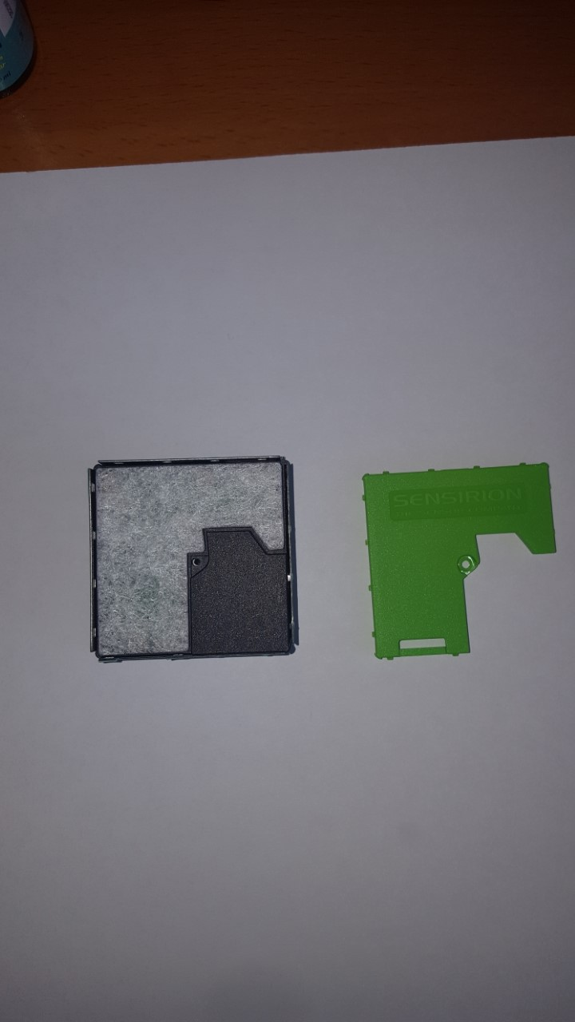
Appendix B : inside SPS30

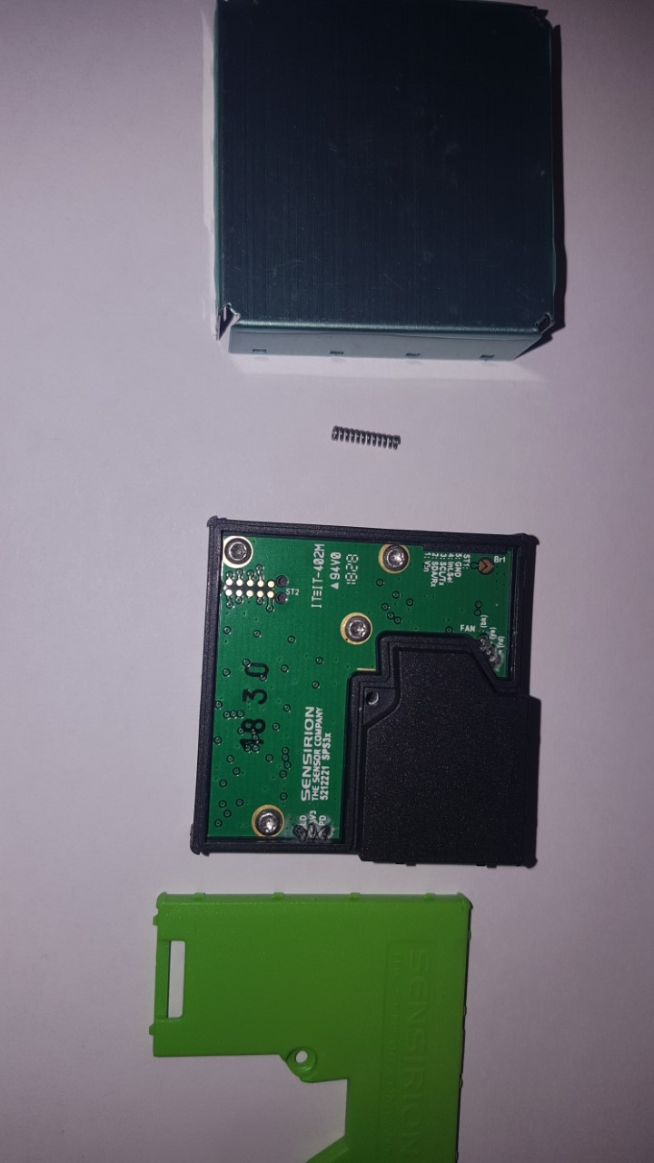
Removing the top cover screw

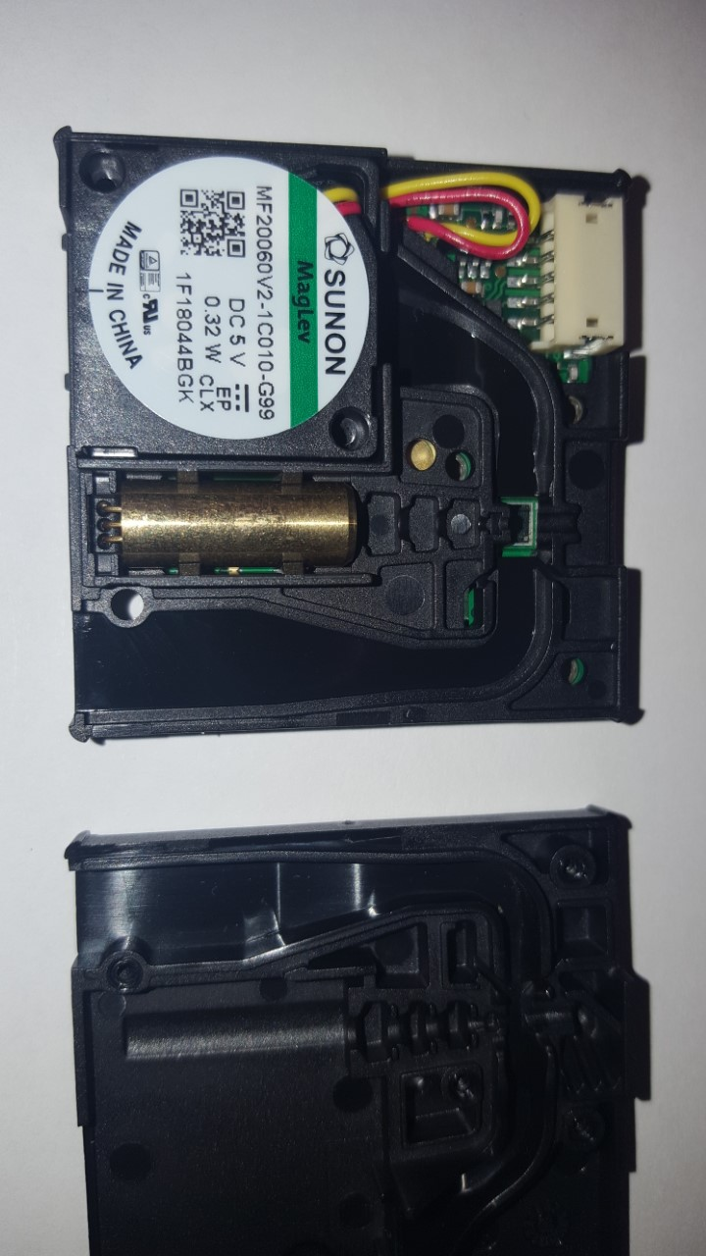
Carefully remove from the housing. Watch the spring at the back. Removing the 4 screws allows the top panel to be removed

Air goes in on the right hand side, through a measurement chamber and is coming out through the fan. At the bottom, the golden piece, is the led.

