Stepper motor on Arduino

Table of Contents
1. Hardware 2
1.2 The stepper motor 2
1.2.1 How many pulses are needed? 3
1.2.2 What is more accurate half-step or full-step ? 4
1.2.3 Maximum speed 6
2. Software 6
Appendix A. Sample code for stepper motor 7
Appendix B : error calculations 12

Just because this stepper motor and board was part of a experiment-kit that I had bought 2 years ago, I decided to give it try. Many others have gone before me and as such A LOT of websites that already describe the setup, but still it turned out to be a fun exercise.

Paul van Haastrecht
paulvha@hotmail.com

Disclaimer

This program is free software / information : you can redistribute it and/or modify it under the terms of the GNU General Public License as published by the Free Software Foundation, either version 3 of the License, or (at your option) any later version.

This information is distributed in the hope that it will be useful, but WITHOUT ANY WARRANTY; without even the implied warranty of MERCHANTABILITY or FITNESS FOR A PARTICULAR PURPOSE. See the GNU General Public License for more details.

1. Hardware

The driver board is an x113647 and the motor is 28BYJ-48.
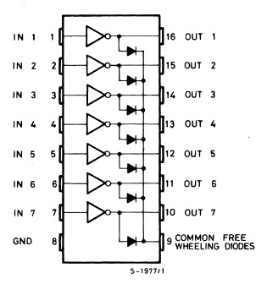
The X113647 has one chip: ULN2003A, which has 7 Darlington drivers and clamp diodes. Only 4 are used, the other 3 have no function. To each of the 4 used output pins a led with a 470 ohm resistor are connected to indicate which output is currently active.
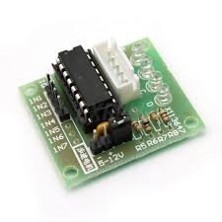
It also has a jumper by which you can remove the power of the output and motor circuit. Only handy during testing, so you can switch off the motor while changing the code.

1.2 The stepper motor

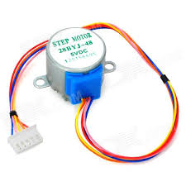
28BYJ-48 is a unipolar stepper motor with both coils center tapped and connected to common pin (9) of the ULN2003A. As per the circuit remaining four ends of the coil are connected to the output pins of a Darlington IC (ULN2003A).

Since 28BYJ works at 5V, we connect the com pin (9) of ULN2003A, through a jumper, to 5V pin of Arduino.

The specification of the motor

Stride angle 5,625 / 64
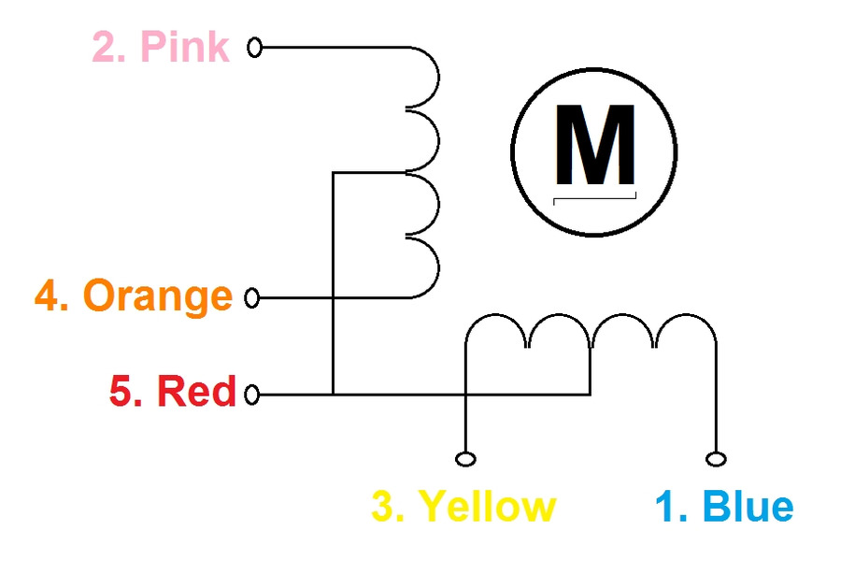
Speed Variation Ratio / gear 1 / 64
Frequency 100hz

1.2.1 How many pulses are needed?
One of the challenges was to understand the number of pulses needed for 360 degree turn.

There is the concept of half-step and full-step, which comes down to the powering-order of the motor-coils. See https://en.wikipedia.org/wiki/Stepper_motor
The stride angle definition is the 360 / 64 = 5,625 degree turn of the motor-shaft in half-step mode.
Half-step
In case of half-step the motor-coils are powered in 8-steps sequence as indicated below. It starts with powering the orange, then the orange and yellow, then only yellow etc. So power 1 coil, then 2 coils then 1 coil again etc.

------------CW ---------->>
1 2 3 4 5 6 7 8
orange X X X
yellow X X X
pink X X X
blue X X X

Half-step is the recommended mode of operation and with each pulse the motor shaft moves 5.625 degrees. After a half-step sequence the motor-shaft has moved 45 degrees (8 * 5.625). As such a full motor-shaft turn needs 8 sequences and thus 64 pulses. (8 * 8)

The speed variation ratio means: 64 internal motor-shaft turns are needed for one turn of top-shaft. Like a gear-box. So 360 degrees turn top-shaft needs 64 * 64 = 4096 pulses. Every pulse cause a 360 / 4096 = 0,08787 degree turn of top-shaft

Full-step
In case of full-step the motor-coils are powered in 4-steps sequence as indicated below. It starts with powering the orange and yellow, then the yellow and pink etc. Always 2 coils at the same time

----CW --->>
1 2 3 4
orange X X
yellow X X
pink X X
blue X X

With every step the motor-shaft turns 11.25 degrees. After a full-step sequence the motor-shaft has moved 45 degrees (4 * 11.25). As such a full motor-shaft turn needs 4 x 8 = 32 pulses.

The speed variation ratio means: 64 internal moto- shaft turns are needed for one turn of top-shaft. So 360 degrees turn top-shaft needs 32 * 64 = 2048 pulses . Every pulse cause a 360 / 2048 = 0,1757 degree of top-shaft.

In full-step the motor can provide the maximum rated torque. It provides 30% to 40% more power, but requires twice as much power from the driver.

1.2.2 What is more accurate half-step or full-step ?

It is hard (read: impossible) to find the difference whether half-step or full-step moves the motor more swiftly. I have not noticed a real difference. Also not in torque due to the “gear-box”. I wondered however: which one is more accurate: half-step or full-step ?

First of all: In most example coding that I have seen, they actually do not care about half-step or full-step. They count in 45 degree motor-shaft turns, often using full-step. They translate a 360 degree top-shaft turn into 512 blocks. I call this block-step. At the end of a block the motor-shaft will have turned 45 degrees (either 4 * 11.25 or 8 * 5.625). After each block the top-shaft will have turned 360 / 512 = 0.703 degrees.

For accuracy assessment, I decided to compare the 3 options : half-step, full-step or block-step.

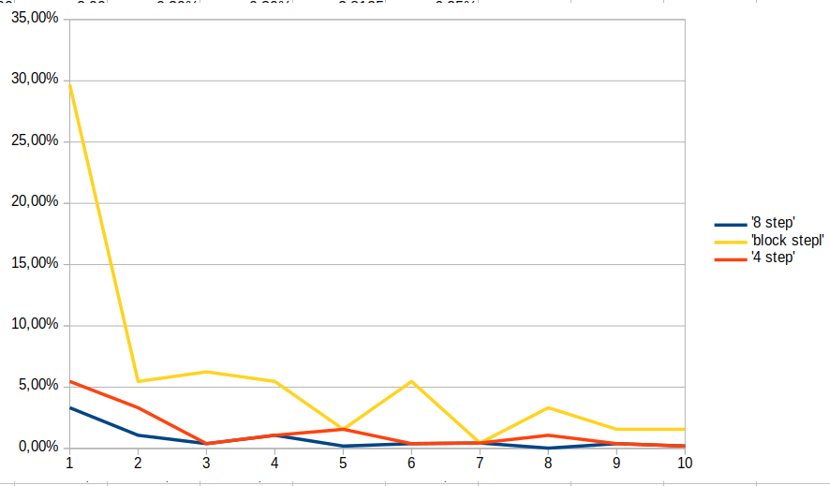

Below 10 degrees turn, there is a high margin of error. The half-step approach is the best with the 3.3% error, followed by the full-step of 5.05% and block-step the worst with 29%.
From 10 to 40 degree turn the error-deviation is 1.6% in full-step or block-step. Again the half-step is the best at 0.2% error.

From 40 to 360 degree turns: the margin of error on average is half-step = 0.02%, full-step = 0.03% and block-step = 0.13%.

However if you expect to turn the top-shaft 45, 90, 180, 270 degrees. All of them have 0.0% error.

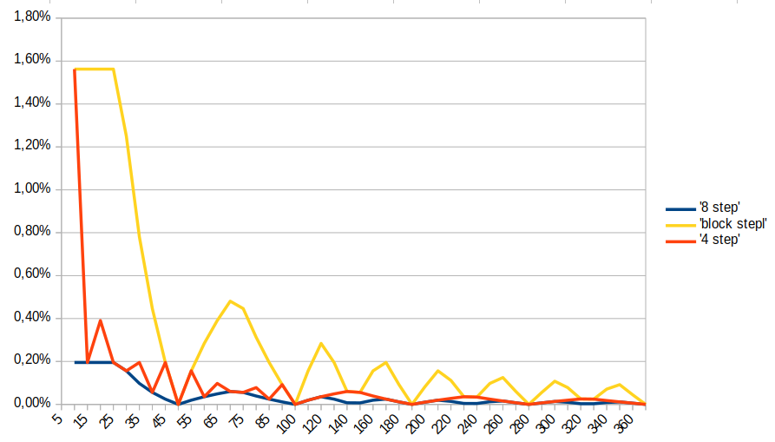

You can find the real numbers in appendix B.
Conclusion

In short… it does not really matter above 10 degree turns. The theoretical margin of error is less than any mechanical ware, although half-step is still most accurate. If you need more power/torque, use the full-step mode. If you turn up to 10 degree at a time, use half-step mode.

1.2.3 Maximum speed

The specification talk about 100Hz for the stepper motor. What does that mean?

A coil activation can happen with a frequency of 100 Hz or 10ms between 2 pull-down pulses.

In case of full-step, 4 steps in a single cycle, a coil is energized 2 steps, followed by 2 steps off.
To achieve 100hz, the delay pulse has to be 2.5ms after each step.

In case of half-step, 8 steps in a single cycle, a coil is energized 3 steps, followed by 5 steps off.
To achieve 100hz, the delay pulse has to be 1.25ms after each step

By experimenting with the delay it is determined that in full-step with 1.8ms delay the motor is still working good, with 1.7ms it is half moving. In half-step mode the minimum has to be 0.9ms. The maximum frequency as such is 1 / (4 * 1.8ms) = 138 Hz

In the program I have applied 2000us = 2ms (125Hz) for high speed, 4ms (62.5Hz) for medium and 8 (31Hz) for slow speed.

2. Software

There are many sketches around. I have just taken one of them and adjusted for my usage. It is available in appendix A.

Whether to apply half-step (8-steps) or full-step (4-steps) is a decision during compiling the code by setting full-step variable to true or false.

The delay between pulses can be set in High, Medium and Low. (see chapter 1.2.3)

It will ask for the degrees to turn, the direction and speed:

The degrees to turn will allow between 1 and up to 360 degrees.
The direction is either 1 = clock-wise or 2 = counter clock-wise
The speed is either 1 = high, 2 = medium or 3 = low

It will then display the requested action as well as the calculate % error of the movement, as well as the expected time it will take to make the turn.

The stepping is performed and then energy is removed from the coils. You could decide to leave the last coils energized for maximum torque, but with the gear-box in place it is already hard to move the top-shaft when not energized.

Appendix A. Sample code for stepper motor

/* example to provide your own input for turning the stepper motor
*
* paulvha October 2018 / version 1.0
*/

#define INPUT1 8 // blue connected to pin
#define INPUT2 9 // pink connected to pin
#define INPUT3 10 // yellow connected to pin
#define INPUT4 11 // orange connected to pin

#define High 2000 // speed in us delay
#define Medium 2 * High // speed in us delay
#define Low 4 * High // speed in us delay

//define # of steps per cycle
int full_step = false;

////////////////////////////////////////////////////////
/// no changes needed after this point
///////////////////////////////////////////////////////

#define CounterClockwise false // direction
#define Clockwise true // direction

void setup(){

pinMode(INPUT4, OUTPUT);
pinMode(INPUT3, OUTPUT);
pinMode(INPUT2, OUTPUT);
pinMode(INPUT1, OUTPUT);
delay(10);

// Serial Monitor is used to control the demo
Serial.begin(9600);
get_input(F("Press any key to begin."));
}

void loop()
{
int dir, sp_move, degr;

// reset values
dir = sp_move = degr = 0;

// get valid degrees
while (degr == 0){
degr = get_input("How many degrees turn ?");
if (degr < 1 || degr > 360) degr = 0;
}

// get valid direction
while (dir == 0){
dir = get_input("Direction to move: 1 = clock-wise, 2 = counter clock-wise ");
if (dir < 1 || dir > 2) dir = 0;
}

// get valid speed of moving
while (sp_move == 0){
sp_move = get_input("How fast to move: 1 = high, 2 = medium, 3 = slow");
if (sp_move < 1 || sp_move > 3 ) sp_move = 0;
}

// display action to perform
Serial.print ("Perform turning ");
Serial.print (degr);

if (dir == 1) Serial.print (" degrees, clock-wise with ");
else Serial.print (" degrees, counter clock-wise with ");

if(sp_move == 1) Serial.print("high");
else if(sp_move == 2) Serial.print("medium");
else Serial.print("low");

if (full_step) Serial.print(" speed using full-step, movement error: ");
else Serial.print ("speed using half-step, movement error: ");

Serial.print(margin_error(degr));
Serial.println ("%");

// now move it.
if (dir == 1) turnStepper(Clockwise,sp_move,degr);
else turnStepper(CounterClockwise,sp_move,degr);

Serial.println();
}

/* calculate number of steps needed */
float calc_steps(int degr)
{
float tmp;

tmp = 360 / (float) degr;

if (full_step) return(round(2048 / tmp));
else return(round(4096 / tmp));
}

/* calculate the movement precision / error depending on
* full-step 4 steps
* half-step 8 steps */
float margin_error(int degr)
{
float result;

// in case full-step
if (full_step) result = calc_steps(degr) * (float) 360 / 2048;
else result = calc_steps(degr) * (float) 360 / 4096;

return((result / (float) degr -1) * 100);
}

/* Display message and expect a number input
* which is returned as a int
*/
int get_input(String message)
{
String inp;

Serial.println(message);

// wait for input
while (!Serial.available());

inp = Serial.readString();

return(atoi(inp.c_str()));
}

/* The specification of the 28BYJ-48 are
*
* Stride angle 5.625 /64
* gear 64
*
* Half-step mode: 8 step control signal sequence (recommended) 5.625 degrees per step / 64 steps per one revolution of the internal motor shaft
* The gear means: 64 internal motor turns are needed for one turn of top-shaft. So 360 degrees turn top-shaft needs 64 * 64 = 4096 pulses
* This also means that the top-shaft can be positioned with 5.625 / 64 = 0.08789 degrees precision.
*
* Full Step mode: 4 step control signal sequence 11.25 degrees per step / 32 steps per one revolution of the internal motor shaft
* The gear means: 64 motor turn are needed for one turn of top shaft. So 360 degrees turn top-shaft needs 64 * 32 = 2048 pulses
* This also means that the top-shaft can be positioned with 5.625 / 32 = 0,1757 degrees precision.
*
* MotorInput (blue, pink, yellow, orange)
*
* ------------CW ---------->>
* 1 2 3 4 5 6 7 8
* orange Y X X
* yellow X Y X
* pink X Y X
* blue X Y X
*
* Setting full-step = true will perform the X-steps
* Setting full-step = false will perform the X and Y steps
*/
void turnStepper(boolean Direction,int spd,int Angle)
{
int i, j, RPM;

RPM = Low;
if (spd == 1) RPM = High;
else if (spd == 2) RPM = Medium;

// display how long this will take
Serial.print("This will take ");
if (full_step) Serial.print((calc_steps(Angle) * RPM) / 1000);
else Serial.print((calc_steps(Angle) * RPM /2) / 1000);
Serial.println("ms");

if (full_step) // 4 step only the X-steps
{

if(Direction){ // clock wise

for(i=0,j=0;i<map(Angle,0,360,0,2048);i++)
{
if (j == 0) motorInput(1,1,0,0);
else if (j == 1) motorInput(0,1,1,0);
else if (j == 2) motorInput(0,0,1,1);
else motorInput(1,0,0,1);
delayMicroseconds(RPM);
if (++j == 4) j = 0;
}
}
else { // counter clock
for(i=0, j=0;i<map(Angle,0,360,0,2048);i++)
{
if (j == 0) motorInput(1,0,0,1);
else if (j == 1) motorInput(0,0,1,1);
else if (j == 2) motorInput(0,1,1,0);
else motorInput(1,1,0,0);
delayMicroseconds(RPM);
if(++j == 4) j = 0;
}
}
}
else // eight steps // X + Y steps
{
if (Direction) { // clock wise

for(i=0, j=0 ;i<map(Angle,0,360,0,4096);i++)
{
if (j == 0) motorInput(1,0,0,0);
else if (j == 1) motorInput(1,1,0,0);
else if (j == 2) motorInput(0,1,0,0);
else if (j == 3) motorInput(0,1,1,0);
else if (j == 4) motorInput(0,0,1,0);
else if (j == 5) motorInput(0,0,1,1);
else if (j == 6) motorInput(0,0,0,1);
else motorInput(1,0,0,1);
delayMicroseconds(RPM/2 );
if(++j == 8) j = 0;
}
}

else { // counter clock
for(i=0, j=0; i<map(Angle,0,360,0,4096);i++)
{
if (j == 0) motorInput(1,0,0,1);
else if (j == 1) motorInput(0,0,0,1);
else if (j == 2) motorInput(0,0,1,1);
else if (j == 3) motorInput(0,0,1,0);
else if (j == 4) motorInput(0,1,1,0);
else if (j == 5) motorInput(0,1,0,0);
else if (j == 6) motorInput(1,1,0,0);
else motorInput(1,0,0,0);

delayMicroseconds(RPM/2);
if(++j == 8) j = 0;
}
}
}

// turn off motor
motorInput(0,0,0,0);

delay(10);
}

/* set signals on the motor */
void motorInput(boolean IN1,boolean IN2,boolean IN3,boolean IN4)
{
digitalWrite(INPUT1, IN1); // blue
digitalWrite(INPUT2, IN2); // pink
digitalWrite(INPUT3, IN3); // yellow
digitalWrite(INPUT4, IN4); // orange
}

Appendix B : error calculations

