SVM30
Table of Contents
1. Foreword 3
2. Hardware connection 4
2.1 connected to MEGA2560 4
2.2 connected to UNO 4
2.3 connected to ESP32 5
2.4 connected to ESP8266 5
2.5 connected to Feather Lora 32U4 6
2.6 connected to DUE 6
3. Software 7
3.1 Functions 7
3.1.1 void EnableDebugging(bool act) 7
3.1.2 bool begin() 7
3.1.3 bool probe() 7
3.1.4 const char * GetDriverVersion() 7
3.1.5 bool TriggerSGP30() 7
3.1.6 bool GetId(uint8_t device, uint16_t *buf) 7
3.1.7 bool reset(uint8_t device) 8
3.1.8 bool GetFeatureSet(char *buf) 8
3.1.9 bool MeasureTest() 8
3.1.10 bool GetBaseLine_CO2(uint16_t *baseline) 8
3.1.11 bool GetBaseLine_TVOC(uint16_t *baseline) 8
3.1.12 bool GetBaseLines(uint32_t *baseline) 8
3.1.13 bool SetBaseLine_CO2(uint16_t baseline) 8
3.1.14 bool SetBaseLine_TVOC(uint16_t baseline) 8
3.1.15 bool SetBaseLines(uint32_t baseline) 9
3.1.16 bool SetHumidity(float humidity) 9
3.1.17 bool GetValues(struct svm_values *v, bool raw) 9
3.1.18 void SetTempCelsius(bool act) 9
3.1.19 Bool GetInceptiveBaseLine_TVOC(uint16_t *baseline) 10
3.1.20 Bool SetInceptiveBaseLine_TVOC(uint16_t baseline) 10
3.2 Values available 11
3.3 Examples provided 11
3.3.1 Example1: basic reading 11
3.3.2 Example2: with humidity compensation 11
3.3.3 Example3: with baseline compensation 11
3.3.4 Example4: SGP30 self test 11
3.3.5 Example5 : with DewPoint, HeatIndex and Fahrenheit 11
3.3.6 Example6 : with Lora & TTN 11
3.3.6 Example7 : basic reading with any I2C channel 12
3.4 baseline compensation 12
4. Observations 13
4.1 Remarks about SVM30 13
4.2 SVM30 concerns 13
4.3 SGP30 concerns 13
4.4 Temperature measurement 14
4.5 Baseline setting 14
5. Benchmark SVM30 / SCD30 / CCS811 15
5.1 Temperature 15
5.2 CO2 values 15
5.3 TVOC values 16
5.4 Compare CO2 and TVOC on SVM30 17
5.5 SVM30 CO2 to baseline 17
5.6 SVM30 CO2 to baseline 18
5.7 humidity 18
6 Benchmark SCD30 / SVM30 / BME280 / BME680 19
6.1. Humidity results 19
6.2 Temperature results 21
6.3 Pressure results 23
Appendix A: scope signal 24
Appendix B: example output Example1 25

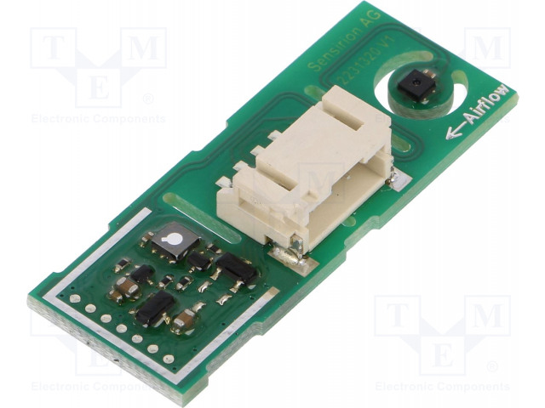
1. Foreword

October 2019 :

The SVM30 is a new board from Sensirion, based on 2 sensor that have been around for a while : SGP30 and SHTC1. The SGP30 provides CO2 and TVOC information, while the SHTC1 is providing temperature and humidity.

The 2 complement each other as humidity information from the SHTC1 can be used to adjust / fine tune the SGP30 output. The board is positioned as a single solution for HVAC systems.

The hardware connection and software function are described in chapter 2 and chapter 3. The library has 5 general purpose sketches and 1 sketch where the SVM30 is connected with Lora to TheThingsNetwork, using a feather Lora 32U4.

While there a number of remarks around the board in chapter 4, the SVM30 is a quality product, as long as it is used in forced air movement, e.g. with a fan. Care should taken when connecting to 3V3 processor board, like ESPxxx.

In chapter 5 the SVM30 a test and compare against CCS811 and SCD30.

August 2020 :

Update to level 1.2 with following changes :

Adding parameter raw to GetValues: read the raw-values for H2_signal and Ethanol_signal. The default is ‘true’ and thus it will read these values and backward compatible. On an old product version of the SGP30/SVM30 (level 9 was the case) this call would fail. Turned out that reading raw was not supported, hence this option was added to exclude reading these values. In that case both signals will be zero.

The delay time between requesting data from the SGP30 and start reading was fixed. However a defined in the datasheet, chapter 6.3 / table 13, some commands need longer time. The read-delay will now be set according the kind of data request to improve the reliability.

Included support to select any I2C / Wire channel in the sketch. This is demonstrated in the added example7 and can be applied to other examples in case of other channel than the embedded Wire.

Included functions for handling SGP30 TVOC inceptive baseline, as introduced in the SGP30 datasheet May 2020. Requires product level 34.

Paul van Haastrecht
paulvha@hotmail.com

2. Hardware connection

The library and examples have been validated to run on Arduino UNO, DUE, MEGA2560, ESP32, ESP8266 and Feather Lora 32U4.

Not Documented, but it seems the SVM30 has on-board pull-up resistors (~20K) as the scope picture in Appendix A shows.

The ESPXX needs special care a the SVM30 will only run on 5V and these boards can only handle 3V3 on the pins.

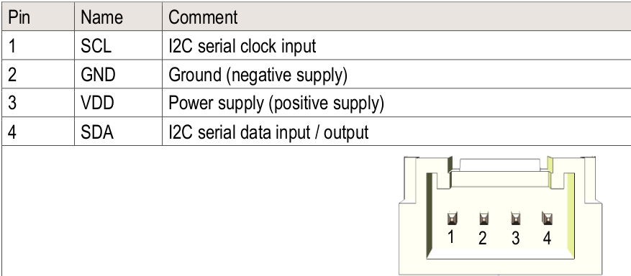

2.1 connected to MEGA2560

SVM30 MEGA2560
1. SCL ----------- SCL
2. GND ---------- GND
3. VCC ----------- +5V
4. SDA ----------- SDA

2.2 connected to UNO

SVM30 UNO
1. SCL ----------- A5
2. GND ---------- GND
3. VCC ----------- +5V
4. SDA ----------- A4

2.3 connected to ESP32

WARNING: THE SVM30 NEEDS BETWEEN 4.5V AND 4.5V (TYPICAL 5V). RUNNING ON 3v3 MAKES IT UNSTABLE. THE ESP32 PINS CAN HANDLE UP TO 3v3 ONLY AND AS SUCH YOU USE A BI-DIRECTIONAL LEVEL CONVERTER.
e.g. https://www.sparkfun.com/products/12009

SVM30 ESP32
1. SCL ----lll----- SCL (pin 22)
2. GND ----------- GND
3. VCC ----------- +5V/VUSB
4. SDA ----lll----- SDA (pin 21)

Make sure :
- use the VUSB pin to connect to the level converter (HV) and VCC of the SVM30
- use the 3V3 pin to connect to the level converter (LV)
- select the Sparkfun ESP32 thing board before compiling
- connect GND, SDA, SCL lines to the level converter and SVM30
- Select serial monitor is NOT active (will cause upload errors)
- Press GPIO 0 switch during connecting after compile to start upload to the board
- Press reset on the ESP32 thing after the sketch is loaded

2.4 connected to ESP8266

WARNING: THE SVM30 NEEDS BETWEEN 4.5V AND 4.5V (TYPICAL 5V). RUNNING ON 3v3 MAKES IT UNSTABLE. THE ESP8266 PINS CAN HANDLE UP TO 3v3 ONLY AND AS SUCH YOU USE A BI-DIRECTIONAL LEVEL CONVERTER.
e.g. https://www.sparkfun.com/products/12009

SVM30 ESP8266
1. SCL ----lll---- SCL
2. GND ---------- GND
3. VCC ----------- VIN
4. SDA ----lll----- SDA

Make sure :
- connect with USB/Serial converter to serial connector for communication with PC (set to provide 3V3)
- connect an EXTRA USB cable to the USB connector for providing
- use the VIN pin to connect to the level converter (HV) and VCC of the SVM30
- use the 3V3 pin to connect to the level converter (LV)
- connect GND, SDA, SCL lines to the level converter and SVM30
- select the Sparkfun ESP8266 thing board before compiling
- serial monitor is NOT active (will cause upload errors)
- close the on-board DTR link after compile to start upload to the board

2.5 connected to Feather Lora 32U4
The 32U4, while a 3v3 device, only seems to have a current restriction. My test example worked without problems directly connected to the SVM30 without level converters. (see example 6)

SVM30 Feather 32U4
1. SCL ----------- SCL
2. GND ---------- GND
3. VCC ----------- VUSB
4. SDA ----------- SDA

2.6 connected to DUE

SVM30 Arduino DUE

1. SCL ----------- SCL NEXT TO SDA ( WHICH IS NEXT TO AREF)
2. GND ----------- GND
3. VCC ----------- +5V
4. SDA ----------- SDA NEXT TO AREF

!!! For the Arduino DUE you can only use Wire1 (use example 7 !!!)

The standard Wire (pin 20 and 21) have on-board pull-up resistor of 1K5 on the DUE. As the
SVM30 also has pull-up resistors the current looks to high for the pins and Wire will not work. There are many complains about the pull-up resistors on standard Wire on the Arduino DUE. Wire1 does NOT have pull-up resistors.

3. Software

3.1 Functions

3.1.1 void EnableDebugging(bool act)
Enable or disable the printing of library debug messages.
- false : no debug messages
- true : enable debug messages

3.1.2 bool begin()
Initialize the communication & start SGP30
return : true on success else false

3.1.3 bool probe()
check if SVM30 sensors are available
return : true on success else false

3.1.4 const char * GetDriverVersion()
return driver version.

3.1.5 bool TriggerSGP30()
Trigger a read on the SGP30

See chapter 3.4 baseline compensation for more info

return : true on success else false

3.1.6 bool GetId(uint8_t device, uint16_t *buf)
read ID number from SGP30 or SHTC1
- Parameter device : SGP30 or SHTC1
- Parameter buffer to store ID (min 3 words)
return : true on success else false

3.1.7 bool reset(uint8_t device)
Reset SGP30 or SHTC1
- Parameter device : SGP30 or SHTC1
return : true on success else false

3.1.8 bool GetFeatureSet(char *buf)
read feature set from SGP30
- Param buf : buffer to store feature set number (min 2)
return : true on success else false

3.1.9 bool MeasureTest()
Perform Measure SELF test on SGP30
return : true on success else false

3.1.10 bool GetBaseLine_CO2(uint16_t *baseline)

3.1.11 bool GetBaseLine_TVOC(uint16_t *baseline)
get individual baseline from SGP30
return : true on success else false

3.1.12 bool GetBaseLines(uint32_t *baseline)
get BOTH baselines (TVOC and CO2) from SGP30
return : true on success else false

3.1.13 bool SetBaseLine_CO2(uint16_t baseline)

3.1.14 bool SetBaseLine_TVOC(uint16_t baseline)
set individual baseline on SGP30
- param baseline (as retrieved with GetBaselines()
source datasheet:
Approximately in the first 15 seconds of operation after start the call will fail unless a previous baseline was restored.
REMARK : Sending baseline values of zero will be treated as an error.
return : true on success else false

3.1.15 bool SetBaseLines(uint32_t baseline)
set BOTH baselines (TVOC and CO2) on SGP30
- param baseline (as retrieved with GetBaselines()
return : true on success else false

3.1.16 bool SetHumidity(float humidity)
set humidity on SGP30
- param humidity: humidity value to set
Sending a humidity value of 0x0000 can be used to turn off the humidity compensation. The humidity value used for compensation is set to its default value (11.57g/m3)

return : true on success else false

3.1.17 bool GetValues(struct svm_values *v, bool raw)
read all measurement values from the sensor, perform calculations and store in structure
- param v: pointer to structure to store
- param raw: read the raw-values for H2_signal and Ethanol_signal. The default is ‘true’ and thus it will read these values. On an old product version of the SGP30/SVM30 (level 9 was the case) this call would fail. Turned out that reading raw was not supported, hence this option was added to exclude reading these values. In that case both signals will be zero.
return : true on success else false

3.1.18 void SetTempCelsius(bool act)
Set temperature type
param act :
- true set to Celsius
- false is Fahrenheit

3.1.19 Bool GetInceptiveBaseLine_TVOC(uint16_t *baseline)

3.1.20 Bool SetInceptiveBaseLine_TVOC(uint16_t baseline)

This concept of inceptive baseline was documented in the Datasheet May 2020 of the SGP30 :

“The inceptive baseline offers an individually calibrated starting reference to the dynamic baseline compensation algorithm. Thereby the feature yields a better TVOC concentration accuracy for the very first start-up under bad air condition. This results in a better user experience especially when accuracy is required. Please note, that the application of this feature is solely limited to the very first start-up period of an SGP sensor. Furthermore,it is limited to the TVOC signal output.”

They require a product level 34 at least. There is no further documentation found (August 2020) about this concept, but it might appear in the future. These functions have not been test (yet).

REMARK : Sending baseline values of zero will be treated as an error.
return : true on success else false

3.2 Values available
/* structure to return measurement values */
typedef struct svm_values
{
uint16_t r_humidity; // SHTC1 (raw data from sensor)
uint16_t r_temperature; // SHTC1 (raw data from sensor)
int32_t humidity; // SHTC1 (converted humidity)
int32_t temperature; // SHTC1 (converted temperature in C)
float absolute_hum; // calculated absolute humidity in g/m3.1.
uint16_t CO2eq; // SGP30
uint16_t TVOC; // SGP30
uint16_t H2_signal; // SGP30 Raw H2 signal (see remark 3.1.17)
uint16_t Ethanol_signal;// SGP30 Raw ethanol signal (see remark 3.1.1&)
float heat_index; // calculated heat index
float dew_point; // calculated dew point
};

3.3 Examples provided

3.3.1 Example1: basic reading
Will do basic reading and display of the read values read.

3.3.2 Example2: with humidity compensation
Is the same as Example1, but does a continuous humidity value update.

3.3.3 Example3: with baseline compensation
Is the same as Example1, but update baseline with code values. The baseline will only be updated after the initialization. See chapter 4.5

3.3.4 Example4: SGP30 self test
Put the onboard SGP30 through a self test

3.3.5 Example5 : with DewPoint, HeatIndex and Fahrenheit
As Example1, but also display the calculated DewPoint and Heatindex

3.3.6 Example6 : with Lora & TTN
As Example1 but extended to support LORA radio on an 32U4 in order to connect to TheThingsNetwork (TTN). You need to make sure to set the right values for TTN connection

3.3.6 Example7 : basic reading with any I2C channel
Read information from SVM30 by selecting any of the I2C / Wire channel. This kind of selection can be applied to the other examples as well if you want to use another channel than the default Wire.

3.4 baseline compensation
An interesting aspect of the SGP30 is the ability to self calibrate and adjust the baselines for CO2 and TVOC results
source : Datasheet SVM30:
“ After the “Init_air_quality” command, a “Measure_air_quality” command has to be sent in regular intervals of 1s to ensure proper operation of the dynamic baseline compensation algorithm.”
“ The on-chip baseline compensation algorithm has been optimized for 1HZ sampling rate. The sensor shows best performance when used with this sampling rate.”

Hence you will find in all sketches that in the loop() triggerSCP30() or GetValues() is called nearly each second.

4. Observations

4.1 Remarks about SVM30

The SVM30 is actually a combination of 2 “known” units (SHTC1 and SGP30) and as such not really a “new kid on the block”. These are high quality measurement components that have now been combined on the same board.

4.2 SVM30 concerns

The claim” Automatic baseline compensation and humidity compensation of MOX gas sensor” is fully correct BUT NOT really what you would expect. (good marketing thou)

- The SGP30 has “ humidity compensation”, but YOU have to read the temperature and humidity from the SHTC1, calculate the absolute humidity and send that in a fixed point format to the SGP30. NOTHING is happening on the board.

The heat dissipation from the on-board components has an impact on the temperature ( < 0.7C) and humidity reading in open air, but in closed cabinet this can have a high impact. The heat dissipation causes an increase of 6 - 7 degrees Celsius on the SGP30, with the transistors in SOT23 package 8 – 9 degrees Celsius warmer than the air (see chapter 4.4)

The board is 5V only VCC. The SGP30 and SHTC1 sensors operate on voltages around 1.8V. Part of the heat dissipation could be because of the needed voltage drop. However the SDA and SCL seem to have on-board pulled-up resistors to 5V. This makes the sensor not usable to 3V3 processor boards without extra hardware.

4.3 SGP30 concerns

Receipt of correct baselines or humidity setting is NOT confirmed by the SGP30 sensor. The baselines can be read back, but for humidity it is hopefully accepted. Either way the output results from the SGP30 is not really changing after setting baseline or humidity. The impact is unknown.

Reading the RAW H2 and Ethanol values does NOT really bring any further information and can be totally discarded. Same is true for the self / measurement test. All nice to have

Setting the baseline to a certain value has its wrong or undocumented challenges. It has the same errors and short comings in the datasheet as the SGP30. I wonder why this has not been corrected after 2 years after the latest SGP30 datasheet?? (see chapter 4.5)

The product feature-information decoding of the SGP30 is completely undocumented. If this is planned to provide information about the capabilities of the software in the sensor, why not share what it is ? For this driver I have implemented the info from the datasheet.

4.4 Temperature measurement

In general the temperature measurement was correct, in open, none forced moving air. A separate high quality temperature device was used to do compare and even after long term measurement ( >2 hours) and the results were close ( < 0.7 C). Then I connected a external ventilator, an 12V CPU cooler fan, and had it run for hours. The results of both separate temperature devices showed similar results ( < 0.1C difference) . Clearly shows that with air flowing the temperature reading is correct. However when turning off the fan, the temperature increased quickly to 1 degree difference.

One can notice that the temperature around SGP30 is much higher due to heat from the on-board components.(just put your finger on it or hold it against your cheek) Measuring the temperature around the SGP30 with the same high quality temperature device showed a 6 to 7C higher reading, with the transistors in SOT23 even up to 9 degrees warmer.

If this sensor is placed in a cabinet, this could have a high impact and it is extremely important to have to a good shield the SGP30 side of the SVM30 from the SHTC1 side and use a fan to force air flow

4.5 Baseline setting

Baseline handling on the SGP30 seems to be half documented and partly documented in error.

- The order is of reading and sending is TVOC, CO2eq (the SVM30 datasheet is reversing the order up for reading, which is NOT correct)

- When sending the baseline values, each word needs to be followed with a CRC (not defined in the SVM30 datasheet)

- Setting a baseline value of zero on CO2 causes CO2 baseline to be the same as TVOC. Setting values of zero should be avoided (not documented)

- TVOC baseline can be set by sending only 1 word/baseline + CRC. (Not documented)

- When setting baseline during the first 15 seconds after power-up/reset, update baseline for CO2 first, then TVOC. Else setting will fail.

- After setting the baseline value during the first 15 seconds after power-up/reset, the baselines will NOT change / updated. Once it is set the baseline stays what it is. (not documented). If set after the initial calibration during the 15 seconds, they will continue to be optimized.

Inceptive Baseline for TVOC measurements, as introduced in the SGP30 Datasheet May 2020, is not clearly understood / documented. It requires level 34 and the included functions could not be tested.

While taken into account the above remarks in chapter 4, the SVM30 a good sensor board.

5. Benchmark SVM30 / SCD30 / CCS811

With all the work done, time to put the SVM30 to a benchmark. The other victims are CCS811 and SCD30. All three were connected to a Raspberry PI, for which the software is available

CCS811 : https://github.com/paulvha/ccs811
SCD30 : https://github.com/paulvha/scd30_on_raspberry
SVM30 : https://github.com/paulvha/SVM30_on_raspberry

The test was done with a fan forcing air movement around the 3 sensors. As the CCS811 needs to warm up, the results were taken after 3 hours of working.

5.1 Temperature

All 3 provide temperature reading. The CSS811 has an CTN, the SCD30 use an SHT30 and the SVM30 SHTC1. The CSS811 and SCD30 show similar results, although the SCD30 reacts faster. The SVM30 result was consistent lower for the whole time, but it was showing the same results as a high quality temperature meter.

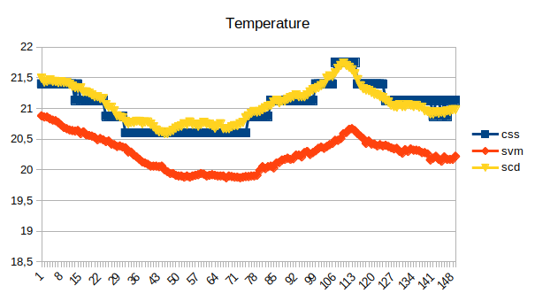
5.2 CO2 values

All 3 provide CO2 information. No matter what… the CCS811 was not showing anything else than 400. On a certain moment I have tested the CCS811 (blowing directly on the board) and it moved up for 2 readings, then back to 400. This was before the samples taken below. The SCD30 has consistent higher reading, apart from the samples spikes around 113, where I breathed air in to the fan. Both SVM30 and SCD30 react very fast on changes in the air. Although the SVM30 has humidity compensation is was not turned on.

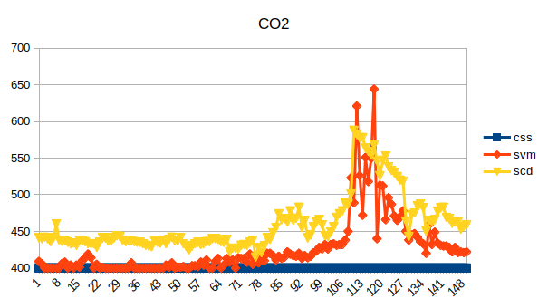

5.3 TVOC values

All CCS811 and SVM30 provide TVOC information. No matter what… CCS811 TVOC continued to be zero.

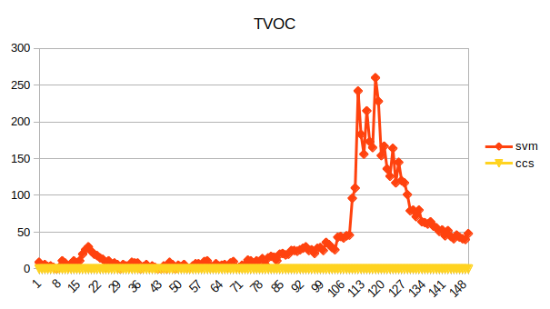

5.4 Compare CO2 and TVOC on SVM30
As one would expect they follow the same pattern, as they use the same sensor, but a different calculation

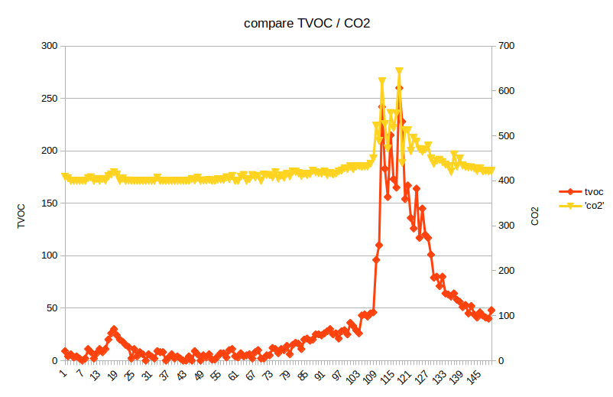
5.5 SVM30 CO2 to baseline

Maybe the baseline helps to get better results for the CO2 reading, the chart below shows that it is not possible to draw conclusion.
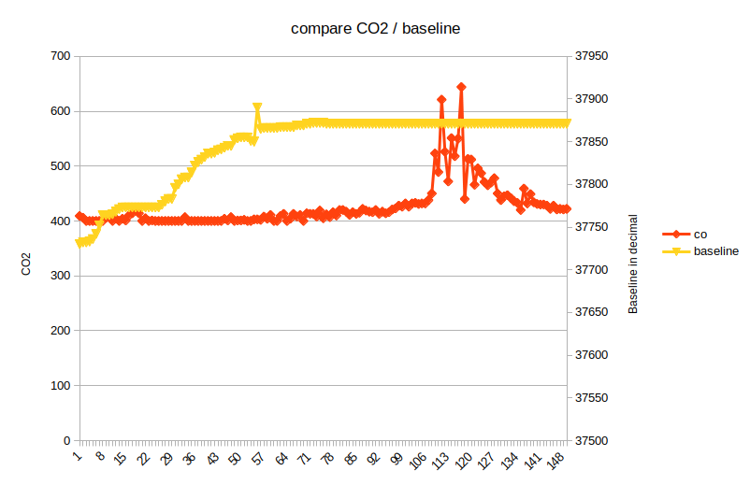

5.6 SVM30 CO2 to baseline
Comparing the TVOC results and TVOC baseline does not shine a light either
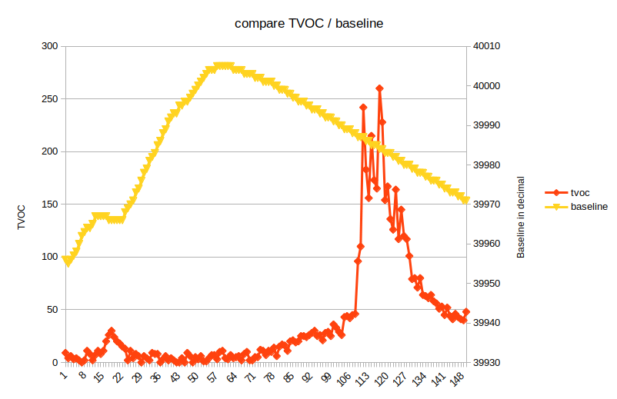

5.7 humidity
The SCD30 provide humidity with an SHT30 and the SVM30 with SHTC1. Both quality sensors and sometimes 1% humidity apart.
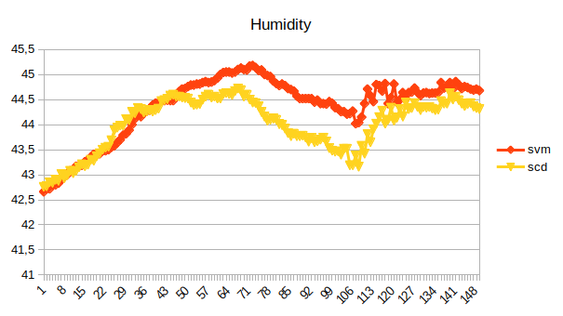

6 Benchmark SCD30 / SVM30 / BME280 / BME680

This benchmark is around humidity, temperature and pressure. All 4 sensors were connected to a Raspberry PI, running at the same time. A computer fan with focused air-stream was used to force air to the 4 sensors. The BME280 and BME680 shared the same I2C line, powering both with 5V.
The sensors have been running for 3 hours, with sampling every minute. The last 1.5 hour samples were used.

6.1. Humidity results
My BME680 RH% were constant much higher. Even moved the BME680 to another place in the air, moved the board around but no difference in the measurement results.
On average over the 95 samples, the BME280, SVM30 and SCD30 results are within 3% points. The BME680 is 7% RH higher than SCD30/SVM30.

6.2 Temperature results

Nearly the same as humidity, with the BME680 being higher

Looking at the average result over the 1.5 hours, the BME680 is 4% point higher. The BME280, SVM30 and SCD30 are within 2% points.

6.3 Pressure results

Although the SVM30 and SCD30 are not providing pressure information, the BME680 and BME280 do. I have included the information in case you want to add either one into your project:

The delta is 1Pa only on average.

Appendix A: scope signal

This signal was taken WITHOUT external / extra pull-up resistors. The SVM30 must have them on-board, otherwise these signals would not exist or have this quality.

Appendix B: example output Example1

Hi there, this is example 1.
Reading information from the SVM30
Driver version : 1.0 / October 2019
SVM30 detected

SGP30 id : 0000 00cb 9e56
SHTC1 id : 0007

SGP30 product type : 0, Product version : 22

CO2 equivalent : 400, TVOC : 0, H2_signal : 13816, Ethanol_signal : 17938, Humidity : 46.02, temperature : 21.91, absolute humidity : 8.89 CO2 equivalent baseline : 0x0, TVOC baseline : 0x0
CO2 equivalent : 400, TVOC : 0, H2_signal : 13829, Ethanol_signal : 17980, Humidity : 46.03, temperature : 21.96, absolute humidity : 8.91 CO2 equivalent baseline : 0x0, TVOC baseline : 0x0
CO2 equivalent : 400, TVOC : 0, H2_signal : 13842, Ethanol_signal : 18016, Humidity : 44.97, temperature : 21.99, absolute humidity : 8.92 CO2 equivalent baseline : 0x89B7, TVOC baseline : 0x928B
CO2 equivalent : 400, TVOC : 0, H2_signal : 13849, Ethanol_signal : 18044, Humidity : 44.90, temperature : 22.02, absolute humidity : 8.92 CO2 equivalent baseline : 0x89E3, TVOC baseline : 0x929D
CO2 equivalent : 400, TVOC : 3, H2_signal : 13852, Ethanol_signal : 18061, Humidity : 44.87, temperature : 22.06, absolute humidity : 8.93 CO2 equivalent baseline : 0x8A27, TVOC baseline : 0x92B6

after 2 hours:
CO2 equivalent : 426, TVOC : 60, H2_signal : 13864, Ethanol_signal : 18607, Humidity : 41.61, temperature : 23.1.96, absolute humidity : 9.03 CO2 equivalent baseline : 0x8EFA, TVOC baseline : 0x9309
CO2 equivalent : 432, TVOC : 56, H2_signal : 13862, Ethanol_signal : 18616, Humidity : 41.63, temperature : 23.1.96, absolute humidity : 9.04 CO2 equivalent baseline : 0x8EFA, TVOC baseline : 0x9309
CO2 equivalent : 428, TVOC : 58, H2_signal : 13855, Ethanol_signal : 18607, Humidity : 41.59, temperature : 23.1.95, absolute humidity : 9.02 CO2 equivalent baseline : 0x8EFA, TVOC baseline : 0x9309
CO2 equivalent : 451, TVOC : 65, H2_signal : 13849, Ethanol_signal : 18607, Humidity : 41.90, temperature : 23.1.92, absolute humidity : 9.08 CO2 equivalent baseline : 0x8EFA, TVOC baseline : 0x9308

