SVM40

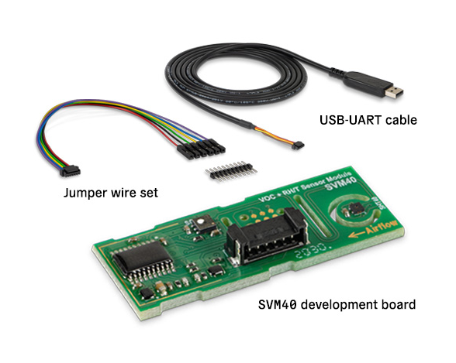

Table of Contents
1. Foreword 3
2. Hardware connections 5
2.1 Serial / UART 5
2.1.1 Serial1 on UNO R4 6
2.2 I2C 7
2.2.1 QWIIC on UNO-R4 WIFI 9
3. Sensirion Control center 9
4. Software 10
4.1 Library calls 10
4.2 I2C communication 11
4.3 examples overview 12
example 1 12
example 2 12
example 3 12
example 4 12
example 5 12
example 6 12
example11 13
example12 13
example13 13
example14 13
example15 13
example16 13
5. VOC-index 14
5.1 What is it ? 14
5.2 Indoor Air Quality (IAQ) ? 15
5.3 Another airQualityindex 15
6. Sample output 16
6.1 Charts 16
6.2 example 1 18
6.3 example 2 19

1. Foreword
Version 2.1 / October 2023

Tested on UNO-R4 WiFi.

After small update it now works on the UNO R4 WIFI with I2C. (See chapter 2.2.1)
When using Wire, pull-up resistors to SDA and SCL need to be applied for it to work as they are NOT populated on the UNO-R4.

When using QWIIC/Wire1, there is NO need for pull resistors as the are on the board

Special attention for connecting Serial1 on the UNO-R4 WIFI! (chapter 2.1.1)

Version 2.0 / 25 December 2020

Guess what ?? Like a Christmas present, suddenly there is SVM40 documentation on the website of Sensirion AND it gets better : I connected the SVM40 to the latest Sensirion controlcenter (17 December 2020) and the firmware of the SVM40 got updated from 1.1 to version 2.2 !!!

That said all the commands that are now documented in the version 1.0 – December 2020 SVM40 interface descriptions are already in the earlier version. Actually there are MORE commands in the library than documented. Also the datasheets have a number of errors that I will report back.

The status information that is returned when connected to serial is now documented and included in the library, as well as updates to the documentation and examples.

Version 1.0.1 / December 2020

I got a mail from Sensirion :

“About SVM40 opposed to SVM30, SVM40 is currently not a product we plan to sell independently of the evaluation kit. This might change if we find a customer guaranteeing high enough volumes. At that point there will be a datasheet. Currently SVM40 is considered an Evaluation Kit and can sever customers interest in the SGP40 as reference design. I agree that some additional information for those wanting to experiment on their own would be useful.”

For sure Sensirion should have done a much better job in communicating and clearly positioning the SVM40. With this knowledge I have re-read a number of webpages (both from Sensirion and others) and some should be updated to reflect this much better. Actually some are totally confusing. That said I have updated some of my verbatim and will continue to follow to see whether there is any update available in the sample codes and update the library accordingly.

Version 1.0 / December 2020
The SVM40 brand new (December 2020) and given that I have worked on the SVM30 and other Sensirion sensors with a lot of pleasure, was looking forward to get my hands on it.

Unlike the SVM30, where one could address the SGP30 and SHTC1 directly with I2C, the SVM40 is following the SPS30 approach with having a single MCU in between. While this adds the possibility to connect either with I2C or Serial, it does seem to limit to use the full potential of both sensors.

With all the announcements there is only a reference to the SGP40, BUT many these options are not possible due to the single MCU in between.

The bad news is that Sensirion does not have any datasheet or information available for the SVM40 MCU protocol. There are only some sample codes, which seems to be aimed at firmware level 2.0, while my SVM40 (brand new version !!) came with firmware level 1.1.

I have re-engineered the opcodes from these (still changing) sample code only to discover that the basic functions for reading and some writing are available on level 1.1.

The VOC-index is something new, another AirQualityindex, which still needs to prove whether it is good or better than the total VOC / C0² eq. It would have a been a good idea to provide BOTH the new VOC-index points as well as the “old” TVOC and CO² values. Before you know you are locked in new index (Sensirion), build your solution around it and then hope it does not change in the future. That said, the Voc-index reacts fast as shown in chapter 6.1.

Regards,
Paul van Haastrecht
paulvha@hotmail.com

2. Hardware connections
I have only tested on MEGA2560 and DUE, but there should be NO reason why it would not work on another platform. (for UNO-R4 see chapter 2.1.1) The connections look a lot like the SPS30, with a sense wire to either select Serial or I2C communication.

The board has a new, different connector than the SVM30, but also different than the SPS30, while has the same hardware connection approach. As I had bought the Evaluation Kit SEK-SVM40 I got the right cables and connectors else I would not know what to use.
Update V2.0 : according to the datasheet the connector is on the board is Molex 5055670671 , so you need an female plug, i.e., Molex 5055650601

2.1 Serial / UART
Successfully tested on ATMEGA2560, Due.
Used Serial1.

SVM40 pin ATMEGA/ Due / UNO-R4
1 VCC ------- RED -------- 5V
2 GND ------ BLACK ------ GND
3 TX ------ GREEN ------ RX1
4 RX ------- YELLOW ---- TX1
5 Select------ BROWN (NOT CONNECTED)
6 nc (NOT CONNECTED)

Also tested on Serial2 and Serial3 successfully.

The RED wire is on the connector-pin which is closest to the MCU or with component side up, the most left pin of connector.

The connection parameters are 115200, No Parity, 8 bits, 1 Stop.

Given the high speed forget about trying to use SoftSerial as that will fail to often. A “real” UART is needed.

Next a picture of the connected serial signals. The yellow is the TX from ATmega to SVM40 and red from SVM40 to Atmega.

The serial signal from the SVM40 is 3V3 and thus save for a 3V3 board.

2.1.1 Serial1 on UNO R4

At first it did not work UNO R4 WIFI with Serial1. Sending the characters is working and received by the SVM40. The characters sent in response are correct (checked with analyzer) but were not detected by the UNO-R4.

The root cause was the output level of the SVM40 being at 3v3 which an UNO-R4 does not like.

The first line shows the digital answer from the SVM40. A clear correct package according to the logic analyzer, but the UNO-R4 WIFI did not show an incoming byte.

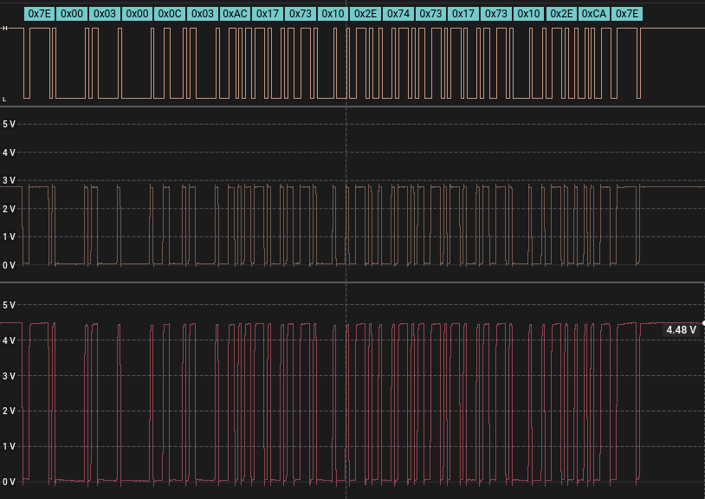
Line 2 is the analog signal as provided by the SVM40. Clearly the level is around 2.7 volt. Apparently not enough for the UNO-R4 as NO bytes were received / detected reading Serial1

I added a level shifter (BOB-12009 / Sparkfun) to increase the analog signal to a voltage of 4.48V.

Line 3 is showing that output signal. NOW IT ALL WORKS ON AN UNO-R4-WiFi

I also tried SoftwareSerial, but as expected with a baudrate of 115K it does not work.

2.2 I2C
Successfully tested on Wire for ATMEGA2560, Due, UNO-R4 WiFi/Minima

SVM40 pin ATMEGA/ Due / UNO-R4
1 VCC ------- RED ---------- 5V -------------!
2 GND ------ BLACK -------- GND |
3 SDA ------ ORANGE ------ SDA ---[####] -! 10K pull-up resistors
4 SCL ------- YELLOW ----- SCL ---[####] -!
5 Select------ BROWN-------- GND (select I2C, BEFORE applying power)
6 nc PURPLE (NOT CONNECTED)

The RED wire is on the connector-pin which is closest to the MCU or with component side up, the most left pin of connector.

During the tests I did not have pull-up resistors and never had a problem with the I2C signal failing however looking at the signals without pull-up resistors, it does not show a nice picture. Both signal show 5V dip, although when you look at the SCL (red) you see it does not get +5V and the SDA (yellow) is now sharp enough.

Adding 10K to 5V pull-up makes both signals much more stable.

Adding 10K to 3V3 pull-up shows that the signal starts with 5V but ends around 3V3. Clearly you need to expect to pull-up to 5V. In case of 3V3 board, using level converters for SDA and SCL.

Update V2.0 : the now available datasheet confirms the need for 10K pull-up resistors.

2.2.1 QWIIC on UNO-R4 WIFI
Successfully tested on QWIIC/Wire1 for UNO-R4 WiFi.

SVM40 pin UNO-R4 WIFI
1 VCC ------- RED ---------- 3.3V
2 GND ------ BLACK -------- GND
3 SDA ------ ORANGE ------ SDA
4 SCL ------- YELLOW ----- SCL
5 Select------ BLUE -------- GND (select I2C, BEFORE applying power)
6 nc PURPLE (NOT CONNECTED)

No need for pull-up resistors as they are on the UNO-R4 WIFI board

3. Sensirion Control center

As part of the Evaluation Kit SEK-SVM40 there is a USB cable. You can download the Control Center (https://www.sensirion.com/en/controlcenter/) and connect the board.

The control center supports many different sensors also the SVM40, while that is not even on the documentation list.

With the control center you can do the basic stuff on the SVM40 read the values and update the temperature offset. The values are both in adjusted and raw available. Nice to see that the sensor works.. but then that is it !

However there looks to be an interesting option : Software update.

At startup, ControlCenter checks automatically if a software update for ControlCenter or a firmware update for a connected SensorBridge device is available and offers the possibility to update. Software and Firmware updates are generally recommended since we are continuously working on improving the offered functionality and stability of the platform.

Update V2.0 : While I had little hope in the beginning whether the old firmware would be updated from 1.1, I was surprised after downloading the latest control center (December 2020), it DID update to version 2.2.

4. Software

4.1 Library calls

The library has been written from scratch, although levering code that I have written before for SVM30 and SPS30.

Please see the foreword about the missing datasheet and status at launch. In the library I have re-engineered the instruction-codes that are available. I have NOT included any code that could be used to update the firmware, as that looks to dangerous for me.

A number of the library calls do not work, probably given the firmware level on my SVM40, or a lack of the right documentation. The following overview provides the library calls are currently available and whether they work :

Library call | I2C | Serial | Remark
EnableDebugging | Yes | Yes
GetTemperatureOffset | Yes | Yes | Needs FW 2.0
GetValues | Yes | Yes
GetVersion | Yes | Yes
GetVocState | Yes | Yes | Needs FW 2.x
GetVocTuningParameters | Yes | Yes | Needs FW 2.x
GetSerialNumber | Yes* | Yes | *See 4.2 !!!
GetProductName | No | Yes
GetProductType | No | Yes
GetSystemUpTime | No* | Yes | * no OpCode defined
reset | Yes | Yes
start | Yes | Yes
stop | Yes | Yes
probe | Yes | Yes
begin | Yes | Yes
SetTempCelsius | Yes | Yes
SetTemperatureOffset | Yes | Yes | Needs FW 2.x
SetVocState | Yes | Yes | Needs FW 2.x
SetVocTuningParameters | Yes | Yes | Needs FW 2.x
StoreNvData | Yes | Yes | Needs FW 2.x

4.2 I2C communication

The I2C / Wire receive buffer on many boards is set a maximum value of 32. After that the boards will stop with receiving.

When reading the serial number 39 bytes (including CRC check bytes) are needed to create a (max) 24 byte Serial number. Reading will fail and you need to increase the buffer (if memory size allows) for your board in Wire.h. This is NOT part of this library, but part of your IDE.

ATMEGA (UNO or 2560 or Due .. maybe others)
I had to increase BOTH otherwise the connection would fail:
Wire/src/wire.h #define BUFFER_LENGTH 64 // was 32
Wire/src/utility/twi.h #define TWI_BUFFER_LENGTH 64 // was 32

esp8266
Wire/src/wire.h #define BUFFER_LENGTH 64 // was 32

esp32
The buffer is already 128
Wire/src/wire.h #define I2C_BUFFER_LENGTH 128

MKRZERO / SAMD / Apollo3
The SAMD library has a different definition as it has a ‘sercom’ setup for all communication.
In wire.h for the a SAMD the RX buffer is defined as : RingBufferN<256> rxBuffer;
The library will handle that and set to 256.

4.3 examples overview

example 1
Provides basic reading over serial of the VOC-index, humidity and temperature from the sensors. The library adds calculated dew-point, absolute humidity and heat-index.

example 2
Provides basic reading over serial of the VOC-index, humidity and temperature from the sensors. It also shows the raw VOC-ticks, raw-humidity and raw-temperature. It also shows the amount of seconds the sensor is up and running since last reset or power-up.

example 3
How to get the current VOC algorithm state and set the VOC algorithm state over serial.
One could potentially, after long running ( < 3 hours) save the current VOC algorithm state before doing a reset or power-down. E.g. for a short maintenance. You could than restore that algorithm after maintenance. The advice is not to restore if that power-down takes longer than 10 minutes.
On UART the call will fail when 3 hours have not passed.
The code of this example should be included in other code ( e.g. example1 or example2) . Running this code separate would not help as algorithm is reset after powerdown or sending reset.

example 4
Provides a sketch to read and write the temperature offset over serial.
Depending on the environmental setup, the SHT40 provided temperature might be to high or too low compared to the real temperature. This sketch enables reading the offset, writing the offset in RAM and/or store the offset in non-volatile RAM so it is preserved and used after a power-down or reset.
The value can be positive, increase the temperature and decrease the humidity results, or negative to achieve the opposite. The raw-temperature and raw-humidity (without offset impact) can be seen with example2.

example 5
Provides a sketch to read and write the algorithm parameter over serial.
There are a number of parameters that impact how the VOC-index is calculated, With this sketch you can read and write the parameters. You can also select to store the parameters in non-volatile RAM so it is preserved and used after a power-down or reset.

example 6
Provides plotter output of Voc-index, VOC-raw ticks, humidity and temperature over serial.
After compile and upload press control + shift + L

example11
Is the same as example1, but then using I2C communication.
Provides basic reading of the VOC-index, humidity and temperature from the sensors. The library adds calculated dew-point, absolute humidity and heat-index.

example12
Is the same as example2, but then using I2C communication.
Provides basic reading of the VOC-index, humidity and temperature from the sensors. It also shows the raw VOC-ticks, raw-humidity and raw-temperature. Showing the amount of seconds up-time does not work in this version yet and will always return 0. The instruction code for the SVM40 on I2C is not known/published yet.

example13
Is the same as example3, but then using I2C communication.
How to get the current VOC algorithm state and set the VOC algorithm state.
One could potentially, after long running ( < 3 hours) save the current VOC algorithm state before doing a reset or power-down. E.g. for a short maintenance. You could that restore that algorithm after maintenance. The advice is not to restore if that power-down takes longer than 10 minutes.
On I2C It will return all zeros is not run for a longer time.
The code of this example (if it works) should be included in other code ( e.g. example11 or example12) . Running this code separate would not help as algorithm is reset after power down/reset.

example14
Is the same as example4, but then using I2C communication.
Provides a sketch to read and write the temperature offset.
Depending on the environmental setup, the SHT40 provided temperature might be to high or too low compared to the real temperature. This sketch enables reading the offset, writing the offset in RAM and/or store the offset in non-volatile RAM so it is preserved and used after a power-down or reset.
The value can be positive, increase the temperature and decrease the humidity results, or negative to achieve the opposite. The raw-temperature and raw-humidity (without offset impact) can be seen with example12.

example15
Is the same as example5, but then using I2C communication.
Provides a sketch to read and write the algorithm parameter..
There are a number of parameters that impact how the VOC-index is calculated, With this sketch you can read and write the parameters. You can also select to store the parameters in non-volatile RAM so it is preserved and used after a power-down or reset.

example16
Is the same as example5, but then using I2C communication.
Provides plotter output of Voc-index, VOC-raw ticks, humidity and temperature over serial.
After compile and upload press control + shift + L

5. VOC-index

5.1 What is it ?

Source SGP40 datasheet (July 2020):
For best performance in indoor-air-quality use cases, Sensirion recommends processing the (humidity-compensated) raw signal SRAW through Sensirion’s powerful VOC Algorithm.

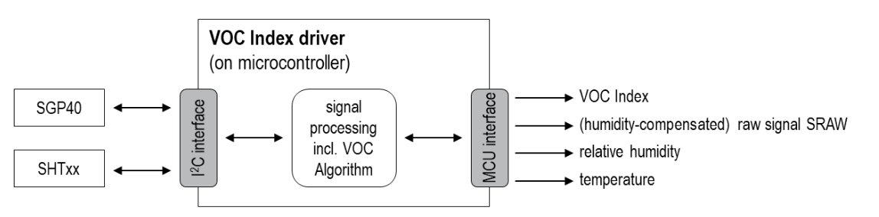

The VOC Algorithm automatically adapts its output to any indoor environment and maps all VOC events to a VOC Index scale ranging from 0 to 500 VOC Index points (Figure 8).

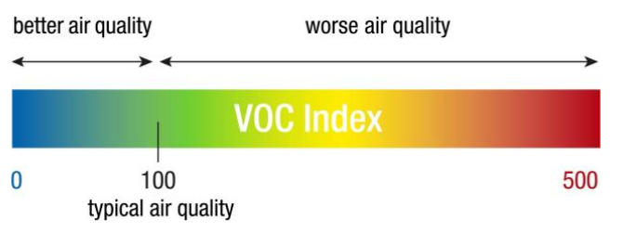

The value 100 refers to the typical indoor gas composition over the past 24 h. While values between 100 and 500 indicate a deterioration, values between 0 and 100 inform about improvement of the air quality.

The VOC Algorithm is included in the VOC Index driver package available on Sensirion’s webpage (see footnote 1 on page 3). SGP40 raw signal needs to be provided to the VOC Algorithm at a sampling rate of 1 Hz.

5.2 Indoor Air Quality (IAQ) ?
This is defined in many ways.

Source : https://en.wikipedia.org/wiki/Indoor_air_quality

IAQ is known to affect the health, comfort and well-being of building occupants. IAQ can be affected by gases (including carbon monoxide, radon, volatile organic compounds), particulates, microbial contaminants (mold, bacteria), or any mass or energy stressor that can induce adverse health conditions

source : https://pdfs.semanticscholar.org/f95c/6199b6759cc4b50f8159cae52c04ffc7e20e.pdf

The quality of the air inside a building is affected by a variety of comfort, physical, chemical and biological factors. Factors influencing the indoor air quality of a room or building include:
• Comfort issues (temperature, humidity)
• Supply of fresh air to the building,
• Accumulation of particulate, biological or chemical contaminants originating from within or outside the building.

That said, we could fill many pages with definitions but THERE IS NO SINGLE MEASUREMENT / CALCULATION OF A STANDARD.

5.3 Another airQualityindex
So actually this is another propriety airquality-index that is adding to the long list of air-quality indexes. In the extras folder the Sensirion VOC Algorithm is included. I remember the BME680 was also having BOSCH IAQ, which calculation came pre-compiled. Now Sensirion is providing the source of their algorithm.. but it is close to impossible to understand what is happening and why this 100 points index is good or better.

With an SVM30, based on the sensor signals, a total VOC signal (TVOC) and a CO² equivalent signal (CO² eq) are calculated, the SVM40 is now providing anything like that. So it will be difficult to compare what is really happening and whether the sensor is better than others. It would have a been a good idea to provide BOTH the new VOC-index points as well as the “old” TVOC and CO² values. Before you know you are locked in new index (Sensirion) , build your solution around it and then hope it does not change in the future.

6. Sample output

6.1 Charts
Test conditions
3 seconds between sample time, about 300 samples. The Voc-ticks are plotted against the left Y-ax, where VOC-index, humidity and temperature are against the left Y-ax. SVM40 on my desk, open noon-controlled environment. Used example 6 data output, although I did not divide the raw-ticks by 1000 to fit the plotter area.

It takes about 1 minute before you see VOC-index appear and then end around the 100 points line.
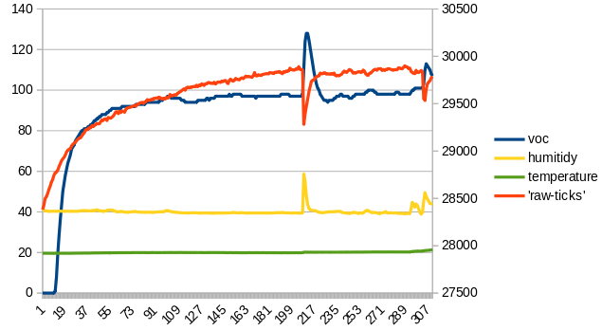
Around sample 217 I have blown to the SVM40. It reacts immediately with both the ticks and humidity.

As the ticks go down the VOC-index goes up and gradually goes down again. The VOC-index is following VOC-ticks nealy one-on-one opposite, with some undershoot as it normalizes again. However what is the impact of humidity ?

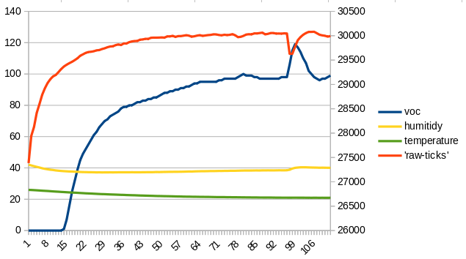
So have tried to block the SHT40 with a small plastic bag around it and taped that off.

The reaction on blowing to the SVM40 is not as sharp, I expect that is because there is hardly reaction on the humidity

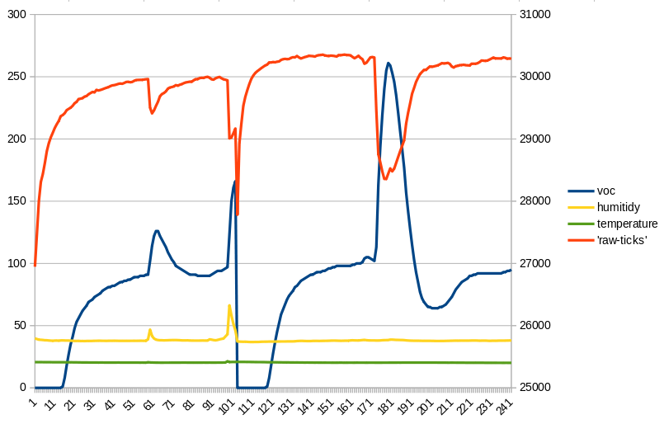
Here another example of blowing harder to the SVM40 around sample 100. Apperently the decline in ticks is to much for the algorithm to handle and the VOC-index goes back to zero to restart.

Around sample 181 I had opened a package of W5 cleaning tissue from Lidl, which contains a lot of alcohol. The humidity does not change, but the ticks drop hard and quickly and again the VOC-index increases from 100 to 255. But even more interested is to see the undershoot to 64 before slowly returning to 100.

The sensor reacts very fast.

6.2 example 1

SVM40-Example1: Basic reading. press <enter> to start
Trying to connect.
Detected SVM40.
Serial number : 0FDBEAAA000002373FA53220
Product name : SVM40
Product Type : 00140000
Firmware level: 2.2 debug disabled
Hardware level: 2.0
SHDLC protocol: 1.0
Library level : 2.0
Measurement started

Hit <enter> to continue reading.

Voc_index Humidity Temperature Heat_index Dew_Point Absolute_humidity
Points RH% *C *C *C g/m3
0 38.25 19.87 18.91 5.22 6.56
0 38.20 19.86 18.90 5.19 6.55
0 38.20 19.88 18.92 5.21 6.55
0 38.24 19.89 18.93 5.23 6.56
0 38.23 19.89 18.93 5.23 6.56
0 38.21 19.89 18.93 5.22 6.56
0 38.23 19.90 18.94 5.24 6.57
0 38.17 19.91 18.95 5.23 6.56
0 38.16 19.92 18.97 5.24 6.56
0 38.14 19.92 18.97 5.23 6.56
0 38.16 19.94 18.99 5.25 6.57
0 38.15 19.96 19.01 5.27 6.58
0 38.17 19.94 18.99 5.26 6.57
1 38.21 19.94 18.99 5.27 6.58
9 38.24 19.94 18.99 5.28 6.58
20 38.26 19.96 19.01 5.30 6.60
31 38.25 19.96 19.01 5.30 6.59
41 38.25 19.98 19.03 5.32 6.60
49 38.34 19.97 19.03 5.35 6.61
57 38.39 19.97 19.03 5.37 6.62
65 38.38 19.97 19.03 5.36 6.62
71 38.42 20.00 19.05 5.40 6.64
76 38.36 20.01 19.07 5.39 6.63
80 38.35 20.02 19.08 5.40 6.64
83 38.18 20.00 19.05 5.31 6.60
85 38.08 20.01 19.07 5.29 6.59
87 38.08 19.98 19.03 5.26 6.57

6.3 example 2

SVM40-Example2: Basic + raw reading serial. press <enter> to start
Trying to connect.
Detected SVM40.
Serial number : 0FDBEAAA000002373FA53220
Product name : SVM40
Product Type : 00140000
Firmware level: 2.2 debug disabled
Hardware level: 2.0
SHDLC protocol: 1.0
Library level : 2.0
Measurement started

Hit <enter> to continue reading.
Voc_index Humidity Temperature Raw-voc Raw-humidity Raw-temperature System uptime
Points RH% *C ticks RH% *C Sec
0 38.28 20.12 30269 38.28 20.12 7
0 38.28 20.10 30264 38.28 20.10 11
0 38.19 20.13 30274 38.19 20.13 14
0 38.08 20.08 30281 38.08 20.08 17
0 38.17 20.12 30286 38.17 20.12 20
0 38.19 20.13 30270 38.19 20.13 24
0 38.26 20.14 30277 38.26 20.14 27
0 38.07 20.12 30277 38.07 20.12 30
0 37.92 20.12 30312 37.92 20.12 33
0 37.88 20.10 30321 37.88 20.10 36
0 37.88 20.10 30303 37.88 20.10 40
0 37.91 20.10 30333 37.91 20.10 43
0 37.88 20.11 30325 37.88 20.11 46
0 37.88 20.09 30321 37.88 20.09 49
5 37.82 20.09 30355 37.82 20.09 53
15 37.80 20.10 30350 37.80 20.10 56
26 37.81 20.10 30334 37.81 20.10 59
39 37.82 20.10 30321 37.82 20.10 62
47 37.87 20.09 30334 37.87 20.09 66
54 37.86 20.09 30338 37.86 20.09 69
60 37.83 20.11 30347 37.83 20.11 72
67 37.86 20.10 30342 37.86 20.10 75
72 37.84 20.09 30336 37.84 20.09 79
75 37.92 20.08 30349 37.92 20.08 82
78 38.00 20.09 30347 38.00 20.09 85
82 37.97 20.08 30336 37.97 20.08 88
85 37.91 20.06 30305 37.91 20.06 92
87 37.90 20.07 30327 37.90 20.07 95
89 37.95 20.05 30335 37.95 20.05 98
91 37.91 20.10 30321 37.91 20.10 101

