Wheel of Fortune

Background
In preparation to a party, I created a “wheel of fortune” (WOF) with 4 lights, which light up in a random manner, start and stopped with push-buttons and controlled by a Raspberry Pi-2. This can easily be extended to the amount of lights needed.

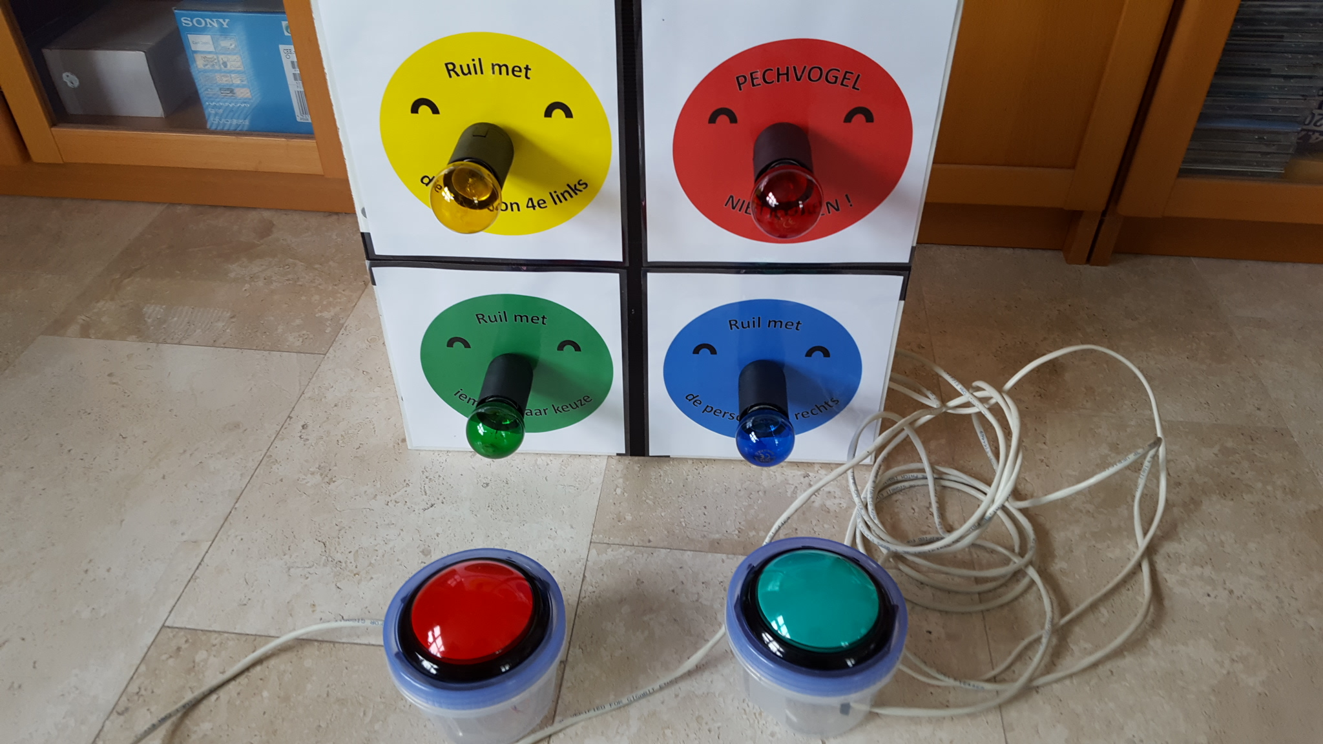
Paul van Haastrecht ( paulvha@hotmail.com)
April 2017

Table of Contents
Background 1
Hardware 2
Push-buttons 2
4-relays module 2
Program user guide 4
Using the program 4
Command line options 4
Automatic start at power-on 5
Software 6
Installation 6
Wof.c high-level 7
Supporting functions/ remarks 7
Appendix A. : Schema Push-button/ sound 9
Appendix B. : 4 relays module schema 10
Appendix C : Output connections to lights 12

Hardware

Push-buttons
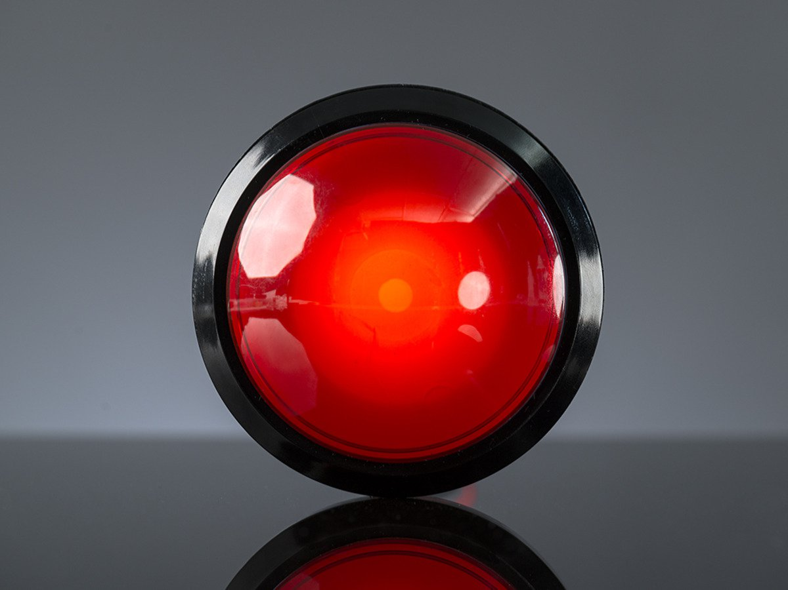
The “wheel of fortune”( WOF) is controlled with 2 ARCADE-style push buttons which are 10 cm in diameter.

They were relatively cheap ( ~ 8 euro) and you get them with different kind of switches. I have placed them in plastic box with a long wire. They have a led that will light if the button has a function in the program, but it is not very bright. The functions will be explained later with the software.

The program can generate a horn-sounds and clicking sound on different moments. For that I used a standard PC-speaker set BUT NOT to the standard audio output from the Raspberry Pi. As the different sounds are generated using the Pulse Width Modulation (PWM) capabilities of the Raspberry, it needs to be connected to GPIO12. (PWM0)

The buttons were connected to the Raspberry using a 5-din plug and the sound to a normal audio connector and a schema of the connection can be found in Appendix A.

4-relays module
The lights are controlled by a 4-relays module (picture below). The schema of the board has been included in appendix B. The GPIO from the Raspberry Pi, are connected to the board input and are driving a led and an opto coupler, which in turn drives a transistor to activate a relays to switch 220V to the light. As such this is a very save way to connect and switch power. There is a jumper on the board that connects the VCC with the JD-VCC. As the Raspberry Pi is normally using 3.3V, the VCC was connected to GPIO-1 on the Raspberry Pi, driving the opto-coupler. I have removed the jumper and connected the JD-VCC to the 5V (GPIO-2), to make sure the relays got the right voltage (although they should work on 3.3V as well)
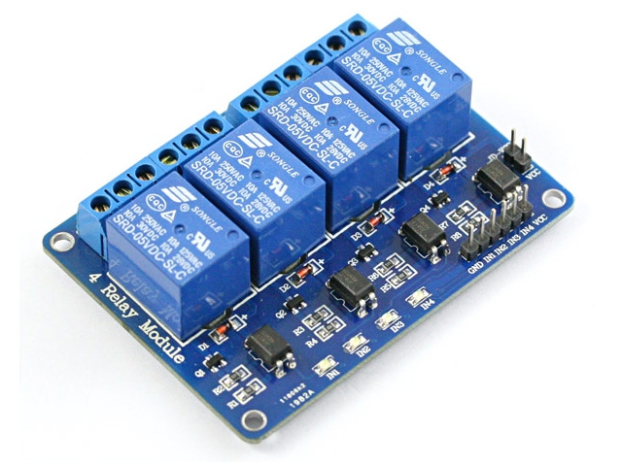

Appendix C contains a drawing of the connection between Raspberry Pi and 4 relays module and the lights.

For the lights have have created a small board from wood where I mounted the lamp sockets. The lamps themselves are colored. A picture is below.
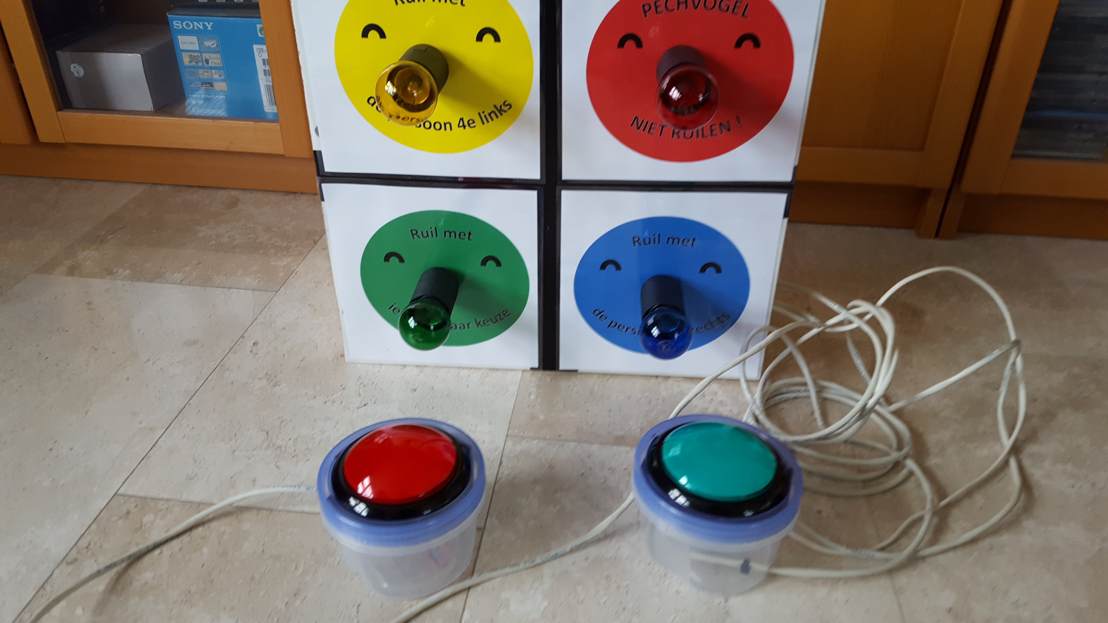

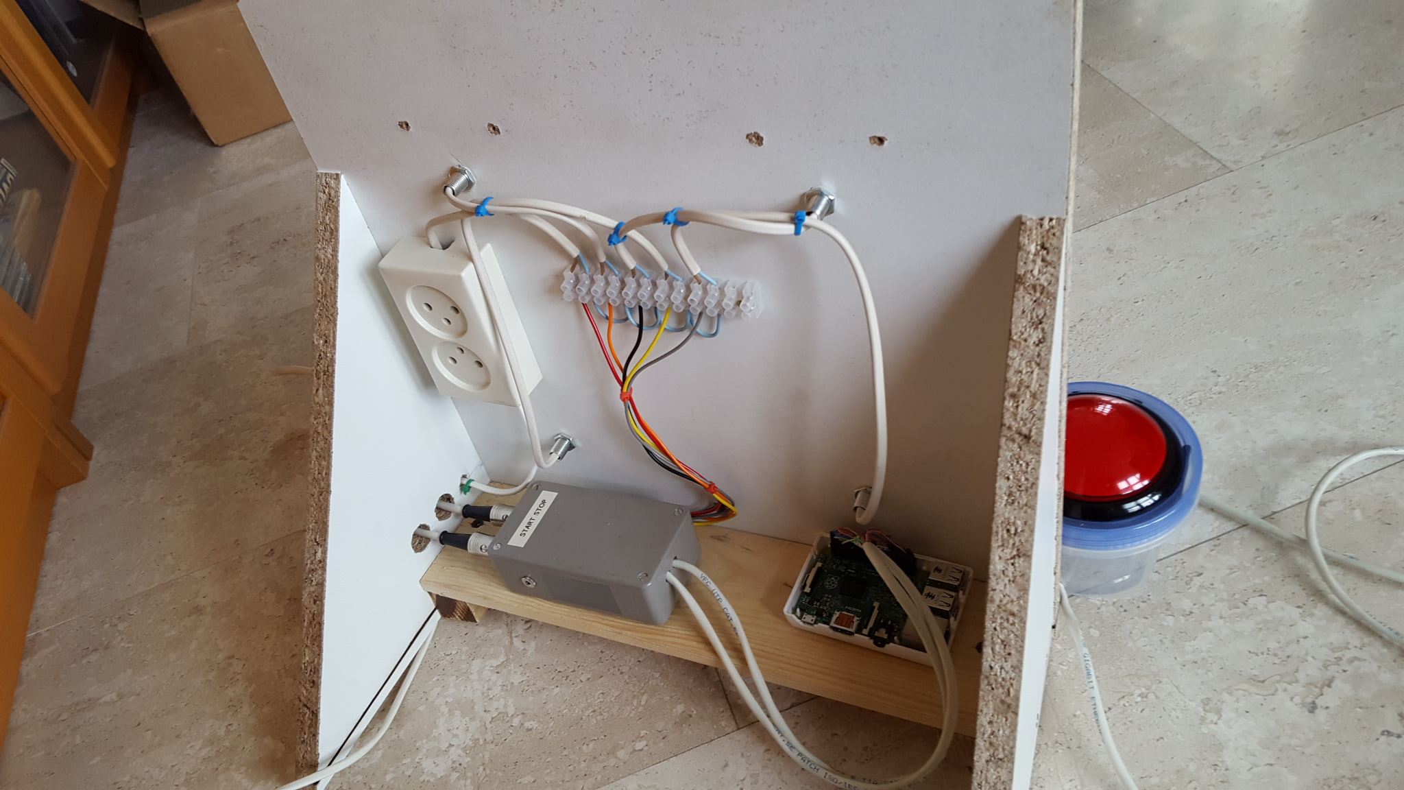

Program user guide
Make sure to make the right connection for the input and output, using the information from the Appendix A and C have been done before starting the program. If you decide to use different GPIO for input/output the software session will explain how to modify that.

Using the program
The program is controlled by 2 push-buttons START (green in my case) and STOP (red in my case) The START is owned by the game-leader, the STOP is used by a member to start and stop the wheel.

When the program is started a light will blink 2sec on and off . This is the indication that program is waiting for you. The led in the START-button is flashing along.
- Pressing START will turn all 4 lights on, indicating “we are ready to go”.
- It is time to start the “wheel”, by either pressing START or STOP button (both will have the led on). When either is pressed a horn-sound can be heard, the lights will random light up, with a speed of about 0.5 seconds. There is also a clicking sound happening.
- If the START is now pushed, this speed is changed to a faster. If START is pressed again it will go slower, pressing again it will go a little faster. This way it can circle around 3 speeds.
- When STOP is pushed, you will hear another horn-sound, the clicking will be slower and the light will continue to move a slow speed for a random amount of times, until it stops. You will hear another horn-sound.
- This light will now continue to blink 2sec on and off, indicating this is the light of choice. The led in the START-button is flashing along.
- The light will continue to blink until you press START and the program repeats from step 1 mentioned above.

The program can be terminate with a keyboard action (e.g. contrl-C or kill command). It will reset the hardware to the original state. The program can be terminated AND the system shutdown with the push-button shutdown: make sure that the program is in step 5 and has a light blinking with a speed of about 2 seconds. Press and HOLD DOWN the STOP push-button (the light will now blink at speed of ~ 0.5 second). While holding down STOP, press on START. A next light will now blink. Keep holding STOP and repeat pressing START for 5 times and every time watch the next light coming on. All 4 lights will now switch on and 1-by-1 switch off. A final horn-sound will happen and the system will be shutdown. This is very handy when started automatically (see below) and have a controlled way of shutdown the system.

Command line options

The program has a number of command-line options

-d, Disable shutdown after STOP & START buttons pressed together for 5 times. See the description just above about the push-button shutdown.

-g, Overrule the default time that a light is on while the “wheel” is turning in step 2 above.

-i, Invert lights. In other words, there will be 3 lights on and one light off in step 2 above.

-l, Disable leds at buttons. In case you do not (want to )make use of a push button with a led.

-r, Light selection is not random, but sequential, e.g. 1, 2, 3, 4 ,1, 2 ,3 ,4 etc.

-s, Disable horn and clicking sound during step 2 and 4 above

-L, Write progress messages to a logfile about the selections done and pushbutton pressed.

-D, enable some of the debug messages on screen.

-h will show the help text

Automatic start at power-on

The program can be started manually, but also automatically at start-up of the Raspberry Pi with wof_start shell script. As such you do NOT need a keyboard and screen to use the program, just plug in the power and the program will start. You can switch of the Raspberry Pi off with the push-button shutdown procedure explained earlier.

To use wof_start for auto start after reboot.

sudo bash # make your self Super user
cp wof_start /etc/init.d
chmod +x /etc/init.d/wof.start
update-rc.d wof_start defaults

wof_start expects that the wof program is located as : /home/pi/wof/wof. If needed this can be changed in wof_start (as with any shell script). Make sure to do an update-rc.d after edit.

Software

As with many projects I make use of the great BMC2835-Library. This allows to be working directly on I/O of the Raspberry PI hardware (BCM2835/BCM2837), instead of working through the kernel drivers. It is fast and brings the flexibility & insight that I am looking for.

The program is written in C and the following modules make it to one executable:

wof.c main user menu program
wof_start shell script for automatic start

The software was created and run on Jessie version of Linux for the Raspberry Pi, but should work on other versions as well.

Installation

Make your self superuser : sudo bash
BCM2835 library
Install latest from BCM2835 from : http://www.airspayce.com/mikem/bcm2835/
- cd /home/pi
- wget http://www.airspayce.com/mikem/bcm2835/bcm2835-1.50.tar.gz
- tar -zxf bcm2835-1.50.tar.gz // 1.50 was version number at the time of writing
- cd bcm2835-1.50
- ./configure
- sudo make check
- sudo make install

“wheel of fortune”

mkdir wof # assumed is /home/pi/wof
cp wof.c wof_start wof
cd wof
cc -o wof wof.c -lbcm2835

sudo ./wof # this MUST be run as root given we use PWM capabilities

Wof.c high-level

At the top of the program are the definitions for the GPIO’s to use for input and output, as well as the values for the horn pulse width modulation (PWM). In case you want to use another GPIO, here is the place to make the change and it will be used in the program.

The program is written for 4 lights and can easily be extended for more as explained in the heading of wof.c

As always it starts in main() to analyze any command-line instructions, and then call do-init() for hardware initializations which will call pwm_set_mode() to enable sound (if not disabled with option -s). set_signals() is called to enable catching kill or control-C signals and reset the hardware to the starting state with close_out(). Now the main_loop() is called to do the real work.

main_loop() will do initializations including for the usage counters (this will be used in the get_random_light() later on). It will then call wait_for_start() with the light of selection. This is actually the step 5 (and zero) in the”usage of the program” earlier in the document.
wait_for_start() will loop to read the push-buttons and wait for START or BOTH-PRESSED. If START detected, it will start another loop and wait for EITHER START or STOP. The program is now starting step 2 in the”usage of the program” earlier in the document.
Now back in the main_loop() it will call get _light(). This will either return a sequential number (if option -r was provided on the command-line) or call get_random_light() to get a random light number. The function glow_light() is then called with the selected light number to switch the light on for an amount of time while checking if a button was pressed and return the value is so. If no button was pressed it will loop back to get_light() and repeat previous steps. If START was pressed during glow_light() the main_loop() will now handle step 3 in the”usage of the program” earlier in the document: changing the speed of the lights on. If STOP was pressed during glow_light() the main_loop() will handle step 4 in the”usage of the program” earlier in the document: let the “wheel” slowly come to a stop. The main-loop() will now restart.

Supporting functions/ remarks
read_switch()
At first I had implemented to use the detect-high and detect-low registers of the BCM2835/2837. That all worked well until I connected the lamps. Switching the relays without a lamp connected caused NO problem, but apparently the switching ON and OFF of a lamp created spikes that caused uncontrolled behavior. I have tried to use capacitors to handle that, but it was not stable enough. As such the read_switch() is looking at the value of the input on THAT moment, instead of detecting it had changed it’s level before. It also mend that in the calling routines I had to create loops to make a regular check, hence you will see a lot of usleep to loop for wait. This routine will also detect and handle the push-button shutdown feature (unless disabled with -d)

get_random_light()
Randomness does not really exist in computer world. No matter how hard you try, it is an art to really get random numbers. (ask the guys in Las Vegas :-)). I have applied some tricks to improve it. Of course I initialize with a large number (the current time) srand(). The more this number changes to more random, and then used the NUMBER of lights to make a selection out of a larger numbers.
But still I found that to often the same light was chosen and some light were NOT chosen. Hence it will now remember the last light that was used. If that the same as the current outcome from rand(), it will look for the light that was the LEAST used (not being the current selected) so far and chooses that light. The usage_cnt is keeping track of the light usage so far and hence this needs to be reset every time in main_loop() at the beginning. I had this run for a large amount of samples and it turned out to spread was nearly evenly across the lights.

set_horn(), set_sound()
For the different sounds Pulse-Width_Modulation (PWM) is being used. By setting the divider and range in the BCM2835/2837 and selecting the GPIO-pin for PWM output, the sound is produced without the need to wait in the program for the (clicking) sound to be finished. It is starting and stopped by the program, by run the hardware. It enabled flexibility for different tones.

Appendix A. : Schema Push-button/ sound

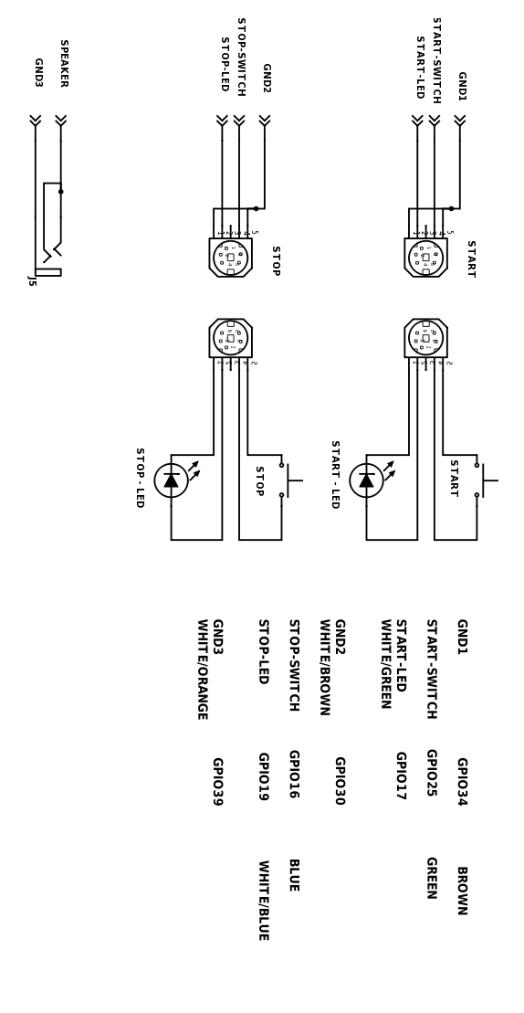

Appendix B. : 4 relays module schema

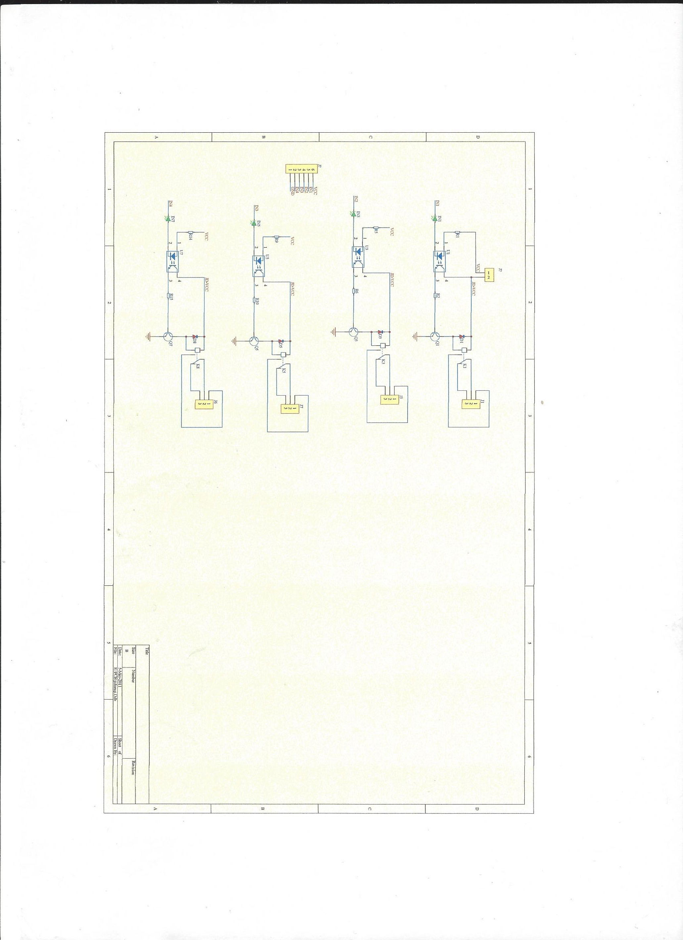

Appendix C : Output connections to lights


