Project 2

Plan for Paul Vonder Haar, working alone

Data Set: Military spending of countries (1960-2019)

<https://www.kaggle.com/nitinsss/military-expenditure-of-countries-19602019>

git link: https://github.com/paulvonderhaar/Historical-Military-Spending

I’m rather interested in the subject of total military expenditure of the world in the post world war 2 era. This data has many obvious interesting trends and uses that an interactive display would help with immensely. One could measure military spending over the course of time for an individual nation or region. Making a line graph, in which one could compare military spending between countries over time could be interesting. I could also make a pie chart, which allows you to click individual nations and add them to a pie chart. So for example, you could click America and Russia and for a particular year see the breakdown of what they spent on the military, and see what percentage of worldwide military spending they accounted for.

With this information at a glance, one could very easily grab a treasure trove of historical information in a nice and digestible way.

Inspiration Graphs:

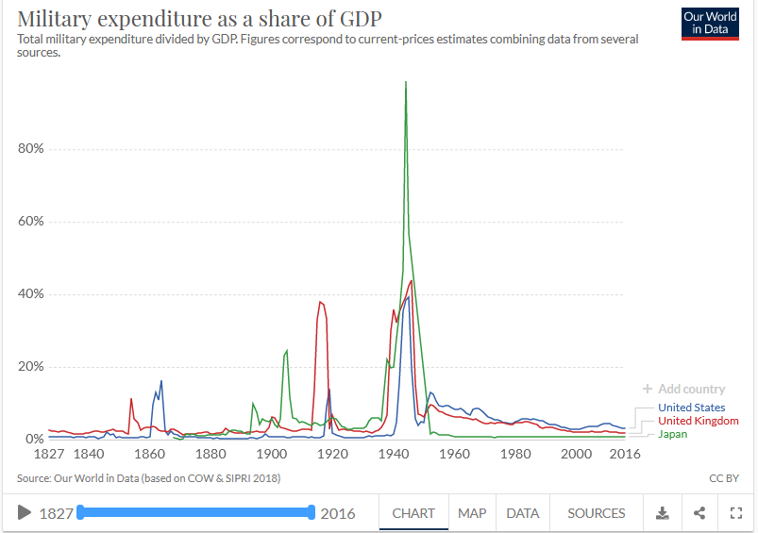

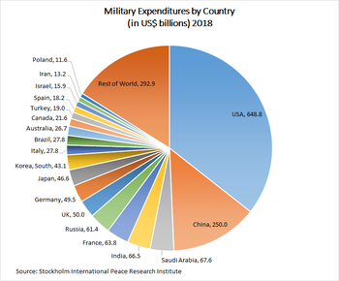

Page designs

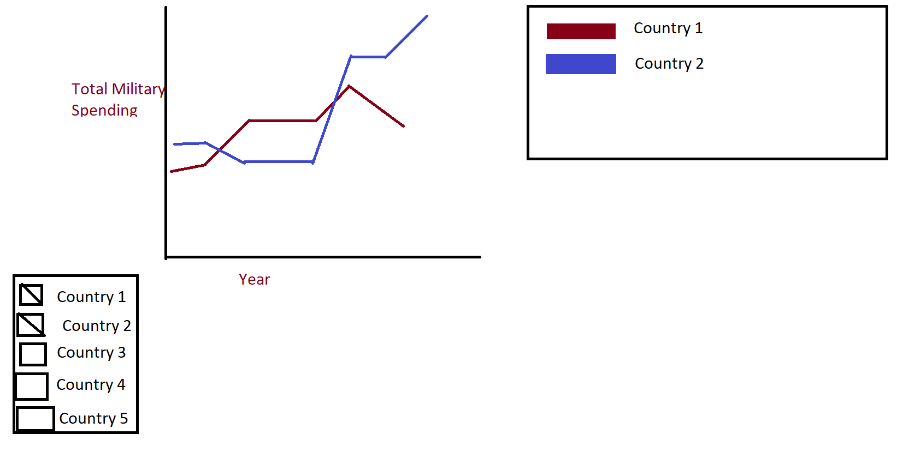

This graph would allow people to select out of a list of all countries and see a visualization of how much that nation spent on the military on any given year. It will also allow you to pick multiple nations from that list to create an obvious and powerful comparison tool.

Design 2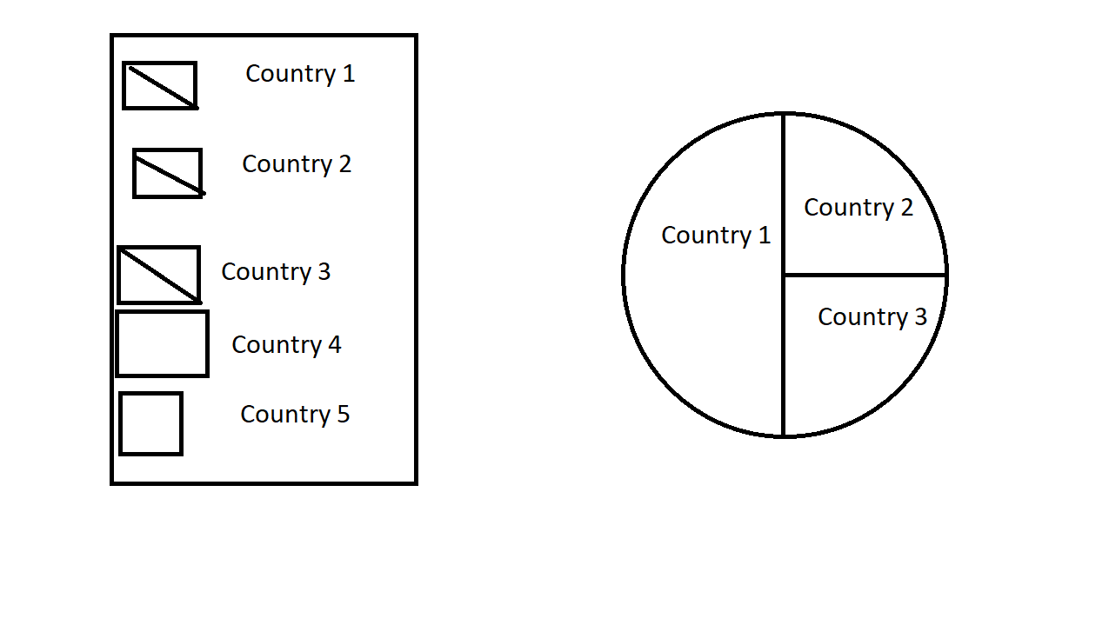

One will be able to pick out countries to add or remove them from the pie graph as they desire. This can be used to tell at a glance how much allied nations on either side of a conflict spent, or the overall spending of various blocs, nato vs warsaw pact for example.