Dream Memo Manual
Revision 1.1
Copyright © 1997-1999 Dream Company

Introduction 1
Getting Started 2
Components architecture 3
Memo and MemoSource 3
Syntax Parsing 4
Using Dream Memo 4
Connecting Memo and MemoSource 4
Loading and saving text 4
Search and Replace routines 5
Bookmarks 8
Keyboard mappings 9
Code Templates 9
Clipboard and Blocks 10
Clipboard history 11
Making Screenshots 11
Printing 12
Memo Background 13
Global Options 14
Gutter and margin 14
Left Indent 15
Gutter Images 15
Selections 16
Memo Options 16
Memo and Databases 16
Edit Unit 17
Parsers 18
Parsers Overview 18
Using OnGetColorData event 19
Creating Custom Parsers 19
Implementing Parsing Methods 21

Introduction

Dream Memo is a set of advanced components that allows you to create professional applications that use Memo control. In comparison with standard Delphi Memo many new powerful features are supported: syntax highlighting, printing, unlimited text size, line numbering, bookmarks, multilevel undo/redo operations, margin and gutter, etc. All components in Dream Memo pack are highly integrated with each other. They can be used independently, but their combined use gives really exciting possibilities. Moreover Dream Memo includes over a hundred different procedures for text handling!

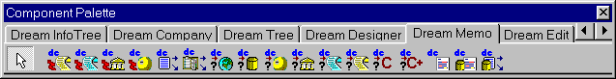

After you have installed Dream Controls you will find Dream Memo tab on your component palette. Now you can use a lot of new controls when developing your applications. Among them are: DCMemo, MemoSource, DCDBMemo, Parsers and Code Designers for different programming languages (including Delphi, C++, Java, VBScript, HTML, SQL, Perl, etc.). Using these controls together gives a powerful quick method for creating programs that require text processing.

Getting Started

So, let’s make the first application with Dream Memo. The base control, that we will use, is TDCMemo. Therefore we will begin with placing TDCMemo on the form. At the first look the control, which appears, is similar to the standard memo control. Yes, you do not need to learn again how, for example, to add text to the new memo or to operate with it. Additionally Dream Memo has a lot of extra powerful methods and properties that will be described in this document.

Okay, now we are ready to take a look at the advantages of Dream Memo controls. Open Object Inspector for the TDCMemo that you have just put on your form. You’ll find Options property there. You can simply change the values of the fields (at design or at run-time) to enable or disable some features. Among them are moColorSyntax (syntax highlighting), moDrawGutter (assign true to it to enable the gutter), moLineNumbers (displays line numbers at the beginning of each line) and others. Didn’t you spend a lot of time, dreaming about such useful features? Probably you did… and now these great possibilities are ready for use!

Dream Memo can operate with large texts – there are no limits for the size of text, displayed in TDCMemo (as you remember standard TMemo can not work with texts larger than 32K). Now you can forget about that headache. To help users with navigation you can specify and manage bookmarks.

Dream Memo control supports several standard keyboard mappings – Default, Standard, Brief and Epsilon that store different hot key schemes. If you want to change the currently used keyboard mapping, modify the KeyMapping property. You can also define custom keyboard mappings.

Undo and Redo operations are the narrow places of standard memo controls. Dream Memo breaks these limits. In Dream Memo Undo operations have unlimited depth! It means that you can undo as many operations as you need. Moreover, two kinds of undo are supported – applied to a single operation and applied to a group of the same operations (for example, two continious delete operations are considered as a single one).

Do you need a gutter? Select moDrawGutter in Options property of the memo and enjoy the gutter. You can put small images on it to indicate a bookmark or, for example, a breakpoint. To specify images that will be displayed on the gutter use GutterImgs property.

Standard memo can not display text with different text styles. Dream Memo can. Moreover, the styles used to display text can be easily customized (TextStyles property).

We can continue talking about the advantages of Dream Memo for a long time. May be it is enough for now in particular if you are waiting impatiently for more detailed information. So, let’s dive together into the ocean of powerful features of Dream Memo.

Components architecture

Memo and MemoSource

The main new concept that is used in Dream Memo is MemoSource. To understand better what MemoSource is, think about standard Delphi component – TDataSource. MemoSource is an object that stores data that is displayed in the memo. Like TDBGrid can be connected to TDataSource, TDCMemo can be connected to TMemoSource. As against to standard Delphi Memo, which stores the text inside itself, TDCMemo only displays the text that is stored in the TMemoSource. Besides that, TMemoSource has many different methods and properties for the text handling, shown in TDCMemo control. But it does not mean that TDCMemo can not be used without a MemoSource. If no MemoSource is specified for a TDCMemo then it uses an internal one.

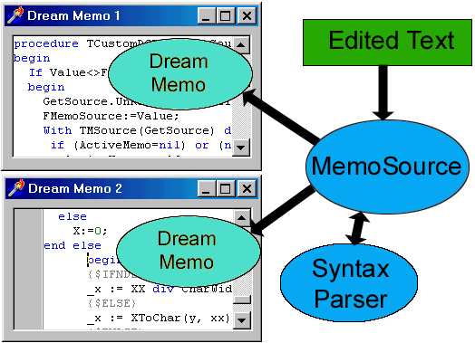

One of the advantages of such architecture is that one text can be edited in several memos simultaneously. Moreover, if the text is modified in one memo it will be automatically updated in all other TDCMemo controls, connected to the same MemoSource. That gives you a possibility to implement controls with split windows quickly and easily.

Note that you have to use TDCMemo.GetSource method to determine the MemoSource to which the memo is connected. The common error is trying to get the MemoSource from the MemoSource property of the TDCMemo control. This is the wrong way, because if no MemoSource is specified in the MemoSource property, then memo uses an internal MemoSource. So here is an example how to access the MemoSource correctly:

DCMemo1.GetSource.ReadOnly := True;

Syntax Parsing

Parsers are the components that provide syntax parsing of the text. Delphi, C/C++, Java, Visual Basic, HTML, SQL and Perl parsers are included in the Dream Memo controls pack. TDCMemo uses parsers for syntax highlighting (SyntaxParser property).

Memos work with Parsers through the MemoSources. Therefore, several Memos connected to the same MemoSource always use the same syntax parser. But, TDCMemo can use parsers even without a MemoSource – in this case an internal one is used.

Using Dream Memo

Connecting Memo and MemoSource

Now, put a TMemoSource component and several TDCMemo controls on your form. Select a memo, find MemoSource property in Object Inspector and specify a MemoSource there. That’s all you have to do to connect TDCMemo control with TMemoSource. In such way you can connect as many memos as you need to a single MemoSource, and the same text will be displayed in several memos.

Loading and saving text

This part has to be easy for you if you worked with standard TMemo control before. But there are several important questions that must be discussed, so that you will clearly understand not only how to load text to a memo, but also see different ways to do that.

Select a TDCMemo control and find Lines property in the Object Inspector. This property contains a TStrings object that represents the text that is displayed in the TDCMemo control. You can modify this property both at design and at run time. At design time you can use a handy editor to type or modify the text for memo. At run time you may call the following methods:

- DCMemo1.Lines.LoadFromFile to load text from the file;
- DCMemo1.Lines.LoadFromStream to load text from the stream.

Besides that you can these methods directly from TDCMemo:

- DCMemo1.LoadFromFile to load text from the file;
- DCMemo1.LoadFromStream to load text from the stream.

You can use the similar methods from TMemoSource:

- DCMemo1.GetSource.LoadFromFile to load text from the file;
- DCMemo1.GetSource.LoadFromStream to load text from the stream;
- DCMemo1.GetSource.LoadFromStrings to load text from the TStrings object.

If several memos are connected to the same MemoSource then text loaded to one of the memos will be also loaded to all other memos connected to this MemoSource, because it is stored in the MemoSource.

Please notice, that the fastest way to load the text to a memo is to use the memosource’s loading methods (e.g. DCMemo1.GetSource.LoadFromFile).

For example, to load ‘sample.txt’ file to the memo, you can write the following code:

DCMemo1.LoadFromFile(‘sample.txt’);

Saving routine is almost the same – for example, instead LoadFromFile you have to call SaveToFile method, specifying the name of the target file. Such methods can also be called directly from TDCMemo and TMemoSource.

For example:

DCMemo1. SaveToFile(‘memotext.txt’);

Certainly you can simply type text in the memo control. And the typed text will be also displayed in all TDCMemo controls, connected to the same MemoSource. Moreover you are able to operate with the text entered in one memo from the other memo!

And now, when we’ve got the text in the memo let’s learn how to modify it, navigate through it, print it, etc.

Search and Replace routines

The users that work with texts often perform search and replace operations. So it is very important to implement good search and replace routines in text-processing applications. As you know, standard TMemo control has no tools to find and replace strings. These problems are solved in Dream Memo – it has several useful methods that provide search and replace operations.

First of all, there are easy to use methods that display Search and Replace dialogs, where the user can specify the search string, the search options and perform search and replace.

So, call

- DCMemo1.GetSource.ShowSearchDialog to display the Search dialog;
- DCMemo1.GetSource.ShowReplaceDialog to display the Replace dialog (both dialogs are included in the Dream Memo pack).

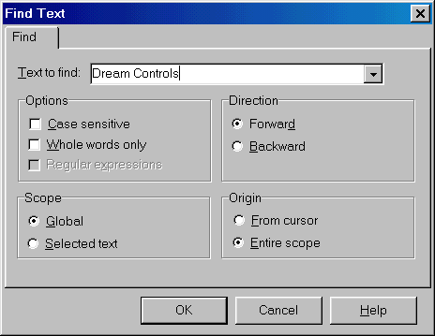

Both of these methods provide an interface for the users. Note that the users can perform search and replace operations with the hot keys that are automatically assigned to different standard operations (e.g. Ctrl-F in Default keyboard mapping). But sometimes you may need to perform search and replace operations without any dialogs – just to find or replace some strings «silently».

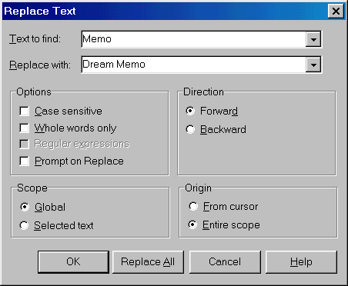

To specify string to be found and the search options use object property DCMemo1.GetSource.SeacrhOptions. With this property you can specify the search string and the search conditions:

- TextToFind contains the search string for the different find/replace routines;
- Direction specifies the search direction, starting from the current cursor position:
sdForward - to the end of the file, it is the default setting,
sdBackward - to the beginning of the file;
- CaseSensitive determines whether the performed search operation depends on the case of the characters from the string that is being processed. For example, if this property is True then «Table Is Black» and «table is black» strings are considered as equal ones, otherwise they are considered as unequal. So, if the case of the characters of the searched text does not matter you may assign False to this property;
- Origin specifies where the search or replace operation should start. Assign soFromCursor to this property if you want to perform the operation from the cursor position. If this property value is soEntireScope then the string is searched (or replaced) in the whole text.
- ReplaceWith property contains a string that will be inserted into the text instead the TextToFind string during the Replace operation;
- ReplaceAll – to replace every occurrence of the search string set True to this property.

Then call:

- TMemoSource.Find method to find a string;
- TMemoSource.FindNext method to repeat the last;
- TMemoSource.Replace to replace one string with another.

So, here is an example how to perform replace operation:

with DCMemo1.GetSource do
begin

SearchOptions.TextToFind := 'white'; //search string
SearchOptions.ReplaceWith := 'black'; // replace string
SearchOptions.PromptOnReplace := False; // no prompt on replace
SearchOptions.CaseSensitive := False; // case insensitive search
SearchOptions.Scope := ssGlobal; //search in the whole text
SearchOptions.ReplaceAll := True; //replace all entries of the search string
Replace;
end;

After this call all entries of ‘white’ string will be replaced with ‘black’ string. No prompt will be given before replacing. The operation will be performed in the whole text. Search will be case insensitive.

You can easily customize colors that are used to indicate a found string. To do this modify the following properties of TDCMemo:

- MatchColor to change the color of a found string;
- MatchBackGround to change the background color of a found string.

Bookmarks

Dream Memo supports bookmarks. You can manage up to 255 bookmarks in the memo. There are several methods that allow you to set, delete, toggle bookmarks and navigate through them.

So, to set a bookmark on the current line of the memo use SetBookmark method, and specify the bookmark’s number as a parameter. For example:

SetBookmark(1); //will set bookmark N1 for the current line

To clear a bookmark you can use ClearBookmark method. It clears the bookmark by the specified number. For example:

ClearBookmark(2); // will clear bookmark N2 for the current line

To clear an existing bookmark or to set a new one (to toggle it) you may use the following methods:

- ToggleBookmark toggles a bookmark with the specified number for the current line;
- ToggleBookmarkForLine toggles a bookmark with the specified number for the given line;
- ToggleBookmark1, ToggleBookmark2, …, ToggleBookmark9 toggles bookmarks number 1, 2, …, 9 respectively.

It is not difficult to go to a line, marked by a bookmark. To do this you can use the methods, listed below:

- GoToBookmark turns to the bookmark with the specified number;
- GoToBookMark1, GoToBookMark2, …, GoToBookMark9 goes to bookmarks number 1, 2, …, 9 respectively.

Keyboard mappings

Dream Memo supports different keyboard mappings: Default, Classic, Brief and Epsilon. Besides that you can define custom keymappings.
To choose a keyboard mapping at design time select a TDCMemo control, switch to Object Inspector and change the value of KeyMapping property. You can also modify this property at run-time. For example:

DCMemo1.KeyMapping := SKBDEpsilon;

After this call DCMemo1 control will use the Epsilon keyboard mapping.

Code Templates

Dream Memo provides Delphi and C++ Builder code templates for different syntax constructions (such as variables declarations, try…finally blocks, etc.) that can be also found in Delphi/C++ Builder IDE (press Ctrl-J when entering the text to activate window with code templates). Moreover, you can define custom code templates and use them as well.

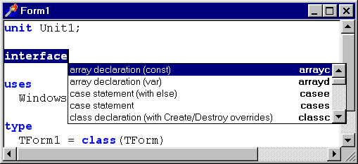

TDCMemo has two properties that manage code templates. Use TemplatesType property to choose the programming language among Delphi, C++Builder or Custom. Select None if you want to disable code templates.

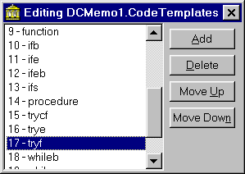

Now let’s turn to CodeTemplates property. At design time select TDCMemo control, find this property in the Object Inspector and press the ellipsis button. You’ll get to the collection editor. Each element of the edited collection contains information about various code templates. Here are the descriptions of collection items properties:
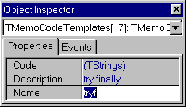
- Name – contains the name of the item;
- Description – contains the text description that is displayed in the code template window;
- Code – contains the code that is used for the template.

When defining custom templates you need to fill this collection with elements that define different code statements.

Here is a sample code template for try… finally statement:

try
|
finally

end;

Please note that “|” character indicates the position where the caret will be placed.

Important: to modify existing code templates (Delphi/C++ Builder) you have to select Custom in the TemplatesType property.

Clipboard and Blocks

First of all you have to know, that Dream Memo supports two types of blocks – streamed and columnar. Streamed blocks are the common ones… and the best way to understand, what is columnar block, is to try it. Just run your application with TDCMemo control, type several lines there, hold Alt key and make a selection.

You can easily determine or change the type of selected block at run-time. Use SelectionType property of the MemoSource (DCMemo1.GetSource.SelectionType).

Value | Meaning
stStreamSelected | The currently selected block is streamed
stBlockSel | The currently selected block is columnar
stNotSelected | No block is currently selected

Now let’s learn how to manage blocks. Dream Memo has methods that provide copying, moving, pasting and deleting of the blocks. You can use the following methods when developing menus (assign them to menu items from «Edit» section):

- DCMemo1.GetSource.CopyBlock copies the selected block to the clipboard;
- DCMemo1.GetSource.PasteBlock pastes a block form the clipboard to the text at the current cursor position;
- DCMemo1.GetSource.CutBlock cuts the selected block from the text and puts it into the clipboard;
- DCMemo1.GetSource.DeleteBlock deletes the selected block from the memo text.

To determine whether paste and copy operations are applicable use CanCopy and CanPaste methods. They return True if the clipboard operation currently can be performed; otherwise CanCopy and CanPaste return True.

Notice that drag and drop operations are also supported in Dream Memo. So the users can easily manipulate with text blocks using mouse, and no coding is required from you! However, if you want to disable drag and drop assign True to Options.moDisableDragAndDrop.

Clipboard history

TClipbrdMemoSource is a component designed to retrieve data from the clipboard. It contains all text that was put into the Windows clipboard form the moment when the MemoSource was created. Memo, connected to such MemoSource, will display the clipboard history (like in Borland Pascal for DOS). Working with TClipbrdMemoSource is not different from working with TMemoSource, as it has the same properties and methods.

Making Screenshots

TDCMemo control allows making screenshots. It has several methods designed to copy an image of memo’s content to the clipboard or to save it to the file (or to the stream), using different graphical formats.

All you have to do to put the image of the memo to the clipboard, is to call CopyGraphicToClipboard method. When calling this procedure specify the graphical format, which will be used to represent the image. The possible values of this parameter are:

Value | Meaning | Special method
GfBitmap | Bitmap format | DrawBitmapToClipboard
GfMetaFile | Windows metafile format | DrawMetaFileToClipboard
GfEnhancedFile | Windows enhanced metafile format | –

Here is an example, how to call CopyGraphicToClipboard:

DCMemo1.CopyGraphicToClipboard(gfBitmap);

You can also call the specialized methods with the corresponding graphical formats (e.g. DrawBitampToClipboard with bitmaps).

This will make a screenshot of the memo content and put it to the clipboard. You can also save the memo screenshots directly to the disk or to TBitmap objects, using the following methods:

- DrawToBitMapFile, DrawToMetaFile, DrawToFile;
- DrawToBitmap, DrawToEMFWMF.

Printing

Have you ever solved the task of printing? Standard Delphi Memo control does not have any printing functionality and Dream Memo has – several handy methods and properties are provided to print the content of the memo. Their usage is very easy – all you have to do is to call the following methods:

- TDCMemo.PrintWithDialog displays the print dialog where the users can select the print options and print the content of the memo using these options;
- TDCMemo.Print prints the memo content «silently» (without any dialogs) using the print options specified in the PrintOptions property.

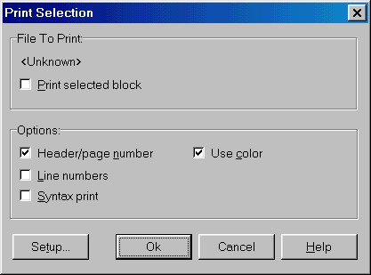

So, let’s discuss PrintOptions property that determines how the text is printed. This property has the following elements:

- poInColor – specifies if the color will be used when printing;
- poPrintSel – specifies whether the whole text will be printed or only the current selection;
- poPrintHeader – if this element is True then the name of the printed file and the page number will be printed at the top of each page;
- poLineNumbers – assign True to this element if you want the numbers of lines to be printed;
- poPrintSyntax – determines whether the text will be printed using different text styles (given by the syntax parser);
- poShowProgress – if this element is True then the progress window will be shown during the printing.

Memo Background

Dream Memo can display background images inside the control. File that contains image file can be specified in the BackGround property of TDCMemo. Please note that memo can display background image in different modes. Use BkgndOption property to specify the background mode. Here is the table that contains the possible values of BkgndOption:

Value | Meaning
boCenter | The image is displayed at the center of the memo control
boTile | The image is tiled on the whole client area of the memo control
boStretch | The image is stretched to fit the entire client area of the memo control
boNone | The image is not displayed

Here is the screenshot of the memo with a tiled background image:

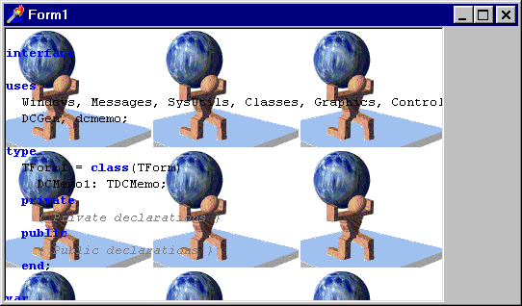

Global Options

Sometimes it is necessary to assign the same options to the several memos. To specify the global options use global memo options. Then assign True to UseGlobalOptions of those memos that have to use the same global options.
The following memo properties are included into the global options: Options, KeyMapping, MarginPos, GutterWidth, GutterBrush, MarginPen, Font and TextStyles.

You can access to the global memo options through GlobalMemoOptions function that returns the current global options for the TDCMemo controls. For exmaple:

GlobalMemoOptions.KeyMapping := 'Brief';

Gutter and margin

TDCMemo supports gutter and margin. To turn on the gutter at design time, select a memo and find Options property in the Object Inspector. Then assign True to moDrawGutter element… and enjoy the gutter. In the same way you can make the margin visible – assign True to moDrawMargin element. Gutter and margin parameters can be customized using the following properties:

- GutterWidth determines the width of the gutter;
- GutterLineColor specifies the color of the vertical line that separates the gutter from the memo;
- GutterImages contains the images that are shown on the gutter (e.g. those that indicate a bookmark or a breakpoint);
- GutterImageHeight, GutterImageWidth define the size of the gutter images. The gutter image will be stretched to fit the sizes, specified in this property, if it is bigger or smaller;
- GutterBrush specifies the Brush used to draw the gutter;
- MarginPos specifies the margin position (in characters);
- MarginPen contains the Pen used to draw the margin.
Left Indent

Please pay attention to the LeftIndent property of TDCMemo. It specifies the left indent (in pixels) that is applied to the whole memo text that is displayed in the memo control. Still you have to assign True to Options.moIndent in order to “turn on” the left indent.

Here is the screenshot that shows the TDCMemo control with applied left indent:

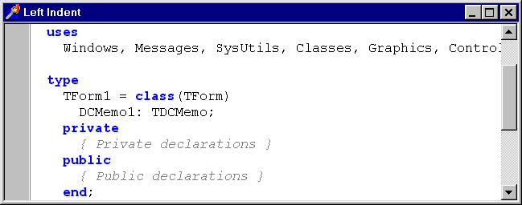

As you can see memo’s text is separated from the gutter by the indent.

Gutter Images

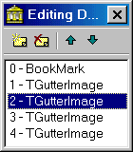
Images that are shown on the gutter are stored in the GutterImgs property of TDCMemo controls. By default there is one image that is usually used to indicate the bookmarks. You can also add custom images to the GutterImgs and they will be displayed on the gutter. To do this follow these instructions:
- switch to design mode, select a memo control and make its gutter visible (as written above);
- find GutterImgs property in the Object Inspector and press ellipsis button;
- now, you can add and delete images from the GutterImgs;
- to specify a glyph for an image, select it and change its Glyph property.

To display a gutter image you can use the following code:

procedure TForm1.Button1Click(Sender: TObject);
begin
DCMemo1.GetSource.ImageBit[3,1] := True;
end;

This call will display the gutter image with index «1» on the fourth line of the memo (line numbers are zero based). To change the line you have to modify the first index of the ImageBit property, to select an image – the second one. If you want to hide the image assign False to the ImageBit property.

Note, that zero item of GutterImgs objects contains a glyph used to indicate a bookmark.

Selections

There are several ways to determine what text is currently selected in the memo. To do this you can use SelStrings or SelText properties of the memo. You can also customize the color and the background that are used to indicate the selected block. To do that, modify SelColor and SelBackColor properties of the memo respectively.

DCMemo1.GetSource.SelStrings usage is more convenient than SelText, because SelStrings is a usual TStrings object. So you can use all methods and properties of TStrings class with SelStrings.

Memo Options

Here is the table that contains brief descriptions of the different TDCMemo.Options elements:

Element | Description | Default value
moDrawMargin | If True then the TDCMemo control displays the margin | False
moDrawGutter | If True then the TDCMemo control displays the margin | False
moThumbTracking | If True then the memo interior is scrolled when the user drags the scroll bar thumb; otherwise memo is scrolled when the user releases the thumb | True
moDblClickLine | If True then the whole text line is selected when the user clicks twice on it | False
moColorSyntax | If True then the memo syntax can be highlighted (if the parser is specified in the SyntaxParser property) | False
moLineNumbers | If True then the Memo displays line numbers near the gutter | False
moOverwriteCaret | If True then the caret changes its shape when the user switches between insert/overwrite modes | False
moLeftIndent | If True then the value specified in the LeftIndent property is applied to the whole memo text; otherwise left indent feature is turned off | False
moDisableDrag | If True then drag and drop operations are disabled | False
moSelectOnlyText | If True then the user can select only text; free space can not be selected | False

Memo and Databases

The common task that needs to be solved by the programmers is to display the content of a database field in the memo control. Dream Memo pack includes two powerful components that work with Databases: TDCDBMemo and TDBMemoSource. Not wasting time, let’s try them at one stroke. Place TTable, TDataSource and TDCDBMemo components on your form. Now, we have to connect them with each other:

- at design time select the Table1 components and specify a database and a table there, using DataBaseName and TableName properties;
- assign True to Active property of the Table1 component;
- select DataSource1 and select assign Table1 to its DataSet property;
- select the DCDBMemo1 control and specify the data source there in the DataSource property and a data field in the DataField property;
- run the application.

TDCDBMemo combines the functionality of TDBMemoSource and of TDCMemo. It can be considered like a usual TDCMemo control, which uses TDBMemoSource as an internal MemoSource. Still, you can use TDBMemoSource with TDCMemo as a MemoSource that retrieves text from the database field – combined use of these controls give the same results as one TDCDBMemo control.
Edit Unit

Dream Memo pack includes Edit Unit, the Delphi form that implements multi-tab edit control. You can see it “in action” in Instant Report (our report/form designer program, you can find smaller version of Instant Report in the \INSTANT folder of your Dream Memo installation), where it is used as a base form for text editing. You can also use it in your own applications that require a convenient and nice multi-tab edit form.

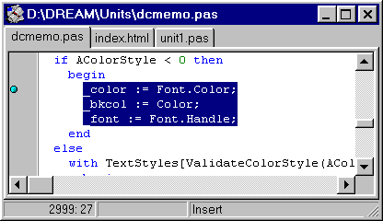

And now, let’s start working with editunit. First of all, you need to know, that the text displayed in the EditForm is stored in MemoSource. Thus you have to put a TMemoSource component on your form. Then, add editunit.pas to the uses section of the unit. Think out a caption, that will be displayed on the tab sheet, and call ShowMemoSource procedure, as it is shown in this example:

MemoSource1.LoadFromFile('d:\dream\units\dcmemo.pas');
MemoSource1.ObjectName := 'd:\dream\units\dcmemo.pas';
ShowMemoSource(MemoSource1, [spCenterOnLine,spCreateNew]);

When calling ShowMemoSource you have to specify a MemoSource and a set of parameters. Here is table that explains the meaning of each possible parameter:

Element | Meaning
spCenterOnLine | The current line of the memosource will be displayed at the center of the memo
spMakeTop | EditForm windows will be placed over other windows – on the top.
spCreateNew | A new EditForm will be created. If you do not specify this parameter, then the new text will be placed into the existing EditForm, in a new tab sheet.

As noticed above, EditForm is a multi-tab form, so you can edit several texts simultaneously. To add a new text to the EditForm, call ShowMemoSource, specifying another MemoSource with the new text. For example:

ShowMemoSource(MemoSource2, []);

Parsers

Parsers Overview

Dream Parsers that come with the Dream Memo package are the powerful components designed to operate with texts. Parsers for different programming languages including Delphi, C/C++, Java, VBScript, HTML, SQL, Perl, etc are included with Dream Memo.

At first, let’s discuss how to use parsers with Dream Memo. Put a TDCMemo control and one of the parsers on your form. Connect your memo with the parser. All you have to do is to specify the parser in the SyntaxParser property of the memo. Select memo and find Options property in the Object Inspector. Assign true to moColorSyntax and enjoy the syntax highlighting! You can even customize the styles used for highlighting. To do this you can use TextStyles property of the memo.

You can also use Parsers with MemoSources. The idea is the same – just specify a parser in the SyntaxParser property of the MemoSource. Now all the memos, connected to this MemoSource will use the same parser. But you can disable syntax highlighting for the particular memo simply changing its moColorSyntax property.

Highlighting for memos is not the only purpose for Syntax Parsers. You can use parsers to implement syntax parsing in your own applications. Parsers analyze text and divide it into tokens. By these tokens you can determine what syntax constructions are used in the text and implement their management.

Using OnGetColorData event

OnGetColorData event is designed to give you an ability to select the text styles that are used to draw text in the memo at run time. It means, for example, that you can make the memo draw different reserved words or even different characters of the one word using different text styles. Several parameters are passed to the OnGetColorData handler:

- Sender is the instance of the Parser that fired the event;
- Token is the current syntax token;
- TokenStr is the current token string;
- ColorData is the string that is used to return the text style indexes for each symbol of the TokenStr.

Each character of the ColorData string contains the text style index that corresponds to one character from the TokenStr. Here is the sample OnGetColorData handler:

procedure TForm1.DelphiParser1GetColorData(Sender: TObject; Token: Integer;
const TokenStr: String; var ColorData: String);
begin
if TokenStr = 'procedure' then
ColorData := #1#1#1#1#4#4#4#4#4;
end;

If such hander is implemented then all ‘procedure’ words will be painted in the following way: characters from 1 to 4 will be painted using the first text style and characters from 5 to 9 – using the fourth text style.

Creating Custom Parsers

Although Dream Memo includes the pack of syntax parsers for most common programming languages you may need to create your own parser. It is not difficult and now we will create the parser step by step, using Java Script parser as an example.

At first you have to define the custom parser class that inherits from TStringsParser (declared in dcparser.pas) or TSimpleParser (declared in dcsystem.pas).

Let’s discuss in detail how to implement a parser, using the TStringsParser as a base class. First you need to create new class (You can use File|New|Component for that)

TJavaScriptParser = class(TStringsParser)

Now, let’s define the reserved words. To do this simply specify the string array, which contains the list of the reserved words.

cMaxJScrResWords=35;
SJScrResWords:Array[0..cMaxJScrResWords - 1] of string=(
'break','case','catch','class','const','continue','debugger','default',
'delete','do','else','enum','export','extends','false','finally','for',
'function','if','import','in','new','null','return','super','switch','this',
'throw','true','try','typeof','var','void','while','with');

After we defined reserved words we need to create method which will initialize parser for the JavaScript syntax (full text of this method is included later in this document). In the beginning of this method call the StrArrayToStrings method to add these reserved words to ResWords array:

StrArrayToStrings(ResWords,SJScrResWords);

Note, that the list of keywords can be customized later at run time with ResWords property.

Now, let’s define methods that will be used to parse the text. Note that there are many existing methods that can be used to parse the common syntax constructions. It means that different programming languages often use the same syntax for comments, string constants, etc. You can also use these methods in your parser.

To make the parsing method work register it with RegisterProc method. For example, let’s register the method that will process string constants enclosed by apostrophes (For example ‘abcd’).

RegisterProc([psNormal],[''''],ParseStrConst);

This call registers ParseStrConst method. It will be called when the apostrophe character is encountered and the parser’s state is psNormal. There are three pre-defined parser’s states: psNormal, psComment and psComment2. The parser is in psComment or in psComment2 state when it is parsing different types of comments; otherwise it is in psNormal state. You can also define custom parser states.

As another example, let’s consider the method used to parse Delphi-style hexadecimal constants (like $12AB):

RegisterProc([psNormal],['$'],ParseHexConst);

This call registers ParseHex method. It will be called when the ‘$’ character is encountered and the parser’s state is psNormal. Please refer to the TDCCustomParser declaration (unit dcparser.pas) for the different parsing methods (parsing methods start with ‘Parse’ prefix)

Implementing Parsing Methods

Let’s discuss how to implement parsing methods. Here is the source of ParseHex method:

function TCustomDCParser.ParseHexConst:Integer;
Begin
inc(FSourcePtr);
while FSourcePtr^ in cHexDigit do
Inc(FSourcePtr);
Result := tokInteger;
End;

Now we will understand what every line means.

- inc(FSourcePtr). This method must be called when the current character is ‘$’. So, first of all, you have to skip it by incrementing FSourcePtr.
- while FSourcePtr^ in cHexDigit do Inc(FSourcePtr). In this cycle all the hexadecimal (cHexDigit) characters are skipped.
- Result := tokInteger. TokInteger token type is returned.

This method skips the current character (in this case it must be ‘$’) and continues skipping hexadecimal (cHexDigit) characters. It returns tokInteger token type that indicates, that all skipped characters except the first one (‘$’) are digits.

Here are the defined token types:

Constant | Value | Meaning
TokNone | -1 | Empty
TokEOF | 0 | End of file (EOF)
TokString | 1 | String
TokComment | 2 | Comment
TokSymbol | 3 | Identifier that is not a reserved word
TokInteger | 4 | Integer digit
TokFloat | 5 | Floating point digit
TokResWord | 6 | Reserved word
TokWhiteChar | 7 | Any character from #33 to #255
TokPreProcessor | 8 | Pre-processor directive
TokAssembler | 9 | Assembler language

You can also define another token types when implementing custom parsers.

Please notice that indices of the textstyles used to display text in the memo match token types. It means that the text style with index “4” will be used to display characters with tokInterger token type.

In this way you need to implement (if they are not already implemented) and register methods that will parse different syntax constructions. Here is the source of the method that registers syntax processing methods for the Java Script Parser:

procedure TCustomDCParser.InitJScrSyntax;
begin
StrArrayToStrings(ResWords,SJScrResWords); //list of Java Script reserved words
InitCommon;
RegisterProc([psNormal],cFirstIdentChar,ParseIdentifier); //Identifier parsing method
RegisterProc([psNormal],['/'],ParseJScrComment); //One-line comments //
RegisterProc([psComment2],cWhiteChar,ParseJscrCommentEnd);
{Multi-line comments used in Java /*abcd*/}
RegisterProc([psNormal],['"'],ParseVBStrConst); //String constants «abc»
RegisterProc([psNormal],[''''],ParseStrConst); //String constants ‘abc’
RegisterProc([psNormal],cDigit,ParseNumConst); //Numeric constants
InitEolState(psComment2);
end;

As you see InitJScrSyntax registers methods that process Java Script syntax constructions. Note, that in Java Script there are two types of string constants: marked by quotation marks and apostrophes. So, two different parsing methods are registered. The same situation is with comments: to parse one-line (//abcd) and multi-line (/*abcd*/) comments we need to register two methods. InitJScrSyntax method is called in the constructor of the class, that implements Java Script parsing:

constructor TJavaScriptParser.Create(AOwner:TComponent);
begin
inherited;
InitJScrSyntax;
end;

