Dream Scripter manual
Revision 1.2
Copyright © 1997 – 1999 Dream Company

TABLE OF CONTENT
Introduction 2
Getting Started 2
Supported Scripting Languages 3
Running Scripts 4
Brief Architecture Description 4
Specifying Script 5
How To Execute Script 5
Script Variables 7
Accessing Script Variables 7
User Variables 8
Passing Parameters 9
Passing Parameters Of TObject Type 9
Passing Sets 10
Passing Open Arrays 11
Calculating Expressions 11
Controlling Script Execution 11
Syntax Checking 12
Debugging 12
Run Detection 13
How To Stop The Script 13
Handling Errors 13
Writing Scripts 14
Registration 14
Import Files 14
IMPGEN usage (GUI version) 14
IMPGEN usage (command-line version) 15
Manual Registration 18
Accessing Objects From The Script 18
Common Rules 18
Adding Delphi Objects To The Script 19
Modules 19
Script Projects 19
Handling Events 20
Scripting Languages 21
Scripting Languages Installation 21
Encoded Scripting Languages 21
Available Scripting Languages 22
Active Scripting 22
Delphi Script 22
Working With Actions 23
Advanced Usage 25
Troubleshooting 26
Introduction

Being the member of Dream Controls family Dream Scripter allows integrating of different scripting languages into your applications. Among them are VBScript, JScript, Perl, Python or any other active scripts. Besides that Dream Scripter provides Delphi interpreter that makes it possible to write Delphi scripts. Dream Scripter turns your application to a scripting host and makes the entire VCL (or any custom Delphi object, procedure, constant, etc.) available to scripts.

Dream Scripter opens really amazing possibilities. Just imagine that you will be able to use VCL in scripts (for example, in VBScript), implement event handlers in scripts… and even work with scripts through Microsoft Script Debugger.

Getting Started

Let’s think of our first application with Dream Scripter. We’ll write a simple program that will add two numbers and display the result. Adding routine will be implemented in VBScript.

To do that you need to place TDCScripter (DCScripter1) component (it can be found on the Dream Company tab of the component palette) on your form.

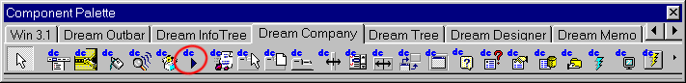
You’ll also need one TButton (Button1) and two TEdit (Edit1, Edit2) controls to specify the added items.

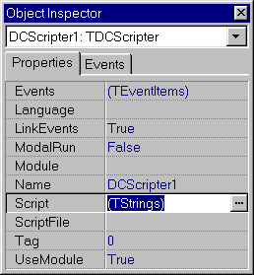
And now take a look at the Script property of DCScripter1 component. It contains the script that will be executed. Find this property in Object Inspector and press the ellipsis button – you’ll get to the TStrings editor. Implement there the following VBScript code:

Function Sum (x, y)
Sum = x + y
End Function
You have just declared the function in VBScript that returns the sum of x and y parameters. Now we need to execute this function from the main program. You can implement the following handler of the OnClick event of Button1 control:

procedure TForm1.Button1Click(Sender: TObject);
var x, y, sum : double;
begin
if (Edit1.Text <> '') and (Edit2.Text <> '') then
// checks whether both fields are not empty
begin
x := StrToFloat(Edit1.Text); // convert strings
y := StrToFloat(Edit2.Text);
sum := DCScripter1.DispatchMethod('Sum', [y, x]);
// executes Sum function from the script
// note: parameters are passed in the reverse order!

ShowMessage('Sum = ' + FloatToStr(sum));
// displays the result in a window
end;
end;

Before running the application you have to specify the scripting language (in this example – VBScript) in the Language property of TDCScripter.

You can find this example in the EXAMPLES\SUM folder.

Supported Scripting Languages

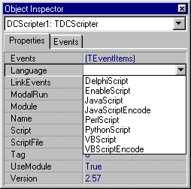
Several more words are to be said about scripting languages. As previously noticed Dream Scripter supports the following ActiveX scripting languages: VBScript, JScript, Perl, Enable Basic, and Python. Dream Scripter also provides DelphiScript interpreter so you can use Delphi scripts in your applications.

Dream Scripter also supports JavaScriptEncode and VBScriptEncode. It means that you can use encoded scripts in your scripting applications.

Please note that all scripting languages except DelphiScript are registered in dcscript unit. DelphiScript is registered in dcpascal unit so you have to add it to your project in order to use DelphiScript.

In addition to the mentioned above scripting languages that are registered automatically you may register any custom Active Scripting language. Please refer to Scripting Languages section of this manual.

Running Scripts

Brief Architecture Description

Let’s talk about the internal architecture of Dream Scripter beginning from its main element – TDCScripter component. This component is one that is placed on the form. Actually programmers work directly with TDCScripter that holds and manages all scripting functionality.

Depending on the script language that is selected in the Language property TDCScripter creates an instance of the T…Runner class for every script that is used in the main program. For example, an instance of TDelphiScriptRunner is created when DelphiScript is selected, an instance of TVBScriptRunner is created when VBScript language is selected, etc.

As you can see from the picture figured below all script runners except TDelphiRunner are inherited from TAxScriptRunner. The matter is that Delphi Script Interpreter that comes with Dream Scripter is implemented in a different way than all other script runners. But you should not notice any difference between working with Delphi scripts and other supported scripts.

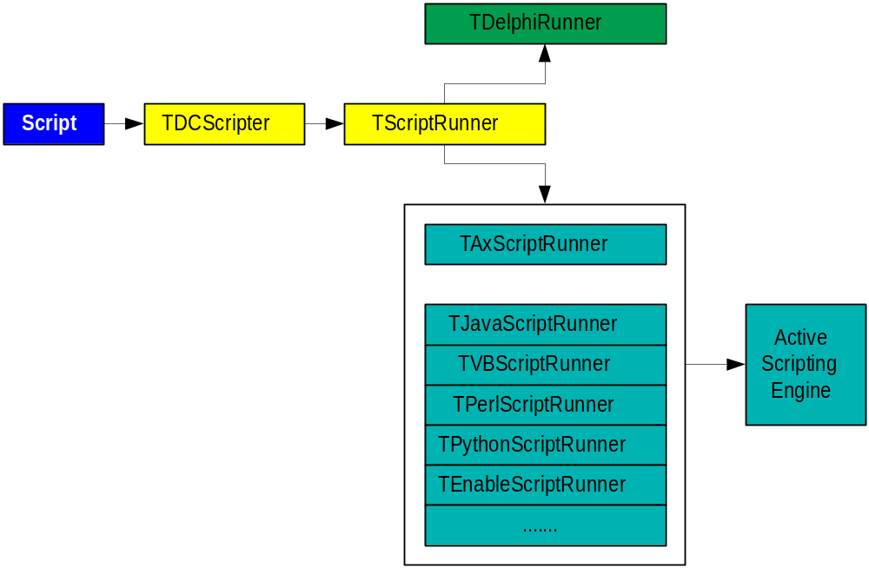

Please note that to use any of Active Script languages you need the corresponding Active Script Engine to be installed. For more detailed information on the Active Scripts download and installation please refer to Scripting Languages Installation chapter.

Specifying Script

There are two easy ways to specify the script that is executed by TDCScripter. First of all you can modify its Script property that contains TStrings object – simply assign script’s text to this property.

The second way is to implement script’s code in a text file and specify this file in ScriptFile property of TDCScripter.

Please note that TDCScripter is capable of loading Delphi forms. It means that the Scripter tries to load the DFM file (if such file exists) with the same name as the one that is specified in ScriptFile property. For example TDCScripter will attempt to load unit1.dfm for unit1.pas, myform.dfm for myform.js, etc.

How To Execute Script

OK, the script is implemented and you need to run it. Sometimes you need to execute the whole script and sometimes only its separate part, for example, one function.

At first, let’s execute a separate function from the script. If it does not require any parameters then you need to use CallNoParams method, passing the name of the executed routine as a parameter. Here is an example of how to call it:

procedure TForm1.Button1Click(Sender: TObject);
begin
DCScripter1.CallNoParamsMethod('MyMessage');
end;

You can use the following script implemented on VBScript to try CallNoParamsMethod:

Sub MyMessage
ShowMessage("Hello World!")
End Sub

And don’t forget to add vclimp unit to the uses section of your unit (vclimp contains is an imported VCL file, it can be founded in the IMPORTED folder of your installation). Otherwise ShowMessage won’t work. For detailed information about imported files see Import Files chapter.

You can find this example in EXAMPLES\Hello folder.

If the function or procedure requires some parameters then you can use DispatchMethod. Specify the name of the executed routine and a list of parameters (they have to be passed in the reverse order). Here is an example of DispatchMethod usage:

procedure TForm1.Button1Click(Sender: TObject);
var n: integer;
begin
n := DCScripter1.DispatchMethod('Sumn', [10, 1]);
ShowMessage('Sum = ' + IntToStr(n));
end;

The VBScript code used in this sample is cited below:

Function Sumn(n1, n2)
s = 0
for i = n1 to n2
s = s + i
next
Sumn = s
End Function

Here we have calculated the sum of the first 10 integer numbers. CallNoParamsMethod and DispatchMethod return the result of the executed script subroutine (as it is shown in example).

You can find this example in EXAMPLES\SUMN folder.

In previous examples we have learnt how to call separate subroutines from the script. But you can also execute the whole script using TDCScripter.Run method. In the following example we’ll calculate the sum of first 10 integers (from 1 to 10):

procedure TForm1.Button1Click(Sender: TObject);
begin
DCScripter1.Run;
end;

VBScript code:

s1 = "Whole "
s2 = "script "
s3 = "is "
s4 = "executed! "

ShowMessage(s1 + s2 + s3 + s4)

You can find this example in EXAMPLES\ALLSCRIPT folder.

Important: if some error occurred during the script execution then CallNoParamsMethod, DispatchMethod or Run return UnAssigned value and RunFailed property is set.

Script Variables

You can access variables that are defined in the script from the main program and vice versa. In this chapter we will discuss in details different ways how to do this.

Accessing Script Variables

To gain access to the values of the variables defined in the script you can use ScriptVars property of TDCScripter. Here is an example that shows how to read and modify script variables:

VBScript code:

X = 10
Country = “USA”

Delphi code:

DCScripter1.ScriptVars[’X’] := 20;
ShowMessage(’Country is ’ + DCScripter1.ScriptVars[’Country’]);

As you can see, variables are accessed by name. In this example we assigned 20 to the X variable and displayed the content of Country in the message box.

Sometimes you may wish to get the list of all variables declared in the script. To acquire their names you can use GetVarList method of TScriptRunner. It requires an instance of TStrings object that will be used to return the names of variables. For example:

procedure TForm1.Button1Click(Sender: TObject);
var VarList: TStrings;
begin
VarList := TStringList.Create;
VarList.Clear;
DCScripter1.Run;
DCScripter1.ScriptRun.GetVarList(VarList);

//…
//… You can implement here some custom code
//…
VarList.Free;
end;

In this example we have created an instance of TStrings object, executed the script and retrieved the list of its variables.

User Variables

Dream Scripter provides a way to manage script variables dynamically. Imagine for example that Scripter processes some script. If it finds an undefined variable then OnGetUserVarID event is fired. Handle this event if you want to check all undefined variables at run-time and “recognize” some of them (may be implement some algorithm that will specify values of such variables).

Let’s discuss how to work with undefined variables (also called user variable). When such variable is found then OnGetUserVarID event is fired. To process user variables you need to handle it:

procedure TForm1.DCScripter1GetUserVarID(const VarName: String;
var VarID: Integer);
begin
if VarName = 'MessageText' then
VarID := 100;
end;

VarName parameter contains the name of the user variable. VarID is used to determine whether the main had “recognized” this variable. By default VarID is –1. If you do not assign any other value to VarID then the variable is considered as undefined. But if you want to process it then assign an identifier to VarID (in example 100 is assigned to VarID).

However you have to handle two more events to read and write value of the user variables. Take a look at the following example to understand better how to do this:

procedure TForm1.DCScripter1GetUserVar(const VarName: String;
VarID: Integer; var VarValue: OleVariant);
begin
if VarID=100 then
VarValue := 'Sample User Variable.';
end;

OnGetUserVar event which handler is implemented above is fired when the Scripter needs to read the value of a user variable. As you can see VarName and VarID parameters are used to “recognize” the variable. VarValue is used to return the value of the variable to the script.

OnSetUserVar event is fired when the Scripter needs to assign some value to a user variable. Parameters passed to the handlers of this event are the same to the ones, passed to the handlers of OnGetUserVar event.

You can find this example in EXAMPLES\USERVAR folder.

Passing Parameters

When working with TDCScripter programmers often need to operate with different Delphi data types in the scripts written in other languages (for example, in VBScript or JScript). As you probably know neither VBScript nor JScript languages have data types that directly correspond to some Delphi types (e.g. sets). Such parameters can not be passed to the script without preliminary conversion to OLEVariant type. In this chapter we will discuss how to work with such data types in scripts.

Passing Parameters Of TObject Type

To pass TObject parameters to the script with DispatchMethod you need to convert them to OLEVariant (please note that parameters are to be passed in the reverse order). To do so you can use VarFromObject function that is declared in dcscript unit (to convert OLEVariant parameter back to TObject use VarToObject function). The following example demonstrates how to perform such conversions:

TObject to OLEVariant:

Delphi code:

procedure TForm1.Button1Click(Sender: TObject);
begin
DCScripter1.DispatchMethod('ClearLines',[VarFromObject(Memo1.Lines)]);
end;

VBScript Code:

Sub ClearLines(S)
S.Clear
End Sub

After the VBScript code is executed the Memo Lines are cleared. You can find this example in EXAMPLES\OPENARRAY folder.

OLEVariant to TObject:

NewList := VarToObject(Var1) as TStringList;

Passing Sets

Sets also have to be converted to OLEVariant in order to be passed or retrieved from the script. To do this you can use VarFromSet and VarToSet functions and procedures.

To create a set in script you can use MkSet method. Here is a VBScript example:

Font.Style = MkSet(fsBold, fsItalic)

Here we assigned bold+italic style to some font.

In Delphi we use in operator to determine whether a set contains the specified element. To perform the same operation in scripts you can use InSet function. Here is a VBScript sample code:

if InSet(A, B)
ShowMessage ("Value is within 1..10 set.")
else
ShowMessage("Value is outside 1..10 set.")
End If

This code corresponds to the following Delphi code:

if A in B then
ShowMessage (‘Value is within 1..10 set.’)
else
ShowMessage(‘Value is outside 1..10 set.’)

You can find this example in EXAMPLES\SETS folder.

Passing Open Arrays

There is the number of Delphi functions that requires open arrays as parameters. Here are the examples that show how to pass open arrays from VBScript/JScript code to Delphi:

VBScript (using Array function):

Format("The height of %s is %d", Array(Button1.Name,Button1.Height))

JScript (using [ ] operator):

Format("The height of %s is %d", [Button1.Name, Button1.Height])

Calculating Expressions

Dream Scripter can calculate expressions and return their values. To calculate an expression you can use Evaluate method, where expression is specified by Expr parameter. For example, you can calculate expressions like the following:

- 2+5
- ((10+15)-5)/2*5
- sin(3.1415926/2)*10
- 2.5*log(3)

Please note: expression syntax has to correspond the currently selected language (see the Language property).

Controlling Script Execution

‘How to control the script?’ – this task often appears before programmers, for example when developing IDE environments. Dream Scripter provides several ways to manage script execution. You can check script’s syntax before run, manually stop its execution, debug it with Microsoft Script Debugger, etc.

Syntax Checking

You can check script’s syntax by using CheckSyntax method of TScriptRunner (starting from Dream Controls 2.56B3). It returns True if syntax is OK, otherwise it returns False. Here is an example that shows how to check the script:

procedure TForm1.BitBtn1Click(Sender: TObject);
begin
DCScripter1.Language := 'VBScript';
DCScripter1.Script := Memo1.Lines;
if DCScripter1.CheckSyntax then
ShowMessage('Syntax is OK.')
else
ShowMessage('There are syntax errors!');
end;

You can find this example in EXAMPLES\SYNTAXCHECK folder.

You can also use CheckSyntaxEx function that acts like CheckSyntax but allows to determine the position of an error character in the text. If an error is found then function returns True; in this case line number and character position are returned in ErrLine and ErrChar parameters.

Debugging

Active Scripts, supported by Dream Scripter, can be debugged with Microsoft Script Debugger. It is freeware product and can be downloaded at http://msdn.microsoft.com/scripting.

After Microsoft Script Debugger is installed you can use it to work with different scripts. For example, implement some VBScript code and execute it with Dream Scripter. Then switch to Microsoft Script Debugger, select View | Running Documents from the menu, and in the window that appeared choose your script project. The script has to come into the view in a new window – you will be able to trace it, inspect its variables and perform all other common debug operations.

Microsoft Script Debugger supports any Active Script Languages. It means that you will be able to debug not only code implemented in VBScript, but also in JScript, Perl, Python, etc.

Please pay attention to the ScriptName property that is used to identify the script in the Microsoft Script Debugger. If this property is not specified then the default script name (filename) will be used.

Run Detection

You can easily detect whether the script is running by using IsModuleRunning function. It returns True if the module (in this case – an instance of TDCScripter) is running; otherwise IsModuleRunning returns False. Here is an example describing how to use this function:

procedure TForm1.Button1Click(Sender: TObject);
begin
if IsModuleRunning(THandle(DCScripter1)) then
ShowMessage(’Script is being executed’);
end;

How To Stop The Script

Sometimes it is necessary to stop the script execution. To do so you can use Stop method like it is shown below:

DCScripter1.Stop;

After this call the currently executed script will be stopped.

Handling Errors

Dream Scripter provides some ways to handle errors that can occur in scripts. You can handle OnError event of TDCScripter to react on script errors. This event is fired every time an error occurs. Five parameters are passed to OnError handler:

Parameter | Meaning
Sender | Contains the Scripter that executes the script
ExcepInfo | TExcepInfo structure that contains error information
LineNo | The number of the line (zero-based) with erroneous character
CharNo | The number (zero-based) of the erroneous character
Handled | Assign True to this parameter if you process the error. Assign False if you want the error to be processed by default manager.

Here is an example describing how to handle OnError event:

procedure TForm1.DCScripter1Error(Sender: TObject;
const ExcepInfo: tagEXCEPINFO; CharNo, LineNo: Integer;
var Handled: Boolean);
begin
Handled := True;
ShowMessage('Error at line ' + IntToStr(LineNo+1) +
' char ' + IntToStr(CharNo+1)+'.');
end;

If such handler is implemented then a message box with information about this error will appear each time error occurs.

Besides that you can check the value of TDCScripter.RunFailed property. True value of this property means that some error has occurred during the script execution.

Writing Scripts

One of the greatest features of Dream Scripter is the capability of working with any VCL, Delphi/C++ Builder or any third-party objects in the scripts. You can read and modify their properties, execute their methods, etc. You can also access objects, procedures, functions and variables declared in your main program from the script.

Registration

Before any class, method or variable from the Delphi/C++ Builder program, VCL, etc. can be used in the script, it has to be registered. Actually, registration routine can be performed manually, but this way is rather inconvenient – imagine how many registrations are to be performed, e.g. for VCL. However, we’ll discuss how to go with manual registering a little bit later, having talked at first about automatic registration.

Import Files

Import files contain registration of different classes, methods, variables, etc. As noticed above you can register these manually, but we suggest you to use IMPGEN utility provided by Dream Company. This utility automatically processes PAS (or INT) files and creates import files with all necessary registrations.

Important: Dream Company provides Import files for Dream Components, VCL and Quick Report for every version of Delphi and CPB in the trial versions of Dream Controls. Registered version does not include any Import files so that you have to create them by yourself. You can include them all at once, adding impreg module to the Uses section of your project. If you need only VCL then add vclimp module instead impreg.

IMPGEN usage (GUI version)

Parameters that are required by IMPGEN utility can be specified in the command line. If IMPGEN is executed without any command line parameters then you will be able to specify them in a graphical dialog. Here is the short description of its fields:

- Source file(s) – files that will be processed (file masks are supported)
- Destination path – location where the output files will be placed;
- Library path – path to the folders where the library files are stored;
- Conditional defines – you can enter here any compiler defines that will be used to generate import files;
- Aliases – you can specify some aliases (e.g. WinTypes = Windows; WinProcs = Windows; …)
- Skip items listed in – specify here a file with a list of the units that are to be skipped by IMPGEN;
- Process subfolders – if this box is checked then Impgen will process the files located in the subfolders of the folders, specified in Source files and Library path fields;
- Postfix – the postfix that will be added to the names of generated files.

You could also notice the unnamed button near Library path field. Press it and IMPGEN will automatically fill this field.

Imagine, for example, that you need to import units located in d:\myfiles\units folder (and its subfolders) skipping files specified in d:\myfiles\toskip.txt file and place imported files to d:\myfiles\imported. We’ll use default library paths, conditional defines, postfix and aliases. To perform such operation fill the fields of IMPGEN dialog as it is shown on the screenshot below:

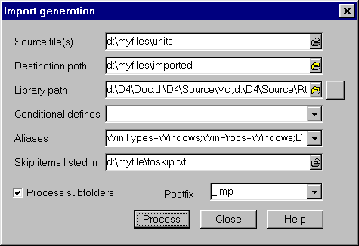

IMPGEN usage (command-line version)

And now we’ll learn how to create imported files with the command-line version of IMPGEN utility.

This process requires you to prepare a DOS-level command telling IMPGEN to get all the *.PAS files from your component source directory and to create *_IMP.PAS versions from them and place those *_IMP.PAS files in another directory. You also need to provide access to any Delphi units ( .PAS,.INT files) that are directly or indirectly referenced by your source files.

That's virtually impossible to do in the 255 char limit of a DOS command, so
you have to move lots of files closer to the root of your drive.
Here are some steps:
- Create a folder named D:\D3
- Next, you need to get all the possible Delphi files that are referenced by
your components into a single folder.
- Copy Program Files\Borland\Delphi 3\Source\VCL\*.* to D:\D3
- Copy Program Files\Borland\Delphi 3\Source\Rtl\Sys\*.* to D:\D3
- Copy Program Files\Borland\Delphi 3\Source\Rtl\Win\*.* to D:\D3
- Copy Program Files\Borland\Delphi 3\Source\ToolsAPI\*.* to D:\D3
- Copy Program Files\Borland\Delphi 3\DOC\*.* to D:\D3

(I think that's all you'll need. Note that we use drive D:, but you can
use whatever drive you want)

- Create a folder to hold the *_IMP.PAS files that get created by IMPGEN. In the example below, the folder is named D:\SAMPUNIT
- Create a .BAT file like this:
IMPGEN -UD:\D3 -P_IMP D:\MYCOMPONENTS\SOURCE\*.PAS D:\SAMPUNIT
Parameter | Description
IMPGEN | Call the IMPGEN executable
-UD:\D3 | Path for the reference units (the Delphi files)
-P_IMP | _IMP will be added to the result file name
D:\MYCOMPONENTS\SOURCE\*.PAS | Source path and mask for the components to convert
D:\SAMPUNIT | Destination path for the converted *_IMP.PAS files

- Place the .BAT file in the same folder as IMPGEN.EXE (..\APPS\IMPGEN\D3 for instance).
- From DOS, move to the directory containing the .BAT file and run it.
- If you get errors, it's likely because the Path for the reference units
does not contain all the required units. Examine the error message for an
unlocated file name, and try to locate either a .INT or .PAS in one
of the Delphi folders. If you find it, copy it to D:\D3.

If your error is of some other type, check your spelling of path names.
13. If all went well, you will now have *_IMP.PAS files in D:\D3.
Next, create an Import .PAS file like this one - refer to the below code to
see how to specify the files in the Uses clause.
interface
uses
Component1_IMP,Component2_IMP,Component3_IMP,
Component4_IMP;
implementation
end.

Important:

- We do not distribute import files with registered version of Dream Controls.You can create all import files with \APPS\IMPGEN program or download one of the trial versions and take import files from there.
- Don't include import file for windows.pas into your project. Not all external functions existing in windows.pas are available in every Windows version. We created small win_imp.pas file.
- You can't use same import files for different Delphi/CPB versions. You need to compile impgen under target Delphi/CPB version and import all neccesary units with this program. You can use -P parameter for specifying postfix for imported unit. For
example we use:

- P_D2 for Delphi 2 units
- P_D3 for Delphi 3 units
- P_D4 for Delphi 4 units
- P_C1 for CPB 1.0 units
- P_C3 for CPB 3.0 units
- P_C4 for CPB 4.0 units

- To import any component, method, procedure or property for use in script you need to run imgen program on unit, where component is declared. You need PAS or INT file for that. For example Borland doesn't distribute BDE.pas, but you can use BDE.int in \DOC directory of Delphi installation.
- Impgen doesn't import CPP files. Only PAS and INT
- In distribution package we included import units for Dream Controls, VCL and
for Quick Report. [for every Delphi and CPB version]. If one of this units isn't compiled ok in your configuration it means that you have other version of Quick Report or VCL. You need to reimport units or manually modify import files.
- If you find any errors during import process delete DPU files and try to import again. Sometimes it works.

Manual Registration

However registration routine can be performed manually. To do this you can use the following procedures:

- RegisterProperty, RegisterIndexedProperty, RegisterConst, RegisterEvent, RegisterProc.

Please refer to Dream Help for more detailed information about these procedures.

Accessing Objects From The Script

As you probably remember from the Introduction chapter of this manual all Delphi, VCL or any other registered object can be accessed from the script code. In this section we will talk about some common questions related with this topic.

Common Rules

There are several rules that define which objects are accessible from the script and which are not. First of all, you can access any components (including ActiveX controls) that are placed on the same form with the TDCScripter component. Besides that you can access components and controls that are placed on the other forms if the units where these forms are declared are included to the uses section of the executed script. Here is the VBScript sample code that describes how to access different controls:

Sub ControlModify

Memo1.Color = Memo1.Color XOR 255
Form2.Button1.Width = Form2.Button1.Width + 20
Form2.Button1.Left = Form2.Button1.Left - 10

End Sub

If such script is executed then Memo1 control changes its color and Button1 control that is placed on the other form (Form2) changes its size and position.

You can find this example in EXAMPLES\ACCESS folder.

Adding Delphi Objects To The Script

In previous example we modified size and position of the Button1 control that was placed on the different form. To access this form from the script we need to add it to the script. To do this you can use AddObjectToScript method as shown below:

DCScripter1.AddObjectToScript(Form2, 'Form2', False);

So, AddObjectToScript requires three parameters:

- an object that is added to the script (e.g. Form2);
- the name of the added object that will be used to access it from the script (e.g. ‘Form2’);
- boolean parameter that defines whether the added object will be considered as a global one for the whole script (if so, you’ll be able to access its properties, methods and events without specifying its name – similar to with operator).

Please note that:

- you can add the same object with different names;
- component that is specified in the Module property of TDCScripter is added to the script automatically;
- all child components of the added object are also accessible;
- all forms and datamodules from the units used in the script are automatically added by the Scripter.

Modules

By default Dream Scripter works with objects that are placed on the same form or datamodule. However you can specify another module using Module property of TDCScripter and all objects from this module will become accessible.

Please note that UseModule property indicates whether TDCScripter uses the module specified in the Module property. Therefore if UseModule is False then the Module property is ignored by TDCScripter.

Script Projects

Dream Scripter supports so called script projects. To understand better what script projects are think about Delphi/C++ Builder projects – files that contain information about units and forms that are used by some application. Script project are very similar to Delphi/C++ Builder ones, they are used for the same purpose and contain information about units (Pascal, JScript, VBScript, etc.) and forms that are used in the script. Script project files have “ipr” extension.

You can create custom script projects using sample IDE application provided by Dream Company – Instant Report (it can be found in the INSTANT folder of your Dream Controls installation).

Handling Events

Dream Scripter gives the programmers a handy way to handle events in the script code. Just imagine that you’ll be able implement event handlers using any of the supported scripting languages – VBScript, JScript, Perl, etc.

May be the best way to understand how to handle events with Dream Scripter is to create a small example.

So, create a new application and place a TDCScripter and a TButton control on the same form – we are going to handle the OnClick event of TButton.

First of all we need to implement an event handler. To do so assign the following lines to the Script property of DCScripter1:

Sub EventHandler(Sender)
ShowMessage("You have just clicked the button")
End Sub

As you see this VBScript code shows a message box – in this way we will react on the OnClick event.

We also need to modify Language property of DCScripter1 and choose VBScript language there. And don’t forget to add vclimp to the uses section of your scripter unit.

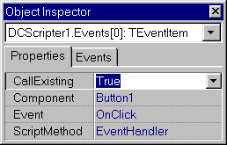
And now, select DCScriper1 component, find its Events property in Object Inspector and press the ellipsis button – you’ll get to the collection editor. Add a TEventItem element and modify its properties in the following way:

- assign True to CallExisting property;
- select Button1 at the component property;
- select OnClick in the event property;
- select EventHandler in the ScriptMethod property.

That’s all you need to implement a VBScript event handler. Run your application and press the button.

This example can be found in the EXAMPLES\EVENTS folder.

Some more words are to be said about event handling. First of all, pay attention to the LinkEvents property of TDCScripter. By default it is True but if you to disable event handlers implemented in the script then assign False to it.

Please pay attention to CallExisting property of TEventItem. It determines whether the event handler main program will be executed (if True) or not (if False).

Scripting Languages

Scripting Languages Installation

Dream Scripter supports all widely used scripting languages, but you need to make some pre-starting procedures before using them:

- ObjectPascal Interpreter is written thoroughly in Delphi and doesn’t require any external scripting engines. All you need to use it is to add dcpascal to the Uses section of your project.

- For VBScript/JavaScript languages support you need to install Microsoft Scripting v3.0+ (freeware product from Microsoft). If you have installed Internet Explorer 3 or higher, you already have v3.0 of Microsoft Scripting but we suggest to download and install latest scripting engine version (5.0 or higher). All related documentation and VBScript/JavaScript languages descriptions can also be found on Microsoft site: http://msdn.microsoft.com/scripting/

- For Perl support you need to download and install latest version of "Active Perl" (freeware product from Active State) from http://www.ActiveState.com

- You need to download and install the latest version of Python interpreter and Python for Active Scripting from http://www.python.org for Python support.

Encoded Scripting Languages

Dream Scripter can work with encoded scripts — JavaScriptEncoded and VBScriptEncoded. Imagine that you want to make scripts that you are using in your application inaccessible to other people. In this case you can encode your scripts with Microsoft Script Encoder. This freeware utility that can be downloaded from the Microsoft web site. So, to use encoded scripts you only have to specify the corresponding encoded scripting language in the Language property of TDCScripter (as you always do when selecting the scripting language).

Available Scripting Languages

Every scripting language supported by Dream Scripter is associated with certain file extension, so that Scripter “recognizes” which language is used in which file. Here is the table that shows which file extension is registered for which scripting language:

Scripting Language | Registered Extension
DelphiScript | .pas
VBScript | .vbs
JavaScript | .js
PerlScript | .pl
PythonScript | .py
EnableScript | .bas

You can register TScriptRunner classes for the custom extensions using RegisterScriptRunner procedure. To get the TScriptRunner class registered for the specified extension use GetScriptRunnerClass function. If no TScriptRunner class is registered for the extension then GetScriptRunnerClass returns nil.

Active Scripting

Dream Scripter supports Active Scripting technology. It means that you can use Dream Scripter with any scripting language that supports standard Active Scripting interfaces.

To make Dream Scripter support new Active Scripting language you need to create the class inherited from TAXScriptRunner class. Override its GetDefualtCatID function that returns the GUID for the scripting language. Here is an example of GetDefaultCatID implementation of TVBScriptRunner class:

function TVBScriptRunner.GetDefaultCatID: TGUID;
const CatID_VBScript = {B54F3741-5B07-11CF-A4B0-00AA004A55E8};
begin
result := CatID_VBScript;
// This is the Active Scripting Engine GUID
end;

Please note that you need to install the corresponding Active Scripting Engine in order to use the Active Scripting Language.

Delphi Script

As noticed above, Dream Scripter provides Delphi Script Interpreter that allows working with Pascal scripts. Delphi Script Interpreter supports the subset of Delphi language that may have the following syntax constructions:

- begin-end
- try-except
- try-finally
- if-then-else
- for, while-do, repeat-until
- exit, break, continue
- with
- goto

Delphi Script Interpreter also support classes, procedures, functions, variables and constants, all logical operations (and, or, not, xor) and other standard Delphi operators. Logical operations are evaluated in short-circuit style. You can use this Delphi language subset to integrate Pascal scripts into your applications.
Working With Actions

Dream Scripter is capable of working with Action objects (TAction) which appeared first in Delphi 4. That is, you can assign script functions to action methods.

Dream Company provides TDCScriptAction class that is inherited from Delphi/C++ Builder TAction. To link subroutines implemented in scripts with actions simply add TDCScriptAction item to TActionList and specify action methods using the following TDCScriptAction properties:

Property | Description
Scripter | Specifies the TDCScripter instance, which functions are used as Action methods
ExecuteMethod | Script method for OnExecute event
UpdateMethod | Script method for OnUpdate event

Let’s make a small example to illustrate how to work with actions in scripts. Create new application and place the following components on the form:
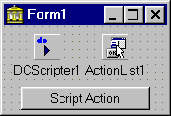
- TDCScripter component from Dream Company page;
- TActionList control from Standard page;
- TButton control from Standard page.

Select DCScripter1 component and implement this simple script (by modifying Script property):

Sub MyMessage(s)
ShowMessage("You've just pressed the button")
End Sub

Of course you have to select VBScript in the Language property of DCScripter1.

Now select ActionList1 component, press the right mouse button on it and select Action List Editor from the popup menu. After you get to the editor press the right mouse button at the Categories area and select New Standard Action from the popup menu. Then, choose TDCScriptAction from the list of standard actions and press OK button.

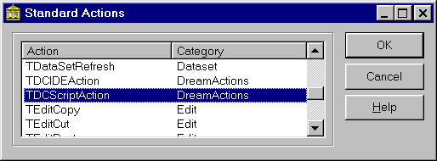

After this DCScriptAction1 has to appear in the list of actions.

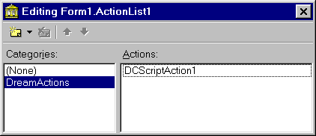

And now we should modify properties of DCScriptAction1. To do so select it in the Action List Editor and turn to the Object Inspector. First of all choose DCScripter1 in its Scripter property. Then select MyMessage in ExecuteMethod property.
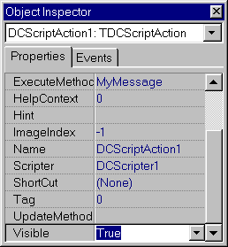
Finally, select Button1 control and specify DCScriptAction1 in its Action property.

Before you run the application please add vclimp and impreg units to the uses section of your application.

And now everything is ready and you can execute the application. When you’ll press the button a message box has to appear.

You can find this example in EXAMPLES\ACTIONS property.

Advanced Usage

In this chapter we will discuss how to operate with script and form associated with it that are stored in the table. We will make a sample application that loads a script and a form from the table, executes the script and displays the form.

Let’s consider a database that has two fields: UNIT and UNIT.DFM designed to store respectively the script and the associated form.

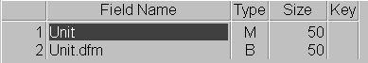

Now we need to create a new file system that has to work with table records. To do so create a new class TBLOBFileSystem deriving it from TFileSystem that is implemented in the dcsystem unit:

type
TBLOBFileSystem = class(TFileSystem)
private
fDataSet : TDataSet;
public
function FileExists(const FileName: TFileName): Boolean;override;
function GetFileStream(const FileName: TFileName; Mode: Integer): TStream;override;
published
property DataSet : TDataSet read fDataSet write fDataSet;
end;

As you can see we override FileExists and GetFileStream functions and implement a new DataSet property. FileExists function is used to determine whether the specified file exists (in our case – table field). Here is the implementation of this method:

function TBLOBFileSystem.FileExists(const FileName: TFileName): Boolean;
begin
result := (DataSet.FindField(FileName) <> nil);
end;

GetFileStream function returns the stream that is used to read/write information to the file (in our case – to table field). Here is the implementation of this method:

function TBLOBFileSystem.GetFileStream(const FileName: TFileName; Mode: Integer): TStream;
begin
with DataSet do
result := CreateBlobStream(FieldByName(FileName), TBlobStreamMode (Mode));
end;

Then we need to write a global function that will return the file system identifier (FilerID) for our file system (TBLOBFileSystem):

function GetBLOBFilerID(DataSet: TDataSet) : TFilerID;
var fs : TBLOBFileSystem;
begin
fs := TBLOBFileSystem.Create(DataSet);
try
fs.DataSet := DataSet;
result := GetFilerID(fs);
finally
fs.Free;
end;
end;

At last we should tell the Scripter that we are going to use custom file system. To do so modify FilerID property of the TDCScripter as it is shown below:

procedure TForm1.FormCreate(Sender: TObject);
begin
DCScripter1.FilerID := GetBLOBFilerID(Table1);
end;

Before you run the application:
- choose the script language in the Language property;
- assign unit to the ScriptFile property (it indicates the table field that will be used to store data);

You can find this example in the EXAMPES\DBSCRIPT folder.
Troubleshooting

The following known problems are described in this section:
- «Scripting engine can't be started» error occurs
- «No Script Runner registered for DelphiScript language» error occurs
- None of VCL procedures or functions is working when calling from within the script
- Script function called by DispatchMethod doesn’t work properly
- Script property of TDCScripter doesn’t affect anything
- I cannot compile application with DCScripter because of some units not found
- I need to refer to some third-part components in script but I haven’t sources
- I have problems when using Perl scripts with Dream Scripter
- When I try to import a unit with the IMPGEN program I got an error «Wintypes not found» or similar
- Events aren't called when executing script projects
- Error cannot be removed with Troubleshooting section hints

«Scripting engine can't be started» error occurs
- Check whether you have pre-installed corresponding scripting language (see Scripting Language Installation section)
- If scripting engine is successfully installed and the problem remains, it is possible to get such message, when Dream Scripter is used from thread. DCScripter uses COM functions, so it requires CoInitialize to be called in the current thread. The solution to this problem is to call CoInitialize(nil) in the thread before using functions of Scripter. Don't forget to call CoUninitialize when your thread is terminated.

«No Script Runner registered for DelphiScript language» error occurs

- Just add dcpascal to the uses clause of your project.

None of VCL procedures or functions is working when calling from within the script
- You need to add import files for VCL. Just add to your project IMPORTED\vclimp.pas file.
Script function called by DispatchMethod doesn’t work properly
- Make sure that you pass parameters in reverse order. Also, don’t call script methods without parameters with DispatchMethod, use CallNoParams Method.
Script property of TDCScripter doesn’t affect anything
- Make sure you don’t use ScriptFile property of TDCScripter. If so, Script property, specified at design time, will be ignored.
I cannot compile application with DCScripter because of some units not found
- We do not distribute import files with registered version of Dream Controls, that is why import files may not be found. You can create all import files with \APPS\IMPGEN program or download one of the trial versions and take import files from there.
I need to refer to some third-part components in script but I haven’t sources
- If you use third part components in your project and have to access its object from script, but vendor doesn't supply sources, ask it for .INT files.

I have problems when using Perl scripts with Dream Scripter
- Some versions of Perl don't support parameters of IDispatch type (TObject type in Delphi) passed to function. It ignores them so if you have event like OnA(Sender: TObject; x: integer) it will be called as if it is declared OnA(x : integer).
When I try to import a unit with the IMPGEN program I got an error «Wintypes not found» or similar
- WinTypes and WinProcs units are present only in Delphi 1. But they can be used in newer Delphi versions as these units are aliased in Delphi as «WinTypes = Windows; WinProcs = Windows». IMPGEN program supports aliases also in the same format. See IMPgen: GUI version section for detailed solution and other common aliases.

Events aren't called when executing script projects
- Event may not be called if its type isn't registered in the Dream Scripter with RegisterEvent routine or corresponding import file. If you add unit impreg.pas to your project, all standard VCL event types will be registered and will be available for use in scripts.
Error cannot be removed with Troubleshooting section hints
- Please, send e-mail with detailed description of your problem to the following address: support@dreamcompany.com. Don’t forget to specify what versions of Delphi/C++ Builder and what OS you are using.

