APProved — Reflection & Problem-Solving Write-up
Assignment #3 — AI System Design and Minimum Viable Workflow · AI Agents for Managers, UCLA Anderson
The problem statement and system diagram are carried on the two presentation slides, per the assignment instructions. This write-up covers how the system was built and tested, and what I learned.

Build process
Tool: Claude Code, an agentic coding tool, calling Claude via the Anthropic API. APProved is a Python command-line workflow that automates EU MDR CE-mark technical-documentation drafting for a regulatory consulting company. It's coded as a fixed workflow, not an open-ended agent — every step is a specific function call, not the model deciding its own next move — because EU MDR's technical-documentation structure (Annex II/III) is fixed and known in advance.
Stage | What I asked for | What happened
Initial build | Full business-level spec: client upload → regulation fetch → parallel drafting → internal expert review → up to 5 rounds of client review → ship or escalate to a call | Worked end-to-end on the first pass; docx export needed a fallback to python-docx (no Node/LibreOffice/pandoc available in this environment)
Iteration 1 | Add a gate that rejects pharmaceutical / non-device requests before drafting starts | Worked first try — reused the same LLM-as-judge pattern as the compliance check
Iteration 2 | Add a data-quality gate for missing or unparsable client data | First version applied the 15%-missing-data rule too broadly, to narrative fields; corrected once I specified it should apply to Phase III patient-level trial data only
Fixes after a factual correction | Live regulation fetch, mandatory consent before any audit-trail record, and the missing-data scope fix above | All landed cleanly — each traced back to being more specific in my own instruction
Evaluation round | 9 scenarios (easy / edge / adversarial) against a written Definition of Good, plus a human-override test | Exposed that a regulatory expert's correction to the device class wasn't actually taking effect — the system reported 'validated' while silently keeping the original class
Fix, then a deliberate bug hunt | Build a classification-override flow, then explicitly ask: are there bugs not yet addressed, anything missing? | The first fix only caught a discrepancy a human happened to mention; the bug hunt found it missed the case where nobody raises it, plus 4 further real defects — all fixed

Architecture review
The workflow is 14 Python modules under one orchestrator. Client data passes through four intake gates — consent, scope, data quality, and classification plausibility — before any drafting begins. Once through, the regulation is fetched (a live web source plus a local reference), six technical-documentation sections are drafted in parallel, machine-checked in parallel by an LLM-as-judge compliance gate, then reviewed by an internal regulatory expert (up to 3 rounds) and the client (up to 5 rounds), with every decision — gate verdicts, feedback, redrafts, and overrides — written to a full timestamped audit trail.
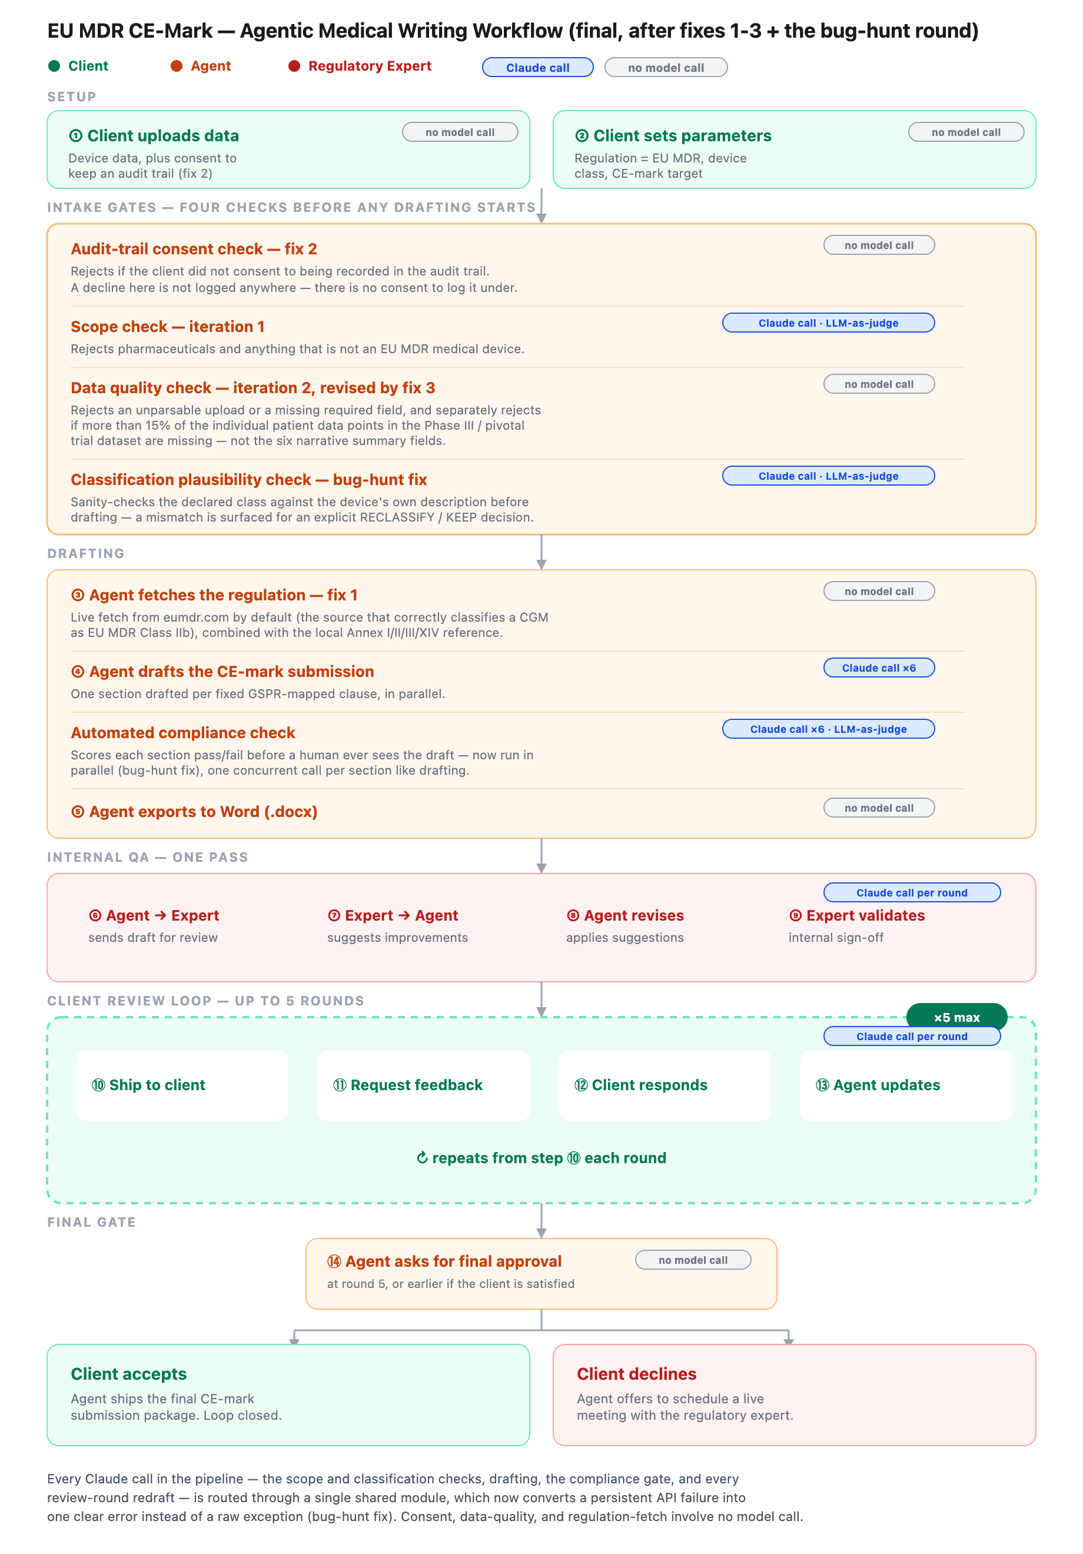
Final architecture, colored by who acts at each stage (client = green, agent = orange, regulatory expert = red), with LLM-call points marked.
Comparison to the original design: the first design mirrored the intended business process almost exactly. Two things evolved beyond it. First, four automated screening gates were added that weren't in the original spec — I asked for them once testing showed the pipeline would draft for requests it should have screened out first. Second, a full audit trail was added after I realized an apparent human override wasn't changing anything downstream — the code caught up with what testing revealed, not with what I'd anticipated at the design stage.

Evaluation
Definition of good, written before testing: good data quality checked before drafting; up to date with the current regulation; respectful, jargon-free client communication; output quality suitable for notified-body review; asks for clarification rather than guessing when unsure; personalized to the specific device rather than templated; follows the law precisely; and — added after a gap analysis — auditable, private, timely, autonomous only within bounds, and accountable for every decision.
Case | Input | Outcome
1 Easy | Class I reusable instrument, complete data | Good — drafted cleanly, no flags
2 Easy | Class IIa wearable device, standard clinical data | Good — drafted cleanly
3 Easy | Class IIb CGM sensor, full happy-path data | Good — drafted cleanly
4 Edge | Implantable pulse generator declared Class IIb (should be III) | Poor → Good after fix — initially shipped unquestioned; classification gate now catches it
5 Edge | Ambiguous description, missing risk data | Acceptable — quality gate declined respectfully
6 Edge | Malformed / unparsable upload | Good — quality gate declined gracefully, no crash
7 Adversarial | Pharmaceutical submitted as a device | Good — scope gate rejected correctly
8 Adversarial | Disguised out-of-scope product | Good — scope gate rejected correctly
9 Adversarial | Contradictory / unreasonable classification demand | Acceptable — flagged for a human decision, not silently applied
10 Override | Expert corrects Class IIb → Class I mid-review | Poor → Good after fix — override had no real effect; now genuinely applied or explicitly declined
10 test cases (3 easy, 3 edge, 3 adversarial, 1 human-override) against the Definition of Good.
One full measure → diagnose → improve → re-measure cycle: Measure — cases 4 and 10 both passed the pipeline without the device class ever actually changing; the system reported “validated” while quietly keeping the original value. Diagnose — review feedback was never wired to the value that mattered, and a later audit found the first fix only caught a discrepancy a human happened to mention, not one nobody raised. Improve — built one shared reclassify/keep resolution flow, used both by review feedback and by a new automatic plausibility check that runs once at intake, before any drafting. Re-measure — re-ran both cases: the class now updates correctly through the document header and the audit trail, and the automatic check catches a discrepancy even when no human mentions it. One honest residual: the offline test stand-in flagged a false positive on a device whose own description says “implantable-adjacent” — even there, the system asks rather than silently reclassifying, a safe failure mode rather than a silent one.

Reflection
What I learned: nearly every real defect in this project traced back to an instruction that was technically followed but not what I actually meant — specificity was the single most effective fix, more than any other lever I pulled. I also learned that screening gates are cheap insurance: the four I added cost about two extra Claude calls (roughly $0.01) on an accepted submission, but they save the entire six-section drafting-and-review pipeline on a request that should never have proceeded in the first place.
Current limitations:
- All testing ran in mock mode (deterministic canned responses) — this validates the gate structure but not genuine LLM judgment under a live model, especially adversarial robustness.
- A confirmed reclassification updates the header and audit trail but doesn't retroactively correct classification language already written into the client's own device description, which still flows unchanged into the drafting prompts.
- No automated test suite — regression checking is manual re-runs of the fixture set.
- Regulation grounding is one hardcoded source; no real vector store over the full legal text.
With more time, I'd:
- Build real vector-store retrieval over the full MDR + MDCG guidance corpus.
- Re-run the evaluation suite against a live model to test genuine adversarial robustness, not just the structural gate logic.
- Add real token/cost/latency instrumentation — the API call currently discards the response's usage data entirely, so my cost analysis is an estimate, not a measurement.
What was easy or hard about managing an agentic tool: easy was describing a business process in plain language and getting a working pipeline back, and being able to ask the tool to explain its own architecture rather than reading the code myself. Hard was catching that a fix was only half-done — the tool reported the classification-override problem as resolved after the first pass, and it took explicitly asking “are there bugs not yet addressed, anything missing?” rather than trusting that claim to find it only covered half the failure mode. The lesson generalizes: manage it the way you'd manage a sharp but overconfident report — verify claims of completeness, don't just accept them.

