Murakami Watchlist: Damodaran-Style Valuations
17 companies: 4 the Murakami investors are adding, 13 potential targets · Data as of 2026-09-30

Summary
Nine of the 17 look undervalued on a discounted-cash-flow basis. Four look roughly fairly priced. Four cannot be justified by their cash flows. Two of those four, Mitsubishi Paper and Yamada, are stocks the family is buying, where the case rests on assets or a deal rather than cash flows. Price-to-book is shown against the level peers with the same return on equity trade at, which is a weak test in Japan.
Company (code) | Group | Price | DCF value / share | vs price | P/B actual / peer | Read
Mitsubishi Paper Mills (3864) | Family adding | ¥1,217 | below zero | — | 0.53 / 0.47 | Overvalued on cash flows; asset or event play
TOW (4767) | Takateru adding | ¥393 | ¥709 | +80% | 1.78 / 2.00 | Undervalued
Yamada Holdings (9831) | Family adding | ¥717 | ¥174 | -76% | 1.08 / 1.71 | Overvalued on cash flows; asset or event play
Primo Global Holdings (367A) | Takateru adding | ¥2,877 | ¥2,237 | -22% | 1.25 / 1.77 | Roughly fair
TPR (6463) | Target, family-size | ¥1,520 | ¥2,138 | +41% | 0.48 / 1.28 | Undervalued
Topre (5975) | Target, family-size | ¥3,310 | ¥3,891 | +18% | 0.71 / 0.92 | Roughly fair
S Foods (2292) | Target, family-size | ¥2,680 | ¥7,779 | +190% | 0.62 / 1.30 | Undervalued
Stanley Electric (6923) | Target, family-size | ¥3,450 | ¥3,063 | -11% | 0.76 / 1.51 | Roughly fair
Kyoei Steel (5440) | Target, family-size | ¥1,923 | ¥3,494 | +82% | 0.39 / 0.73 | Undervalued
Hi-Lex (7279) | Target, family-size | ¥2,431 | ¥1,070 | -56% | 0.39 / 0.66 | Overvalued on cash flows; asset or event play
Futaba Corporation (6986) | Target, small | ¥732 | ¥840 | +15% | 0.33 / 1.44 | Roughly fair
Asahi Broadcasting Group (9405) | Target, small | ¥832 | ¥1,726 | +107% | 0.42 / 2.14 | Undervalued
Musashi (7521) | Target, small | ¥2,647 | ¥8,311 | +214% | 0.57 / 1.22 | Undervalued
Nakayama Steel Works (5408) | Target, small | ¥619 | ¥1,882 | +204% | 0.35 / 0.68 | Undervalued
Cleanup (7955) | Target, small | ¥932 | ¥1,347 | +45% | 0.56 / 1.14 | Undervalued
Fukuvi Chemical Industry (7871) | Target, small | ¥1,010 | ¥1,757 | +74% | 0.51 / 1.15 | Undervalued
Kitagawa (6317) | Target, small | ¥2,552 | ¥777 | -70% | 0.52 / 1.35 | Overvalued on cash flows; asset or event play

Method
Each company follows Aswath Damodaran's (NYU Stern) sequence: the business story drives revenue growth, operating margin and reinvestment. Those give free cash flow to the firm, which is discounted at a cost of capital that reflects the risk. The same inputs are used for every company, so differences come from the businesses, not from the analyst.
- Riskless rate 2.5%. The 10-year JGB yields 3.10%. Damodaran removes the sovereign default spread when a government is not Aaa, and Japan is A1 with a 0.60% spread.
- Equity risk premium 5.14%. This is Damodaran's January 2026 figure for Japan: a 4.23% mature-market premium plus a 0.91% country premium.
- Beta. Damodaran's Japan industry unlevered beta, corrected for cash, re-levered at each company's market debt-to-equity. Tax rate 29.74%.
- Cost of debt. The riskless rate plus a spread from a synthetic rating based on interest coverage.
- Growth. Years 1–5 use the average of company guidance and the three-year sales growth rate, capped between −2% and 8%. Growth then fades to 2.5% by year 10.
- Margins. The operating margin moves from this year's guided level to its five-year average by year 5.
- Reinvestment. The change in revenue divided by the company's sales-to-capital ratio, clipped between 0.8 and 4.
- Terminal value. Return on capital equals the cost of capital, so growth after year 10 adds no value. This is Damodaran's default for firms without a lasting moat.
- Equity value. Operating value plus cash and investment securities at book, minus debt and minority interests. It is divided by shares outstanding excluding treasury stock.
- Peer check. Price-to-book regressed on return on equity across the company's Tokyo Stock Exchange sector. It gives the price-to-book peers with the same return on equity trade at, and R² shows how little that explains.
Limits: these are mechanical valuations for screening, not recommendations. They credit cash and securities at full book value, which Damodaran would discount when cash is trapped or poorly managed. Values for the deepest-value names are very sensitive to margins and the discount rate.

Asset plays: can they lever up or sweat the assets?
Twelve of the 17 are asset plays in one of two senses. For Mitsubishi Paper, Yamada, Hi-Lex and Kitagawa, the cash flows do not support the price, so the question is whether the assets do. For the other eight, cash and investment securities make up half or more of the market value, so the question is how much could be returned or borrowed against.
- Net cash + securities per share. Cash and short-term investments plus long-term investment securities at book, minus all debt.
- Payout capacity. Cash above 5% of revenue, plus the new debt the business could carry at the lower of 2.0 times EBITDA and an A-level interest coverage of 4.25 times. This is a prudent limit, shown as a share of market value.
- Damodaran optimal debt ratio. The debt ratio that minimizes the cost of capital using synthetic credit ratings. For cash-rich firms it often comes out at 50–75%, which is a theoretical ceiling that ignores cyclical risk, not a recommendation. For over-levered firms it shows how far debt should fall.
- Value at sector-median margin. The same DCF with the target operating margin raised to the median of the company's Tokyo Stock Exchange sector, where that is higher than its own five-year average. This measures what sweating the assets is worth.
Company (code) | Net cash + securities / share | Price | Price / tangible book | Payout capacity | Value at sector-median margin | Debt ratio now → Damodaran optimum
Mitsubishi Paper Mills (3864) | −¥813 | ¥1,217 | 0.52 | 0% | ¥153 | 54.9% → 0.0%
Yamada Holdings (9831) | −¥379 | ¥717 | 0.80 | 0% | ¥483 | 39.4% → 15.0%
Hi-Lex (7279) | ¥2,643 | ¥2,431 | 0.52 | 64% | ¥5,487 | 10.5% → 25.0%
Kitagawa (6317) | ¥120 | ¥2,552 | 0.54 | 38% | ¥4,757 | 40.5% → 50.0%
TPR (6463) | ¥1,486 | ¥1,520 | 0.57 | 68% | ¥2,851 | 23.6% → 60.0%
TOW (4767) | ¥223 | ¥393 | 1.56 | 70% | ¥709 | 4.1% → 70.0%
Futaba Corporation (6986) | ¥1,255 | ¥732 | 0.37 | 110% | ¥1,345 | 1.6% → 0.0%
Asahi Broadcasting Group (9405) | ¥948 | ¥832 | 0.43 | 96% | ¥2,863 | 28.5% → 75.0%
Musashi (7521) | ¥3,759 | ¥2,647 | 0.49 | 157% | ¥8,311 | 16.3% → 75.0%
Nakayama Steel Works (5408) | ¥345 | ¥619 | 0.31 | 61% | ¥1,882 | 20.2% → 50.0%
Fukuvi Chemical Industry (7871) | ¥994 | ¥1,010 | 0.51 | 81% | ¥2,504 | 7.0% → 60.0%
Cleanup (7955) | ¥463 | ¥932 | 0.59 | 65% | ¥2,936 | 21.0% → 55.0%
Hidden gains on land carried at historical cost are not captured here; for Yamada in particular they are the main unknown.

Names the Murakami investors are adding

Mitsubishi Paper Mills (3864)
The cash flows do not support the price: the DCF value is below zero, against ¥1,217, so the case rests on assets or an event.
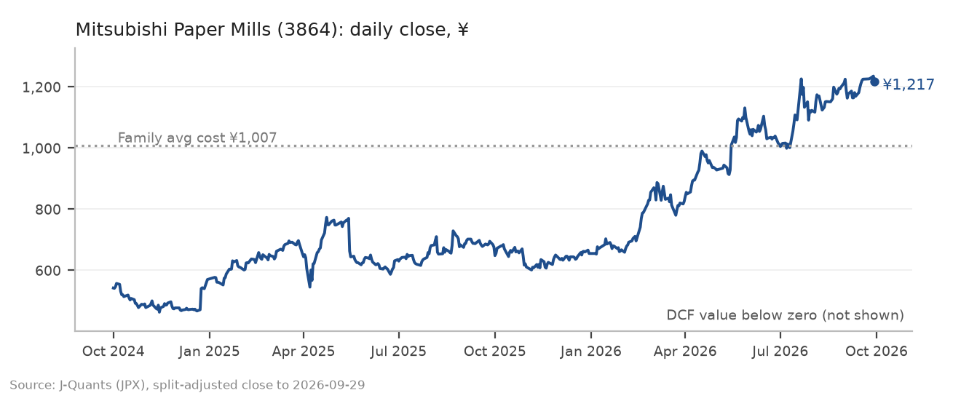
The story
Mitsubishi Paper makes printing, specialty and imaging papers. Oji Holdings, Japan's largest paper maker, has owned about a third of it since a 2018 capital alliance and holds 32.8% today. Margins have run close to zero: 0.2% last year and 1.2% on a five-year average. That is far below the 7.9% cost of capital, so the operating business is worth less than its net debt in a DCF.
From story to value
Base-year revenue | ¥157.5B (fiscal year to 2026-03)
Operating margin, last year → target | 0.2% → 1.2% (five-year average, reached by year 5)
Revenue growth, years 1–5 | 1.0% a year, fading to 2.5% by year 10
Sales-to-capital (reinvestment) | 1.13
Return on capital vs cost of capital | 0.1% vs 7.9%
Beta (industry) | 0.99 (Paper/Forest Products; unlevered 0.53)
Cost of equity / cost of capital | 7.6% / 7.9%
Cash / investment securities / debt | ¥4.9B / ¥24.4B / ¥64.9B (balance sheet 2026-03)
DCF value per share (cost of capital ±1 point) | below zero
No-growth value per share | below zero
Terminal value share of operating value | 94.0%
Price-to-book: actual vs peer-predicted | 0.53 vs 0.47 (ROE 1.8%; Pulp & paper sector regression, 23 companies, R² 0.16)
Price (2026-09-29) | ¥1,217
The DCF cannot justify the price. This is an event bet: on Oji buying the rest, on asset sales, or on a paper-industry merger the family is pushing for. Margins would need to recover to several times their recent level for cash flows alone to support the stock.
The asset angle
Asset value. The stock trades at 0.52 times tangible book of ¥2,332 a share. But that book is mostly paper mills, with ¥65.7B of plant, and it is financed with debt. Current assets fall ¥859 a share short of total liabilities. Mills are worth far less outside the industry than their book value suggests.
Can it lever up? No. Net debt is already 10.4 times EBITDA. On Damodaran's optimal-capital-structure test the value-maximizing debt ratio is zero, against 54.9% today, because thin margins leave no room for interest. The balance sheet needs to shrink, not grow.
Can it sweat the assets? Not enough. Raising margins to the 3.6% pulp-and-paper median gives only about ¥153 a share, against a ¥1,217 price. The price therefore depends on a transaction. The most plausible is Oji, which already owns 32.8%, buying the rest to capture the cost savings it has pursued since 2018.
Top 10 shareholders plus treasury stock (March 2026 annual report)
# | Shareholder | Stake | Shares | vs prior half
1 | 王子ホールディングス | 32.84% | 14,693,000
2 | インタラクティブ･ブローカーズ | 5.25% | 2,351,000 | down
3 | 那須功一 | 2.95% | 1,320,000
4 | MSIPクライアントセキュリティーズ | 2.38% | 1,063,000
5 | 自社取引先持株会 | 2.23% | 996,000
6 | 日本マスタートラスト信託銀行(役員報酬BIP信託口・76599口) | 1.88% | 842,000
7 | 野村證券 | 1.76% | 786,000
8 | 中原証券 | 1.62% | 723,000
9 | 寺田英司 | 1.58% | 709,000 | down
10 | 野村證券 | 1.50% | 673,000
11 | 自社(自己株口) | % | 0.18

TOW (4767)
Undervalued on our numbers: the DCF value is ¥709 (¥656–¥775) a share, against a price of ¥393.
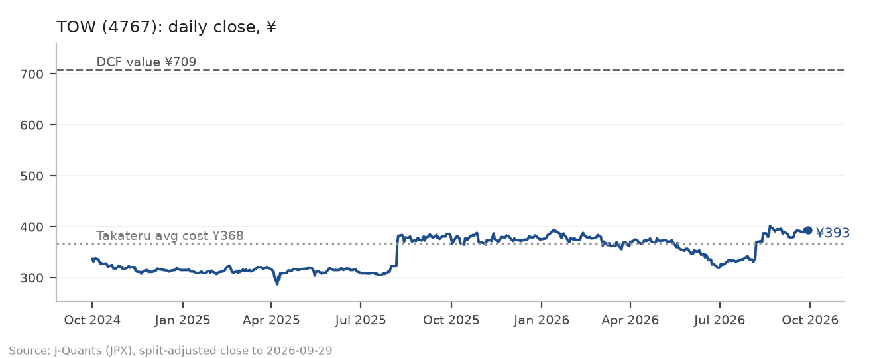
The story
TOW plans and produces corporate events, exhibitions and promotions. It is asset-light, earns a 10.8% operating margin and a very high return on capital, and has no net debt. It holds 16% of its own shares in treasury. Takateru Murakami owns 2.7% personally and 7.5% with his companies, and his filings ask for buybacks and higher dividends.
From story to value
Base-year revenue | ¥18.7B (fiscal year to 2026-06)
Operating margin, last year → target | 10.8% → 10.4% (five-year average, reached by year 5)
Revenue growth, years 1–5 | 8.0% a year, fading to 2.5% by year 10
Sales-to-capital (reinvestment) | 4.00
Return on capital vs cost of capital | 89.3% vs 9.9%
Beta (industry) | 1.51 (Advertising; unlevered 1.46)
Cost of equity / cost of capital | 10.2% / 9.9%
Cash / investment securities / debt | ¥8.7B / ¥1.2B / ¥0.7B (balance sheet 2026-06)
DCF value per share (cost of capital ±1 point) | ¥709 (¥656–¥775)
No-growth value per share | ¥557
Terminal value share of operating value | 50.6%
Price-to-book: actual vs peer-predicted | 1.78 vs 2.00 (ROE 12.8%; Services sector regression, 473 companies, R² 0.11)
Price (2026-09-29) | ¥393
At ¥393 the market prices TOW as if event demand will shrink. Our DCF assumes growth at the company's guided pace, fading to 2.5%, and gives ¥709 (¥656–¥775). The risk is that events are cyclical and project-driven.
Asset angle: cash and payout capacity
There is almost no plant; the value is the business plus ¥8.7 billion of cash. About ¥7.8 billion is surplus to operating needs, and it could carry about ¥3.5 billion of debt, together about 70% of market value. The 16% of shares already in treasury shows management is willing to buy back stock.
Top 10 shareholders plus treasury stock (June 2026 annual report)
# | Shareholder | Stake | Shares | vs prior half
1 | 自社(自己株口) | 15.72% | 7,698,800 | up
2 | 日本マスタートラスト信託銀行(信託口) | 9.90% | 4,848,000 | down
3 | 真木勝次 | 7.44% | 3,642,000
4 | MURAKAMI TAKATERU | 2.74% | 1,340,000
5 | 日本カストディ銀行(信託口) | 2.55% | 1,249,000 | down
6 | ライク | 2.12% | 1,040,000
7 | MI2 | 1.80% | 880,000
8 | 今津秀 | 1.14% | 560,000
9 | 佐竹一郎 | 1.10% | 537,000
10 | 村津憲一 | 0.87% | 426,000
11 | 舛森丈人 | 0.82% | 403,000

Yamada Holdings (9831)
The cash flows do not support the price: the DCF value is ¥174 (¥63–¥329) a share, against ¥717, so the case rests on assets or an event.
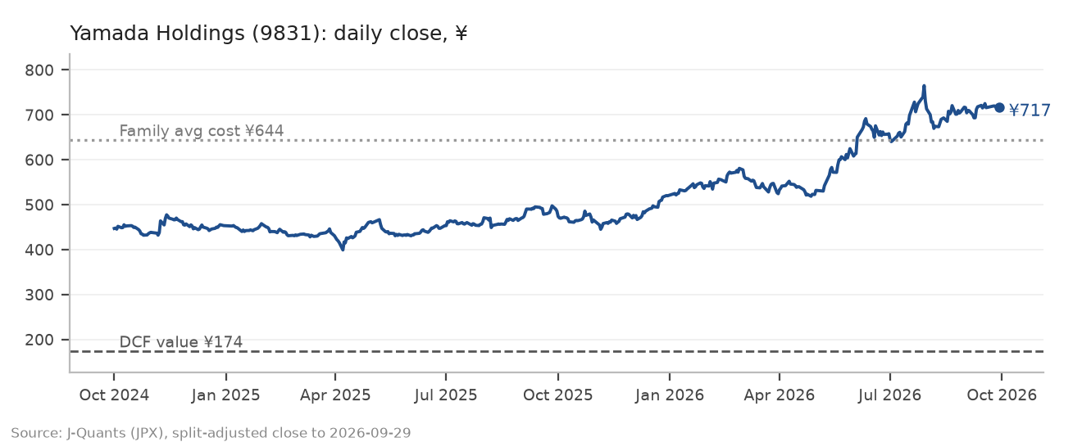
The story
Yamada is Japan's largest consumer-electronics chain, with housing, recycling and consumer-finance units attached. Operating margin fell to 1.0% on ¥1.69 trillion of sales, and return on capital of 1.3% is far below its 6.6% cost of capital. In Damodaran's terms, every yen of growth destroys value.
From story to value
Base-year revenue | ¥1,691.8B (fiscal year to 2026-03)
Operating margin, last year → target | 1.0% → 2.6% (five-year average, reached by year 5)
Revenue growth, years 1–5 | 3.5% a year, fading to 2.5% by year 10
Sales-to-capital (reinvestment) | 1.89
Return on capital vs cost of capital | 1.3% vs 6.6%
Beta (industry) | 1.29 (Retail (Special Lines); unlevered 0.89)
Cost of equity / cost of capital | 9.1% / 6.6%
Cash / investment securities / debt | ¥38.2B / ¥19.3B / ¥309.6B (balance sheet 2026-03)
DCF value per share (cost of capital ±1 point) | ¥174 (¥63–¥329)
No-growth value per share | ¥311
Terminal value share of operating value | 92.0%
Price-to-book: actual vs peer-predicted | 1.08 vs 1.71 (ROE 2.3%; Retail sector regression, 283 companies, R² 0.01)
Price (2026-09-29) | ¥717
The DCF gives ¥174 (¥63–¥329) against ¥717, and even a no-growth value at normal margins is only ¥311. The family's case is assets and restructuring, not cash flow. Its filing proposes selling non-core units, industry consolidation and a management buyout. The company already holds 31% of its own shares.
The asset angle
Asset value. The stock trades at 0.80 times tangible book of ¥898 a share. Under that sits ¥469.8B of property and equipment, much of it owned stores and land carried at historical cost. Current assets fall short of total liabilities, and net debt is 4.7 times EBITDA.
Can it lever up? No. Damodaran's optimal debt ratio for Yamada is about 15.0%, against 39.4% today, so it is already over-levered and more borrowing would raise its cost of capital.
Can it sweat the assets? Partly. Raising the margin to the 3.6% retail median lifts the DCF to about ¥483, still below ¥717. The realistic route is to turn property into cash. That means sale-and-leasebacks of owned stores or selling the housing and finance units, with the proceeds used to cut debt and buy back shares, which is what the family's filing asks for. Store property at market value is not disclosed in these data, so how far that closes the gap is the key unknown.
Top 10 shareholders plus treasury stock (March 2026 annual report)
# | Shareholder | Stake | Shares | vs prior half
1 | 自社(自己株口) | 31.28% | 302,422,800 | up
2 | 日本マスタートラスト信託銀行(信託口) | 7.77% | 75,111,200 | up
3 | テックプランニング | 6.76% | 65,327,300
4 | 日本カストディ銀行(信託口) | 3.40% | 32,854,500 | up
5 | ソフトバンク | 2.50% | 24,200,000
6 | 山田昇 | 2.12% | 20,472,900 | down
7 | 公益財団法人山田昇記念財団 | 1.62% | 15,648,000 | up
8 | 野村絢 | 1.48% | 14,345,800
9 | 群馬銀行 | 1.24% | 12,000,000
10 | ステート･ストリート･バンク＆トラスト505001 | 1.16% | 11,253,000
11 | 自社従業員持株会 | 0.95% | 9,229,300

Primo Global Holdings (367A)
Roughly fairly priced: the DCF value is ¥2,237 (¥1,559–¥3,178) a share, against a price of ¥2,877.
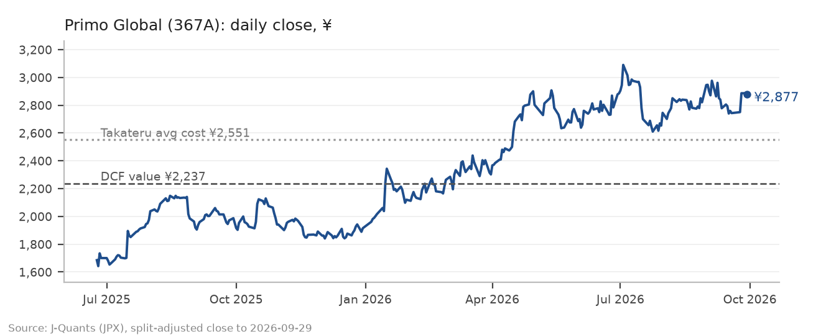
The story
Primo Global sells bridal rings under the I-PRIMO brand in Japan and is expanding in Taiwan, Hong Kong, mainland China and Singapore. It earns an 11.2% operating margin. It relisted in 2025, and its private-equity owner Integral still holds 18.9%. Borrowings from the buyout are about ¥18 billion.
From story to value
Base-year revenue | ¥28.0B (fiscal year to 2025-08)
Operating margin, last year → target | 11.2% → 11.2% (five-year average, reached by year 5)
Revenue growth, years 1–5 | 4.6% a year, fading to 2.5% by year 10
Sales-to-capital (reinvestment) | 0.80
Return on capital vs cost of capital | 6.3% vs 6.6%
Beta (industry) | 1.33 (Retail (Special Lines); unlevered 0.89)
Cost of equity / cost of capital | 9.4% / 6.6%
Cash / investment securities / debt | ¥3.2B / ¥0.0B / ¥18.1B (balance sheet 2026-05)
DCF value per share (cost of capital ±1 point) | ¥2,237 (¥1,559–¥3,178)
No-growth value per share | ¥2,099
Terminal value share of operating value | 76.7%
Price-to-book: actual vs peer-predicted | 1.25 vs 1.77 (ROE 8.8%; Retail sector regression, 283 companies, R² 0.01)
Price (2026-09-29) | ¥2,877
The DCF gives ¥2,237 (¥1,559–¥3,178) against ¥2,877, so the price already assumes faster growth than the 4.6% we use. Takateru's filings raise buybacks and a take-private, and a private-equity owner looking to exit makes a sale plausible. That event, not the DCF, is the investment case.
Top 10 shareholders plus treasury stock (February 2026 half-year report)
# | Shareholder | Stake | Shares | vs prior half
1 | インテグラル3号投資事業有限責任組合 | 18.89% | 1,652,000
2 | BNY･GCMクライアントJPRD･ISG･FEAC | 3.77% | 330,000 | up
3 | ヨシダ トモヒロ | 3.00% | 262,000 | up
4 | イノベーション･アルファ(ケイマン) | 3.00% | 262,000
5 | インテグラル | 2.98% | 261,000
6 | BNYメロンGCMクライアントM･ILMFE | 2.22% | 194,000 | up
7 | 岡三証券 | 2.00% | 175,000
8 | 日本マスタートラスト信託銀行(信託口) | 1.83% | 160,000
9 | ノムラ･インターナショナル･アカント･ジャパンフロウ | 1.54% | 135,000
10 | UBS(ロンドン)IPBセグリゲイテッド･クライアント | 1.37% | 120,000

Takateru Murakami's stakes by entity
Each of his 5% filings is a joint report. The combined stake is the sum of his personal holding and his investment companies MI2, MI5 and MI1. Most of the money is his own: about ¥15.0 billion of the ¥17.9 billion is held in his name, MI2 holds about ¥2.9 billion, and MI5 holds token amounts. MI1 appeared only in the exited Ashimori stake.
Company (code) | Holder | Stake | Shares | Cost | Value now | Filing
Metal Art (5644) | Takateru Murakami (personal) | 22.17% | 700,000 | ¥5.1B | ¥5.1B | 2026-08-13
Metal Art (5644) | MI2 | 4.57% | 144,200 | ¥1.2B | ¥1.1B | 2026-08-13
DaikyoNishikawa (4246) | MI2 | 0.06% | 40,800 | ¥36M | ¥43M | 2026-05-01
DaikyoNishikawa (4246) | Takateru Murakami (personal) | 6.06% | 4,305,900 | ¥3.7B | ¥4.6B | 2026-05-01
DaikyoNishikawa (4246) | MI5 | 0.01% | 10,000 | ¥8M | ¥11M | 2026-05-01
Primo Global (367A) | MI2 | 2.51% | 219,900 | ¥590M | ¥633M | 2026-09-24
Primo Global (367A) | Takateru Murakami (personal) | 9.84% | 860,500 | ¥2.2B | ¥2.5B | 2026-09-24
AD Works Group (2982) | MI2 | 3.31% | 1,676,200 | ¥688M | ¥699M | 2026-09-08
AD Works Group (2982) | Takateru Murakami (personal) | 9.51% | 4,821,200 | ¥2.0B | ¥2.0B | 2026-09-08
AD Works Group (2982) | MI5 | 0.01% | 5,000 | ¥2M | ¥2M | 2026-09-08
TOW (4767) | MI2 | 2.89% | 1,272,600 | ¥475M | ¥500M | 2026-09-14
TOW (4767) | Takateru Murakami (personal) | 4.55% | 2,002,400 | ¥730M | ¥787M | 2026-09-14
TOW (4767) | MI5 | 0.03% | 11,000 | ¥4M | ¥4M | 2026-09-14

Holder | Cost | Value at 2026-09-29 close | Gain
Takateru Murakami (personal) | ¥13.7B | ¥15.0B | +9%
MI2 | ¥3.0B | ¥2.9B | -1%
MI5 | ¥15M | ¥17M | +17%
Cost is the acquisition money stated in each filing. Stakes are percentages of each company's shares outstanding, as reported.

Potential targets: family-size (¥80–800 billion)

TPR (6463)
Undervalued on our numbers: the DCF value is ¥2,138 (¥1,993–¥2,322) a share, against a price of ¥1,520.
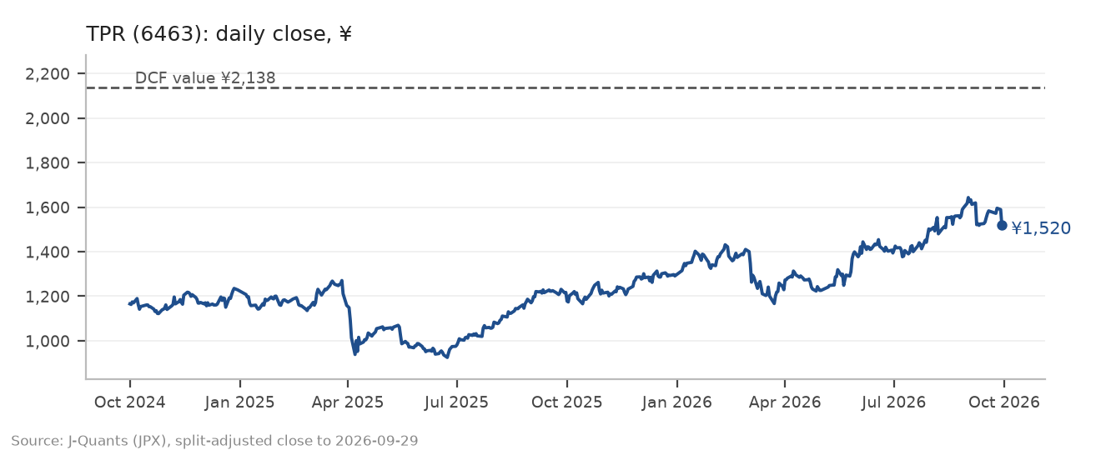
The story
TPR makes piston rings, cylinder liners and other engine parts, plus resin exterior parts and industrial products. Cash of ¥61.6B and investment securities of ¥63.9B together exceed its market value, and it trades at 0.48 times book. The register is institutional, led by trust banks, Meiji Yasuda, Sompo and Mizuho, with no controlling holder.
From story to value
Base-year revenue | ¥190.6B (fiscal year to 2026-03)
Operating margin, last year → target | 5.4% → 5.6% (five-year average, reached by year 5)
Revenue growth, years 1–5 | 2.0% a year, fading to 2.5% by year 10
Sales-to-capital (reinvestment) | 1.62
Return on capital vs cost of capital | 6.1% vs 9.1%
Beta (industry) | 1.70 (Auto Parts; unlevered 1.39)
Cost of equity / cost of capital | 11.2% / 9.1%
Cash / investment securities / debt | ¥61.6B / ¥63.9B / ¥30.2B (balance sheet 2026-03)
DCF value per share (cost of capital ±1 point) | ¥2,138 (¥1,993–¥2,322)
No-growth value per share | ¥2,179
Terminal value share of operating value | 54.8%
Price-to-book: actual vs peer-predicted | 0.48 vs 1.28 (ROE 4.5%; Machinery sector regression, 196 companies, R² 0.06)
Price (2026-09-29) | ¥1,520
Even with only 2.0% growth, the DCF gives ¥2,138 (¥1,993–¥2,322) against ¥1,520, because the cash and securities alone cover most of the price. The long-run risk is the shift to electric vehicles, which erodes demand for piston rings. It is the cleanest Murakami-style target on this list.
Asset angle: cash and payout capacity
Net cash and securities cover the whole market value. It has no net debt, about ¥52 billion of cash above operating needs and room for about ¥14 billion of new debt, together about two-thirds of its market value. With no controlling holder, a large buyback or special dividend is feasible, and the securities could be sold.
Top 10 shareholders plus treasury stock (March 2026 annual report)
# | Shareholder | Stake | Shares | vs prior half
1 | 日本マスタートラスト信託銀行(信託口) | 8.84% | 5,884,000 | down
2 | 明治安田生命保険 | 7.20% | 4,790,000 | up
3 | 損害保険ジャパン | 6.89% | 4,586,000 | up
4 | みずほ銀行 | 4.56% | 3,037,000 | up
5 | ヒューリック | 3.70% | 2,463,000 | up
6 | 東京建物 | 2.81% | 1,867,000
7 | 自社取引先持株会 | 2.65% | 1,765,000
8 | みずほ信託銀行 | 2.30% | 1,532,000
9 | 自社(自己株口) | 2.30% | 1,529,500 | down
10 | 日本カストディ銀行(日野自動車退職給付信託口) | 2.24% | 1,489,000
11 | 日本カストディ銀行(信託口) | 2.11% | 1,404,000 | down

Topre (5975)
Roughly fairly priced: the DCF value is ¥3,891 (¥3,444–¥4,465) a share, against a price of ¥3,310.
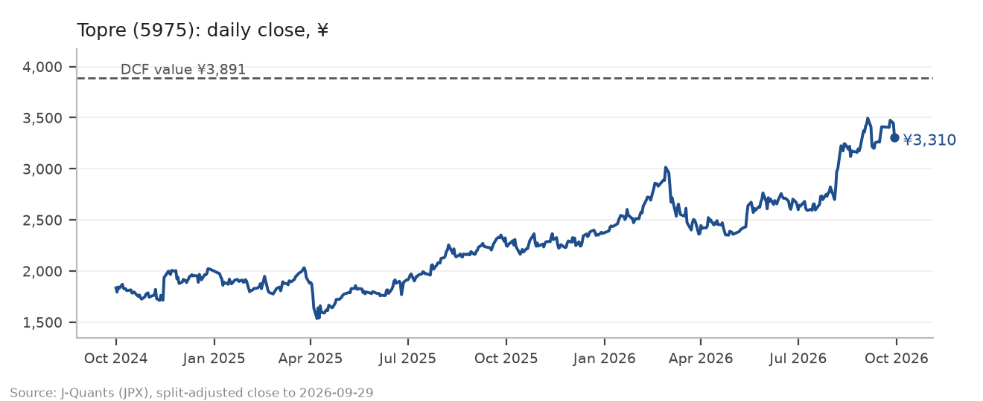
The story
Topre makes car-body stampings, truck refrigeration units, air-conditioning equipment and Realforce keyboards. Its margin rose to 7.4% last year against a 5.3% five-year average. Trust banks are its largest holders, and 8% is treasury stock.
From story to value
Base-year revenue | ¥378.8B (fiscal year to 2026-03)
Operating margin, last year → target | 7.4% → 5.3% (five-year average, reached by year 5)
Revenue growth, years 1–5 | 6.4% a year, fading to 2.5% by year 10
Sales-to-capital (reinvestment) | 1.87
Return on capital vs cost of capital | 9.7% vs 9.1%
Beta (industry) | 1.68 (Auto Parts; unlevered 1.39)
Cost of equity / cost of capital | 11.1% / 9.1%
Cash / investment securities / debt | ¥68.8B / ¥22.7B / ¥46.4B (balance sheet 2026-03)
DCF value per share (cost of capital ±1 point) | ¥3,891 (¥3,444–¥4,465)
No-growth value per share | ¥4,065
Terminal value share of operating value | 75.1%
Price-to-book: actual vs peer-predicted | 0.71 vs 0.92 (ROE 7.4%; Metal products sector regression, 81 companies, R² 0.14)
Price (2026-09-29) | ¥3,310
After a 42% rise over twelve months, most of the discount has closed. Our DCF fades margins back to average and gives ¥3,891 (¥3,444–¥4,465) against ¥3,310. It is fairly priced unless the higher margin proves durable.
Top 10 shareholders plus treasury stock (March 2026 annual report)
# | Shareholder | Stake | Shares | vs prior half
1 | 日本マスタートラスト信託銀行 | 11.57% | 6,253,000 | up
2 | 日本カストディ銀行 | 9.03% | 4,876,000 | up
3 | 自社(自己株口) | 8.20% | 4,430,200
4 | 石井直子 | 4.92% | 2,660,000
5 | 日本生命保険 | 3.95% | 2,135,000
6 | りそな銀行 | 3.46% | 1,870,000
7 | 自社取引先持株会 | 3.00% | 1,622,000 | down
8 | 住友生命保険 | 2.65% | 1,429,000
9 | みずほ銀行 | 2.34% | 1,265,000
10 | ステート･ストリート･バンク＆トラスト505223 | 2.28% | 1,229,000 | up
11 | ステート･ストリート･バンク＆トラスト505001 | 2.11% | 1,138,000

S Foods (2292)
Undervalued on our numbers: the DCF value is ¥7,779 (¥5,894–¥10,784) a share, against a price of ¥2,680.
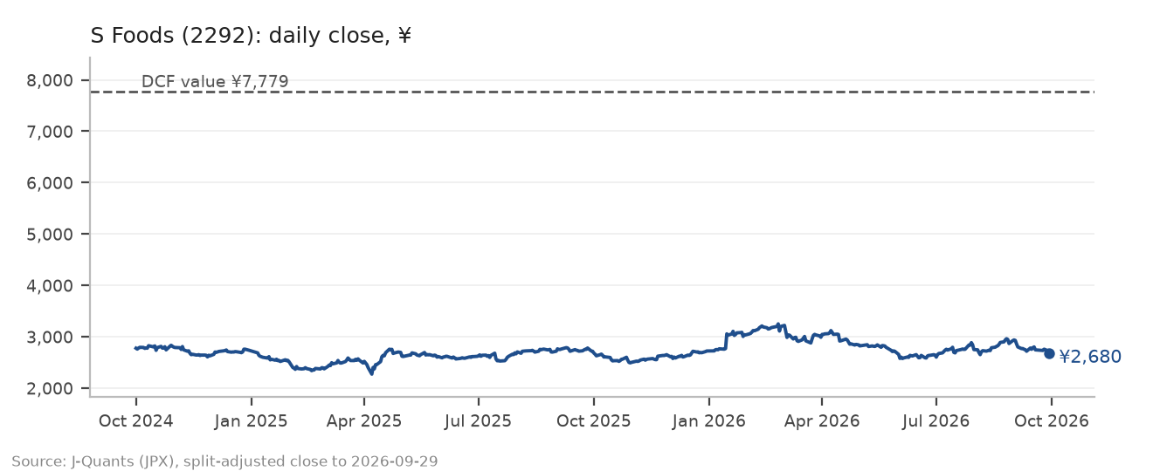
The story
S Foods processes and wholesales meat, including the Kotechan brand, on ¥472 billion of sales with thin 2–3% margins. Damodaran's food-processing beta is very low, which gives a 4.6% cost of capital and a high DCF of ¥7,779 (¥5,894–¥10,784) against ¥2,680.
From story to value
Base-year revenue | ¥472.3B (fiscal year to 2026-02)
Operating margin, last year → target | 2.2% → 3.0% (five-year average, reached by year 5)
Revenue growth, years 1–5 | 5.8% a year, fading to 2.5% by year 10
Sales-to-capital (reinvestment) | 3.35
Return on capital vs cost of capital | 5.2% vs 4.6%
Beta (industry) | 0.70 (Food Processing; unlevered 0.48)
Cost of equity / cost of capital | 6.1% / 4.6%
Cash / investment securities / debt | ¥37.8B / ¥19.4B / ¥57.3B (balance sheet 2026-02)
DCF value per share (cost of capital ±1 point) | ¥7,779 (¥5,894–¥10,784)
No-growth value per share | ¥6,547
Terminal value share of operating value | 88.9%
Price-to-book: actual vs peer-predicted | 0.62 vs 1.30 (ROE 6.6%; Foods sector regression, 118 companies, R² 0.07)
Price (2026-09-29) | ¥2,680
It looks cheap at any reasonable discount rate, but 89% of the value sits in the terminal year, so the figure is fragile. Feasibility is the bigger problem. The founder, 村上真之助, holds 24.8% and Marubeni 15%, which leaves an outside activist little leverage.
Top 10 shareholders plus treasury stock (February 2026 annual report)
# | Shareholder | Stake | Shares | vs prior half
1 | 村上真之助 | 24.80% | 8,001,000
2 | 丸紅 | 15.00% | 4,841,000
3 | 日本マスタートラスト信託銀行(信託口) | 7.13% | 2,301,000 | down
4 | 日本カストディ銀行(信託口) | 4.34% | 1,400,000 | up
5 | (有)ファイブエム | 3.26% | 1,052,000 | down
6 | チェース･マンハッタン･バンク(ロンドン)SLオムニバスアカウント | 2.71% | 873,000
7 | BBHフィデリティ･ロープライスドストックファンド | 2.12% | 685,000 | up
8 | 野村信託銀行(投信口) | 1.95% | 629,000
9 | SMBC信託銀行(三井住友銀行退職給付信託口) | 1.89% | 610,000
10 | 自社(自己株口) | 1.84% | 594,300
11 | JPモルガン･チェース･バンク385781 | 0.73% | 236,000

Stanley Electric (6923)
Roughly fairly priced: the DCF value is ¥3,063 (¥2,660–¥3,582) a share, against a price of ¥3,450.
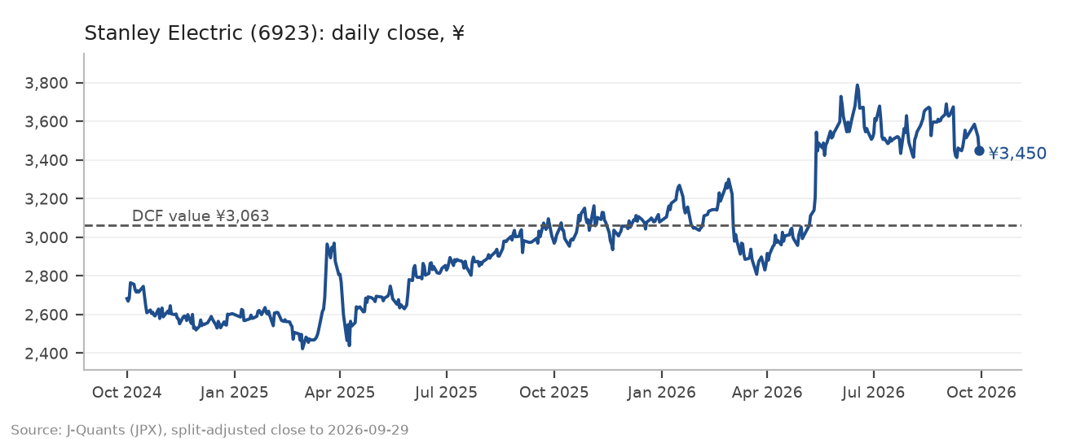
The story
Stanley Electric makes car lamps, mainly LED headlamps, and sells heavily to Honda, which owns 13.3%. It holds ¥227.0B of cash and ¥71.7B of investments. The Murakami family held 6% in 2025 before cutting to just under 5%.
From story to value
Base-year revenue | ¥518.5B (fiscal year to 2026-03)
Operating margin, last year → target | 8.2% → 8.2% (five-year average, reached by year 5)
Revenue growth, years 1–5 | 8.0% a year, fading to 2.5% by year 10
Sales-to-capital (reinvestment) | 1.32
Return on capital vs cost of capital | 7.6% vs 9.1%
Beta (industry) | 1.67 (Auto Parts; unlevered 1.39)
Cost of equity / cost of capital | 11.1% / 9.1%
Cash / investment securities / debt | ¥227.0B / ¥71.7B / ¥120.9B (balance sheet 2026-03)
DCF value per share (cost of capital ±1 point) | ¥3,063 (¥2,660–¥3,582)
No-growth value per share | ¥3,142
Terminal value share of operating value | 81.4%
Price-to-book: actual vs peer-predicted | 0.76 vs 1.51 (ROE 5.7%; Electrical equipment sector regression, 195 companies, R² 0.05)
Price (2026-09-29) | ¥3,450
Even assuming 8% growth, the DCF gives ¥3,063 (¥2,660–¥3,582) against ¥3,450, which is roughly fair to slightly expensive. If the family returns, the ask would be buybacks funded from the cash pile rather than a deep-value rerating.
Top 10 shareholders plus treasury stock (March 2026 annual report)
# | Shareholder | Stake | Shares | vs prior half
1 | 本田技研工業 | 13.28% | 16,735,000 | up
2 | 日本マスタートラスト信託銀行(信託口) | 11.77% | 14,831,000 | up
3 | 日本カストディ銀行(信託口) | 5.92% | 7,460,000 | up
4 | 日本生命保険 | 5.47% | 6,886,000 | up
5 | ステート･ストリート･バンク＆トラスト505001 | 3.13% | 3,939,000
6 | シティインデックスイレブンス | 3.02% | 3,808,000
7 | 自社(自己株口) | 2.45% | 3,089,600 | down
8 | JPモルガン証券 | 2.37% | 2,987,000
9 | 全国共済農業協同組合連合会 | 2.25% | 2,834,000 | up
10 | ステート･ストリート･バンク＆トラスト505103 | 2.24% | 2,827,000 | up
11 | BNYメロンSANV(Lux.)UCITSノントリーティ1 | 2.20% | 2,770,000 | up

Kyoei Steel (5440)
Undervalued on our numbers: the DCF value is ¥3,494 (¥2,647–¥4,726) a share, against a price of ¥1,923.
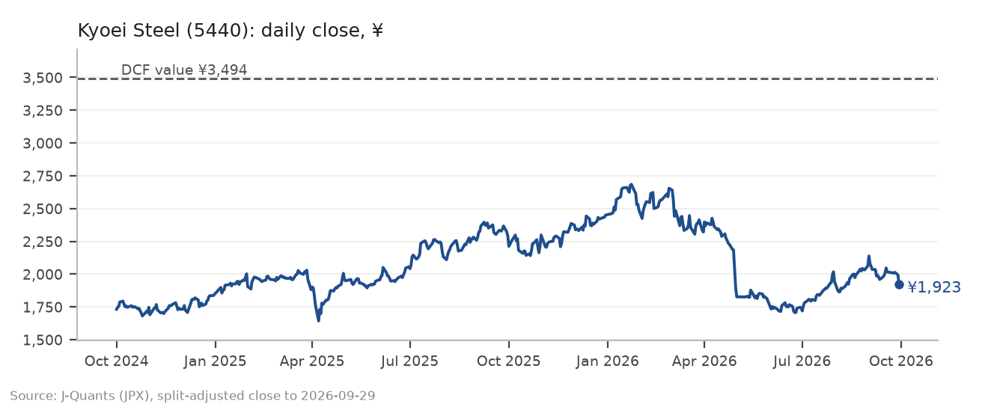
The story
Kyoei Steel makes rebar and merchant bars in electric furnaces in Japan, Vietnam and North America, and runs a waste-recycling business. It trades at 0.39 times book. Nippon Steel owns 25.8% and the founding Takashima family about 15%. Air Water owns 6%, and the family is pushing Air Water to sell non-core assets.
From story to value
Base-year revenue | ¥315.1B (fiscal year to 2026-03)
Operating margin, last year → target | 5.4% → 4.8% (five-year average, reached by year 5)
Revenue growth, years 1–5 | 5.5% a year, fading to 2.5% by year 10
Sales-to-capital (reinvestment) | 1.39
Return on capital vs cost of capital | 5.3% vs 5.9%
Beta (industry) | 1.41 (Steel; unlevered 0.79)
Cost of equity / cost of capital | 9.8% / 5.9%
Cash / investment securities / debt | ¥68.9B / ¥18.6B / ¥94.6B (balance sheet 2026-03)
DCF value per share (cost of capital ±1 point) | ¥3,494 (¥2,647–¥4,726)
No-growth value per share | ¥3,805
Terminal value share of operating value | 97.8%
Price-to-book: actual vs peer-predicted | 0.39 vs 0.73 (ROE 4.5%; Iron & steel sector regression, 36 companies, R² 0.12)
Price (2026-09-29) | ¥1,923
The DCF gives ¥3,494 (¥2,647–¥4,726) against ¥1,923, but it is fragile. Heavy debt pulls the cost of capital down to 5.9%, and 98% of the value sits in the terminal year. The Air Water stake could change hands in a block sale.
Top 10 shareholders plus treasury stock (March 2026 annual report)
# | Shareholder | Stake | Shares | vs prior half
1 | 日本製鉄 | 25.82% | 11,592,932
2 | 高島秀一郎 | 9.68% | 4,347,460
3 | 日本マスタートラスト信託銀行(信託口) | 5.95% | 2,671,400
4 | 高島成光 | 4.97% | 2,233,000
5 | 三井物産 | 3.27% | 1,470,000
6 | 自社(自己株口) | 3.21% | 1,439,800
7 | 合同製鐵 | 3.00% | 1,347,000
8 | 日本カストディ銀行(エア・ウォーター退職給付信託口) | 2.92% | 1,308,900
9 | 日本カストディ銀行(エア・ウォーター防災退職給付信託口) | 1.54% | 692,000
10 | エア・ウォーター | 1.54% | 691,500
11 | 日本カストディ銀行(信託口) | 1.53% | 689,000 | down

Hi-Lex (7279)
The cash flows do not support the price: the DCF value is ¥1,070 (¥1,030–¥1,110) a share, against ¥2,431, so the case rests on assets or an event.
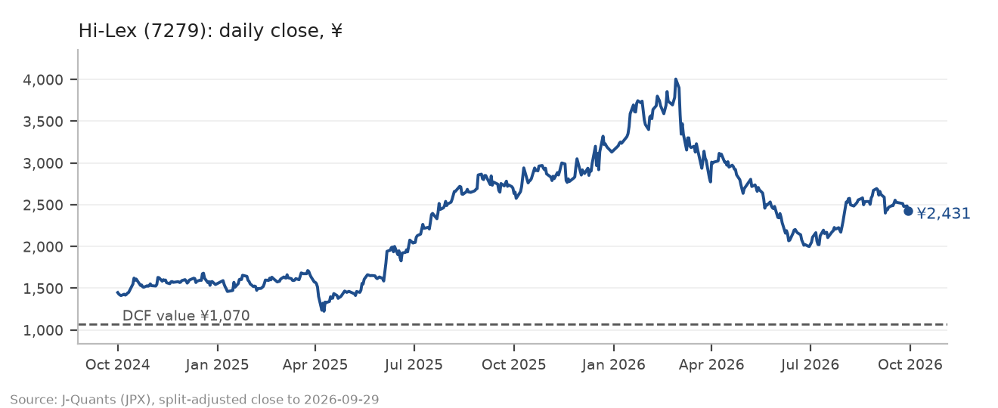
The story
Hi-Lex makes control cables, window regulators and door systems for cars, plus some medical devices. Margins have collapsed to about 1.1%, and the five-year average is near zero, so our DCF values the operations below zero. Founder company Teraura Kosan owns 27.7% and a related foundation another 4.1%.
From story to value
Base-year revenue | ¥304.1B (fiscal year to 2025-10)
Operating margin, last year → target | 1.1% → 0.1% (five-year average, reached by year 5)
Revenue growth, years 1–5 | 8.0% a year, fading to 2.5% by year 10
Sales-to-capital (reinvestment) | 3.22
Return on capital vs cost of capital | 2.5% vs 9.4%
Beta (industry) | 1.51 (Auto Parts; unlevered 1.39)
Cost of equity / cost of capital | 10.3% / 9.4%
Cash / investment securities / debt | ¥62.8B / ¥45.1B / ¥10.6B (balance sheet 2025-10)
DCF value per share (cost of capital ±1 point) | ¥1,070 (¥1,030–¥1,110)
No-growth value per share | ¥2,273
Terminal value share of operating value | n/m
Price-to-book: actual vs peer-predicted | 0.39 vs 0.66 (ROE 3.6%; Transport equipment sector regression, 76 companies, R² 0.34)
Price (2026-09-29) | ¥2,431
The ¥1,070 per-share value is essentially cash and investments less debt, against a ¥2,431 price. The market is paying for a margin recovery that has not yet shown up. The founder's stake means an outsider cannot force change.
The asset angle
Asset value. Net cash plus investment securities is ¥97.3B, or ¥2,643 a share, above the ¥2,431 price. The market values the operating business at less than nothing. Tangible book is ¥4,658 a share, so the stock trades at 0.52 times tangible book.
Can it lever up? Modestly, and it barely needs to. It could add about ¥9.4B of debt at an A-level interest coverage and release about ¥47.6B of cash above operating needs. Together that is about 64% of its market value available for buybacks or dividends.
Can it sweat the assets? Margins near zero, against a 5.2% sector median, are the whole problem. At the sector median margin the DCF rises to about ¥5,487 a share. The catch is founder company Teraura Kosan, at 27.7%. A large buyback would lift its stake further, which could also be a path to a management buyout.
Top 10 shareholders plus treasury stock (April 2026 half-year report)
# | Shareholder | Stake | Shares | vs prior half
1 | 寺浦興産 | 27.73% | 10,598,000 | up
2 | CEPLUXインディペンデントUCITS･PF2 | 4.52% | 1,726,000 | up
3 | 公益財団法人寺浦奨学会 | 4.07% | 1,554,000
4 | 日本マスタートラスト信託銀行(信託口) | 3.30% | 1,260,000 | up
5 | 日本生命保険 | 3.29% | 1,259,000
6 | 自社(自己株口) | 3.21% | 1,225,500
7 | 西川ゴム工業 | 2.71% | 1,034,000
8 | BNYメロンSANV･WSゼナー･ジャパンEIファンド | 2.50% | 955,000 | up
9 | ノーザン･トラスト(AVFC)UKUC･UCITS･NL10PCT | 2.14% | 816,000
10 | アルファ | 2.11% | 806,000
11 | 三菱UFJ銀行 | 1.93% | 739,000

Potential targets: Takateru-size (¥20–80 billion)

Futaba Corporation (6986)
Roughly fairly priced: the DCF value is ¥840 (¥819–¥857) a share, against a price of ¥732.
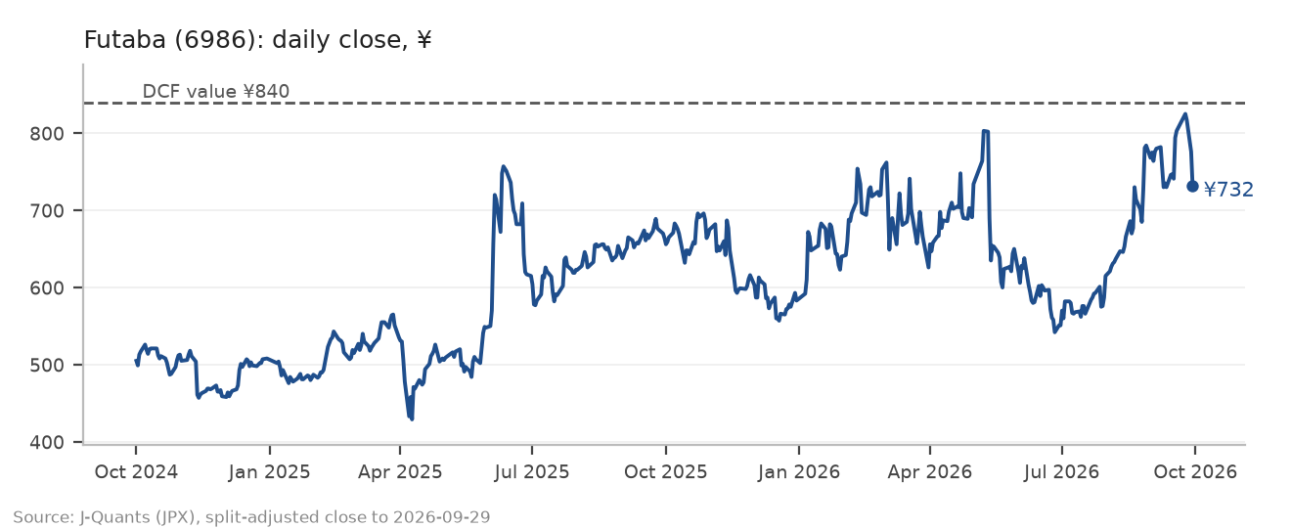
The story
Futaba makes display modules, touch panels, radio-control systems and mold-base components. It is losing money, with a -5.3% margin, yet its cash of ¥36.4B and investments of ¥17.3B exceed its market value. Brandes, a US value investor, holds about 10%.
From story to value
Base-year revenue | ¥43.0B (fiscal year to 2026-03)
Operating margin, last year → target | -5.3% → -3.5% (five-year average, reached by year 5)
Revenue growth, years 1–5 | -2.0% a year, fading to 2.5% by year 10
Sales-to-capital (reinvestment) | 1.02
Return on capital vs cost of capital | -3.8% vs 10.9%
Beta (industry) | 1.65 (Electronics (General); unlevered 1.63)
Cost of equity / cost of capital | 11.0% / 10.9%
Cash / investment securities / debt | ¥36.4B / ¥17.3B / ¥0.5B (balance sheet 2026-03)
DCF value per share (cost of capital ±1 point) | ¥840 (¥819–¥857)
No-growth value per share | ¥758
Terminal value share of operating value | 53.0%
Price-to-book: actual vs peer-predicted | 0.33 vs 1.44 (ROE 2.7%; Electrical equipment sector regression, 195 companies, R² 0.05)
Price (2026-09-29) | ¥732
Even assuming losses continue at the five-year average, the DCF gives ¥840 (¥819–¥857) against ¥732. The stock trades below its cash net of expected losses. The obvious activist ask is to stop the losses and return the cash.
Asset angle: cash and payout capacity
The cash alone is worth more than the company. With EBITDA negative it cannot borrow, but about ¥34 billion of surplus cash equals 110% of its market value. The lever is to stop the losses. At the electrical-equipment median margin, the DCF rises to about ¥1,345 a share.
Top 10 shareholders plus treasury stock (March 2026 annual report)
# | Shareholder | Stake | Shares | vs prior half
1 | 日本マスタートラスト信託銀行 | 10.18% | 4,321,000 | down
2 | 公益財団法人双葉電子記念財団 | 7.67% | 3,255,000
3 | 吉田嘉明 | 4.71% | 2,000,000
4 | 川崎まり | 4.40% | 1,866,000
5 | 千葉銀行 | 4.38% | 1,857,000
6 | ノーザン･トラスト(AVFC)USLノントリーティ | 4.12% | 1,746,000 | down
7 | LIMジャパン･イベント･マスター･ファンド | 3.00% | 1,273,000 | up
8 | 細矢晴江 | 2.62% | 1,113,000
9 | 桜田恵美子 | 2.52% | 1,069,000
10 | ノーザントラスト(AVFC)リUS･10PCT･CL | 2.37% | 1,006,000
11 | 自社(自己株口) | % | 0.03

Asahi Broadcasting Group (9405)
Undervalued on our numbers: the DCF value is ¥1,726 (¥1,621–¥1,869) a share, against a price of ¥832.
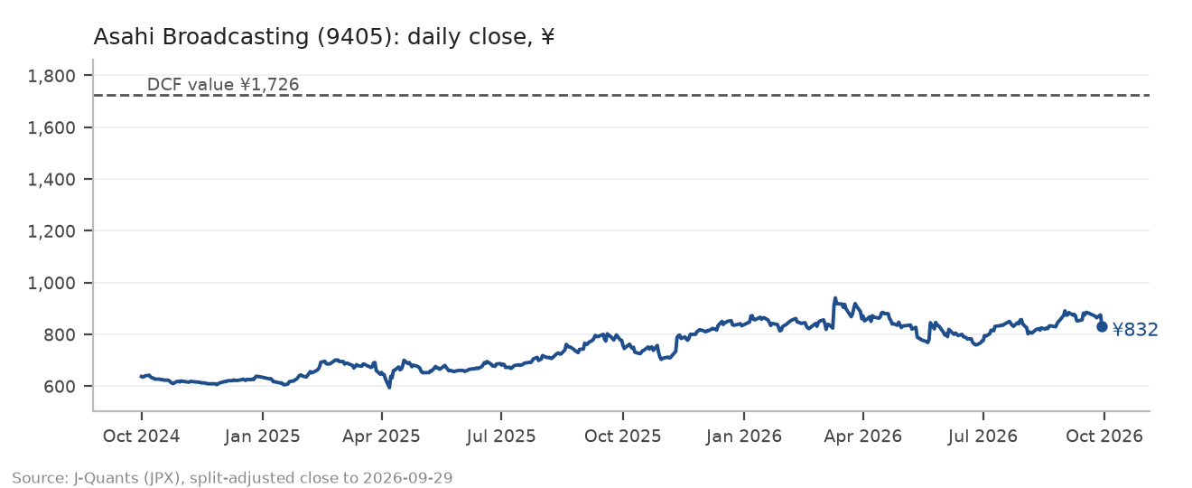
The story
Asahi Broadcasting runs ABC TV, the Osaka station in the TV Asahi network, along with radio, events and content businesses. Its cash of ¥35.2B and securities of ¥18.1B cover most of its market value. At 0.42 times book, it looks like Fuji Media before the family's campaign.
From story to value
Base-year revenue | ¥96.0B (fiscal year to 2026-03)
Operating margin, last year → target | 5.0% → 3.3% (five-year average, reached by year 5)
Revenue growth, years 1–5 | -0.3% a year, fading to 2.5% by year 10
Sales-to-capital (reinvestment) | 2.14
Return on capital vs cost of capital | 7.5% vs 6.8%
Beta (industry) | 1.18 (Broadcasting; unlevered 0.92)
Cost of equity / cost of capital | 8.6% / 6.8%
Cash / investment securities / debt | ¥35.2B / ¥18.1B / ¥13.8B (balance sheet 2026-03)
DCF value per share (cost of capital ±1 point) | ¥1,726 (¥1,621–¥1,869)
No-growth value per share | ¥1,689
Terminal value share of operating value | 53.7%
Price-to-book: actual vs peer-predicted | 0.42 vs 2.14 (ROE 5.4%; Information & communication sector regression, 494 companies, R² 0.04)
Price (2026-09-29) | ¥832
The DCF gives ¥1,726 (¥1,621–¥1,869) against ¥832. The catch is the register. The Asahi Shimbun holds 14.9%, TV Asahi 9.3% and the Kosetsu Museum 7.0%, a related media group of about 31% that would likely side with management.
Asset angle: cash and payout capacity
Cash and securities exceed the market value, and roughly all of the market value could be returned without new debt. Margins are well below the sector median. But about 31% of the shares sit with the Asahi Shimbun group, which has little reason to push for a payout.
Top 10 shareholders plus treasury stock (March 2026 annual report)
# | Shareholder | Stake | Shares | vs prior half
1 | 朝日新聞社 | 14.88% | 6,224,900
2 | テレビ朝日ホールディングス | 9.27% | 3,877,600
3 | 公益財団法人香雪美術館 | 7.00% | 2,930,000
4 | 日本マスタートラスト信託銀行(信託口) | 4.35% | 1,818,811 | down
5 | 学校法人帝京大学 | 3.76% | 1,571,000
6 | 朝日新聞信用組合 | 3.59% | 1,500,000
7 | 大阪瓦斯 | 2.55% | 1,065,000
8 | 嶋村吉洋映画企画 | 1.92% | 804,000
9 | 近鉄バス | 1.91% | 800,000
10 | 竹中工務店 | 1.86% | 776,600
11 | 自社(自己株口) | % | 0.10

Musashi (7521)
Undervalued on our numbers: the DCF value is ¥8,311 (¥7,593–¥9,333) a share, against a price of ¥2,647.
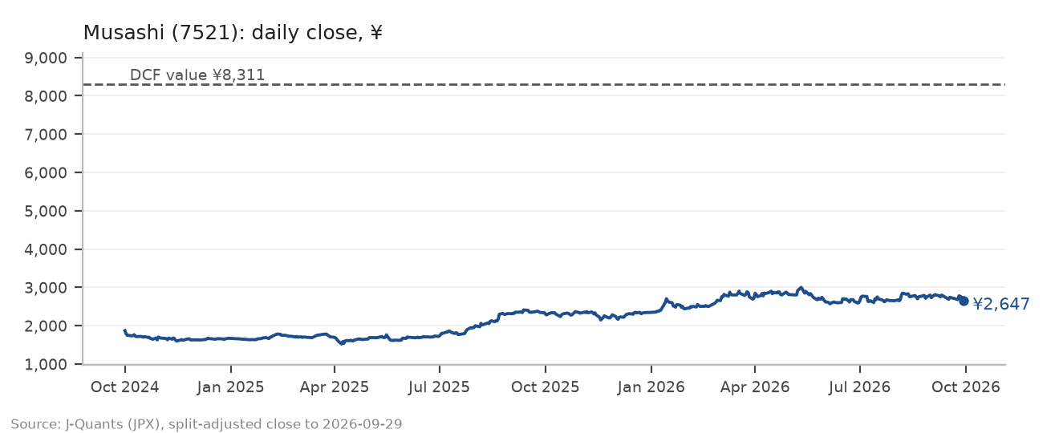
The story
Musashi sells election systems such as vote-counting machines, document digitization, printing and cash-handling equipment. Earnings rise and fall with election cycles. Last year's 11.5% margin was well above the 7.1% five-year average we use. Cash of ¥23.6B is roughly equal to its market value.
From story to value
Base-year revenue | ¥40.6B (fiscal year to 2026-03)
Operating margin, last year → target | 11.5% → 7.1% (five-year average, reached by year 5)
Revenue growth, years 1–5 | -2.0% a year, fading to 2.5% by year 10
Sales-to-capital (reinvestment) | 3.58
Return on capital vs cost of capital | 29.0% vs 5.8%
Beta (industry) | 0.77 (Office Equipment & Services; unlevered 0.68)
Cost of equity / cost of capital | 6.5% / 5.8%
Cash / investment securities / debt | ¥23.6B / ¥5.6B / ¥3.5B (balance sheet 2026-03)
DCF value per share (cost of capital ±1 point) | ¥8,311 (¥7,593–¥9,333)
No-growth value per share | ¥8,915
Terminal value share of operating value | 61.9%
Price-to-book: actual vs peer-predicted | 0.57 vs 1.22 (ROE 7.6%; Wholesale sector regression, 270 companies, R² 0.10)
Price (2026-09-29) | ¥2,647
The DCF of ¥8,311 (¥7,593–¥9,333) against ¥2,647 mostly reflects that cash plus a steady business. Two private companies, 上毛実業 (17.5%) and ショウリン商事 (11.3%), plus 14% treasury stock, leave a small free float and little room for an outsider.
Asset angle: cash and payout capacity
Cash is larger than the market value. It could return one and a half times its market value from surplus cash and modest debt, but 43% of the shares sit with two private holders or in treasury. The lever exists; the will is the question.
Top 10 shareholders plus treasury stock (March 2026 annual report)
# | Shareholder | Stake | Shares | vs prior half
1 | 上毛実業 | 17.46% | 1,388,000
2 | 自社(自己株口) | 14.29% | 1,135,700
3 | ショウリン商事 | 11.28% | 897,000
4 | 自社社員持株会 | 3.94% | 313,000
5 | 自社互助会 | 3.76% | 299,000
6 | 小林厚一 | 2.98% | 237,000
7 | 日本カストディ銀行(信託口) | 2.94% | 234,000
8 | 内藤征吾 | 2.87% | 228,000 | down
9 | インタラクティブ･ブローカーズ | 2.55% | 203,000
10 | 光通信KK投資事業有限責任組合 | 2.49% | 198,000
11 | みずほ銀行 | 2.01% | 160,000

Nakayama Steel Works (5408)
Undervalued on our numbers: the DCF value is ¥1,882 (¥1,656–¥2,196) a share, against a price of ¥619.
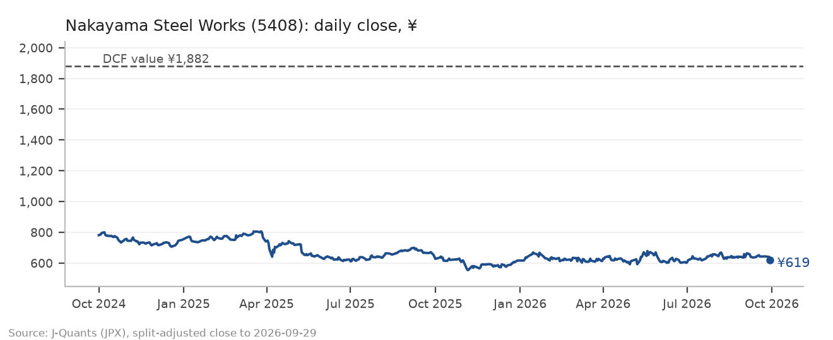
The story
Nakayama Steel makes hot-rolled sheet, bars and wire rod in Osaka, plus engineering, building materials and real estate. Margins slid to 3.3% last year. Hanwa Kogyo (12.8%) and Air Water (7.5%) are its largest outside holders, and 14% is treasury stock.
From story to value
Base-year revenue | ¥148.3B (fiscal year to 2026-03)
Operating margin, last year → target | 3.3% → 5.3% (five-year average, reached by year 5)
Revenue growth, years 1–5 | -0.9% a year, fading to 2.5% by year 10
Sales-to-capital (reinvestment) | 1.64
Return on capital vs cost of capital | 3.8% vs 6.3%
Beta (industry) | 0.93 (Steel; unlevered 0.79)
Cost of equity / cost of capital | 7.3% / 6.3%
Cash / investment securities / debt | ¥23.2B / ¥4.0B / ¥8.5B (balance sheet 2026-03)
DCF value per share (cost of capital ±1 point) | ¥1,882 (¥1,656–¥2,196)
No-growth value per share | ¥1,977
Terminal value share of operating value | 59.9%
Price-to-book: actual vs peer-predicted | 0.35 vs 0.68 (ROE 2.2%; Iron & steel sector regression, 36 companies, R² 0.12)
Price (2026-09-29) | ¥619
The DCF assumes margins return to the 5.3% five-year average and gives ¥1,882 (¥1,656–¥2,196) against ¥619. That normalization is the whole case. As with Kyoei Steel, Air Water's stake could come up for sale.
Asset angle: cash and payout capacity
The stock trades at 0.31 times tangible book, with ¥16 billion of surplus cash, about half its market value. Margins at the five-year average already justify the DCF. The added lever is Air Water's 7.5% block, which the family is pressing Air Water to sell.
Top 10 shareholders plus treasury stock (March 2026 annual report)
# | Shareholder | Stake | Shares | vs prior half
1 | 自社(自己株口) | 14.05% | 8,863,800
2 | 阪和興業 | 12.77% | 8,058,000
3 | エア・ウォーター | 7.50% | 4,729,000
4 | 日本マスタートラスト信託銀行(信託口) | 6.08% | 3,836,000 | down
5 | 大阪瓦斯 | 3.05% | 1,923,000
6 | 丸一鋼管 | 2.06% | 1,300,000 | down
7 | 尼崎製罐 | 2.02% | 1,274,000
8 | BNYメロンSANV･WSゼナー･ジャパンEIファンド | 1.68% | 1,058,000
9 | 中山持株共栄会 | 1.36% | 859,000
10 | 日鉄物産 | 1.29% | 815,000
11 | ディメンションETFトラスト･ディメンションInt`l･SCV･ETF | 0.95% | 598,000

Cleanup (7955)
Undervalued on our numbers: the DCF value is ¥1,347 (¥1,198–¥1,553) a share, against a price of ¥932.
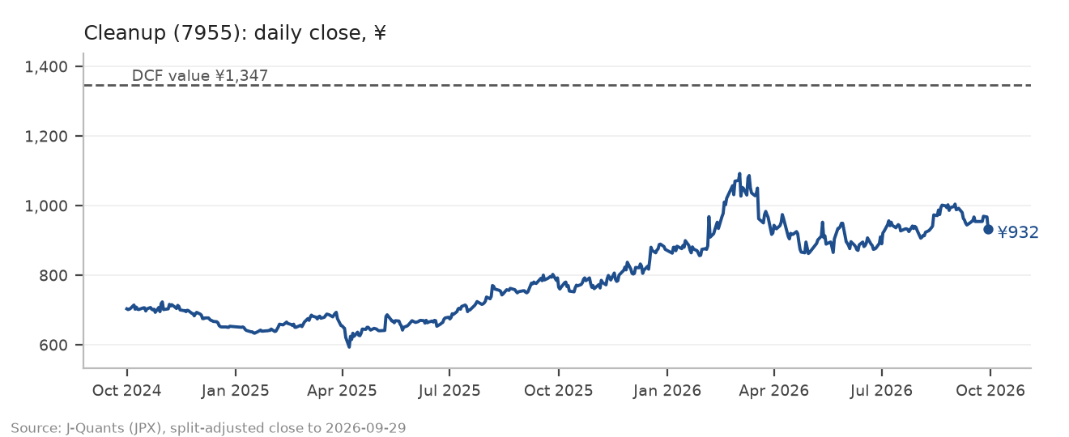
The story
Cleanup makes kitchen systems and bathroom units for Japanese housing and renovation. It has thin 2–3% margins but little debt and ¥19.4B of cash. The founding family's company, 井上, holds 23.6%, and two supplier and customer associations hold another 13%.
From story to value
Base-year revenue | ¥134.5B (fiscal year to 2026-03)
Operating margin, last year → target | 2.9% → 2.3% (five-year average, reached by year 5)
Revenue growth, years 1–5 | 4.2% a year, fading to 2.5% by year 10
Sales-to-capital (reinvestment) | 3.05
Return on capital vs cost of capital | 6.3% vs 6.8%
Beta (industry) | 1.07 (Furn/Home Furnishings; unlevered 0.90)
Cost of equity / cost of capital | 8.0% / 6.8%
Cash / investment securities / debt | ¥19.4B / ¥5.7B / ¥8.8B (balance sheet 2026-03)
DCF value per share (cost of capital ±1 point) | ¥1,347 (¥1,198–¥1,553)
No-growth value per share | ¥1,356
Terminal value share of operating value | 76.9%
Price-to-book: actual vs peer-predicted | 0.56 vs 1.14 (ROE 5.8%; Other products sector regression, 98 companies, R² 0.21)
Price (2026-09-29) | ¥932
The DCF gives ¥1,347 (¥1,198–¥1,553) against ¥932. The discount reflects a shrinking housing market, and the founder-friendly register shields management from pressure.
Asset angle: cash and payout capacity
Cash net of debt is about half the market value, and margins are well below the sector median. At the median margin, the DCF would roughly double. The founding family's 24% holding and the business associations' 13% make change slow.
Top 10 shareholders plus treasury stock (March 2026 annual report)
# | Shareholder | Stake | Shares | vs prior half
1 | (株)井上 | 23.62% | 8,609,000 | up
2 | 日本マスタートラスト信託銀行 | 6.78% | 2,471,000 | up
3 | クリナップ真栄会 | 6.60% | 2,405,000 | up
4 | クリナップ共進会 | 6.25% | 2,277,000 | up
5 | (株)タカヤス | 5.17% | 1,885,000 | up
6 | 自社社員持株会 | 4.84% | 1,764,000 | up
7 | 自社(自己株口) | 3.23% | 1,177,600 | down
8 | ステート･ストリート･バンク＆トラスト | 2.42% | 881,000 | up
9 | JPモルガン･チェース･バンク | 2.34% | 852,000
10 | ミツウロコグループホールディングス | 1.64% | 597,000
11 | 三菱UFJ銀行 | 1.53% | 557,000 | down

Fukuvi Chemical Industry (7871)
Undervalued on our numbers: the DCF value is ¥1,757 (¥1,638–¥1,918) a share, against a price of ¥1,010.
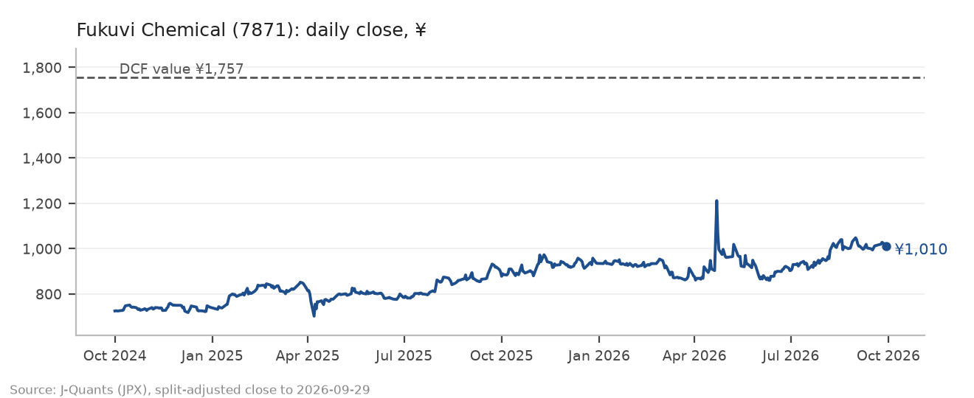
The story
Fukuvi makes plastic extruded building materials, such as skirting boards, flooring and trim, sold mainly to housing makers. It has ¥13.5B of cash and ¥7.7B of investments against about a ¥20 billion market value. Its register is corporate: 八木熊 12.4%, Nagase & Co. 11.9%, a Mitsui Chemicals pension trust 9.0% and Mitsui & Co. Plastics 4.8%.
From story to value
Base-year revenue | ¥40.6B (fiscal year to 2026-03)
Operating margin, last year → target | 4.3% → 4.0% (five-year average, reached by year 5)
Revenue growth, years 1–5 | 3.1% a year, fading to 2.5% by year 10
Sales-to-capital (reinvestment) | 1.94
Return on capital vs cost of capital | 5.8% vs 7.2%
Beta (industry) | 0.99 (Building Materials; unlevered 0.94)
Cost of equity / cost of capital | 7.6% / 7.2%
Cash / investment securities / debt | ¥13.5B / ¥7.7B / ¥1.5B (balance sheet 2026-03)
DCF value per share (cost of capital ±1 point) | ¥1,757 (¥1,638–¥1,918)
No-growth value per share | ¥1,754
Terminal value share of operating value | 68.0%
Price-to-book: actual vs peer-predicted | 0.51 vs 1.15 (ROE 4.1%; Chemicals sector regression, 193 companies, R² 0.14)
Price (2026-09-29) | ¥1,010
The DCF gives ¥1,757 (¥1,638–¥1,918) against ¥1,010. An activist would push for the corporate holders to sell or for a parent to buy out the rest.
Asset angle: cash and payout capacity
Net cash and securities about equal the market value, and surplus cash plus modest debt could return about 80% of it. The corporate holders, Nagase, Mitsui Chemicals and 八木熊, would decide any recapitalization.
Top 10 shareholders plus treasury stock (March 2026 annual report)
# | Shareholder | Stake | Shares | vs prior half
1 | (株)八木熊 | 12.44% | 2,574,000
2 | 長瀬産業 | 11.91% | 2,464,000
3 | 日本カストディ銀行(三井化学退職給付信託口) | 8.97% | 1,856,000
4 | 三井物産プラスチック | 4.75% | 983,000
5 | 自社(自己株口) | 4.33% | 895,900
6 | 八木誠一郎 | 4.01% | 830,000
7 | 福井銀行 | 3.43% | 710,000
8 | 昭和興産 | 3.24% | 670,000
9 | 北陸銀行 | 3.02% | 625,000
10 | 自社従業員持株会 | 2.91% | 601,000
11 | 蝶理 | 2.90% | 600,000

Kitagawa (6317)
The cash flows do not support the price: the DCF value is ¥777 (¥586–¥1,039) a share, against ¥2,552, so the case rests on assets or an event.
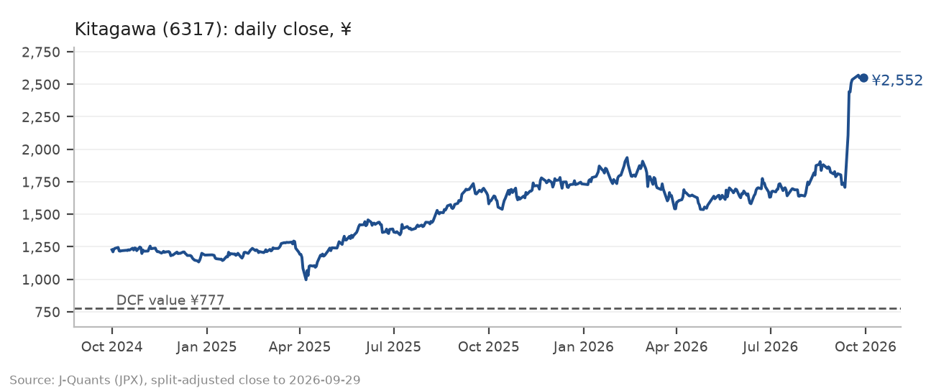
The story
Kitagawa makes machine-tool chucks, tower cranes, multi-level parking systems and car castings. The stock is up 56% in three months. On September 14 the company raised its full-year operating profit forecast from ¥3.0 billion to ¥4.5 billion and its dividend from ¥64 to ¥110, partly on delayed and one-off project revenue.
From story to value
Base-year revenue | ¥58.4B (fiscal year to 2026-03)
Operating margin, last year → target | 4.6% → 2.9% (five-year average, reached by year 5)
Revenue growth, years 1–5 | 5.9% a year, fading to 2.5% by year 10
Sales-to-capital (reinvestment) | 1.30
Return on capital vs cost of capital | 4.2% vs 8.2%
Beta (industry) | 1.87 (Machinery; unlevered 1.27)
Cost of equity / cost of capital | 12.1% / 8.2%
Cash / investment securities / debt | ¥12.0B / ¥5.6B / ¥16.4B (balance sheet 2026-03)
DCF value per share (cost of capital ±1 point) | ¥777 (¥586–¥1,039)
No-growth value per share | ¥1,655
Terminal value share of operating value | n/m
Price-to-book: actual vs peer-predicted | 0.52 vs 1.35 (ROE 6.7%; Machinery sector regression, 196 companies, R² 0.06)
Price (2026-09-29) | ¥2,552
Return on capital of 4.2% is below the 8.2% cost of capital, so growth destroys value. The DCF gives ¥777 and a no-growth value of ¥1,655, both below ¥2,552. On our numbers, the rally has run ahead of the fundamentals.
The asset angle
Asset value. This is not really an asset play: net cash plus securities is only 5% of market value. Tangible book is ¥4,763 a share, so the stock trades at 0.54 times tangible book. That is a cushion, but the book is plant earning a 4.2% return.
Can it lever up? There is little room. Net debt is 0.7 times EBITDA, and more debt would not lower its cost of capital. About ¥9.0B of cash above operating needs could fund buybacks, roughly 38% of market value.
Can it sweat the assets? This is the real question. The five-year margin is 2.9% against a 8.7% machinery median. September's guidance of ¥4.5 billion on ¥65.7 billion of sales implies 6.8%. If that margin holds, the DCF is about ¥3,473 a share against ¥2,552. If it was one-off project revenue, the value falls back toward ¥777.
Top 10 shareholders plus treasury stock (March 2026 annual report)
# | Shareholder | Stake | Shares | vs prior half
1 | 日本マスタートラスト信託銀行(信託口) | 8.44% | 815,000 | down
2 | 北川鉄工所みのり会 | 7.75% | 748,000 | up
3 | インタラクティブ･ブローカーズ | 5.00% | 483,000 | up
4 | 広島銀行 | 4.62% | 446,000
5 | 自社(自己株口) | 4.14% | 399,200
6 | みずほ信託銀行 | 2.38% | 230,000
7 | 自社株投資会 | 2.37% | 229,000
8 | 秋元利規 | 2.07% | 200,000
9 | 日本カストディ銀行(信託口) | 1.82% | 176,000 | down
10 | 朝日生命保険 | 1.77% | 171,000
11 | 北川祐治 | 1.48% | 143,000

Sources
- Financial statements and business descriptions: Financial Modeling Prep
- Prices, guidance, shares outstanding and treasury stock: J-Quants (JPX)
- Top-10 shareholders: Kabutan shareholder pages, e.g. TPR
- Damodaran, Japan industry betas (January 2026)
- Damodaran, country default spreads and risk premiums
- Japan 10-year government bond yield (Trading Economics)
- Oji Holdings takes 33% of Mitsubishi Paper (Nikkei, 2018)
- Kitagawa raises guidance and dividend (Zaikei, 2026-09-14)
- Murakami-linked large-shareholding filings (ufocatch)
Primo Global's borrowings (about ¥18 billion) come from a disclosure summary and were not checked against the filing.

