Murakami Watchlist Through the LENS Model
Which of the 17 companies a governance activist in the style of Robert Monks would pick · Data as of 2026-09-30

Summary
Five of the 17 fit the LENS model: Futaba, TOW, TPR, Nakayama Steel Works and Kitagawa. Each has lagged the market, shows governance red flags, trades well below what better governance could unlock, and has a register an activist could win with institutional support. Nine more pass some tests but are blocked by a founder, parent or allied group, or show no value gap. Three are not LENS cases.
Company (code) | Under-performance | Governance flags | Value gap | Collective action | Score | Verdict
Futaba Corporation (6986) | 2 | 2 | 2 | 1 | 7/8 | LENS target
TOW (4767) | 1 | 1 | 2 | 2 | 6/8 | LENS target
TPR (6463) | 1 | 2 | 2 | 1 | 6/8 | LENS target
Nakayama Steel Works (5408) | 2 | 1 | 2 | 1 | 6/8 | LENS target
Kitagawa (6317) | 1 | 1 | 2 | 2 | 6/8 | LENS target
Stanley Electric (6923) | 2 | 2 | 0 | 2 | 6/8 | Possible
Hi-Lex (7279) | 2 | 2 | 2 | 0 | 6/8 | Possible
Asahi Broadcasting Group (9405) | 2 | 2 | 2 | 0 | 6/8 | Possible
Yamada Holdings (9831) | 1 | 2 | 0 | 2 | 5/8 | Possible
Kyoei Steel (5440) | 2 | 1 | 2 | 0 | 5/8 | Possible
Topre (5975) | 1 | 1 | 0 | 2 | 4/8 | Possible
Musashi (7521) | 1 | 1 | 2 | 0 | 4/8 | Possible
Cleanup (7955) | 1 | 1 | 2 | 0 | 4/8 | Possible
Fukuvi Chemical Industry (7871) | 1 | 1 | 2 | 0 | 4/8 | Possible
Mitsubishi Paper Mills (3864) | 1 | 2 | 0 | 0 | 3/8 | Not a LENS case
S Foods (2292) | 1 | 0 | 2 | 0 | 3/8 | Not a LENS case
Primo Global Holdings (367A) | 0 | 1 | 0 | 1 | 2/8 | Not a LENS case
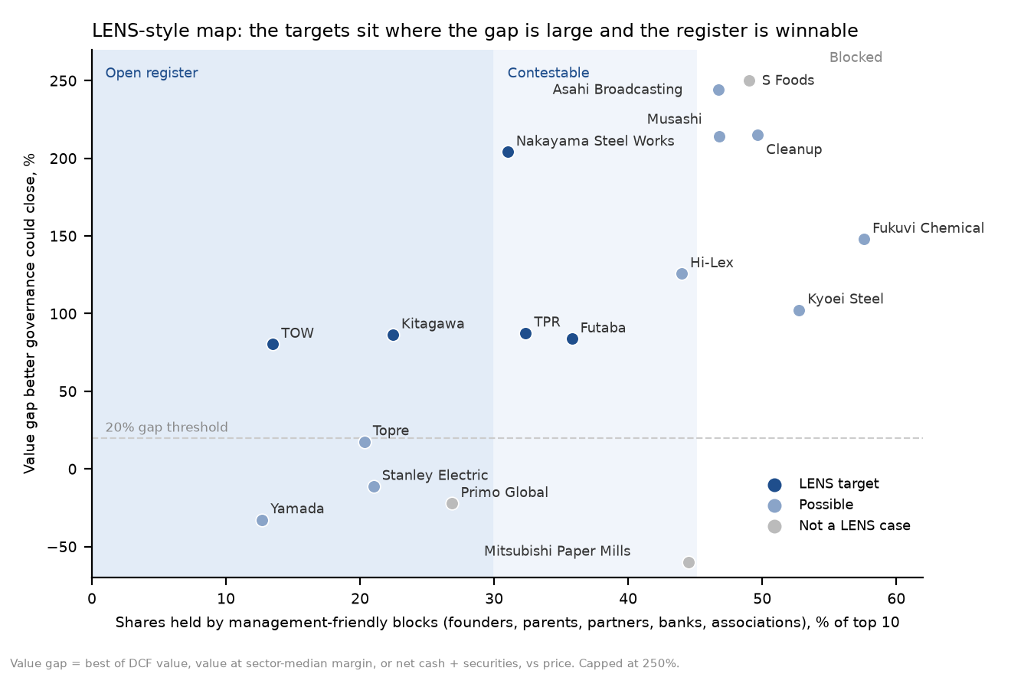

What LENS was, and how it is applied here
Robert A.G. Monks and Nell Minow launched LENS in 1992 to invest in "a handful of enterprises where investor activism could engineer governance improvement—and induce rising value." It bought into underperforming companies, used shareholder rights to push for board and structural change at Sears, Kodak, Stone & Webster and Scott Paper, and earned 25.1% a year against 20.5% for the S&P 500 over six years before merging into Hermes. Monks named high pay and dependence on acquisitions as telltale signs of poor governance, and at Sears he ran a newspaper ad branding the directors "non-performing assets."
LENS did not publish a scoring rule, so the four tests below are this report's interpretation of its approach, using data available for Japanese companies. Each test scores 0 to 2.
- Underperformance. One point for a five-year price return at least 25% below TOPIX (TOPIX rose 103%), one for a return on equity more than 2 points below the cost of equity from the valuation report.
- Governance red flags. One point each, up to two, for: surplus cash of 30% or more of market value; investment securities of 20% or more of equity; a recent acquisition or merger; net debt above four times EBITDA.
- Value gap. The best of the DCF value, the value at the sector-median margin, and net cash plus securities, against the price. Two points for a gap of 50% or more, one for 20–50%.
- Collective action. LENS worked by rallying other institutions. Two points if management-friendly blocks (founders, parents, business partners, banks and insurers, employee and supplier associations) hold under 30% of the top 10 and none holds 15%; one point up to 45% with no holder above 25%; zero otherwise.
- Gates. A LENS target needs 6 or more points, a value gap and a winnable register. A company that fails either gate is at most "possible", whatever its score.
Limits: board independence, CEO pay and takeover defenses were not scored because the data were not available for these companies. Of the takeover defenses, only Mitsubishi Paper's abolition was confirmed. Registers are judged from the top 10 holders only.

The five LENS-style targets

Futaba Corporation (6986): LENS target, 7/8
Test | Score | Evidence
1. Underperformance | 2/2 | -54% vs TOPIX over five years; return on equity 2.7% vs cost of equity 11.0%
2. Governance red flags | 2/2 | surplus cash 110% of market value; investment securities 21% of equity
3. Value gap | 2/2 | +84% to ¥1,345 a share (value at sector-median margin)
4. Collective action | 1/2 | management-friendly blocks 36% of the top 10; largest Futaba foundation 7.7%; trust banks and foreign institutions 10%
The LENS agenda
- Stop the losses: identify the loss-making lines and fix or exit them.
- Return the surplus cash, about ¥34 billion or more than the whole market value, through a tender-offer buyback.
- Sell the investment securities, 21% of equity, and tie directors' pay to a return on equity above the 11% cost of equity.
Campaign path. Start privately, with Brandes (about 10%) and the trust-bank holders as natural allies. A shareholder proposal on capital return at the June meeting is the escalation.

TOW (4767): LENS target, 6/8
Test | Score | Evidence
1. Underperformance | 1/2 | -44% vs TOPIX over five years; return on equity 12.8% vs cost of equity 10.2%
2. Governance red flags | 1/2 | surplus cash 48% of market value
3. Value gap | 2/2 | +80% to ¥709 a share (DCF value)
4. Collective action | 2/2 | management-friendly blocks 13% of the top 10; largest founder 真木勝次 7.4%; trust banks and foreign institutions 17%
The LENS agenda
- Pay out the surplus cash, about half the market value, and cancel the 16% of shares held in treasury.
- Adopt an explicit payout or equity-return policy. The business already earns more than its cost of equity; the discount is about capital allocation, not operations.
Campaign path. Takateru Murakami already holds 7.5% and is asking for the same things. With only 13% in friendly hands, institutions could carry a vote, so this is the easiest register on the list.

TPR (6463): LENS target, 6/8
Test | Score | Evidence
1. Underperformance | 1/2 | +2% vs TOPIX over five years; return on equity 4.5% vs cost of equity 11.2%
2. Governance red flags | 2/2 | surplus cash 53% of market value; investment securities 37% of equity
3. Value gap | 2/2 | +88% to ¥2,851 a share (value at sector-median margin)
4. Collective action | 1/2 | management-friendly blocks 32% of the top 10; largest Meiji Yasuda Life 7.2%; trust banks and foreign institutions 11%
The LENS agenda
- Return about ¥52 billion of surplus cash and sell the cross-held securities, 37% of equity.
- Refocus on engine and resin parts; the housing, caregiving and insurance side-businesses are the diversification Monks warned against.
- Set a return-on-equity target above the 11% cost of equity and a board that answers for it.
Campaign path. The swing votes are the insurers and banks on the register, Meiji Yasuda, Sompo and Mizuho. They are probably cross-holders, and their own stewardship codes now push them to unwind such holdings, so the campaign runs through them.

Nakayama Steel Works (5408): LENS target, 6/8
Test | Score | Evidence
1. Underperformance | 2/2 | -28% vs TOPIX over five years; return on equity 2.2% vs cost of equity 7.3%
2. Governance red flags | 1/2 | surplus cash 47% of market value
3. Value gap | 2/2 | +204% to ¥1,882 a share (DCF value)
4. Collective action | 1/2 | management-friendly blocks 31% of the top 10; largest Hanwa Kogyo 12.8%; trust banks and foreign institutions 8%
The LENS agenda
- Cancel the 14% treasury stake and return surplus cash, about half the market value.
- Publish a plan to get margins back to the five-year average, or explore a sale to a larger steelmaker.
- Press Hanwa Kogyo and Air Water, which the family is already pushing to sell non-core holdings, over their blocks.
Campaign path. The register is contestable at 31% friendly. Air Water's 7.5% changing hands would decide it.

Kitagawa (6317): LENS target, 6/8
Test | Score | Evidence
1. Underperformance | 1/2 | -21% vs TOPIX over five years; return on equity 6.7% vs cost of equity 12.1%
2. Governance red flags | 1/2 | surplus cash 38% of market value
3. Value gap | 2/2 | +86% to ¥4,757 a share (value at sector-median margin)
4. Collective action | 2/2 | management-friendly blocks 22% of the top 10; largest Hiroshima Bank 4.6%; trust banks and foreign institutions 15%
The LENS agenda
- Make September's dividend increase a standing policy, such as a payout or equity-return floor.
- Explain which businesses earn below the cost of capital, whether cranes, parking systems or castings, and fix or sell them.
- Set return-on-capital targets above the roughly 8% cost of capital.
Campaign path. The register is open: the largest holder is Hiroshima Bank at 4.6%. A private letter backed by a few institutions would carry weight.

Possible, but blocked or without a value gap

Stanley Electric (6923): Possible, 6/8
Test | Score | Evidence
1. Underperformance | 2/2 | -39% vs TOPIX over five years; return on equity 5.7% vs cost of equity 11.1%
2. Governance red flags | 2/2 | surplus cash 47% of market value; bought Iwasaki Electric from Carlyle (Jan 2026)
3. Value gap | 0/2 | -11% to ¥3,063 a share (DCF value)
4. Collective action | 2/2 | management-friendly blocks 21% of the top 10; largest Honda 13.3%; trust banks and foreign institutions 31%
Every governance test flags: five-year underperformance, return on equity half the cost of equity, surplus cash of almost half the market value, and a new acquisition (Iwasaki Electric), a Monks warning sign. But our DCF shows no value gap, so LENS would pass unless margins can rise well above plan.

Hi-Lex (7279): Possible, 6/8
Test | Score | Evidence
1. Underperformance | 2/2 | -31% vs TOPIX over five years; return on equity 3.6% vs cost of equity 10.3%
2. Governance red flags | 2/2 | surplus cash 53% of market value; investment securities 26% of equity
3. Value gap | 2/2 | +126% to ¥5,487 a share (value at sector-median margin)
4. Collective action | 0/2 | management-friendly blocks 44% of the top 10; largest founder company Teraura Kosan 27.7%; trust banks and foreign institutions 10%
It passes the value and governance tests. But the founder company holds 27.7% and a related foundation 4.1%, so no vote can be won without them. The only path is persuading the founder, which points to a management buyout.

Asahi Broadcasting Group (9405): Possible, 6/8
Test | Score | Evidence
1. Underperformance | 2/2 | -44% vs TOPIX over five years; return on equity 5.4% vs cost of equity 8.6%
2. Governance red flags | 2/2 | surplus cash 88% of market value; investment securities 22% of equity
3. Value gap | 2/2 | +244% to ¥2,863 a share (value at sector-median margin)
4. Collective action | 0/2 | management-friendly blocks 47% of the top 10; largest Asahi Shimbun 14.9%; trust banks and foreign institutions 4%
It fails on the register: the Asahi Shimbun, TV Asahi and a related museum hold about 31%, and friendly blocks total 47%. A campaign would have to win over the Asahi group itself.

Yamada Holdings (9831): Possible, 5/8
Test | Score | Evidence
1. Underperformance | 1/2 | -24% vs TOPIX over five years; return on equity 2.3% vs cost of equity 9.1%
2. Governance red flags | 2/2 | agreed a merger of equals with Edion (Jun 2026), ratio not yet set; net debt 4.7x EBITDA
3. Value gap | 0/2 | -33% to ¥483 a share (value at sector-median margin)
4. Collective action | 2/2 | management-friendly blocks 13% of the top 10; largest テックプランニング (founder-related) 6.8%; trust banks and foreign institutions 16%
LENS would treat this as a merger-terms campaign, not a rerating. The share ratio with Edion is not set, and the deal needs a two-thirds vote at each company in June 2027. The asks would be an independent special committee, a fairness opinion and a ratio that reflects Yamada's owned property. The family's 8.4% is about 12% of voting shares, so it would need the trust banks to block.

Kyoei Steel (5440): Possible, 5/8
Test | Score | Evidence
1. Underperformance | 2/2 | -31% vs TOPIX over five years; return on equity 4.5% vs cost of equity 9.8%
2. Governance red flags | 1/2 | surplus cash 64% of market value
3. Value gap | 2/2 | +102% to ¥3,891 a share (value at sector-median margin)
4. Collective action | 0/2 | management-friendly blocks 53% of the top 10; largest Nippon Steel 25.8%; trust banks and foreign institutions 7%
Nippon Steel (25.8%) and the founding Takashima family together outvote any campaign. Air Water's 6% block is the only moving piece.

Topre (5975): Possible, 4/8
Test | Score | Evidence
1. Underperformance | 1/2 | +27% vs TOPIX over five years; return on equity 7.4% vs cost of equity 11.1%
2. Governance red flags | 1/2 | surplus cash 31% of market value
3. Value gap | 0/2 | +18% to ¥3,891 a share (DCF value)
4. Collective action | 2/2 | management-friendly blocks 20% of the top 10; largest 石井直子 (individual) 4.9%; trust banks and foreign institutions 25%
The register is open and cash is plentiful, but after a 42% rise the value gap is only about 18%. It is a watch-list name.

Musashi (7521): Possible, 4/8
Test | Score | Evidence
1. Underperformance | 1/2 | -38% vs TOPIX over five years; return on equity 7.6% vs cost of equity 6.5%
2. Governance red flags | 1/2 | surplus cash 119% of market value
3. Value gap | 2/2 | +214% to ¥8,311 a share (DCF value)
4. Collective action | 0/2 | management-friendly blocks 47% of the top 10; largest 上毛実業 17.5%; trust banks and foreign institutions 5%
Two private holders own 29%, and 14% sits in treasury. The cash is there, but the votes are not.

Cleanup (7955): Possible, 4/8
Test | Score | Evidence
1. Underperformance | 1/2 | -19% vs TOPIX over five years; return on equity 5.8% vs cost of equity 8.0%
2. Governance red flags | 1/2 | surplus cash 38% of market value
3. Value gap | 2/2 | +215% to ¥2,936 a share (value at sector-median margin)
4. Collective action | 0/2 | management-friendly blocks 50% of the top 10; largest founder company 井上 23.6%; trust banks and foreign institutions 12%
The founding family's company holds 23.6% and two business associations another 13%, which protects management.

Fukuvi Chemical Industry (7871): Possible, 4/8
Test | Score | Evidence
1. Underperformance | 1/2 | -16% vs TOPIX over five years; return on equity 4.1% vs cost of equity 7.6%
2. Governance red flags | 1/2 | surplus cash 57% of market value
3. Value gap | 2/2 | +148% to ¥2,504 a share (value at sector-median margin)
4. Collective action | 0/2 | management-friendly blocks 58% of the top 10; largest 八木熊 12.4%; trust banks and foreign institutions 0%
Corporate holders make up 58% of the top 10, so there is no free float to rally.

Not LENS cases

Mitsubishi Paper Mills (3864): Not a LENS case, 3/8
Test | Score | Evidence
1. Underperformance | 1/2 | +63% vs TOPIX over five years; return on equity 1.8% vs cost of equity 7.6%
2. Governance red flags | 2/2 | investment securities 24% of equity; net debt 10.4x EBITDA
3. Value gap | 0/2 | -87% to ¥153 a share (value at sector-median margin)
4. Collective action | 0/2 | management-friendly blocks 44% of the top 10; largest Oji Holdings 32.8%; trust banks and foreign institutions 10%
Oji Holdings owns 32.8% and decides the outcome, and on our numbers there is no value gap without a deal. It is an event play, not a governance campaign.

S Foods (2292): Not a LENS case, 3/8
Test | Score | Evidence
1. Underperformance | 1/2 | -56% vs TOPIX over five years; return on equity 6.6% vs cost of equity 6.1%
2. Governance red flags | 0/2 | none found in the data
3. Value gap | 2/2 | +349% to ¥12,044 a share (value at sector-median margin)
4. Collective action | 0/2 | management-friendly blocks 49% of the top 10; largest founder 村上真之助 24.8%; trust banks and foreign institutions 15%
The founder (24.8%) and Marubeni (15%) block any vote, and the data show no governance red flags.

Primo Global Holdings (367A): Not a LENS case, 2/8
Test | Score | Evidence
1. Underperformance | 0/2 | listed only since 2025; return on equity 8.8% vs cost of equity 9.4%
2. Governance red flags | 1/2 | net debt 4.8x EBITDA
3. Value gap | 0/2 | -22% to ¥2,237 a share (DCF value)
4. Collective action | 1/2 | management-friendly blocks 27% of the top 10; largest Integral (private equity) 18.9%; trust banks and foreign institutions 14%
The private-equity owner Integral holds 18.9%, the stock is fairly valued on our numbers, and debt is already 4.8 times EBITDA.

Sources
- Harvard Law School Forum: Bob Monks, a life in corporate governance
- Harvard Law School Forum: An ode to Robert Monks (the Sears contest)
- Institutional Investor: Monks sees gold in governance
- Yamada Holdings and Edion merger agreement (Nihon M&A Center, 2026-06-05)
- Stanley Electric acquires Iwasaki Electric from Carlyle (MARR, 2026-01-29)
- Mitsubishi Paper abolishes its takeover defense (MARR)
- Top-10 shareholders: Kabutan, e.g. TPR
- Valuations, cost of capital and asset data: the companion report, Murakami Watchlist: Damodaran-Style Valuations
Prices and TOPIX: J-Quants (JPX). Financial statements: Financial Modeling Prep.

