EJERCICIO 1.

public class FakeBinary {

public static String fakeBin(String numberString) {

String newString = "";

for (int x = 0; x <numberString.length(); x++) {

char c = numberString.charAt(x);

if (c < '5') {

newString += "0";

} else if (c >= '5') {

newString += "1";

}

}

return newString;

}

}

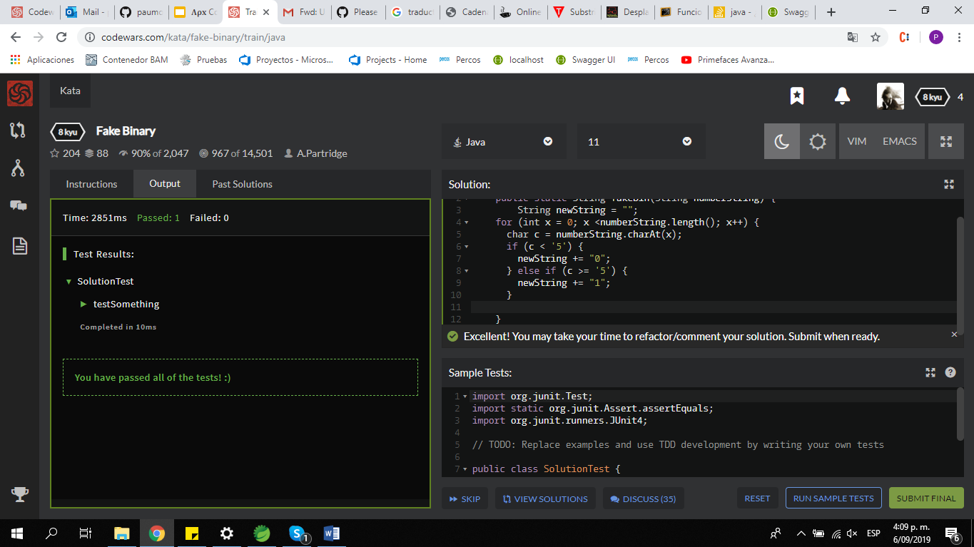

EJERCICIO 2

public class EvenOrOdd {

public static String even_or_odd(int number) {

String result = "";

if ( number % 2 == 0 ){

result = "Even";

} else{

result = "Odd";

}

return result;

}

}

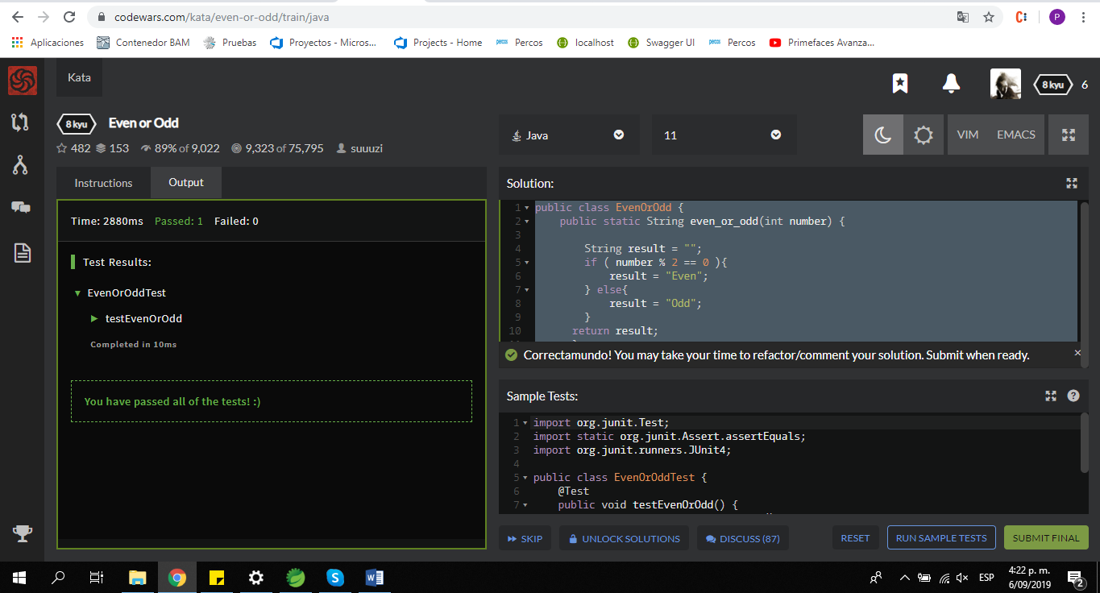

EJERCICIO 3

public class Printer {

public static String printerError(String s) {

char[] l = new char[13];

int cont = 0;

String result = "";

for ( int i=0; i<13; i++) {

l[i] = (char) ('a' + i );

for (int x = 0; x < s.length(); x++) {

char c = s.charAt(x);

if(c==l[i]){

cont++;

}

}

}

result = (s.length()-cont) + "/" + s.length();

return result;

}

}

