Diablo Valley College-Pleasant Hill
will host All-Comers T&F Meets July 9, 16, 30.
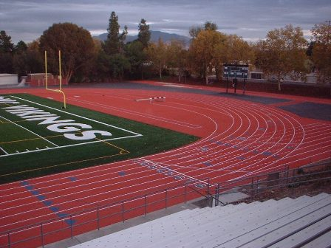
DIABLO VALLEY COLLEGE WILL HOST Winter ALL-COMER Track & Field SERIES, meets will feature steeplechase (2000 and 3000 meter events, depending upon interest).
Where: | Diablo Valley College (3/16” spikes only, No Pin Spikes!) Shoes will be inspected. Spikes will be available for sale.
When: | July 9, 16, 30 Thursday Evenings
Time: | 6:00pm – Running Events, Steeplechase, then rolling schedule, see below. Field Events, 6:00pm (No Hammer in the Winter)
Who: | OPEN, COLLEGE, MASTERS, HIGH SCHOOL AND YOUTH; BOYS & GIRLS; MEN AND WOMEN
Entry Fee: | $6.00 PER ENTRANT, Unlimited Events, SPECTATORS $2.00; Must register on line at www.directathletics.com
Contact: | Head Track Coach, Daniel Cruz (925) 437-6013; dcruz412@sbcglobal.net
cc: | ALL COACHES AND ATHLETES

DVC features a new 400 Meter Rekortan track surface and jumping area.
Summer All-comer track meet series is slated to begin with three (3) meets in July, beginning July 9th. All meets to begin at 6:00pm, Running and Field Events, 6:00pm. DVC Head Coach Daniel Cruz has announced that DVC will host an all-comer track & field series with the steeplechase listed as a feature event each week. The Men and Women's Hammer Throw will not be contested in the summer series. Go to www.directathletics.com to register. Follow instructions for registering as an individual then go to the posted meet you wish to enter and follow the entry instructions. Pay your entry fees when you arrive at the meet. Please register on Directathletics. We will take race-day entries. However, for ease on meet management, use DA. Thank you!
Order of Events, Open Time Schedule (Running and Field Events), FAT Timing

6:00pm Steeplechase (2K, 3K) |  | Field Events, 6:00pm
 | 4 x 100R | LJ (Open Pit)
 | 1500 (Mile, last meet) | HJ (5 Alive)
 | 55M HH-60MH | PV
 | 400 | SP
 | 100 | Discus (to follow SP)
 | 800 | Triple to follow LJ
 | IH (300) | (Open Pit)
 | 200
 | 3000, 5000 last meet
 | 4 x 400R

