Press Release - Winter All-Comers Series Slated @ DVC
January 3, 10, 17, 24, 31
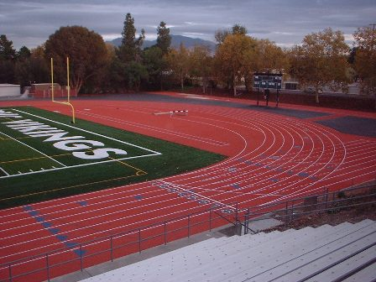
DIABLO VALLEY COLLEGE WILL HOST Winter ALL-COMER Track & Field SERIES, meets will feature steeplechase (2000 and 3000 meter events, depending upon interest). DVC features a new 400 Meter Rekortan track surface and jumping area.
Winter All-comer track meet series is slated to begin with five (5) meets in January, beginning January 3rd. All meets to begin at 2:00pm, Field Events, 2:30pm. DVC Head Coach Daniel Cruz has announced that DVC will host an all-comer track & field series with the steeplechase listed as a feature event each week. The Men and Women's Hammer Throw will not be contested in the winter series.
Go to www.directathletics.com to register. Follow instructions for registering as an individual then go to the posted meet you wish to enter and follow the entry instructions. Pay your entry fees when you arrive at the meet. You must be registered on Directathletics!
Order of Events, Open Time Schedule (Running and Field Events), FAT (Fully Automatic Timing)
Where: | Diablo Valley College (3/16” spikes only, No Pin Spikes!) Shoes will be inspected. Spikes will be available for sale.
When: | January 3, 10, 17, 24, 31
Time: | 2:00pm – Running Events, Steeplechase, then rolling schedule, see below. Field Events, 2:30pm (No Hammer in the Winter)
Who: | OPEN, COLLEGE, MASTERS, HIGH SCHOOL AND YOUTH; BOYS & GIRLS; MEN AND WOMEN
Entry Fee: | $10.00 PER ENTRANT, Unlimited Events, SPECTATORS $3.00
Contact: | Head Track Coach, Daniel Cruz (925) 437-6013; dcruz412@sbcglobal.net
cc: | ALL COACHES AND ATHLETES

2:00pm Steeplechase (2K, 3K) |  | Field Events, 2:30pm
 | 4 x 100R | LJ (Open Pit)
 | 1500 (Mile, last meet) | HJ (5 Alive)
 | 55M HH-60MH | PV
 | 400 | SP
 | 100 | Discus (to follow SP)
 | 800 | Triple to follow LJ
 | IH (300) | TJ (Open Pit)
 | 200
 | 3000, 5000 last meet
 | 4 x 400R

