
2010 USATF OHIO Association
Junior Olympic Track & Field
Championships

Saturday - Sunday, June 26-27, 2010
Cedarville University-Cedarville, Ohio

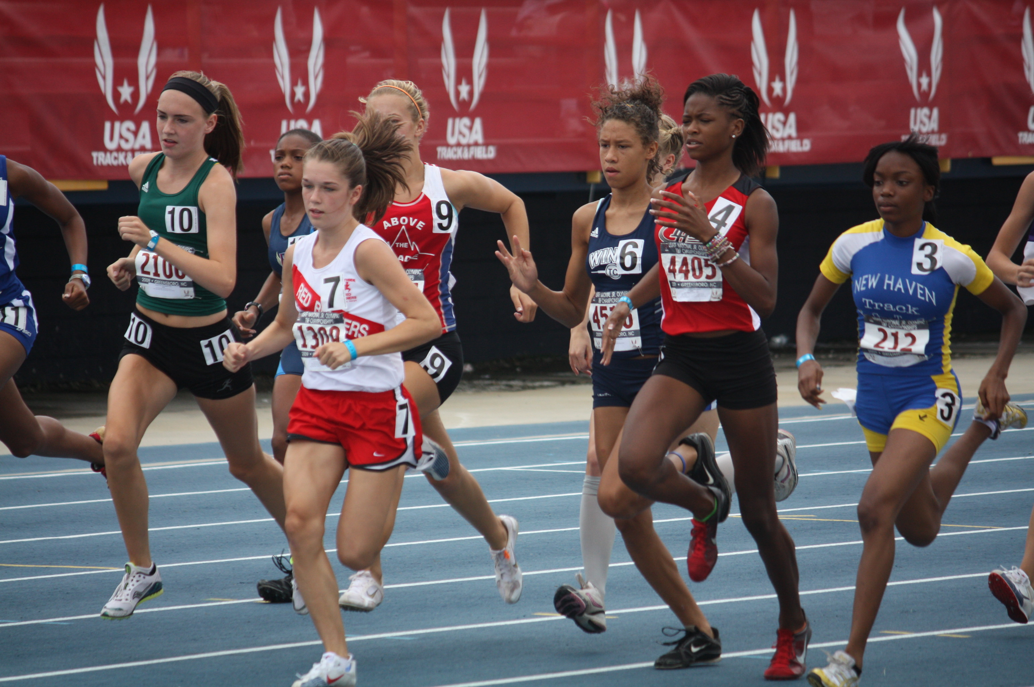
Age Divisions & Eligibility Requirements:

Age Divisions
Bantam (born 2000 and later)
Midget (born 1998–1999)
Youth (born 1996–1997)
Intermediate (born 1994–1995)
Young (born 1992-1993)
* athletes born in 1991 are also eligible if they do not turn 19 on or before 8/1/2010

Individuals: Only U.S. citizens, aliens living in the United States, and foreign exchange students are eligible to compete in these Championships. See the USATF Rules for more information and exceptions. A competitor must compete in his/her age division only. There will be no "moving up" in any events, including relays. Competitors in the Bantam and Midget divisions may compete in a maximum of three (3) events, including relays. Competitors in the Youth, Intermediate, and Young divisions may compete in a maximum of four (4) events, including relays. Combined events are not included in the event count. All athletes must be 2010 members of USATF in good standing.

Relay Teams: Only registered 2010 USATF member clubs may enter a relay team(s). All athletes representing the club must be affiliated with and members of that club as part of their USATF membership. Visit www.usatf.org and select “Products/Services” to become a member.

ENTRY PROCESS:

Individual Entries: $dollar amount (max of $6 dollars) per event
Relay Entries: $dollar amount (max of $24 dollars) per relay team
Decathlon/Heptathlon: $dollar amount (max of $16 dollars) per event
Triathlon/Pentathlon: $dollar amount (max of $10 dollars) per event

On-Time Registration: Entry forms must be received (postmarked) by date
Day of Event: Entries closed at time

Before the meet start date, please ensure that the membership chair has received (via mail or fax) a copy of the athlete’s Proof of Birth (copy of birth certificate, passport, certified baptismal record, driver’s license, or U.S. government identification). See Rule 300.1 (h) for further explanation.

Membership Chair: (Insert Name)
Address: (Insert address)
Fax: (Insert fax number)
For questions, contact at: (Insert e-mail address and phone number)

All entries must be made using the official entry form. Proof of Birth (copy of birth certificate, passport, certified baptismal record, driver’s license, or U.S. government identification) is required and must be submitted with each entry form (even if it was already submitted to the membership chair). For relay team entry, please follow the instructions on the official Relay Roster Form.

Send entry forms, fees (only money orders and checks payable to name) and age verification documents to:

Name: (Insert Name)
Address: (Insert Address)
City, State Zip: (Insert City, State, and Zip Code)

AWARDS: USATF Junior Olympic medals will be awarded to the top three (3) individuals and the top three (3) relay teams in each event of each age division.

ADVANCEMENTS: The top number individuals and relay teams in each event of each age division will advance to the USATF Region 5 Championships to be held on dates at location (city, state).

All advancement/entry forms for the USATF Region 5 Championships must be completed, paid for, and submitted (cash or money order only) prior to leaving Cedarville University on June 27. The National Championships will be held from Tuesday, July 27 to Sunday, August 1 at Hughes Stadium – Sacramento City College, Sacramento, CA. The top 3 athletes at the Region 5 Championships will qualify for the National Championships. Information is available at: http://www.usatf.org/events/2010/USATFJuniorOlympicTFChampionships/.

SCHEDULE:

(Insert schedule information)

IMPLEMENT WEIGH-IN: (Insert times and location)

EVENT CHECK-IN: There will be separate check-in areas for Running and Field events. Athletes must check in at these designated areas 45 minutes prior to the event's scheduled starting time. All athletes will be required to remain in the designated warm-up areas after checking in.

COMPETITION BIB NUMBERS: All competitors must wear their assigned bib numbers during competition and on the front on their jerseys only. If an athlete loses the bib number, a replacement can be purchased for a fee of $dollar amount. Bib numbers will be distributed to athletes (describe pick-up times and location).

EVENT RESULTS: During competition, event results will be posted (describe location at the track facility). In addition, event results will be posted at (insert web site address).

PROTESTS: There will be a $dollar amount fee for all protests. Protests must be submitted to the Protest Referee at once and not later than 30 minutes after a result has been announced. The protest fee will be refunded if the protest is upheld.

RULES – CONDUCT & FACILITY: (Insert your information)

GATE ADMISSION FEES: (Insert your information)

DIRECTIONS & PARKING: (Insert your information)

CONTACT:
Name: (Insert contact person’s name)
Phone Number: (Insert contact person’s phone number)
E-mail: (Insert contact person’s e-mail address)

