 | Masters All-Comers  Post-Nationals Track Meet  Presented by the  PACIFIC STRIDERS  AUGUST 11, 2007 6-8 PM  Granada High School, Livermore, CA |  |   USATF Sanctioned
Event Schedule (open athletes welcome)  6:00 100 meters  6:15 1000 meters (W/M)  6:30 400 meters  6:45 200 meters  7:00 3000 meters  7:20 4x200 meters (W)  7:30 4x200 meters (M)  7:40 Women’s Ironman Relay*  7:50 Men’s Ironman Relay*  *2 athletes: Runner A- 400/ Runner B- 800/ Runner A- 800/ Runner B- 400 |  | 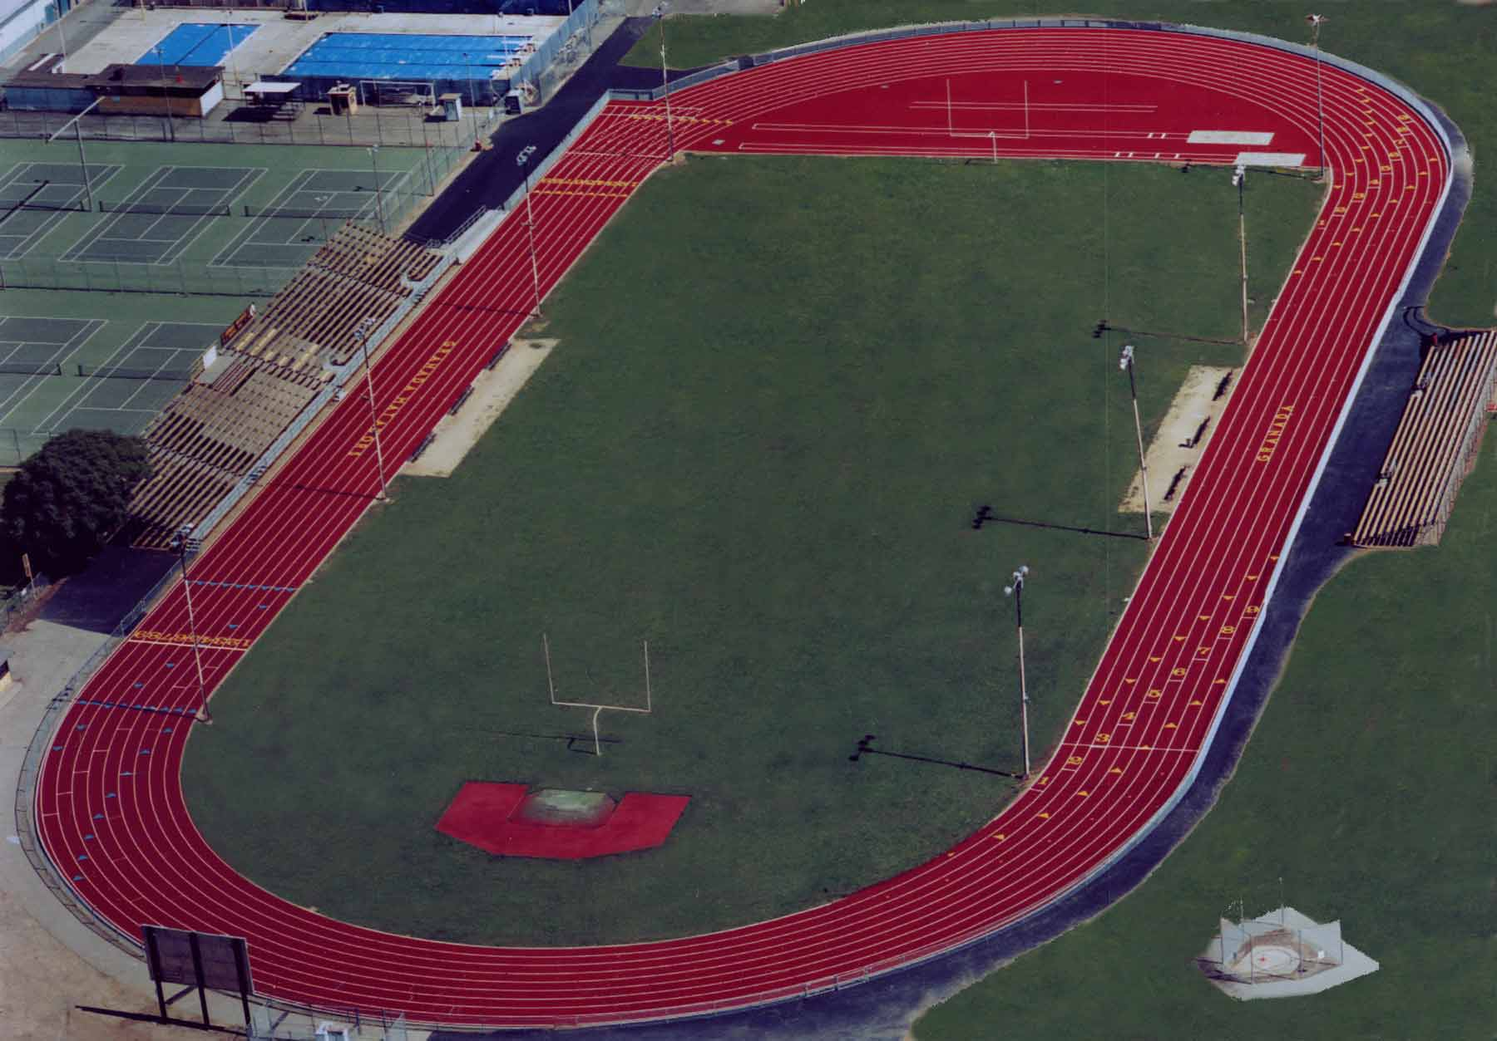  http://www.granadahigh.com/
- Check-in 30 minutes prior to event
- Relay teams must declare by 7:00PM
- Entry Fee: Before 8/6/2007 First event $15.00, Late Fee: $20,
- Add $5 for each additional event
- Mail entry and fee payable to “Pacific Striders” 1325 Arrowhead Ave Livermore, 94551

Event | Predicted Time

Name:________________________________ Sex: __M __F
Age on 8/11/07 ______Club Affiliation_______________________
Address:________________________________________________
City: _________________________ State: _____ Zip _________
Phone:________________ USATF # ___________________
Email:____________________________________________
Waiver: (Signature required) I hereby waive all my rights that I or my assigns or heirs may have against Granada High School, LUSD, Pacific Striders, arising from any accident or illness that I may sustain in participating in, arriving or departing from this event. I declare that I am fit and in good health to participate in this event

Signature: _________________________________ Date: ____________

