***Student Name: Frida Prince  
Student Number: 20213509***

***NEAR EAST UNIVERSITY GRADUATION PROJECT***

- Interactive 3D Map Using HTML CSS JavaScript & MapBox GL JS

- Smooth scrolling in each section.

-Interactive Zoom Control feature on each building.

- Street View for the Entire School Building

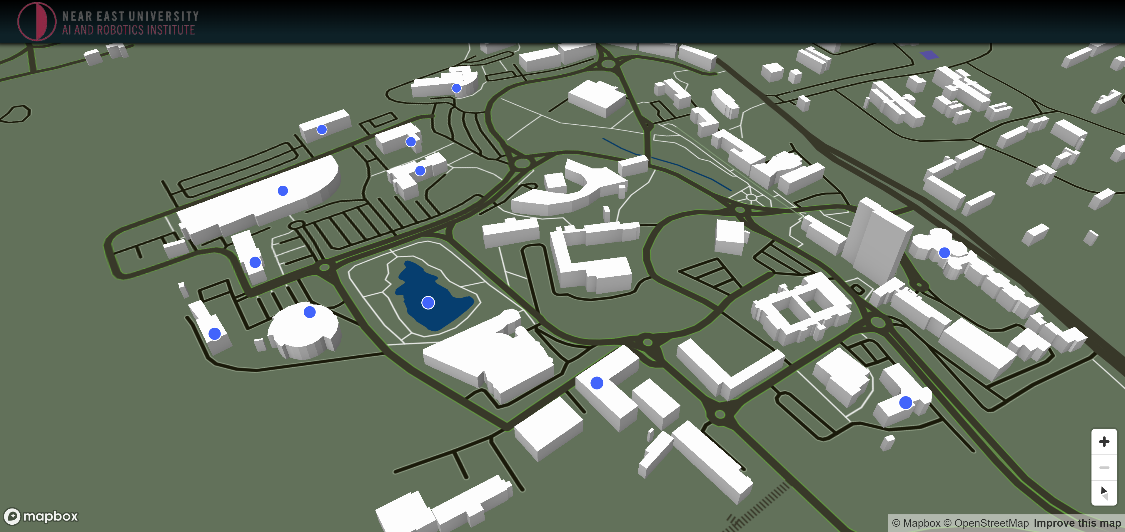

***###############################***

***HOW TO RUN PROJECT***

- Clone Repository

- Launch Visual Studio Code

- Un-zip Folder and Open in Visual Studio Code

- Launch Live Server

- Go Live

***######################################***