**Task2.1PWebHook**

Summary

Webhooks are user-defined HTTP call-back function that have the ability deliver data to other apps in real time, creating a communication by event triggering and event processing. This allows for more efficient and interactive user experience, automatically pushing data without the need to regularly check for data updates, webhooks data sync in real time as changes/updates are mad.

In a real-world usage scenario, webhooks are utilise in many of our daily use applications and services to facilitate a real time data exchange and automation action. For example, a communication platform or application like Microsoft Teams. In Microsoft Teams, there are integration of various apps and services that plays a huge role in providing a seamless workflow and enhancing communication. In specific, the calendar events apply webhook to send notifications/reminders or updates/change meetings and events from a calendar service directly into Teams.

GitHub - <https://github.com/pautangpua/Task2.1WebHook>

CIRCUIT BOARD

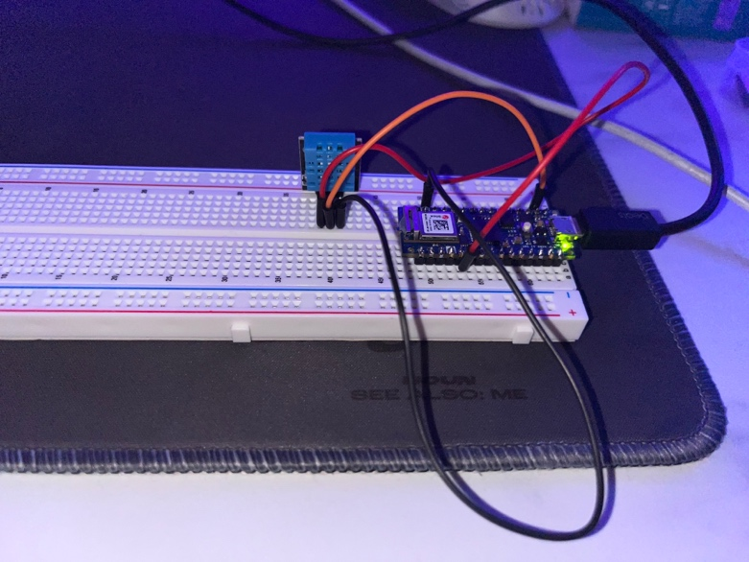

THINGSPEAK

