Report B:-

## B-1 Can you tell me No of Vehicles by Brand Available on ebay for sale with the help of visualization ?

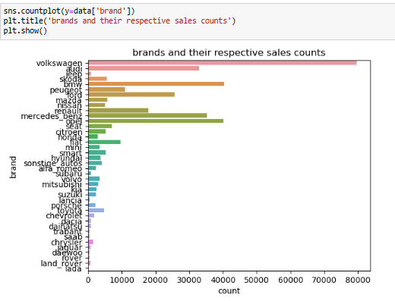

* “Volkswagen” brand has huge sales count on ebay.

## B- 2. What is the Average price for vehicles based on the type of vehicle as well as on the type of gearbox.Explain me with both numerical and visualization analysis ?

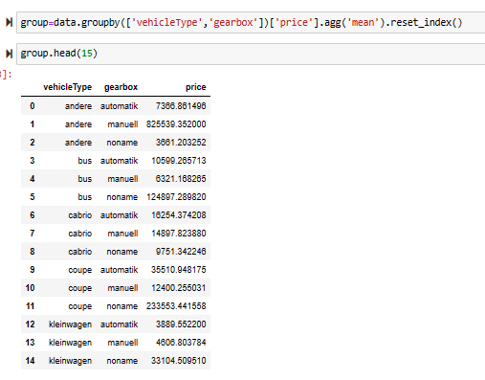

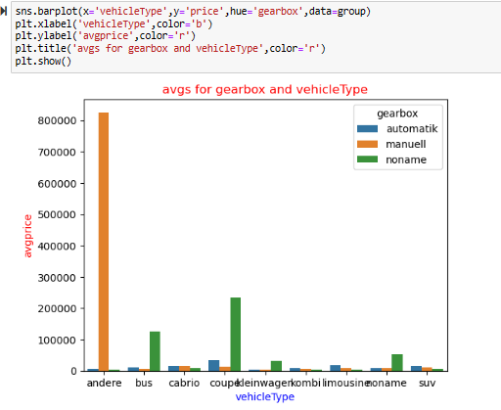

* Andere manuell has highest average price and andere automatic has least average price.
* Kleinwagen manuell has very low average price.

## B-3 What is the marginal probability of private seller ?[¶](http://localhost:8888/notebooks/python%20coding%20file/Data%20Analysis%20Project-1.ipynb#B-3-What-is-the-marginal-probability-of-private-seller-?)

pd.crosstab(index=data["seller"]=="privat",columns=data["seller"]=="gewerblich",rownames=["privat"],colnames=["gewerblich"],normalize='columns',margins=True)

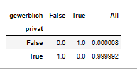

* Marginal probability of private cellar is 0.999992.