Table of Contents

Introduction 4
Job Inventory 4
Adding Systems in Redwood 7
Defining Process Definition 14
Scheduling the job 18
Defining Time & Date 21
Defining a Chain Definition 24
Monitoring 28
Raising an Incident for Job Failure 31
Retention Plan 34
Change Management Process 35
Audit Jobs and logs 36
Integration of S3 bucket 36
Redwood Queue Management 36

Introduction

SAP BPA by Redwood is a job scheduling tool which drops jobs to the SAP & Non-SAP system. It is having its own advantages which makes it more user friendly and less prone to performance issues.

Whenever an SAP system is connected to Redwood, it creates its own SAP System at Redwood side which has its own process server, and the same process server has multiple queues assigned to it.
By default, on creation of a new SAP System in redwood, one process server and one queue will be created respective to it.
If required, another queue can be created and assigned to a Process Server to release jobs in certain way.
An incident is being created when jobs are in an error state, when variants are not updated, maintained or are not available.

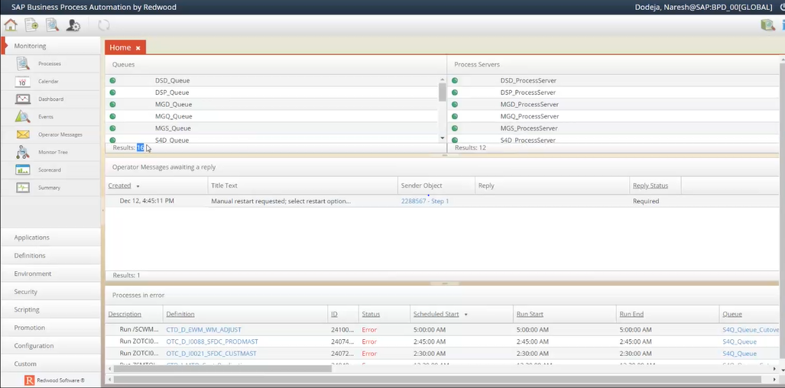
Home Tab

Job Inventory

MONARCH SHAREPOINT PORTAL-
It is a common area where everyone can see and update details about a specific job.
Sections that are available on the portal are -

Days of the week:
Business day = working day
Business day minus one = last working day of previous month

SharePoint Portal for Redwood

Development/staging/quality scheduled status: Toggled to ON mode when the job is scheduled in respective environment.
Release approach: There are two options
- Controlled: Manual execution until notified by functional team. Put jobs on hold, don’t release them until functional team confirms it.
- Automatic: Automatically turned on.
Development comments: Updated by functional team

On Redwood, we can see the list of jobs by going to section “Process Definition” which will include both functional & pre-defined redwood jobs.

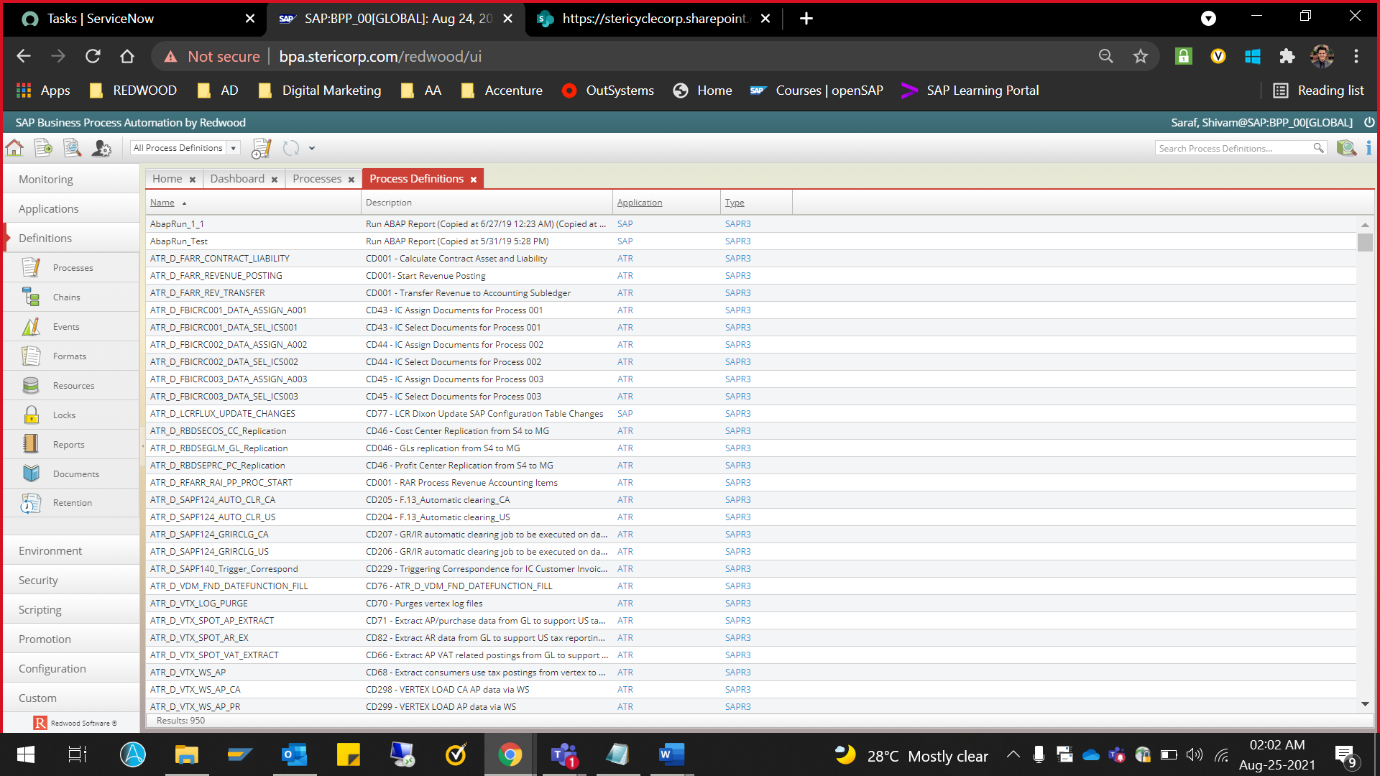

Adding Systems in Redwood
Systems can be added in Redwood from “Environment” option from left side pane.

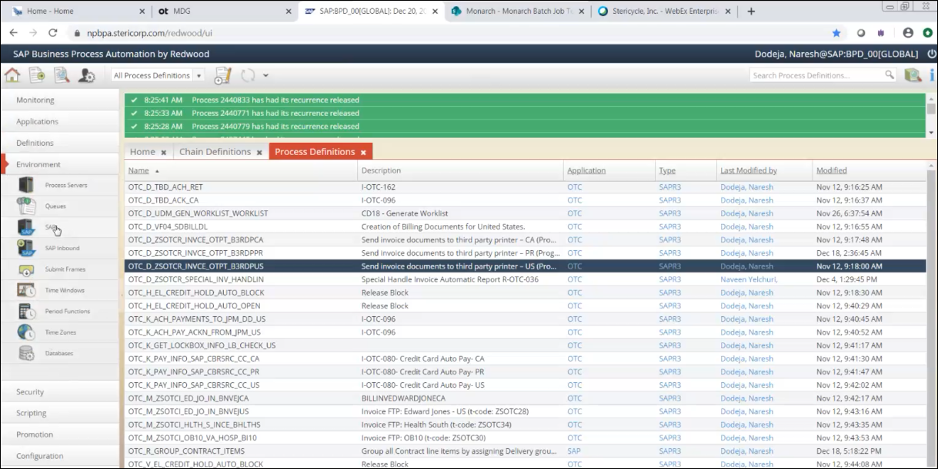
Adding SAP Systems

Creating an SAP system in Redwood

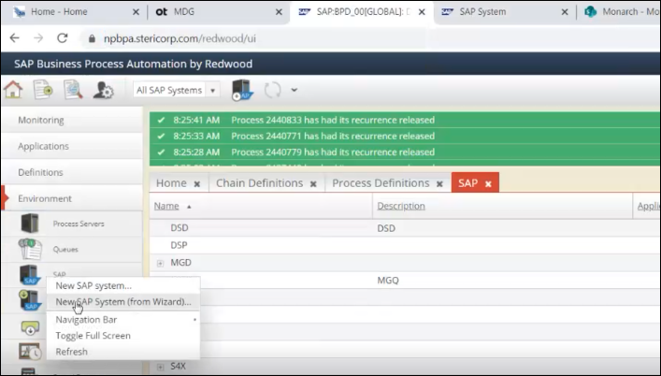
Creating New SAP System

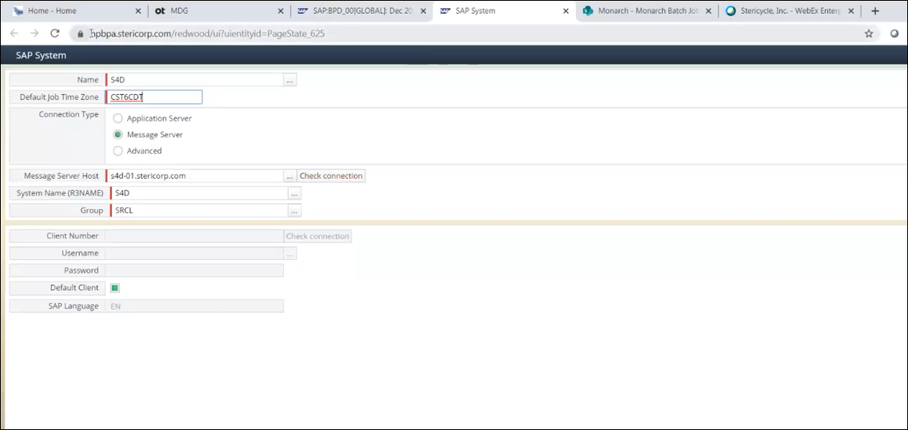
Creating New SAP System

Besides this, we must create connection from Redwood AS Java to the desired ABAP server using NWA.

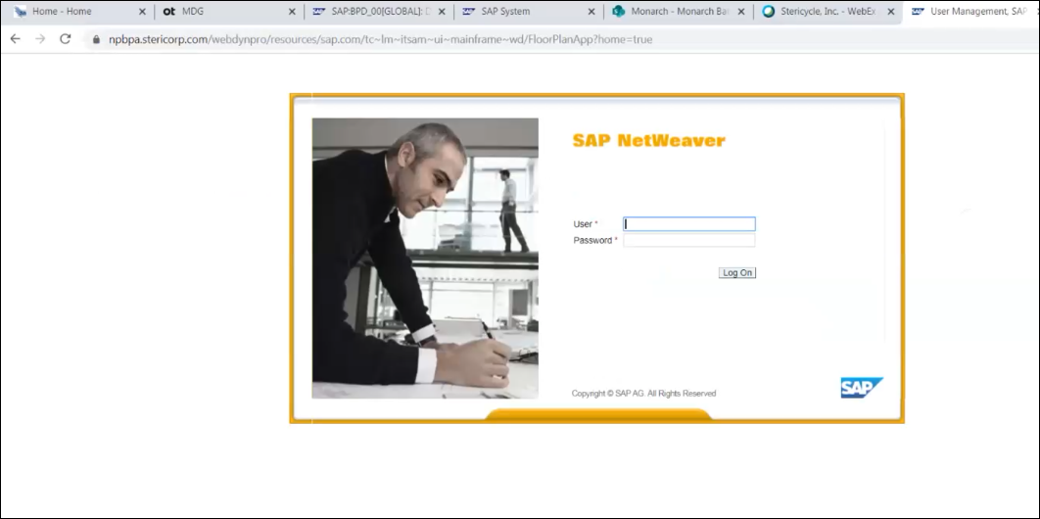
Logging into NetWeaver

NWA à Configuration à Connectivity à Destinations
Then click on create to establish a new RFC connection to the desired ABAP server

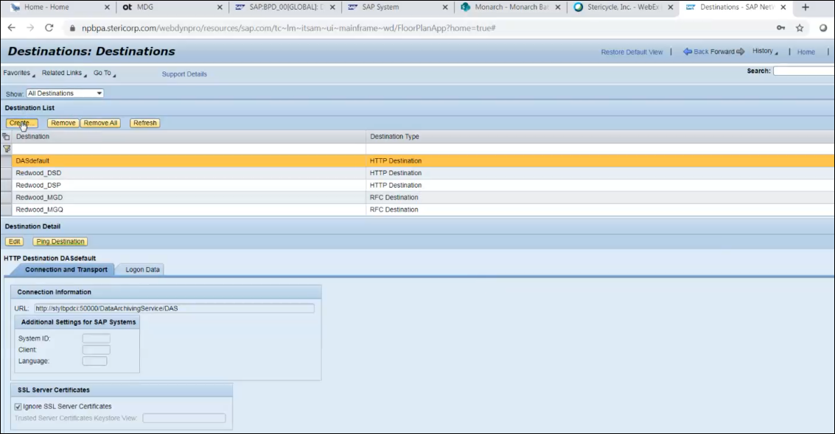
Creating new RFC connection

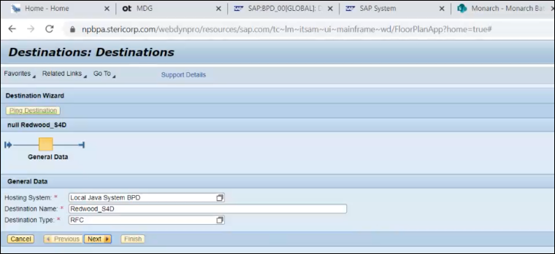
Destinations Wizard - General Data
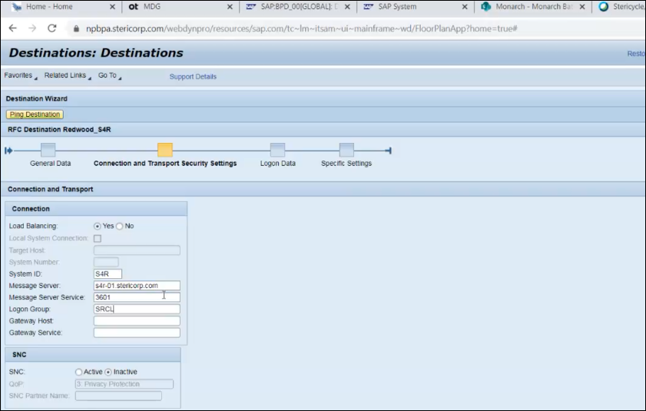
Destinations Wizard - Connection and Transport Security Settings

User ID to be used for connectivity should always be BTC_BAS

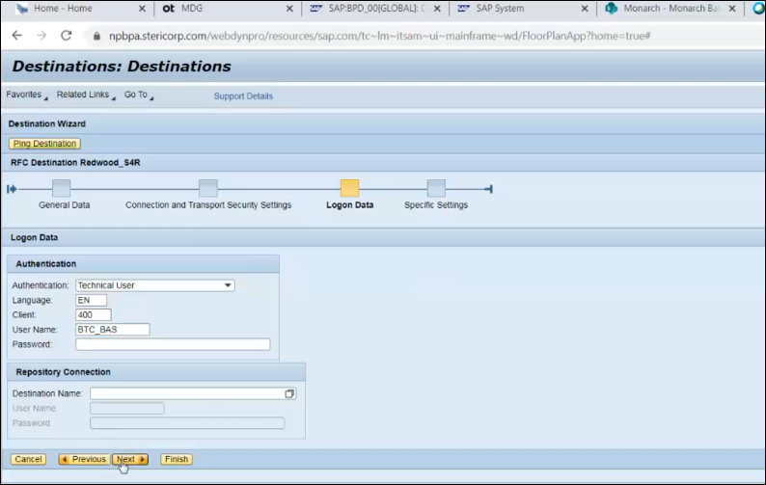
Destinations Wizard - Logon Data

Do not make changes in next step “Specific Settings” and click on “Finish”.

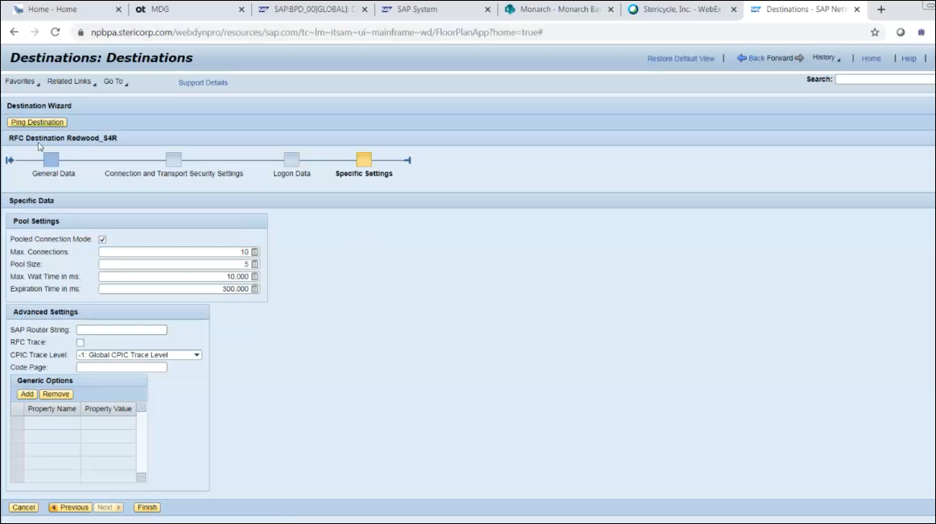
Destinations Wizard - Specific Settings

And finally click on “Ping Destination” to check the connectivity with target system.

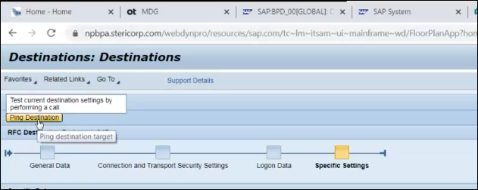
Testing the RFC Connection on NWA

After all the configurations on NWA and on Redwood are completed, then click “Check Connection” to test the connectivity in Redwood as well
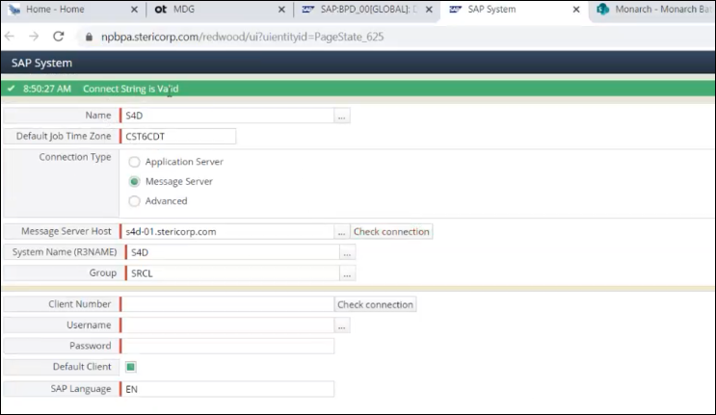
Filling in RFC Details in Redwood
After adding the user credential, we can check the connectivity of that user which will be scheduling jobs from Redwood to ABAP system.
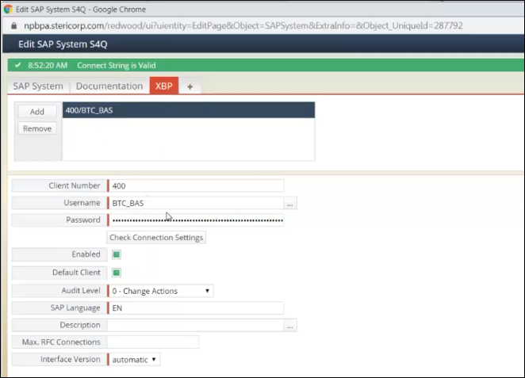
Testing the RFC Connection on Redwood
Also, various other clients of the same system can be added, and their credentials can be maintained accordingly.
After successful addition of the SAP system, a Process server & a Queue will be created corresponding to the SAP system.

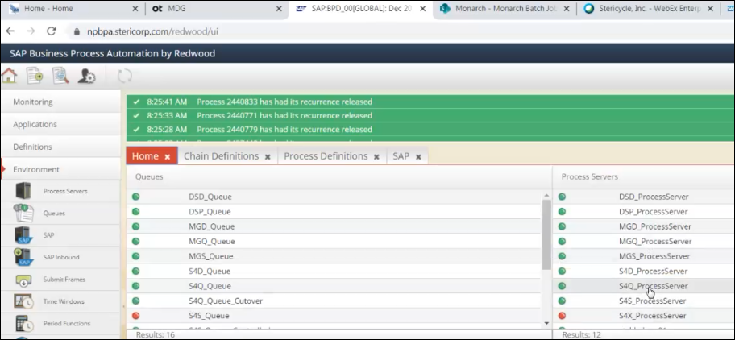
RFC Connection Tested

Process Server can be stopped/started once SAP system is good to go after initial configuration.

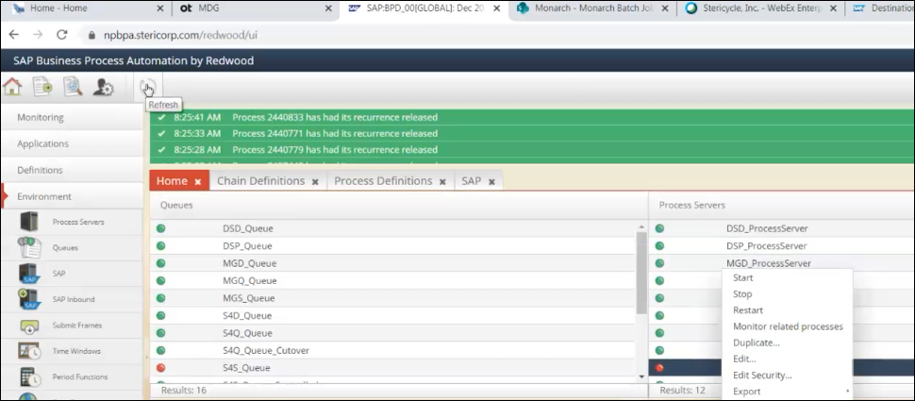
Starting/Stopping Process Server

Issue - SAP system was added successfully in Redwood, but the Process Server was not starting up.
Resolution - SAP recommended to stop the application instance of Redwood so that the target ABAP system can be started from Redwood. Make sure to bring back the Application instance of Redwood.

Defining Process Definition

Whenever a new request comes for creating a new job and triggering in connected systems, we ask the concerned team for a Service Request and also tell them to update the job details in Sharepoint location.

And if there is any change required in the existing Process Definition then we ask the concerned team to create a Chang Request for us and also provide the SA approval so that we can be sure that the desired request is approved.

Job definitions which are present by default will be having type “SYSTEM” and those which are created individually will be having type as “SAPR3”.
“SAP_AbapRun” is the standard Process definition for creating a new definition just by duplicating it.
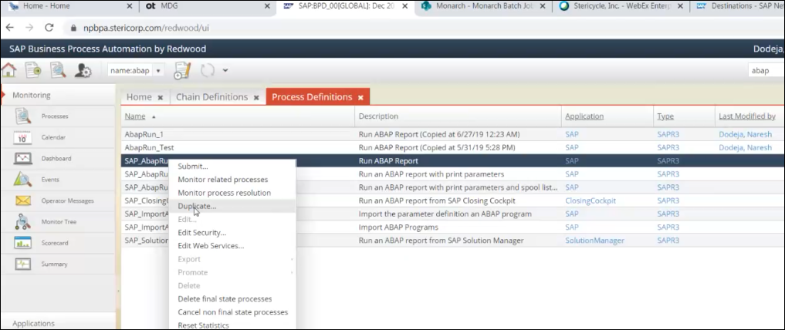
Duplicating a Process Definition
After duplicating the original definition, following screen will be shown in which we have to fill the name & description of the job

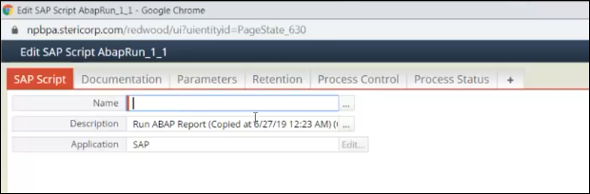
Filling in the details of the job

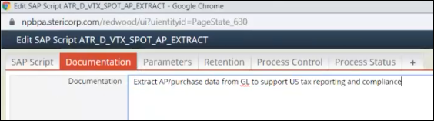
Documentation Tab

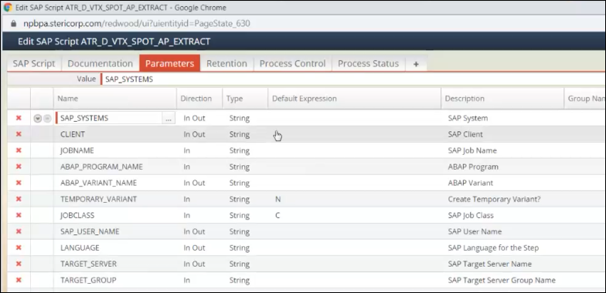
Adding parameters and their values

In parameter section, we should not be giving any default value for “SAP_SYSTEMS” & “CLIENT” as this process definition itself can be used for multiple systems and can be reused.
SAP_USER_NAME can be changed as per the requirement by functional team.

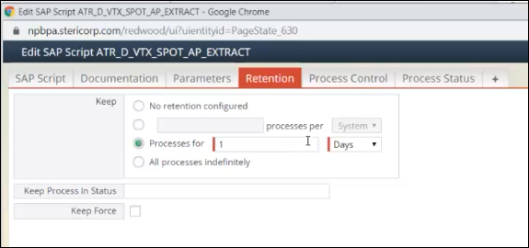
Retention Tab
The screen above shows the period for which we want to retain the logs of the current definition
Daily – 15 days
5 mins – 240 mins
More than 5 mins – 360 mins

For the tab “Process Status”, we must make sure that return codes 0,4 are mentioned so that whenever job gets completed with 0 & 4 in SAP, Redwood will always show that job is completed. But for other return codes Redwood will show “Error”

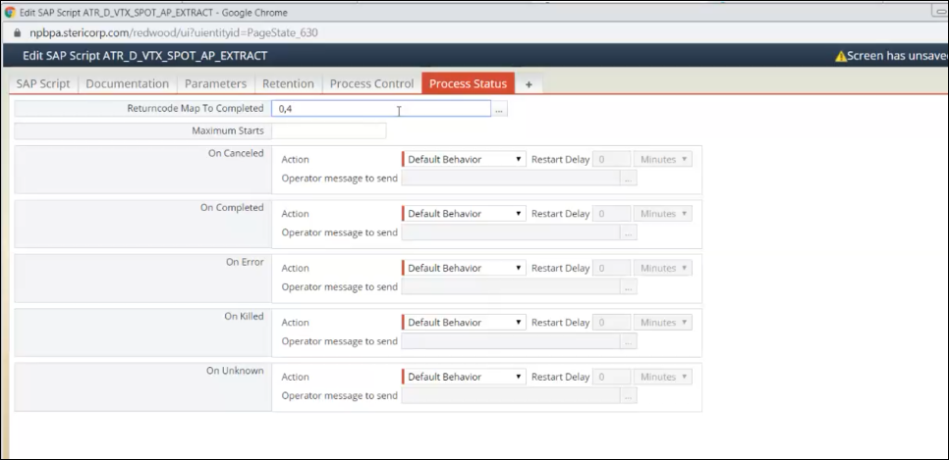
Process Status Tab

After successful filling of the details in Process definition, job will be created and will be available as per below screen
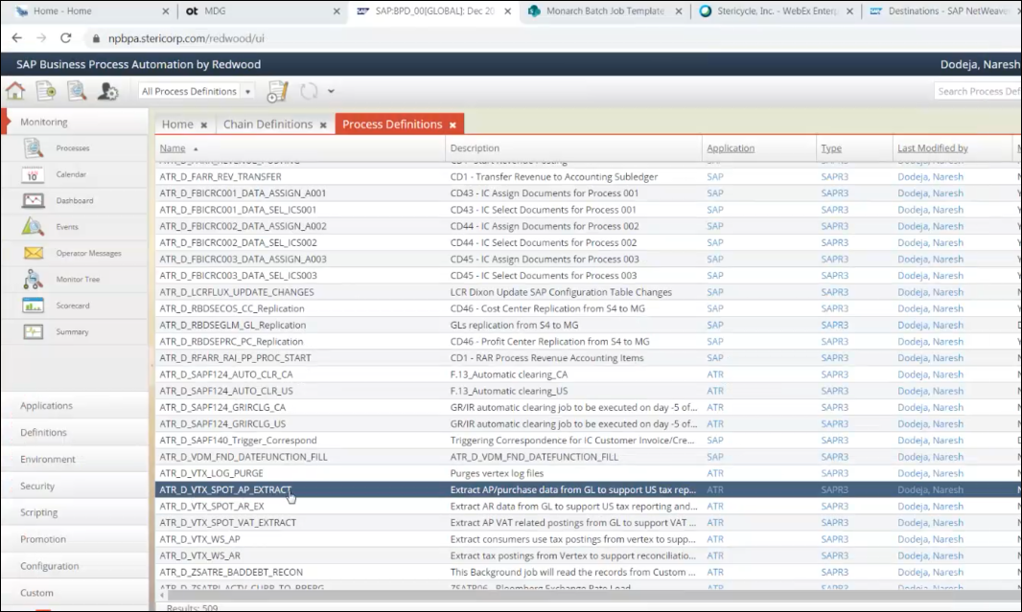
Process Definition Tab

Scheduling the job
For putting a job into a schedule, we need to have a Service Request and SA approval with details updated on Sharepoint. Once those details are there, we will proceed for job creating as per previous section and will follow by finding the job definition and perform a right click on it to find an option “Schedule” which will help in providing the system in which job has to run and for which time window and for how many times.

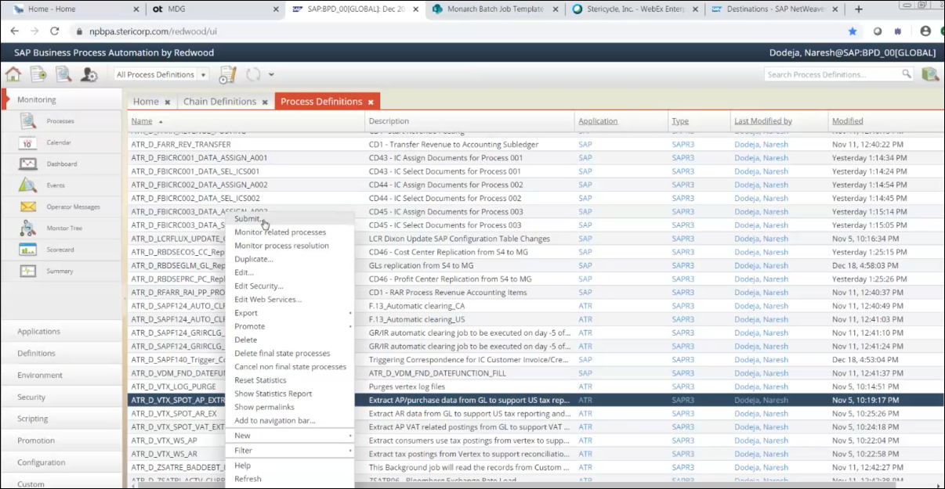
Submitting a Process Definition

In the next screen, Parameters must be provided in the below manner

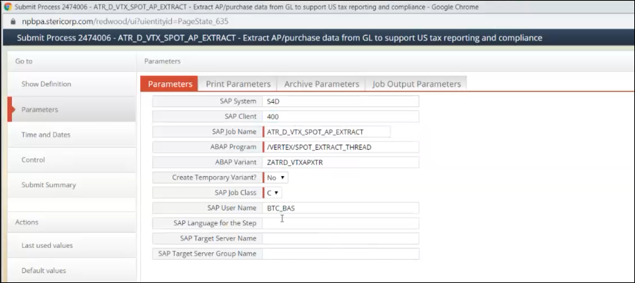
Parameters Tab

Select the time & date details in next screen

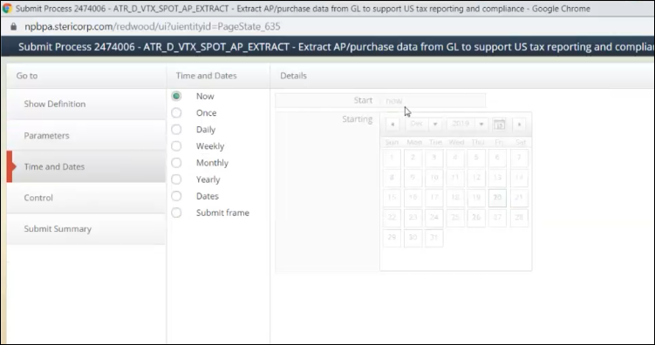
Time and Date Tab

Further, the Queue must be defined which will direct the job to correct process server & later to correct SAP System

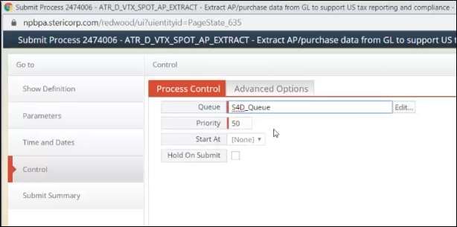
Defining the Queue

In the last step, automatically a process ID will be generated & assigned, and it will show the summary of job that is going to be scheduled.

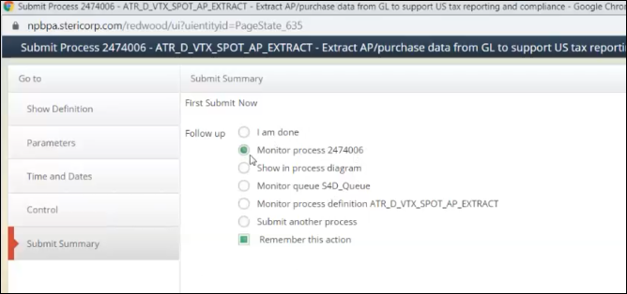
Submit Summary Tab

After submitting the job, we must monitor it by going again to the Process definition section and find the job. After that right click the job and look for the option “Monitor related processes” which will display all the scheduled/completed processes for that particular job.

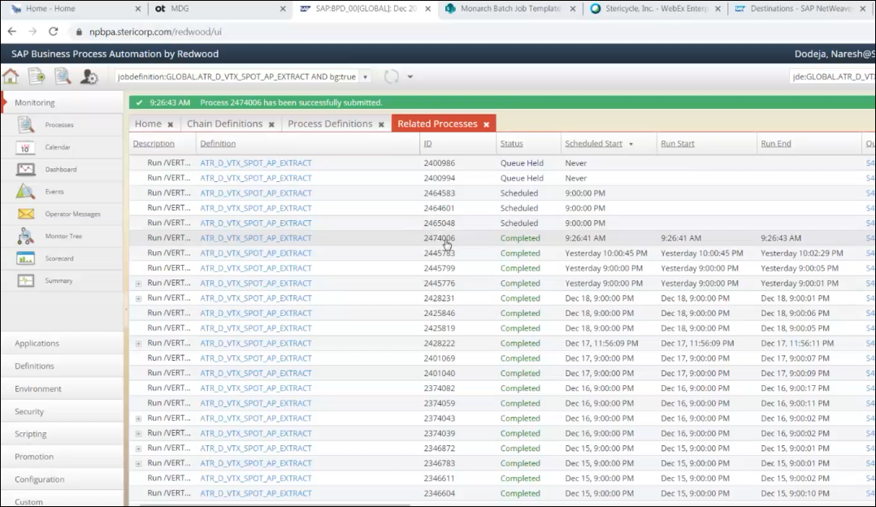
Related Processes Tab

If job must be submitted but we don’t want to get it dropped to the system, then we can put a hold onto it while submitting as per below screen.

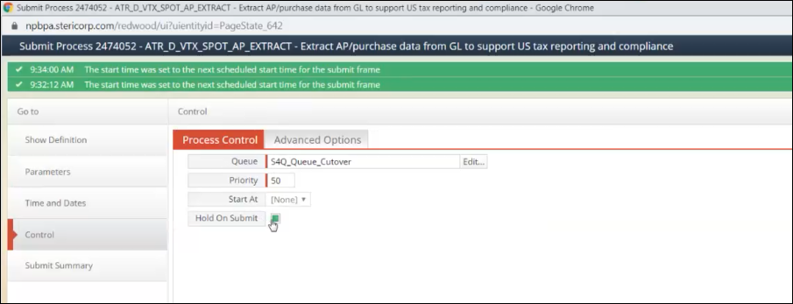
Control Tab

Hold can be applied on a single iteration and complete schedule of the job by selecting the desired option after we select put on hold.

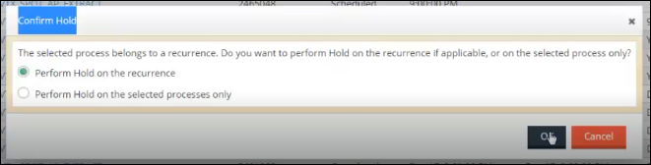
Confirming On Hold

Defining Time & Date
Do not use options other than “Now”, “Once” & “Submit Frame”
Submit frames helps in scheduling the job with a certain frequency. We have some pre-defined Submit frames for scheduling the jobs but we have created our own so that the jobs can be scheduled as per Functional team’s requirement.

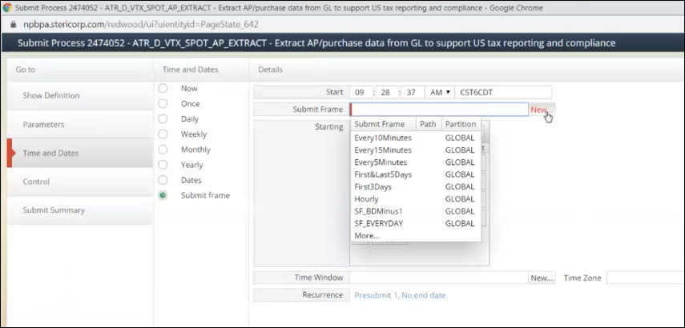
Time and Dates Tab

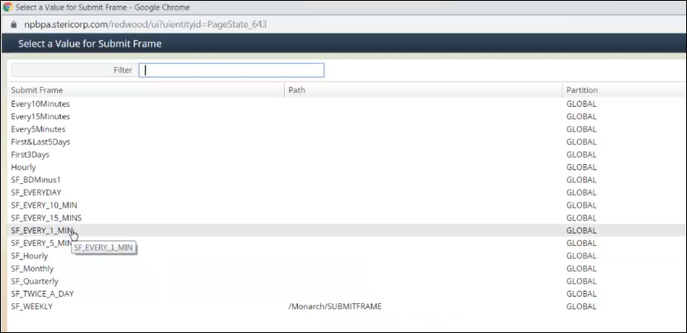
Submit Frame

Time Window shows the days or time slots for which the job should run

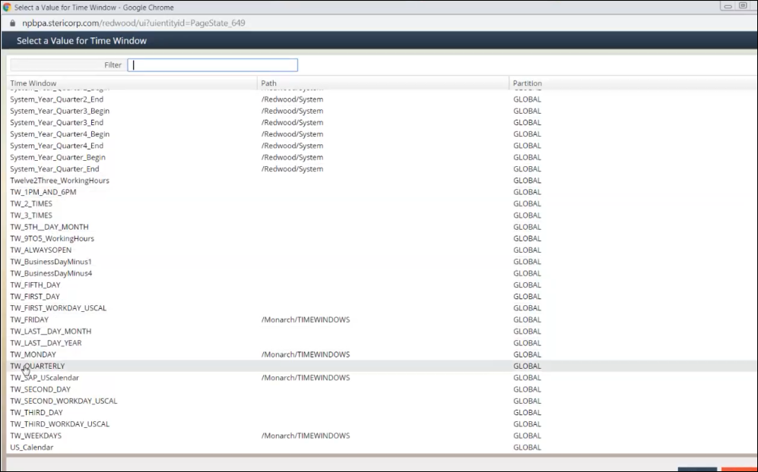
Submit Frame
If any team want to change the timing or frequency of the job, then they need to get SA approval and then submit a Service Request to get the details updated in Redwood.

Defining a Chain Definition

Chain definition is required in case we want to run the jobs in a sequence with predecessor & successor. But we do not have all jobs with predecessor & successor in Production, still we are creating the Process definition for each job so that whenever the job completes, the pre-defined process definition of sending a mail notification will get triggered in case job fails. This will help us in getting the notifications at the earliest so that the desired actions can be taken on failed jobs.

To start with Chain definition, we need to add chain Definition name at the beginning of the description of process definition, this is done so that it is easy to identify which job belongs to which chain definition.

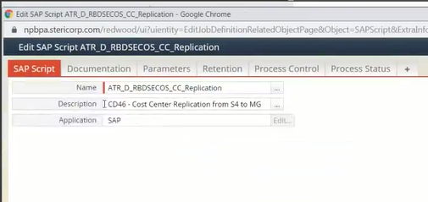
Adding Chain Definition name at the beginning of process definition description

While adding steps in Chain Definition, the SAP System & SAP Client Parameters should be left blank so that the same Chain Definition can be used for multiple Systems

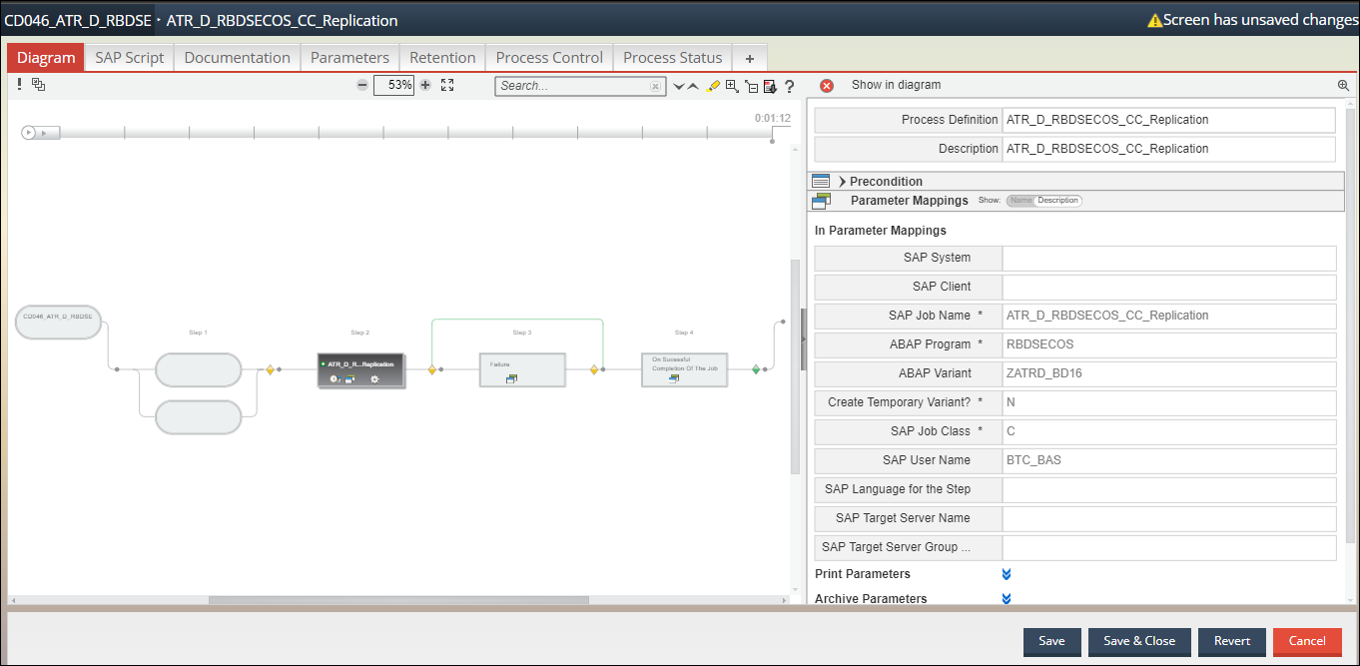
Adding steps in a Chain Definition

After adding steps in a Chain Definition, we will go to the Retention tab
In Retention we will set the period for which we want to retain the logs of the current definition

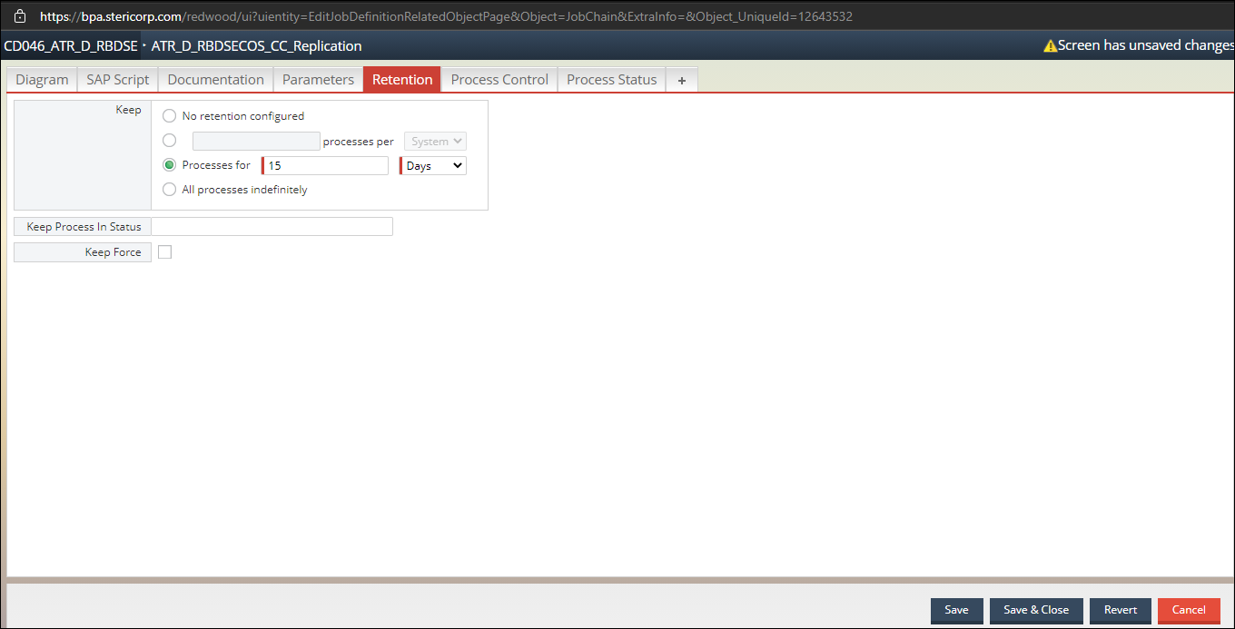
Retention Tab

After Retention tab, we will access the Process Status tab

Under Process Status tab we will set the column ‘Returncode Map To Completed’ as 0,4 so that whenever job gets completed with 0 & 4 in SAP, Redwood will always show that job is completed. But for other return codes Redwood will show status as “Error”

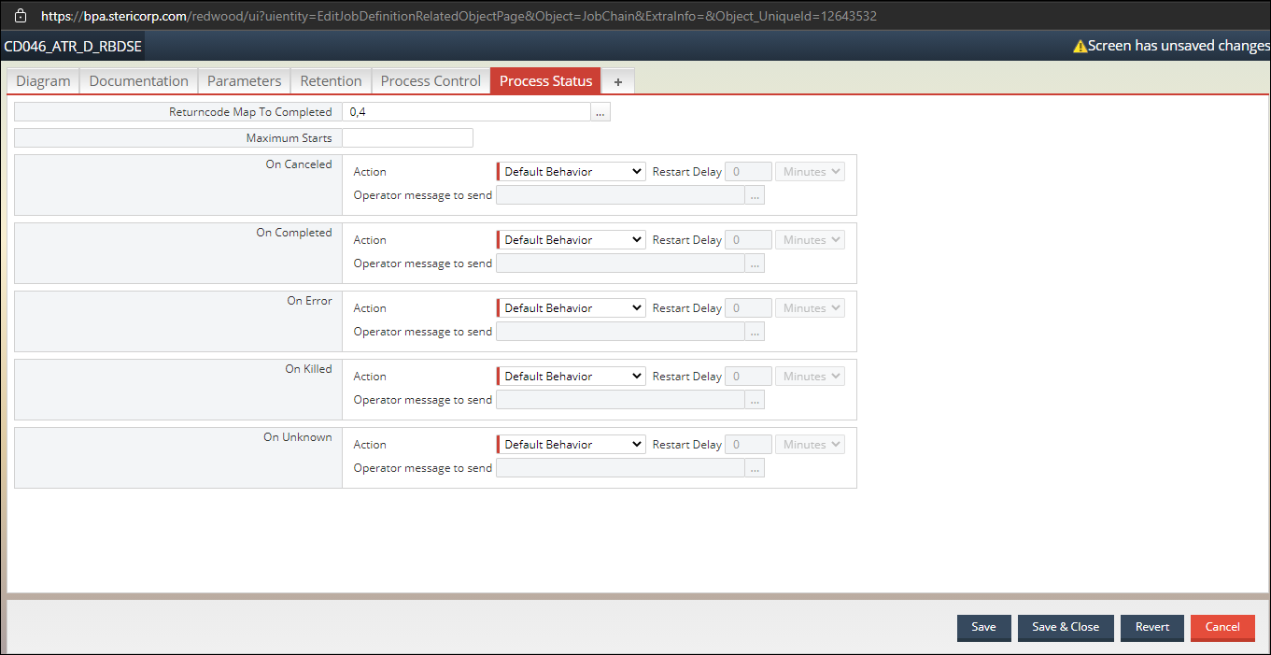
Process Status tab

Under the Diagram tab ‘Request restart by default’ needs to be set as “Disabled”, if it is set as “Enabled” and the first step goes into “Error” State, it will be skipped, and the next step will start. (first step won’t re-run)

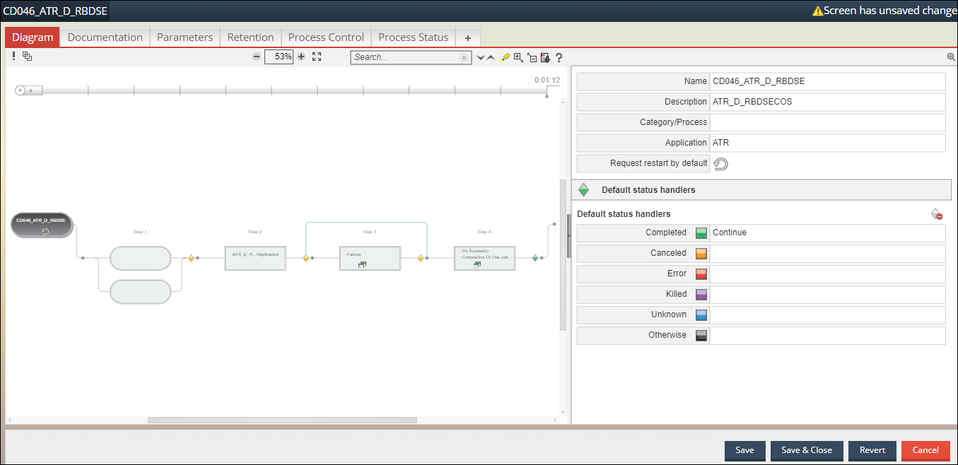
Disabling Request restart by Default

Monitoring

Monitoring is performed for the production system frequently and is being checked for any jobs that have got failed. For this, we start monitoring by going to the home tag, check for errors in ‘Processes in error’

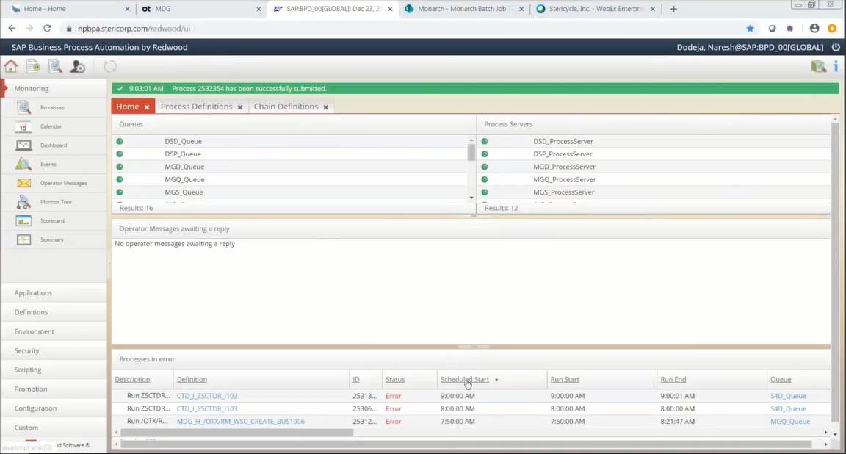
Home Tag

Under the Process Definition/Chain Definition Tag select the definition which has ‘Status’ as “Error”, right click on it and select Monitor related jobs

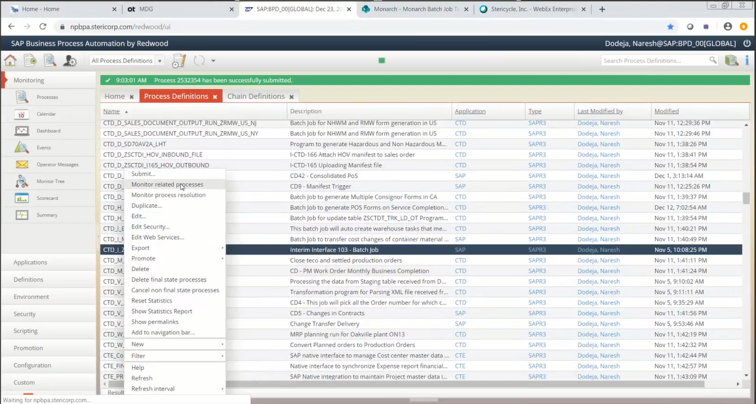
Process Definition Tag

It will show all the Processes the job has gone through

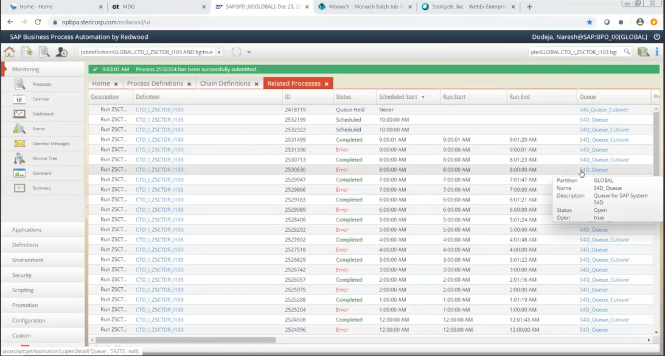
Related Jobs Tag

Select the entry with ‘Status’ as “Error” of the Job Definition

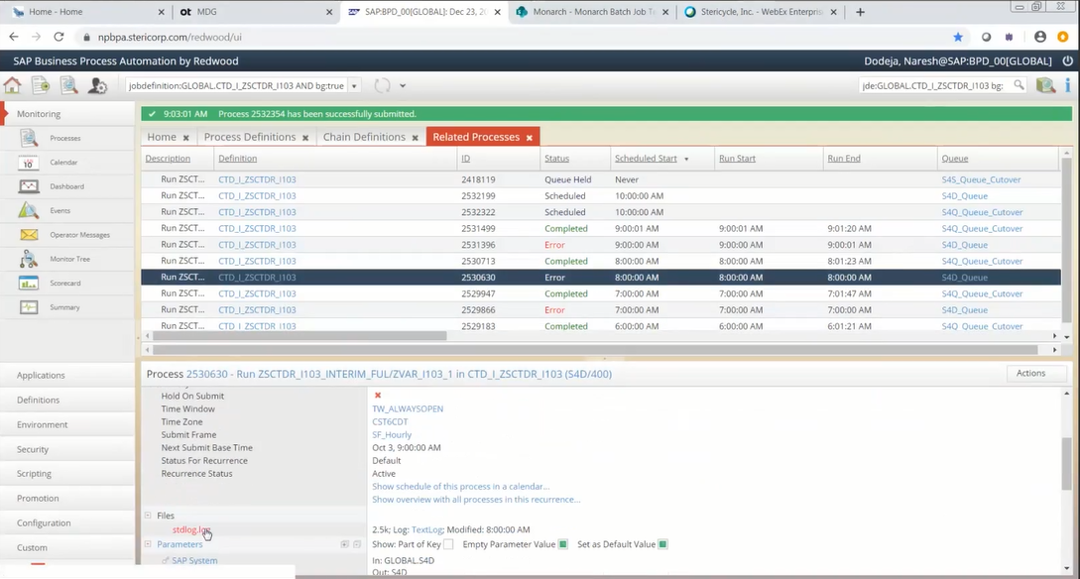
Related Jobs Tag

And then open the log file

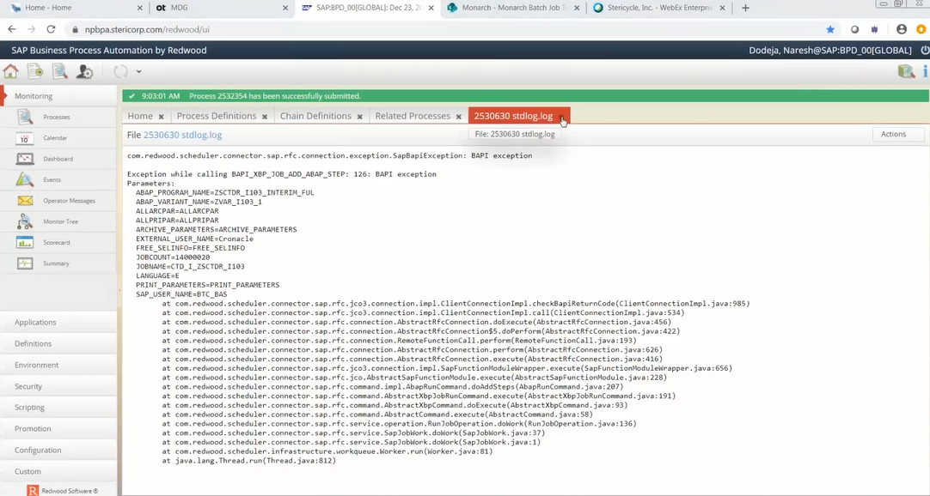
Error log file

You will be able to see the issue due to which the Job went into “Error” status.

Raising an Incident for Job Failure

As mentioned in section “Defining a Chain Definition”, we have configured each and every job within a chain which is followed by a mail notification job which will send mail to associated functional team and to Service Now so that functional team is aware of the job failure and also a Service Now Incident is being created.

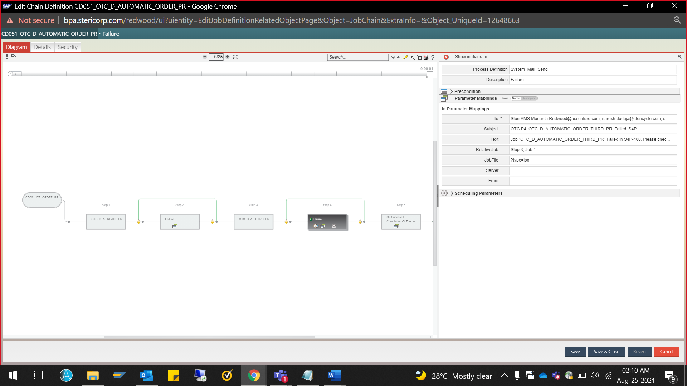
Raising an Incident

An automated mail notification will be sent

Also, email was sent to Service Now so that INC will get generated like below –

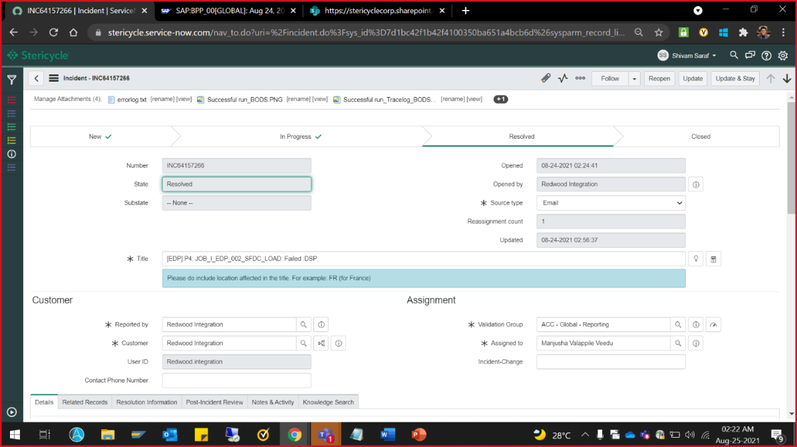

Once, the INC is created, it will be directly assigned to concerned team based on the configurations done on Service Now to identify the job and to assign it to the correct functional validation group. Then, functional team will start working on correcting the job. If they want some time to correct the job and till then job needs to be put on hold, then they have to submit a request for that.

And once the issue is corrected, either the team will ask to re-trigger the job or the job will run on its own if it’s a frequent one.

In such cases, job will trigger with its next set frequency.

Retention Plan
- Retention is used to refer to the time period for which the data remains in the database, from the time it is entered to the time it is archived.
- In Redwood, we have following retention period for different job runs as follows:
    - If Job runs for every 5 mins /10 mins / 15 mins / 30mins / 1 h - Retention will be for 2 days.
    - For Daily job - Retention will be for 15 days
    - For Weekly job - Retention will be for 2 months
    - For Monthly job - Retention will be for 6 months
    - 6 months / yearly job - not giving any value in retention field which means all logs of the jobs will be retained.
    - 24 hours job - Running at around 11.50 PM or 12 AM CST - it will consider last 24hrs job logs and store in on OS in CSV format. Cron job will move that CSV file to S3 bucket.

Change Management Process
- A change management plan is a process that a business follows to implement changes across the organization.
- In Redwood, whatever we are doing from Process definition perspective, everything we kept under service request and change request and, we have UAT & PIT documents as well.
- Any changes implementing in production through Redwood, we should get approval of SA.

Audit Jobs and logs
- Audit Job is basically the job which tracks all the activities performed by users in the Application.
- In Redwood, we have one Audit job named "Last_24hrs_Schedules" which is 24hours job.
- It runs daily at 11.50PM or 12AM CST and picks up the last 24hours job details which includes all job runs, job failures and store in on OS in CSV format. After that it will move these reports from OS level to S3 bucket.
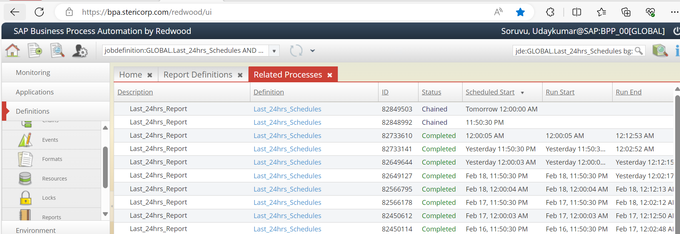

- Audit logs are the one which records all actions taken by members within the application.

Integration of S3 bucket
- S3 (SIMPLE SERVICE STORAGE) Bucket is a service provided by amazon mainly used to help individuals and enterprises meet their data storage, backup and delivery needs in the cloud.
- Whenever we run 24hours job in Redwood, reports are moved from OS level to S3 Bucket then it will be used by Audit team to understand what job got failed and whether those jobs created any tickets or not.

Redwood Queue Management
- Generally, we run jobs through queues, and we have process server as well where the processes run. We can connect multiple queues to a single process server.
- Few queues are available on ‘Home’ screen which have named Smoke test queues. We don't use in normal conditions. Incase all queues are stopped and if you want to run any adhoc jobs after patching or maintenance sort of activities.
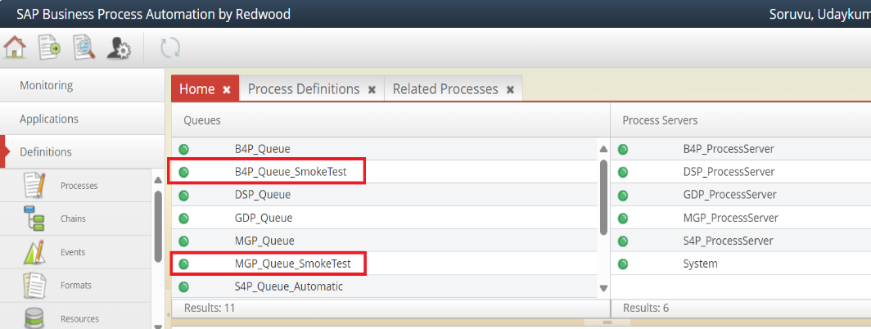
- we can release smoke test queues as they do not have anything to run there and just trigger any adhoc job to make sure things are working fine.

