Pavan Nagesh, D18128936, TU059, D18128936@mytudublin.ie
Review and Simulation of Selective Bayesian Classifier

Motivation: It is proved that enhancement and optimization of Naïve Bayes(NB) has always been a challenging task. Most of the research done have tried boosting of NB where multiple classifiers are used to obtain the misclassification rate, but these approaches are not applicable to all the domains. Another approach was to use only those features that are more relevant. These attributes are found as a result of applying decision tree and KNN, though decision trees are immune to correlated features but if the training set is large enough the tree becomes too complex. The motive of selecting this paper with respect to others is that it takes up on different approach to optimize NB called Selective Bayesian Classifier (SBC) here they have particularly concentrated on feature subset selection where C4.5 decision tree is used to obtain the subset of features and NB is trained and tested with only these features. If only relevant and highly optimal features are used NB is proven to show better results, also complexity of the model is reduced, and the model learns faster than NB model without feature selection.

INTRODUCTION
Feature selection or Feature subset selection is considered as one of the vital process in machine learning. It is important to select only relevant features rather than selecting all the feature which tend to degrade the accuracy of the model and increase the complexity. Many researchers have developed novel approaches for feature subset selection and most of these methods either involve tuning of the induction algorithms to tacitly carry out feature selection or develop separate algorithm to obtain subset of features to be used for induction algorithms or wrapping techniques where the relevant features are selected by the process of adding and deleting subset of features directly into the induction algorithm. C4.5 and NB algorithms are two of the most widely used machine learning algorithms. C4.5 constructs decision trees by using features to try and split the training set into positive and negative examples until it achieves high accuracy on the training set, NB represents each class with a probabilistic summary, and finds the most likely class for each example it is asked to classify (Ratanamahatana & Gunopulos, 2002). One of the major drawbacks of using NB is that it does not perform well when highly correlated features are there but C4. 5 on the other hand doesn’t have this problem, if two features are highly correlated, they cannot be used to split the training set as it leads to same split. This paper proposes a novel approach called Selective Bayesian Classifier (SBC) which uses ensemble of two different classifiers and proves that with the relevant set of features NB shows better accuracies and learns faster compared to C4.5 and base NB classifier. Ten different datasets from UCI Machine Learning Repository and large set of synthetic data is created for experiment. The results show that SBC performs well compared to C4.5 and NB and SBC is compared with Augmented Bayesian Classifiers (ABC) and for most of the datasets SBC outperforms ABC.

Naïve Bayes and c4.5 Decision Tree

Naïve Bayes Classifier
Naïve Bayes Classifier is a supervised learning algorithm used for classification. It works on the principle of conditional probability as given by Bayes theorem. The Bayes theorem basically calculates the conditional probability of the occurrence of an event based on prior knowledge of conditions that might be related to the event. In machine learning classification problem, there are multiple features and classes say C₁, C_{2,}....,C_{k}. The main aim in the Naive Bayes algorithm is to calculate the conditional probability of an object with a feature vector x₁, x₂,….,x_{n} belongs to a particular class C_{i} given x₁, x₂ up to x_{n}.

C4.5 Decision tree
C4.5 is an algorithm used to generate a decision tree developed by Ross Quinlan. C4.5 algorithm is based on the previous algorithm ID3. The aim is to find a small or simple decision trees based on some premises that if all cases belongs to the same class at this point the tree is a leaf, labelled with this class and for each attribute potential information provided by a test on the attribute is calculated. The gain is calculated using entropy i.e. the measure of disorder of the data. Below is the entropy of the instance set
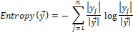
Below is the entropy of the instance set considering class
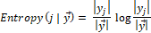
Below is the gain considering and instance set and class
The aim of this calculation is to maximize the gain, dividing by overall entropy due to split argument by value j. One of the problems with using C4.5 to generate decision trees when there are too few training examples available is that it might give a constant decision.(Ratanamahatana & Gunopulos, 2002).

Selective Bayesian Classifier
The main aim of this paper is to enhance the NB classifier by subset optimal features from the set and to remove highly correlated features. SBC is developed by combination of C4.5 and NB. It is known that NB works on a conditional independence assumption and C4.5 constructs its tree considering features that are most relevant. The reason for choosing C4.5 for feature selection in SBC is that C4.5 constructs simple tree if there are smaller number of training set and when training set increases the features are selected such a way that they are not correlated because C4.5 considers only one set of correlated feature set to make split. If the tree becomes too complex i.e. if there are many branches, then SBC is structured such a way that it only selects the features from first three levels of the tree. This method of feature selection helps us to improve the performance of NB classifier without having to compromise the accuracy. The SBC algorithm works as follows (Ratanamahatana & Gunopulos, 2002).
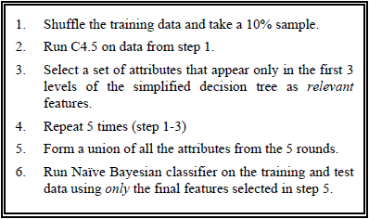
Figure 1. SBC Algorithm

Experimental Evaluation
The experiment is carried out by taking 10 different datasets from UCI repository and one synthetic dataset created using Gaussian distribution which has 1,200,000 instances with 20 attributes and 2 classes. The datasets are chosen such that 5 of the set shows NB outperforming C4.5 and remaining 5 C4.5 outperforms NB (Ratanamahatana & Gunopulos, 2002). Different sets of disjoint random sets of training and testing datasets are created(10% train and 90% test, 20% train and 80% test…,90% train and 10% test, 99% train and 1% test). C4.5, NB and SBC are modeled using each of the pairs of training and testing sets. The experiment is repeated 15 times for each partition of train and test set and for each model. The overall accuracy of the model is obtained by mean accuracies of each iterations. Finally, Augmented Bayesian Classifier (ABC) was also performed on 10 UCI datasets and the results were compared with SBC.

Experimental results and Conclusion
The results clearly showed that SBC outperforms the base models NB and C4.5 for all the datasets. And, another experiment on the same set of data was carried out with 80% train and 20% test(5-fold cross validation) to compare the results of SBC with ABC. ABC outperformed SBC for some datasets(Ecoli, KrVsKp, Monk and Soybean). To test the SBC learning speed synthetic data was used which is much larger than any of the datasets used for the experiment. The running time for SBC gave 1.14 and 4.24 speedup over the original NBC and C4.5. The experiment also showed that more than half of the features were irrelevant for the NB classifier and hence the accuracy was improved when SBC was used which optimized NB by feature subset selection. From the results obtained the paper concludes that the proposed model SBC outperforms C4.5 and NB in accuracy, speed of the model and how fast it can learn. Since C4.5 doesn’t use redundant features in its tree, the features extracted can be used to model NB and the high accuracy SBC achieves with few training examples is indicative of the fact that using these features for probabilistic induction leads to higher accuracy both in Bayesian classifier and C4.5 itself in each of the domains examined (Ratanamahatana & Gunopulos, 2002).

Learning Outcome
The paper helped to get clear understanding of two of the prominently used machine learning algorithm i.e. Naïve Bayes classifier and C4.5 decision tree and how they can be combined to propose a new model. The importance of feature selection for NB was understood by the experiment conducted and the proposed algorithm help to understand a unique approach to optimize NB. SBC also showed how C4.5 can be used to solve the redundant feature problem of NB. By the end of the review, analysis as to why C4.5 variant of decision tree was used in comparison to others was conducted and the apt answer is as C4.5 solves the overfitting issue which is observed in ID3 and CART by post- pruning the tree and thus the features involved can be considered as the most optimal set to be used for NB.

Simulation Of Selective Bayesian Classifier
This section explains the simulation of SBC that has been done with reference to the algorithm explained by (Ratanamahatana & Gunopulos, 2002). The main aim of doing this simulation is to get in depth knowledge on how the NB can be optimized and how C4.5 tree be used for feature subset selection. The simulation done tries to capture most of the important steps of the SBC algorithm and the experiment conducted but still there exists certain differences. The platform that has been used is R studio. Since SBC is proposed by combining two algorithms namely C4.5 and NB, RWeka and e1071 package available in R studio are used to model the algorithms respectively. The original experiment was conducted using 10 datasets from UCI machine learning repository and a synthetic data created by the researcher(List of the dataset is shown in appendix section). For the simulation only one dataset in considered i.e. Ecoli(336 instances, 8 attributes and 8 classes) as the same simulation can be replicated with different dataset. The data used to model is not pre-processed as there was no missing values available and all the attributes had appropriate datatypes. With reference to SBC algorithm, first the training set is randomly sampled so that we do not get the same set in each iteration. Further 10% of the training sample is taken to model C4.5 decision tree. Since only the attributes of first three levels of the tree are required, empty vectors are created in order to store the attributes of the tree. C4.5 model is created from RWeka package with the default settings of the tree. The output of the model was in list and partykit package was used to obtain the splitting rules of the tree in form of list so that the attributes can be extracted from it. The main technique involved in attributes extraction is, first all attributes of the dataset is stored in a variable and the node extraction of the tree is done by recording the position of the node in tree. The process starts with the root node and this is the first feature selected, its next child node is extracted using the position of the child node and its child is extracted in similar fashion. This way no matter how deep the tree is spread out only the features appearing in first three levels of the tree is stored. This process is done five times according to the SBC algorithm such that different sample of training set is obtained, and different tree and the relevant features are extracted in each iteration. The union of all the features from each iteration is the final set of the features used to model the NB. The number of final features that is obtained from simulation and that obtained by (Ratanamahatana & Gunopulos, 2002) is same. The algorithm that paper proposed and the one simulated show similar result.
Further the paper performs experiment using 10 randomly shuffled disjoint sets of training and test. For each of this SBC, NB and C4.5 is modeled and repeated 15 times. Since the data used for simulation is small SBC does not generate trees for small number of training sets and hence the split starts from 40% train and 60% test to 90% train and 10% test. For each partition the experiment is repeated 15 times similar to the experiment done by (Ratanamahatana & Gunopulos, 2002). The accuracy of each partition is obtained by taking the mean of the accuracies of all iteration. The results found in simulation and the one obtained in the paper do differ as random sample are generated in each run and the C4.5 tree is modeled with default settings. The setting with which the C4.5 tree is created is not shown in the paper. Also, information of preprocessing of data is not present and hence the simulation is done with assumption that pre-processing is not mandatory as there were no missing entries.
To compare the results of SBC simulation is also performed on NB and C4.5 using the similar experiment. The results of the simulation are shown below.
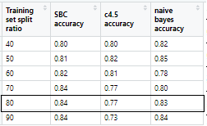
Table 1. SBC Simulation results for different partitions of training and test sets

Simulation results
The results clearly show that SBC outperforms C4.5 and NB for large number of training samples. This result is approximately similar to the one obtained in the paper. Due to limited knowledge and resources, generation of synthetic data was not achieved and running time for each model is not calculated as simulation lacks large data. Original experiment also involved comparing SBC results with ABC, but the simulation was not done on ABC as this is the model proposed by different paper and not much detail is present to replicate the algorithm. Below is the result shown in the paper for 80% training and 20% test with 5-fold cross validation.
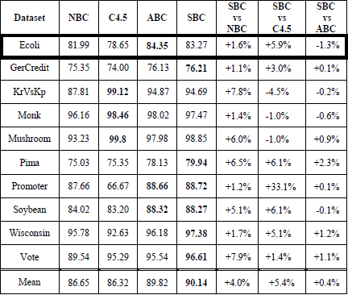
Table 2. Accuracy of each learning method using 5-fold cross-validation observed in paper

From the result for 80% train and 20% test an accuracy of 84% was achieved in simulation and 83.27% was achieved in the paper and hence it can be concluded that simulation is successful and credible. Though replication of SBC was successful with few differences, simulation may not produce the same results when different dataset is used and hence this simulation cannot be generalized.
References
- Ratanamahatana, C. “Ann,” & Gunopulos, D. (2002). Scaling up the Naive Bayesian Classifier: Using Decision Trees for Feature Selection. Retrieved from https://www.semanticscholar.org/paper/Scaling-up-the-Naive-Bayesian-Classifier-%3A-Using-Ratanamahatana-Gunopulos/bee1fb17a8c6610f46ec10fe3f8cf67f5242eaa6
- Awati, K. (2015). A gentle introduction to Naïve Bayes classification using R. A Gentle Introduction to Naïve Bayes Classification Using R. Retrieved from https://eight2late.wordpress.com/2015/11/06/a-gentle-introduction-to-naive-bayes-classification-using-r/
- Hornik, K. (2020). An R interface to Weka (Version 3.9.3). Retrieved from https://cran.r-project.org/web/packages/RWeka/RWeka.pdf
- Hothorn, T., & Zeileis, A. (2020). A Toolkit for Recursive Partytioning. Retrieved from https://cran.r-project.org/web/packages/partykit/partykit.pdf
- Zeileis, A. (2015). Properties and their values out of J48 tree (RWeka). Retrieved from https://stackoverflow.com/questions/32168408/properties-and-their-values-out-of-j48-tree-rweka
- Lateef, Z. (2019, May 22). A Comprehensive Guide To Naive Bayes In R. Retrieved from https://www.edureka.co/blog/naive-bayes-in-r/
- Saha, S. (2018, August 20). What is the C4.5 algorithm and how does it work? Retrieved from https://towardsdatascience.com/what-is-the-c4-5-algorithm-and-how-does-it-work-2b971a9e7db0
Appendix
Below are the results that is obtained by the experiment performed in paper

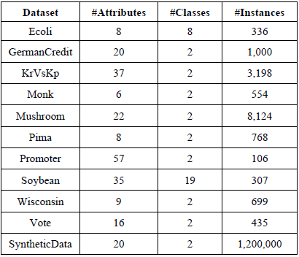
Table 3. Dataset used in paper for experiment

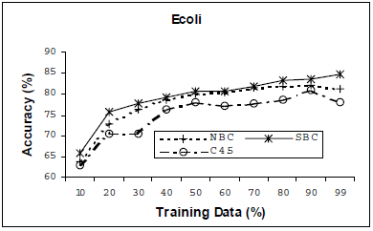
Figure 2. Accuracies for SBC, NB and C4.5 for different partitions of training and test sets observed by paper

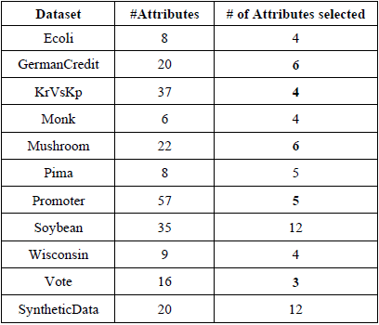
Table 4. Number of attributes selected by SBC algorithm

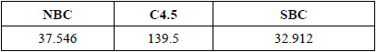
Table 5. Mean Elapsed time for Synthetic Dataset (sec)

