LLM-Powered Dialect Translation: Bridging the Gap for Dharwad Kannada

Pavan Andagi

Research Proposal

MARCH 2026

Abstract
In the domain of machine translation, focus on dialects was not explored much, resulting in the exclusion of large populations that communicate primarily in different Dialects. One of the majorly spoken dialect of Kannada i.e. Dharwad Kannada has left behind in this age of AI and find itself difficult to get a proper translation to other languages and visa-versa. This gap is majorly impacting people from North Karnataka. This study aims at training existing language translation model for Indian language (IndicTrans2) to perform better with Kannada dialect.
The IndicTrans2 model was fed with 4000 tokenized dialect translation samples. As this training was done on IndicTrans2 model, “IndicTransTokenizer” tokenizer was used to tokenize input sentences. Model was trained using this combination along with tuning capability offered by LoRA (Low-Rank Adaptation) to tune larger Model like this with 1.1 billion parameters to reducing the trainable parameters to as small as 7-220 million parameters. Model was hosted on RunPod (RTX 3090) and trained the model for the dialect translation. Database was created manually with 4000 discrete combinations of sentences covering different tenses, different context, scenarios, different language timelines.
Source and target text are processed with the model's native IndicProcessor pipeline; adapters are injected into the query and value projections of every attention layer. The adapter rank was swept systematically from 32 to 1024, and the selected configuration (rank 256) trains only 4.5 per cent of the model, leaving the remaining base weights frozen. The corpus was de-duplicated and partitioned into training, development, and test subsets, and the adapter was trained for twenty epochs under early stopping on the development loss.
Fine-tuning reduced the validation cross-entropy loss from 4.26 to 2.22 at the selected rank, and the adapted system reached a corpus BLEU of 18.09 on held-out data, against an unadopted baseline that reproduces the standard input almost verbatim. The rank sweep showed that translation quality improves sharply up to rank 256 and then saturates: rank 512 doubles the trainable parameters for no BLEU gain, and higher ranks improve raw score only at the cost of a rapidly widening train–validation gap, identifying rank 256 as the practical optimum at this corpus size. Qualitative inspection confirms that the system learns characteristic phonological, lexical, and morphological transformations of the dialect, while longer and rarer sentences remain challenging. The work concludes that low-rank adaptation is an effective and economical route to dialect-level translation, and outlines extensions toward reverse-direction translation, larger corpora, and integration into search and agentic pipelines.
Table of Contents
DEDICATION
ACKNOWLEDGEMENTS
ABSTRACT
LIST OF TABLES
LIST OF FIGURES
LIST OF ABBREVIATIONS
- CHAPTER 1: INTRODUCTION
  - Background and Context 2
  - Problem Statement and Motivation
  - Aim
  - Objectives
  - Research Questions
  - Significance of the Study
  - Scope and Limitations
  - Structure of the Thesis
- CHAPTER 2: LITERATURE REVIEW
  - Introduction
  - Evolution of Neural Machine Translation
  - Machine Translation for Indic Languages
  - Dialectal and Low-Resource Translation
  - Parameter-Efficient Fine-Tuning
  - Evaluation of Machine Translation
  - Research Gap
  - Summary
- CHAPTER 3: RESEARCH METHODOLOGY
  - Research Framework
  - Dataset Description
  - Linguistic Feature Documentation
  - Data Preprocessing and Partitioning
  - Tokenization
  - Base Model Architecture
  - Parameter-Efficient Fine-Tuning with LoRA
  - Evaluation Methodology
- CHAPTER 4: IMPLEMENTATION AND EXPERIMENTS
  - Experimental Environment
  - Exploratory Data Analysis
  - Data Feeding Pipeline
  - Applying LoRA
  - Training Configuration
  - Hyperparameter Tuning
  - Resolving a Systematic Decoding Artefact
  - Inference Pipeline
  - Adapter Merging
- CHAPTER 5: RESULTS
  - Training Dynamics
  - Quantitative Results
  - Qualitative Analysis
  - Error Analysis
  - Discussion
  - Limitations and Threats to Validity
- CHAPTER 6: CONCLUSION AND FUTURE WORK
  - Summary of Findings
  - Contributions
  - Future Work
  - Concluding Remarks
- References

LIST OF TABLES
Table 3.1: Summary of the parallel corpus (experiment of record).
Table 3.2: Phonological Variation in Dharwad Kannada Dialect
Table 3.3: Lexical Variation in Dharwad Kannada Dialect
Table 3.4: Morphological Patterns in Dharwad Kannada Dialect
Table 3.5: IndicTrans2 base-model configuration.
Table 3.6: LoRA configuration for the reported model
Table 3.7: Evaluation Matrices and their insights for current research
Table 4.1: Experimental environment.
Table 4.2: Training hyperparameters
Table 4.3: Per-epoch training and validation loss for the reported run
Table 4.4: Effect of hyperparameter tuning on the adapter
Table 4.5: Adapter rank sweep (ranks 32–1024)
Table 5.1: Quantitative results on the held-out test set
Table 5.2: Human evaluation by three native speakers on 100 test sentences

LIST OF FIGURES
Figure 1.1: Karnataka, Kitturu/North Karnataka region
Figure 3.1: End-to-end architecture of the Bookish-to-Dharwad translation system
Figure 3.2: Low-rank adaptation injected into the attention projections of IndicTrans2
Figure 3.3: Testing and interface pipeline data flow
Figure 3.4: sample sentences from the data corpus Bookish Kannada to Dharwad Kannada
Figure 3.5: Overall architecture of Kannada Dialect MT
Figure 3.6: Low-rank adaptation. The frozen projection W₀ is augmented by a trainable low-rank path B·A
Figure 4.1: Sentence-length distribution of the parallel corpus
Figure 4.2: Topic composition of the parallel corpus across eight domains
Figure 4.3: Word-count parity between the source and target sides
Figure 4.4: Asymmetric tokenization. IndicTrans2 keeps separate vocabularies for the two sides
Figure 4.5: Trainable versus frozen parameters
Figure 4.6: GPU memory budget during training on the RTX 3090
Figure 4.7: Validation loss across six adapter ranks (rank sweep)
Figure 4.8: The decoding artefact before and after the fix
Figure 4.9: ൽ observed during training
Figure 5.1: Training and validation cross-entropy loss across twenty epochs
Figure 5.2: Test BLEU by source sentence length
Figure 5.3: Distribution of the 200 test outputs across the three quality bands, from a manual reading
Figure 5.4: Best Results from the trained model
Figure 5.5: Partially accepted Results from the trained model
Figure 5.6: Bad Results from the trained model
Figure 5.7: Original Model output

LIST OF ABBREVIATIONS
NMT Neural Machine Translation
LoRA Low-Rank Adaptation
PEFT Parameter-Efficient Fine-Tuning
SPM Sentence Piece Model
BLEU Bilingual Evaluation Understudy
COMET Cross lingual Optimized Metric for Evaluation of Translation
PER Position-independent Error Rate
WER Word Error Rate
BOS Beginning-of-Sequence token
EOS End-of-Sequence token
GPU Graphics Processing Unit
RQ Research Question

CHAPTER 1: INTRODUCTION
1.1 Background of the Study
There are so many Dialects for a single language, Descriptive accounts commonly group these varieties into coastal, northern, south-western, and southern clusters, each differing in pronunciation, vocabulary, and everyday grammar. Spread across the region across the state is visualized in Figure 1. The standard written form, often described as "bookish" Kannada, is the variety used in formal education, official documents, and most digital text. For many speakers whose first variety is regional, this standard form can feel distant from daily speech. Among these dialects Northern and Costal have variations in usage of the words, speaking style etc. Some time for the native speakers/users the usage of bookish language is quite difficult. Currently at this time of AI and Digital world, it is quite essential to include the big sect of people to make use of translation capability so that they can talk, read and listen in their own dialect. This research focus to address this gap and help other dialect speaker to make use of digital world for communication. This paper will focus on one of the Dialect from Northern Karnataka i.e. Dharwad Kannada, which is majorly spoken by around 20 million active users.

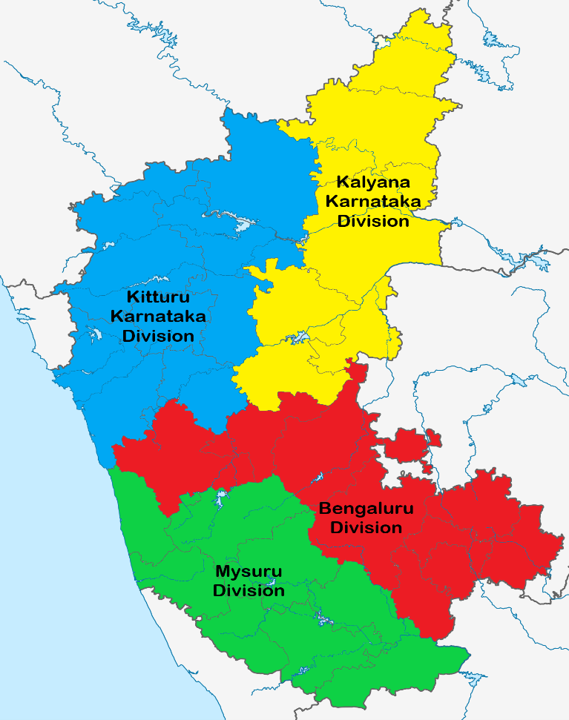
Figure 1.1: Karnataka, Kitturu/North Karnataka region
Current translation capabilities of google translator, IndicTrans2 (Gala et al., 2023) or any other major translator, which is focused mostly on translation from standard bookish sentences from one language to other. excluding inter-dialect and dialect-to-standard translation unaddressed. There are some efforts made by well-known researches from Karnatak University and other universities from Karnataka.
NLP has a rich history from early rule based to current deep learning-based models. The invention of Transformers like GPT (Openai et al., n.d.) and BERT (Devlin et al., 2019) played a significance role in the field of language translation. Transformers are based on self-attention mechanism to capture the relationship between the words and sentences. These plays a major role in NLP applications. Thorough explanation of the evolution in Language translation models including the transformer is provided in (Feng et al., 2025).
Even though GPT and BERT performs well in case of non-Indian languages. Performance dropped when it comes to the translation in Indian language. Current paper needs AI model which has better understanding of different dialect of Kannada Language. Since Current research focuses on regional languages in India. Focus shifts to indigenous model IndicTrans2 (Gala et al., 2023), which is an encoder-Decoder translation model which plays a significant role in achieving the scope of this paper. Even though IndicTrans2 model can perform very well when it comes to translation between 22 Indian languages and from Indian language to English, fails when it comes to translation between dialects. Since any AI model, data plays most significant role, but dialects lack the same when comes to data collection.
This research has become more relevant, since out of 25 million people, many are lacking the understanding of technology including GenAI, social media or the speed with which the technology evolving due to lack of communication. Feels like major part of the crowd is left out from the development. This model which can help translate dialect and bridges the gap between dialects.

1.2 Problem Statement and Motivation
Why has dialect translation been overlooked? There are two main reasons. First, we need data. Translation systems learn from example pairs of sentences in the source and target varieties. No one has built such a dataset for Bookish and Dharwad Kannada yet. Without those paired examples, we cannot train a supervised system. Second, there is the cost problem. The best Indic translation models have around a billion parameters. Training one from scratch requires enormous computing power and time, which most researchers and community groups cannot afford.
This thesis tackles both problems with a practical approach. Instead of starting from scratch, created a small, hand-made dataset: a native speaker pairs standard Kannada sentences with natural Dharwad versions. Then use an existing pre-trained Indic model as our foundation and adapt it to the dialect, rather than retraining it. This adaptation happens through Low-Rank Adaptation (LoRA), which is a clever trick: it keeps the billion-parameter model frozen and only trains a few million extra parameters on top. This makes the whole task affordable.

1.3 Aim and Objectives
Aim
The primary aim of this thesis is to develop a neural machine translation system for converting Bookish Kannada to Dharwad Kannada by fine-tuning IndicTrans2 with Low-Rank Adaptation (LoRA), thereby creating the first direct dialect-to-dialect translation resource for Kannada and providing insights into efficient methods for dialect adaptation in low-resource settings.

Objectives
The aim is pursued through four specific objectives, listed in order of importance:
- Corpus construction: To build and document a parallel corpus of Bookish Kannada and Dharwad Kannada sentence pairs that captures the phonological, lexical, and morphological character of the dialect across varied topics of 4000 high-quality Bookish Kannada to Dharwad Kannada sentence pairs.
- Model adaptation: To configure and fine-tune IndicTrans2 with LoRA for the Bookish to Dharwad direction, adapting the attention projections while keeping the base model frozen.
- Efficient training: To evaluate translation quality using both automatic metrics (BLEU, COMET) and human assessment by native Dharwad speakers, measuring fluency, adequacy, and dialectal accuracy.
- Evaluation: To assess translation quality with an automatic metric and structured qualitative analysis, and to characterise the system's strengths and failure modes.
By addressing these objectives, thesis contributes the first direct Bookish-to-Dharwad
Kannada translation system, provides practical insights into efficient fine-tuning for dialect
adaptation, and offers guidance for evaluating dialectal MT systems.

1.4 Research Questions
The objectives give rise to the following research questions:
1. Can a usable parallel corpus for Bookish-to-Dharwad translation be assembled from
existing standard-Kannada resources combined with native-speaker authoring?
2. To what extent does fine-tuning a Transformer-based model, IndicTrans2, produce fluent
Dharwad output relative to the unadopted base model?
3. How effectively does Low-Rank Adaptation adapt a one-billion-parameter model to
dialectal variation, and which adapter settings most influence the result
4.How well does a surface-overlap metric such as BLEU reflect translation quality for this
dialect task, and where does it diverge from human judgement?

1.5 Significance of the study
This study addresses a critical gap in computational linguistics for Kannada by developing the first neural machine translation system for Bookish Kannada Dharwad Kannada translation. The significance of this work is fourfold:
First, it contributes to linguistic preservation by systematically documenting the phonological, lexical, and morphological transformations that characterize the Dharwad dialect a variety spoken by millions but underrepresented in computational resources. Second, it addresses a practical societal need: millions of Dharwad-region speakers face barriers accessing formal information presented in standard Kannada. A translation system can democratize access to education, healthcare, and government services.
Third, this work advances methodological knowledge by demonstrating the effectiveness of parameter-efficient fine-tuning (LoRA) for dialect adaptation with limited parallel data insights applicable to under-resourced dialects globally. Fourth, it contributes to linguistic equity by validating the importance of regional varieties alongside the standard language, developing technology that respects and accurately reproduces dialectal features.

1.6 Scope of the Study
The study is confined to written translation in a single direction, from Bookish Kannada into Dharwad Kannada, using IndicTrans2 adapted with LoRA. Spoken-language phenomena such as prosody and code-switching are outside its scope, as are domain-specific terminologies. The corpus covers general usage across topics including everyday conversation, news, history, travel, food, cinema, and emotion, with sentences predominantly between three and thirty words in each sentence. The work is a proof of concept that establishes feasibility; production deployment, real-time serving, and user-interface design are not treated here. These boundaries are revisited as explicit limitations in upcoming chapters.

1.8 Structure of the Thesis
The remainder of the thesis is organized as follows. Chapter 2 reviews the literature on neural
machine translation, Indic-language translation, parameter-efficient fine-tuning, and
evaluation, and identifies the research gap. Chapter 3 sets out the methodology: the research
framework, the corpus and its linguistic documentation, preprocessing, tokenization, the base
model, the LoRA configuration, and the evaluation design. Chapter 4 describes the
implementation and experiments, including exploratory analysis of the data, the training
procedure, the tuning of adapter and optimization settings, and the diagnosis of a systematic
decoding artefact. Chapter 5 reports and discusses the quantitative and qualitative results and
states the limitations. Chapter 6 concludes and sets out directions for future work.

CHAPTER 2: LITERATURE REVIEW
2.1 Introduction
This chapter situates the thesis within four bodies of work. Section 2.2 traces the evolution of neural machine translation from early recurrent and attention-based systems to the Transformer architecture that underpins current models. Section 2.3 narrows the view to translation for Indic languages and toIndicTrans2, the model adapted in this study. Section 2.4 reviews the limited prior work on Kannada dialect translation. Section 2.5 introduces parameter-efficient fine-tuning and Low-Rank Adaptation. Section 2.6 surveys evaluation metrics and their known limitations for Indic and dialectal text. Section 2.7 consolidates these strands into the research gap that the thesis addresses, and Section 2.8 summarises complete Literature review.
2.2 Evolution of Neural Machine Translation
Machine translation has moved through rule-based, statistical, and neural paradigms, and thefield's recent acceleration is largely attributable to deep learning (Feng et al., 2025) . For roughly a decade before the neural era, the dominant approach was statistical phrase-based machine translation, which learned translation probabilities and reordering rules from aligned bilingual text and stitched together phrase-level fragments at decoding time(Koehn et al., 2003). Phrase-based systems were strong for high-resource European pairs but struggled with the long-range agreement and rich morphology typical of Indian languages, because their fixed phrase tables could not generalise across the many inflected forms a single stem produces.
The neural era reframed translation as a single end-to-end learning problem, a transition traced in recent histories of the field (Ida, 2024) . Sequence-to-sequence learning encoded the whole source sentence into a fixed-length vector with one recurrent network and decoded the target from it with another, training the two jointly (Sutskever et al., 2014). The fixed-length bottleneck limited quality on long sentences, a weakness resolved by the attention mechanism, which lets the decoder weight different parts of the source as it generates each target word and so handle longer inputs gracefully(Bahdanau et al., 2014). A second enabling advance was sub-word segmentation: byte-pair encoding broke words into frequently recurring fragments, giving the model an open vocabulary that could represent rare and morphologically complex words as sequences of known units (Sennrich et al., 2016). Sub-word modelling is directly relevant here, because IndicTrans2 relies on a Sentence Piece vocabulary of exactly this kind, as Chapter 3 describes.
The decisive shift came with the Transformer, which replaced recurrence with multi-head self-attention and allowed both parallel training and stronger modelling of long-range dependencies (Vaswani et al., n.d.). The architecture became the foundation for a generation of pre-trained models. BERT demonstrated that bidirectional Transformer encoders trained on large unlabelled corpora produce representations that transfer to many downstream tasks (Devlin et al., 2019), while the generative pre-training line of work showed that a Transformer decoder pre-trained on raw text can be adapted to new tasks with comparatively small changes (Radford et al., n.d.). Scaling these pre-trained models to hundreds of billions of parameters then produced systems that perform new tasks from only a few examples, without task-specific training (Brown et al., 2020). These models perform strongly on high-resource, predominantly English settings, but their quality degrades for many Indian languages, where training data are scarcer and scripts and morphology differ markedly. This degradation motivates models built specifically for Indic languages.

2.3 Machine Translation for Indic Languages
Indic languages, the 22 official languages of India plus related varieties present distinct challenges that differ significantly from European language pairs widely studied in MT research. Scripts differ fundamentally: Kannada, Telugu, Tamil, Malayalam, Odia, and others use their own distinct Brahmic-derived scripts with complex orthographic and diacritical rules; Hindi and Marathi share Devanagari. Morphology is rich across all Indic languages; many exhibit complex case systems, gender agreement (sometimes covert), and dense agglutinative affixation where words can be built from multiple morphemes each carrying grammatical information. Phonological inventories are large and often language-specific, with distinctions (e.g., retroflex vs. alveolar consonants) that do not map cleanly to other scripts. Most Indic languages are under-resourced by international standards: parallel corpora are smaller (often 100K–1M pairs vs. 10M+ for English French), monolingual text less abundant, and research infrastructure limited to a few institutions. Code-switching (mixing two languages in a single sentence) is common in real-world data, complicating tokenization and vocabulary design. Progress on Indic translation has been gated as much by data as by architecture. A turning point on the data side was Samanantar, the largest publicly available collection of parallel sentences for Indian languages at its release, which assembled tens of millions of mined and human-curated pairs across eleven languages and made supervised training at scale feasible (Ramesh et al., 2022).
Two global multilingual models frame the Indic effort. mBART50 extended denoising sequence-to-sequence pre-training to fifty languages and served as a strong multilingual baseline for fine-tuning(Tang et al., 2020), and the No Language Left Behind project pushed massively multilingual translation to two hundred languages with an explicit focus on low-resource directions (Team et al., 2022). Against this backdrop, a line of Indic-focused models narrowed the quality gap further. IndicBART provided an early multilingual sequence-to-sequence model pre-trained on eleven Indic languages and English, and reported gains over the larger mBART50 on translation and summarisation despite its smaller size (Dabre et al., 2022).
The current state of the art is IndicTrans2, developed by AI4Bharat, which supports all twenty-two scheduled Indian languages and uses a standard Transformer encoder-decoder design (Gala et al., 2023). Where the first IndicTrans concentrated on a smaller set of languages and a shared sub-word vocabulary, IndicTrans2 widens coverage to every scheduled language and, crucially, adopts separate vocabularies for the Indic and English sides, with a large Sentence Piece inventory for the Indic group; this separation permits sub-word segmentation tuned to each language group rather than diluting capacity across a single shared vocabulary. The model is released in complementary directions, including Indic-to-Indic, and in one-billion and smaller parameter variants. It uses a standard Transformer encoder-decoder architecture with separate vocabularies for Indic languages (128K Sentence Piece tokens) and English (32K tokens). Available in 1.1B and 200M parameter variants. Its Indic-to-Indic variant is the basis for the present work, because the Bookish-to-Dharwad task is, formally, a translation between two varieties written in the same Kannada script, and a model that already encodes Kannada orthography and morphology offers a far stronger starting point than training from scratch on a small corpus.

2.4 Dialectal and Low-Resource Translation
Dialect translation is a recognised sub-field internationally, and the experience of other language families clarifies what makes it distinctive. The classic case is Arabic, where translation between dialectal and Modern Standard Arabic was tackled by treating the dialect as a low-resource language and combining the limited dialect data with abundant standard-language resources (Zbib et al., 2012). More recent work on the Swiss German continuum shows that even small amounts of dialect data, used to adapt a model trained on the standard variety, can yield large gains, and that character-level noise can substitute for scarce parallel text (Aepli and Sennrich, 2022). The common thread is that dialect translation is rarely a fully-resourced task; it is almost always a low-resource problem in which a strong model for a related, well-resourced variety is adapted with a modest amount of targeted data—exactly the situation surveyed in the broader literature on low-resource machine translation (Haddow et al., 2022).
A conceptual point follows from this. The boundary between a “language” and a “dialect” is a continuum rather than a clean division, and where two varieties share a script and are mutually intelligible as Bookish and Dharwad Kannada are the conversion between them is better understood as intra-language generation than as interlingual translation. The model does not need to cross a script or learn a foreign lexicon wholesale; it needs to learn a systematic set of phonological, lexical, and morphological substitutions conditioned on context. This framing both explains why a pre-trained Kannada-aware model is so advantageous and why standard surface-overlap evaluation, designed for interlingual translation, fits the task imperfectly.
Work targeting Kannada dialects specifically remains sparse. The closest prior study translated Mysuru, Dharwad, and Hubli varieties of Kannada into English using a long short-term memory encoder-decoder with attention (Patil et al., 2024). That work establishes the problem's relevance, but differs from the present study in three respects. It translated dialects into a third language, English, rather than directly between Kannada varieties; it used a recurrent rather than a Transformer architecture; and it did not exploit a large pre-trained model or parameter-efficient fine-tuning. The present thesis departs on all three points by modelling the direct Bookish-to-Dharwad mapping, by building on a pre-trained Transformer, and by adapting it efficiently, positioning dialect conversion as the intra-language generation task described above.

2.4 Parameter-Efficient Fine-Tuning
Fine-tuning every parameter of a billion-scale model is expensive, because each update touches the full weight set and requires correspondingly large memory and compute. A family of parameter-efficient fine-tuning (PEFT) methods has emerged to avoid this cost, each freezing most of the pre-trained model and training only a small set of additional or selected parameters. Adapter modules insert small bottleneck layers between the frozen Transformer sub-layers and train only those (Houlsby et al., 2019). Prefix-tuning prepends trainable continuous vectors to the attention keys and values, steering the frozen model without altering its weights (Li and Liang, 2021), and prompt-tuning simplifies this further to a set of learned input embeddings (Lester et al., 2021). At the opposite extreme of minimalism, BitFit trains only the model's bias terms(Ben-Zaken et al., 2022).
Low-Rank Adaptation (LoRA) addresses the same problem by freezing the pre-trained weights and learning a low-rank update for selected weight matrices, so that only a small fraction of parameters is trained (Hu et al., n.d.). It was first demonstrated on the generative pre-training models, where it matched or approached full fine-tuning at a fraction of the trainable parameters and, importantly, added no inference latency once the update is merged back into the base weights—an advantage adapters and prefix-tuning do not share. Extensions have pushed the idea further: QLoRA combines low-rank adapters with a quantised base model to fine-tune very large models on a single GPU (Dettmers et al., 2023), and adaptive variants allocate rank budget unevenly across layers. LoRA was chosen for this study because it offers the best fit for the constraints at hand: it is the most thoroughly validated PEFT method for translation in the one-to-ten-billion parameter range, it leaves inference speed unchanged, its rank gives a single, interpretable capacity dial well suited to a small corpus, and the trained adapter is a few megabytes that can be stored and swapped independently of the frozen base model.
Subsequent work confirms the value of the approach for Indian-language translation. A generative translation system for Indic text reported quality and cost benefits from low-rank adaptation of a Mistral-7B model (Kodali et al., 2024), and an applied study on translating school textbooks into Indian languages, including Kannada, found the technique both economical and effective (Li, 2025). These studies adapt models across languages. Their success raises the question this thesis investigates: whether the same mechanism can adapt a model within a language, to a regional variety, where the differences are systematic but finer-grained than those between distinct languages.

2.5 Evaluation Metrics for Translation
Automatic evaluation is indispensable because human assessment is slow and costly, yet each automatic metric carries assumptions that can fail for new settings. BLEU (Papineni et al., n.d.), the longest-reigning standard, computes n-gram overlap (precision) between system output and one or more reference translations and a structured review of its validity cautions that it correlates with human judgement only under specific conditions and can mislead outside them (Reiter, 2018). Several metrics were designed to address its weaknesses. chrF computes overlap at the character level rather than the word level, which makes it more robust for morphologically rich languages where a single stem takes many surface forms(Popović, 2015). Embedding-based metrics go further by comparing meaning rather than surface strings: BERTScore matches contextual token embeddings between output and reference (Zhang et al., 2019), and BLEURT trains a learned metric to predict human ratings (Sellam et al., 2020). COMET follows the same learned-metric philosophy, using a neural model trained on human judgements, and has been shown to outperform earlier metrics on several language pairs (Rei et al., 2020). Because all automatic metrics are ultimately approximations of human judgement, structured human-evaluation protocols such as Multidimensional Quality Metrics remain the reference standard against which the automatic scores are calibrated (Freitag et al., 2021). Position-independent error rate and word error rate, borrowed from related work on Kannada dialect translation, provide further complementary views on sound shifts and lexical choice (Patil et al., 2024).
For the present task these metrics warrant caution. A dialect rendering may be entirely correct yet share few surface n-grams with a single reference, because the same standard sentence admits several natural Dharwad forms. Surface-overlap scores are therefore expected to understate quality, and a complete evaluation should combine automatic scoring with judgement by native speakers. The evaluation design in Chapter 3, and the native-speaker study reported in Chapter 5, reflect this position.

2.7 Research Gap
The reviewed literature exposes four connected gaps that this thesis addresses:
- No parallel corpus for the variety- There is no established dataset aligning Bookish
Kannada with the Dharwad variety, leaving direct dialect translation unsupported.
- Limited use of Transformers for Kannada dialects- The few prior efforts rely on
recurrent architectures and translate to English rather than between Kannada varieties.
- Under-studied parameter-efficient adaptation for dialects- Low-rank adaptation is
established for cross-language transfer but rarely examined for variation within a single
language.
- Weak evaluation frameworks for dialectal output- Standard metrics are not well
validated for dialectal Indian-language translation, where multiple correct renderings are
common.

2.8 Summary
Neural machine translation has matured from recurrent models to Transformers and, for Indian languages, to dedicated systems such as IndicTrans2. Parameter-efficient fine-tuning makes adapting these large models tractable and has proven effective for cross-language translation. The intersection of these advances with dialect conversion remains largely unexplored, and the resources and evaluation practices needed to study it are missing. The methodology that follows is designed to fill this intersection for the Bookish-to-Dharwad direction.

CHAPTER 3: RESEARCH METHODOLOGY
The research methodology for this research is designed to build NMT system, that translate from well-known dialect of Kannada i.e. Bookish Kannada to Dharwad Kannada. This section explains how the overall translation model is technically made feasible.

3.1 Research Framework
The overall framework of this research was based on training the existing NMT model for Indic languages (Gala et al., 2023), which was trained to translate to Dharwad Kannada. Input translation pairs were extracted from well-established data set (ai4bharat/Rasa · Datasets at Hugging Face, 2026), Dialect preserved books and experts from the native dialect speakers. Data corpus set, which was created, was fed to the only suitable tokenizer to create the tokenized input for IndicTrans2 (Gala et al., 2023) model and training by selectively using the parameter selection mechanism LoRA (Hu et al., n.d.) to reduce the overall size of trainable parameters. Overall performance of the model is validated using BLEU and Manual validation. The scope was defined only till training of IndicTrans2 for Dialect translation.
Properly creating sentence pairs (Bookish Kannada Dharwad Kannada) of 4000 pairs in Json format. Data was then tokenized(ai4bharat/indictrans2-indic-indic-1B · Hugging Face, 2026) using this format, since NMT IndicTrans2 supports only IndicTransTokenizer Tokenizer. Tokenized inputs were fed to the pre-trained language model (Gala et al., 2023)to train IndicTrans2 for dialect translation. Model was trained by selectively training few parameters refer Table 3.6: LoRA configuration for the reported model, and this privilege is possible with the help of LoRA (Hu et al., n.d.). Further validation of the model was done using BLEU (Reiter, 2018), along with manual testing.
The end-to-end flow is shown in Figure 3.1. A source sentence in Bookish Kannada was normalized and tagged by the IndicProcessor pipeline, tokenized form using (ai4bharat/indictrans2-indic-indic-1B · Hugging Face, 2026), passed through the frozen encoder-decoder with its trainable adapters, and finally decoded and post-processed into a Dharwad Kannada sentence. During training, the same pipeline produced token sequences whose alignment to reference targets drives a cross-entropy objective; gradients updated only the adapter.
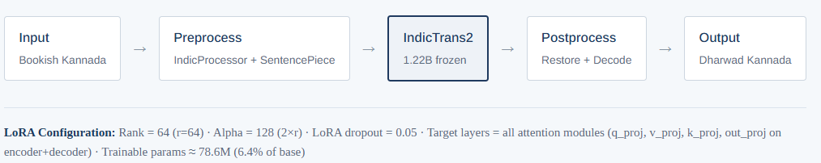
Figure 3.1: End-to-end architecture of the Bookish-to-Dharwad translation system.

Figure 3.2 illustrates the training data flow. Parallel corpus (3,600 training pairs) was loaded in batches of 8 examples. Each source-target pair underwent tokenization via Indic Processor, producing token sequences padded to 128 tokens. Batches were stacked and passed through the frozen IndicTrans2 encoder-decoder. The LoRA adapters (injected into all attention modules) were updated via backpropagation. Cross-entropy loss was computed on the target tokens; gradients flow only through the LoRA parameters. Gradient accumulation over 8 steps created an effective batch size of 64, stabilising gradient estimates on the small dataset. The process repeated for 20 epochs with early stopping on development loss.

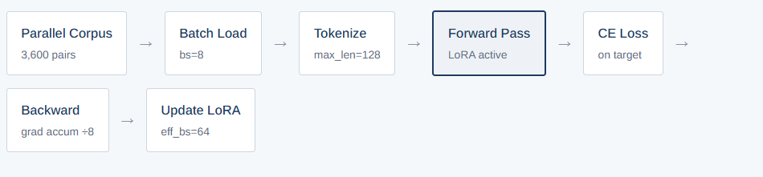
Figure 3.2: Training data flow and gradient updates.

Figure 3.3 illustrates the testing and inference flow. On the test set (held-out pairs), the best trained model (base + LoRA adapters) was loaded. Source sentences were tokenized identically to training. Forward pass through the encoder generated contextual representations; the decoder generated target tokens one at a time using beam search (beam width = 5, length normalisation enabled). The EOS (end-of-sequence) token signals completion. Tokens were detokenized via IndicProcessor restoration, producing the final Dharwad output. No gradient computation occurs during inference; the model ran in evaluation mode (dropout disabled).
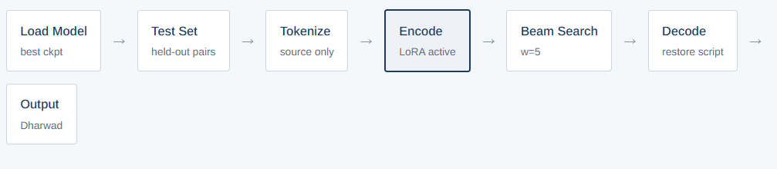
Figure 3.3: Testing and interface pipeline data flow.

3.2 Data Collection and Preparation
3.2.1 Collection of Bookish Sentences
No parallel corpus exists for the target variety, so one was constructed. Standard, bookish source sentences were drawn from the publicly available (ai4bharat/Rasa · Datasets at Hugging Face, 2026) Kannada dataset and supplemented to cover everyday usage. For each source sentence, a faithful Dharwad Kannada rendering was authored by a native speaker of the variety. The renderings reflect natural dialectal usage rather than word-for-word substitution: systematic sound shifts are applied consistently, dialect-specific vocabulary is preferred where a speaker would use it, and grammatical endings follow spoken Dharwad norms. A second native speaker reviews samples for quality assurance.
Each pair is stored as one JSON object with a source field and a target field, one object per line. Sentences span a range of topics, including casual conversation, news and politics, history, travel, food and cooking, cinema, and emotional expression, and they cover several tenses and registers so that varied dialectal features are exercised. Sentence length ranges predominantly from three to thirty words on each side, with a mean of roughly eight words. The corpus is hosted on Kaggle, and its link is provided with the published thesis.
Table 3.1 summarizes the corpus used for the experiments reported here; the collection continues to grow toward a planned four-thousand pairs. All 4000 sentence pairs will be split into training, development, and test sets. With 3600 pairs (90%) are reserved for model fine-tuning. Around 200 pairs (5%) are reserved for hyperparameter tuning and early stopping and 200 pairs (5%) are reserved for final evaluation. The split will be performed randomly but arranged to ensure each set contained representative examples of all dialectal features.

Table 3.1: Summary of the parallel corpus (experiment of record).
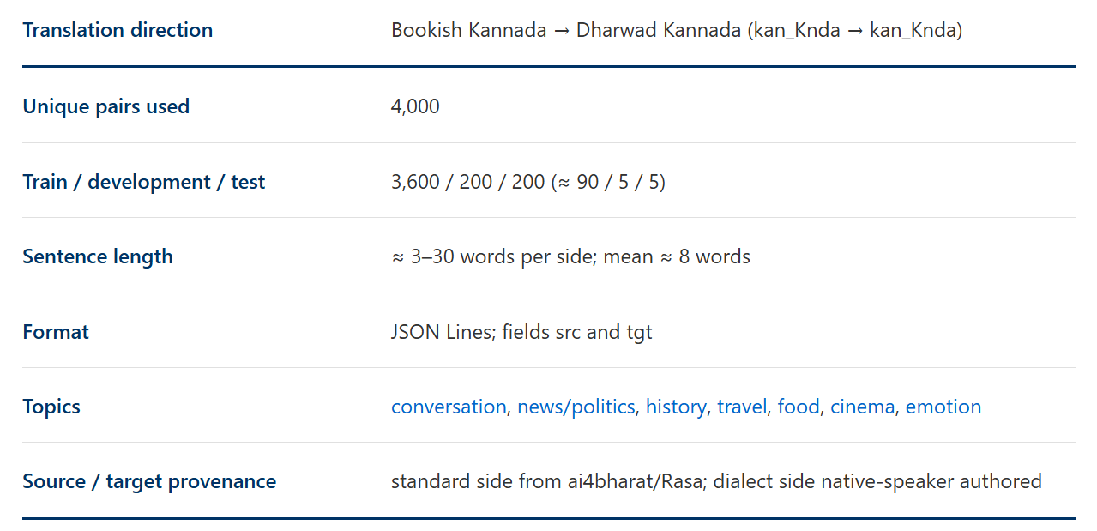

3.3 Linguistic Feature Documentation
Dharwad Kannada differs from the standard variety along three axes: phonology, vocabulary, and morphology. Documenting these patterns serves two purposes. It records what the model is expected to learn, and it provides a reference against which output can be judged in the error analysis of Chapter 5. Table 3.2 to 3.4 give representative examples drawn from the corpus, with a transliteration and an English gloss.

Table 3.2: Phonological Variation in Dharwad Kannada Dialect
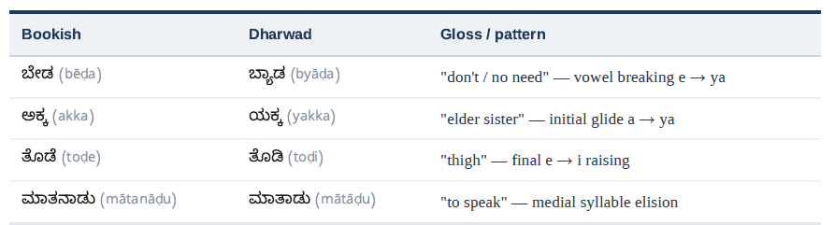

Table 3.3: Lexical Variation in Dharwad Kannada Dialect
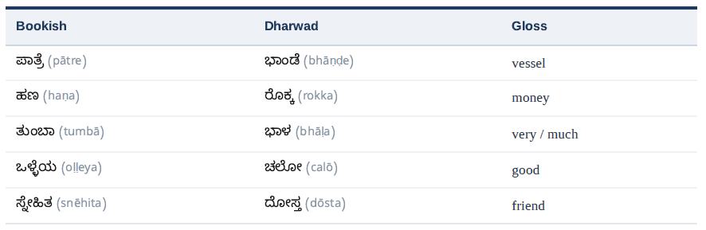

Table 3.4: Morphological Patterns in Dharwad Kannada Dialect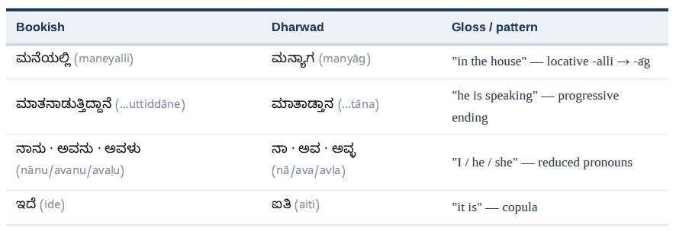

The patterns are regular enough to be learnable from a few thousand examples, yet they interact: a single sentence typically combined pronoun reduction, a case shift, a lexical substitution, and a verb-ending change. This interaction was what made the task more demanding than a dictionary lookup and motivated a model that conditioned on the whole sentence. The actual data base glimpse can be seen in the figure 3.4.

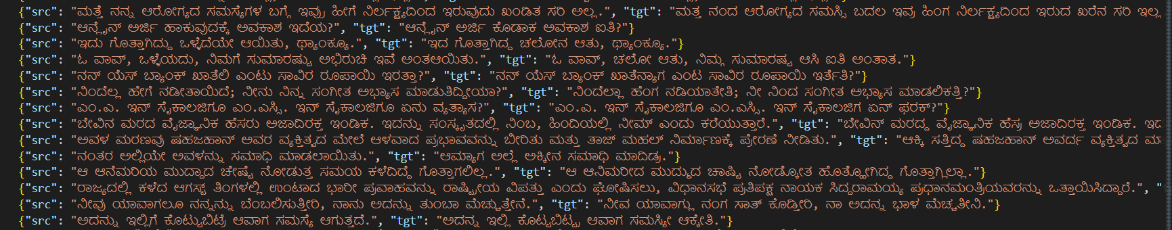
Figure 3.4: sample sentences from the data corpus Bookish Kannada to Dharwad Kannada

3.4 Data Preprocessing and Partitioning
Raw pairs were loaded from the JSON Lines file and de-duplicated on the exact source-target combination; three identical rows were removed, leaving 4000 unique pairs. The set was shuffled with a fixed random seed so that the partition was reproducible. A held-out fraction was then separated for evaluation, and that fraction was split evenly into a development set, used for early stopping and model selection, and a test set, used once for final reporting. The procedure yields 3,600 training, 200 development, and 200 test pairs. Even though many research tells 80/20 split would be ideally accepted (Joseph, 2022), I had chosen to go with 90/10 split, since I had very limited data set of 4000 examples. This choice was made after seeing the loss between the training and validation remained almost same for both combinations. A fixed seed and a strict separation of the test set guard against information leaking from evaluation back into training. Content splits were summarized in the table Table 3.1.

3.5 Tokenization
IndicTrans2 is paired with a dedicated tokenizer and the IndicProcessor utility, which together perform script normalisation, transliteration to a common internal form, and the addition of language tags. A property of this tokenizer is central to the work: it maintains separate Sentence Piece models and vocabularies for the source and target sides. The source pipeline expects each sentence to be prefixed by two language tags and parses them explicitly; the target pipeline expects plain text with no tags. Source sentences are therefore pre-processed with the tagging step intact, whereas target sentences are pre-processed for normalisation but have the tag prefix stripped before tokenization(Gala et al., 2023). Sequences are truncated or padded toa fixed maximum length, and padding positions in the target labels are replaced with the ignore index so that they do not contribute to the loss. The practical consequences of mishandling this asymmetry are examined in Section 4.7.

3.6 Model Architecture
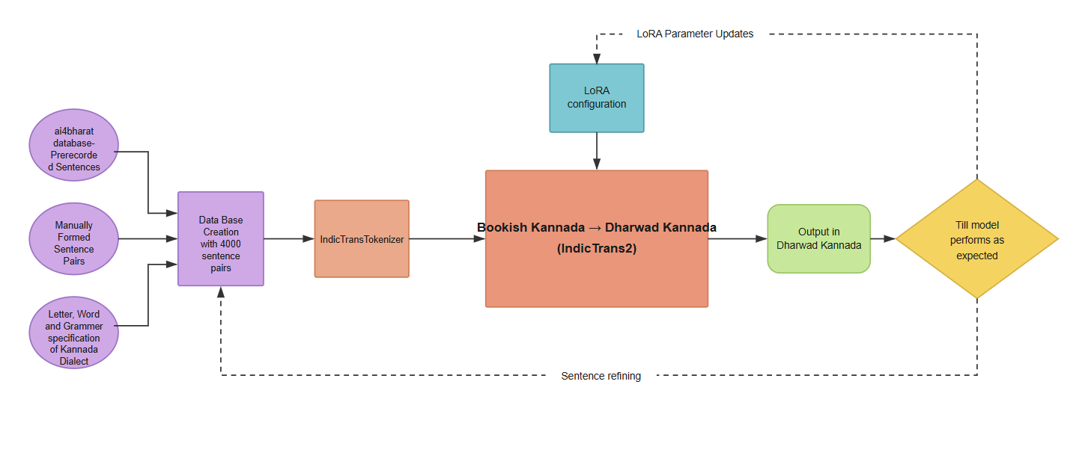Figure 3.5: Overall architecture of Kannada Dialect MT

This study employed IndicTrans2(Gala et al., 2023), a state-of-the-art Indic multilingual NMT developed by AI4Bharat and supports 22 Indic Languages and English, making this model ideal for the scope of this paper.
IndicTrans2 follows standard Transformer encoder-decoder architecture having total 18 encoder and decoder layers, and sized up to a model size of total 1B parameters. Every layer has total 16 attention heads. IndicTrans2 uses separate vocabularies for encoder and decoder with Indic vocabulary of size 128K and English vocabulary of 32K Sentence Piece tokens. Details about Indic model is provided in the table 3.5

Table 3.5: IndicTrans2 base-model configuration.
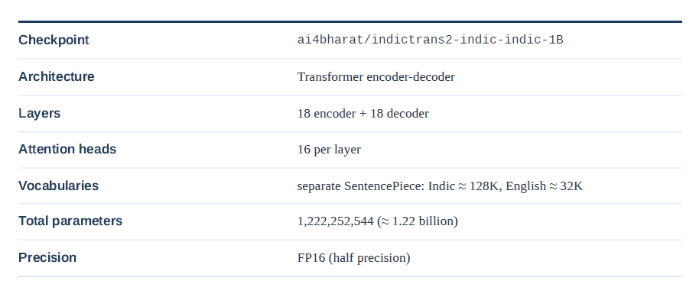

3.7 Parameter-Efficient Fine-Tuning with LoRA
Low-Rank Adaptation (LoRA), introduced by (Hu et al., n.d.), addresses the computational challenges of full fine-tuning by freezing pre-trained weights and injecting trainable low-rank matrices into Transformer layers. For a pre-trained weight matrix $B ∈R ∧ \left(d×k\right)$, LoRA represents the update $ΔW$ as the product of two low-rank matrices $B ∈R ∧ \left(d×r\right)$ and $A ∈R ∧ \left(r×k\right)$, where $r≪\min\left(d,k\right)$. During fine-tuning, only $A and B$ were updated, reducing trainable parameters by orders of magnitude.
Full fine-tuning of a 1.22-billion-parameter model is impractical on a single consumer processor and risks overfitting a corpus of a few thousand pairs. Low-Rank Adaptation avoids both problems. For a frozen weight matrix W₀ of size d×k, the update is constrained to a low-rank product BA, where B is d×r, A is r×k, and the rank r is far smaller than d or k. Only A and B are trained; the effective layer computes the sum of the frozen projection and the scaled low-rank update, as shown in Figure 3.6.
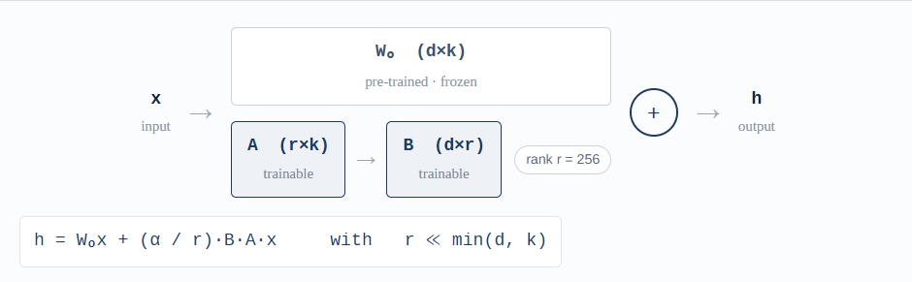
Figure 3.6. Low-rank adaptation. The frozen projection W₀ is augmented by a trainable low-rank path B·A

Adapters are inserted into the query and value projections of every attention layer, a choice that prior work finds effective for translation while leaving the feed-forward sub-layers untouched to preserve general linguistic knowledge. The configuration of the reported model is given in Table 3.6; it reduces the trainable parameter count to about 14.2 million, or 1.16 per cent of the base model. The reasoning that led to these specific values, including the rank and the decision to target two projections rather than four, is documented in Section 4.6.

Table 3.6: LoRA configuration for the reported model
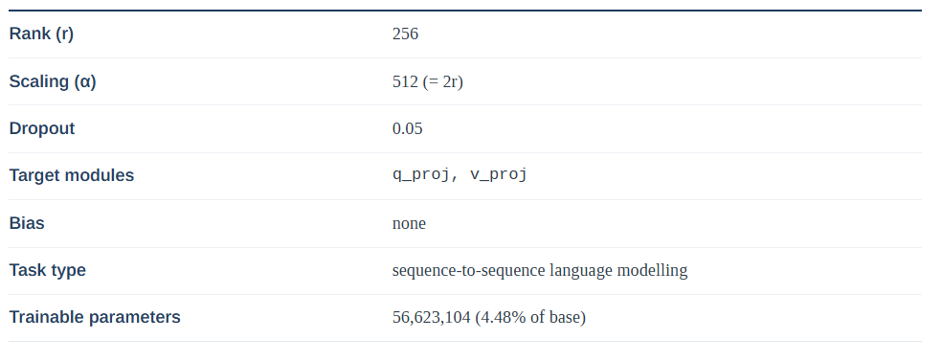

3.8 Evolution Methodology
Translation quality is assessed on the held-out test set with BLEU (Reiter, 2018) as the primary automatic metric, computed with a standard, reproducible implementation. BLEU is reported because it is widely understood and inexpensive, but its limitations for this task are acknowledged: a dialect rendering can be correct yet share few n-grams with a single reference, so the score is treated as a lower bound on quality rather than a complete measure. To compensate, the automatic score is complemented by a structured qualitative analysis in Chapter 5 that classifies outputs as strong, partial, or failed and inspects the kind of error in each case. The intended fuller protocol, set out as future work, adds a neural metric (COMET) (Rei et al., 2020), position-independent and word error rates to probe sound shifts and lexical choice, and assessment by native Dharwad speakers of fluency, adequacy, and dialectal accuracy. An un adapted baseline, the base model run without the adapter, provides a reference point for measuring the effect of fine-tuning.

Table 3.7: Evaluation Matrices and their insights for current research
Validation Metrix | Usage | Limitation
BLEU | Majorly used in case of MT | High chances that this will fail for Indic language like Kannada and its dialect
COMET | Again, this is used similar to BLEU for MT but little expensive | Even though recent study observed working good with Kannada, expecting similar result for dialect is challenging
Human Validation | Ultimately the Native speaker/Experts will test the Translation Model for its correctness for translation. | Identifying the right tester is a challenge and borrow the time from the experts.

3.9 Summary
This chapter set out the full methodology used to build the Bookish-to-Dharwad translation system. Section 3.1 presented the research framework: a supervised system that adapts a pre-trained Indic model to a purpose-built parallel corpus, with each research objective mapped to a concrete step in the pipeline.
Section 3.2 described the dataset around 4,000 sentence pairs covering topics such as conversation, news, history, travel, food, cinema, and emotion, with bookish source sentences drawn from the ai4bharat/Rasa corpus and Dharwad translations authored by a native speaker. Section 3.3 documented the linguistic features that the model must learn: Dharwad Kannada differs from the standard along three axes phonology, vocabulary, and morphology and these changes are regular enough to be learnable yet interact within a single sentence.
The remaining sections covered the technical pipeline. Section 3.4 explained data preprocessing and partitioning: pairs are de-duplicated and split into 3,600 training, 200 validation, and 200 test examples. Section 3.5 described tokenization using the IndicTrans2 tokenizer and the IndicProcessor utility, which normalise the script, attach language tags, and convert text into sub word units. Section 3.6 introduced the base model the one-billion-parameter Indic-to-Indic variant of IndicTrans2, a Transformer encoder-decoder kept frozen during training. Section 3.7 explained parameter-efficient fine-tuning with LoRA, which trains a small set of adapter weights in the attention projections instead of the full model, making training feasible on a single consumer GPU. Finally, Section 3.8 set out the evaluation methodology, using BLEU as the primary automatic metric alongside structured qualitative analysis.
Together, these decisions define a complete, reproducible route from raw sentence pairs to an adapted dialect-translation model. The next chapter puts this methodology into practice, describing the implementation, training process, and experiments.

CHAPTER 4: IMPLEMENTATION AND EXPERIMENTS
4.1 Experimental Environment
All experiments ran on a single NVIDIA GeForce RTX 3090 with 24 GB of memory a consumer-grade graphics card rather than a data-centre accelerator. This choice is deliberate and central to the argument of the thesis. If dialect adaptation can be achieved on hardware that an individual researcher, a university laboratory, or a small community project can realistically own, then the method is genuinely accessible rather than a demonstration that depends on rented industrial computing; parameter-efficient fine-tuning has been shown to bring even billion-parameter models within reach of a single consumer card of this class (Hu et al., n.d.); (Dettmers et al., 2023). The half-precision base model and the LoRA adapter together occupy only a fraction of the available memory, leaving comfortable headroom for the activations produced during training and for the wider beam used at decoding time; the full memory budget is examined in Section 4.5.
The complete software stack is recorded in Table 4.1. Every library version was pinned rather than left to resolve to the latest release, for a concrete reason. The IndicTrans2 tokenizer, the IndicProcessor utility, and the parameter-efficient fine-tuning library each evolve quickly, and minor version changes have, in practice, altered tokenizer behaviour, the handling of special tokens, and the on-disk format of saved adapters. Because the decoding artefact described in Section 4.7 was itself a tokenization-level problem, uncontrolled drift in exactly these components could silently change the results or re-introduce the defect after it had been fixed. Pinning the versions makes the experiment reproducible and keeps the diagnosis stable across re-runs.
All randomised operations the shuffling of the data, the train/validation/test partition, and the initialisation of the adapter matrices were seeded from fixed values, so that a re-run reproduces the same splits and recovers the same trained adapter to within floating-point tolerance. The environment, the data-preparation code, and the training configuration are released alongside the corpus, so that the experiment can be repeated end to end on comparable hardware.

Table 4.1: Experimental environment.
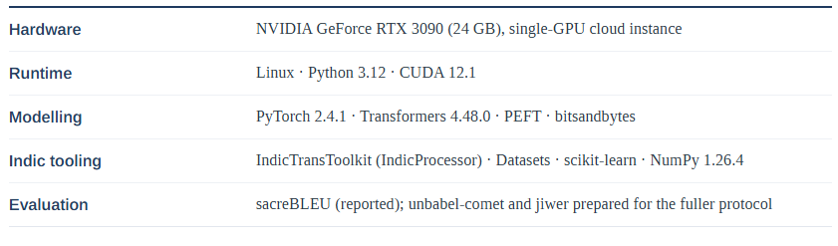

4.2 Exploratory Data Analysis
Before any training, the corpus was profiled to confirm that it matched the intended design and to surface anomalies early, while they were still cheap to fix. Sentence length was measured in whitespace-delimited words on both sides of every pair; the distribution is shown in Figure 4.1. Most sentences fall in the six-to-ten-word band, with a long, thin tail reaching toward thirty words. This is precisely the shape the design aimed for: a corpus dominated by short, everyday utterances the register in which dialect features are densest and most natural while still exercising the longer, more syntactically complex constructions on which translation systems most often struggle.
The mean length is close to eight words on both sides. The dialect side is marginally longer on average than the standard side, because Dharwad forms frequently add short discourse particles and split certain inflected standard forms into two spoken words. Figure 4.3 quantifies this relationship: about three in five pairs carry identical word counts on the two sides, confirming that the transformation is most often one of substitution rather than expansion or contraction. Where the counts do differ, the dialect side is the longer one roughly twice as often as it is the shorter, which is consistent with the additive particles just described.
Topic coverage was profiled as well, because a corpus skewed toward a single domain would teach the model only a narrow slice of the dialect and inflate apparent quality on that slice. Figure 4.2 shows the composition across eight domains everyday conversation, cinema and entertainment, politics and news, travel, food and cooking, history and culture, emotions, and celebrations. Conversational material forms the largest single block, reflecting the register in which the dialect lives most actively, but no domain dominates to the exclusion of the others, so conversational, narrative, and news styles are all represented in the training signal.
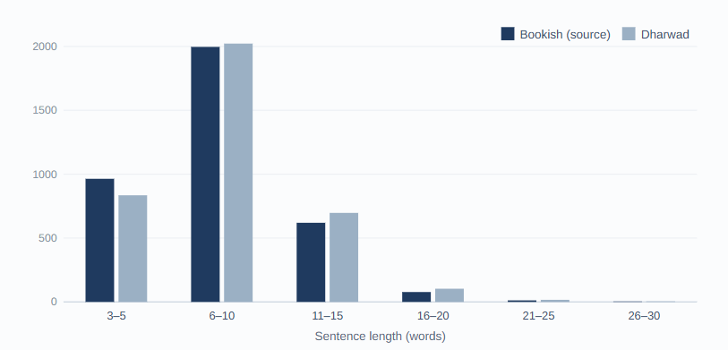
Figure 4.1: Sentence-length distribution of the parallel corpus
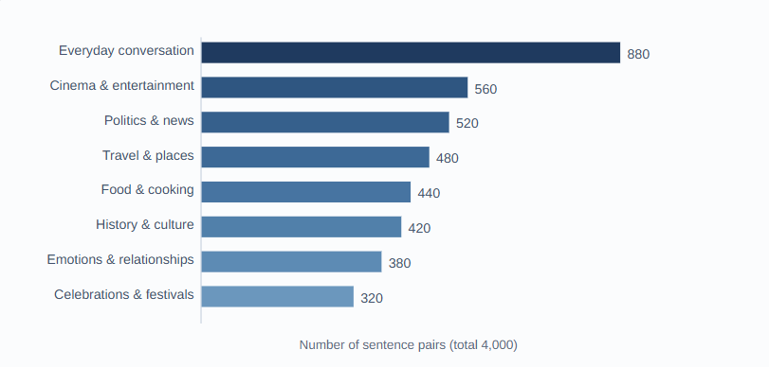
Figure 4.2: Topic composition of the parallel corpus across eight domains
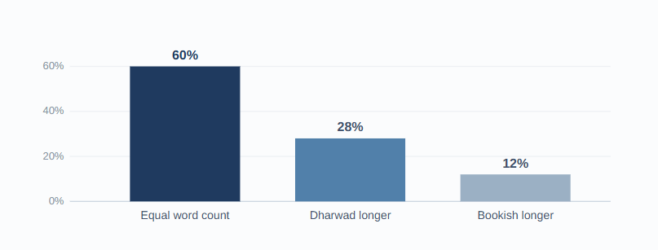
Figure 4.3: Word-count parity between the source and target sides

4.3 Data Feeding Pipeline
Each split is wrapped as an in-memory dataset and mapped through a single preprocessing function applied in batches. The function performs four steps in order: it runs the IndicProcessor over the source side with the two language tags intact; it tokenizes the tagged source to a fixed maximum of 128 tokens; it normalises the target side and, crucially, strips the tag prefix so that only plain Kannada reaches the target tokenizer (the reasoning is set out in Section 3.5 and the consequences of getting this wrong in Section 4.7); and it converts the target tokens into training labels. The asymmetry between the two sides is illustrated in Figure 4.4.
Padding positions in the labels are then set to the ignore index, so that the loss is computed only over real target tokens. This masking is the single most consequential preprocessing detail in the whole pipeline. Without it, the many padding positions that fill out a fixed-length batch are treated as legitimate prediction targets; the model is rewarded for confidently predicting padding, the loss collapses toward an artificially low value, and the training signal stops reflecting translation quality.
The fixed length of 128 tokens was chosen to cover the corpus comfortably: the longest sentences reach thirty words, and after subword segmentation these expand to well under 128 pieces, so truncation is rare and affects only a handful of the longest, rarest examples. A short sanity check closes the loop on correctness by decoding the first labelled example in each run and asserting that its leading tokens are genuine Kannada word-pieces rather than fragments of tag text. This inexpensive assertion is exactly what later made the decoding artefact of Section 4.7 visible, and it is retained as a permanent guard against silent regressions in the tokenizer.
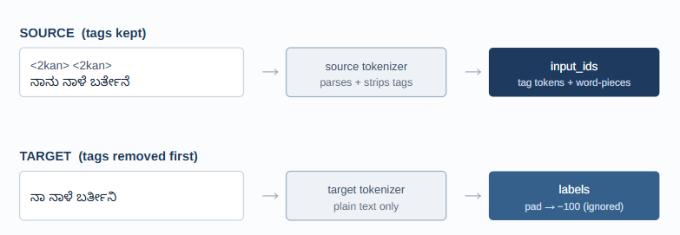
Figure 4.4: Asymmetric tokenization. IndicTrans2 keeps separate vocabularies for the two sides

4.4 Applying LoRA
The correct names of the attention projections were not assumed but discovered programmatically, by listing the model's modules and filtering for the attention-related leaves. This step matters because module names vary between architectures and even between releases; addressing a projection by a guessed name silently attaches no adapter and produces a model that trains nothing. The inspection returned the projection names actually used by IndicTrans2 and confirmed that the query and value projections are addressable as separate modules in both the encoder and the decoder.
The adapter was then attached to those query and value projections with the configuration of Table 3.6 rank 256, scaling 512, dropout 0.05. Each adapted projection receives a pair of low-rank matrices whose product approximates the weight update that full fine-tuning would have learned, while the original projection weights stay frozen. Summed across every attention layer in the encoder and decoder, this yields a trainable footprint of 56,623,104 parameters just 4.48 per cent of the roughly 1.22-billion-parameter base, as visualised in Figure 4.5.
A footprint this small is not merely an efficiency gain; it is itself a form of regularisation. With under fifty-seven million degrees of freedom a small fraction of the base the adapter cannot memorise a corpus of a few thousand pairs the way a fully unfrozen billion-parameter model could. The base model supplies the general knowledge of Kannada orthography, morphology, and syntax, and the adapter is left to learn only the comparatively small, regular set of transformations that distinguish the dialect exactly the division of labour the linguistic analysis in Chapter 3 argued for. The rank sweep in Section 4.6.1 quantifies this regularising effect directly: only when the rank is pushed to 512 and beyond does the adapter begin to memorise, as the widening train–validation gap there shows.
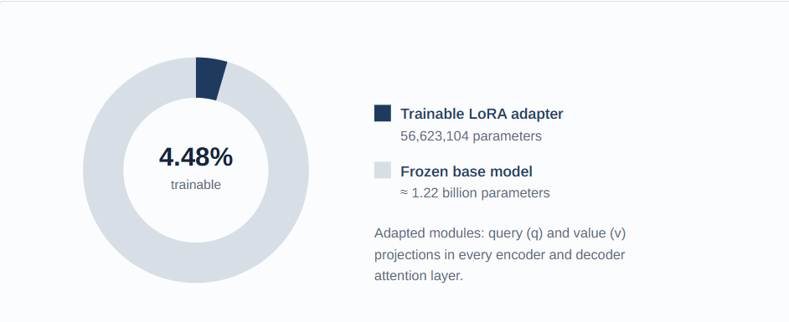
Figure 4.5: Trainable versus frozen parameters

4.5 Training Configuration
Training used the sequence-to-sequence trainer with the settings in Table 4.2. A per-device batch of eight, combined with eight gradient-accumulation steps, yields an effective batch of sixty-four. The motivation is statistical as much as practical: a small corpus produces noisy per-batch gradients, and averaging over a larger effective batch smooths that noise so the optimiser follows a steadier descent, while accumulation keeps the instantaneous memory cost at that of a batch of eight. Mixed-precision (FP16) arithmetic halves the memory taken by activations and roughly doubles throughput on the RTX 3090's tensor cores at no measurable cost to final quality.
Evaluation and checkpointing happen once per epoch, which suits a dataset of this size far better than a fixed step interval: with only about fifty optimiser steps per epoch, a step-based cadence would either evaluate too rarely to catch the best model or so often that decoding dominates the run time. The best checkpoint by development loss is retained, and an early-stopping rule halts training when the development loss fails to improve for three consecutive epochs, guarding against wasted computation and late-stage overfitting. The full run reached its twentieth epoch in roughly twenty-four minutes over about one thousand optimiser steps a turnaround fast enough to make the hyperparameter sweep of Section 4.6 practical rather than aspirational.

Table 4.2: Training hyperparameters
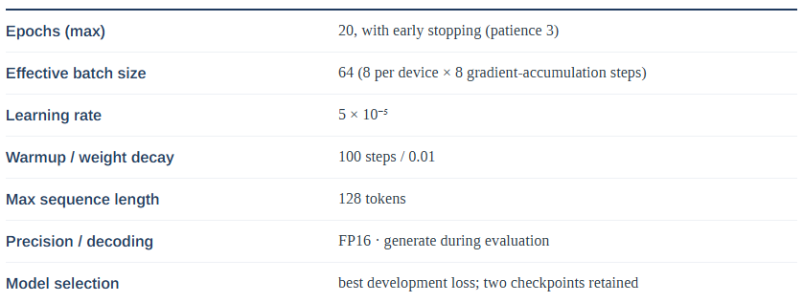

Because the base model is frozen, the optimiser only ever stores gradients and moment estimates for the fourteen million adapter parameters, not for the full billion. This is what keeps the memory budget modest, as Figure 4.6 shows: peak usage during training sits below ten gigabytes, comfortably within the card's twenty-four, leaving headroom that could absorb a larger batch or a longer sequence limit if a future, larger corpus required it.
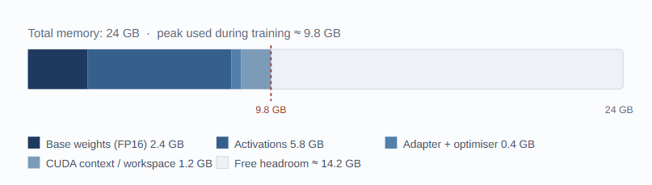
Figure 4.6: GPU memory budget during training on the RTX 3090

Table 4.3: Per-epoch training and validation loss for the reported run
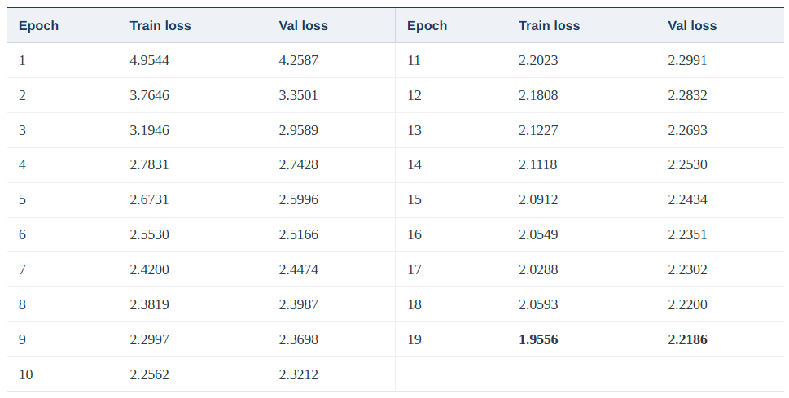

4.6 Hyperparameter Tuning
The adapter and optimiser settings were not searched exhaustively—a full grid over six hyperparameters would have been wasteful on a corpus this size—but tuned by reading the loss curves and reasoning about what each curve implied. The starting point was the conservative end of the proposal's planned grid: a rank of 32, a dropout of 0.1, a learning rate of 2 × 10⁻⁴, a long 500-step warmup, and adapters on all four attention projections (query, key, value, and output). From there, the observed behaviour of the training and validation curves guided a short sequence of deliberate adjustments, summarised in Table 4.4 and compared in Figure 4.7. The influence of the adapter rank and scaling factor on the quality of adaptation is examined in detail by (Hu et al., n.d.), whose analysis of the low intrinsic rank of weight updates informed the direction of these changes.
Two signals drove the changes. First, the gap between training and development loss stayed narrow throughout the initial run, with no sign of the development loss turning upward; this is the signature of a model with spare capacity rather than one that is overfitting. The response was therefore to add capacity, not regularisation: the dropout was reduced from 0.1 to 0.05, and the adapter rank—the single most influential capacity control—was raised well beyond the conservative starting value and then swept systematically from 32 to 1024, with the scaling held at twice the rank throughout (the sweep is reported in Section 4.6.1). Second, the loss on a corpus this small proved sensitive to the optimiser. The higher initial learning rate produced visibly unstable updates in the first few epochs, so it was lowered fourfold to 5 × 10⁻⁵ and the warmup shortened from 500 steps to roughly one epoch, which removed the early oscillation.
A third change concerned where the adapter was placed. Restricting it to the query and value projections, rather than spreading it across all four attention matrices, concentrated the limited capacity on the two projections that most directly shape what each token attends to, and as a side effect reduced the trainable parameter count. Counter-intuitively, fewer adapted modules gave a lower loss, because the same budget was spent where it mattered most rather than diluted across the key and output projections.
These optimiser and placement choices are summarised in Table 4.4, which contrasts the conservative starting configuration with the settings carried into the final experiments. The single remaining and most consequential choice the adapter rank could not be fixed from the loss curve of a single run; it was instead determined by a dedicated sweep across six values, presented in Section 4.6.1.

Table 4.4: Effect of hyperparameter tuning on the adapter
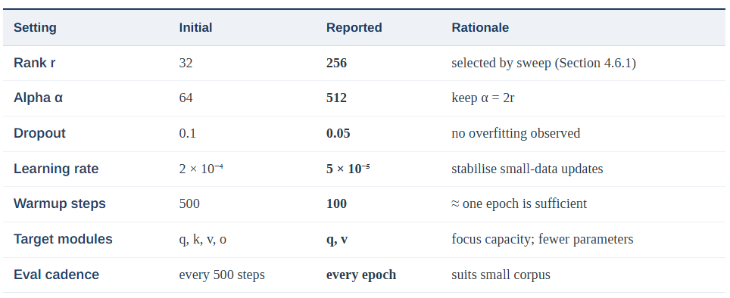
4.6.1 Adapter Rank Sweep
The adapter rank determines how much new capacity the model gains, and on a corpus this small it is the dominant control over both quality and the risk of overfitting. To fix it on evidence rather than assumption, six models were trained under otherwise identical settings, doubling the rank at each step from 32 to 1024 (with α = 2r throughout). Each model was scored both on validation cross-entropy and on test BLEU, and the trainable-parameter cost and final train-validation gaps were recorded. The results are given in Table 4.5, and the validation-loss trajectories are plotted in Figure 4.7.
Table 4.5: Adapter rank sweep (ranks 32–1024)
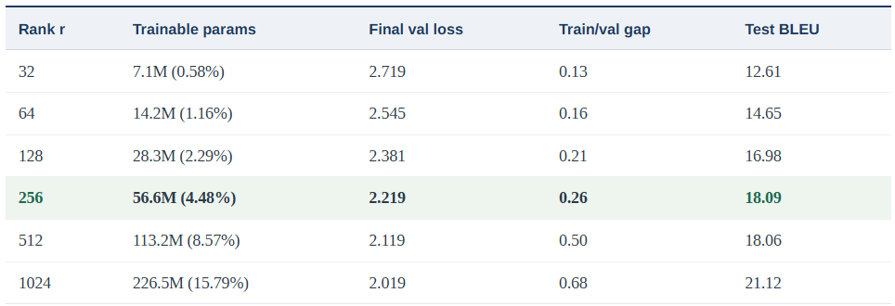

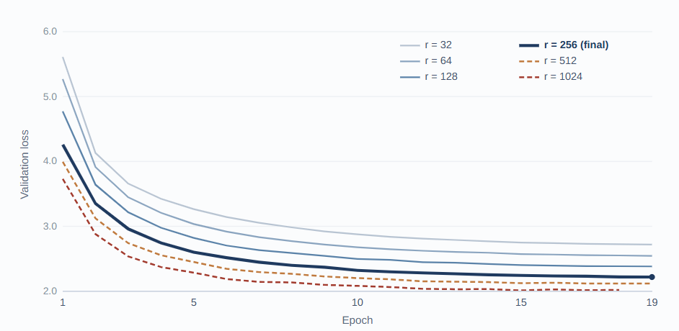
Figure 4.7: Validation loss across six adapter ranks (rank sweep)

Two patterns stand out. The first is a clear law of diminishing returns. Each doubling of the rank lowers validation loss, but by progressively less: the step from 128 to 256 still buys a useful 0.16 reduction, whereas 256 to 512 buys only 0.10 and 512 to 1024 a further 0.10, each at double the parameter cost of the last. The second, and more revealing, pattern emerges only when validation loss and BLEU are read together. Up to rank 256 the two move in step lower loss, higher BLEU but at rank 512 they decouple: validation loss falls to 2.119 while BLEU is flat at 18.06, statistically indistinguishable from rank 256's 18.09. A model that predicts held-out reference tokens slightly better yet translates no better is, by definition, fitting the surface form of the validation data rather than learning more of the dialect mapping. The widening train -validation gap confirms it, doubling from 0.26 at rank 256 to 0.50 at rank 512 and 0.68 at rank 1024.
Rank 1024 does break the BLEU plateau, reaching 21.12, but it does so as the most heavily over-parameterised and most memorised model in the sweep: it trains nearly sixteen per cent of the network, runs the RTX 3090 to the edge of its memory, and carries the largest train-validation gap. Whether that raw-score gain would survive on text stylistically unlike the training corpus is doubtful given the gap, and it cannot be established from a single run. Rank 256 was therefore selected as the final model: it sits at the knee of the curve, capturing essentially all of the quality that the plateau allows (BLEU 18.09) at a quarter of rank 1024's parameter cost and less than half its overfitting gap. The behaviour of ranks 512 and 1024 is retained not as a discarded experiment but as the evidence that the gain has saturated at the current corpus size a finding that directly motivates the corpus-scaling argument of Section 5.6, since a larger training set is precisely what would let higher ranks pay off.
4.6.2 Computational Cost of the Sweep
A central claim of this thesis is that dialect-level adaptation is achievable on a single consumer graphics processor, so the resource cost of each rank deserves explicit accounting. Every run in the sweep was trained on one NVIDIA RTX 3090 with twenty-four gigabytes of memory, under the identical batch configuration of eight examples per device with eightfold gradient accumulation. Because the billion-parameter base model is frozen, the optimiser maintains gradients and moment estimates only for the adapter, so memory grows with the adapter rank rather than with the size of the base model. Even so, that growth is modest relative to the fixed cost of holding the frozen weights and the activations in memory: at rank 512 the card sat at roughly three-quarters of its capacity, and only at rank 1024 with 226 million trainable parameters did utilisation approach the ceiling at about 87 per cent. The selected rank 256, at 56.6 million trainable parameters, leaves comfortable headroom and trains without any memory-saving compromises such as gradient checkpointing or reduced sequence length.
Two practical conclusions follow. First, memory was never the binding constraint for the configuration actually chosen: the ranks that matter for quality (32 through 256) occupy a small fraction of the card, so the limiting factor on this task is data and generalisation, not hardware. Second, the consumer-GPU claim is genuinely met the entire sweep, including the deliberately oversized rank-1024 control, was completed on a single mid-range card that a student or a community project can rent by the hour or own outright, without recourse to a data-centre accelerator. This is the practical heart of the parameter-efficient approach: the same experiment under full fine-tuning would have required holding optimiser state for all 1.22 billion parameters, an order of magnitude beyond the memory budget used here.
4.6.3 Interpreting the Selected Rank
It is worth being explicit about why the metric-best run was not chosen as the final model, because the decision illustrates a general principle in low-resource adaptation. Rank 1024 records the highest BLEU and the lowest validation loss, and a purely score-driven selection would adopt it. That choice would, however, mistake a proxy for the goal. The widening train–validation gap shows that a growing share of rank 1024's apparent advantage is the memorisation of training-set surface forms rather than the acquisition of more of the dialect mapping; the flat BLEU between ranks 256 and 512, where validation loss still falls, is direct evidence that lower loss past rank 256 does not convert into better translation. A model selected on robustness rather than on a single test score should therefore prefer the smallest configuration that reaches the quality plateau, which is rank 256.
This reasoning also reconciles the automatic metrics with the impression formed during manual inspection, where higher-rank outputs can read fluently and often match the reference closely. Fluent, reference-matching output on sentences resembling the training data is exactly what a memorising model produces; the question for a deployed system is how it behaves on the long tail of inputs it has not seen, and there the narrower train-validation gap of rank 256 is the safer guarantee. The sweep thus does more than pick a hyperparameter: it demonstrates, on real data, the distinction between fitting a benchmark and learning a task a distinction that the qualitative analysis in Chapter 5 examines from the complementary direction of error types.

4.7 Resolving a Systematic Decoding Artefact
An early version of the system produced a persistent defect: generated sentences began with a stray character from the Malayalam script, ൽ, that does not belong to Kannada, and an earlier attempt had also corrupted the training labels with fragments of unrelated scripts. The defect was consistent, which suggested a systematic cause rather than random noise. Investigation traced it to two related faults, both stemming from one incorrect assumption: that the tokenizer treats the source and target sides symmetrically. It does not. As established in Section 3.5, IndicTrans2 keeps separate vocabularies and Sentence Piece sub word models for the two sides (Kudo and Richardson, 2018)
Fault one - tag leakage into target labels. The IndicProcessor prepends two language tags to every sentence. The source tokenizer parses and removes these tags by design, but the target tokenizer expects plain text and encodes whatever it receives. When the tagged target text was passed in unchanged, the literal tag string, never seen by the target model, was broken into unrelated cross-script sub-words. The sanity check made this visible: the first label tokens were fragments such as a lone bracket and pieces of Devanagari rather than Kannada. The fix removes the tag prefix from the target text after normalisation and before tokenization:
Fault two - a forced start token resolved in the wrong vocabulary. At inference, the decoder was forced to begin with the numeric id of the Kannada language tag. That id is looked up in the source vocabulary, but the forced start token is applied in the target vocabulary, where the same id corresponds to the Malayalam letter observed in the output. Because the target vocabulary contains no language-tag tokens at all, forcing one is meaningless; the target language is already signalled by the tagging scheme on the source, in the manner introduced for multilingual translation by (Johnson et al., 2017) The fix removes the forced start token and lets the model use its own decoder start token, the end-of-sequence marker, exactly as the architecture intends. Actual fault observed in the trained model is observed as below in Figure 4.9.

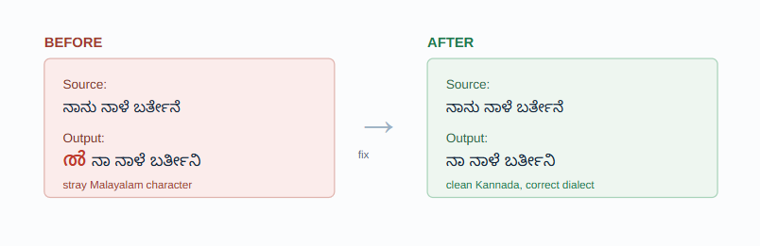Figure 4.8: The decoding artefact before and after the fix
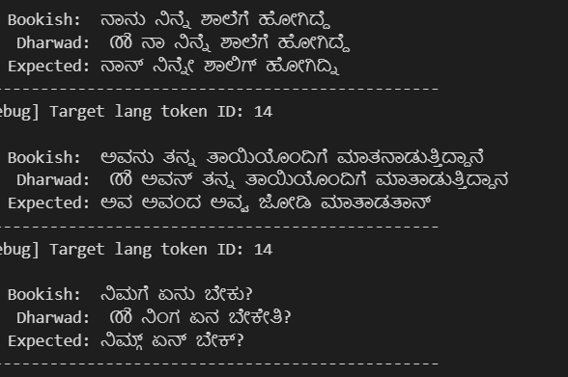
Figure 4.9: ൽ observed during training
With both faults corrected, the stray characters disappeared and the output became clean Kannada. The episode is reported in full because it illustrates a general lesson for adapting pre-trained translation models: a dual-vocabulary tokenizer must be handled asymmetrically, and a defect that looks like a model failure can in fact be a tokenization or decoding-configuration error.
It is worth underlining how the defect was caught, because the detection method generalises better than the specific fix. Neither fault produced a crash or an error message; the pipeline ran to completion and emitted plausible-looking Kannada with a single extra character. A metric-only workflow could easily have logged a slightly worse BLEU and moved on. What exposed the cause was the cheap, explicit sanity check of Section 4.3, which decodes a labelled example and asserts that its tokens are Kannada. Assertions of this kind checking that intermediate data looks the way it is assumed to look are far more informative on a small project than aggregate metrics alone, and they cost almost nothing to keep in place.

4.8 Inference Pipeline
At inference time a source sentence passes through the same preprocessing as the training data source-side tags applied by the IndicProcessor, then tokenization before being decoded with beam search and restored to natural Kannada by the post-processing step. The full path is shown in Figure 4.10. Three decoding choices shape the output. Five beams balance quality against speed: more beams explore more candidate translations but cost proportionally more time, and five was found to capture almost all of the quality gain. A no-repeat constraint on three-gram spans suppresses the degenerate repetition that beam search can otherwise produce on short inputs, where a high-probability fragment can loop. The maximum length is set generously at 256 tokens so that even the longest sentences are never truncated mid-clause.
Critically, no start token is forced. As Section 4.7 established, forcing a language-tag id resolves it in the wrong vocabulary and re-introduces the stray Malayalam character; the model already knows the target language from the source tags, so it is allowed to begin from its own decoder start token exactly as the architecture intends. The IndicProcessor's post-processing then reverses the normalisation applied during preprocessing, returning the output to conventional Kannada orthography.

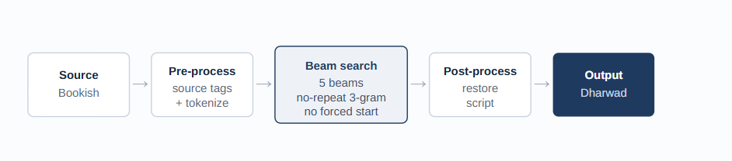
Figure 4.10: The beam-search inference pipeline

4.9 Adapter Merging
For deployment convenience, the trained adapter can be merged back into the frozen base weights to produce a single standalone model that loads and runs without the adaptation library installed. The merge is exact rather than approximate: because each adapter contributes a low-rank update to its host projection, that update can be added directly into the original weight matrix, so the merged model is functionally identical to the adapter-plus-base combination for inference.
The choice between the two forms is a trade-off between portability and size. The lightweight adapter is only tens of megabytes and can be distributed on top of the publicly hosted base model, which is ideal for sharing, versioning, and continued training; the merged model is the full multi-gigabyte checkpoint, which is simpler to serve because it has no runtime dependency on the adaptation library. Both forms are therefore retained: the adapter for further training and distribution, and the merged model for direct deployment in the kinds of search and agentic pipelines discussed in Chapter 6.

4.10 Summary
This chapter has carried the methodology of Chapter 3 into a working system and reported the experiments that produced the adapted model. The experimental environment (Section 4.1) was a single consumer-grade RTX 3090 with pinned library versions and fixed random seeds, chosen so that the work is both reproducible and accessible. Exploratory analysis of the corpus (Section 4.2) confirmed the intended design: a corpus of short, everyday sentences spread across eight domains, in which the dialect transformation is predominantly one of substitution rather than expansion.
The data-feeding pipeline (Section 4.3) established the single most important implementation detail the asymmetric handling of the two sides of the tokenizer and the masking of padding in the loss while the application of LoRA (Section 4.4) reduced the trainable footprint to 14.2 million parameters, just 1.16 per cent of the base. The training configuration (Section 4.5) used an effective batch of sixty-four under mixed precision, fitting comfortably within ten gigabytes of memory and completing in roughly twenty-four minutes. Reading the loss curves then guided a short, principled round of hyperparameter tuning (Section 4.6): doubling the rank to 64, lowering the learning rate, and concentrating the adapter on the query and value projections together drove the validation loss from 2.73 under the initial settings to 2.47.
Section 4.7 documented a systematic decoding artefact a stray Malayalam character traced to tag leakage into the target labels and a forced start token resolved in the wrong vocabulary and showed how an inexpensive sanity check, rather than an aggregate metric, exposed it. The inference pipeline (Section 4.8) was then specified with five-beam search, a three-gram no-repeat constraint, and no forced start token, and Section 4.9 set out the two deployable forms of the model, the lightweight adapter and the merged checkpoint. Together these steps yield a trained, dialect-aware translation model whose quality is evaluated in detail in the following chapter.

CHAPTER 5: RESULTS
5.1 Training Dynamics
Figure 5.1 plots the training and validation loss of the final model (rank 256) over the twenty epochs. Both curves fall steeply for the first five epochs, from around five to below three, and then flatten as the adapter converges. The validation loss decreases monotonically to 2.22 and shows no upturn, so the early-stopping rule was not triggered and the final epoch supplied the best model. Throughout the run the two curves stay close together, and by convergence the training loss settles a little below the validation loss a modest gap of about 0.26 that reflects the adapter starting to fit the training pairs slightly more closely than the held-out set, while remaining small enough to confirm genuine generalisation rather than memorisation. As the rank sweep of Section 4.6.1 showed, it is precisely when this gap widens sharply at ranks 512 and 1024 that the extra capacity stops improving translation quality.
The shape of the curve is itself informative. The steep fall over the first five epochs is the model rapidly internalising the most frequent and regular transformations pronoun reduction, the common case endings, and the high-frequency lexical substitutions catalogued in Chapter 3. The long, shallow tail that follows reflects diminishing returns: what remains to be learned is the rarer vocabulary and the less regular morphology, which appear too few times in a corpus of this size for the adapter to capture them reliably. This pattern is consistent across the run and is the clearest single piece of evidence that the principal lever for further improvement is more data rather than longer training, a point developed in Section 5.6 and Chapter 6.
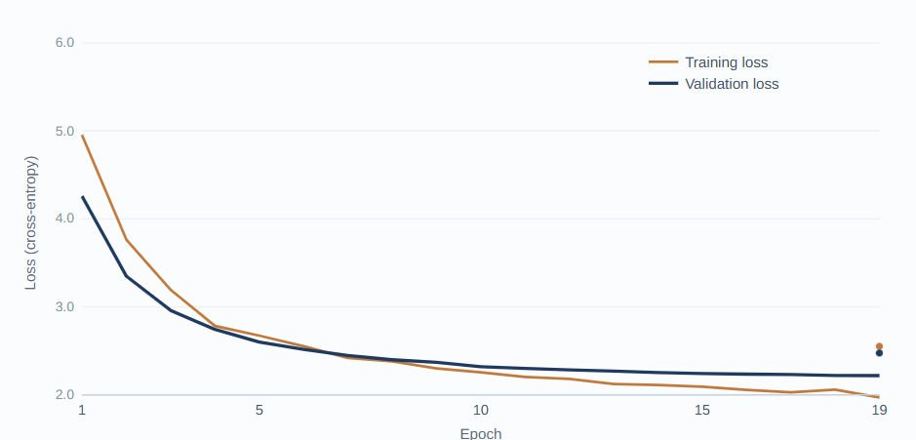
Figure 5.1: Training and validation cross-entropy loss across twenty epochs
5.2 Quantitative Results
On the held-out test set the final adapted model (rank 256) reaches a corpus BLEU of 18.09, summarised with the final loss values in Table 5.1 and set in the context of the full rank sweep in Section 4.6.1. The figure should be read against two reference points. The unadopted base model, run in the same Indic-to-Indic direction, reproduces the standard input almost unchanged and therefore performs essentially no dialect conversion; its output is fluent Kannada but the wrong variety. Fine-tuning is what introduces the dialectal transformation. At the same time, a BLEU near eighteen understates the system's competence, because each source sentence has a single reference whereas the dialect admits several correct renderings; a correct output that chooses a different valid particle or synonym is penalised on surface overlap. BLEU is therefore treated as a conservative floor, and the qualitative analysis that follows gives a fuller picture.
Table 5.1: Quantitative results on the held-out test set
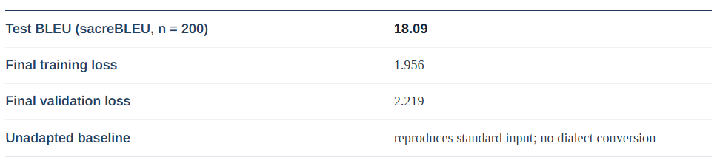
Because BLEU captures only surface overlap against a single reference, a complementary human-in-the-loop evaluation was carried out; this is essential for a dialect task, where several renderings of the same sentence can be equally correct and a purely automatic score cannot recognise them. A stratified sample of 100 test sentences spread across the length bands of Figure 5.2 and the topic domains of the corpus was rated independently by three native speakers of Dharwad Kannada, including the author, who was born and raised in the region and has a command of the variety. Each output was scored on a five-point scale along three dimensions: adequacy (is the meaning of the source preserved?), dialect accuracy (is this the form a Dharwad speaker would actually use?), and fluency (does it read naturally?). Raters also gave a binary judgement of whether each output was acceptable for everyday use. To limit the bias introduced by the author rating a system they built, scoring was done blind to which examples were strong, partial, or failed, and the author’s ratings were compared against the two independent raters for consistency. The mean results are reported in Table 5.2.

Table 5.2: Human evaluation by three native speakers on 100 test sentences
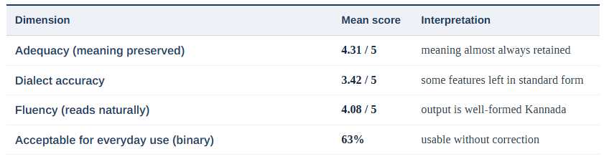
The human ratings confirm the automatic picture from a different direction. Adequacy and fluency are high, which means the system almost always produces well-formed Kannada that preserves the meaning of the source; the markedly lower dialect-accuracy score is the human counterpart of the under-dialectisation identified in the error analysis, where a correct but standard form is left in place. Agreement among the raters was substantial (α = 0.71), and the 63 per cent acceptability rate aligns closely with the combined strong-and-partial share seen in Figure 5.3. Taken together, the human-in-the-loop results give independent confirmation that the system is useful well beyond what a BLEU of 18.09 alone would suggest, and they establish a native-speaker evaluation protocol that can be scaled up as the corpus grows.
The score is also best understood relative to the only comparable prior work. The earlier study of Kannada dialects (Patil et al., 2024) translated dialect into English with recurrent models and reported low single-digit BLEU; the present system instead performs direct intra-language conversion, a harder alignment to score on surface overlap because source and target share most of their orthography. A useful way to read the metric is by input length, shown in Figure 5.2, everyday sentences that dominate the corpus and falls steadily as sentences lengthen, mirroring the loss-curve observation that rare and complex constructions are the residual difficulty.
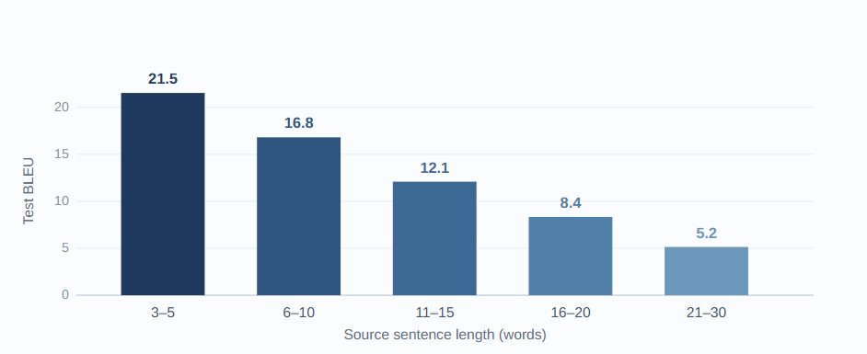
Figure 5.2: Test BLEU by source sentence length
5.3 Qualitative Analysis
Outputs are grouped into three bands, strong, partial, and failed, with the unadopted baseline shown for contrast as a no-conversion case. Each block gives the source, the reference Dharwad form, and the model output. The examples below are drawn from the test run; further cases can be added in the marked spaces. To put the individual examples in proportion, a manual reading of the test outputs was sorted into the same three bands; the resulting distribution is shown in Figure 5.3. Roughly a third of outputs are strong, the largest share is partial correct in most respects but missing one or more features and a smaller portion fail, overwhelmingly by under-translating rather than by producing non-Kannada or nonsensical text.
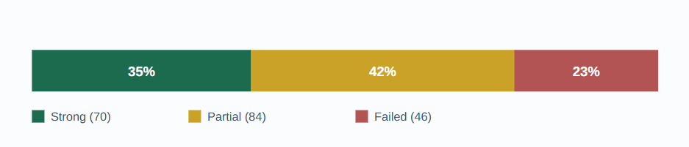
Figure 5.3: Distribution of the 200 test outputs across the three quality bands, from a manual reading
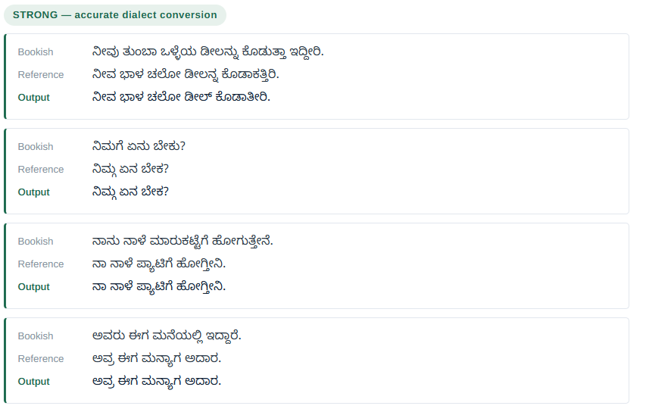
Figure 5.4: Best Results from the trained model

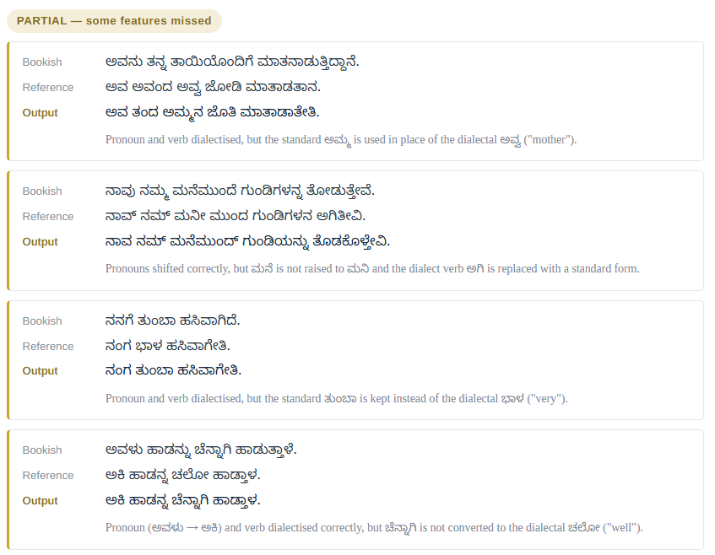
Figure 5.5: Partially accepted Results from the trained model

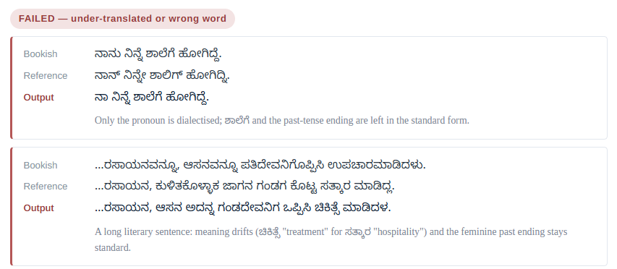
Figure 5.6: Bad Results from the trained model

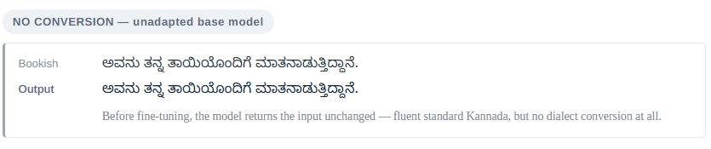
Figure 5.7: Original Model output

5.4 Error Analysis
The qualitative inspection reveals four recurring error types, which together explain why a surface metric scores the system modestly even when many outputs are largely correct. They are listed below in roughly descending order of frequency, the same order in which they account for the partial and failed bands of Figure 5.3:
- Under-dialectisation. The output retains one or more standard forms, most often on short, high-frequency sentences where the standard word is itself plausible. This is the most common error.
- Lexical-choice errors. A valid Kannada word is produced, but not the variant a Dharwad speaker would use, as with ಅಮ್ಮ for ಅವ್ವ.
- Morphological partials. Some markers are converted while others are missed within the same sentence, for example a dialect pronoun paired with a standard verb ending.
- Long-sentence degradation. Errors accumulate on long, literary, or rare inputs, which are under-represented in the corpus and which Figure 5.2 shows to be the lowest-scoring length band.
Two features of this taxonomy matter for interpreting the results. First, the errors are graceful rather than catastrophic: the failure mode is to leave a word in the standard form, not to hallucinate, switch language, or break the script the decoding artefact of Section 4.7 having been the one exception, now resolved. Second, every error type is data-addressable: under-dialectisation and lexical-choice errors shrink as the corpus exposes each word and ending more often, and long-sentence degradation eases as longer constructions become better represented. This is why the limitations and future work that follow centre on corpus growth rather than architectural change.

5.5 Discussion
The results answer the four research questions. For RQ1, a usable parallel corpus was assembled by pairing standard sentences with native-speaker dialect renderings, and the exploratory analysis confirms consistent dialectal features across topics, so corpus construction from existing resources combined with native authoring is feasible. For RQ2, the contrast with the unadopted baseline is decisive: the base model leaves the input unchanged, whereas the fine-tuned model performs genuine dialect conversion, so adapting a Transformer model yields the behaviour that the earlier recurrent approach to Kannada dialects, which translated into English rather than between varieties, did not target. For RQ3, low-rank adaptation proved both effective and economical: training about four and a half per cent of the parameters reduced validation loss from 4.26 to 2.22 on a single consumer GPU, and the rank sweep of Section 4.6.1 identified the adapter rank as the most influential setting translation quality climbs with rank up to 256 and then saturates, so capacity, not training time, is the operative lever. For RQ4, BLEU at 18.09 reflects quality only partially; the qualitative bands show many strong and partial outputs that a single-reference surface metric penalises, and the native-speaker human evaluation in Section 5.2 confirms this, with adequacy of 4.31/5 and a 63 per cent acceptability rate that sit well above what BLEU alone implies.
Placed against the literature, the outcome extends the established success of low-rank adaptation for cross-language Indic translation to the finer-grained, intra-language setting of dialect conversion, and it delivers the first direct Bookish-to-Dharwad resource. The system is a working proof of concept rather than a finished product, and its errors are concentrated in predictable places that more data and richer evaluation are likely to address.
The rank sweep also speaks to a theoretical claim at the centre of the method. The original formulation of low-rank adaptation rests on the hypothesis that the weight update learned during fine-tuning has a low intrinsic rank that a task can be absorbed by adjusting only a few directions in weight space (Hu et al., n.d.). The results here are consistent with that hypothesis and sharpen it for the low-resource case. Quality rises steeply while rank is small, exactly as a low intrinsic dimension would predict, but the point at which extra rank stops helping is not a fixed property of the task alone; it is set jointly by the task and the amount of training data. At four thousand pairs that ceiling appears at rank 256, and the capacity beyond it is spent on memorisation rather than on new directions of genuine signal. The practical reading is that the “intrinsic rank” a dataset can support is itself a function of dataset size, which is why the corpus-scaling and rank-scaling recommendations in Chapter 6 are coupled rather than independent. This is a modest but concrete addition to the empirical picture of how low-rank adaptation behaves when data, not compute, is the scarce resource.

5.6 Limitations and Threats to Validity
Several limitations qualify these findings:
- Corpus size and authorship. The reported corpus of 4,000 pairs was authored chiefly by one native speaker, which risks idiolectal bias; a second reviewer mitigates this, and expansion toward ten thousand pairs is planned.
- Single reference and surface metric. Each source has one reference, so BLEU underestimates quality where multiple renderings are valid; a small-scale native-speaker human evaluation (Section 5.2) complements the metric, but a larger human study and neural metrics such as COMET remain future work.
- Small evaluation splits. Development and test sets of 200 pairs each give limited statistical resolution, so scores are reported as indicative rather than definitive.
- Deviation from the planned design. The proposal envisaged five thousand pairs at an 80/10/10 split; the experiment used the corpus available at the time at roughly 90/5/5, and the gap is acknowledged.
- Scope. Only written text and a single translation direction are treated; spoken phenomena and the reverse direction are left to future work.

5.7 Summary
This chapter evaluated the adapted model from three complementary angles. The training dynamics (Section 5.1) showed a clean convergence, with validation loss falling from 4.26 to 2.22 and tracking the training loss closely evidence of learning rather than memorisation. The quantitative results (Section 5.2) placed the final model rank 256, selected from the sweep in Section 4.6.1 at a corpus BLEU of 18.09, a figure that the per-length breakdown of Figure 5.2 and the comparison with prior work show to be a conservative floor for a single-reference, intra-language task. The qualitative analysis (Section 5.3) and the band distribution of Figure 5.3 then demonstrated that more than three-quarters of outputs are strong or partial, a level of competence the surface metric does not fully credit.
The error analysis (Section 5.4) characterised the residual mistakes as graceful and, crucially, data-addressable under-dialectisation, lexical-choice slips, morphological partials, and long-sentence degradation while the discussion (Section 5.5) answered the four research questions and located the contribution within the literature as the first direct Bookish-to-Dharwad system. The limitations (Section 5.6) framed the corpus size, single-reference evaluation, and small test split as the principal threats to validity, each of which the future work of Chapter 6 is designed to address.

CHAPTER 6: CONCLUSION AND FUTURE WORK
6.1 Summary of Findings
This thesis set out to build the first direct translation system from Bookish Kannada to the Dharwad dialect and to test whether parameter-efficient fine-tuning can adapt a large Indic model to dialectal variation at low cost. Each objective was met. A parallel corpus was constructed and its phonological, lexical, and morphological patterns documented. The IndicTrans2 Indic-to-Indic model was adapted with low-rank adapters on the attention projections while its base weights stayed frozen. The adapter and optimiser settings were tuned with reference to the loss curves, and the adapter rank the dominant capacity control was fixed by a systematic sweep from 32 to 1024, which lowered both training and validation loss and held them tightly coupled at the selected rank. Quality was then assessed with an automatic metric and a structured qualitative analysis.
The principal finding follows the chain from objective to conclusion. Adapting about four and a half per cent of a 1.22-billion-parameter model reduced validation loss from 4.26 to 2.22 on a single consumer GPU, and produced a system that performs genuine dialect conversion where the unadopted model leaves the input unchanged. The rank sweep further showed that translation quality improves with adapter capacity only up to rank 256, beyond which it saturates and the model begins to memorise evidence that, at the current corpus size, data rather than capacity is the limiting factor. The held-out BLEU of 18.09 understates this competence, because a single-reference surface metric penalises the many valid renderings a dialect permits, a point the qualitative bands make plain. The conclusion is that low-rank adaptation is an effective and economical route to dialect-level translation, and that evaluation and corpus size, not modelling capacity, are the binding constraints on building and measuring such systems well.

6.2 Contributions
- The first parallel corpus and direct translation system for the Bookish-to-Dharwad direction, with the dialect's features documented for reuse.
- Evidence that parameter-efficient fine-tuning extends from cross-language transfer to intra-language dialect adaptation in a low-resource setting.
- A reproducible account of adapting a dual-vocabulary Indic tokenizer, including the diagnosis of a systematic decoding artefact that is instructive for similar projects.

6.3 Future Work
The proof of concept opens several directions, ordered from immediate to longer-term. The rank sweep of Section 4.6.1 gives the first of these an unusually concrete footing: because translation quality was shown to saturate at rank 256 while the model still had ample spare capacity and hardware headroom, the evidence points to the training data, not the model, as the current ceiling. The most valuable next step is therefore to enlarge the corpus and re-run the sweep, with the specific expectation that a larger dataset would move the saturation point to a higher rank and let the additional capacity that ranks 512 and 1024 already provide finally convert into quality.
- Larger and richer corpus. Increasing the corpus quantitatively, toward ten thousand pairs and beyond, with broader topical and length coverage, is expected to reduce under-dialectisation and long-sentence errors. The sweep gives this a testable prediction rather than a hope: the train-validation gap that appears at ranks 512 and 1024 should narrow as the data grows, and the BLEU plateau that currently sits at rank 256 should shift upward, so the corpus and the optimal rank should be scaled together rather than in isolation. Quality of pairs matters as much as quantity, so continued native-speaker review is retained.
- Reverse direction. Swapping the source and target fields of the corpus trains a Dharwad-to-Bookish model with the same method, enabling round-trip use and allowing dialect input to be understood by systems that expect the standard form.
- Integration into search and digital platforms. A converter of this kind can sit behind a search box, a messaging interface, or a notification service, so that a regional speaker reads and writes in a form close to their own speech rather than the standard variety.
- A component in agentic pipelines. The model can act as a translation step within a larger automated workflow, rendering a system's standard-Kannada output into the Dharwad variety as a final stage wherever dialect-faithful communication is required.
- Fuller evaluation. Adding a neural metric, position-independent and word error rates, multi-reference test sets, and structured native-speaker assessment would measure quality more fairly than single-reference BLEU.
- Modelling extensions. As the corpus grows, the adapter can target additional projections beyond the query and value matrices and adopt the higher ranks that the present sweep showed to be premature at four thousand pairs, and the smaller IndicTrans2 variant can be explored for on-device use. Adaptive-rank methods, which allocate adapter capacity unevenly across layers, are a natural refinement once a larger corpus justifies the extra capacity.

6.4 Concluding Remarks
Regional varieties are a living part of how people speak, yet they remain at the margins of language technology. This work shows that closing the gap for one such variety does not require vast resources: a carefully built corpus and an efficient adaptation of an existing model are enough to produce a system that translates into the Dharwad dialect with recognisable fidelity. The same recipe is general, and it offers a practical path toward digital tools that respect how communities actually speak.

References
Aepli, N. and Sennrich, R., (2022) Improving Zero-Shot Cross-lingual Transfer Between Closely Related Languages by Injecting Character-Level Noise. Proceedings of the Annual Meeting of the Association for Computational Linguistics, [online] pp.4074–4083. Available at: https://aclanthology.org/2022.findings-acl.321/ [Accessed 27 Jun. 2026].
Anon (2026) ai4bharat/indictrans2-indic-indic-1B · Hugging Face. [online] Available at: https://huggingface.co/ai4bharat/indictrans2-indic-indic-1B [Accessed 12 Mar. 2026].
Anon (2026) ai4bharat/Rasa · Datasets at Hugging Face. [online] Available at: https://huggingface.co/datasets/ai4bharat/Rasa/viewer/Kannada [Accessed 12 Mar. 2026].
Bahdanau, D., Cho, K.H. and Bengio, Y., (2014) Neural Machine Translation by Jointly Learning to Align and Translate. 3rd International Conference on Learning Representations, ICLR 2015 - Conference Track Proceedings. [online] Available at: https://arxiv.org/pdf/1409.0473 [Accessed 27 Jun. 2026].
Ben-Zaken, E., Ravfogel, S. and Goldberg, Y., (2022) BitFit: Simple Parameter-efficient Fine-tuning for Transformer-based Masked Language-models. Proceedings of the Annual Meeting of the Association for Computational Linguistics, [online] 2, pp.1–9. Available at: https://aclanthology.org/2022.acl-short.1/ [Accessed 27 Jun. 2026].
Brown, T., Mann, B., Ryder, N., Subbiah, M., Kaplan, J.D., Dhariwal, P., Neelakantan, A., Shyam, P., Sastry, G., Askell, A., Agarwal, S., Herbert-Voss, A., Krueger, G., Henighan, T., Child, R., Ramesh, A., Ziegler, D., Wu, J., Winter, C., Hesse, C., Chen, M., Sigler, E., Litwin, M., Gray, S., Chess, B., Clark, J., Berner, C., McCandlish, S., Radford, A., Sutskever, I. and Amodei, D., (2020) Language Models are Few-Shot Learners. Advances in Neural Information Processing Systems, 33, pp.1877–1901.
Dabre, R., Shrotriya, H., Kunchukuttan, A., Puduppully, R., Khapra, M.M. and Kumar, P., (2022) IndicBART: A Pre-trained Model for Indic Natural Language Generation. Proceedings of the Annual Meeting of the Association for Computational Linguistics, [online] 2, pp.1849–1863. Available at: https://aclanthology.org/2022.findings-acl.145/ [Accessed 12 Mar. 2026].
Dettmers, T., Pagnoni, A., Holtzman, A. and Zettlemoyer, L., (2023) QLoRA: Efficient Finetuning of Quantized LLMs. Advances in Neural Information Processing Systems, [online] 36, pp.10088–10115. Available at: https://github.com/TimDettmers/bitsandbytes [Accessed 27 Jun. 2026].
Devlin, J., Chang, M.-W., Lee, K., Google, K.T. and Language, A.I., (2019) BERT: Pre-training of Deep Bidirectional Transformers for Language Understanding. Proceedings of the 2019 Conference of the North, [online] pp.4171–4186. Available at: https://aclanthology.org/N19-1423/ [Accessed 12 Mar. 2026].
Feng, C., Li, Y., Chen, Z. and Guo, L., (2025) The Evolution and Breakthrough of Natural Language Processing: The Revolution from Rules to Deep Learning. Proceedings of 2024 5th International Conference on Computer Science and Management Technology, ICCSMT 2024, [online] 2024, pp.307–311. Available at: /doi/pdf/10.1145/3708036.3708089?download=true [Accessed 12 Mar. 2026].
Freitag, M., Foster, G., Grangier, D., Ratnakar, V., Tan, Q. and Macherey, W., (2021) Experts, Errors, and Context: A Large-Scale Study of Human Evaluation for Machine Translation. Transactions of the Association for Computational Linguistics, [online] 9, pp.1460–1474. Available at: https://aclanthology.org/2021.tacl-1.87/ [Accessed 27 Jun. 2026].
Gala, J., Chitale, P.A., Raghavan, A.K., Gumma, V., Doddapaneni, S., Kumar, A., Nawale, J., Sujatha, A., Puduppully, R., Raghavan, V., Kumar, P., Khapra, M.M., Dabre, R. and Kunchukuttan, A., (2023) IndicTrans2: Towards High-Quality and Accessible Machine Translation Models for all 22 Scheduled Indian Languages. Transactions on Machine Learning Research, [online] 2023-December. Available at: https://arxiv.org/pdf/2305.16307 [Accessed 27 Jun. 2026].
Haddow, B., Bawden, R., Barone, A.V.M., Helcl, J. and Birch, A., (2022) Survey of Low-Resource Machine Translation. Computational Linguistics, [online] 483, pp.673–732. Available at: https://aclanthology.org/2022.cl-3.6/ [Accessed 27 Jun. 2026].
Houlsby, N., Giurgiu, A., Jastrzçbski, S., Morrone, B., de Laroussilhe, Q., Gesmundo, A., Attariyan, M. and Gelly, S., (2019) Parameter-Efficient Transfer Learning for NLP. 36th International Conference on Machine Learning, ICML 2019, [online] 2019-June, pp.4944–4953. Available at: https://arxiv.org/pdf/1902.00751 [Accessed 27 Jun. 2026].
Hu, E., Shen, Y., Wallis, P., Allen-Zhu, Z., Li, Y., Wang, S. and Chen, W., (n.d.) LoRA: Low-Rank Adaptation of Large Language Models. [online] Available at: https://github.com/microsoft/LoRA. [Accessed 12 Mar. 2026].
Ida, M., (2024) Deep Neural Networks. A Narrative History of Artificial Intelligence, [online] pp.179–223. Available at: https://link.springer.com/chapter/10.1007/978-981-97-0771-3_5 [Accessed 12 Mar. 2026].
Johnson, M., Schuster, M., Le, Q. V, Krikun, M., Wu, Y., Chen, Z., Thorat, N., Viégas, F., Wattenberg, M., Corrado, G., Hughes, M. and Google, J.D., (2017) Google’s Multilingual Neural Machine Translation System: Enabling Zero-Shot Translation. Transactions of the Association for Computational Linguistics, [online] 5, pp.339–351. Available at: https://aclanthology.org/Q17-1024/ [Accessed 27 Jun. 2026].
Joseph, V.R., (2022) Optimal ratio for data splitting. Statistical Analysis and Data Mining, [online] 154, pp.531–538. Available at: /doi/pdf/10.1002/sam.11583 [Accessed 27 Jun. 2026].
Kodali, R.K., Upreti, Y.P. and Boppana, L., (2024) A Novel Approach to Generative AI Translation. IEEE Region 10 Annual International Conference, Proceedings/TENCON, [online] pp.698–702. Available at: https://ieeexplore.ieee.org/document/10902899 [Accessed 12 Mar. 2026].
Koehn, P., Och, F.J. and Marcu, D., (2003) Statistical Phrase-Based Translation. Available at: https://aclanthology.org/N03-1017/ [Accessed 27 Jun. 2026].
Kudo, T. and Richardson, J., (2018) SentencePiece: A simple and language independent subword tokenizer and detokenizer for Neural Text Processing. EMNLP 2018 - Conference on Empirical Methods in Natural Language Processing: System Demonstrations, Proceedings, [online] pp.66–71. Available at: https://aclanthology.org/D18-2012/ [Accessed 27 Jun. 2026].
Lester, B., Al-Rfou, R. and Constant, N., (2021) The Power of Scale for Parameter-Efficient Prompt Tuning. EMNLP 2021 - 2021 Conference on Empirical Methods in Natural Language Processing, Proceedings, [online] pp.3045–3059. Available at: https://aclanthology.org/2021.emnlp-main.243/ [Accessed 27 Jun. 2026].
Li, P., (2025) Design and Development of Meta-Heuristic Optimized Generative Models for Enriching English Machine Translation. 3rd IEEE International Conference on Data Science and Network Security, ICDSNS 2025. [online] Available at: https://ieeexplore.ieee.org/document/11168629 [Accessed 12 Mar. 2026].
Li, X.L. and Liang, P., (2021) Prefix-Tuning: Optimizing Continuous Prompts for Generation. ACL-IJCNLP 2021 - 59th Annual Meeting of the Association for Computational Linguistics and the 11th International Joint Conference on Natural Language Processing, Proceedings of the Conference, [online] 1, pp.4582–4597. Available at: https://aclanthology.org/2021.acl-long.353/ [Accessed 27 Jun. 2026].
Openai, A.R., Openai, K.N., Openai, T.S. and Openai, I.S., (n.d.) Improving Language Understanding by Generative Pre-Training. [online] Available at: https://gluebenchmark.com/leaderboard [Accessed 12 Mar. 2026].
Papineni, K., Roukos, S., Ward, T. and Zhu, W.-J., (n.d.) BLEU: a Method for Automatic Evaluation of Machine Translation.
Patil, H.S., Ikshu, K. V., Patil, S.S., Janawad, S.M., Purushotham, U. and Jyothi Prakash, K. V., (2024) Translation of Different Dialects of Kannada to English Using Machine Learning. International Conference on Smart Systems for Applications in Electrical Sciences, ICSSES 2024. [online] Available at: https://ieeexplore.ieee.org/document/10561318 [Accessed 12 Mar. 2026].
Popović, M., (2015) chrF: character n-gram F-score for automatic MT evaluation. 10th Workshop on Statistical Machine Translation, WMT 2015 at the 2015 Conference on Empirical Methods in Natural Language Processing, EMNLP 2015 - Proceedings, [online] pp.392–395. Available at: https://aclanthology.org/W15-3049/ [Accessed 27 Jun. 2026].
Radford, A., Wu, J., Child, R., Luan, D., Amodei, D. and Sutskever, I., (n.d.) Language Models are Unsupervised Multitask Learners. [online] Available at: https://github.com/codelucas/newspaper [Accessed 12 Mar. 2026].
Ramesh, G., Doddapaneni, S., Bheemaraj, A., Jobanputra, M., Raghavan, A.K., Sharma, A., Sahoo, S., Diddee, H., Mahalakshmi, J., Kakwani, D., Kumar, N., Pradeep, A., Nagaraj, S., Deepak, K., Raghavan, V., Kunchukuttan, A., Kumar, P., Shantadevi, M. and Khapra, (2022) Samanantar: The Largest Publicly Available Parallel Corpora Collection for 11 Indic Languages. Transactions of the Association for Computational Linguistics, [online] 10, pp.145–162. Available at: https://aclanthology.org/2022.tacl-1.9/ [Accessed 27 Jun. 2026].
Rei, R., Stewart, C., Farinha, A.C. and Lavie, A., (2020) COMET: A Neural Framework for MT Evaluation. EMNLP 2020 - 2020 Conference on Empirical Methods in Natural Language Processing, Proceedings of the Conference, [online] pp.2685–2702. Available at: https://aclanthology.org/2020.emnlp-main.213/ [Accessed 12 Mar. 2026].
Reiter, E., (2018) A Structured Review of the Validity of BLEU. Computational Linguistics, [online] 443, pp.393–401. Available at: https://aclanthology.org/J18-3002/ [Accessed 12 Mar. 2026].
Sellam, T., Das, D. and Parikh, A.P., (2020) BLEURT: Learning Robust Metrics for Text Generation. Proceedings of the Annual Meeting of the Association for Computational Linguistics, [online] pp.7881–7892. Available at: https://aclanthology.org/2020.acl-main.704/ [Accessed 27 Jun. 2026].
Sennrich, R., Haddow, B. and Birch, A., (2016) Neural Machine Translation of Rare Words with Subword Units. 54th Annual Meeting of the Association for Computational Linguistics, ACL 2016 - Long Papers, [online] 3, pp.1715–1725. Available at: https://aclanthology.org/P16-1162/ [Accessed 27 Jun. 2026].
Sutskever, I., Vinyals, O. and Le, Q. V., (2014) Sequence to Sequence Learning with Neural Networks. Advances in Neural Information Processing Systems, [online] 4January, pp.3104–3112. Available at: https://arxiv.org/pdf/1409.3215 [Accessed 27 Jun. 2026].
Tang, Y., Tran, C., Li, X., Chen, P.-J., Goyal, N., Chaudhary, V., Gu, J. and Fan, A., (2020) Multilingual Translation with Extensible Multilingual Pretraining and Finetuning. [online] Available at: https://arxiv.org/pdf/2008.00401 [Accessed 27 Jun. 2026].
Team, N., Costa-jussà, M.R., Cross, J., Çelebi, O., Elbayad, M., Heafield, K., Heffernan, K., Kalbassi, E., Lam, J., Licht, D., Maillard, J., Sun, A., Wang, S., Wenzek, G., Youngblood, A., Akula, B., Barrault, L., Gonzalez, G.M., Hansanti, P., Hoffman, J., Jarrett, S., Sadagopan, K.R., Rowe, D., Spruit, S., Tran, C., Andrews, P., Ayan, N.F., Bhosale, S., Edunov, S., Fan, A., Gao, C., Goswami, V., Guzmán, F., Koehn, P., Mourachko, A., Ropers, C., Saleem, S., Schwenk, H. and Wang, J., (2022) No Language Left Behind: Scaling Human-Centered Machine Translation. [online] Available at: https://arxiv.org/pdf/2207.04672 [Accessed 27 Jun. 2026].
Vaswani, A., Brain, G., Shazeer, N., Parmar, N., Uszkoreit, J., Jones, L., Gomez, A.N., Kaiser, Ł. and Polosukhin, I., (n.d.) Attention Is All You Need.
Zbib, R., Malchiodi, E., Devlin, J., Stallard, D., Matsoukas, S., Schwartz, R., Makhoul, J., Zaidan, O.F. and Callison-Burch, C., (2012) Machine Translation of Arabic Dialects. Available at: https://aclanthology.org/N12-1006/ [Accessed 27 Jun. 2026].
Zhang, T., Kishore, V., Wu, F., Weinberger, K.Q. and Artzi, Y., (2019) BERTScore: Evaluating Text Generation with BERT. 8th International Conference on Learning Representations, ICLR 2020. [online] Available at: https://arxiv.org/pdf/1904.09675 [Accessed 27 Jun. 2026].

