1.

path testing - explore all possible paths

statement testing - execute every statement at least once

branch testing - execute a branch at least once

steps:

- write code

- convert to flow graph

- give numbering

- perform statement coverage, branch coverage, path coverage

- conclusion

2.

Validation Testing

- validation test criteria

- configuration review

- alpha testing

- beta testing

System Testing

- recovery testing

- security testing

- stress testing

- performance testing

3.

Bug Def: Deviates from expected behaviour is a bug

Consequences

- Mild

- Moderate

- Annoying

- Disturbing

- Serious

- Very Serious

- Extreme

- Intolerable

- Catastrophic

- Infectious

BUG Format

Issue Name

Originator

Submit Date

Area

Description

Priority

Status

Business Impact

Expected Date

Assigned To

4.

STLC

- Requirement Analysis

- Test Planning

- Test Case Development

- Env Setup

- Test Execution

- Test Cycle Closure

Automation testing Tools

- HP UFT

- Rational Robot

- Selenium

Test Case: A test case is step by step instructions to test a specific requirement

Test Case Format

- Test Scenario

- Test Case

- Pre-Condition

- Test Steps

- Test Data

- Expected Results

- Actual Results

- Pass/Fail

5.

Test Plan Document

- Test Plan ID

- Introduction

- Test Items

- References

- Features to be tested

- Features not to be tested

- Entry Criteria

- Exit Criteria

- Suspension Criteria

- Responsibilities

- Name, Role, Responsibilities

- Schedule

- Task, Days, Duration, Remarks

- Training

- Risks and Mitigations

- Test Env

- Test Deliverables

- Approvals

- Tasks, Author, Date & Sign

- Glossary

7.

7.1 Recording Modes

- Normal Recording Mode or Context Recording Mode:

- Analog Recording mode

- For Paint

- For Window Application

- For Multiple window

- Low Level Recording Mode

- Insight Recording Mode

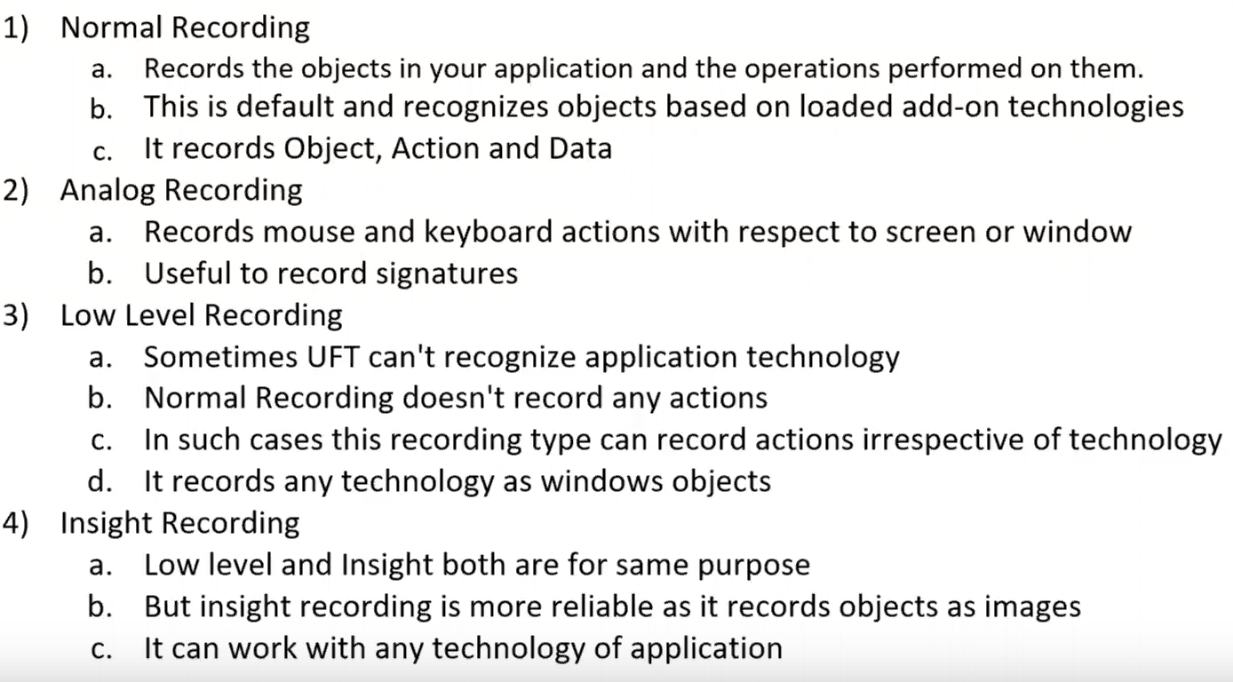

7.2 Parameterization of tests

Parameterization is:

✓ For Checkpoints

✓ In object repository

✓ In action steps

Why Parameterization:

✓ Parameterization allows us to pick different values at run time

✓ Reduces time and effort

✓ Usage of data drivers allow us to use the same data for various input boxes.

7.3 checkpoints (all types)

A checkpoint is verification step that compare actual vs expected

Based on expected value, checkpoints are classified as

1. Standard checkpoint
2. Page checkpoint
3. Text/Text area checkpoint
4. Image checkpoint
5. Data Base checkpoint
6. XML checkpoint
7. Bitmap checkpoint
8. Table checkpoint
9. Accessibility checkpoint

7.4 actions

Performing operations on Actions:

• Creating Actions

• Splitting Actions

• Renaming Actions

• Deleting Actions

• Call to copy an action

• Calling an existing action

• Making an action Reusable and Non –Reusable

7.5 transactions

✓ You can measure how long it takes to run a section of your test by defining transactions

✓ You define transactions within your test by enclosing the appropriate sections of the test with start and end transaction statements.

✓ Transactions can be inserted anywhere in the script

✓ There is no limit to the number of transactions that can be added to a test

✓ You can also insert a transaction within a transaction

7.6 Synchronisation points

• It is required to match execution speed of HP UFT with the loading/responding speed of application. Otherwise, the test execution may fail at unexpected ways.

• If you do not want QuickTest to execute a step or checkpoint until particular object in your application appears, you should insert a synchronization point to instruct QuickTest to pause the test until the object appears (or until a specified timeout is exceeded).

• You can add synchronization point from menu (Insert > Synchronization Point) after start recording the test.

• And, we can use Exist or Waitproperty statement for providing synchronization