Central university of Haryana

Department of computer science & engineering under SOET



Python lab

(BT CS 521)

Assignment-1

.  

Submitted by :- submitted to :-

Ponnaganti pavan kumar anant rajee bara

ROLL NO: 202102

Write a function which return all the unique palindromes from a given string

Github:

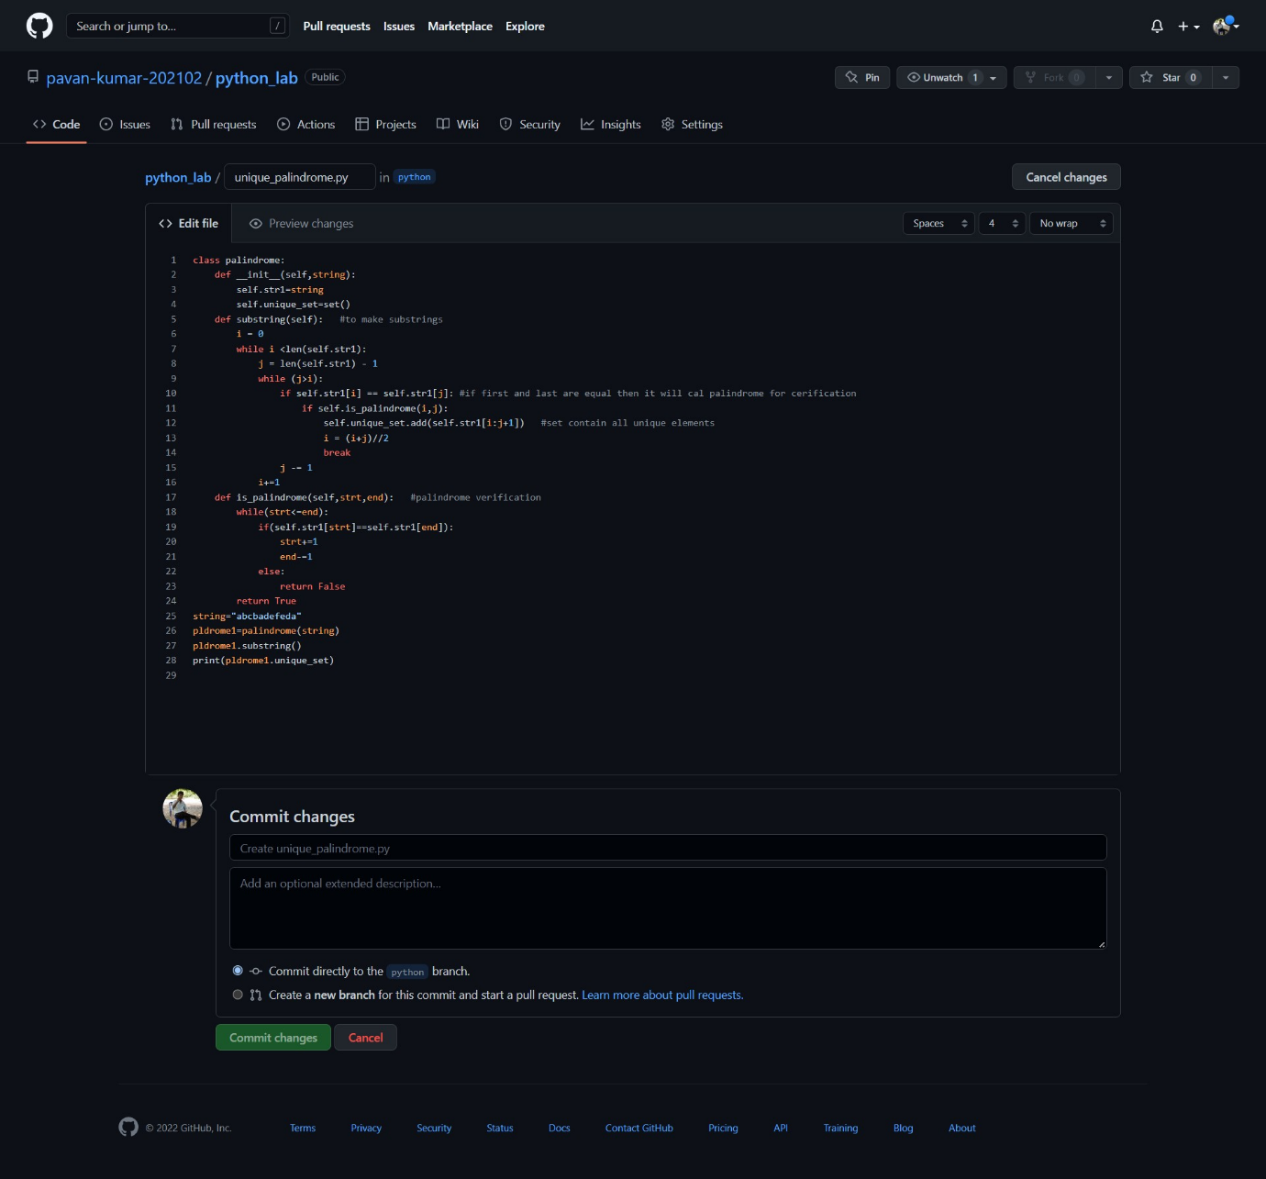

Output:

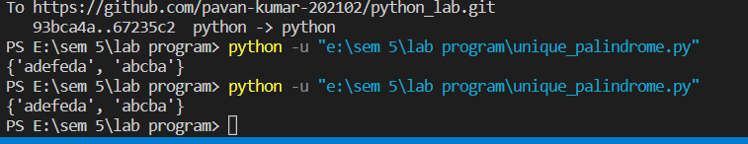

Github link:

https://github.com/pavan-kumar-202102/python_lab/blob/python/unique_palindrome.py