Central university of Haryana

Department of computer science & engineering under SOET



Python lab

(BT CS 526)

Lab-5.

Submitted by :- submitted to :-

Ponnaganti pavan kumar anant rajee bara

ROLL NO: 202102

**Problem statement:**

WAP to represent Graph using Adjaceny list

**code:**

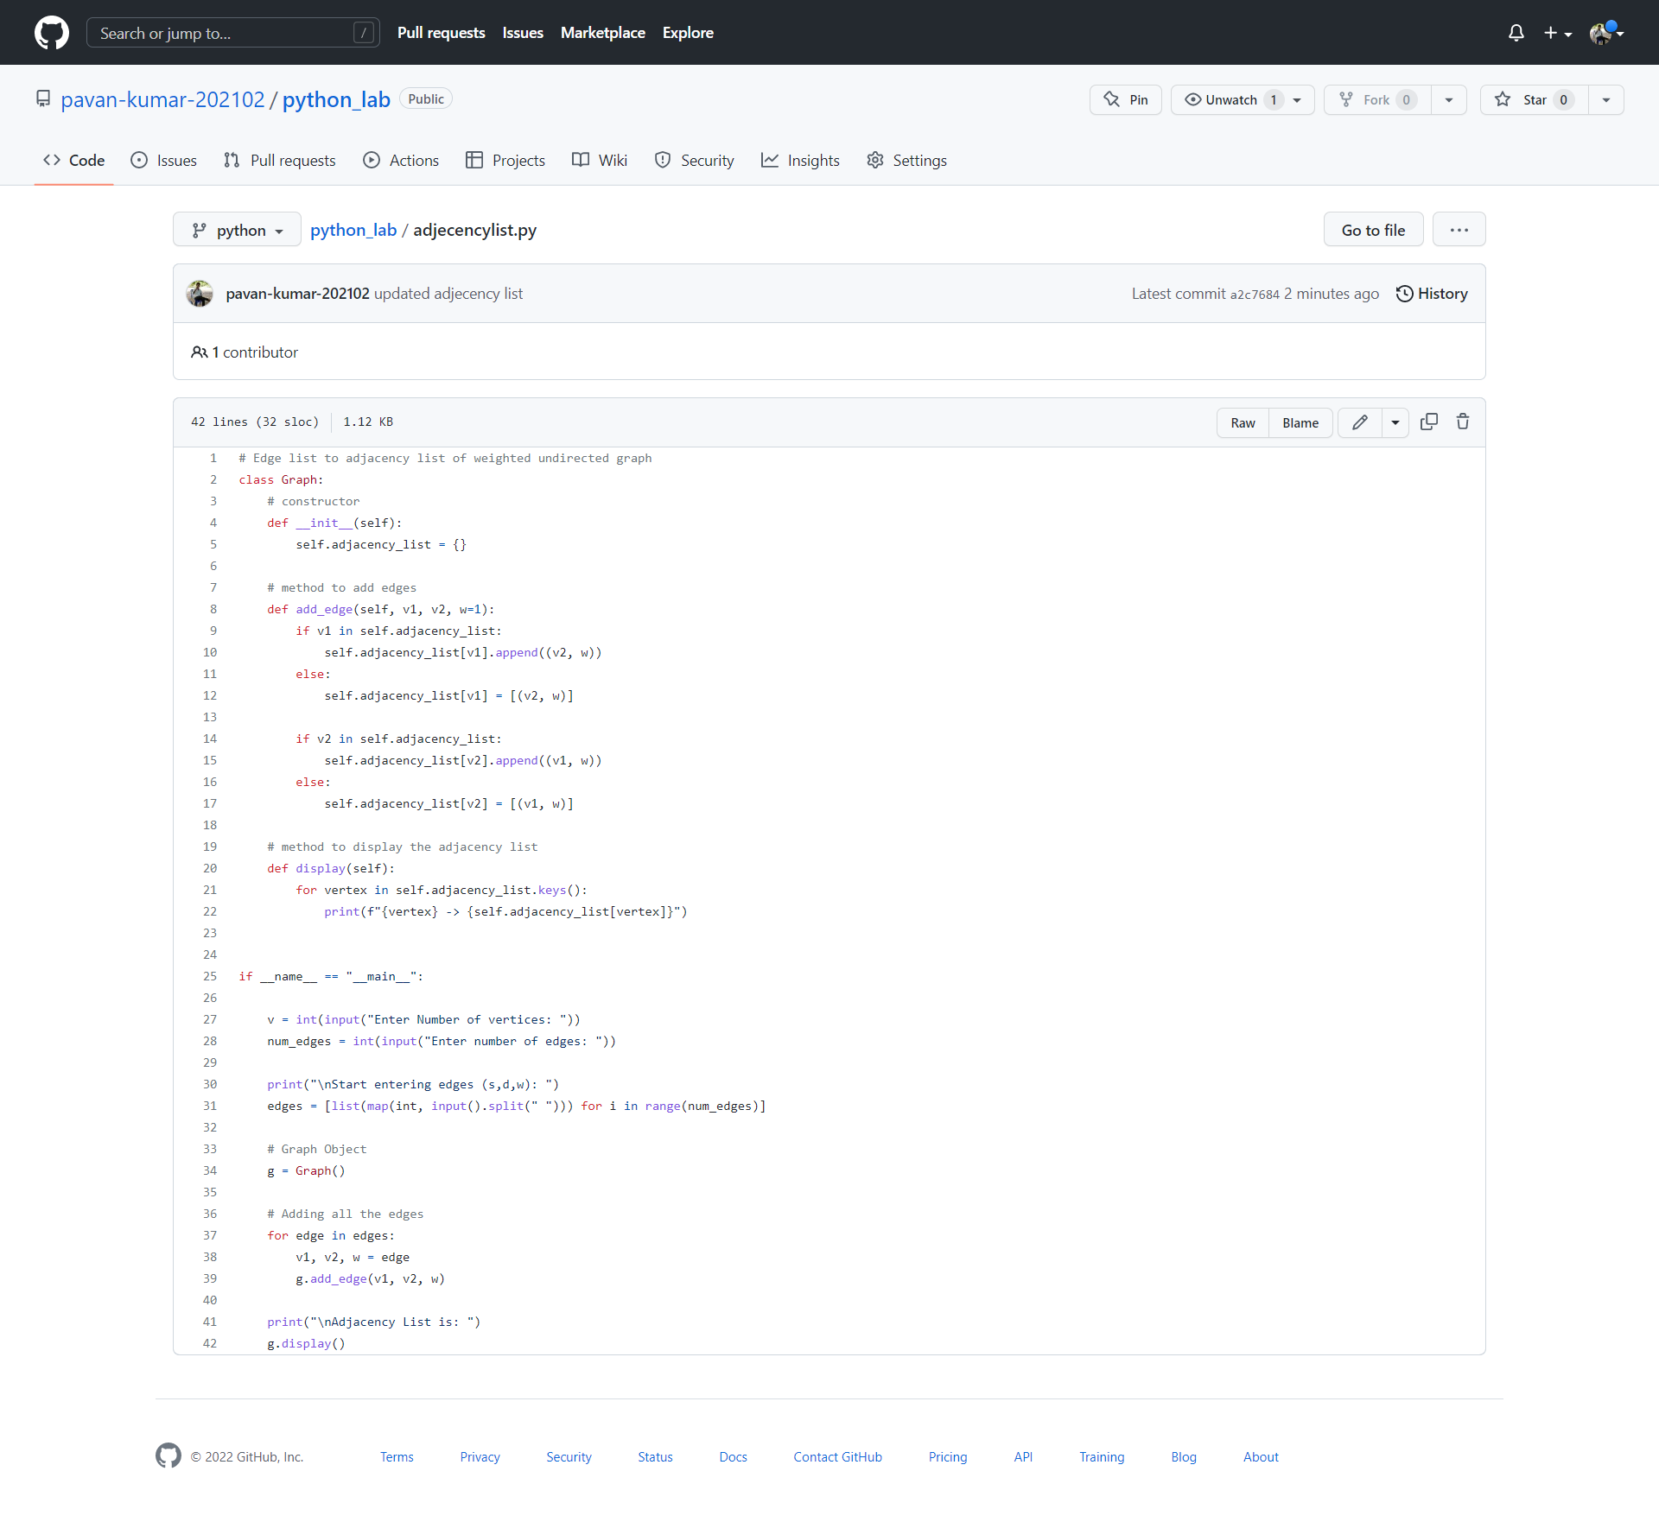

**Output:**

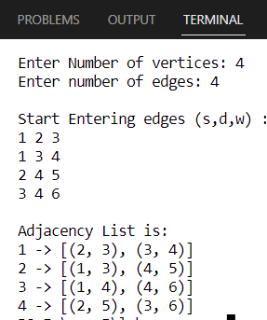

**Github link:**

<https://github.com/pavan-kumar-202102/python_lab/blob/python/adjecencylist.py>