Central university of Haryana

Department of computer science & engineering under SOET



ADA lab

(BT CS 505a)

Assignment-1

.  

Submitted by :- submitted to :-

Ponnaganti pavan kumar anant rajee bara

ROLL NO: 202102

Implement binary search

Github code ss:

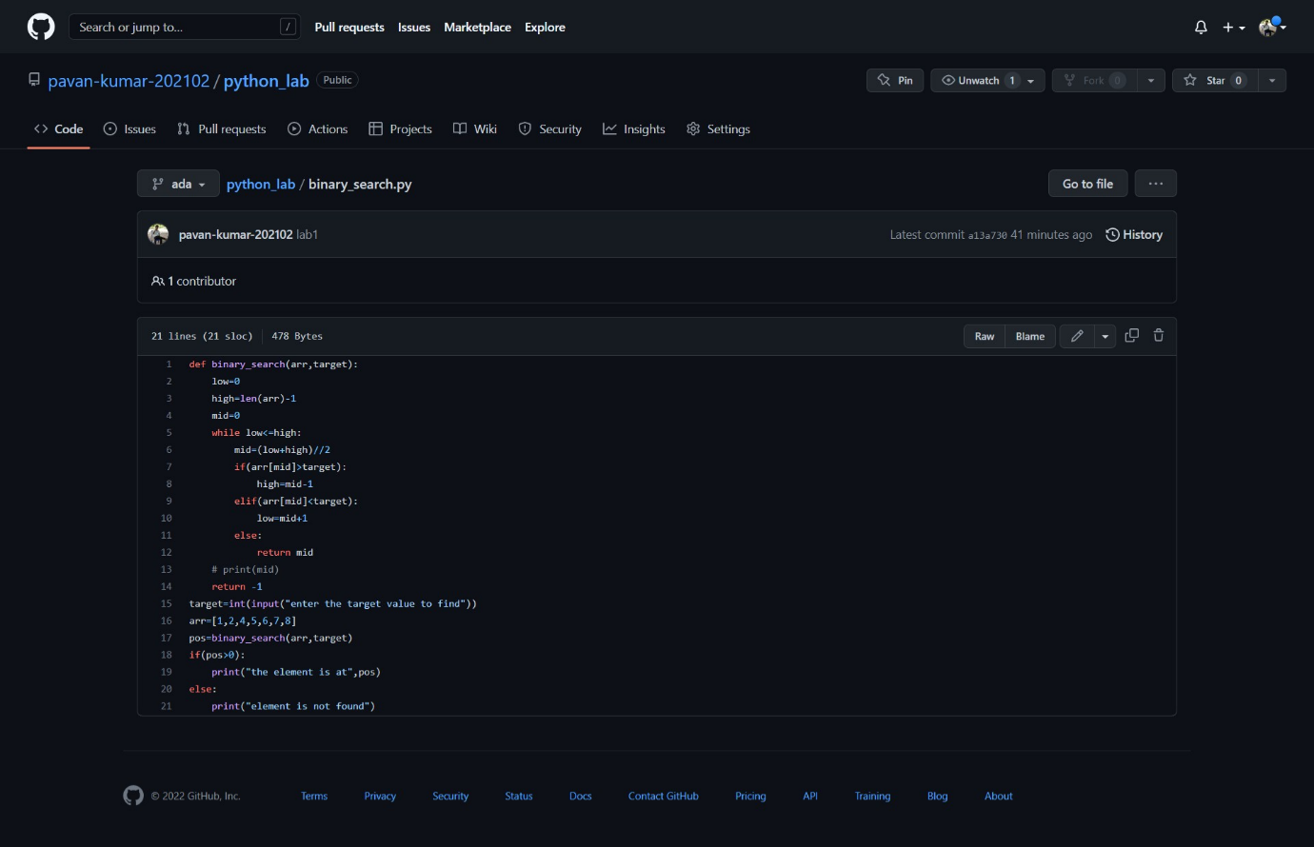

Output:

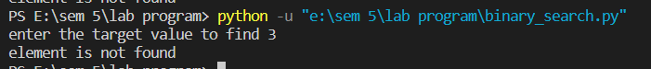

Repository link:

https://github.com/pavan-kumar-202102/python_lab/blob/ada/binary_search.py