Central university of Haryana

Department of computer science & engineering under SOET



ADA lab

(BT CS 505A)

Lab-5.

Submitted by :- submitted to :-

Ponnaganti pavan kumar anant rajee bara

ROLL NO: 202102

**Problem statement:**

Implement jobsequencing with deadline in which output as maximum profit

**code:**

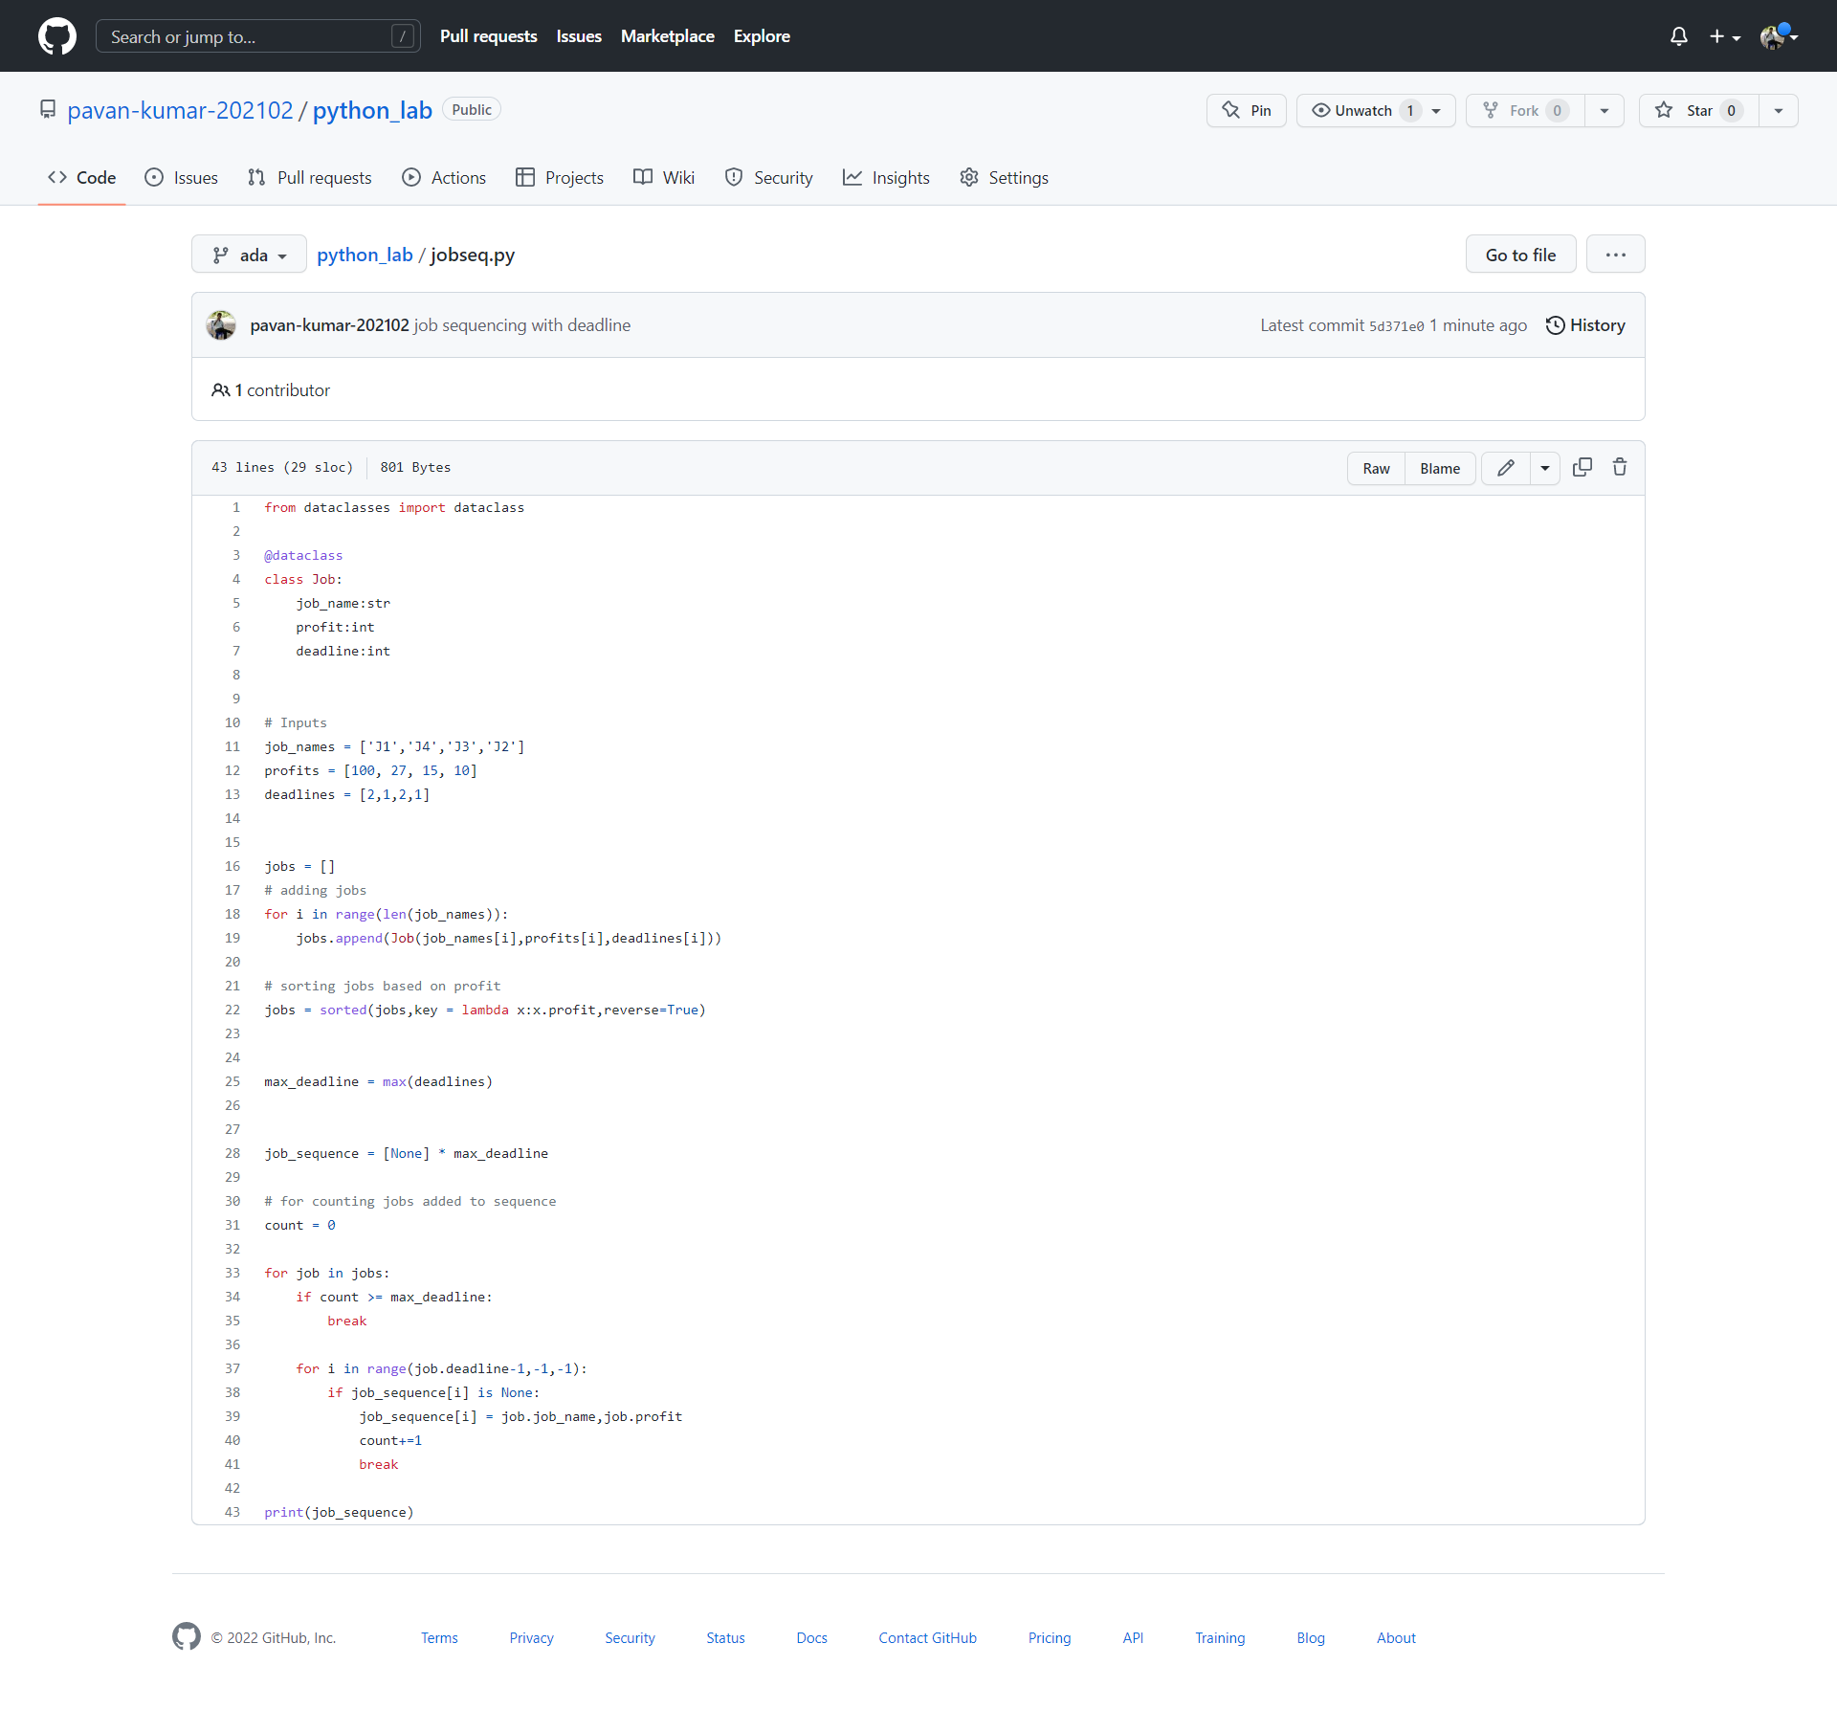

**Output:**



**Github link:**

<https://github.com/pavan-kumar-202102/python_lab/blob/ada/jobseq.py>