Central university of Haryana

Department of computer science & engineering under SOET



python lab

(BT CS 526)

Lab-1.

Submitted by :- submitted to :-

Ponnaganti pavan kumar anant rajee bara

ROLL NO: 202102

# Lab-1: Write a function which return all the unique palindromes from a given string :

# Code:

# 

**Output:**

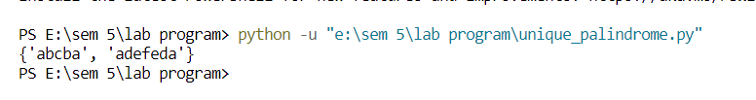**Github Link:**

<https://github.com/pavan-kumar-202102/python_lab/blob/python/unique_palindrome.py>