Central university of Haryana

Department of computer science & engineering under SOET



Algorithms lab

(BT CS 505a)

Lab-6.

Submitted by :- submitted to :-

Ponnaganti pavan kumar anant rajee bara

ROLL NO: 202102

**Problem statement:**

WAP to represent Graph using Adjaceny list

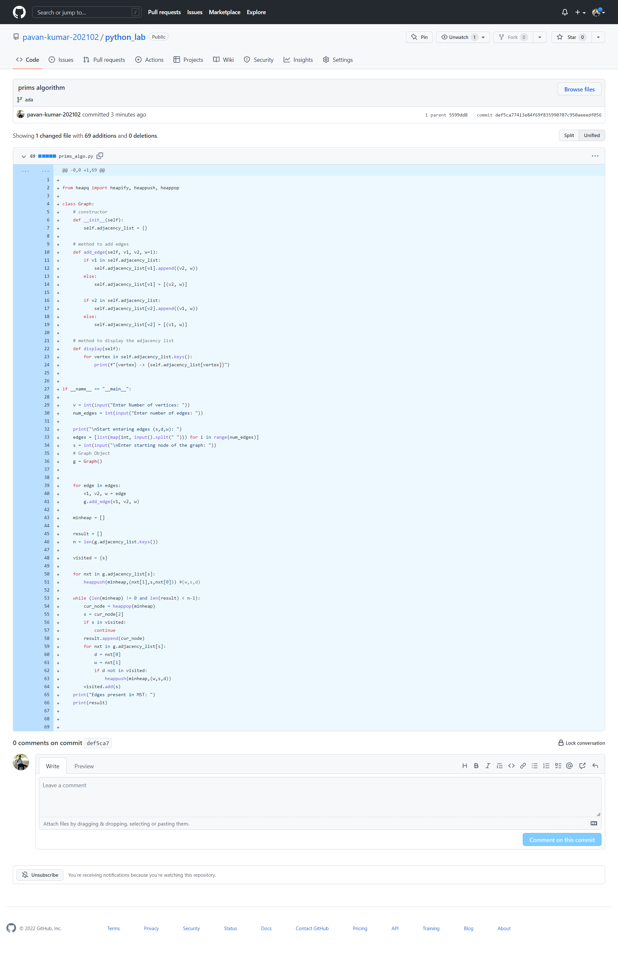

**Output:** 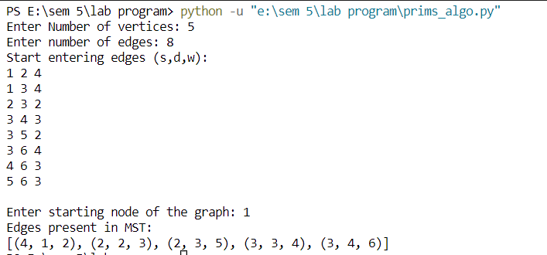

**Github link:**

<https://github.com/pavan-kumar-202102/python_lab/commit/def5ca77413e84f69f835990707c950aeeedf056>